2018/19

Jaynik Parsotomo

The City of Leicester COLLEGE

Candidate no: 2132

CENTRE NUMBER: 25214

Maths Snake

OCR Computer Science Project

Contents

Analysis 3

Who Is My Client 3

Problems the Client is facing 4

Computational Methods 5

Stakeholders 6

Conduct Research 7

**Structed Interview** 9

**Questionnaire** 15

**Observations** 20

**Images of Current System** 22

**Existing Solutions** 22

**Data Flow Diagram of Current Process** 31

**Structure Diagram of Current Process** 32

Essential Features 34

Limitations to Solution 36

Hardware Requirements 37

Software Requirements 37

Success Criteria 38

Design 43

Decompose the Problem 43

Gantt Chart 44

Flowchart for Current System 46

Flowchart for Proposed Solution 47

DFD for Current System 48

DFD for Proposed System 49

Usability Feature 50

User Interface 51

**User Interface Hand Drawn Sketches** 51

**First Design** 52

**User Feedback on First Design** 55

**Second Design** 57

**User Feedback** 60

**Improvements After Client’s Feedback** 62

**Colour Scheme and Font choice for User Interface** 63

User Feedback 64

Design Specification 71

Iterative Test Plan 77

Post Development Testing 81

Structure Diagram of Solution 86

Pseudocode and Variables Table 87

Implementation 96

Creating the Window 96

Creating the Main Menu 97

Creating the Sections 99

Improved Main Menu 102

Creating How to Play Section 105

Creating Snake 110

Controls 121

Snake Features 128

Score Tracker 131

Questions 136

Progress Tracker List 139

Incorporating the Progress Tracker and Questions into the Game 143

Questions for the other Difficulty Levels 148

Score Lists 152

Highest Score 153

Fixing the Question’s Labels 155

Display the Top 5 Scores 156

Displaying the Progress Tracker 159

Final Code Annotated 160

Iterative Testing 178

Evaluation 182

Post Development Testing 182

Validation 198

Usability Features 199

Success Criteria 203

Usability Features 208

Future Developments 210

Maintenance Issues 212

Limitation Developments 213

Bibliography 215

# **Analysis**

## **Who Is My Client**

**Name:** Harsh Parsotamo

**Gender:** Male

**Age:** 10

**Profession:** Full-time Student

**Place:** Krishna Avanti Primary School

My end client is a 10-year-old boy named Harsh Parsotamo who is currently a Year 6 student in a Primary School called Krishna Avanti. My client is studying the basic required subjects like English and Maths at the primary school with other extra curriculum like Art, Science and PE.

My client was not born in the UK, he was born in Lisbon, Portugal, and moved to the UK in 2013. He moved to a new country without knowing its language however, he is now able to speak English fluently alongside with Portuguese and Gujarati.

Over the few years he has adapted himself to living in a completely new country and a new school where he had to overcome the language barrier. However, he has managed to overcome this obstacle and now enjoying his new school and now he is entering his final year, Year 6, where he will have to do his SATs. My client will need to do his English and Maths SATs.

My client having grown up surrounded with technology and having many resources available to him which he loves to use to play games keeping himself entertained and helping him learn. My client is also very competitive when it comes to wining something like in sports or games, meaning he hates to lose. However, my client currently uses a textbook, pen and paper, where he would learn the skills and answer questions for Maths. This system was implemented by his parents. Though, my client does not find it entertaining to learn the content this way.

## **Problems the Client is facing**

The problem my client is currently facing is that he finds it difficult to study Maths. He finds it boring as there is nothing to keep him entertained or active into learning it. This is because he must do something that will keep his brain active and alert, not just sit there with a pen and paper and do some calculations. The way he learns Maths is not practical enough, as he excels within Science and English, as he learns these through practical ways, like for Science he does experiments and in English he learns through drama. However, in Maths he learns through an old-style method, learn the content from the book and then answer questions based on the content learnt, which he does not enjoy and learns very little from this way of learning. My client needs an active way to learn Maths, so he finds it fun to learn Maths.

His current way of learning is old school, as he uses the textbook to learn the content and then answer questions. However, the visual aspect of the book is not pretty, which is not helpful for my client as he is a visual learner. My client is very visual therefore he needs a method of learning that is visually pleasing to him. He needs more colour, as the textbooks he uses are very plain. This is so he can use the colours to learn which would help him have the knowledge embedded into his brain. My client needs a way that is attractive to him, which helps him in his visual learning.

Another problem my client is facing is the lack of motivation to improve his skills in Maths. Currently his system for learning Maths is using pen and paper with a textbook, however this method is not suitable with him as he finds it boring which is bringing down his motivation level to study this subject. My client likes to have fun whilst learning like he does in his other subjects, English and Science, as when he is having fun he is at his best and this boosts his motivation levels up. However, the way he is learning is not enjoyable thus his motivation to improve his Mathematical skills is very low. My client mindset currently is that he will only do what is required from his teachers and parents, like finishing homework, but he does not want to grow his mathematical skills. My client needs something that will improve his motivation to learn Maths.

An additional problem that my client has is he finds it difficult to keep track of his progress. Most of his work is done on paper, and because of this he finds it very difficult to keep track of what he has done correct or wrong. My client finds it difficult to go back and go through his previous work to see what he needs to do as everything is kept together. He currently doesn’t have a system that can help him keep track on what he has done correctly and what he needs to work on.

The problem with the system is that this way of learning was introduced to him by his parents, who grew up without technology and learned through pen and paper, thus they are also trying to use this with my client. However, this way is not suitable for him to learn the skills he requires within Maths. My client has grown up with technology, a very different era to his parents, and he has been using technology since an early age, using it to help him in his studies and playing games. However, since his parents are old fashion, they are enforcing their way of learning into him and he is not able to take full advantage of using technology. His parents do allow him to use it for Maths but for either looking for questions or as a calculator. My client has not been able to use technology to help him enough therefore he needs a system using technology which would be very helpful for him and help his parents understand his way of working is different.

## **Computational Methods**

The problems my client is facing can be solved through a computational method as currently he does not have a computerised system. My client does most of his Maths work on paper and hardly uses technology to help him study Maths apart from using the internet to search for questions and answers. Having grown up with technology and using it in his everyday life he has grown accustomed to using it for most things. However, for Maths he does not use a computer system, therefore having a computer system to learn Maths would benefit my client as he is used to using it for other things so, using it for Maths would make Maths a more enjoyable and comfortable learning experience.

This brings me to my second reason as to how a computational method would help my client: He does not enjoy Maths. A computer program would help solve this as my client loves to play games and using a computer, I can program a computer game, a fun program. By creating a fun computer system for my client to learn Maths, this would boast his activeness in learning Maths, as he would want to play the game and advance far in the game as well but, to do that he must learn the theory to answer the questions within the game. Therefore, he becomes more active in learning Maths but more importantly he is having fun, solving two of the problems my client is currently facing.

Furthermore, this solves another problem my client has, his parents. They have enforced the textbook method into him and does not use any computer systems to help him, but his problem can be solved by a computer system as if my client has fun learning Maths and is learning all the required theory at the same time then this would persuade his parents to accept that this way is better for him. Thus, he would then be able to use technology more.

Using programming I can help him overcome his problem in aesthetic way of learning. Currently his way learning is very plain in a visual aspect, but through programming this can be solved. My solution of making a fun program can help this as I can use any colour and images in the program to help him visuals the mathematical problem. I can use certain colours in certain types of questions to aid him in his visual learning, as colours would help him see it clearly in his head. I can also use other visual aspects like shapes, so he can see an image clearly of what his is learning.

Creating a computer system, will also solve his problem to keep track of his progress within Maths as I will be able to create a program that would keep track of what questions he got wrong and right. A computer would easily keep track of this and display the information to him with ease as he and his parents will be able to access it faster. Having his progress computerised will let him be able to see it with ease instead of having it on paper and then looking through all the papers to see where he is at. Moreover, I can show what he is good at and what he isn’t using the computer program. This kind of system will also benefit his parents as they will be able to see what he is good at and what he is struggling with and thus they will able to focus on those kinds of question with him.

Overall, by solving these problems this would also increase his motivation to learn Maths as he would have less problems to deal with. Furthermore, by having a fun system to learn Maths and using a method of learning that he is more comfortable with, he will more likely want to learn Maths thus motivating him to learn the required skills he needs in Maths.

## **Stakeholders**

The stakeholders of who will be using this system are my client, Harsh Parsotamo and his parents.

My client needs a solution as he is a student in Year 6 who is currently studying for his SATs however, he is struggling in Maths, therefore he needs a solution that will help him in his studies for Maths. My client finds the current system boring, and not engaging enough leading him to do poorly within Maths. The solution I am proposing needs to help him in learning the required Maths, by engaging him into learning Maths, and to do this the best solution would be learning through a game. Having a Maths game will keep my client entertained and engaged whilst learning Maths, thus more likely to remember the required skills. Furthermore, he is an active learner and competitive person, meaning a game will benefit his personality as he will want to play the game try to best his own best score and his brain will stay active thus more likely to absorb the learning content.

His parents need a solution that will help their son but also help them keep track of how he is doing, and to help him focus in the areas of Maths that he is really struggling at in other words a way to keep track of his progress. The current system is using a pen and paper to study Maths however my client does not learn very well with this method and his parents help him with everything in Maths and don’t specifically focus on the areas he needs. Therefore, my solution to create a fun program for my client to play but at the same time answer questions, will benefit him as he will be having fun but also, he will be learning the content and way to answer the questions. The game will also keep track of questions he is getting wrong and right and thus his parents will be able to review what he is getting wrong or right and then help him the areas he is getting wrong.

## **Conduct Research**

To find out more in-depth information about my client’s problems, and what he needs exactly I will need to conduct a more in-depth research. To do this I will be using these following methods, Structured Interview, Questionnaire and Observations.

**Advantages and Disadvantages of a Structed Interview:**

The main advantage of a structured interview was that I will be able to get the information directly from him, therefore the information is reliable, but also the answer to my questions will help me come up with the perfect solution. Furthermore, this sort of method is easy to repeat as it will be the same as it was the first time, and this is due to the fact the questions being written down, therefore if I don’t extract all the information from the first interview, I can easily do another. Moreover, I can prevent any misunderstanding with a question my client may have, and this is possible as it is a face to face interview, so I can explain clearly as to what information I require from the question. This makes the information retrieved more reliable. This method is also quick and cheap, since this is structed, I will only need to ask the questions and the interviewee will only need to respond. This method does not require lots of resources as I just need to get a set of questions ready and set a time and place for the interview.

The main disadvantage is that my client is 10-years-old therefore, the questions I come up with must be simple, in a manner that someone his age understands otherwise he may reluctantly give an answer which he doesn’t really mean thus the information is unreliable and the solution may not help him at all. Furthermore, I can only clear his misunderstanding if he himself says he doesn’t understand it, and if he doesn’t then information, I got is completely wrong. Also, since I will be doing the interview face to face, I could end up influencing him by my body language, tone of voice and etc, to say a different answer to what he really means, this the result is unreliable

**Advantages and Disadvantages of a Questionnaire:**

The biggest advantage of this method is that is very cost efficient and quick. This method is the most affordable way for me to obtain data quickly. I will be using this method to gain data from the other stakeholders, and since they are both working, with this method I can give it to them in any form, hard copy, mail or an electronic version. His means they can access the questionnaire with ease. This I can get results quickly as they can access it whenever they want in any form. Furthermore, it is easy for the stakeholders since they have jobs, they need time to do this, but with a questionnaire since they is not time limit they have time to fill in the questionnaire I their own time, there isn’t anybody waiting for them to give an answer. In addition to this I can make sure the questionnaire answers all the relevant topics that I need to cover, and this is because on a questionnaire I can ask as many questions as I want. There are also many formats of questionnaire that I can pick, and types of questions asked as well, open-ended or multiple choice. This means I can get vast amounts of information on my subject in different ways.

The biggest disadvantage with a questionnaire is dishonesty as the respondents may not be 100% truthful with their answer as they could be protecting their privacy thus the result is invalid. Furthermore, they may also not read the question fully or rush through it without giving it a second thought and give an answer which is not really, what they are thinking therefore answer I get may be unreliable. Also, they may not understand the question and end up giving an answer which is different to your interpretation of the question, making the results invalid.

**Advantages and Disadvantages of an Observation:**

The main advantage of this form of research is that I will be able to experience first-hand of the problems that are affecting him clearly in his daily life. This will help me come up with the best solution to his problem as I will be able to see how he can use it, what will be best for him, how his problems can be solved. In addition to this the validity of the data I collected can be strong, as he will be facing the problems in real time and I can consider as to what I can do through computational methods to solve or make it easier with the problems he is facing. I will be able to get a real in-depth in-sight of how he is really coping with his current system and what are the flaws with it. I can then use this sort of information to help improve the system or create a more efficient one.

The main disadvantage of this method is the observer, meaning me. This is because he may become uncomfortable or react in a way that is completely different to what he normally does because he may not be work under these conditions. This then will affect the reliability of my observation research as he his response to problems he is facing may not be genuine thus this can affect the solution as I may either ignore it may not be an issue or his actions could have made it into a bigger problem than it really is, therefore the results I get are invalid. This method is also time consuming for me and the observant as well, as I would need to do a minute by minute observation on what he is doing, and I need to make sure I get all the information as to how he is facing his current problems, which can take time. This method is exhausting for the observant as well as me being here can influence him to act normal which instead would make him act unrealistically to normal. All of this would make my observation invalid as it isn’t a realistic representation of how he is using his current system and his existing problems.

### **Structed Interview**

**Arranging the Interviews**

I contacted my client’s Dad via phone to arrange the interview.

**Arrangement for Interview 1: Arrangement for Interview 2:**

Arranged on Sunday 30th September 2018 Client visited my house on 26th October 2018

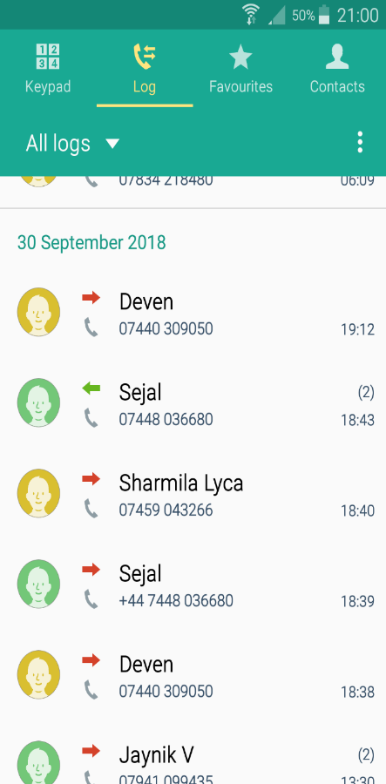

**Client Interview 1**

**Interviewer:** Jaynik Parsotomo

**Interviewee:** Harsh Parsotamo (Client)

**Time Started:** 19:16

**Time Finished:** 19:34

**Date:** Sunday 30th September 2018

**Location:** Client’s House

**Interviewer: How do you currently learn Maths?**

Interviewee:“I learn Maths from answering questions that I print out from the internet and my teacher gives some questions. I sometimes ask my friends for help and do the questions with them but if it is too hard, I will ask the teacher for help.”

**Interviewer: Do you like the way you are learning Maths right now?**

Interviewee: “I don’t like the way I learn Maths. I find it boring and not fun. I prefer to learn through a game”

**Interviewer: What problems are you facing with your current way of learning?**

Interviewee:“It boring, I don’t like it at all. There is no colour, we use very little colour our maths book is very boring no colour. I used colour to colour different size of number once. I liked that I wanted to do more of that sort of thing.”

**Interviewer: What do you want to change with your current way of learning?**

Interviewee:“I would like to change it by having more colour and more fun way to learn like a game”

**Interviewer: What kind of way would you want to learn Maths?**

Interviewee:“I prefer to learn through a game. I like to have fun when I am learning. Right now, I find maths hard and boring.”

**Interviewer: What are you struggling with in Maths?**

Interviewee:“I find doing fractions hard. I find it hard to convert the fraction to decimals or percentages”

**Interviewer: How do you keep track of your progress with in Maths?**

Interviewee:“I know what I got wrong and what I need to do looking at the questions I got wrong. My teacher will tell me what I need to do more work on.”

**Interviewer: How do you use technology with your studies?**

Interviewee:“I don’t use technology to learn Maths. I don’t use a calculator, my tablet or PC only if I need to print questions out. We used to have this Maths app I can’t remember its name, but that app needs a password and my password doesn’t work anymore. I don’t use the app anymore.”

**Interviewer: Would you like to learn Maths through a game?**

Interviewee:“Yes, I would. I want to have fun learning Maths I would prefer a game”

**Interviewer: What kind of features do you want the most within the game?**

Interviewee:“I want the game to have different levels, and the questions start easy and then in the game get harder. I want to play it as a computer app”

**Analysis of Structured Client Interview 1**

By interviewing my client, I got more of an understanding of what he thinks of Maths, I got to hear the problems he is facing and what kind of solution he wants.

The first question allowed me to get an insight from the client himself of what he thinks of the system he is currently using. From the answer I received, I found out that he currently learns Maths by answering questions, from test papers, which he prints out or questions his teacher sets. This tells me his current system is very basic, as all he does is learn how to answer a question and then apply that knowledge. I learnt that his system is very plain which does not suit him. I also learnt what he does when he is stuck on a question, he asks his friends or teachers for help. I then asked him a direct question, if he likes to learn this way and by asking this I learnt he does not like it at all, and reasons why, it is ‘boring’ and ‘not fun’. I have also learnt he would like to learn Maths through a game. From this question it gave me an insight of what my solution should do for him when learning maths using it, which is to be entertained and having fun. Furthermore, that the solution should be a game.

From the next 3 questions, which are directed to the problems he is facing with his current system and ways he would like to improve it. In these answers I got an insight on what problems he is facing and what he wants to do to solve them. The main problem I learnt is that he finds it boring as there are no colours which he does not like. The reason being is that it does not help him in his visual learning since he is a visual learner. Then from the next question I learnt that he wants to change it by having more colour and a more fun way to learn, and he links this back to a game. This helps me come up with a solution and what the solution should have. The next question is a direct question as what kind of system he wants. The answer he provided was he wants a game, which tells me the solution must be a game that helps him in Maths.

The next question is about what he is struggling at within Maths. The reason I asked this is, so I can focus my solution to help him on the most difficult areas he finds within Maths. From this I learnt he finds converting fractions in decimals difficult therefore now I know that I should focus the game on helping him in this area more.

The last 3 questions are to help me with my solution, a way to help me solve his problem through a computational method. First of I asked how he uses technology in Maths, and he replied he only uses it for printing out questions, but he also had an app for Maths, but it does not work anymore. From this I learnt that he barley uses technology to help him in his studies. Therefore, having a programmed solution would be a better experience for him to learn Maths. The next 2 questions were to do with my solution idea, a game. I first asked him is he wants a game to learn Maths or not, which he replied yes. Then finally to help me as to what features my game should have I asked him what he wants within the game. He wants the questions to start easy then get harder through the game and the game to be playable on tablet.

From this interview I found out my client wants a game and how the game should solve his problems, like having colour. I also know he needs to focus on converting fractions, so my game should focus on that. Furthermore, the game should be programmed to be playable on his tablet, so I know it needs to be an android app. However, I haven’t gotten all the information I need which is way I will be conducting another interview.

**Client Interview 2**

**Interviewer:** Jaynik Parsotomo

**Interviewee:** Harsh Parsotamo (Client)

**Time Started:** 18:34

**Time Finished:** 18:47

**Date:** 26th October 2018

**Location:** Client’s House

**Interviewer: Who taught you how to do Maths like this?**

Interviewee: “I was taught to do Maths like this by my dad and my teacher at school “

**Interviewer: How do you keep track of your progress in Maths?**

Interviewee: “I look at the questions I got right and wrong and try the wrong ones again and if I get them right again then I try other questions”

**Interviewer: Where do you keep all your work for Maths?**

Interviewee:” I keep all my Maths work at school in a folder or at home in a folder”

**Interviewer: Do you use a calculator in Maths?**

Interviewee: “No I don’t”

**Analysis of Structured Client Interview 2**

The purpose of this second interview was so I can find out more of other problems affecting him.

The first question I asked was, so I can get a confirmation from him about who taught him this way of learning Maths. I learnt that he was taught this way from his Dad and his teacher. The reason for this was because I needed to know as to who my solution should be directed towards the most, from my other stakeholders.

The second question was directed at my clients and other stakeholder problem which is keep track of his progress. This is one of the main problems that they find it difficult to keep track of his progress, as to what he needs to work on and what he doesn’t. From the interview I was able to find out that he keeps track by going through his questions, as to what he got right or wrong.

The next question was to find out where he puts all his maths work, so I know how organised he is, or if he has an efficient system. I found out he puts them into a single folder, one for school and home with no ordering system at all. This tells me that having no system that makes it easier for m=him to view the questions, means it is affecting his progress tracking as he can’t find what he wants with ease without looking through the folder. Furthermore, this would affect his motivation as he would become fed and have a low morale to do the work as he is not able to find it, and the disorganised folder will put him off.

The final question I asked was so that I know all the questions are mental Maths questions, and don’t require a calculator. Therefore, I know that all the questions need to be doable mentally.

### **Questionnaire**

I created a survey for my stakeholders, who are my client and his parents. I created a survey to find out how they feel about the way he their son is currently studying Maths, and what they think of my solution.

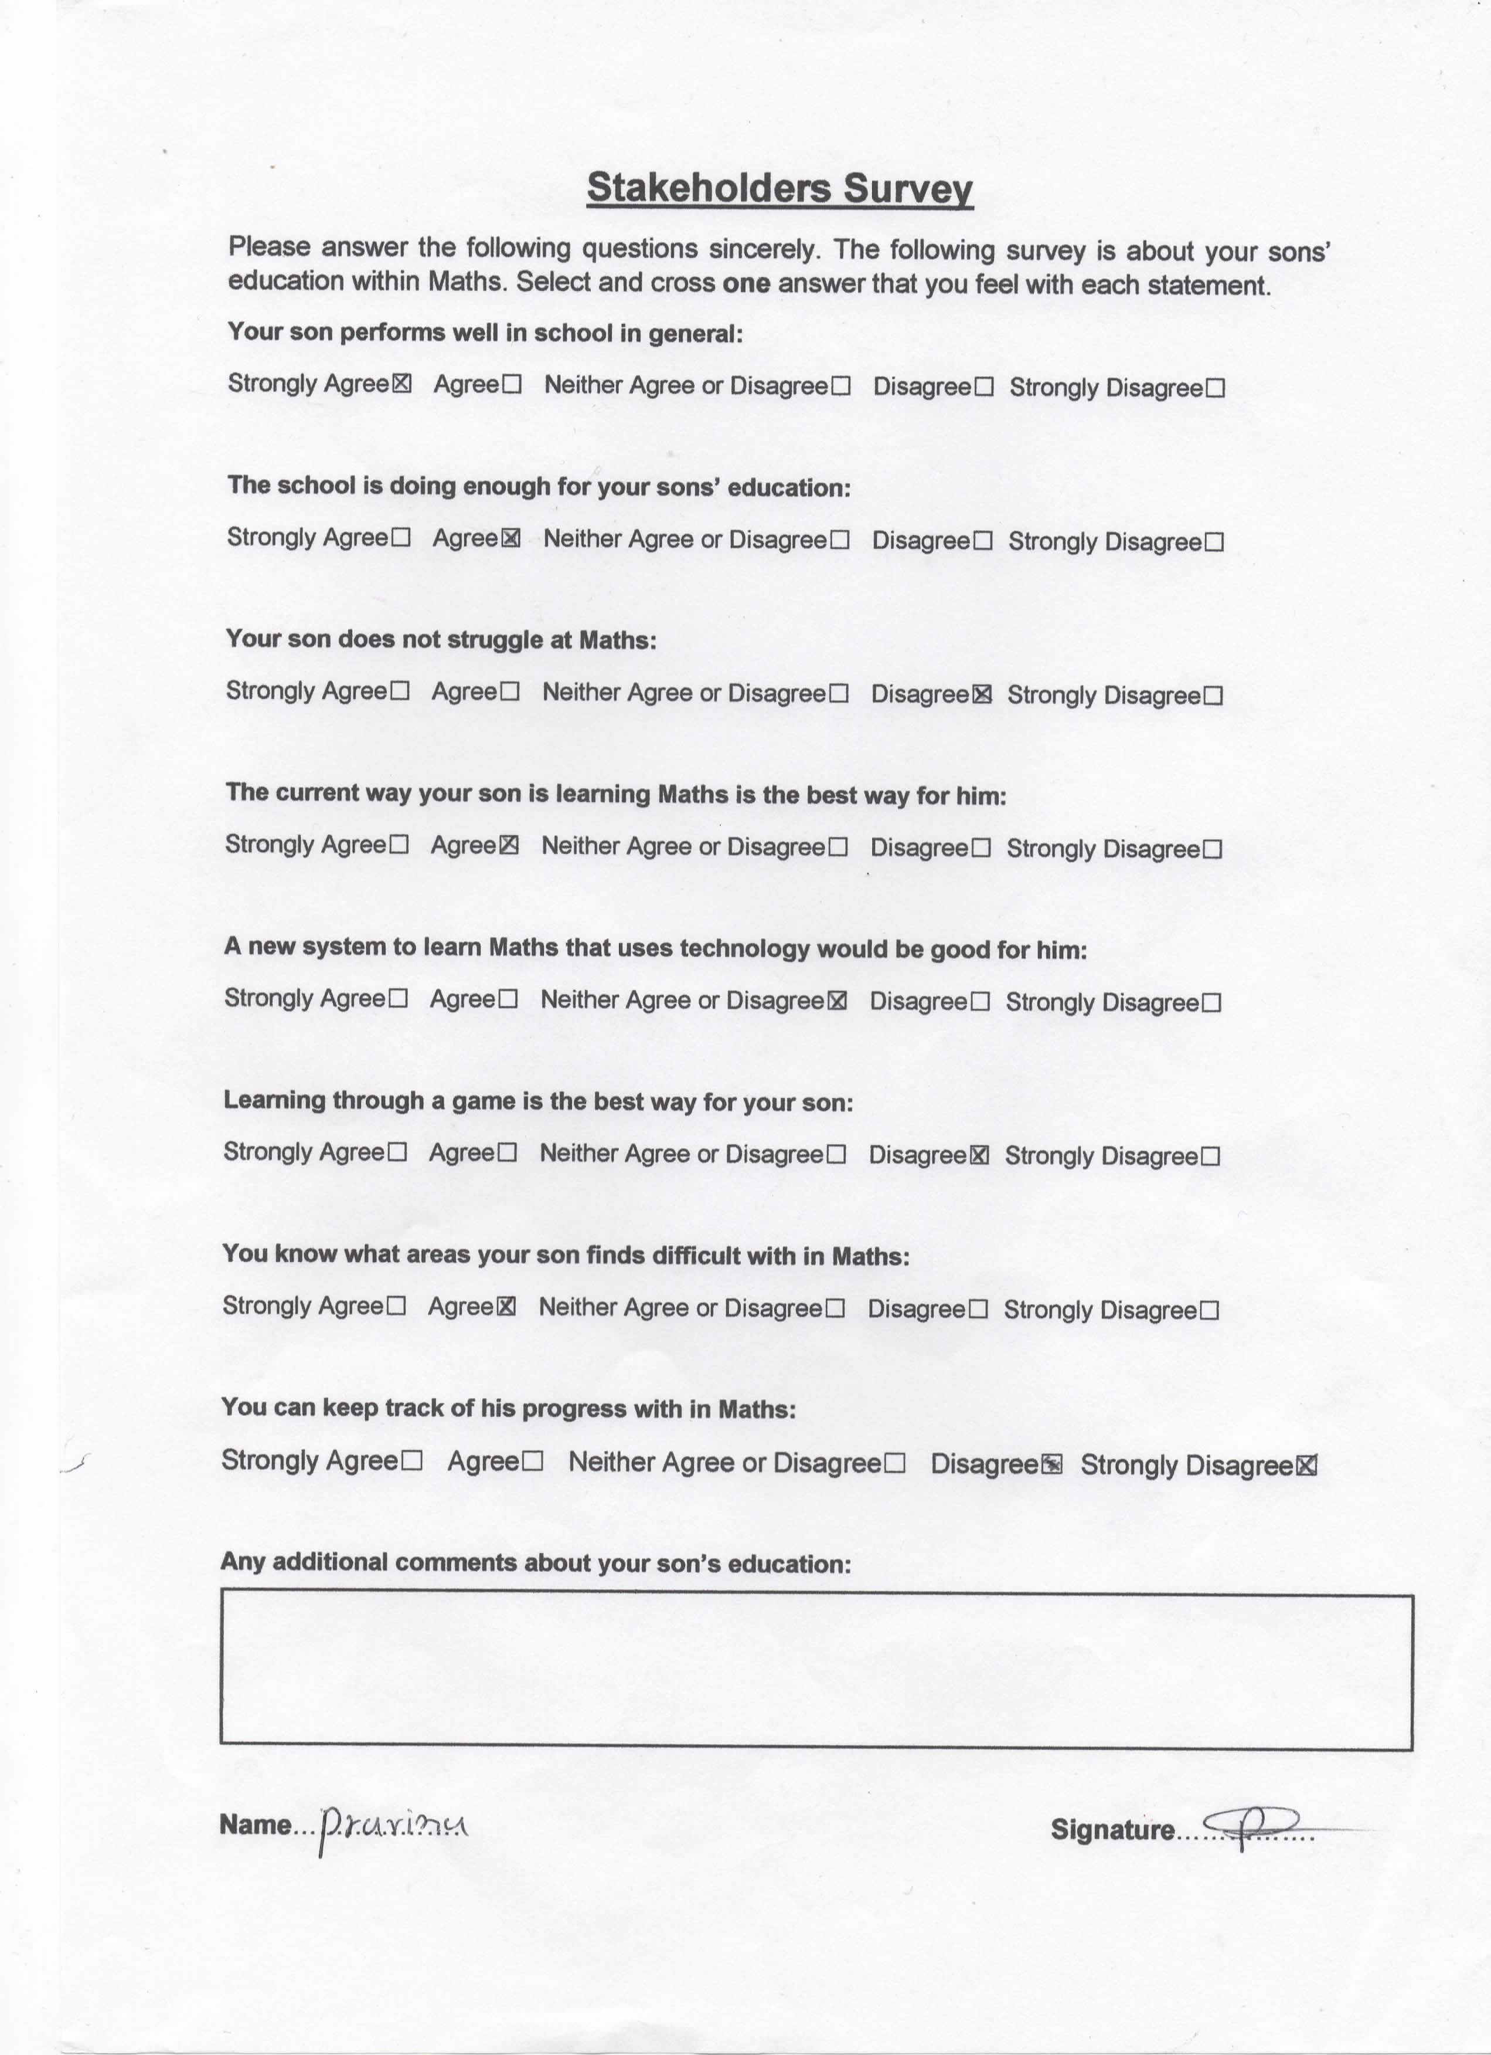**Client’s Mum:**

**Client’s Dad:**

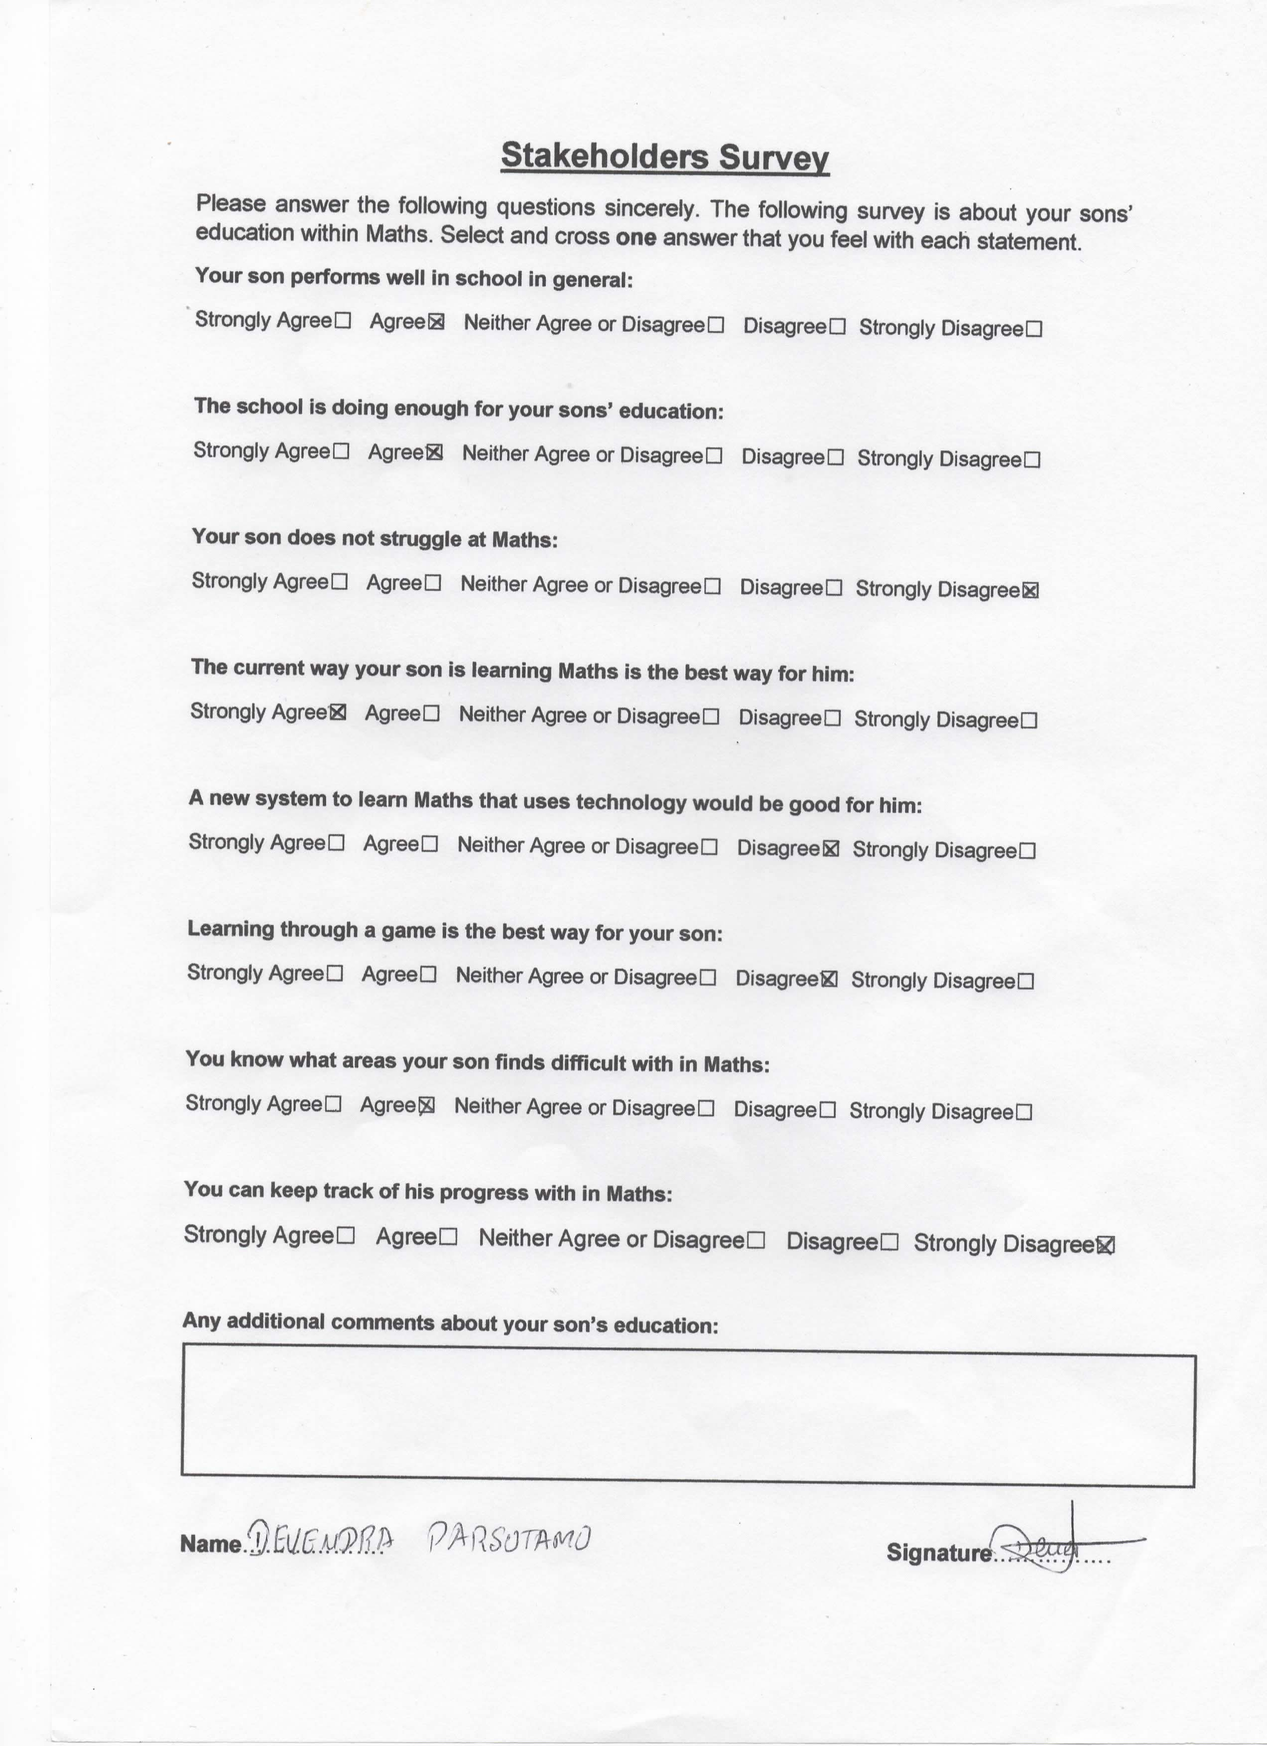

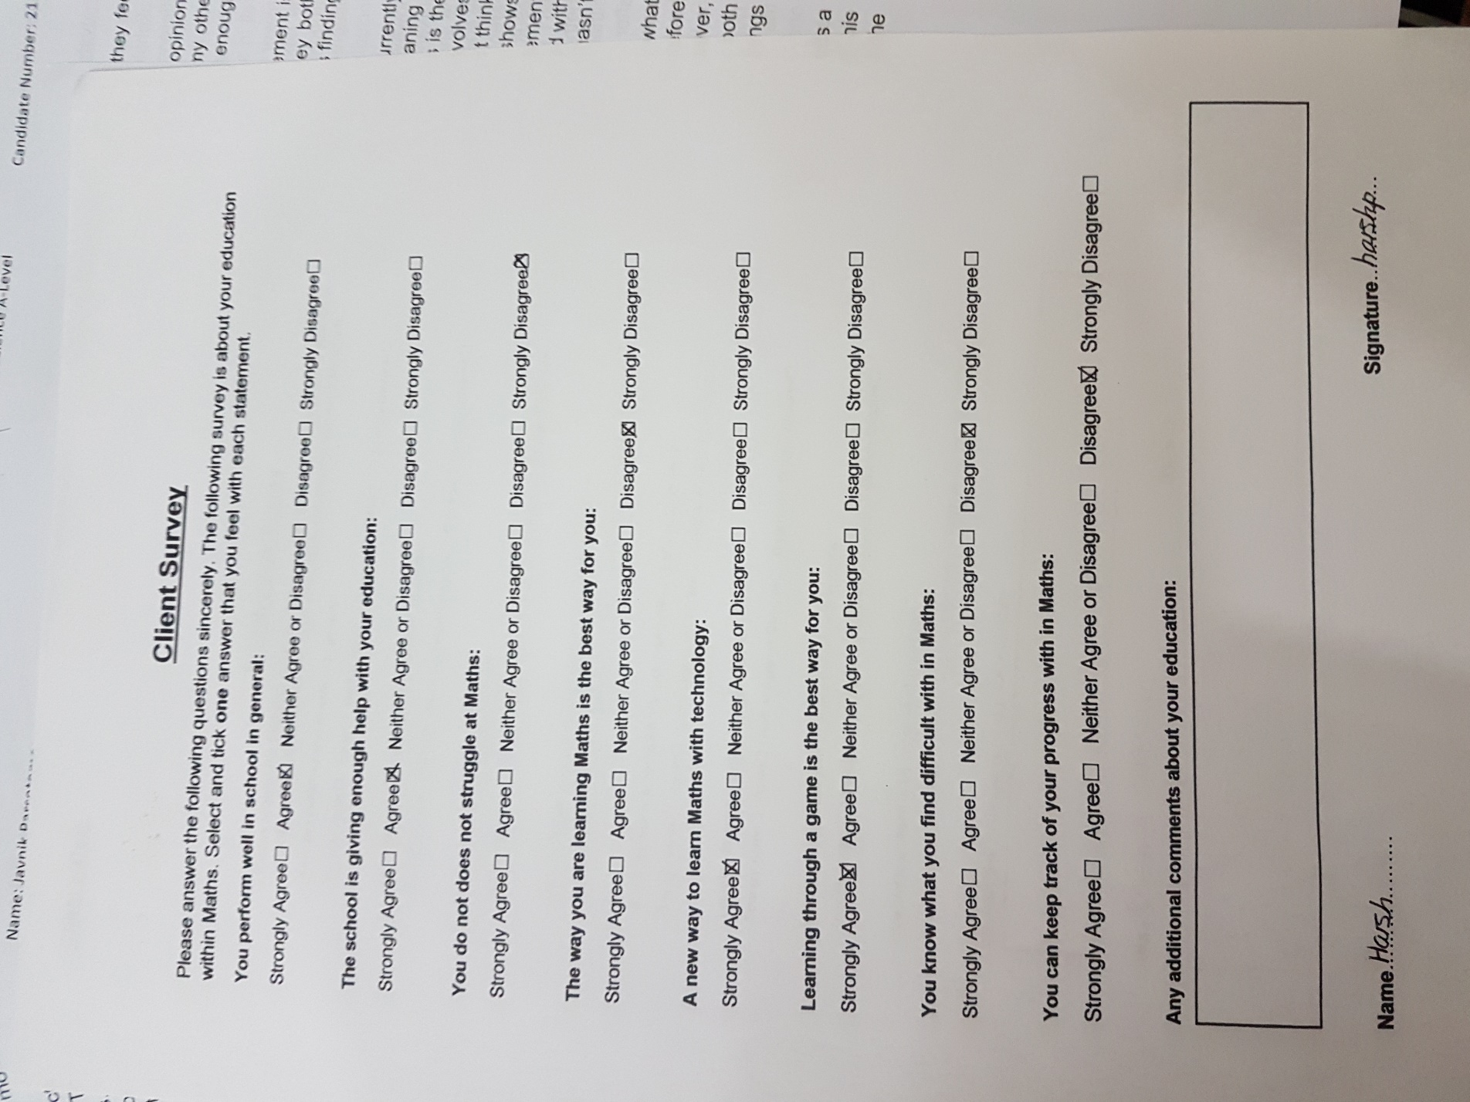**Client:**

**Analysis of Questionnaire for Other Stakeholders**

To find out what my stakeholders think I created a survey to find out what they feel against each statement.

From the questionnaire I found out that my clients Mum and Dad have similar opinions on how he is doing in Maths. From the first 2 statements I found out that my other stakeholders have similar opinion that they think the school is doing good and enough for their son’s education.

The next statement which is about his education within Maths. The first statement is about if their son does not struggle in Maths and from this, I found out they both disagree with this statement. This tells me that they both know that their son is finding Maths hard.

However, from the next statement which is if they think that the system he is currently needs to be changed, their answer was they disagree with this statement, meaning I know that they know he is struggling but they don’t know that the cause of this is the system he is using. I then asked if a new system to learn Maths which involves technology would be a good idea, however here I found the client’s Mum doesn’t think anything of that suggest but my client’s Dad disagrees with this sort of idea. This shows to me they think that the current system is good for their son. I then made a statement to do with my solution idea which is to make a game however they both disagreed with the idea. This helps me understand as what my client problem is as to why he hasn’t changed his system which is because his parents have enforced this system.

The last 2 statements are related to their son’s Maths. I first asked if they know what he is struggling at within Maths and they both agreed with the statement, therefore they know what areas they need to focus on within Maths to help their son. However, the next statement I asked was if they can keep track of his progress but they both disagreed meaning my client could be struggling at other things or focusing on things he doesn’t need help on.

To summarise my findings from the questionnaire, I now know why my client needs a computational way to solve his problems but also to be able to keep track of his progress is also an issue. Therefore, I need to add a feature to my solution to help the other stakeholders see my client’s progress.

**Analysis of Questionnaire for Client**

This questionnaire was directed at my client with similar statements to my other stakeholder questionnaire to find out how he felt about each of the statements and the difference between my client and other stakeholders.

From the first statement, which is how well he thinks he is doing in school his opinion is the same as his parents, that he agrees with the statement he thinks he performs well in school in general. For the second statement my client has also put a similar answer to his parents, that the school is giving him enough help in his education. For the next statement which is directed at Maths as to whether he thinks he doesn’t struggle at Maths, and he put the same answer to his parents that that they disagreed/strongly disagreed with the statement meaning they all know that my client (including himself) that Maths is his weakness.

However, for the next statement the answers between my client and my other stakeholders is whether he finds the current system the best system to learn Maths the answer I received was the opposite from my other stakeholders. This tells me that he does not like the current system at all and it is not benefitting him in no way, but his parents do not recognise this. Furthermore, for the next statement it was the same result that my client wants to use technology whereas my other stakeholder think it isn’t necessary and this is another reason why my client needs a computational method to learn Maths as my other stakeholders don’t welcome games to learn Maths either. Whereas my client would love to play a game to learn Maths. The statement after this one my client and his parent have a matter of difference in opinion. My other stakeholders say they know what my client finds difficult, but my client disagrees that he doesn’t know what he really needs to work on due to the fact his parent help him on things they think he needs to do.

This leads into my last statement where my client and other stakeholders both have the same opinion that they are unable to keep track of his progress. Meaning this is one of the essential features I need to add to my game. They need a way to clearly see what he got right or wrong for each question, this will allow them to see what my client needs help on.

### **Observations**

**Observation of client doing Maths work. Observation Lasted for 15 Minutes**

**Date:** Wednesday 3rd October 2018

**Start time:** 17:39

**End time:** 17:54

**Location:** Client’s House

**17:39** - Client got out his pink plastic envelop folder

**17:39** – From that folder he got out his Maths practice papers, sat down at the table

got his pencil out and opened the Maths paper

**17:40** – Starts to answer the question, reading it in his head

**17:41** – Got his pencil and starts to answer the question, using his fingers to do

calculations

**17:41-17:45** – He carries on doing the calculation for that question

**17:45** – He turns the page over and starts to read the question

**17:47** - He starts to bite the end of the pencil whilst reading the question

**17:48** – He starts to write on the paper with his pencil, and crosses out what he just

wrote

**17:48** – Starts to bite his pencil again

**17:49** – He says to himself “Leave it” and turns to the next page

**17:49** – Reads the question on the page, whispers to himself “Finally”

**17:50** – Gets his ruler out and starts to draw, using the ruler

**17:51** – He moves onto the next question and sighs

**17:51** – Reads the question, whilst biting his pencil

**17:52** – He sighs and starts to stare at the wall in front of him

**17:52** – He stops staring at the wall and carries on answering the question

**17:53** – Writes down calculations using his fingers to help him with the calculation

**17:54** – Finishes writing an answer and moves onto the next question

**End of Observation**

**Analysis of Observation:**

Here I observed my client as to how he uses his current system.

From this observation I noticed how his system is affecting him. First off is his organisation of how he keeps everything for maths within a envelop folder with little order, observed at 17:39. This makes it difficult to look for certain questions he wants to do and keep track of his own progress.

Then I observed him at 17:40 answering the questions, however when he was answering them, he would bite his pencil (17:47) or sigh (17:51) which tells me he is finding it boring. Therefore, he needs something that will keep him entertained and active as a boring system means he will not absorb all his learning. Furthermore, at 17:52 I also noticed how he would stare into space sometimes and not work, meaning he is not interested in learning the content decreasing his motivation.

I have also notice that when he is required to do mental Maths like addition, subtraction, it takes him a while to do this. By seeing this it tells me that he needs to improve his mental Maths but also his timing as well, as he is on a question longer because of his Maths skills. Therefore, I need to add an timer to my solution which would help him work faster, under pressure but his skills would improve quickly as well.

During my observation at 17:49 I also saw how he would give up. This kind of system is decreasing his motivation to learn how to answer a question as he gives up if he can’t answer it and moves on to the next question. It shows how this system is creating a lack of motivation to learn these problems. Moreover, at 17:49 he starts to answer the question however at this point I heard him say ‘Finally’ meaning he found a question he can answer. This shows how he is lacking motivation to answer the harder questions and skipping them to answer easier ones.

Overall, this observation allowed me to see how the problems are affecting him. This helps me to see what solution the best for him is as I can visuals how he will use it. This also helps me decide that a game would be the best way for him to learn as he is losing his motivation and concentration with his current system therefore learning through a game would increase his motivation and concentration in Maths as he would want to learn Maths to play the game.

### **Images of Current System**

### **Existing Solutions**

From my research I discovered to solve my client’s problems the best solution would be to program a game. Furthermore, I discovered that I need to design a game that is playable on my client’s computer as a app. Therefore, I decided to research Maths apps available on the Google Play Store, that can be download on PC.

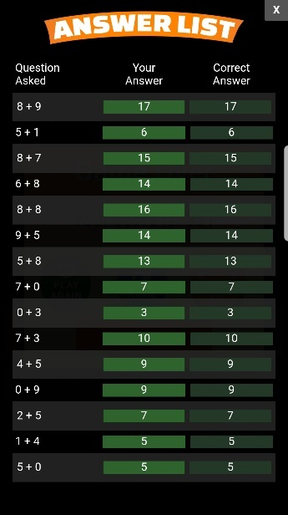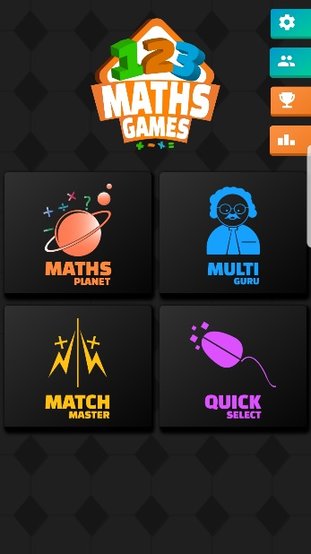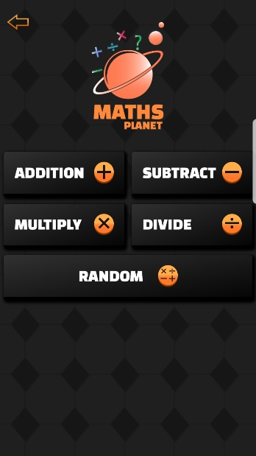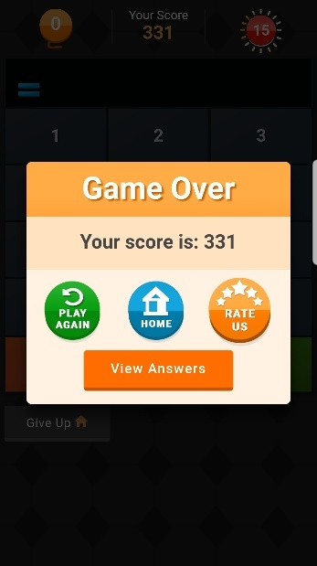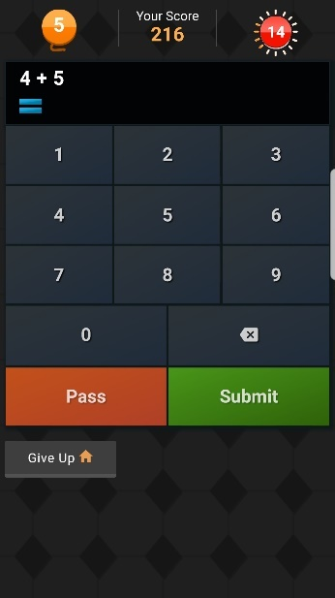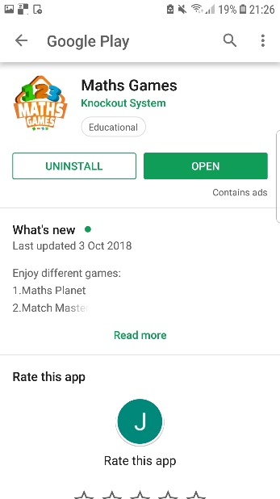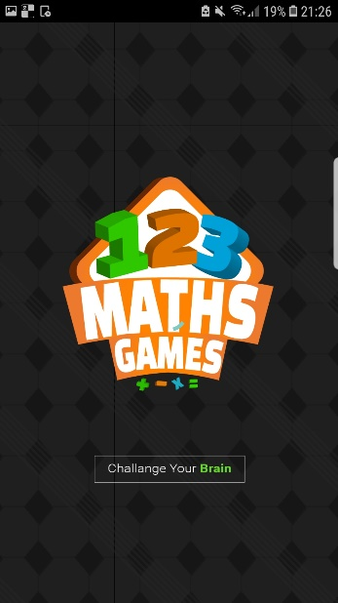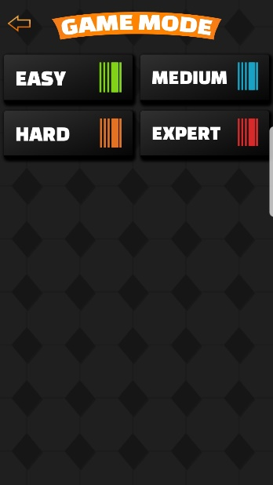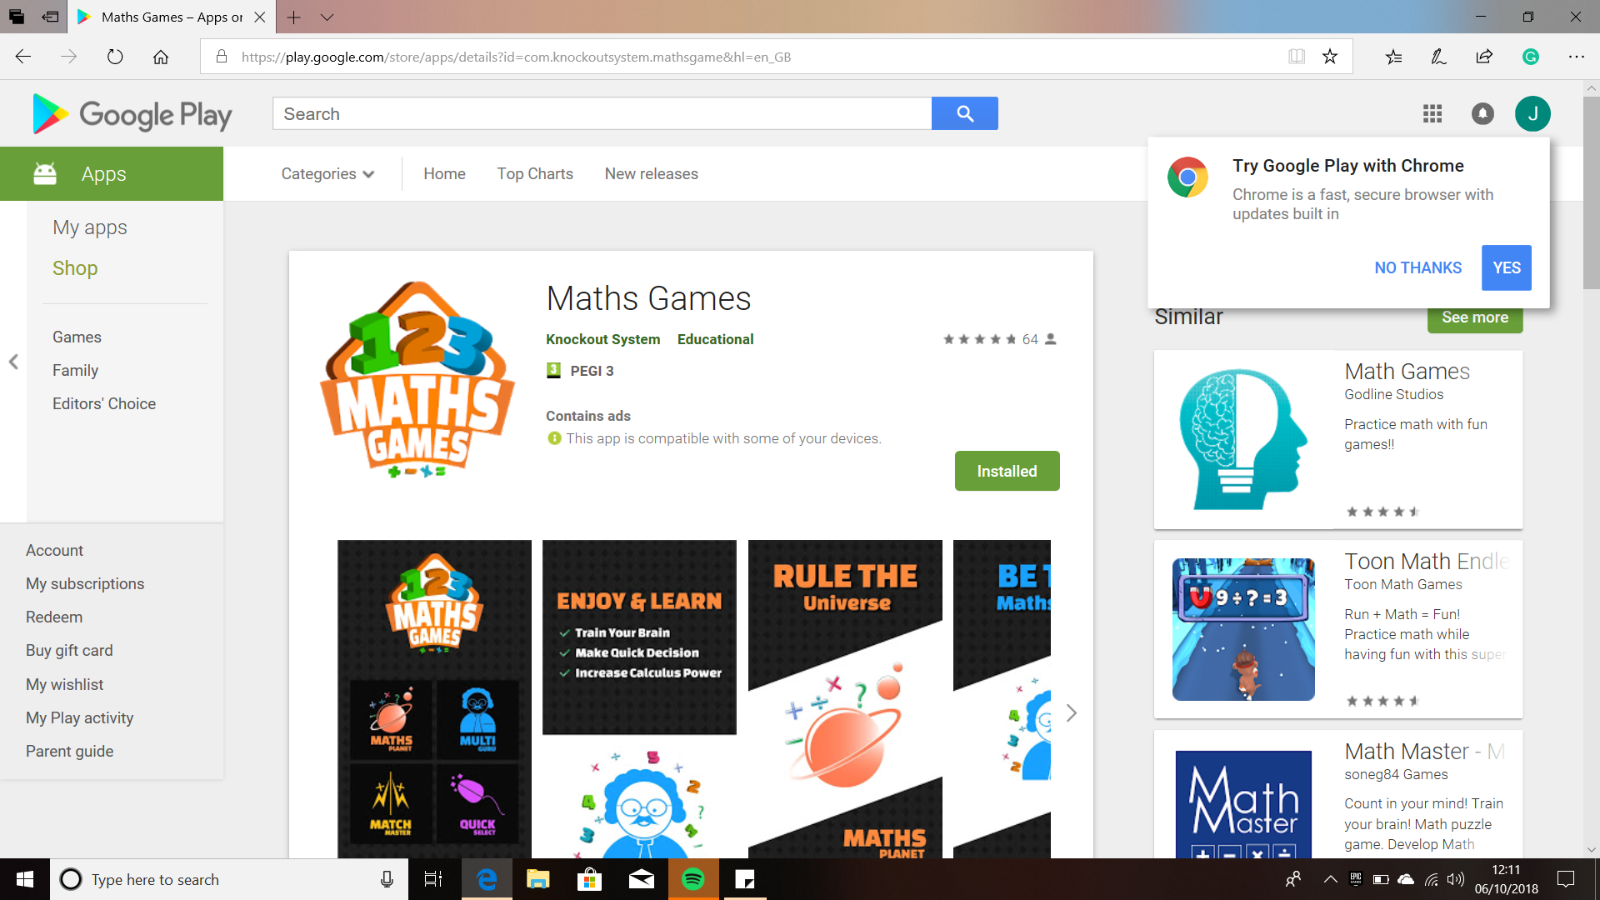**App 1: Maths Games by Knockout System**

**Screenshots**

This Maths game contains 4 different games to learn Maths. The aim of the game is to improve your mathematical skill. It tests your mental Maths skills on addition, subtraction, division and multiplication. In each different game mode, you are tested on how fast your mental Maths skills are, as you have a time limit to answer as many questions you can. Furthermore, each game mode has 4 levels of difficultly that the user can select.

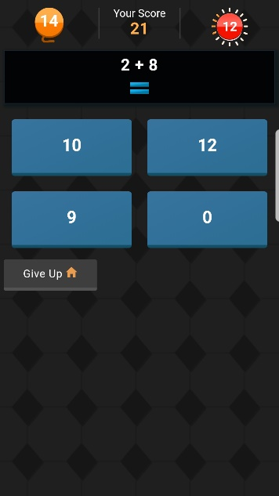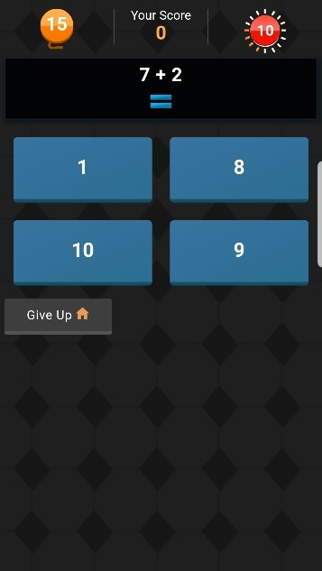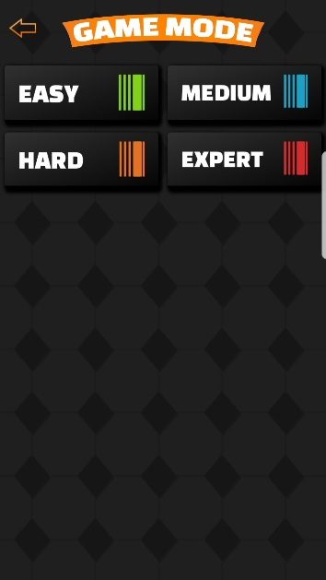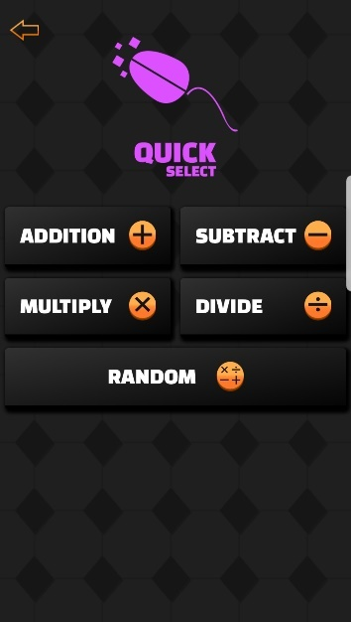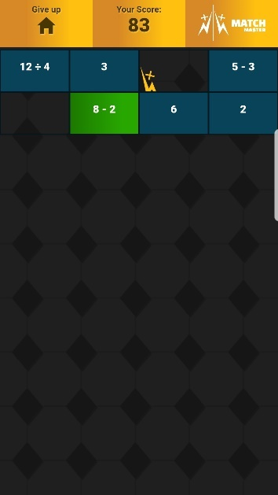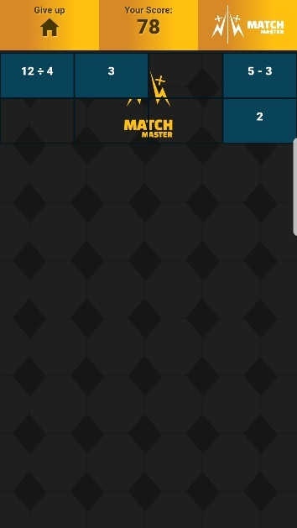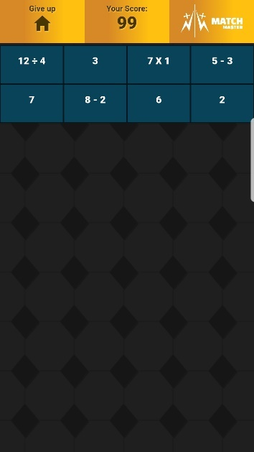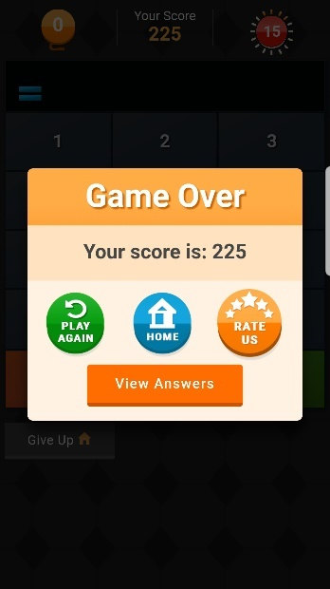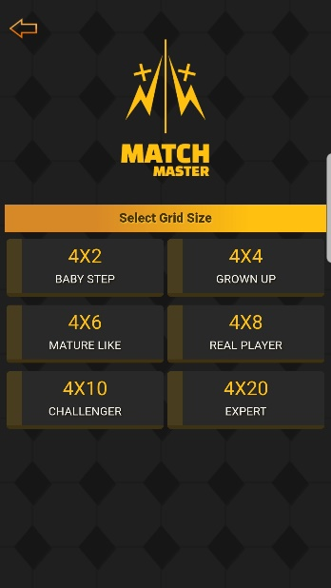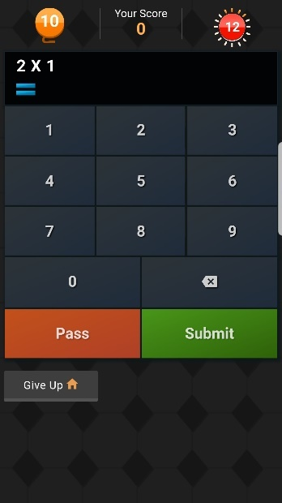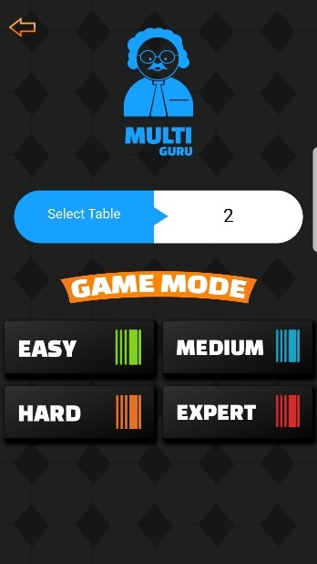

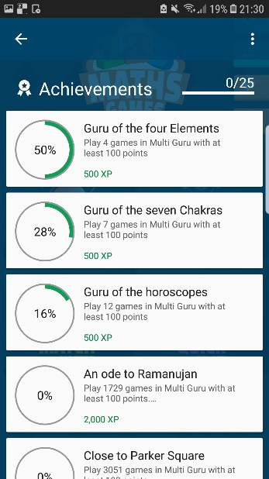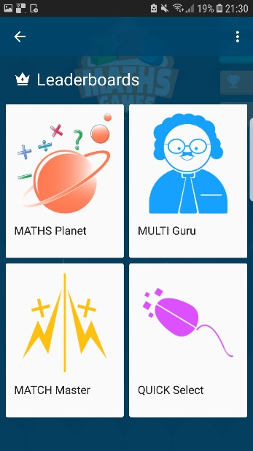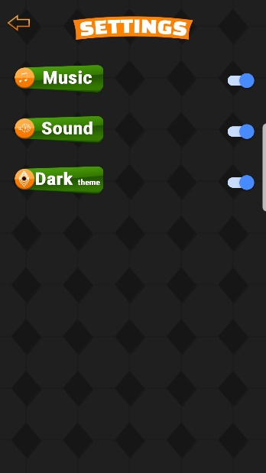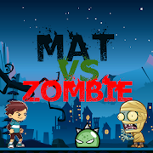**App 2: math game for kid by aprender jugando**

**Analysis of App 1:**

This app has many features that I can take away. The first feature in this game I like is the fact there are different game modes. Having this feature of different ways to learn Maths within one game would mean that my client would not get bored of the game as he would have different ways to learn Maths. This would solve his problem of being active and entertained whilst learning Maths but also, he would be motivated to learn Maths as well.

I also like the fact you can select the difficulty level. Having this sort of feature in my solution would mean my client can first start of easy and slowly, and it would help him get into the game. This is necessary as if the questions are hard from the beginning then he might not be able to enjoy the game and thus give up, therefore having this option means he can learn Maths at his own pace. Also, this would increase his motivation to learn Maths as he would want to try all the difficulty levels.

The game modes also have a time limit and a score tracker. Having this feature within my solution, would help my client work under pressure but also his mental maths skills would improve as he would need to be quick to answer the question. Furthermore, having a score after each round would keep my client active in learning Maths as he would want to beat his high score.

In addition to this, in this game after the user has done a game, the user has the option to view his answers and the questions. Having this in my solution would mean my client can see the questions he got right and wrong, so he can take note and practice the ones he got wrong. This way he can see the areas he is struggling at and keep track of his progress. Also having it marked straight away is a benefit over his current system as he would need to wait for someone to mark it. Therefore, he saves time and will know what to focus on within Maths.

Moreover, this game has achievements that the user can unlock which would motivate the user to play this game and learn and improve their maths. This would benefit my client as he is a competitive person meaning he would want to get all the achievements thus he would want to learn Maths, and this would make it fun for him as well.

This is an action maths game. The aim of the game I to shoot the zombies whilst answering Maths question and see how far you can get in this game you can select what sort of operation you want to practice (addition, subtraction and multiplication). You can also select the difficulty level as well.

**Screenshots**

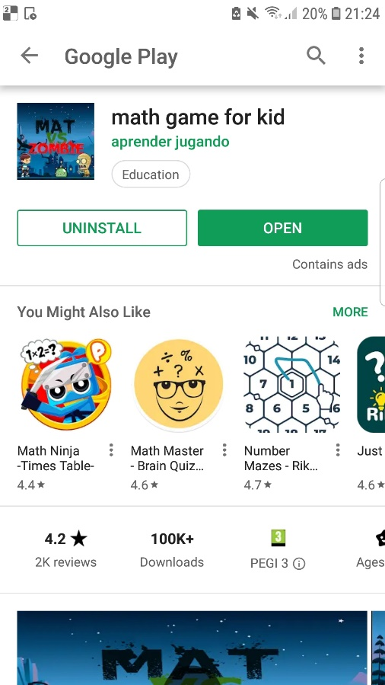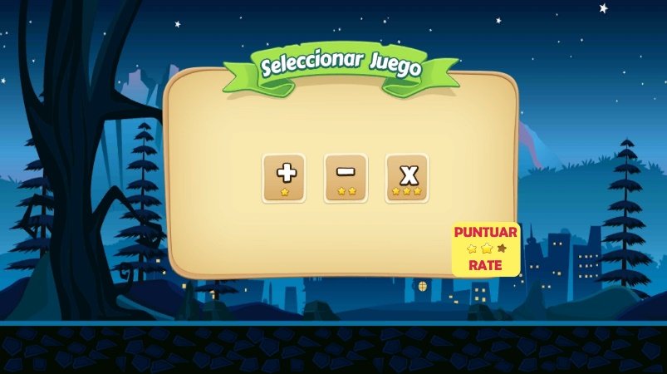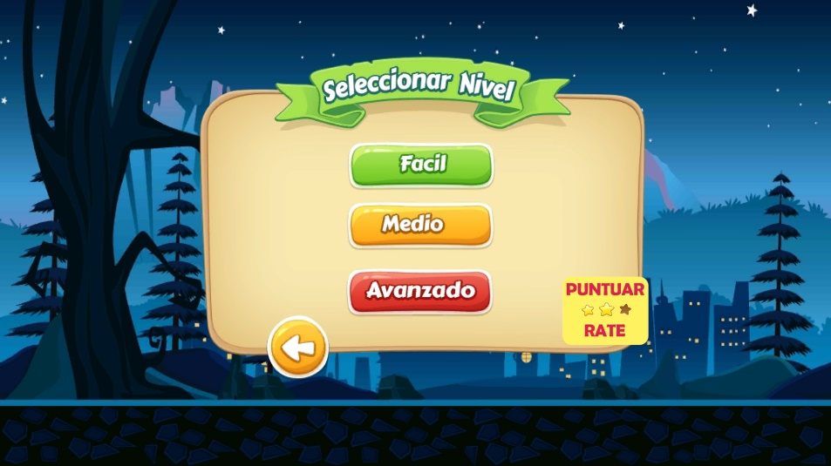

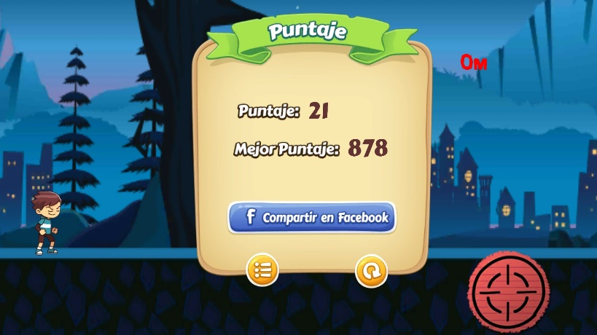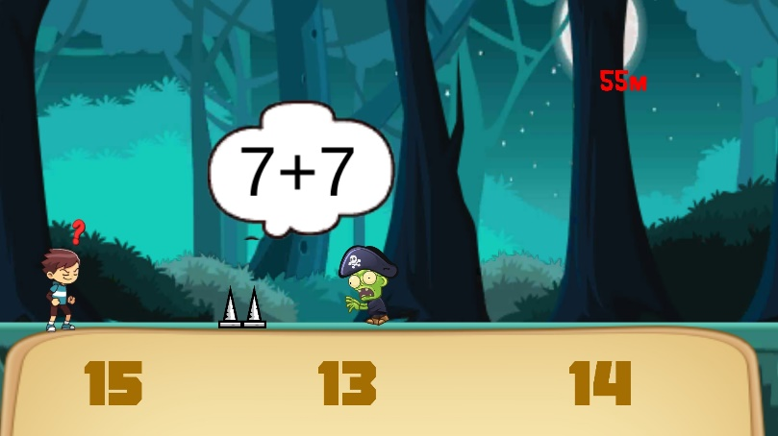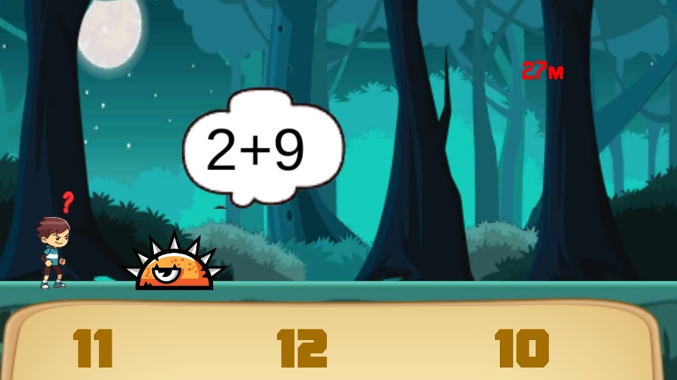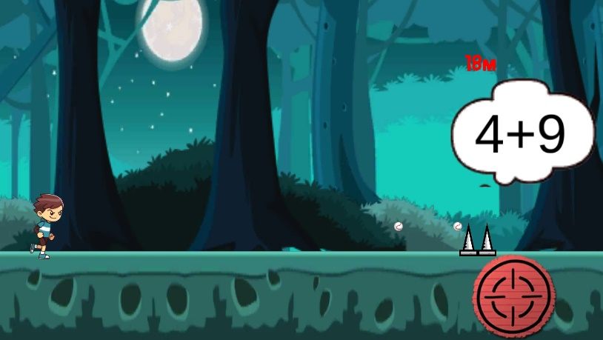

**Analysis of App 2:**

This app is different from the first app. This app is where the user plays the game whilst answering the question. The user is able to shoot the zombies using the red target button. Having a feature which is not related to Maths would benefit my client as if the whole game is based around Maths the client may get fed up or bored with it. Therefore, having an element in my solution not relating to Maths would mean my client does not get bored and has fun whilst playing the game. The colourful appearance would be attractive to my client since he is a visual learner, he would want to play it. This thus makes sure he is using the game so then he can improve his mathematical skills.

This game also has different operations you want to test your skills in and has different difficult levels, therefore he my client would be able to work at his own pace and advance through the game. This makes sure he is challenged throughout the game as he progresses the questions get harder, but he would want to play it as he would find it fun therefore, he would want to improve his maths skills. This increases his motivation to learn maths but also become more active in it as well.

This game is a quick pace game so when the user answers the question from the selection of answer, they need to think fast thus their mental maths skills improve. Having this sort of feature in the game would mean my client becomes more active in learning Maths as he just needs to select the correct answer, but the quick pace of the game would make my client think instantly and select answer. This would improve his maths overall as the maths he does is all mental.

Furthermore, having a score tracker and the score being the distance travelled, would benefit my client as he would want to try and bet his score. But to do this he needs to progress within the game by answering the Maths questions. Therefore, he will need to improve his mathematical skills. This also utilises his competitive side.

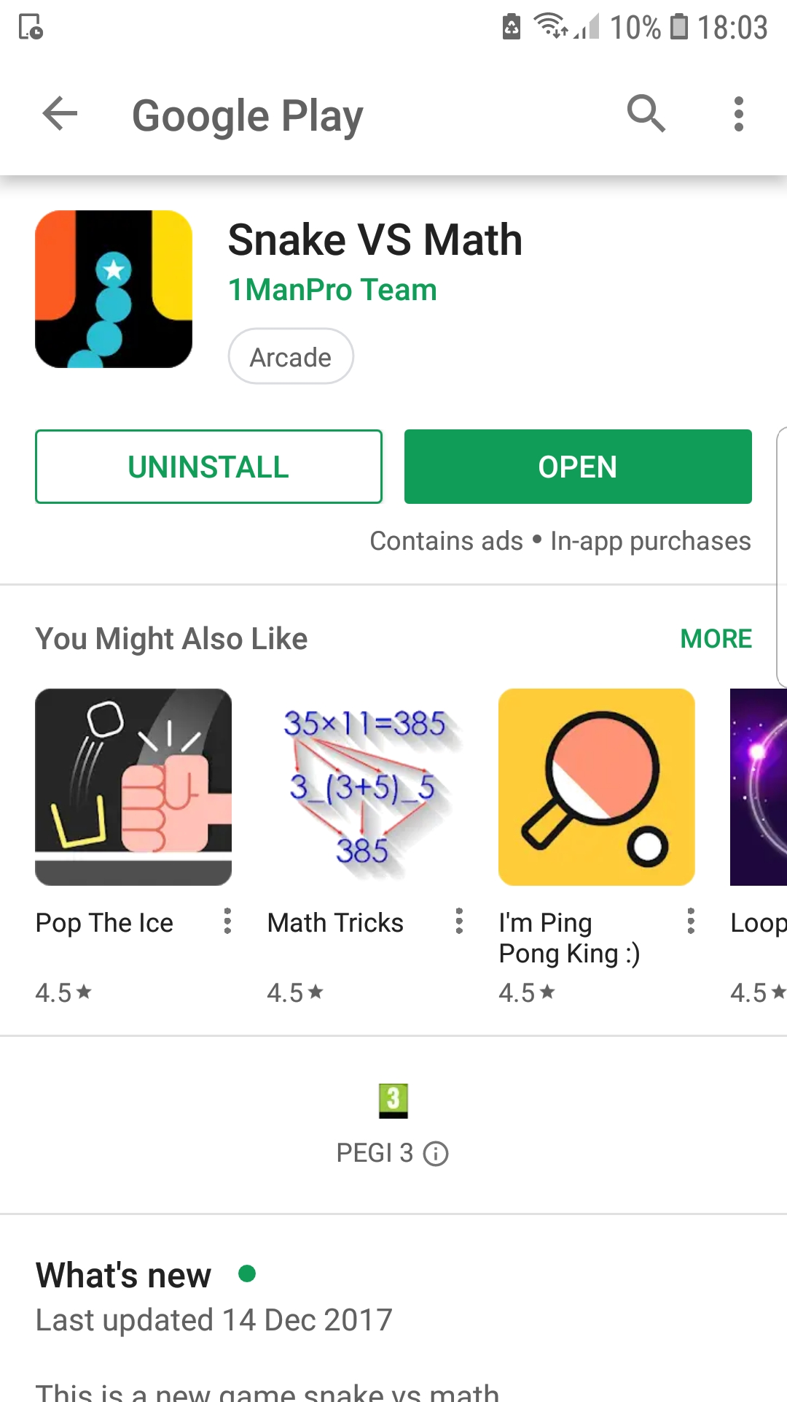**App 3: Snake VS Math by 1ManPro Team**

The aim of this app is to test your mental maths skills in the 4 mathematical operations, addition, subtraction, division and multiplication. The user controls the snake by swiping on the screen with their finger and moves it the equation that make the number in the grey rectangles. The user must do this whilst dodging obstacles and the wrong equations and must move it to the correct equation. If the equation you choose is wrong you lose, if it is right you carry on and you point tally increases. The user is also able to collect starts which add to their points.

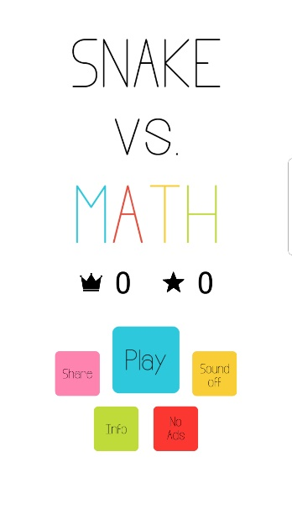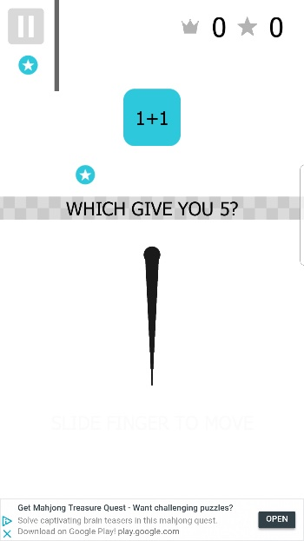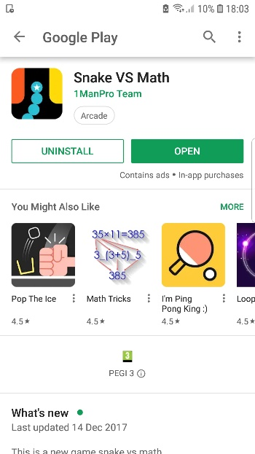

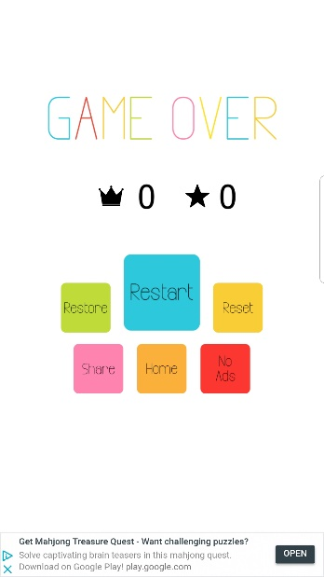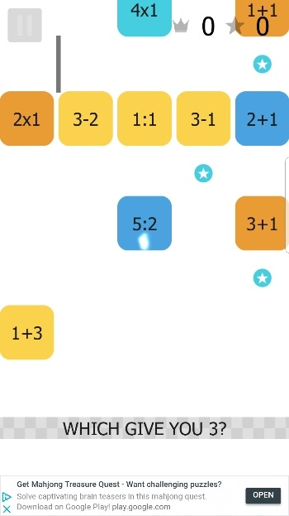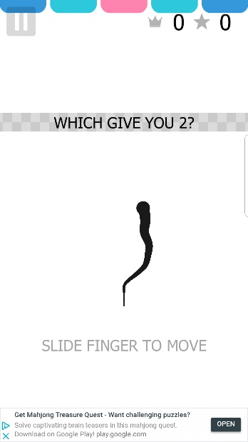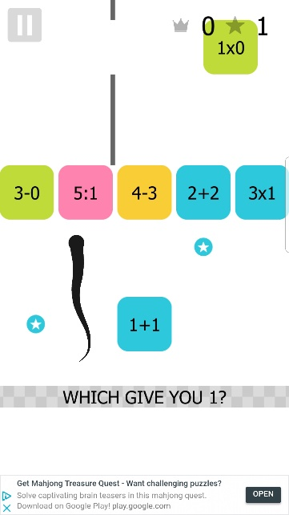

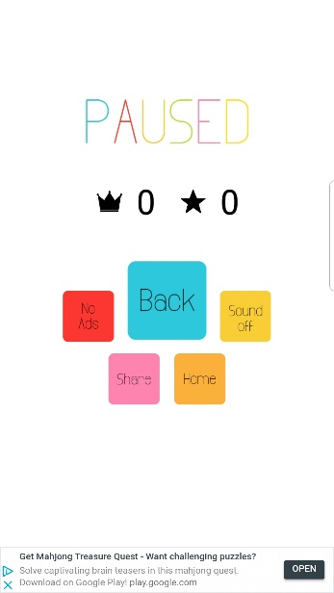

**Analysis of App 3:**

The reason I have research ed this kind of app is because for my solution I want to make a maths snake game.

The features of this game that I can use in my own is that having the blocks they collect being the maths the user is being tested on gives the classic snake game a twist. Having this sort of twist would intrigue my client as it is different to the other games, it is a unique variation of a n all time classic. Furthermore, my client being a game fanatic would love to play this sort of game, therefore he would play it but whilst playing he’d also be improving his mental Maths skills as well.

The functionality of the game is simple as everything is self-explanatory, play button leads to the game, sound off turns off sound, info gives information about the game etc, meaning this is very simple for a 10-year-old boy to understand. The way to control the snake and how to play is simple as well which I can use as I need to make my solution simple enough that my client can understand quickly. Otherwise, if complicated he may not want to play as he does not understand the game.

The colour of this game is a very simple colour scheme however the uses of bright colours makes the game look appealing to the user. Using this sort of colour scheme within my game would help my client stay engage in this game as it would not look plain and boring, helps him in his visual learning and solves on of his problems ‘more colour’.

The way the game works is also very simple, move the snake to the equation that equals to the number in the question. I can use this concept in my own game as I can make the questions and the questions in the box related to conversions. From the interview I have learnt he finds converting fractions into decimals, percentage and vice versa difficult. Therefore, I can change the concept of this game to him answering conversions. Having this sort of game means he can focus on the what he finds difficult more than having a mixture of different types that maybe something he is already good at. Also, this will help him do the conversions more quickly as this game is fast paced.

**Existing Features Summary**

From researching my other programs, I have discovered similarities between each app:

**All apps feature:**

* Bright simple colours
* Easy to navigate menu
* Focuses on a specific area within Maths (these apps focused on the main mathematical operations)
* Some sort of time limit to answer the question
* Score tracker to keep tally of points earned
* Highest score achieved

**Similar features between app 1 & 2:**

* Different levels of difficulty

**Similar features between app 2 & 3:**

* Answering Maths questions whilst playing a game that has nothing to do with maths

Some have features that make it different to the other apps available

**App 1:**

* Different game modes
* Able to view answers to the questions after playing a game
* Unlock achievements

**Features I will incorporate into my solution**

Bright simple colours: this will help my client with his visual learning, and improve his activeness and aesthetic design as well to learn Maths

Different levels of difficulty: The different levels of difficulty will allow him to ease into the game but also give my client a better judgement as to where his skill level in Maths is. Furthermore, this will have work towards a goal that he needs to try and do well enough to do good in the higher levels.

Answering Maths questions whilst playing a game that has nothing to do with Maths. This will solve his problem of motivation and not having fun, as it will not be centred around Maths only, but has another objective and in my solution, this is Snake.

Score tracker to keep tally of points earned and Highest score achieved, this is to utilise his competitive side, so he will want to beat his own score. This will thus further motivate him to play the game thus learning more Maths.

Easy to navigate menu: A simple to use menu will mean each section can be accessed quickly with ease and little effort. No time is wasted for the client and other stakeholders

### **Data Flow Diagram of Current Process**

### **Structure Diagram of Current Process**

**Analysis of Research:**

1. The way his current process starts is he needs to get the papers from his teacher. Therefore, the process starts with the teacher to the first process getting the tests papers, either by printing, photocopying and the papers are handed to the client.
2. The next process is the client answering the questions. He does this at home or in school, answering the questions using pencil and rulers. However, he may find some questions difficult to answer.
3. The third process is my client asking for help on questions. My client asks his parents, teacher and friends for help. Client will receive feedback on how to answer the questions from them.

1. After that the client will finish answering all the questions and get the paper marked. The marking is done by his parents, friends or teacher, and the results of the marking are given back the client

.

1. The client then reflects over what he got wrong or right. What he needs to work on and up level the questions he got wrong as well.
2. The final process is my client storing the papers into a folder, therefore he can access them later. This is so he can go back and reflect on them to help him understand what he did on a question.

From my research I have found out how the problems effect my client first-hand but also what my solution should do to solve them. From my interview I learnt how he doesn’t not like maths and that he is not coping well with the subject. I have also found out what he finds the most difficult area in Maths which is conversions. This information I retrieved helped my research of existing solutions as within the existing solutions each app focused on something specific. Therefore, by researching the existing solutions it helped me understand that I should focus the solution on a specific area. This means I should focus the app on what he needs help on the most, which I found out through my interview, conversions of fractions. Furthermore, from the observation I have learnt his mental maths skills needs improving. By discovering this through my research I can add features to my game that helps him improve his mental maths skills and I can do this by adding the feature of different levels and time limits which I learnt from researching app 1. This means he can improve his mental maths skills at his own pace.

From the questionnaire that the other stakeholders filled in learnt how they know what their son is finding difficult and he is struggling within maths however they do not think it is because of the current system. Furthermore, I know from the survey that they cannot track his progress, as there is no system that tells them in a straightforward manner what he clearly got right or wrong. This is because from my research in current existing system pictures, observation and data flow diagram you see that once the questions have been answered or marked, they are stored into a folder. Then my client will review the answers by taking them out form the folder, but he will not be able to see clearly without looking through them what he got right or wrong, or the answers either. Therefore, I will need to incorporate a way for him and his parents to see clearly what he got wrong or right and be able to view the answer.

From both of my interviews and the survey I have done with my client I have found he loves to play games and he wants to learn Maths whilst playing a game. Due to this I have been thinking about making a more interactive game where the game has another goal other than answering questions. Therefore, I researched App 1 and App 2, as the concept of the games is unique, and the Math side seems like a secondary objective within the game. This leads me to make a game that makes the Maths a secondary objective, which will make sure my client uses the App, as it will not be fully based around Maths thus he can have fun whilst learning Maths.

## **Essential Features**

**Computational Solution:**

My proposed solution to help solve my client’s problem is to create a classic game, snake however I will incorporate Maths into it.

This game will have the same rules as the classic version however the difference here is they will have to answer questions along the way. My solution is a question will appear, and the “foods” that the user needs to collect to make the snake grow will contain the answers. The user must navigate the snake to the “food” containing the correct answer. Once obtained and the answer is correct the score will increase, and the snake will grow. The user will also have a set number of lives so if they get the question wrong, hit the wall they lose a life, once all the lives have been lost the game ends. The user will also be able to select the level of difficulty, so higher the difficulty level the harder the questions are. The user will also be able to view their progress, so see how many times they got a question wrong or right, and the answer to it as well.

**Features within my solution:**

The main feature I have taken away from one of the existing solutions I researched was App 3: Snake vs Math. I got concept of my game from this app as to how the questions appears and the answer is within the things they must collect. Having this sort of feature within my solution will benefit my client as this is effectively like an multi choice question where he will need to pick an answer from a group of answers. This will benefit him as once he works out an answer to the question, he will able to check if that answer is available within the answers available. This is improving his mental maths skills as he must quickly select an answer to increase his score, but also helping him with multiple-choice questions and he is also able to check whether he is right or wrong on his own, by checking if the answer he came up with is there or not.

From the existing solutions I have researched I have taken away the ability to select the level of difficulty. In my solution I will have the same difficulty levels that were in the existing apps, 1 & 2. In my solution, my client will select the difficulty which doesn’t affect the game but difficulty of the questions. This will help my client slowing improve his ability to answer different types of questions and improve his mental maths skills at his own pace. This will help him judge as to how good his skills are and when to move on to the next level. My client will be able to track his progress as he can see his skills improving knowing as to which level he is at.

This brings me to my third feature which is tracking his progress. From App 1 I have taken away how he can see the questions he got right or wrong after a game. However, in my solution I will program a section on the main menu, so he can easily view a tally for each question as to how many times he got question right or wrong. Furthermore, he will be able to view the answer as well. This will solve his problem of not being able to keep track efficiently with his current system as to what he needs to work on. Through this he and his parents will be able to see which questions he does not need help on but also which ones he keeps getting wrong, so they can help him on that.

My fourth feature is the score system. All the apps I have researched have a scoring system when the user is playing the game and when they have achieved the highest score it will display that as a high score. Having this sort of system will motivate my client to play the game as he would want to beat his own high score. Furthermore, this will bring out his completive side thus making him play the game and this would allow him to have fun as well trying to beat himself.

The final feature I took from my research was the simplicity of the navigation menu. The navigation menu is very simple in all the designs, as they each have meaningful labels and you don’t need to go looking for anything as you can access everything from the main menu with one or two clicks. Furthermore, I need to have these kind of main menu as it needs to be simple and straightforward enough for my client who is a 10-year-old boy. My solution needs to have a simple navigation system that take him to the game after one or two clicks as people at his age may not have the patience.

One feature I have added to my solution that was not in any of the apps I researched is having lives. The reason I have added lives was because of who my client is, a 10-year-old boy. This influence me to add this feature as since his skills within Maths are not good, he may get the question wrong and thus the game ends. This may make him give up on the game but also decrease his motivation further. Therefore, I decided to add lives so if he makes a mistake, he will have more chances, so he will not give up on the game.

## **Limitations to Solution**

**The limitations to my solution are the following:**

* Limited amount of time
* Detail of the graphics
* User’s Device
* Programming Skills

Having limited amount of time, means I may not have enough time to add in all the features into the game. Having a small-time scale would mean I would need to take lots of shortcuts and cut features out as I may not have enough time to program them. Having a short amount of time means I must choose what features I should program first and sacrifice some features. For example, the main attraction of this game is the will be the priority to design first, the snake, and the user being able to answer questions. This means, I may have to sacrifice features like life tracker because of the time scale most of my time will go into designing this, which means I may not have enough tie to design other features like life tracker. Furthermore, I need to keep a set amount of time to test each feature and fixing each bug shorting the time scale for programming the features further.

Another limitation to my solution is the detail of the graphics. For the game I will be using very simple designs. For example, I will be using simple shapes like squares ro circles, with different colours for the snake. This would mean the graphics of the game may not be too appealing, due to the time-scale and the programming techniques I will be using. The aesthetic of the design may not be what my client would want, considering he plays games with high quality graphics, putting him off the game.

I will be programming the app on PC, and I will be testing the app on PC most of the time. Therefore, this limits the solutions being the most effective as this game will be played by the client on different platforms. My client wants this app on his PC which has a completely different software and hardware to what I will designing it on therefore, some features may not work as intended.

My programming skills will also be limited as this will be my first experience using this type of programming technique and designing this sort of system. This will limit the app design as it may not be exactly what the client and I expected due to the fact I do not have enough knowledge or experience in this sort of technique. Some features will not look as pleasant or work as I intended to as the programming techniques will be fixed to a certain degree. I will not be able to edit everything as I pleased.

## **Hardware Requirements**

* A PC
* Keyboard and Mouse or Touchscreen
* Monitor
* Hard Disk Space (Minimum 1 GB)
* Minimum 2 GB RAM
* CPU (Intel Core i5 processor or equivalent alternative)

|  |  |
| --- | --- |
| Hardware Requirements | Reasons Why |
| PC | Device required to play the game |
| Keyboard and Mouse or Touchscreen | Allows user to interact with the game, click buttons, move snake, select options |
| Monitor | The user can view the interface: buttons, colours, gameplay |
| Hard Disk Space (Minimum 1 GB) | Memory required to download the software needed to access and play the game |
| Minimum 2 GB RAM | Memory to run the application efficiently, and to play with out problems, no freezing when playing |
| CPU (Intel Core i5 processor or equivalent alternative) | This is required so the game runs fast, the appropriate software to play the game can be accessed without any problems and runs efficiently |

## **Software Requirements**

* Operating System: Windows 7 (Minimum Requirement)
* Web Browser
* Installer

|  |  |
| --- | --- |
| Software Requirements | Reasons Why |
| Operating System: Windows 7 (Minimum Requirement) | This is so the program used to make the game and run the game are supported by the OS otherwise the game cannot be played |
| Web Browser | Required to download the necessary software and tools onto the device |
| Installer | Software needed to install the files/software, or run the exe file on the client’s device |

## **Success Criteria**

|  |  |  |  |  |
| --- | --- | --- | --- | --- |
| **Criteria** | **Justification** | **Requirements** | **Comments** | **Yes/No** |
| App | From my interview I found out he wants it available as an app | Downloadable and playable as an app |  |  |
| Screen Size | The game screen size will be a set size, so it can be playable on all monitor sizes | The game needs to be a reasonable size, the size will be set to 800x600 | The game window will not be adjustable |  |
| Title | Each section within the game needs to have a clear title to tell the user what that section is about | The title needs to show up on every section, at the top, large size and with high contrast colours |  |  |
| Easy Navigation | The app needs to have an easy navigation for the client to access every section with ease | Large, bright coloured buttons with clear labels |  |  |
| Back-Button | The game needs to have a back-button on every page, that allows the user to go back to the Main Menu, to access other areas within the game | The button needs to be a unique colour which stands out from all the other buttons, and in a noticeable location |  |  |
| Main Menu | There needs to be a main menu, so the user can access all the areas within the app, with the use of buttons | The Main Menu needs to be the first section the user accesses. It should contain the buttons, Play, Progress, How to Play, High Score and Exit | The Play button should stand out the most |  |
| Play Button | The Play button starts off the process to the actual game, leads the user to the next section | The Play button needs to lead the user to Select Difficulty Level Menu |  |  |
| Select Difficulty Level | This section will take the user to a section where they can access the 3 different levels, which will change the difficult of the questions | This section needs to contain the following buttons: Easy, Medium and Hard which should be colour coded for easy access | Easy: Green  Medium: Orange  Hard: Red |  |
| Gameplay | The user then actually plays the game, where the client plays snake whilst answering the question | The actual gameplay should contain the snake game, questions and answers, score tracker life tracker |  |  |
| Snake | The snake is the main attraction of the game, what the user will control the snake to eat the food | The Snake needs to move at a constant speed  The user needs to be able to control the snake using the control keys (Arrows Keys) |  |  |
| Question | The purpose of the game is to help my client with Maths, which is why there needs to be a Maths question that the client will need to answer to progress through the game | The question needs to pop out in a new window with an entry box and a way to submit the answer |  |  |
| Answers | The questions will be answered through the entry box in the new window. | Once the answer has been entered there needs to be a way for the user to submit the answer |  |  |
| Score Tracker | The score tracker is necessary, so the user can keep tracker of his score, and can compete against himself motivating the client to play the game | The score tracker needs to be on the left, and increases when the answer is correct |  |  |
| Life Tracker | This is needed so the user doesn’t get fed up as a life tracker means the client has more chances | The Life Tracker Position will be on left. The life will go down if the answer is wrong or if the body collides |  |  |
| Game Over | This will tell the user when the game is over, in other words when the game is finished | The game will be finished when life = 0. A message with Game Over will appear giving 2 options Play Again or Home |  |  |
| Progress | This is one of the main features where my client and other stakeholders will be able to see clearly which question, he is getting right or wrong | This section will contain a table that has question, how many times you got it right and wrong and answer within a table. Headings table should contain: Question, Right, Wrong and Answer  Able to scroll down to see every question |  |  |
| How to Play | This is needed to tell my client how to play the game and how to use the other features within the app | Section called Instructions, of what the user needs to do (aim of the game)  Section to explain what the Progress page displays, and how to use it  Section called Controls, informs the user on how to control the snake and image of the controls |  |  |
| High Score | This is so my client can see his past scores, as how much better he is doing previously, another way he can see his progress | List of High Score  High Score list is displayed for each difficulty level  Show the 5 last high scores |  |  |
| Exit | Exit so my client can close the game down with no problem | Option for Yes and No  Yes, Game closes down  No take you back to Main Menu |  |  |
| Colours and Font | This is needed so the game aesthetics appeals to my client | Background: White  Title foreground and background: Red and Black respectively  Button: Symbolic or High Contrast colours  Snake and ‘Foods’: Red and Green respectively  Font: Fixedsys |  |  |

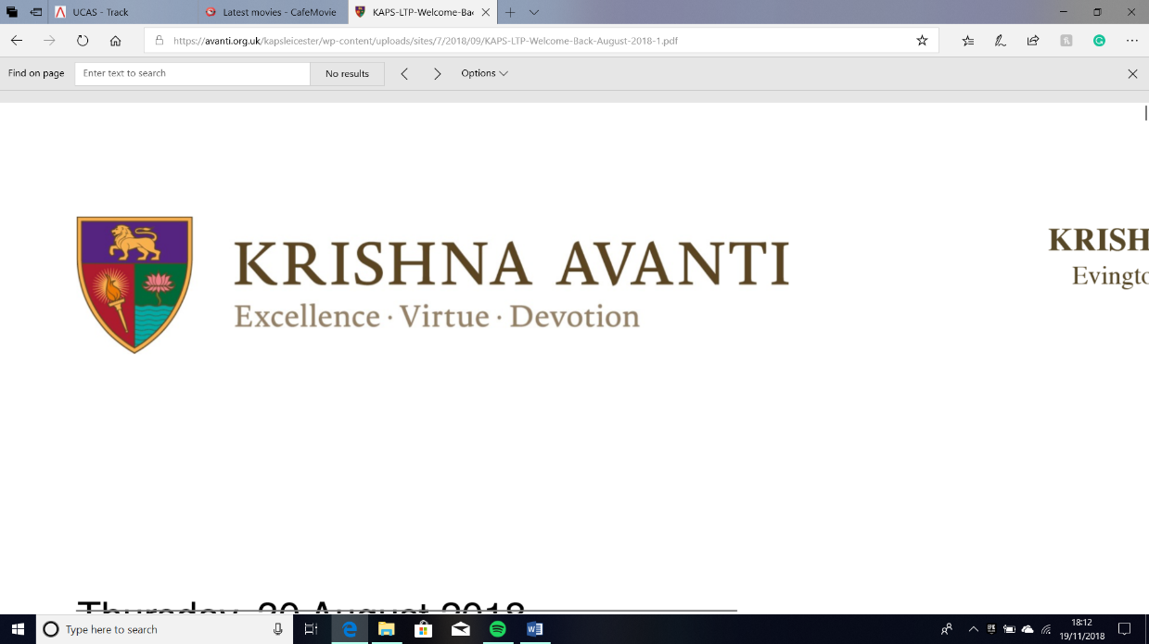**KRISHNA AVANTI PRIMARY SCHOOL**

Evington Hall, Spencefield Lane, Leicester, LE5 6HN

Telephone: 0116 241 9880

Twitter: @KirshnaAvantiPS

Email: kapsleicester@avanti.org,uk

Website: www.avanti.org.uk/kapsleicester

Principal: Denham Kite B,Ed (Hons)

**Requirements Document**

* App is clicked on, should open to Main Menu automatically ***(5 secs)***
* Click Play from Main Menu, menu to select difficulty level ***(2 secs)***
* Difficulty Level is selected, takes user to game ***(2 secs)***
* User uses controls to move snake ***(response time 0.5 secs)***
* When question is answered correctly ***(Question closes within 1 sec)***
* Score should go up ***(1 secs)***
* Life goes down when answer is wrong ***(1 sec)***
* When life goes to zero, a pop-up screen called Game Over should appear ***(2 secs)***
* If Play Again, is press take it back to Select Difficulty menu ***(2 secs)***
* Otherwise Main Menu, Home is pressed ***(2 secs)***
* Click Progress from Main Menu, a table of his progress should appear, Questions, amount of times a question was answered right or wrong and answers ***(2 secs)***
* Scroll down to see more questions ***(0.5 secs)***
* Home button click, navigates back to Main Menu ***(2 secs****)*
* Click How to Play from Main Menu, Instructions, Controls, and other areas of the app should appear ***(2 secs)***
* Home button click, navigates back to Main Menu *(****2 secs)***
* Click High Score from Main Menu, list of top 5 high scores for each difficulty level should appear ***(2 secs)***
* Home button click, navigates back to Main Menu ***(2 secs)***
* Click Exit from Main Menu, Option Yes or No should be available ***(2 secs)***
* If Yes is pressed, then game closes ***(4 secs)***
* If No is pressed, returns to Main Menu ***(2 secs)***

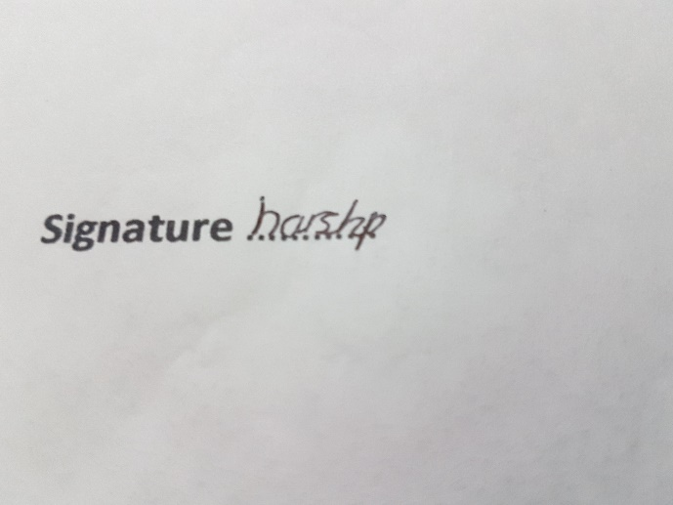

**Signature** ………… **Date**……………

# **Design**

## **Decompose the Problem**

The problem with the current system is the following: boring, not visually pleasing, difficult to keep track of progress, not active enough and lack of motivation.

The system being boring means my client is not able to engage within Maths, as he would not find it interesting to learn Maths. Furthermore, with the current system he does not find Maths enjoyable meaning he loses interest as it is not fun, thus not learning Maths. This sort of problem can easily be solved by a computational approach as I can program a game. I can code a game with Maths incorporated into it, thus he would be able to play a game which he fully enjoys but simultaneously learn Maths.

The current system is also not visually pleasing, as he currently answers questions that are black and white, very plain, which is not attractive to a 10-year-old boy. This is not effective for him as he is a visual learner, so he finds it difficult to absorb the content in as well. This is suitable for a computational solution as within the game, I’ll be designing, I can incorporate lots of colours freely available within the programming language. I can use this to colour the game with bright colours which will appeal to the client, but I can also use them to colour code sections for easier recognition. I can also easily put in images into the game to help my client in his visual learning but also make it more interesting and pleasing to look at.

The next problem is my client not being active enough when learning Maths. My client is an active learner, so he will absorb the learning through doing something active and fun, however the current system does not meet these criteria. Therefore, the problem would be fixed through a computational solution as creating a game will keep him entertained thus active into learning Maths.

Progress tracking is a major problem my client and my other stakeholders have. The current system is all paper based and stored within a file with no organisation making it difficult for my stakeholders to see what my client is getting right or wrong. The problem with this is he may be getting help on areas he doesn’t need. A computational solution is perfect to solve this as I can use file manipulation and databases to store data on the questions he gets right or wrong within the game and then display them in a section within the game for easy access.

All of this would solve his lack of motivation as a game to learn Maths is something that is suitable for the client but also something, he is familiar with it so he would want to play the game thus learning the content in Maths.

## **A screen shot of a building Description automatically generatedGantt Chart**

Implemtation

Evaluation

Design

Analysis

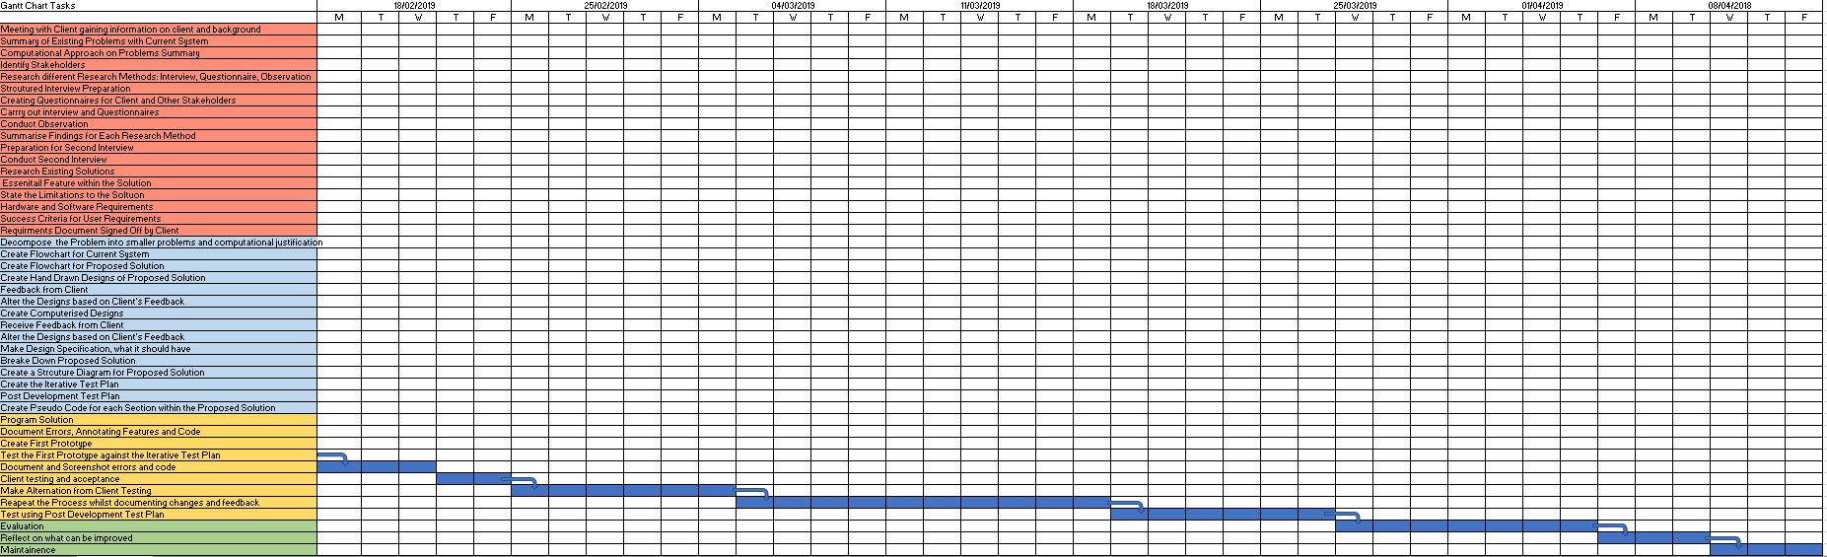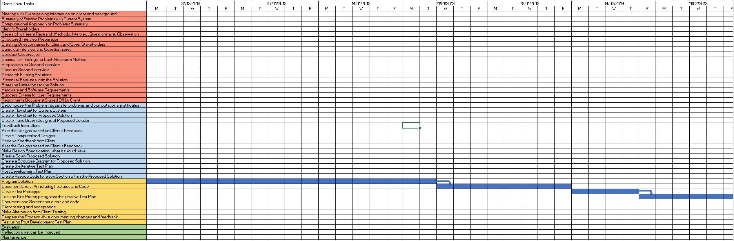

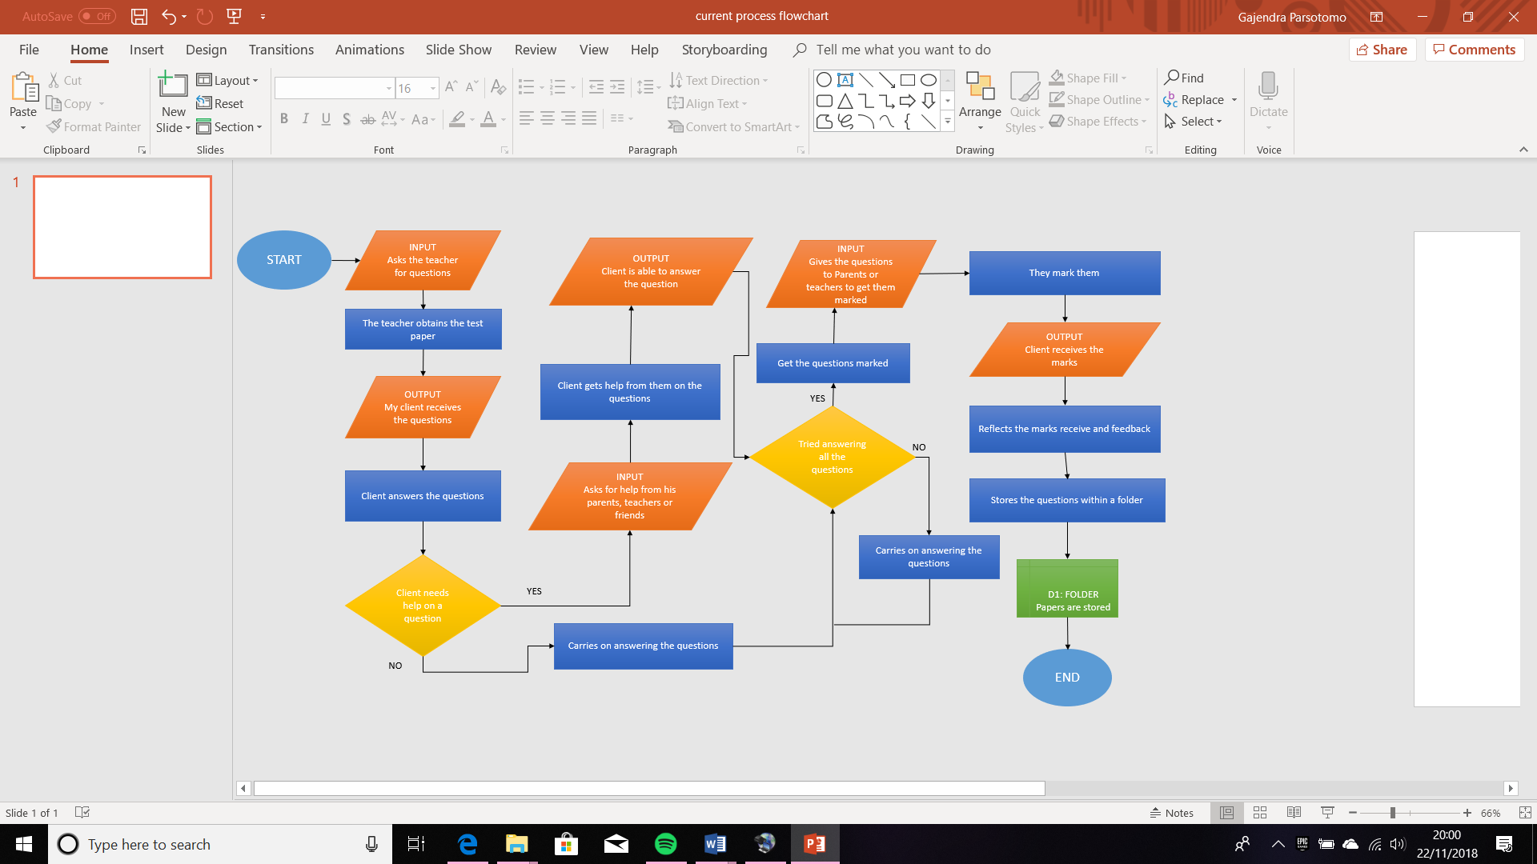

## **Flowchart for Current System**

## **Flowchart for Proposed Solution**

## **A close up of a map Description automatically generatedDFD for Current System**

## **A close up of text on a white background Description automatically generatedDFD for Proposed System**

## **Usability Feature**

The features that my user will need within the program are: tracking progress, a playable game with a way to answer Maths questions, simple navigation, life tracker and high score list.

The program needs a fun game for the user to play whilst answering Maths questions. The main problem that my client has he finds Maths boring. This feature will solve it as he will be learning Maths whilst having fun, which is when he learns the best. Therefore, this needs to be a necessary feature as he needs this, so he can become successful at Maths.

Tracking Progress will be a necessary feature for the user to use, as this is one of his main problems which is not able to keep track. Therefore, creating a section that is dedicated to keep track of the number of times my client gets an answer right or wrong makes it easier to see what he needs to work on. This is a feature the program will so my stakeholders can see the progress clearly.

A Simple Navigation for the program. This is a needed feature for the user to navigate to the areas that he wants to go to quickly and efficiently. There needs to be a main menu that can be used to access every area within the program, and each button and area needs labels that clearly tell the user what it is for. This is so since he is 10-years-old he can get frustrated easily, so if he doesn’t find the game straight away, he may give up, therefore it needs to be straightforward way to the game.

A life tracker is needed since my client is a 10-years-old. This feature is needed so my client doesn’t get fed up of the game. This is because if he gets a question wrong but loses straight away, he would get frustrated and this would demotivate him further into learning Maths. However, a life tracker counteracts this as he has more chances to get the answer thus, he has more likely chance of learning Maths and the motivation to learn it increases.

A high score list will encourage and motivate my client to play the game thus learns Maths quickly. Within the High Score section, I will have a top 5 high score list for each difficulty level therefore it will motivate him to beat his high score, as he is a competitive person. From the list he’ll be able to see his improvement and see how well he does in each level.

## **User Interface**

### **A close up of text on a white background Description automatically generatedA close up of text on a white background Description automatically generatedA close up of text on a white background Description automatically generatedA close up of text on a white background Description automatically generatedA close up of text on a white background Description automatically generatedA close up of text on a white background Description automatically generatedUser Interface Hand Drawn Sketches**

### **First Design**

Using my hand drawn sketches of the user interface I created the first computerised version of the User Interface

**When the App is opened:**

First computerised design of the Main Menu developed by the sketches approved by the client. Main Menu is displaying the title of the game and the 5 main buttons the user needs.

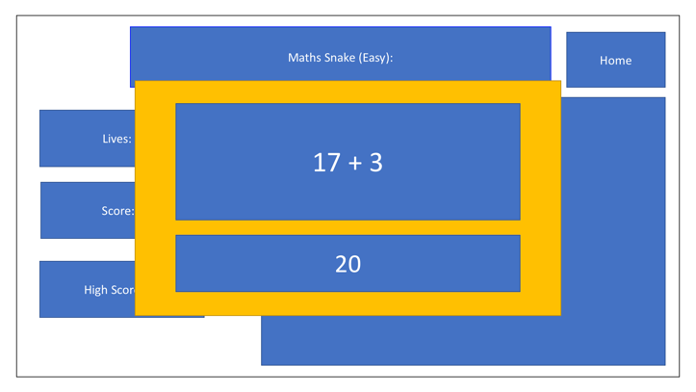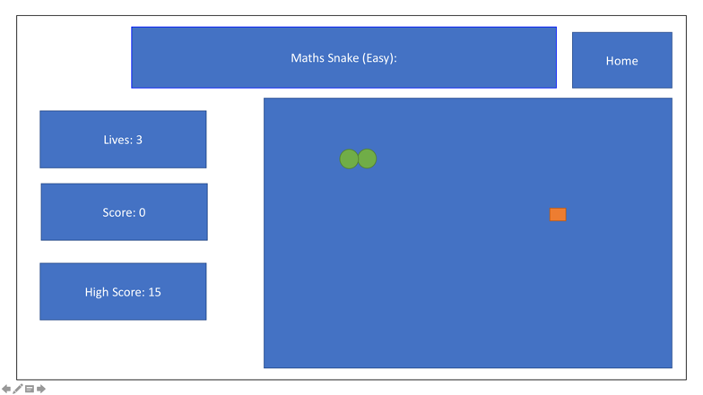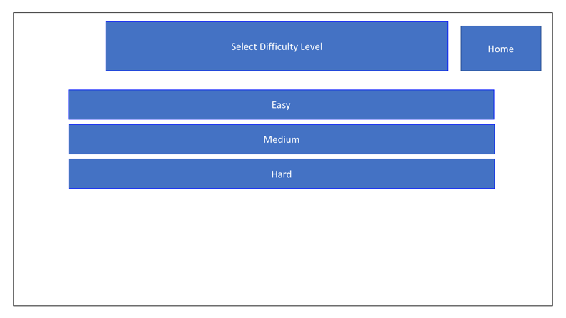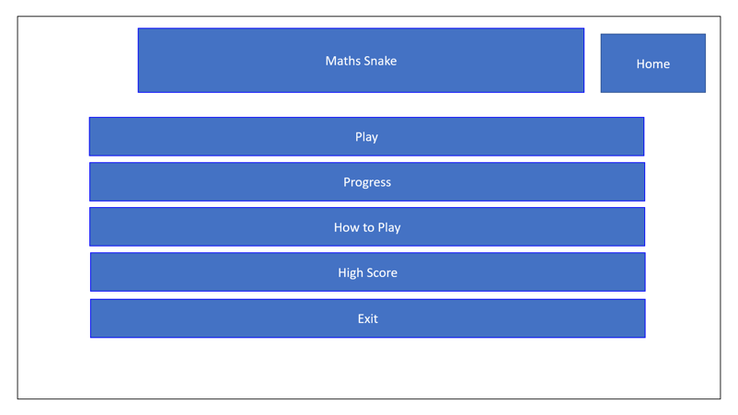

**Food Eaten:**

When the snake eats the food the question should appear in a pop-up with an entry box.

**Level Selected:**

When the level is selected the game should appear. The trackers on the left side and the game play on the other side.

**Play Button:**

When the play button is clicked, the user should be directed to the Select Difficulty Level Section. Display the three levels, Easy, Medium and Hard.

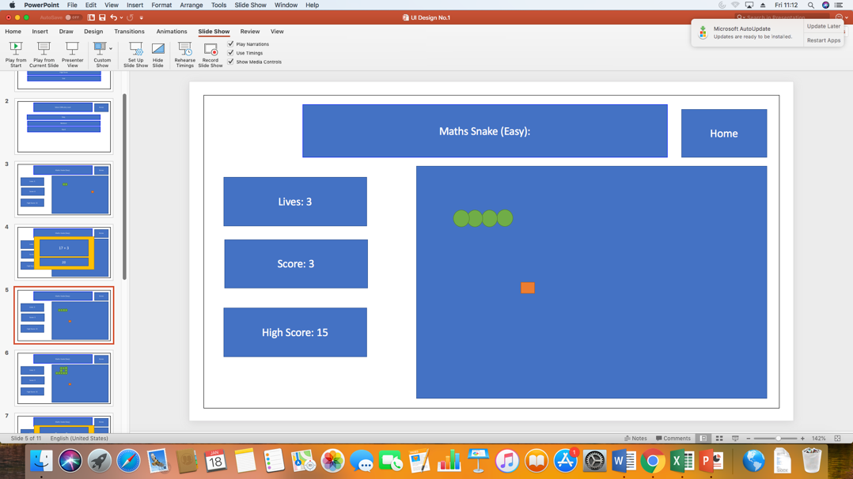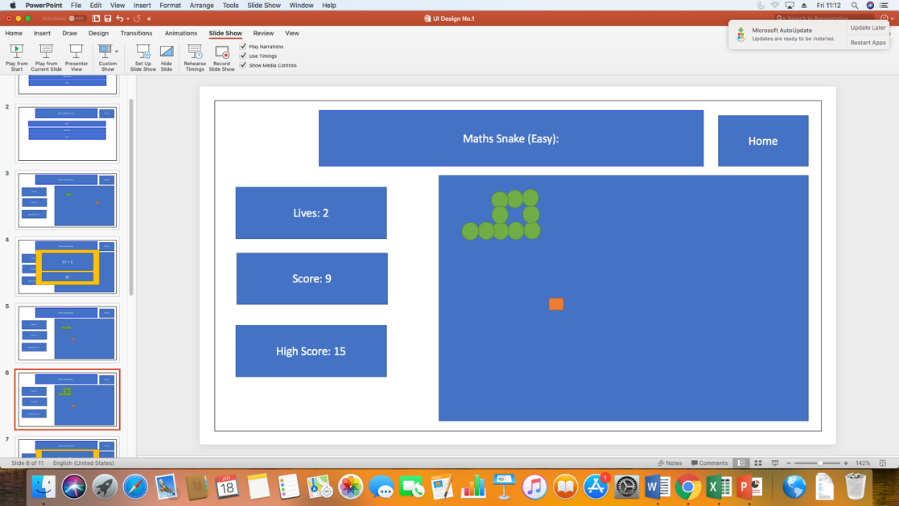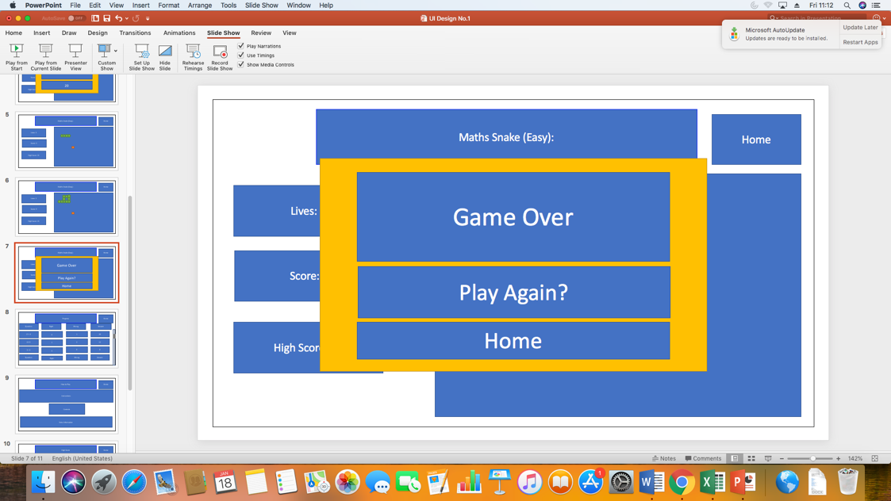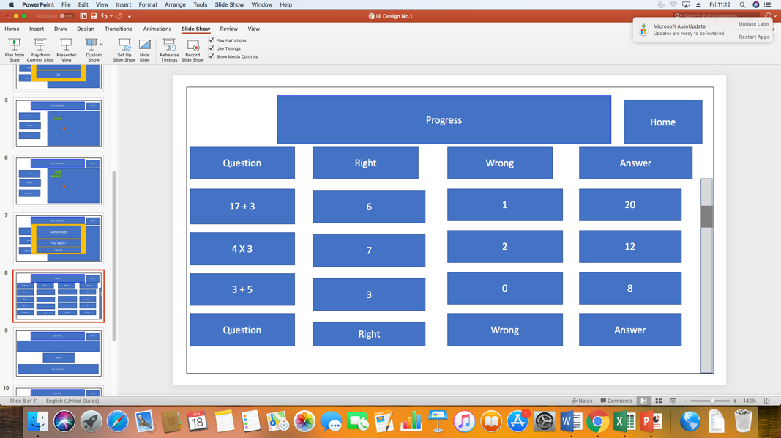

**Correct Answer:**

If the answer to the question was correct, the snake should grow and the score should increase. A new food should also appear.

**Incorrect Answer/Snake Ate Itself:**

If the answer to the question was incorrect or the snake ate itself the number of lives should decrease by one and the score should not increase.

**Progress Tracker:**

A table to track the progress with the headings Question, Right, Wrong and Answer should appear. Underneath should be the tracker relating to each question. A scrollbar to view all the questions should appear.

**Lives reach 0:**

If the number of lives reach zero, then a pop-up message with Game Over written should appear. With it, 2 options Play Again and Home.

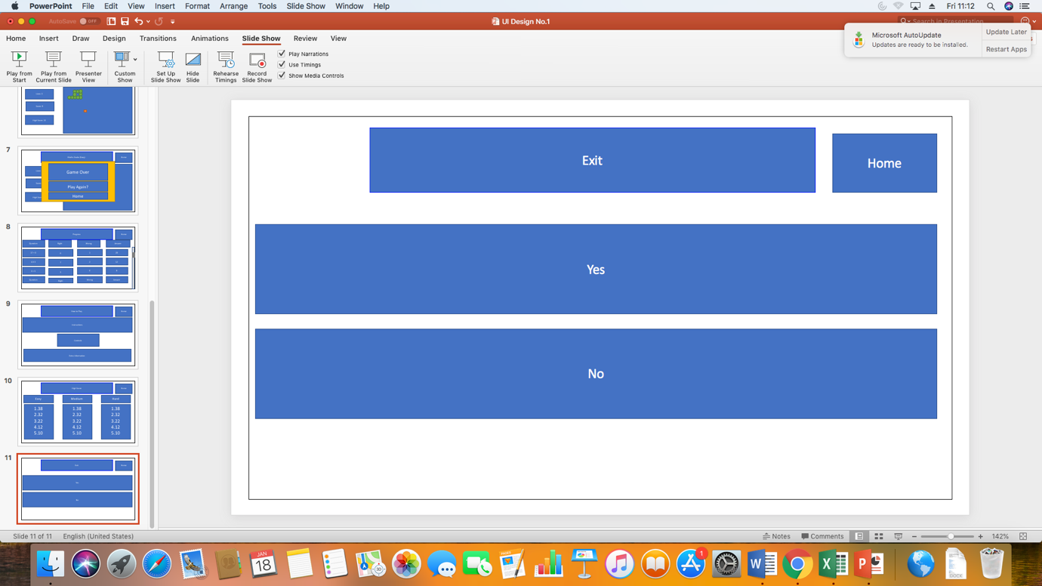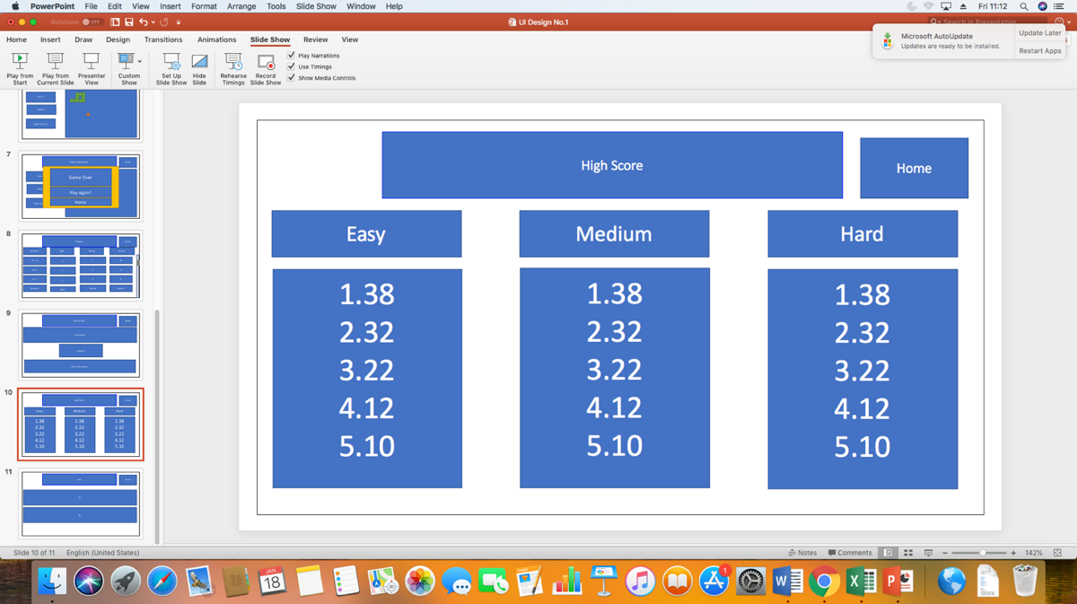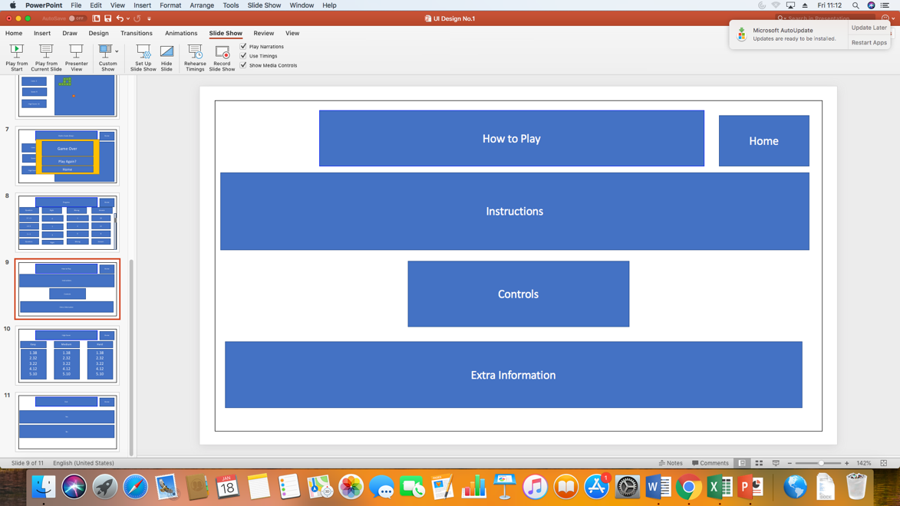

**High Score:**

Top 5 high scores for each level under each heading.

**How to Play:**

This section should have three sub-sections. Instructions, Controls and Extra information, how to use the progress table.

**Exit:**

Exit should have 2 options, Yes and No.

### **User Feedback on First Design**

**Pros:**

* I like that it has all the features that I want
* The Buttons are in the order I like, keep like that
* How to Play has all the information I will need
* The format of how high scores is laid out is good, no changes needed
* I like how the questions pop up in a new window

**Cons:**

* Change the layout of the interface so the Home button is on the left side and all the content is on the right side of the screen
* I want to change the shape of the snake and food, so the snake is squares and the food are circles
* I don’t want it to say game over once I lose all my lives
* Progress to be more of a table format
* Have the tracker number underneath the title, current score underneath the Score

**KRISHNA AVANTI PRIMARY SCHOOL**

Evington Hall, Spencefield Lane, Leicester, LE5 6HN

Telephone: 0116 241 9880

Twitter: @KirshnaAvantiPS

Email: kapsleicester@avanti.org,uk

Website: www.avanti.org.uk/kapsleicester

Principal: Denham Kite B,Ed (Hons)

**User Feedback Agreement**

**Pros:**

* I like that it has all the features that I want
* The Buttons are in the order I like, keep like that
* How to Play has all the information I will need
* The format of how high scores is laid out is good, no changes needed
* I like how the questions pop up in a new window

**Cons:**

* Change the layout of the interface so the Home button is on the left side and all the content is on the right side of the screen
* I want to change the shape of the snake and food, so the snake is squares and the food are circles
* I don’t want it to say game over one I lose all my lives
* Progress to be more of a table format
* Have the tracker number underneath the title, current score underneath the Score



**Signature** ………… **Date**…………

### **Second Design**

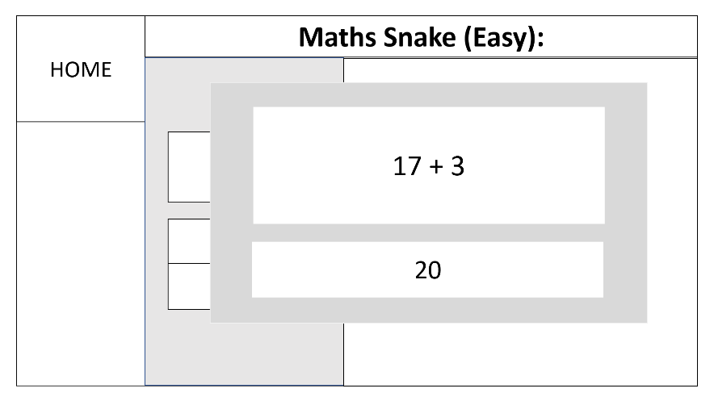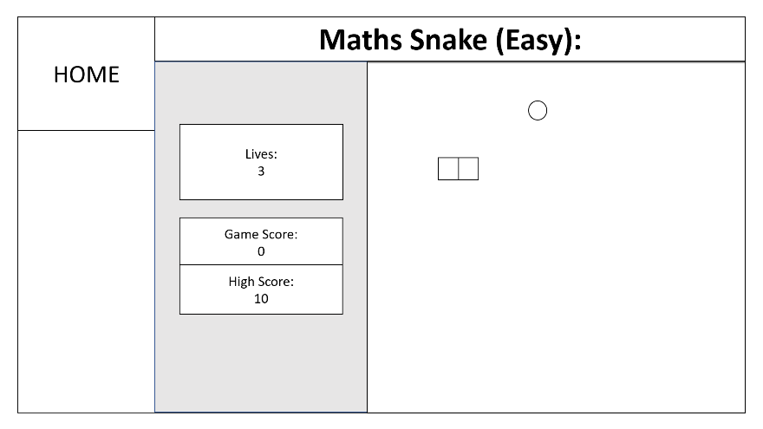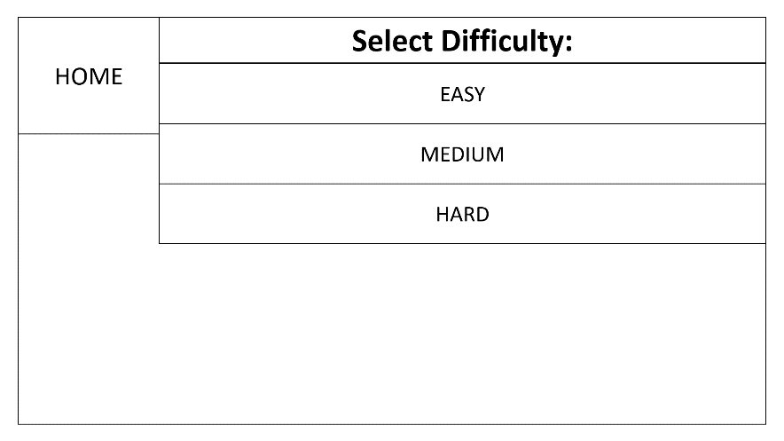

**When the snake eats a food:**

A question will pop-up when the snake eats a food. The question will be at the top of the pop-up, and underneath it there will be an entry box. The entry box will allow the user to enter their answer.

**When a level is selected:**

When the level is selected the game will begin. At the top the game name and the difficulty level that the game is will be shown at the top. The within the body, the left the game contains the life tracker and the score tracker, with addition to high score viewer as well. On the right that is where the actual gameplay is, the snake in the form of squares and the food in the form of a circle.

**When Play is clicked:**

A menu where the user can select the level of difficulty. The menu will have the following buttons: Easy, Medium, Hard

**When the App is opened:**

This is how the Main Menu will look like when the client first opens the app. The title of the game will be placed at the top. The Main Menu will contain the 5 buttons as shown: Play, Progress, How To Play, High Score, Exit. I have also placed a Home button in the top left corner, which will be present on every single page within the App.

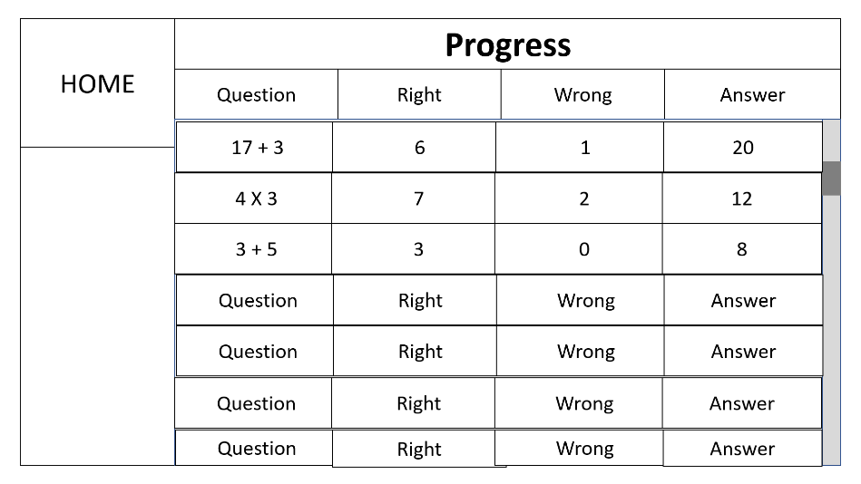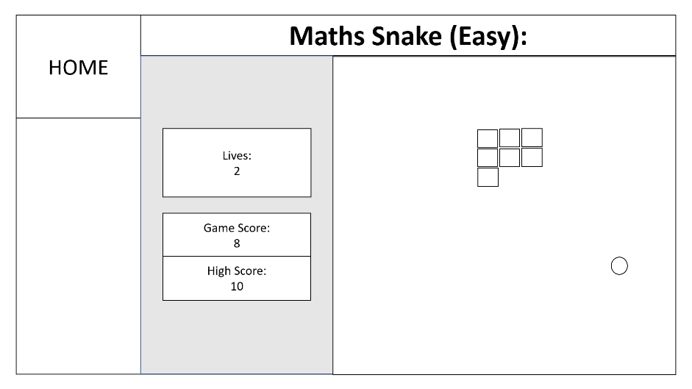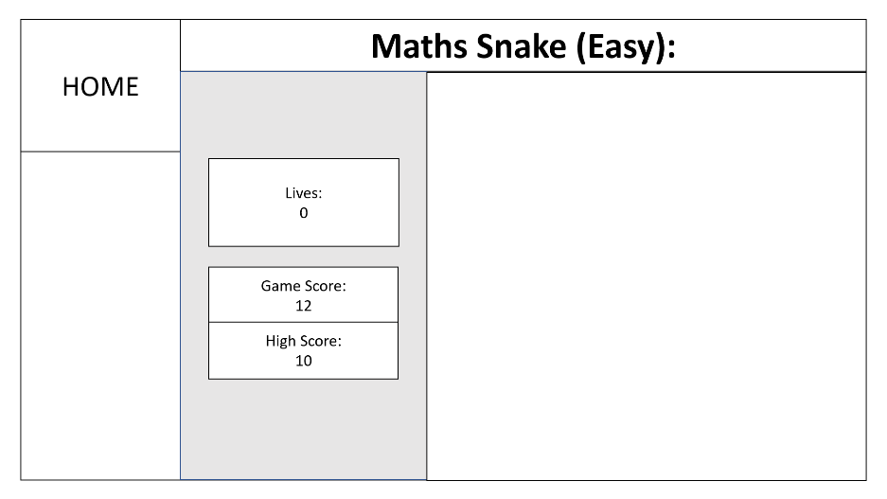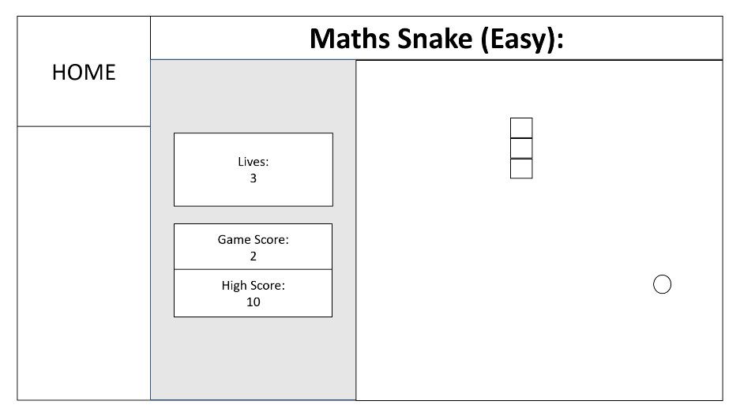

**When Progress is clicked:**

Within progress, there will be a table that the client can go through to see the number of times he has gotten a question right or wrong, which will be displayed from the list containing the information. The table will have four sections: Question, Right, Wrong and Answer. On the far right there will be a scroll bar that the stakeholders can use to scroll through the progress table.

**When lives = 0:**

Once the number of lives reaches 0 the game will end and if the game score is higher than the high score that will be saved as the current high score. The final score will also be saved within a score file.

**When the user loses a life:**

If the answer to the questions that the user had entered was wrong, the lives decreases by one and the snake doesn’t grow, and the score stays the same. The life will also decrease if the snake eats itself. The tally for the question, number of wrongs will be increased within the file, so the progress tracker can be updated

**When a question has been answered:**

Once the question has answered the pop-up will close and if the answer was right the game will carry on with the score increasing and another food appearing in a random location. The snake will also grow by one square. The tally for the question, number of rights, will be increased within the file, so the progress tracker can be updated.

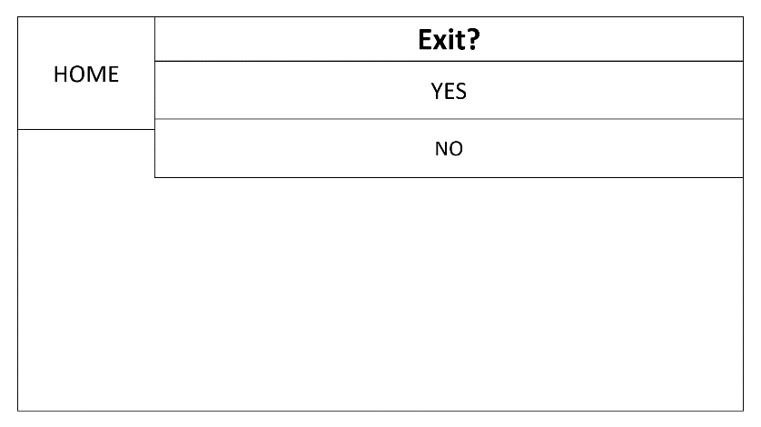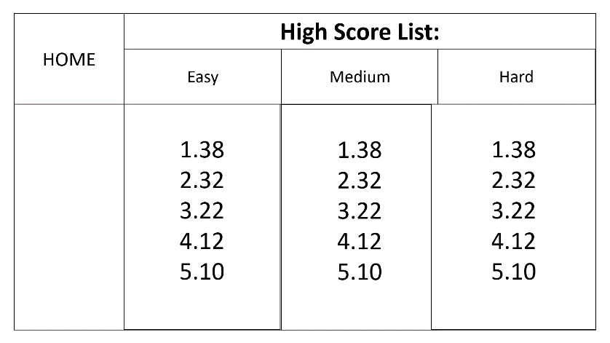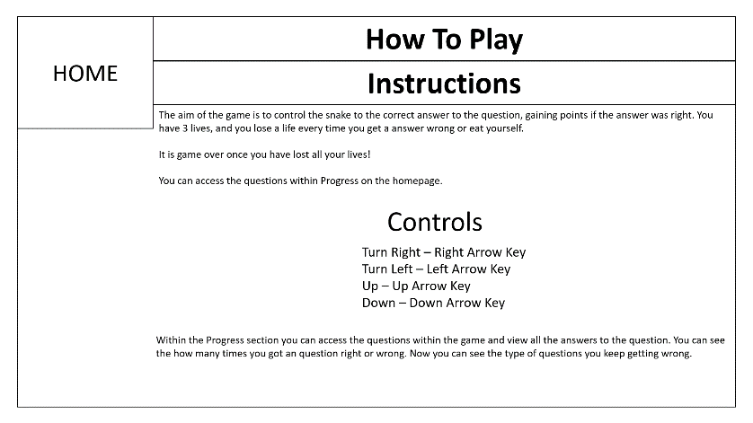

**When Exit is clicked:**

There will be 2 buttons: Yes, and No. If Yes is selected the app will close. If No is selected the user will be redirected to the Main Menu.

**When High Score is clicked:**

This section will contain the top 5 high scores for each difficulty level. It will be shown within a numbered list under a heading. The scores within the file, will be compared with each other, to come up with the top 5 scores.

**When How to Play is clicked:**

This section will 3 sections: instructions, controls and a paragraph explaining the progress section. Instructions telling the user the aim of the game, controls on how to controls the snake and a progress explainer as to what it shows to the user.

### **User Feedback**

I showed my client the first User Interface design to get feedback on what areas the interface he liked and to improve on, what he wants to add or change.

**Pros:**

* The Main Menu having all the buttons, for easy access to all the other areas
* Having a HOME button on every page to get back to the Main Menu
* Having the difficulty level in the title when playing the game, so I don’t forget
* The questions coming up in a new window
* Progress has a scroll bar and the table is easy to follow
* Having an induvial high score list for each level

**Cons:**

* Have the home button fill in the whole space so it is a big button
* The game starts soon as a level is selected, would like it to have a option to start when I want it to start when I want it to start
* An option to restart the game, so I can stop it
* Instead of having writing for the controls I want it to be an image of the controls
* Headings in boxes for each section within How to Play
* When I press exit, I would rather not have the options just exits straight away

**KRISHNA AVANTI PRIMARY SCHOOL**

Evington Hall, Spencefield Lane, Leicester, LE5 6HN

Telephone: 0116 241 9880

Twitter: @KirshnaAvantiPS

Email: kapsleicester@avanti.org,uk

Website: www.avanti.org.uk/kapsleicester

Principal: Denham Kite B,Ed (Hons)

**User Feedback Agreement**

**Pros:**

* The Main Menu having all the buttons, for easy access to all the other areas
* Having a large HOME button on every page to get back to the Main Menu
* Having the difficulty level in the title when playing the game, so I don’t forget
* The questions coming up in a new window
* Progress has a scroll bar and the table is easy to follow
* Having an induvial high score list for each level

**Cons:**

* Have the home button fill in the whole space so it is a big button
* The game starts soon as a level is selected, would like it to have a option to start when I want it to start when I want it to start
* An option to restart the game, so I can stop it
* Instead of having writing for the controls I want it to be an image of the controls
* Headings in boxes for each section within How to Play
* When I press exit, I would rather not have the options just exits straight away



**Signature** ………… **Date**……………

### **Improvements After Client’s Feedback**

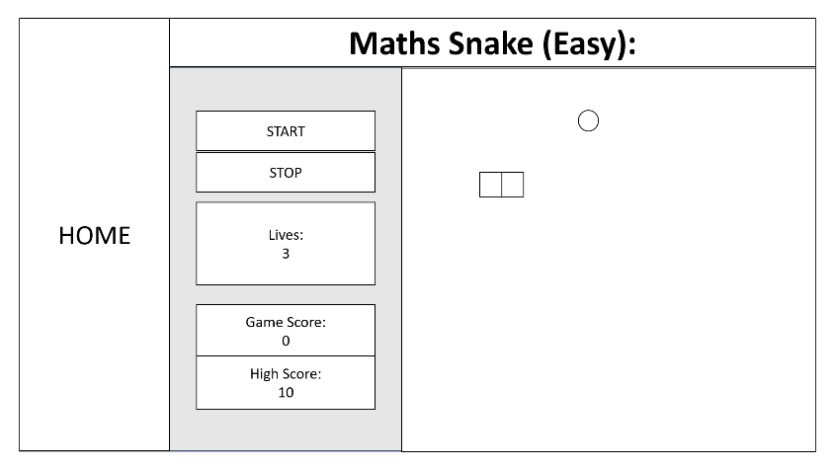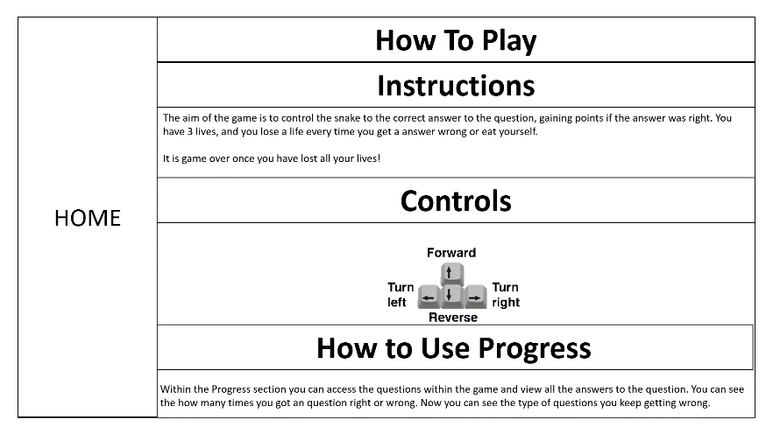

**Improvement 3 & 4– Controls Image and Headings:**

The next feedback my client gave me Is to add an image of the controls instead of having it in writing form, so he can tell what the controls are and for more easily.

I then improved the heading by adding in boxes around the headings and added a extra heading

**Improvement 2 – Start and Restart:**

The second feedback my client gave me Is to add a button to start and restart the game at will. So, the game doesn’t start straight away when the level is selected. Therefore, I added a start and restart button into the design interface next to the gameplay.

**Improvement 1 – Large HOME Button:**

I have increased the size of the home button on every page as my client requested to fill in all the space.

**Improvement 5– Controls Image:**

No more options when Exit is clicked on, the game closes straight away.

### **Colour Scheme and Font choice for User Interface**

I then showed my client the colours and fonts available within the programming language I will be using which is Python using Tkinter.

I showed my client the colour chart and fonts from these websites:

Colours: <http://www.science.smith.edu/dftwiki/index.php/Color_Charts_for_TKinter>

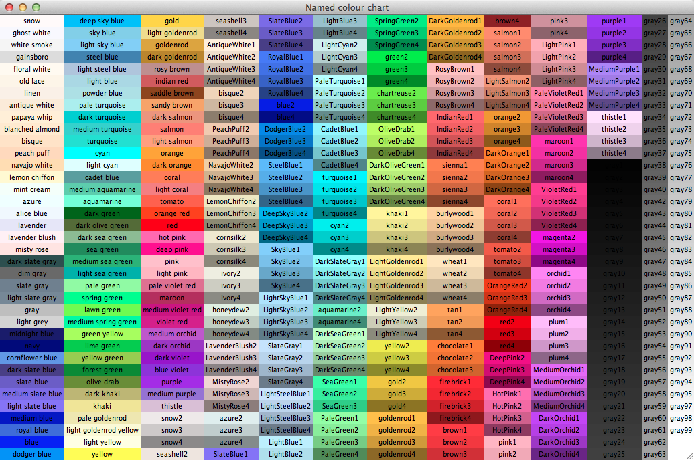Fonts: <http://effbot.org/tkinterbook/tkinter-widget-styling.htm>

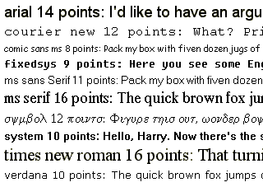

The font my client has selected is called fixedsys. The reason being is that the sort of font gives the game a more retro feeling to the game, thus feeling more like the original snake game

## **User Feedback**

Once my client was happy with the final User Interface, I gave him the colour charts to pick the colours he wanted for each element within the User Interface.

**Titles of Sections:** Background – Black, Text – Red

**Home Button**: Background – Blue2, Text – Yellow2

**Button’s Text:** White

**Main Menu Colours:**

* Play Button – Purple3
* Progress, How to Play and High Score Buttons – Green3
* Exit – Red

**Play:**

* **Select Difficulty Menu:**
  + Easy – Green3
  + Medium – Dark Orange
  + Hard – Red
* **Game:**
  + Canvas (Where the game is played) – Black
  + Snake – Green3
  + Food – Red
  + Start Button – Green3
  + Stop Button – Red
  + Life Tracker – DodgerBlue2
  + Score Tracker – Orange

**Progress:**

* Table Headings – Background: Yellow, Text: Blue
* Table colours – Colour1 – Chocolate1, Colour2 – Dark Orange

**How to Play:**

* **Instruction Section:**
  + Heading – Background: Gold2, Text: Blue
  + Text – Blue
* **Control Section:**
  + Heading – Background: Green3, Text: Blue
* **How to Use Progress Section:**
  + Heading – Background: Aquamarine, Text: Blue
  + Text – Green4

**High Score List:**

* Headings – Easy: Green2, Medium: Dark Orange, Hard: Red
* Text – Blue

****Evington Hall, Spencefield Lane, Leicester, LE5 6HN

Telephone: 0116 241 9880

Twitter: @KirshnaAvantiPS

Email: kapsleicester@avanti.org,uk

Website: www.avanti.org.uk/kapsleicester

Principal: Denham Kite B,Ed (Hons)

**Client Agreement on Colour and Text for User Interface**

**Titles of Sections:** Background – Black, Text – Red

**Home Button**: Background – Blue2, Text – Yellow2

**Button’s Text:** White

**Main Menu Colours:**

* Play Button – Purple3
* Progress, How to Play and High Score Buttons – Green3
* Exit – Red

**Play:**

* **Select Difficulty Menu:**
  + Easy – Green3
  + Medium – Dark Orange
  + Hard – Red
* **Game:**
  + Canvas (Where the game is played) – Black
  + Snake – Green3
  + Food – Red
  + Start Button – Green3
  + Stop Button – Red
  + Life Tracker – DodgerBlue2
  + Score Tracker – Orange

**Progress:**

* Table Headings – Background: Yellow, Text: Blue
* Table colours – Colour1 – Chocolate1, Colour2 – Dark Orange

**How to Play:**

* **Instruction Section:**
  + Heading – Background: Gold2, Text: Blue
  + Text – Blue
* **Control Section:**
  + Heading – Background: Green3, Text: Blue
* **How to Use Progress Section:**
  + Heading – Background: Aquamarine, Text: Blue
  + Text – Green4

**High Score List:**

* Headings – Easy: Green2, Medium: Dark Orange, Hard: Red
* Text – Blue

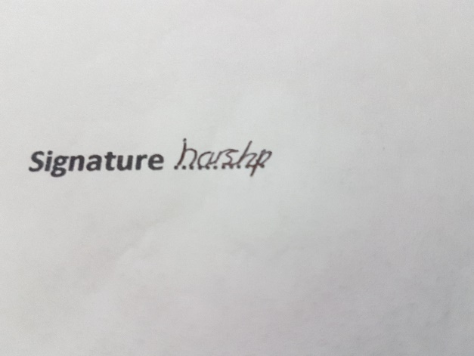

**Signature** ………… **Date**……………

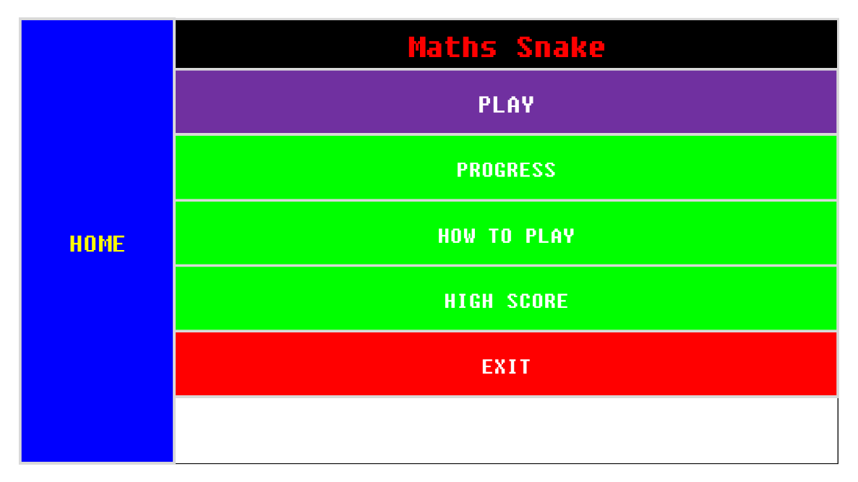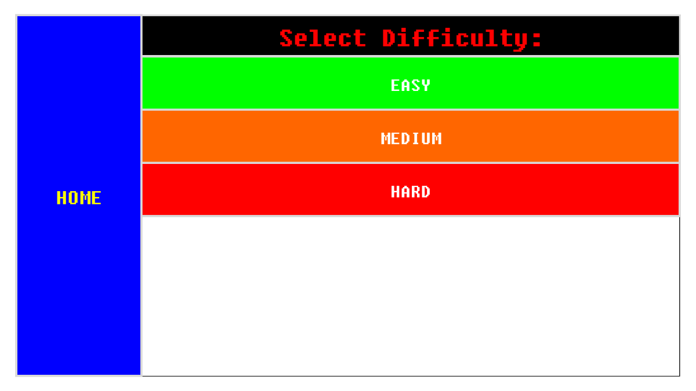

**Final User Interface**

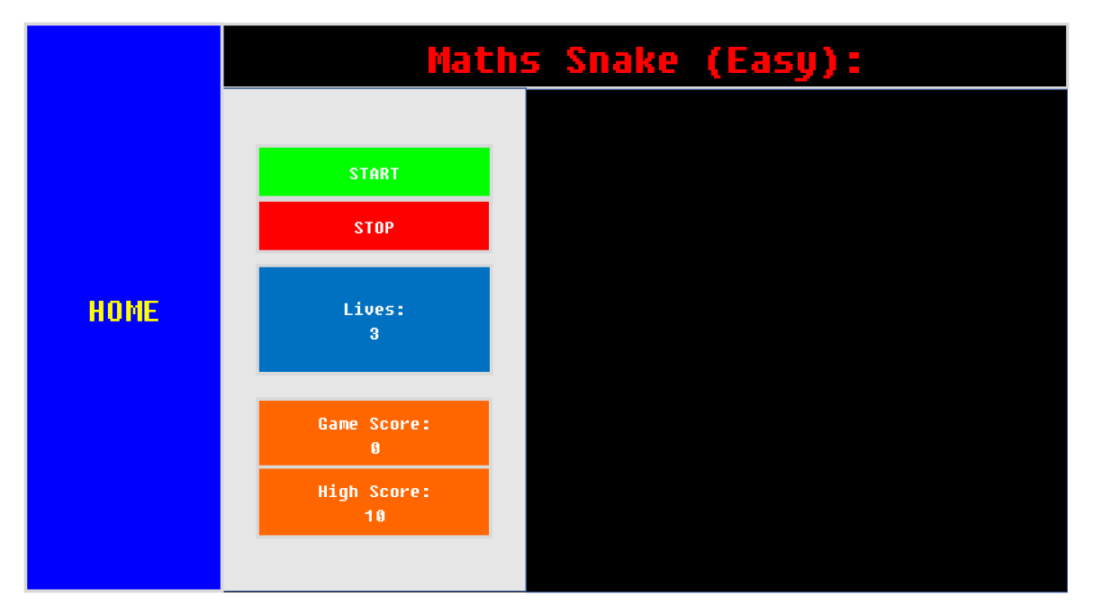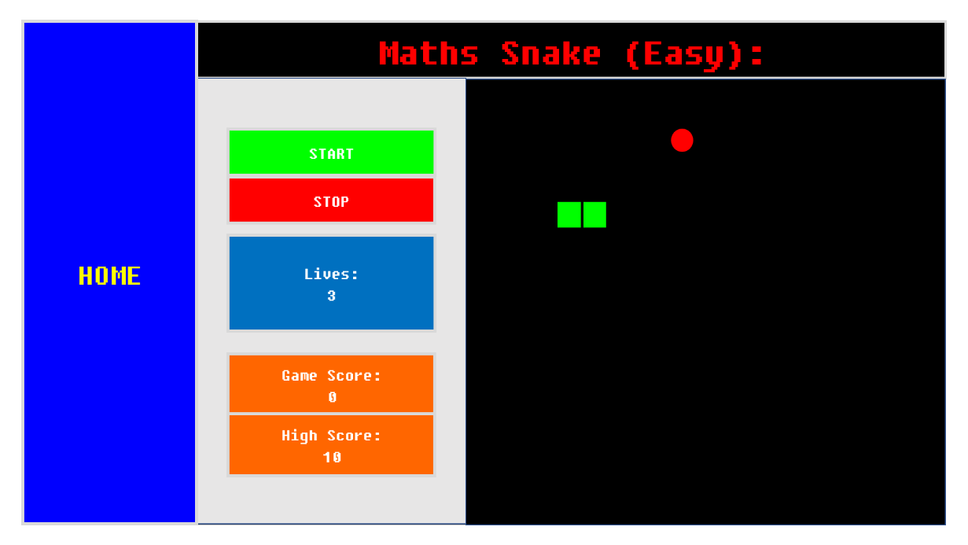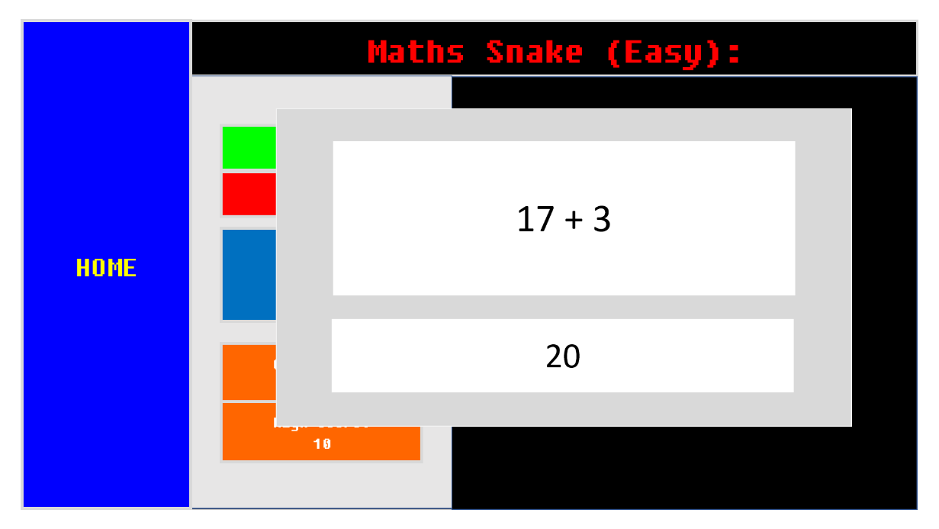

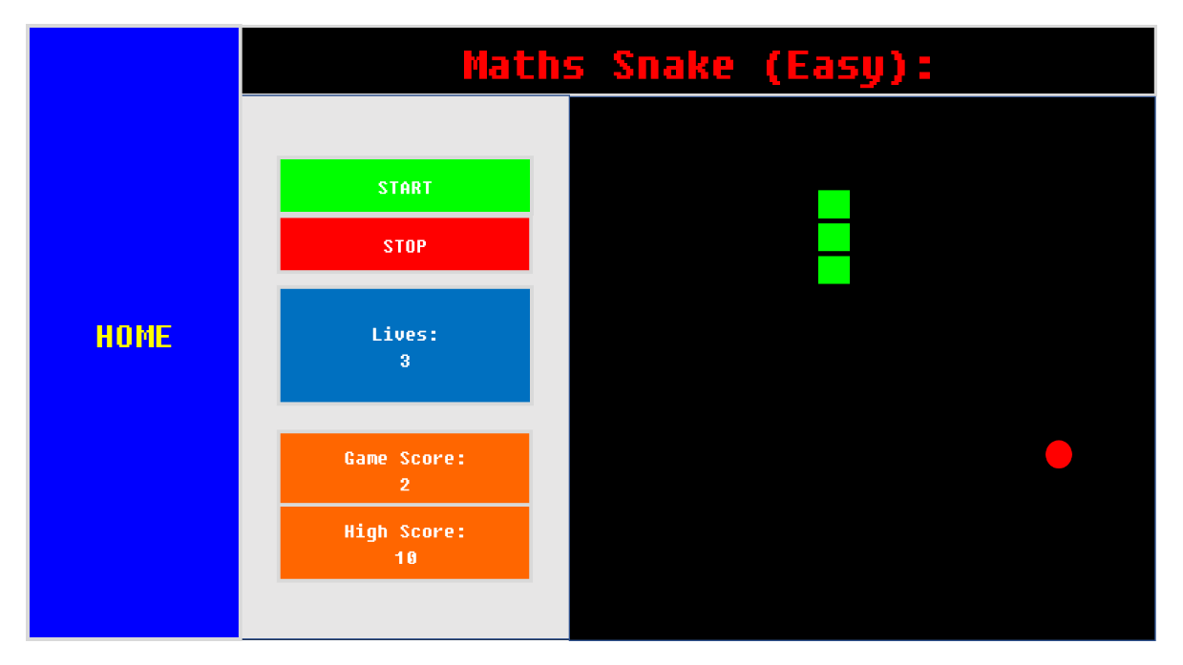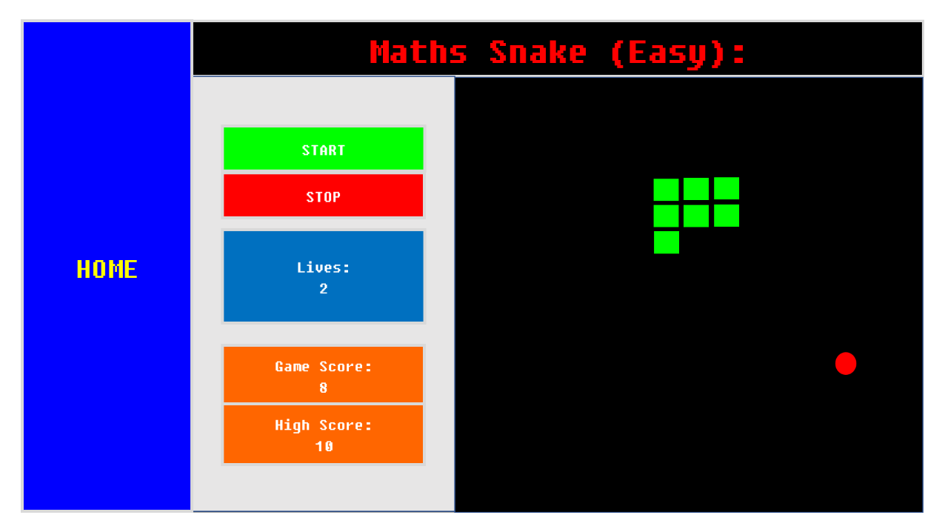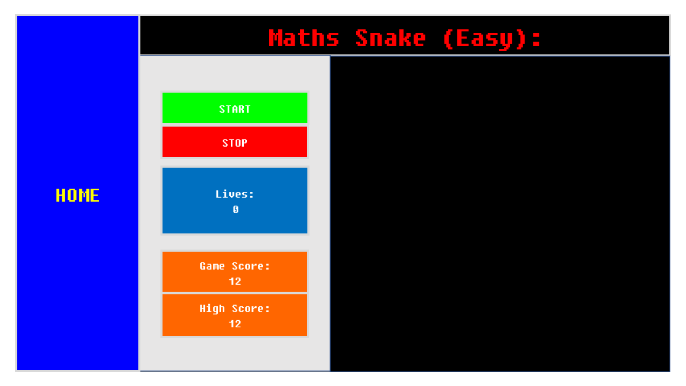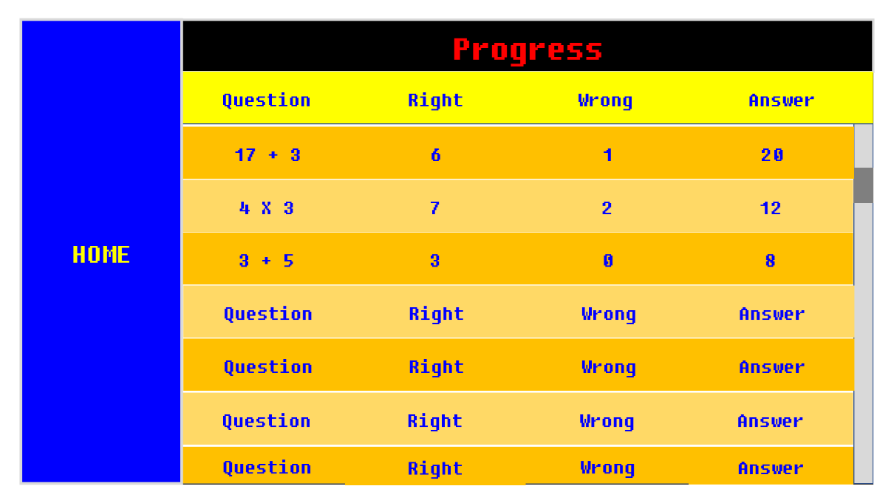

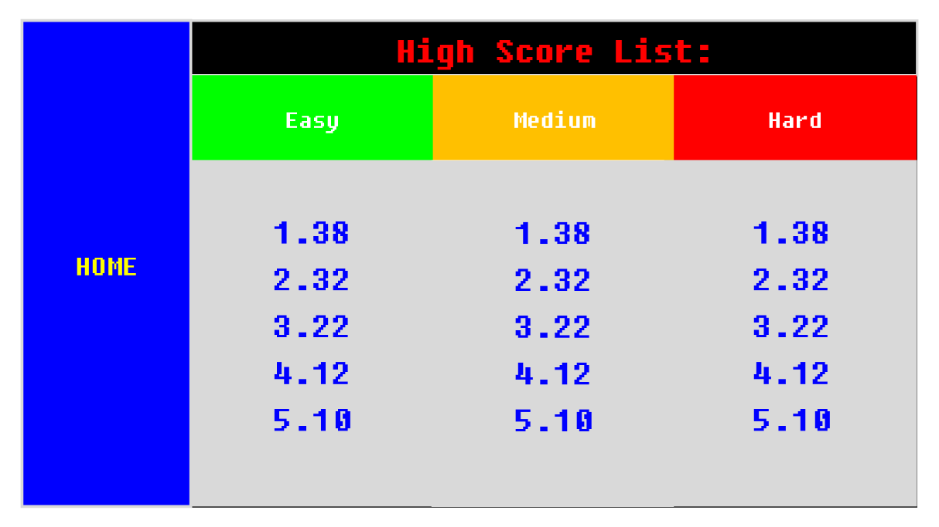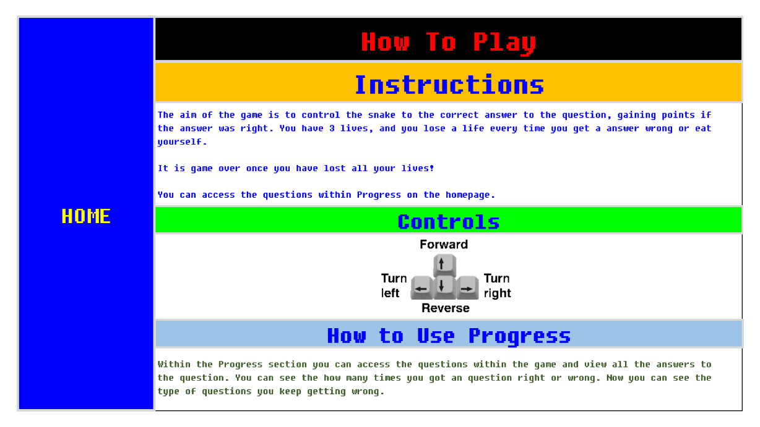

**KRISHNA AVANTI PRIMARY SCHOOL**

Evington Hall, Spencefield Lane, Leicester, LE5 6HN

Telephone: 0116 241 9880

Twitter: @KirshnaAvantiPS

Email: kapsleicester@avanti.org,uk

Website: [www.avanti.org.uk/kapsleicester](http://www.avanti.org.uk/kapsleicester)

Principal: Denham Kite B,Ed (Hons)

**Client Agreement on Final User Interface**

***By signing this you agree that you are happy with the final user interface design***



**Signature** ………… **Date**……………

## **Design Specification**

**Application**

* **Input:**
  + App can be clicked upon by the user, so the application starts
* **Processing**
  + The application will start up opening to the Main Menu of the game
  + Open within 5 seconds
* **Output**
  + App will output the Main Menu of the game
* **Aesthetic** 
  + Screen Size will be 800x600 pixels, unable to change size
  + App has Maths Snake written within the app

**Main Menu**

* **Input:**
  + User can click on the Main Menu buttons
* **Processing**
  + When the button is clicked,
    - The user is directed to designated area
    - The function connecting to the button is called upon thus taking the user to the designated area
* **Output**
  + Game name: Maths Snake
  + Play button
  + Progress button
  + How to Play button
  + High Score button
  + Exit button
  + Home button
* **Aesthetic:**
  + **Colours:**
    - Game Name – Background: Black, Foreground: Red
    - Play button – Background: Purple, Foreground: White
    - Progress, How to Play and High Score button – Background: Green, Foreground: White
    - Exit Button – Background: Red, Foreground: White
    - Home Button – Background: Blue, Foreground: Yellow
  + **Font:**
    - Fixedsys
  + **Layout:**
    - Right Side:
      * Title at top
      * Underneath Title: Play button, Progress button: How to Play button, High Score button and Exit button
    - Left Side:
      * Home Button

**Select Difficulty Level**

* **Input:**
  + User can click on the different difficulty level buttons, to select the difficulty level
* **Processing**
  + When the button is clicked,
    - The user is directed to designated difficulty level game
    - The function linked to the difficulty level is called upon thus taking the user to the designated area
    - In this case the user will be directed to the game, where the difficulty of the questions will increase, higher the difficulty level is
* **Output**
  + Title of Section: Select Difficulty Level
  + Easy button
  + Medium button
  + Hard button
  + Home button
* **Aesthetic:**
  + **Colours:**
    - Section Name – Background: Black, Foreground: Red
    - Easy button – Background: Green, Foreground: White
    - Medium button – Background: Orange, Foreground: White
    - Hard Button – Background: Red, Foreground: White
    - Home Button – Background: Blue, Foreground: Yellow
  + **Font:**
    - Fixedsys
  + **Layout:**
    - Right Side:
      * Title at top
      * Underneath Title: Easy button, Medium and Hard button
    - Left Side:
      * Home Button

**Maths Snake Game**

* **Input:**
  + Start Button, clicked by user to start the game
  + Restart Button, clicked to end game
  + Arrow Keys to control the snake:
    - Up Arrow Key – Snake Moves Up
    - Down Arrow Key – Snake Moves Down
    - Right Arrow Key – Snake Moves Right
    - Left Arrow Key – Snake Moves Left
  + User enters answer to question
* **Processing**
  + The screen where the game will be played on will be created using canvas, and the characters, snake and the food will also be created using the canvas technique
  + When Start is clicked: The snake will appear at the place that I want it to using set coordinates within the canvas, whenever start is pressed upon, the function that contains it will be called upon
  + When Stop is clicked: The game screen will be cleared out and the if the current score is higher than the current high score then that will become the new high score
  + Constantly check if snake has collided, if the coordinates of the snake head and food are the same, snake has eaten food
  + The food will appear randomly on the screen using random X and Y coordinates, whenever the Snake ‘eats’ the food
  + Constantly check if snake head has collided with the body, if so number of lives should decrease by 1
  + When food is eaten a question should pop-up, user answer is then checked with the correct answer
  + The score must increment each time the user gets the question correct or if wrong lives should decrease by 1
  + If lives = 0, game should end
  + When the user gets a question wrong or right the tracker for progress, should increment by 1 ach time in the appropriate file/database
* **Output**
  + Title of Section: Maths Snake, in brackets, difficulty level
  + Start button
  + Stop button
  + Life Tracker
  + Score Tracker
  + Current High Score
  + Game Play Canvas
  + Snake, in the form of squares
  + Food, in the form of circles
  + Question, and Entry Box with Pop-Up
  + Home button
* **Aesthetic:**
  + **Colours:**
    - Section Name – Background: Black, Foreground: Red
    - Start button – Background: Green, Foreground: White
    - Restart button – Background: Red, Foreground: White
    - Life Tracker – Background: DodgerBlue2, Foreground: White
    - Scoreboard– Background: Orange, Foreground: White
    - High Score – Background: Orange, Foreground: White
    - Snake – Colour: Green3
    - Food – Colour: Red
    - Question and Entry Box – Background: White/Default, Foreground: Black/Default
    - Home Button – Background: Blue, Foreground: Yellow
  + **Font:**
    - Fixedsys
  + **Layout:**
    - Right Side:
      * Title at top
      * Underneath Title: Game
      * Next to game: Start & Stop Button, Life Tracker and Scoreboard
    - Left Side:
      * Home Button

**Progress**

* **Input:**
  + User can view all the questions, answers and the number of times they have got it wrong or right using the table and scrollbar
* **Processing**
  + When the user uses the scrollbar the progress table should scroll down or up
  + Every time a question is answered correctly or incorrectly the tally for each one should increment by 1, within the file/database storing the value
* **Output**
  + Title of Section: Progress
  + Table Headings: Questions, Right, Wrong and Answer in respective order
  + Row and columns of Questions, Right, Wrong and Answer
  + Scroll Bar
  + Home button
* **Aesthetic:**
  + **Colours:**
    - Section Name – Background: Black, Foreground: Red
    - Table Headings – Background: Yellow, Foreground: Blue
    - Rows – Background: Dark and Light Orange, Foreground: Blue
    - Scroll Bar – Background: Grey/Default
    - Home Button – Background: Blue, Foreground: Yellow
  + **Font:**
    - Fixedsys
  + **Layout:**
    - Right Side:
      * Title at top
      * Underneath Title: Progress Table
    - Left Side:
      * Home Button

**How to Play**

* **Input:**
  + Click the button from Main Menu to access this area
* **Processing**
  + Display all text and the image
* **Output**
  + Title of Section: How to Play
  + Heading: Instructions, Controls and How to use Progress
  + Instructions and How to use Progress in Text
  + Controls in Images
  + Home button
* **Aesthetic:**
  + **Colours:**
    - Section Name – Background: Black, Foreground: Red
    - Instruction Heading – Background: Gold, Foreground: Blue
    - Controls Heading – Background: Green, Foreground: Blue
    - How to use progress Heading – Background: AquaMarine, Foreground: Blue
    - Instructions Text – Foreground: Blue
    - How to use Progress Text – Foreground: Green
    - Home Button – Background: Blue, Foreground: Yellow
  + **Font:**
    - Fixedsys
  + **Layout:**
    - Right Side:
      * Title at top
      * Underneath Title: Instructions, Controls and How to Use Progress
    - Left Side:
      * Home Button

**High Scores**

* **Input:**
  + Click the button from Main Menu to access this area
* **Processing**
  + Compare all the high score to get the top 5 for each level
  + Compare the high scores to get from highest
  + Put them into a numbered list
* **Output**
  + Title of Section: High Scores
  + Heading: Easy, Medium and Hard
  + List of top 5 high scores
  + Number list
  + Home button
* **Aesthetic:**
  + **Colours:**
    - Section Name – Background: Black, Foreground: Red
    - Easy Heading – Background: Green, Foreground: White
    - Medium Heading – Background: Orange, Foreground: White
    - Hard Heading – Background: Red, Foreground: White
    - Text – Foreground: Blue
    - Home Button – Background: Blue, Foreground: Yellow
  + **Font:**
    - Fixedsys
  + **Layout:**
    - Right Side:
      * Title at top
      * Underneath Title: Top 5 High Score under each Level
    - Left Side:
      * Home Button

## **Iterative Test Plan**

|  |  |  |  |  |  |  |  |  |
| --- | --- | --- | --- | --- | --- | --- | --- | --- |
| Test No. | Test Subject | Type of Testing | Input, Output and Functionality Expected | No. of Test | Actual Outcome | Errors | Fix | Justification |
| 1 | Main Menu Button: Play | Black Box | **Input:** Play is clicked by the User  **Output**: Display Select Difficulty Menu:   * Select difficulty title * Easy Button * Medium Button * Hard Button | 1 |  |  |  | Using Black Box test as I only need to check the if the output is correct when the button is clicked. In this test I do not need to concern myself with the functionality of the code. From this test I only need to show that the user is taken to Select Difficulty Level which is specified within the Success Criteria |
| 2 |  |  |  |
| 3 |  |  |  |
| 2 | Main Menu Button: Progress | Black Box  White Box Testing | Display Progress Table | 1 |  |  |  | Using Black Box test as I need to check the if the output is correct when the button is clicked. A table that shows how many times the user got a question right and wrong. Calculates this. |
| 2 |  |  |  |
| 3 |  |  |  |
| 3 | Main Menu Button: How to Play | Black Box | Input: How to Play is clicked  Output: Instructions, Controls and Extra Info on Progress | 1 |  |  |  | Black Box testing as I just need to see if the correct output is given or not. Each section within this Page should have a heading followed by the content |
| 2 |  |  |  |
| 3 |  |  |  |
| 4 | Main Menu Button: High Score | Black Box  White Box Testing | Input: High Score Button is Clicked  Output: Top 5 High Scores for each level  Functionality: Scores within a file are compared to give the top 5 scores | 1 |  |  |  | For this part I need to test the input and output when eh button is clicked but also the data that is shown is the correct data. Black box to test that the correct output is given according to the Success Criteria. I also need to check that the code is functioning correctly by comparing all the scores within the file and retrieving the top 5 scores, to do this I need to check the code |
| 2 |  |  |  |
| 3 |  |  |  |
| 5 | Main Menu Button: Exit | Black Box | Input: Exit is clicked  Output: Game Closes  Functionality: The pre-defined function used works as expected, and that is called upon input | 1 |  |  |  | The output given when the button is pressed is that the game closes straight away. For this I need to make sure I am using the correct function, thus using White Box Testing, so it meets the requirements of the success criteria. |
| 2 |  |  |  |
| 3 |  |  |  |
| 6 | Select Difficulty Menu | Black Box | Input: User selects a level by clicking a button  Output: Directs user to Snake Game | 1 |  |  |  | This is to check that the buttons for this section leads straight to the game |
| 2 |  |  |  |
| 3 |  |  |  |
| 7 | Game | Black Box | Input: Start and Restart  Output: Game screen, scoreboard, lives and start and restart button – game starts and stops | 1 |  |  |  | Black Box Testing the correct output has been given and matches the success criteria. Checks that the input from the start and restart button give the correct output. |
| 2 |  |  |  |
| 3 |  |  |  |
| 8 | Snake Movement | Black Box  White Box Testing | Input: Snake is Controlled using arrow keys  Functionality: The snake follows the direction the correct directions  Output: Snake moves in that direction | 1 |  |  |  | This is needed so the correct input is giving the correct output, and white box makes sure that the correct code is needed |
| 2 |  |  |  |
| 3 |  |  |  |
| 9 | Collisions with body | White Box Testing | Functionality: Constant check if the head of the snake has collided with body, by checking if they have the same coordinates, then the functions for life tracker will be called upon | 1 |  |  |  | White Box will test that it does this check constantly and the correct function for the function that is directly affect by this event is called upon. This is needed so the life tracker can go down, |
| 2 |  |  |  |
| 3 |  |  |  |
| 10 | Collisions with food | White Box Testing Box | Functionality: Checks if the coordinates of the head and the food are the same. Then the function for deleting and creating the food tis called and a question should then appear | 1 |  |  |  | This needs to be tested so that when the collision happens the coordinates are checked so the correct functions can be called upon, for the next stage. White Box testing will test that the code functions correctly, as intended. |
| 2 |  |  |  |
| 3 |  |  |  |
| 11 | Snake Growth | White Box Testing, Black Box Testing and Extreme Testing | Input: Snake grows when user has entered correct answer to question  Output: Snake grows by one square  Functionality:  Extreme: How big the snake can get, if it affects gameplay | 1 |  |  |  | This is one of the most important factors of snake, that the snake grows. Therefore, will need to test that it is outputting the growth, the code for it functions correctly, by incrementing a square. I need to test this as a extreme value to see if there is a limit to how big the snake can get. |
| 2 |  |  |  |
| 3 |  |  |  |
| 12 | Questions | White Box Testing, Black Box Testing and Extreme Testing | Input: Entry box, user enters answer  Output: The question in a pop-up window  Functionally: Each time the user gets it right or wrong the value for the tally of that question is incremented | 1 |  |  |  | White box testing is important that the value for the question right or wrong is increased otherwise the progress table would not update |
| 2 |  |  |  |
| 3 |  |  |  |
| 13 | Score Tracker | White Box Testing | Functionality: The score increments each time the user gets a question right; the score then is saved to a file when the game ends | 1 |  |  |  | Need to make the score increase only if the answer was right otherwise the program is errored |
| 2 |  |  |  |
| 3 |  |  |  |
| 14 | Life tracker | White Box Testing | Functionality: Life decrease when snake eats its own body and when 0 game stops | 1 |  |  |  | White box testing is needed to see if the life goes down or not only if the answer to the question is wrong or snake has collided with its body |
| 2 |  |  |  |
| 3 |  |  |  |
| 15 | Home Button | Black Box | Input: Button is clicked  Output: User is directed to Main Menu  Must be displayed on every page | 1 |  |  |  | This is an important feature as in the success criteria this button needs to be on every page, so the user get back to the main menu from every page. |
| 2 |  |  |  |
| 3 |  |  |  |

## **Post Development Testing**

|  |  |  |  |  |  |  |  |
| --- | --- | --- | --- | --- | --- | --- | --- |
| Test No. | Test Subject | Description | Type of Testing | Expected Outcome | Actual Outcome | Pass/ Fail | Justification |
| 1 | Main Menu | Does are all the main menu buttons and colours correct? | Black Box Testing | Main Menu to contain:   * Play Button - Purple * Progress Button – Green * How to Play Button – Green * High Score Button – Green * Exit - Red |  |  | According to the success criteria the main menu needs ti have all these buttons with the correct colours displayed as the Client wants, therefore Black Box testing will test the output, the correct output is given or not. |
| 2 | Play Button | Does the button work? Dies the button take the user to the Select Difficulty Page? Are the correct buttons and colours being outputted? | Black Box Testing | Direct to Select Difficulty Menu when users press Play:  Easy Button – Green  Medium Button - Orange  Hard Button - Red |  |  | The success criteria state these button and symbolic colours need to appear as the client wants. Black Box Testing test the output, thus design whether the correct buttons and colours are displayed or not |
| 3 | Easy Button | Is the user directed to the game? Does the title have the correct level in it? | Black Box Testing | When users press Easy:  Maths Snake (Easy):  Game buttons and trackers  Game Screen |  |  | Black Box Testing will test that the outputs are correct. That the output is whether the expected or not. |
| 4 | Medium Button | Is the user directed to the game? Does the title have the correct level in it? | Black Box Testing | When users press Medium:  Maths Snake (Medium):  Game buttons and trackers  Game Screen |  |  |
| 5 | Hard Button | Is the user directed to the game? Does the title have the correct level in it? | Black Box Testing | When users press Hard:  Maths Snake (Hard):  Game buttons and trackers  Game Screen |  |  |
| 6 | Start and Restart Button | Does the game start when the user presses start? Does the game stop when the user presses Restart? | Black Box Testing | Start Button – Snake and Food will appear  Restart Button – Game Screen will be cleared |  |  | Need to test whether the correct output happens when the user presses the buttons. Black Box will test that the button gives the correct output, when pressed |
| 7 | Constant Snake movement | Does the snake move constantly? | Black Box Testing and White Box Testing | Snake moves constantly at the rate of 2 bits |  |  | The snake needs to move constantly non-stop. Needs to be tested as it is important to the game snake. The movement needs to be checked with black box, if the movement looks correct or not. White Box to see if the function of the code is correct, it does move at that rate |
| 8 | Snake Controls – Up Arrow Key | Does the snake move up when the up-arrow key is pressed? | Black Box Testing | Snake moves up |  |  | Need to test that the correct controls are being used for the correct direction as the user wanted as stated in the success criteria. Black Box test the correct input gives the correct output. |
| 9 | Snake Controls – Down Arrow Key | Does the snake move up when the Down arrow key is pressed? | Black Box Testing | Snake moves down |  |  |
| 10 | Snake Controls – Left Arrow Key | Does the snake move up when the Left arrow key is pressed? | Black Box Testing | Snake moves left |  |  |
| 11 | Snake Controls – Right Arrow Key | Does the snake move up when the Right arrow key is pressed? | Black Box Testing | Snake moves right |  |  |
| 12 | Snake eats food | Does the food disappear when the snake collides with, the food? Does a question pop-up? Does a new food randomly appear? | Black Box Testing and White Box Testing | Snake Eats food:  Question appears in new window  Once question is answered, there should be a new food |  |  | Need to test this as the question should appear straight after the snake hits the food. The food should appear randomly on the screen, and the other should be deleted, as the success criteria stated. |
| 13 | Snake eats Body | Does the snake collide with the body? Does the number of lives go down? Does the snake carry on moving? | Black Box Testing |  |  |  | The snake needs to collide with itself to make the game more challenging and it is an important feature the clients wants, another way for the lives to go down as the client wanted. Black Box as I am testing the output is correct when the input of the snake hitting itself is given. |
| 14 | Snake growth | Does the snake grow? Does the snake grow only if the answer to the question was correct? | Black Box Testing | Snake grows by one square |  |  | Black box as I need to observe the output only. The success criteria say it should only grow if the answer to the question was correct or not. |
| 15 | Snake Travels to the edge of the Game Screen | Does the snake move to through the edge and come out the opposite side? | Black Box Testing | The snake comes out the opposite side |  |  | The client wants the snake to go through the screen and come out the other side |
| 16 | Question Answered | Is the question there? Is there a entry box? Does the question close when the answer is entered? | Black Box Testing and White Box Testing | Question in pop-up window:  Question at top in a large rectangle  Entry Box underneath the question  Question: 17 + 3  Answer: 20 |  |  | White Box need to make sure the answer is check with the correct answer to the question, and that the tally is increased as well for the Progress Table. Black Box to make the layout is as the client wanted. |
| 17 | Score Tracker | Does the score increase when the answer to the question is correct? | Black Box Testing | Score is increased by 1 if the answer was right, new score is displayed |  |  | Black Box testing as I only need to check if the correct input gives the correct output, the score increasing, which is in the success criteria. |
| 18 | Current High Score | Is the current high score being displayed? If high score is beaten is the high score updated straight away? | Black Box Testing and White Box Testing | Current High Score is shown under current score  High score is updated when the current score suppresses current high score |  |  | White Box, to make sure the new high score is saved within the file. Black Box to make sure the display of the score is correct. |
| 19 | Live Tracker | Does it start with 3 lives? | Black Box Testing | Display 3 lives when game first starts |  |  | Need to make sure lives start with 3 as specified within the success criteria |
| 20 | Life Decrease | Does the life decrease when answer is wrong?  Does the life decrease when the snake eats the body? | Black Box Testing | Lives decrease by one when answer is wrong, or the snake has collided with itself |  |  | This is the only times the number of lives should decrease as this is how the client wants it. |
| 21 | Game Over | Does the game end when lives hit zero? | Black Box Testing | Game Screen is cleared  Score and High Score are displayed |  |  | Black Box as I only need to see what the output is when the lives hit 0. |
| 22 | Progress Button | Does it direct the user to the progress table? | Black Box Testing | The progress table is displayed |  |  | In the success criteria the button Progress should take the user directly where they can see the stats for each question |
| 23 | Progress Table | Does the progress table have the correct headings? Does it have the information on the questions underneath the correct headings? | Black Box Testing and White Box Testing | Headings – Questions, Rights, Wrongs and Answer. Underneath should be the questions, tallies and answer respectively |  |  | This Is important as this is one of the main features that all the stakeholder will use, so I need to make sure it is displaying correctly using Black Box and it is functionating correctly using White Box |
| 24 | Correct tally for right and wrong tracker | Is the tally increased correctly for each question? | White Box Testing | Display the correct number of rights and wrong for a question |  |  | White Box as the tally needs to increase each time the user answers the question and the correct tally should be incremented, otherwise progress table is defective |
| 25 | Scrollbar | Can the user see all the progress? | Black Box Testing | Scroll down to view more Progress? |  |  | Need this so the user can see all the questions as the scree size is not big enough for all the questions |
| 26 | How to Play Button | Does it direct the user to the How to Play section? | Black Box Testing | Display the how to play section |  |  | This is needed as in the success criteria this tells the uses how to use the game. |
| 27 | Instructions | Does it have the heading instruction? Does it have the instructions? | Black Box Testing | Display the Heading Instructions  Display the actual instructions |  |  | The instructions need to be in the format as specified the success criteria and the design speciation |
| 28 | Controls | Does it have the heading Controls? Does it have the controls in the form of an image? | Black Box Testing | Display the Heading Controls  Display the controls as an image |  |  | The controls needs to be in the format as specified the success criteria and the design speciation |
| 29 | How to use Progress | Does it have the heading how to use progress? Does it have the extra info? | Black Box Testing | Display the Heading How to use Progress  Display the extra info |  |  | The how to use progress needs to be in the format as specified the success criteria and the design speciation |
| 30 | High Score Button | Does the button lead the user to the top 5 scores for each difficulty? | Black Box Testing | High Score Tables for each difficulty level |  |  | The success criteria stats that the output of the button being clicked needs to display he high scores of each level, this using Black Box |
| 31 | High Score table for Easy | Top 5 scores for Easy | Black Box Testing | Numbered list up to 5 of high scores |  |  | The user wants to see the top 5 scores for each level. |
| 32 | High Score table for Medium | Top 5 scores for Medium | Black Box Testing |  |  |
| 33 | High Score table for Hard | Top 5 scores for Hard | Black Box Testing |  |  |
| 34 | High Score File | Does it contain all the high scores? Does it compare the high scores? | White Box Testing | All the high scores are compared to give the top 5 |  |  | Need to check whether all the scores are being saved and compared to find the top 5 scores |
| 35 | Exit Button | Does the game close straight away? | Black Box Testing | The game closes |  |  | Game needs to close straight away when exit is pressed as specified in the success criteria |
| 36 | Home Button | Does it take the user to the Main Menu directly? | Black Box Testing | Home is pressed  Main Menu is Displayed |  |  | This is an back button where the user can use to get to the main menu from any page |

## **Structu**re Diagram of Solution

## **Pseudocode and Variables Table**

**START** Snake

**CLASS** Snake

**METHOD** __init__():

snake = snakehead #Creates an attribute to save the snake head

snakeBody = [snake + snakeShape] #Attribute to store the body within a list

food = foodShape #Creates the food, using the function to create the shape of the food

**METHOD** snakeMove():#method to define the characteristics of the snake

**IF** snake.coordinates(x)==food.coordinates(x) **AND** snake. coordinates(y)== food. coordinates(y): #Checks if the snake head coordinates are equal to the food coordinates

Question() #Calls a class called Question which will created the question pop-up

food.delete() #Need to delete the eaten food

food = foodShape #Need to create a new food

**ELSE** snake. coordinates(x).coordinates(y) == snakeBody.coordinates(x).coordinates(y):

LifeTracker.lifeLoss() #Calling the method lifeLoss from class LifeTracker

|  |  |  |  |
| --- | --- | --- | --- |
| Variable Name | Element Type | Data Type | Justification |
| Snake() | Class |  | I will be using object orientated code for the snake game, which is why I created a class called Snake. This will hold the data required to create the snake and describe the movements. |
| __init__() | Method |  | This is the first method within a class that is used to declare the attributes to be used. |
| Snake | Tkinter Object |  | Need a way to store the head of the snake, which I will use to increment the coordinates of the snake |
| SnakeBody | Array, List |  | This will store the snake body within a list |
| Food | Tkinter Object |  | Creates the food, using the foodShape function |
| SnakeMove() | Method |  | This will contain the characteristic of the snake, as to what it can and cannot do |
| coordinates |  | Integer | Will be used to check the coordinates of the snake head and food |
| Question() | Class |  | Contains the code to create the question pop-up |
| Delete() | Function |  | This function will be used to delete the tkinter objects, like the food |
| LifeTracker() | Class |  | Contain the code to keep track of the number of lives the user has, using the method from it |

**START** Life Tracker

**CLASS** LifeTracker():

**METHOD** __init__():

life = 3 #Starting value of number of lives

**METHOD** lifeLoss():

life= -1 #Will take one life away

SnakeMovement() #Call the class to move the snake

**METHOD** gameOver():

**IF** life == 0: #Checks if the number of lives is equal to zero

End() #Function to end the game

|  |  |  |  |
| --- | --- | --- | --- |
| Variable Name | Element Type | Data Type | Justification |
| LifeTracker | Class |  | Contain the instructions for the life tracker. |
| __init__() | Method |  | This is the first method within a class that is used to declare the attributes to be used. |
| life |  | Integer | Store the starting life value at the beginning of the game, and then the current life value as it decreases |
| lifeLoss | Method |  | This will contain the instructions of what do when a life need to be taken away |
| SnakeMovement() | Class |  | Will define how the snake moves after a life is taken |
| gameOver | Method |  | This will contain the instructions when the number of lives reach zero |
| End() | Function |  | This function will contain the code to end a game, when the requirements to end a game are met |

**START** Score Tracker

**CLASS** ScoreTracker

**METHOD** __init__():

scoreCounter = 0 #The score counter set at zero, track of current score

highScore = **READ**(highScoreFile) #Will read the highest score from eh file

score = 0 #Used to display current score, starting score is zero

**METHOD** scoreIncrease(): #Method which will contain the instructions to increase the score

score = scoreCounter+ 1 #Increments the score

highScore = **MAX(**score, highScore) #Picks the highest value

scoreCounter = score #Saves the score to the counter so it can be used to increment

highScore = **SAVE**(highscore, highScoreFile) #Save the highScore to the file

**METHOD** reset():#Method to reset the score tracker

**RESET** scoreCounter #Resets the score tracker

**DISPLAY** score, highScore #Need to output the current score and highest score

|  |  |  |  |
| --- | --- | --- | --- |
| Variable Name | Element Type | Data Type | Justification |
| ScoreTracker() | Class |  | Contains the code to keep track of the score |
| __init__() | Method |  | This is the first method within a class that is used to declare the attributes to be used. |
| scoreCounter |  | Integer | Keep track of the score during the game |
| score |  | Integer | Used to display the current score |
| highScore |  | Integer | Picks out he high score from the file |
| highScoreFile | File |  | Will contain the list of the high scores |
| ScoreIncrease | Method |  | This will contain the code to increase the score |
| Reset() | Method |  | This will be used to reset the score tracker values. |

**START** Question

**IMPORT** random:# Use this library to pick out a random question from the list

**GLOBAL** easyQ = [’10 + 3’, ‘2 + 2’] #Creates a list for the questions

**GLOBAL** easyA = [‘13’, ‘4’]:#Creates a list for the answers

**GLOBAL** right = [0, 0]:#Creates the right tracker for the progress tracker

**GLOBAL** wrong = [0, 0]:#Creates the wrong tracker for the progress tracker

randomQ = random.randit(easyQ) :#Picks a random question form easy

ans = easyA[randomQIndex] :# Uses the index to pick out the answer rot the question

**CLASS** Question()::

**METHOD** __init__():

root = CREATE-POP-UP:#Creates the pop-up

entryBox = TKINTER-ENTRY-BOX :#Creates the entry box using the tkinterr function

submitButton = BUTTON(save()) :#Creates a button which will call save when clicked

**DISPLAY** randomQ in root :#Output the question on the root

**METHOD** save():

**IF** entryBox.answer ==ans: :#checks if the answer from the entry box is equal to the asnswer

**CLOSE** root :#Closes the pop-up

right.insert(randomQIndex, +1) :#Adds one to the right tracker list at the index of the question.

snakeBody.add(snakeShape) :#Adds an extra snake shape to the body list

ScoreTracker().increase() :#Increases the score using the method

**ELSE:**# If the answer is wrong

**CLOSE** root

wrong.insert(randomQIndex, +1):#Adds one to the wrong tracker list at the index of the question

LifeTracker()#Calls the LifeTracker class to deduct a life

|  |  |  |  |
| --- | --- | --- | --- |
| Variable Name | Element Type | Data Type | Justification |
| Question | Class |  | Contains the code to create the questions |
| __init__() | Method |  | This is the first method within a class that is used to declare the attributes to be used. |
| easyQ, mediumQ and hardQ | Global, List |  | These contains the list of questions for each level, easy medium and hard |
| easyA, mediumA and hardA | Global, List |  | These contain the answers to the question for |
| randomQ |  | String | Used to save the randomly selected question from the list |
| randomQIndex |  | Integer | Will contain index of the selected question |
| ans |  | String | Contain the answer to the question |
| right | List |  | Contains the list for the right tracker |
| wrong | List |  | Contains the list for the wrong tracker |
| root | Tkinter Object |  | Will create the tkinter window |
| entryBox | Tkinter Object |  | Will create the entry box |
| submitButton | Tkinter Object |  | Will create the button |
| save | Method |  | Contain the instruction when the button is clicked |

|  |  |  |  |
| --- | --- | --- | --- |
| Variable Name | Element | Data Type | Justification |
| User Interface Variables | | | |
| mainMenu | Function |  | Function containing the Main Menu buttons |
| playButton | Tkinter Object, button |  | Create the Play Button on the Main Menu, which directs the user to Select Difficult Menu |
| progressButton | Tkinter Object, button |  | Create the Progress button, to led the use rot the progress tracker |
| howToPlayButton | Tkinter Object, button |  | Create the how to play button to teach the use how to us the application |
|  |  |  |  |
| highScoreButton | Tkinter Object, button |  | Create the high score button, lead the use rot the list of high scores |
| exitButton | Tkinter Object, button |  | Create the exit button, close the application |
| easyButton, mediumButton and hardButton | Tkinter Object, button |  | Create the difficulty level buttons for the user to select which difficulty they want to play |
| (sectionname)Title | Tkinter Object, label |  | Will be used to create a title on each section, the name of the section will be placed before title for easy recongintion |
| homeButton | Tkinter Object, button |  | Create the Home Button, take the user back to the Main Menu |
| root | Tkinter Object |  | Will create the tkinter window for the application |
| startButton | Tkinter Object, button |  | Create the start button, to start the game |
| restartButton | Tkinter Object, button |  | Create the restart Button to restart the game |
| scoreBoard | Tkinter Object, label |  | Will display the current score and high score |
| lifeBoard | Tkinter Object, label |  | Will display the life tracker |

# **Implementation**

## **Creating the Window**

This is the first version where I am creating the app window where the game graphics will be placed within. To program my solution, I am using Python with TKinter.

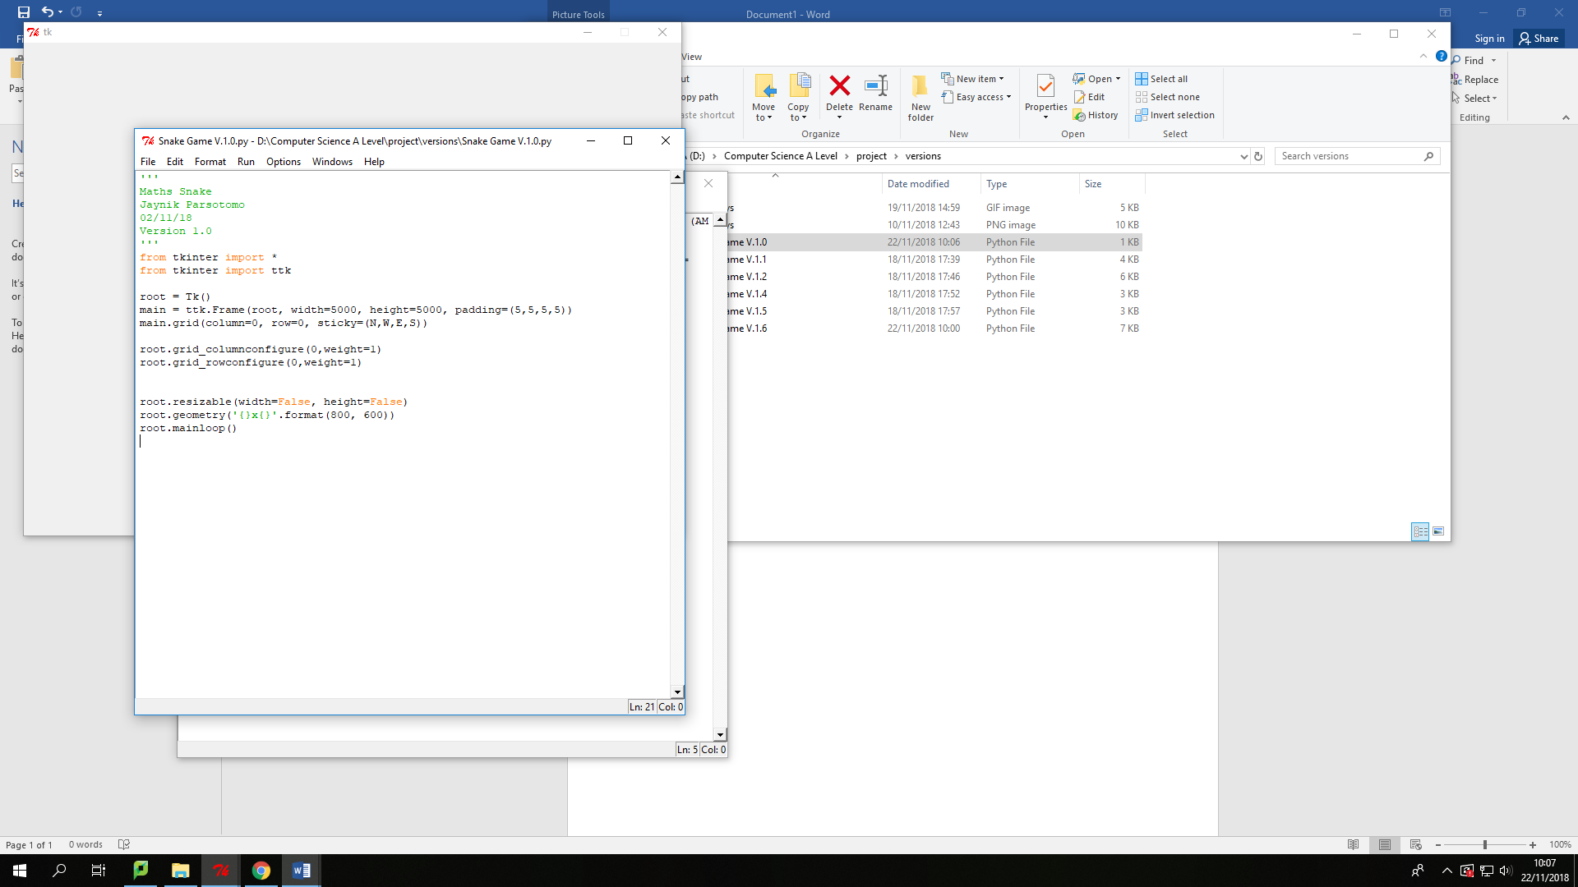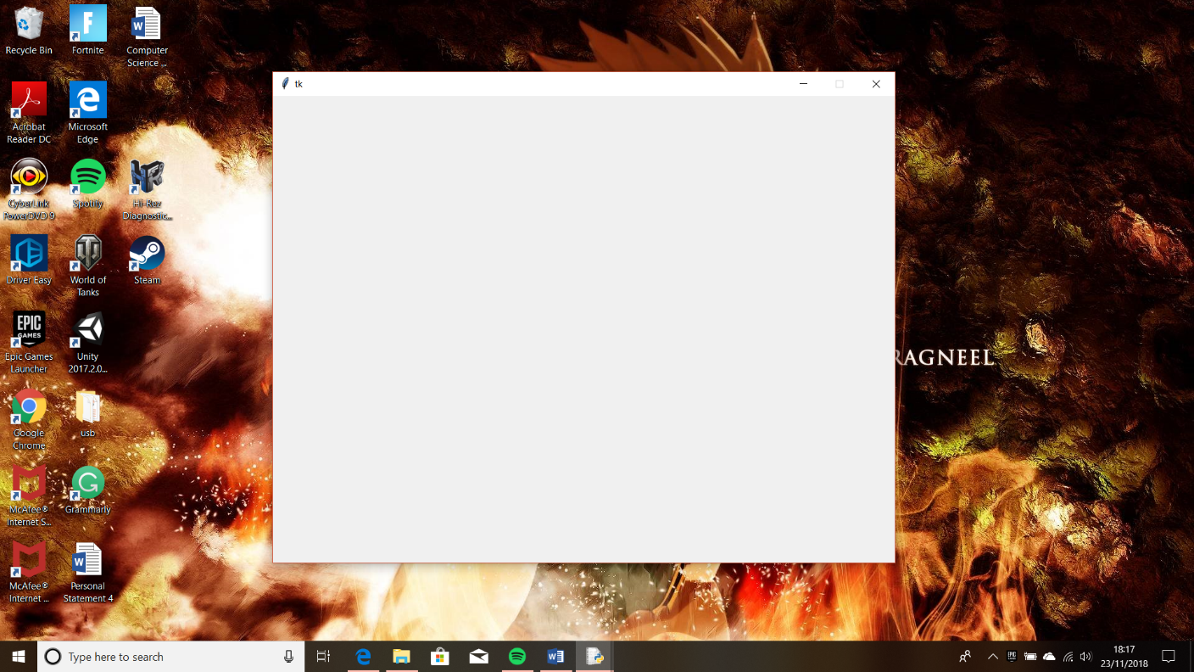

This imports the library TKinter into Python, so I can use the functions and widgets available within it freely within my own code. First line imports the whole library, the second imports a specific content from the Library.

This sets up the window that the game will be within:

* The first line creates the window that the game will be held within, and saves it to a variable called root
* The next line creates a Frame within the window (root) in a variable called main, where all the graphics, main objectives of the game will go into.
  + The code in the brackets:
  + Root – where the frame will be place in
  + Width and Height – edit the dimensions of the frame,
  + Padding - creates whitespace around the frame so the content in the frame is not too close to the edges

These lines of code edit the grids within the root (window) with rows and columns. This is the method I am using to place the content, graphics buttons, text and etc into the frame. The configure part of the code allows me to edit properties.

Within the brackets:

* 0 - this edits column/row 0
* Weight –this will allow the column/row to fill in extra space, and by giving them both weight they will fill the space in the root and frame equally

The last lines of code edit the properties of the root, the window.

* First line edits the window being resizable to, and within the brackets I set the height and width to False meaning the size of the window cannot be changed. Therefore, I will not need to consider the graphics changing size and position if the window size is changed.
* Next line edits the height and width pixels wise. Geometry does this for me and format allows me to change them using geometry. I have changed the dimensions to 800X600 a requirement from the success criteria.
* The last line makes sure the game doesn’t close after an action (button is clicked), it keeps it running in a loop.

This is what the lines of code output. The code outputs an empty window at size 800 X 600.

**Output:**

## **Creating the Main Menu**

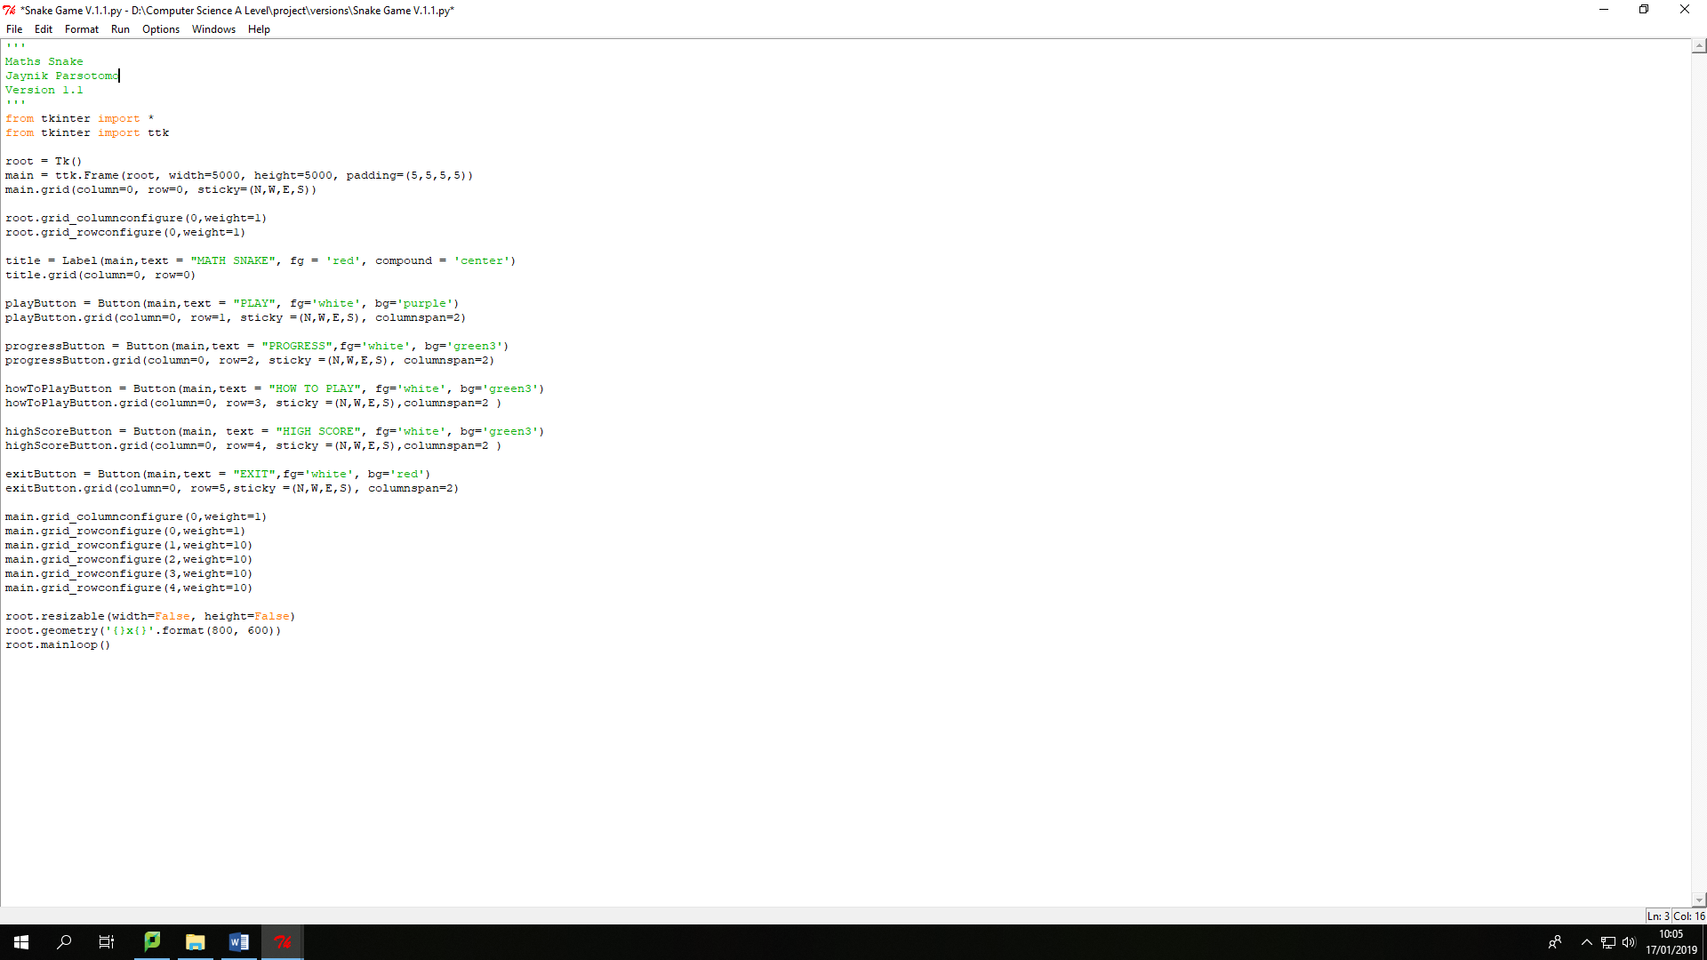In V.1.1, I have started to add in graphics to my app. In this version I have added in all the buttons that will be displayed in the Main Menu. These buttons should be the first element to be displayed to the user, when first opening the app.

This line of code, as the variable suggests creates a title. To create this, I used a widget that is available within TKinter, and the widget I used is call Label. To use this widget I used ttk.Label, this is so it retrieves the widget from ttk in TKinter.

Within the brackets which edits the properties of the label:

* Main – where the Label should be placed within, and main is the variable where I stored the frame. This is where all the content will be placed within
* Text – This adds text in the label, so I can place my title of the game into it. The title I have chosen is ‘MATHS SNAKE’, since I will be creating snake where you answer Maths questions.
* Fg – This is an abbreviation of foreground, which changes the colour of the text. I changed the colour to ‘red’
* Compound – This change the position of the Label in the grid, and I have used it to centre it.

The second line positions the title using the grid method. Within the brackets I have stated which column and row the tile should be within. I have selected the first row and column, 0 since it is the title.

These next lines of code create the main menu buttons, that user clicks to access other areas within the game.

To create these buttons, I have used another widget available within TKinter. The widget is called Button, which as the name suggests creates a button.

For each button I have used the same code with little variance. For each button I have used appropriate variable names that match the purpose of the button, so I can easily recognise the purpose of that code. The buttons that I have created for the main menu are: Play, Progress, How to Play, High Score and Exit.

Within the brackets for Button:

* Main – This place the button within the Frame
* Text – Allows to add text to the button
* Fg – Edits the colour of the text within the button. Changed it to white for legibility
* Bg – For this I have used a colour code from a website to get a desired green for the button. I used the following link: <http://www.science.smith.edu/dftwiki/index.php/Color_Charts_for_TKinter>

The code underneath the button code, is for the grid, as to where each button should be placed. I have placed each button in the same column but changed the rows, so each button is underneath one another.

New property code:

* Sticky – This spread the button out in all the directions, N = north, W = west, E = east and S = south, so it fills in the space.
* Columnspan - Lets a widget span more then one column

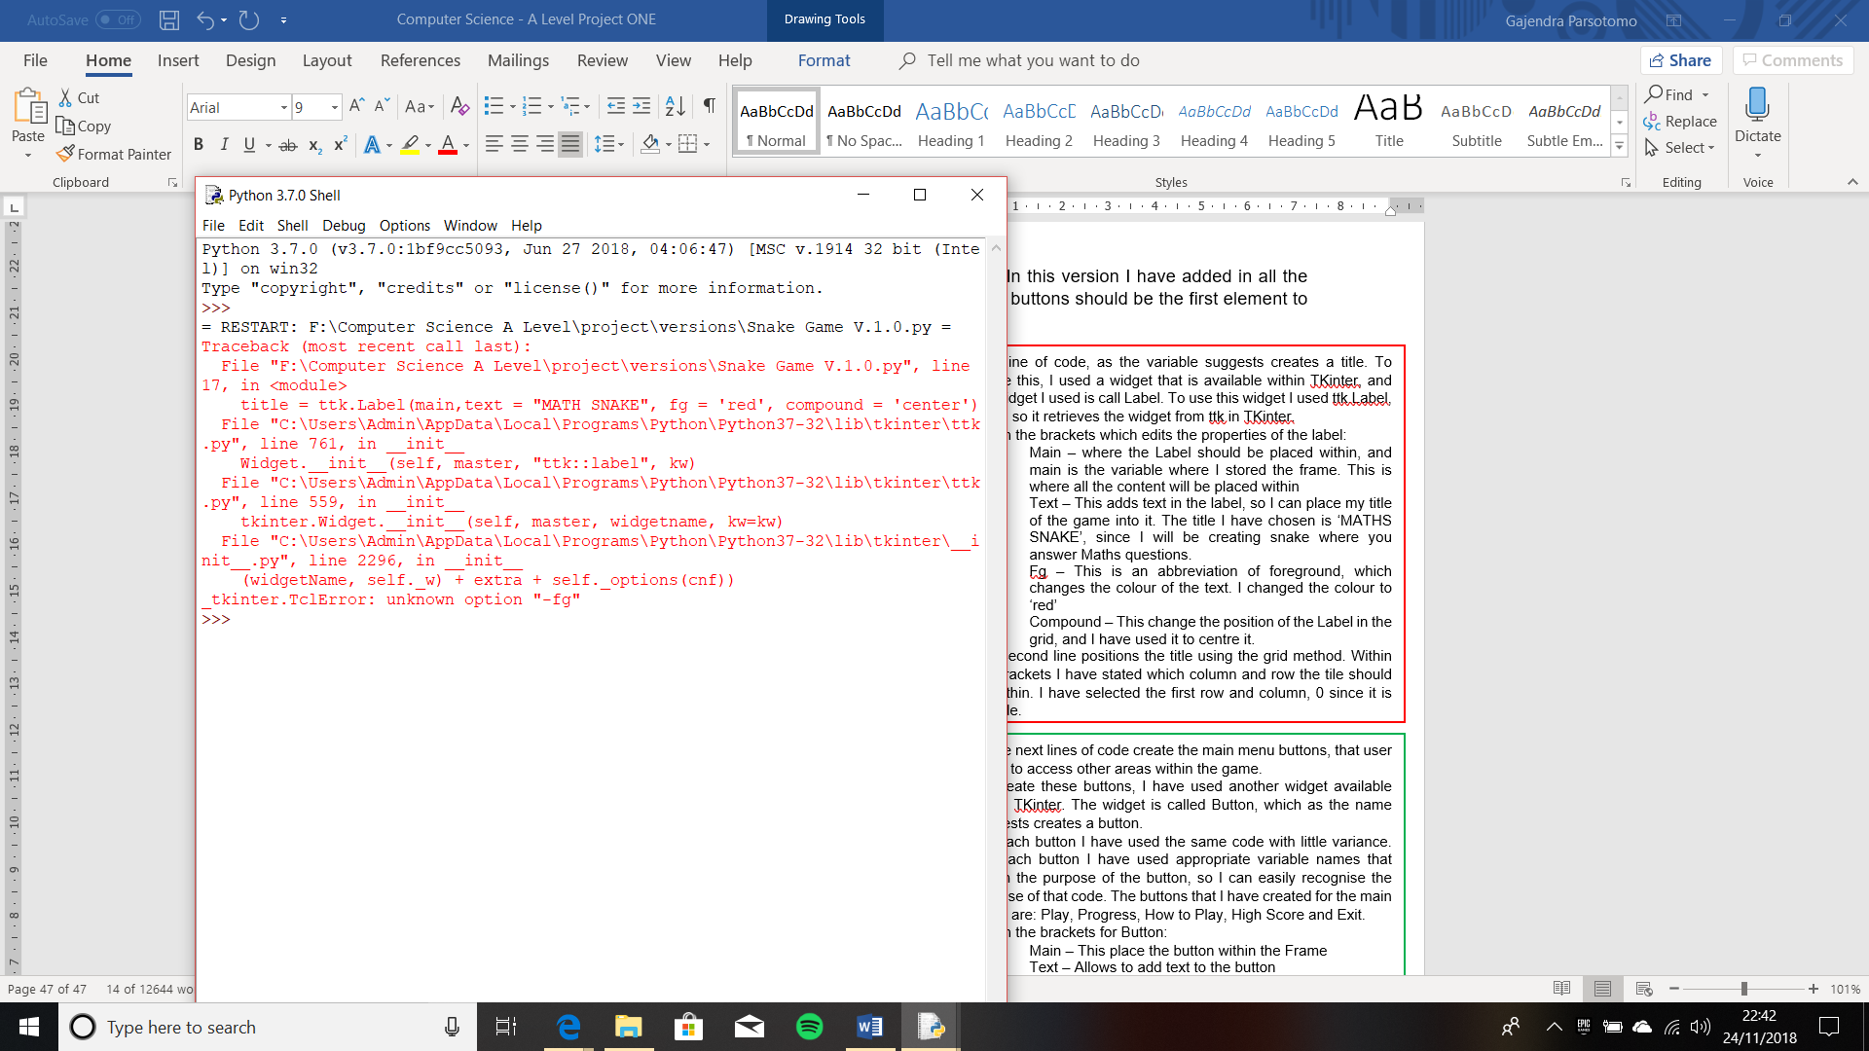

The configure part of the code allows me to edit properties of the grids.

**Output:**

  


The output I got from the code was not my expected output. The output I expected was the title ‘MATHS SNAKE’ positioned at the top, and underneath the title 5 buttons: Play, Progress, How to Play, High Score and Exit in respective order.

However, the output I got was an error, and a empty TKinter window. From reading the error message in the Python shell I found out the error I had made. The error I had made was that the instruction/code fg could not be recognised, which led the code to break. Therefore, I researched the solution online.

On the internet I found out that ttk has no attribute of fg, meaning I cannot use this instruction to change the foreground colour. In fact, there Is not easy way to change the colour. However, on website the solution was to use the widget without the ttk, as the widget on its own can be changed using the code fg, bg. Therefore, I edited the code by deleting the ttk, and just used Button and Label on its own

<https://stackoverflow.com/questions/27347981/how-to-change-the-color-of-ttk-button>

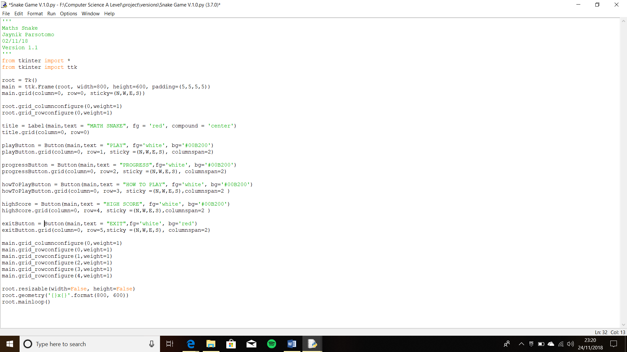



**Output:**

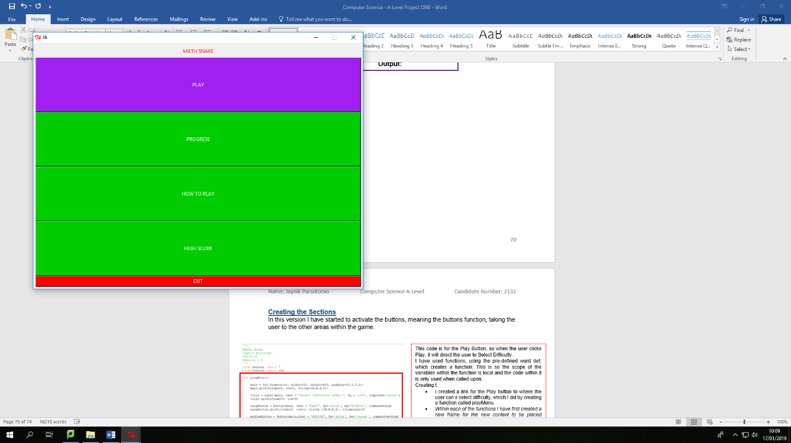

**Iterative Testing:**

**Test 1, No.1**

## **Creating the Sections**

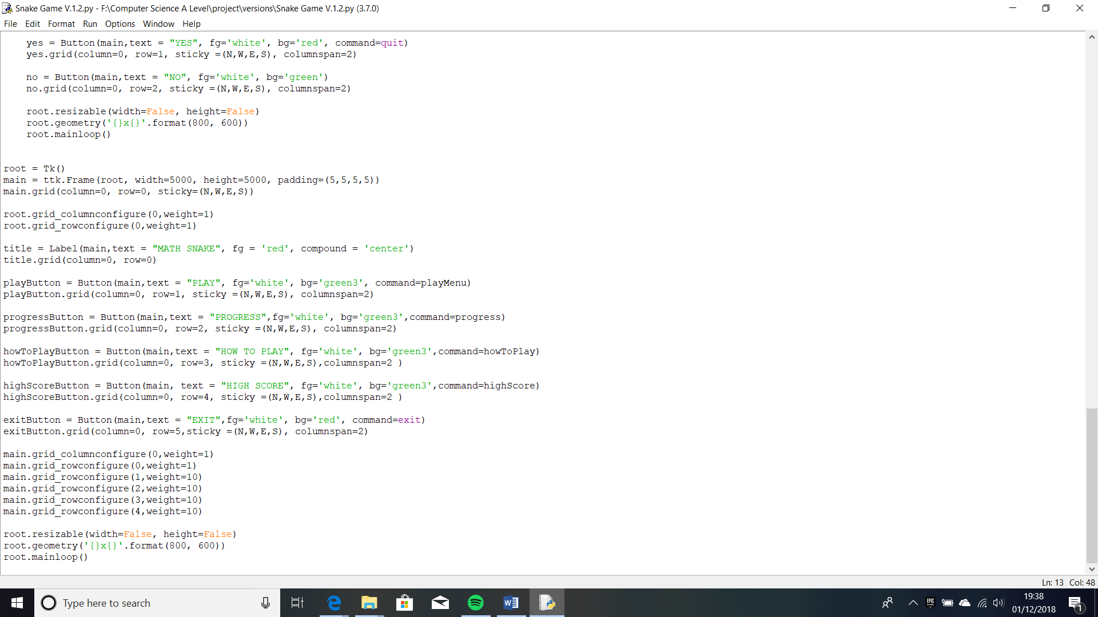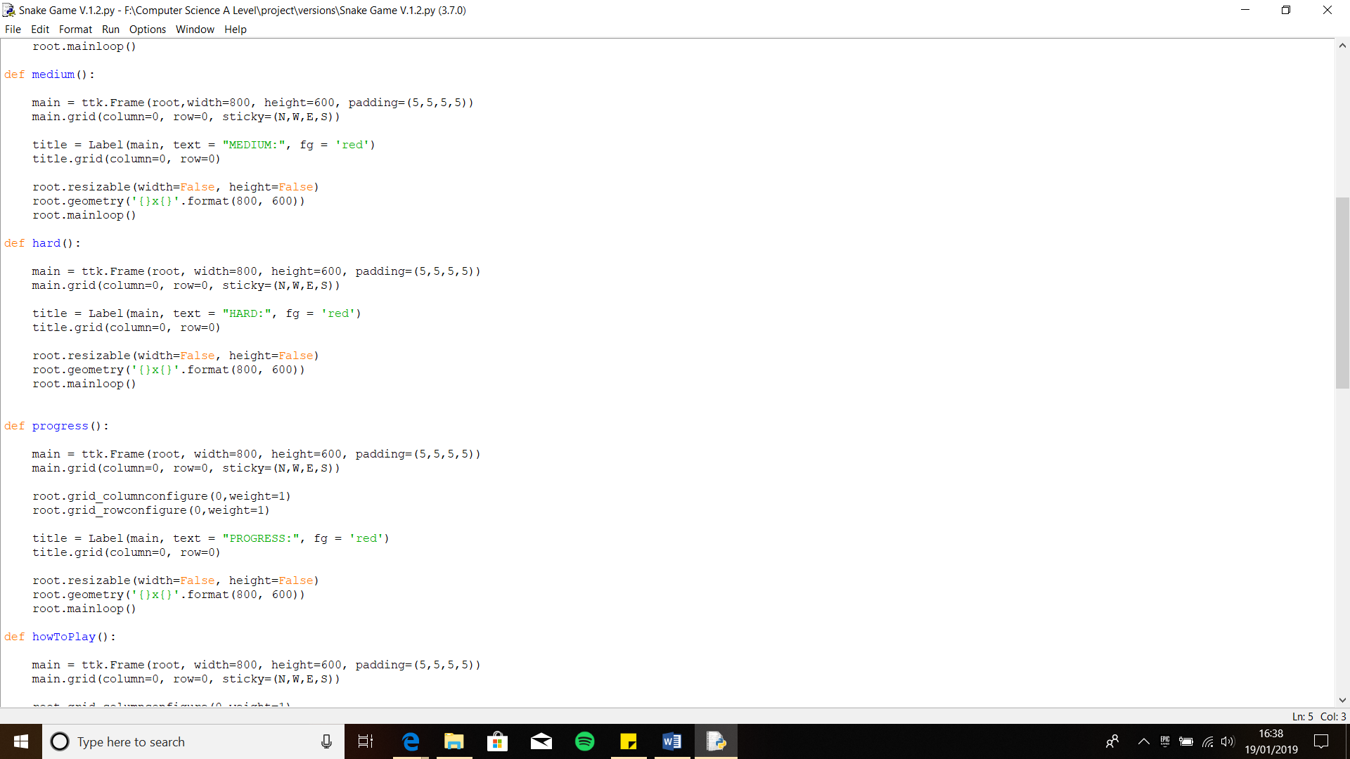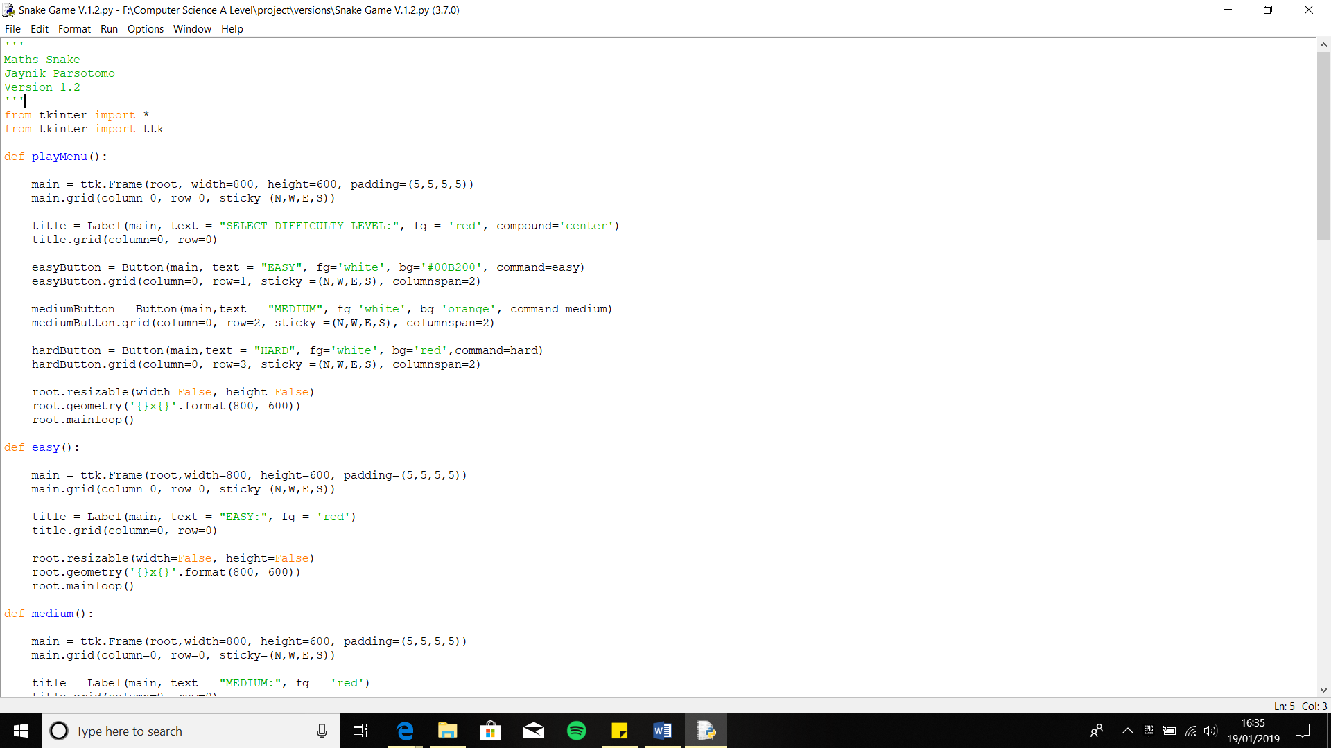 In this version I have started to activate the buttons, meaning the buttons function, taking the user to the other areas within the game.

This code is for the Play Section, so when the user clicks Play, it will direct the user to Select Difficulty.

I have used functions, using the pre-defined word def, which creates a function. This is so the scope of the variables within the function is local and the code within it is only used when called upon.

Creating the Play Menu:

* I created a link for the Play button to where the user can select difficulty, which I did by creating a function called playMenu.
* *Within each of the functions I have first created a new frame for the new content to be placed within. Followed by the title of the section, using the widget Label.*
* In playMenu I created the buttons for the difficulty levels that the user will select. The buttons I created were, Easy, Medium and Hard. For each button I created a suitable variable and used the Button widget. I used the same code to create these buttons as the buttons on the main menu with little alternation like colour and text. I coloured coded each of the buttons, for easier access: Easy = Green, Medium = Orange and Hard = Red.
* Then I created links for the difficulty levels button, so I defined separate functions for each one.
* To link the functions to the button, I used a attribute called command. This allows you to link the function to the button, so when the button is clicked the function is called upon thus allowing the user to access that section. To use this, you must put the command in the button that will be clicked to take the user to the area and make it equal to the function name.

This code is for the Progress Section, so when the user clicks Progress, it will direct the user to where the Progress Tracker table will be.

Creating the Progress Section:

* I created a link for the function called progress with the Progress button using the defined word of tkinter, Command
* Within the function I used Label to create the title ‘Progress’ and changed the colour to red using ‘fg’ and then I added all the general modification needed to make the code work within the tkinter window

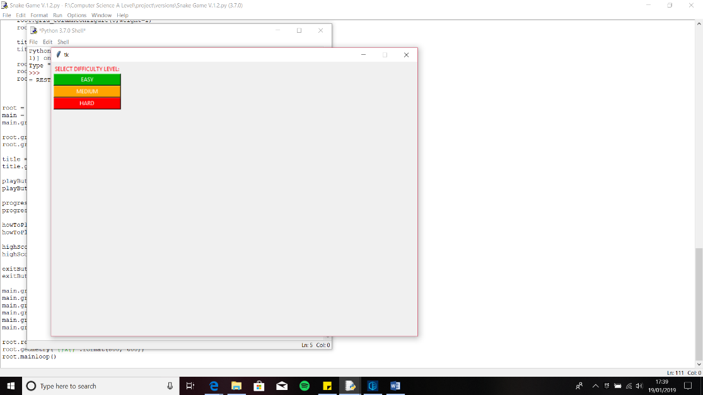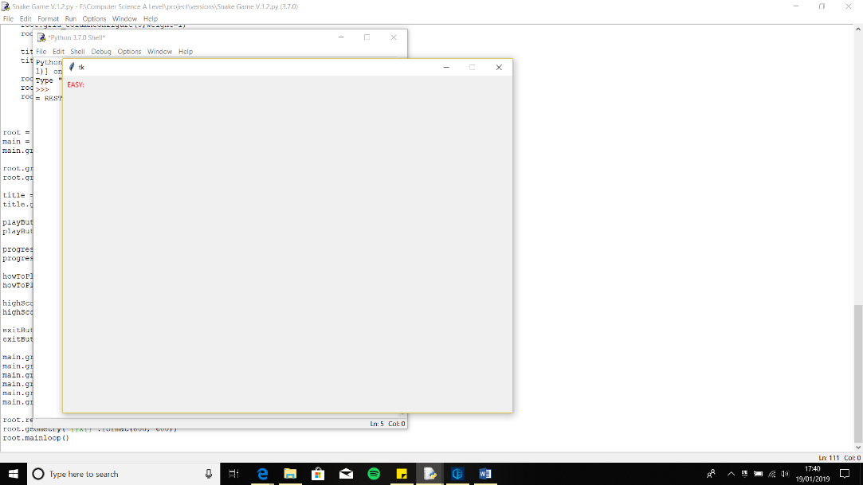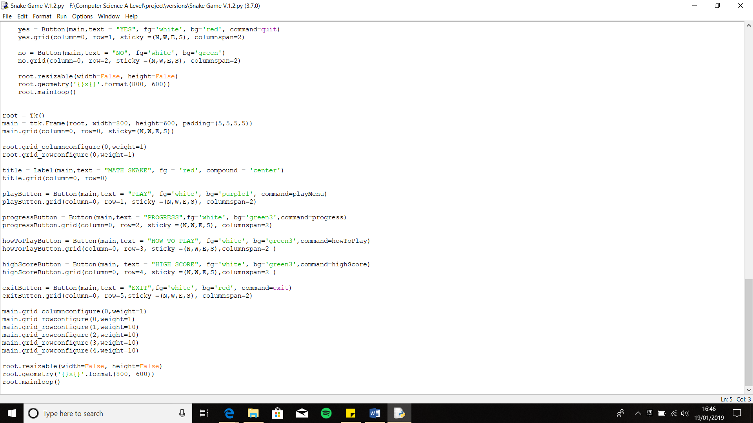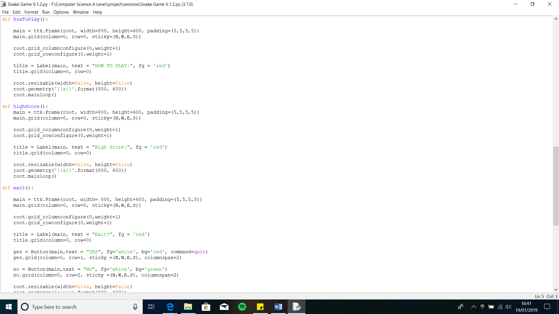

This code is for the How to Play Section, so when the user clicks How to Play, it will direct the user to where the instructions and controls are.

Creating the How to Play Section:

* I created a link for the function called howToPlay with the How to Play button using the defined word of tkinter, Command
* Within the function I used Label to create the title ‘How to Play’ and changed the colour to red using ‘fg’ and then I added all the general modification needed to make the code work within the tkinter window

This code is for the How to Play Section, so when the user clicks High Scores, it will direct the user to where the top 5 high scores for each level will be

Creating the High Score Section:

* I created a link for the function called highScore with High Score button using the defined word of tkinter, Command
* Within the function I used Label to create the title ‘High Score’ and changed the colour to red using ‘fg’ and then I added all the general modification needed to make the code work within the tkinter window

This code is for the Exit Section, so when the user clicks Exit, te game will close down

Creating the Exit Section:

* I used command to make the button equal to the pre-defined function exit in python so when the user clicks the Exit button the game closes

**Output:**

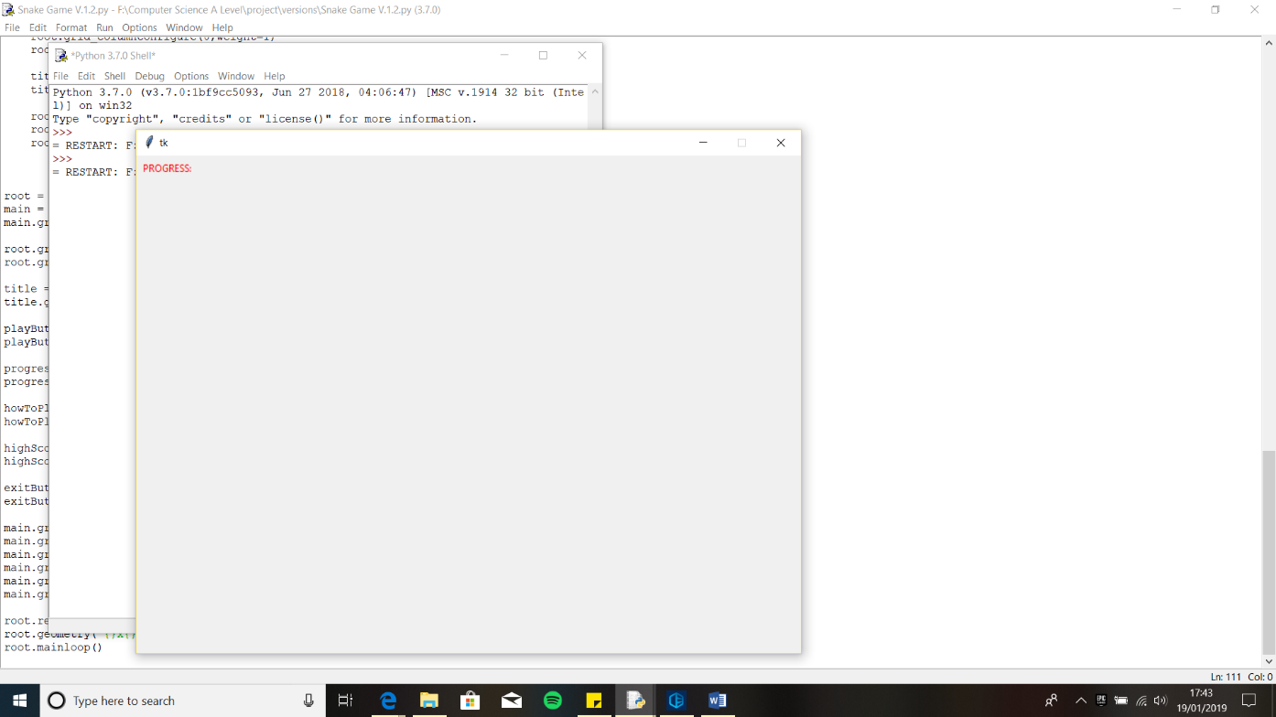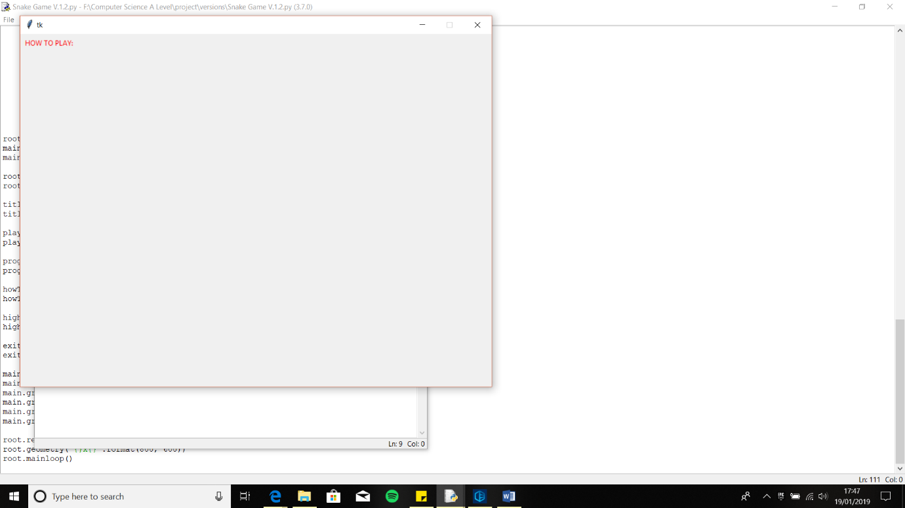

**Iterative Testing:**

**Test 1, No.2**

The output I got from my code was not the output I had expected. The reason being is that when I click play the title and the buttons were small and squashed in the top left corner, this happened on every new section. The code itself works fine as the title and the button and function of the buttons appear to work but the wat everything is laid out and size of it is not what I had hoped for. However, my exit button and using the exit function had worked perfectly

To try and solve this problem, I thought of using the sticky function within tkinter which sticks the object, like a button to each direction of the frame and thus the button would expand out. Therefore, I edited the code, so the buttons now have sticky within button brackets. However, when I ran the code, I received the same output.

Even though my fix did not work this had given me a hint as to how to solve this problem and what is causing it. Within each of the function I have created I also recreated a new frame, therefore al the new content buttons, titles will be placed within the new frame. However, the new frames are local thus they are not affected by the global variables, like weight. In the original frame I have changed the weight which edits the amount the button expands. This means if I increase the weight the buttons should expand within the new frame however this sought of method is incredibly inefficient. Furthermore, I have no space for the ‘Home’ button to be placed if I use weight in all of the frames. Therefore, I thought I’d change the style of my code by making the new content appear in the one frame by clearing the frame.

**Error: Incorrect Output, Buttons Displayed Incorrectly**

## **Improved Main Menu**

In this improved main menu, I used different frames for the different parts of the main menu. I have created different frames for the navigation button, which is for the ‘HOME’ button, a title frame, which will contain the title for the section and finally a body frame which is used for the actual game content.

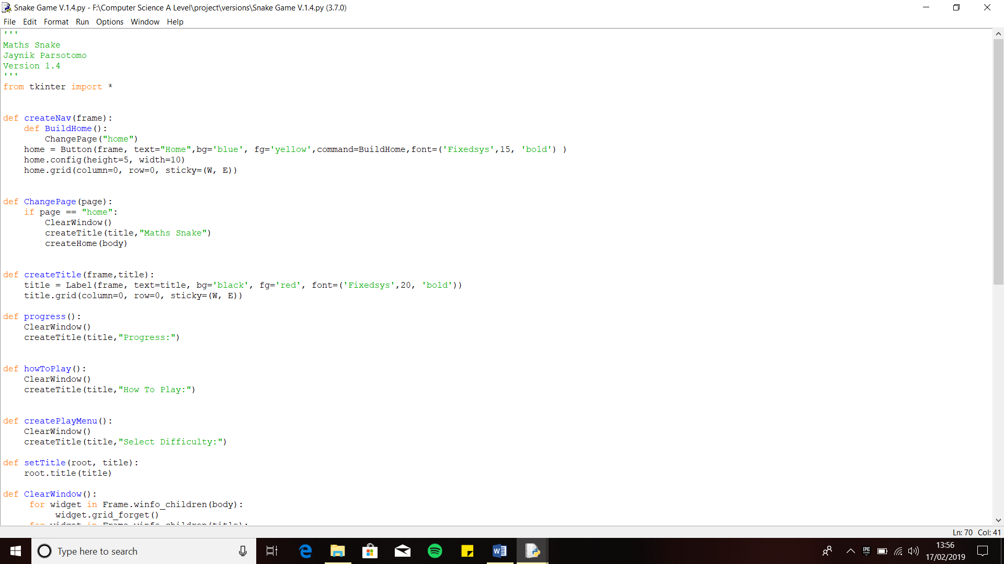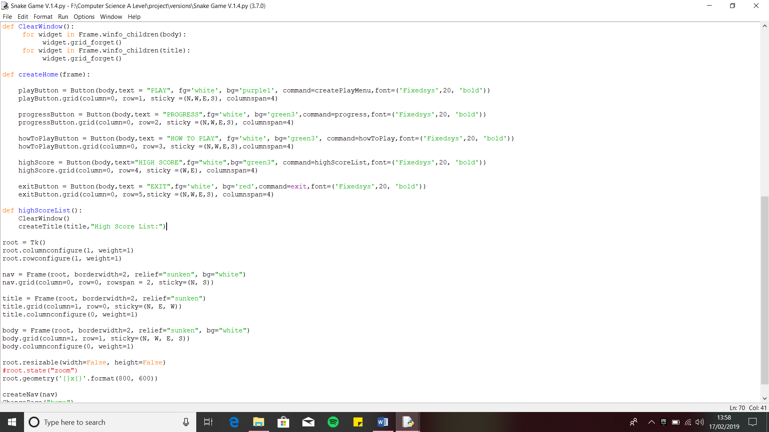

This section of the code creates the different frames, and I have saved them to the appropriate variables.

For the home button I have saved the frame to the variable name nav, since the frame is used for navigation to the main menu and also it keeps the name separate from the home button variable. For the title frame I have saved it within the variable called title, since it will contain the title for each section and the body frame, I have used the variable name body. For each frame I have used the grid method to place the frames where I want it to be and I have given the body and frame weight so they fill in the whole space of the tkinter window.

The code ‘relief = ‘sunken’, changes the way the frame will look like, so the frame isn’t as obvious. This is achieved by the word ‘sunken’.

The function ‘createHome’ as the name suggests creates the Main Menu. Within the function I have passed the parameter ‘frame’, so the Main Menu is placed within the frame.

Within the function the following buttons are created:

* Play Button
* Progress Button
* How to Play Button
* High Score Button
* Exit Button

These functions create the Navigation for the Home button. I created a function called ‘createNav’, passed a parameter ‘frame’ again. Within the function ‘ChangePage’, it allows the page to change to the Main Menu when the Home button is pressed.

Within the function **createNav:**

* Created another function called ‘**BuildHome’**
  + This function will create the Main Menu when home is clicked by the user, by calling the function ChangePage
* The function also contains the code that makes the button, linked to the Build Home, calls itself (recurrence), so the button can be repeatedly pressed

Within the function **ChangePage:**

* I have an IF statement so that if the home button is pressed the function within the IF statement are called upon in a sequence:
  + ClearWindow – delete the current page content
  + CreateTitle – Create the title within the frame title, called ‘Maths Snake’
  + CreateMainMenu – Loads the Main Menu buttons into the body Frame
* I have used an IF statement so that if necessary, I can add more Navigation Buttons to the Nav Frame if needed

These functions help to make it easier for me to change pages and create titles for sections.

**createTitle function:**

* Passed the parameters frame and title, so I can create a title within the frame
* I have also created a variable called title, and using the tkinter pre-defined function Label will create the title
* I have also modified the title to my client’s design, the colour and font he wanted.

**setTitle function:**

* Passed the parameters root and the frame title, as the title will be set within the root
* Root.title(title), creates the actual title within the root

**clearWindow function:**

* This function is used to empty out the tkinter window so new content can be loaded
* I have used the tkinter pre-defined functions widget, winfo_childern and forget()
* Used these codes to check the widgets, the attributes of tkinter, within the frame, which are called the children and then used the forget function to delete the widgets within the specified frame, ‘body’
* I have used this for the frames of the body and title, so I can empty and change their content more efficiently using all the function together

**Output:**

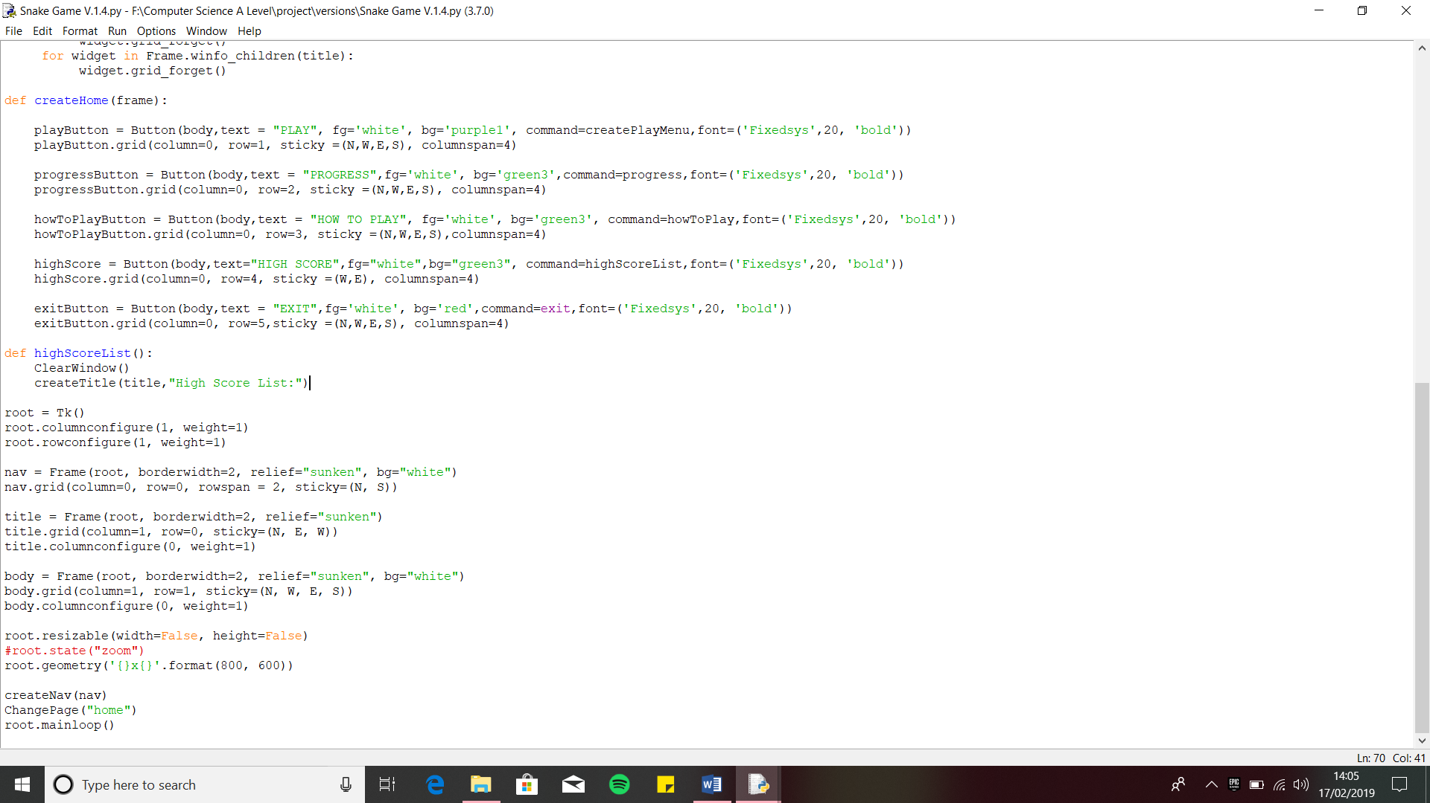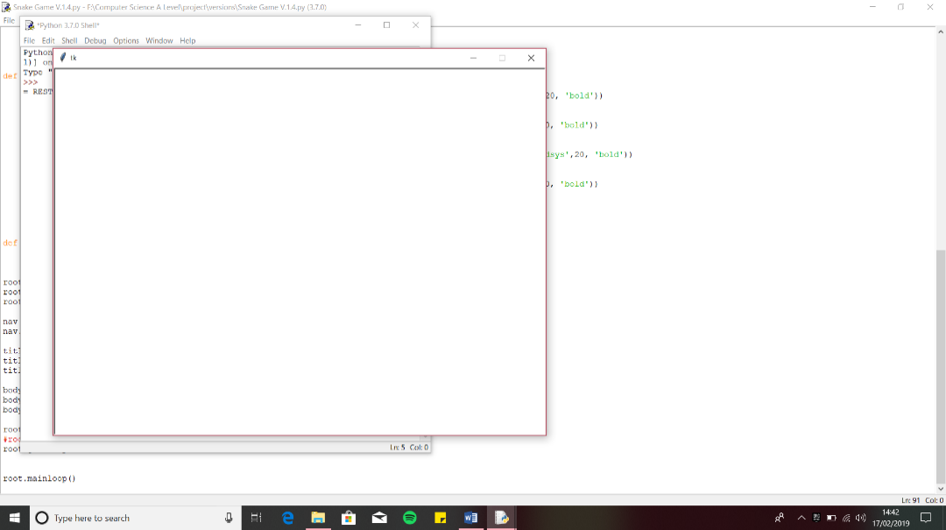

These are the lines of code I added which call the functions, so when program is running the first thing to be called is the Main Menu thus the user will see that first.

‘root.mainloop()’ makes sure the program keeps running, so when an action is completed the program doesn’t stop running or close itself, until it is ended by the user themselves.

When I ran the program, this is the output I received. The reason I got this output was because I forgot to call the function. Therefore, I add the following code:

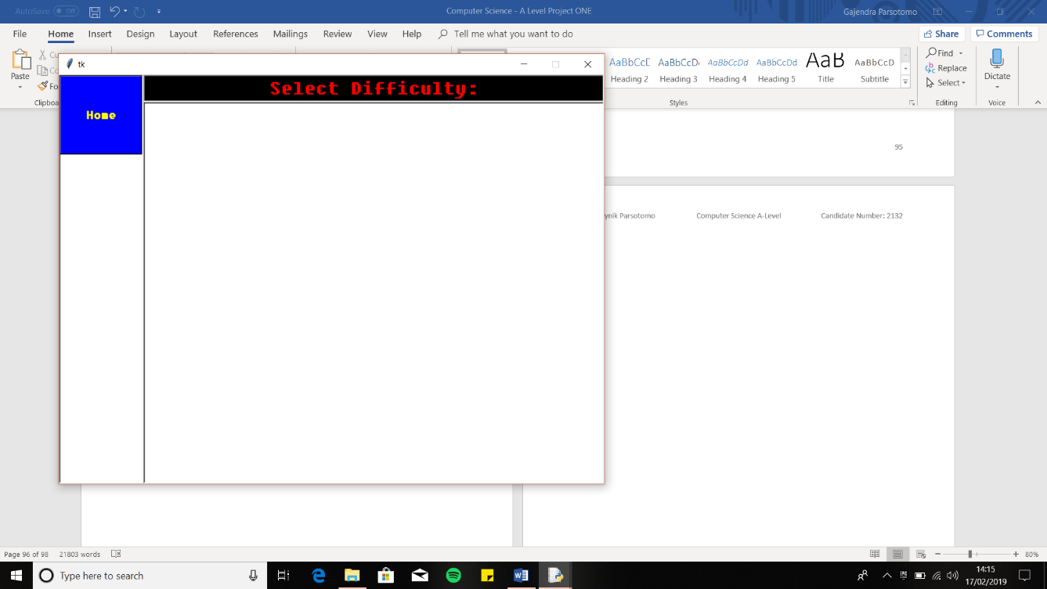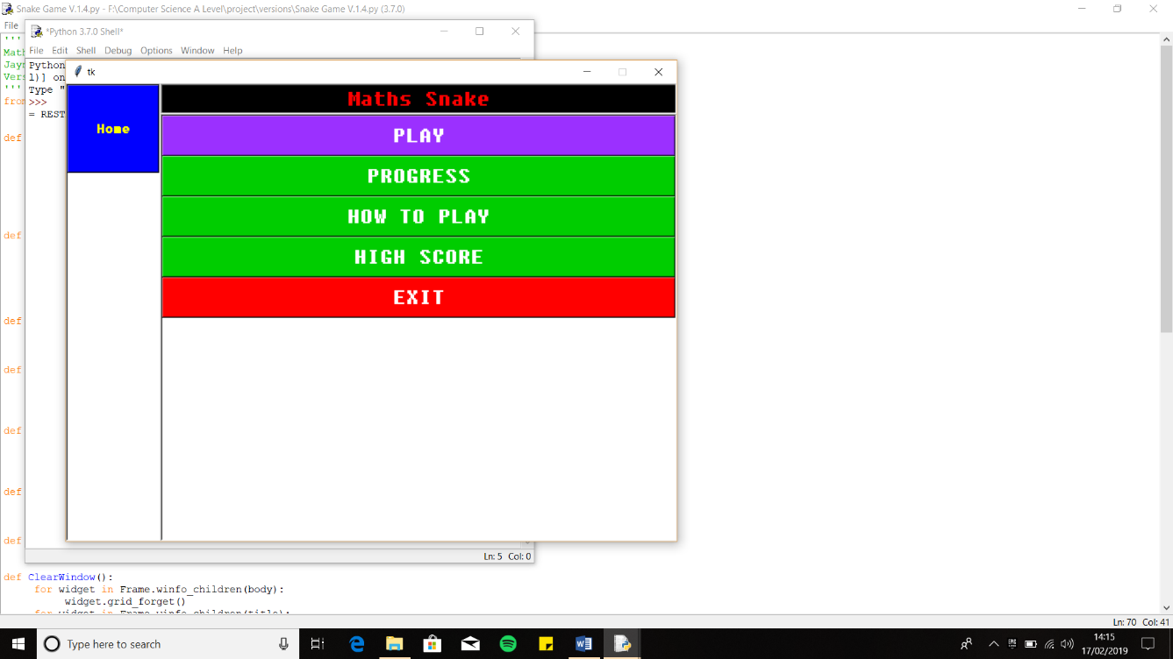

**Error: Incorrect Output, No Main Menu Displayed**

**Iterative Testing:**

**Test 5, No.1**

**Iterative Testing:**

**Test 15, No.1**

Within the code I have created functions for each button and within each function I have placed the functions that I have just created so I can test whether they work or not.

When I ran the program, I got the expected outcome, which was the Main Menu and the home button showing.

Finally, I tested to see if the ‘Home’ button works when clicked. It should direct the user to the Main Menu.

When I clicked it, it directed me to the Main Menu thus giving the correct output.

Then I tested out if the functions ‘clearWindow’ and ‘createTitle’ function or not. To do this I clicked ‘Play’ and the content of the Main Menu should be cleared, and the title being replaced with the section name.

I got the expected output where the body frame and the title frame where cleared out and the title frame content being replaced with the new specified title.

## **Creating How to Play Section**

In this Version, 1.5 I have now started to add the necessary features to the How to Play section, that my client wants which are, Instructions, Controls and How to use Progress.

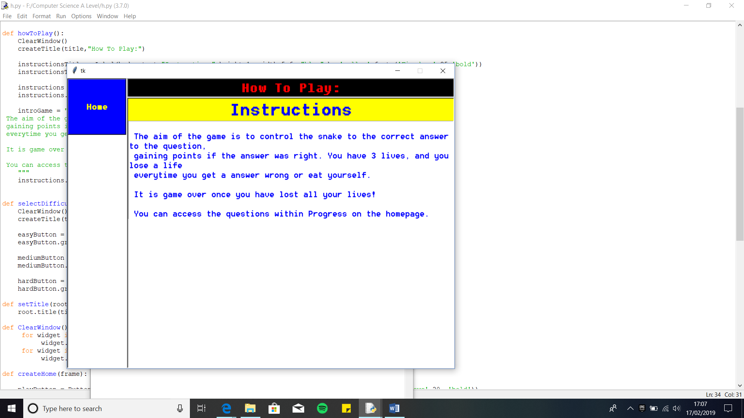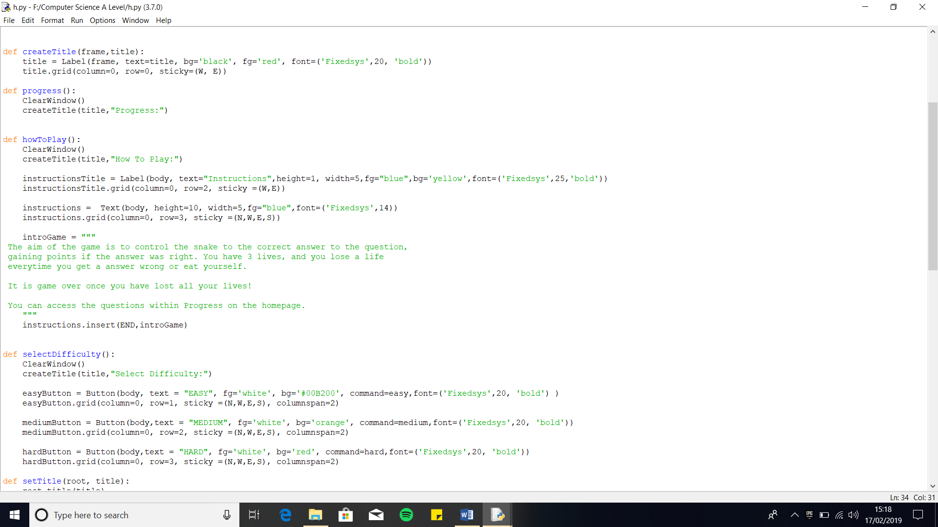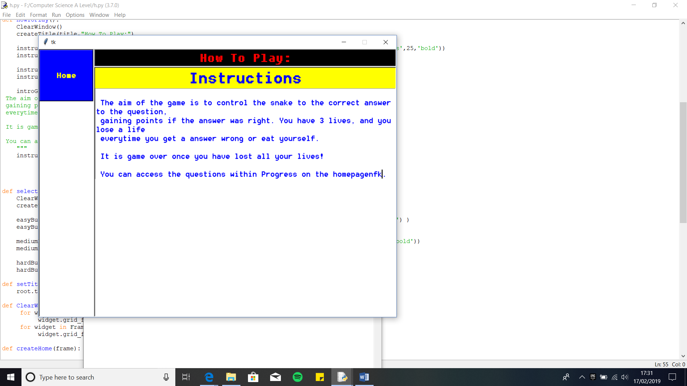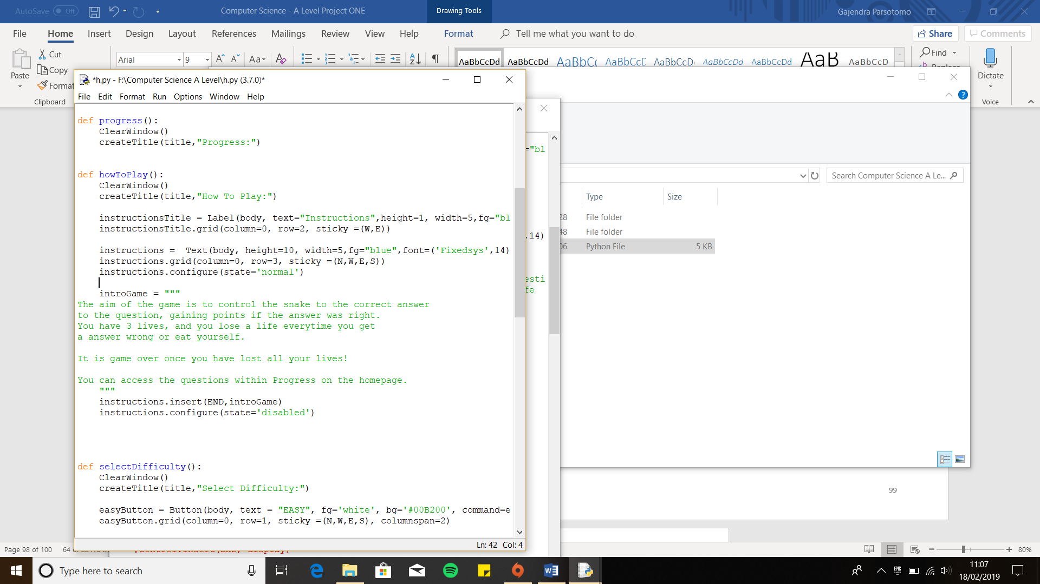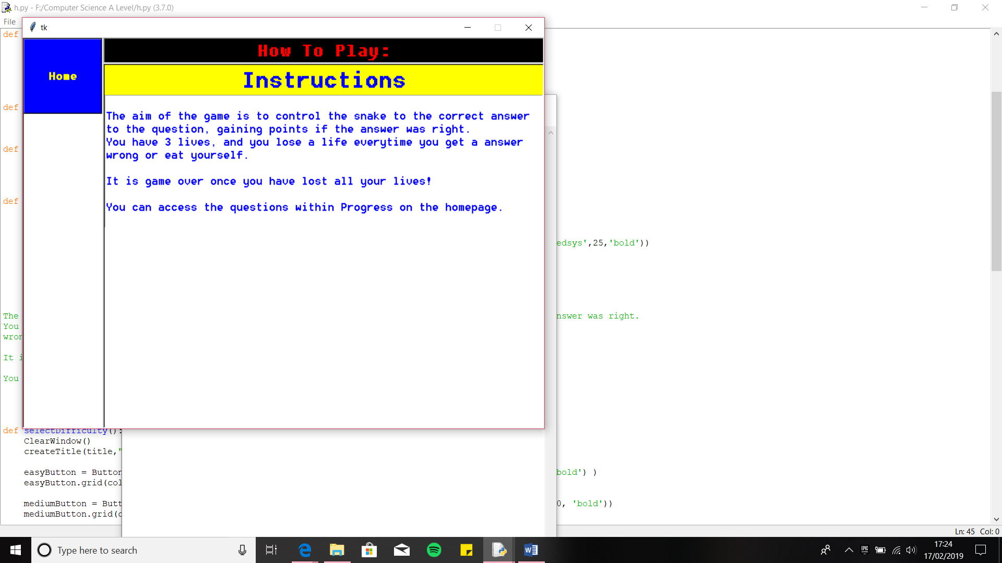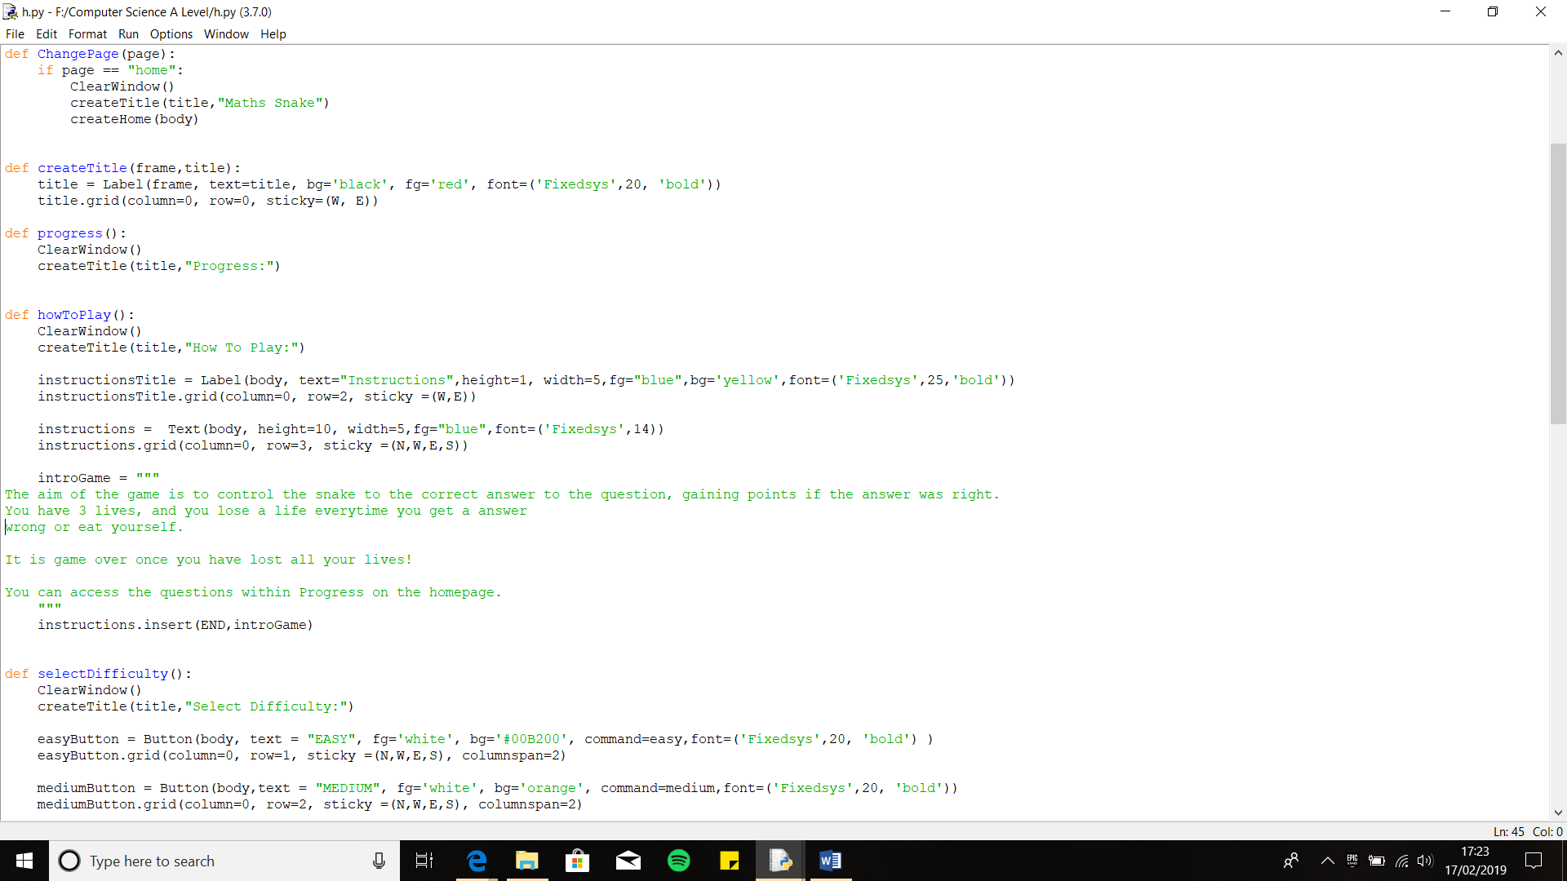

For the How to Play section, I will need to have 3 sub-heading section. These lines of code create the first sub-heading section the user will see, Instructions. For this I have created the variable instructipnTitle, where using the pre-defined function tkinter, Label I created this heading. I have then edited the properties of the Label, by changing height and width, colour of the text and background and the typeface style to suit my clients need according to the success criteria.

I then needed to add the actual Instruction underneath the title, however I can’t do this using ‘Label’, therefore I researched a method available in tkinter that allows me to add lots of text at once. Online I found a widget within tkinter called ‘Text’ from <https://www.python-course.eu/tkinter_text_widget.php> this allows me to display text however I want. I saved this to a variable called instructions, and I added the properties that the text style should be.

Then I created a new viable called introGame, which will contain the actual text for the game instructions. I used three speech marks, so I can create a multi-line quote, so I can type all the instructions at once. Finally to the instructions into the variable using Text, I found you can do this using ‘.insert’. Using this with the parameters END, which corresponds to the position just after the last character, so it ends right after the last character, followed by the actual text to be inserted, in my case the variable introGame is the parameter.

**Output:**

The outcome I received was correct, with the Heading appearing and the text as well. However, the error I received is a logical error, since the text is uneven, with sentences starting on a new line.

To fix this I just need to change the text positions within the variable introGame, by adjusting the spaces so they become even.

**Error: Incorrect Layout**

**Iterative Testing:**

**Test 3, No.1**

**Error: Allows Editing**

This is the fix I found, where you must state it can be edited and then disable it.

To do this I used configure widget and within he brackets I can use ‘state’ to ‘normal’ at first so I can edit the text widget by inserting the instruction text. But then I must disable the editing, using the same method but make ‘state’ equal to ‘disabled’

However, I then realised another problem which I was able to add text to the sentence, in other words editing was enabled.

To try and solve this I went online to try and find a solution where I found a solution on <http://effbot.org/tkinterbook/text.html> and on this website I found how to disable editing. To disable it I have found you need to state it.

After adjusting the spacing the text now fits within the frame perfectly without any words or lines straight on the next line randomly.

The next sub-section I coded was the Control, where I must display an image of the controls to controls the snake that my clients wants.

This is the Image I have chosen (link below):

<https://www.google.com/url?sa=i&rct=j&q=&esrc=s&source=images&cd=&cad=rja&uact=8&ved=2ahUKEwi11Zr-l8XgAhUpBGMBHfIgCXwQjRx6BAgBEAU&url=https%3A%2F%2F2567910.github.io%2Fgame%2F&psig=AOvVaw2Dhyp07DFSt4I6Ohn_wiLG&ust=1550576028513873>

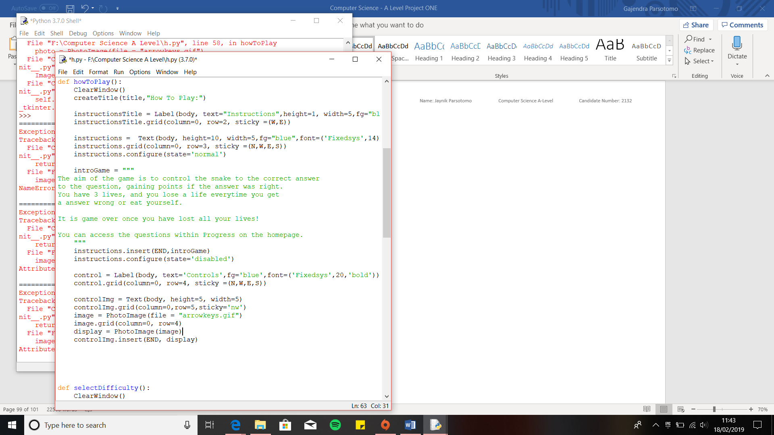[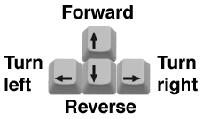](https://www.google.com/url?sa=i&rct=j&q=&esrc=s&source=images&cd=&cad=rja&uact=8&ved=2ahUKEwi11Zr-l8XgAhUpBGMBHfIgCXwQjRx6BAgBEAU&url=https://2567910.github.io/game/&psig=AOvVaw2Dhyp07DFSt4I6Ohn_wiLG&ust=1550576028513873)

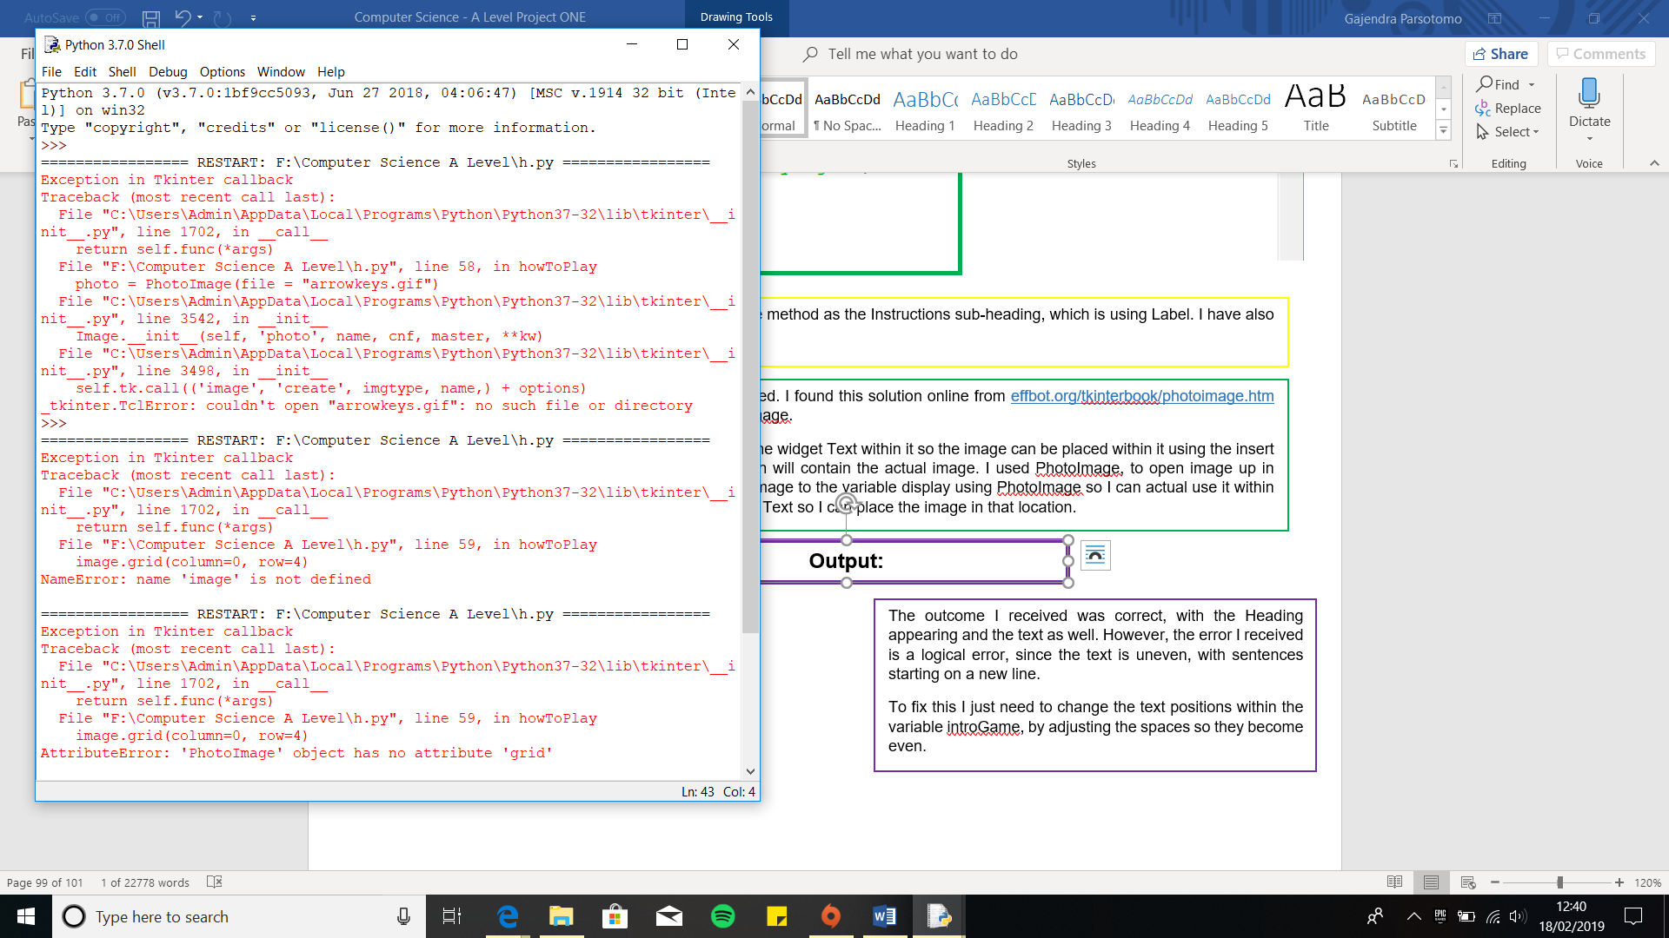

When I ran the program, I received an error. The error was that the image I wanted to open within the program, couldn’t be opened as it did not exist.

I received this error because the image file was in a different location to program’s location. Both files need to be stored in the same location for the program to be able to access the image from the file. Therefore, to fix this error I moved the image file to the same location as the program file.

**Error: Image file not found**

**Output:**

This is the section that allows the image to be displayed. I found this solution online from effbot.org/tkinterbook/photoimage.htm where I found you need to use a widget called PhotoImage.

I first created a variable called controlImg, and I used the widget Text within it so the image can be placed within it using the insert function. I then created a variable called image, which will contain the actual image. I used PhotoImage, to open image up in program, by opening the file name. Then I saved the image to the variable display using PhotoImage so I can actual use it within the tkinter window. Finally, I used the insert function for Text so I can place the image in that location.

I first created the sub-heading, controls using the same method as the Instructions sub-heading, which is using Label. I have also changed the properties to match my client’s criteria.

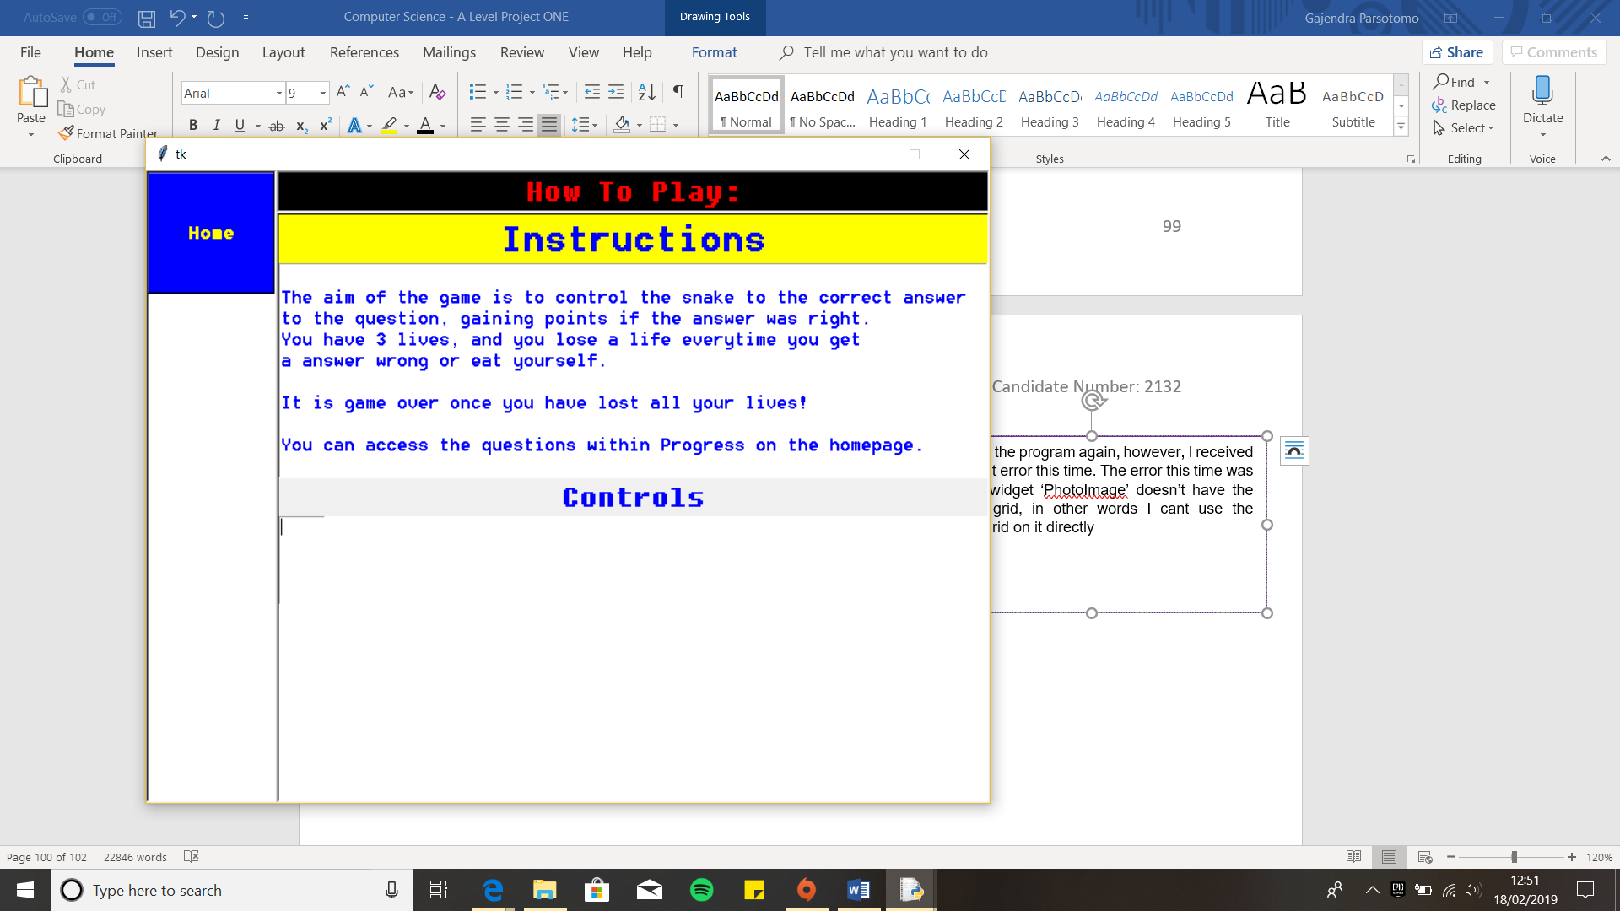

I then ran the program again, however, I received a different error this time. The error this time was that the widget ‘PhotoImage’ doesn’t have the attribute grid, in other words I can’t use the method grid on PhotoImage. Furthermore, because I have used the ‘Text’ widget I am still able to edit text on it, which means I either need to use the ‘state’ method or use a different Widget.

**Error: Grid method cannot be applied directly on PhotoImage and editing is enabled**

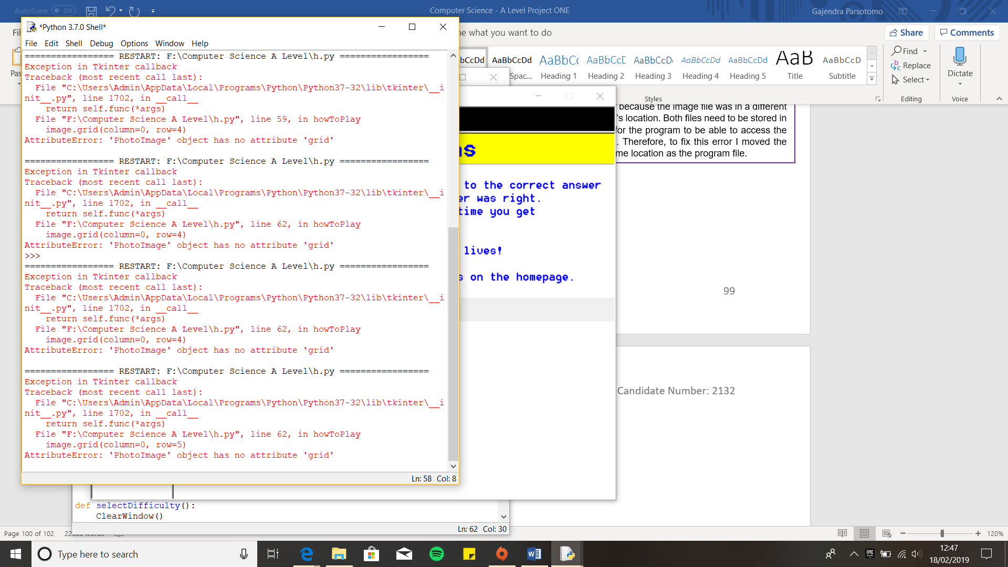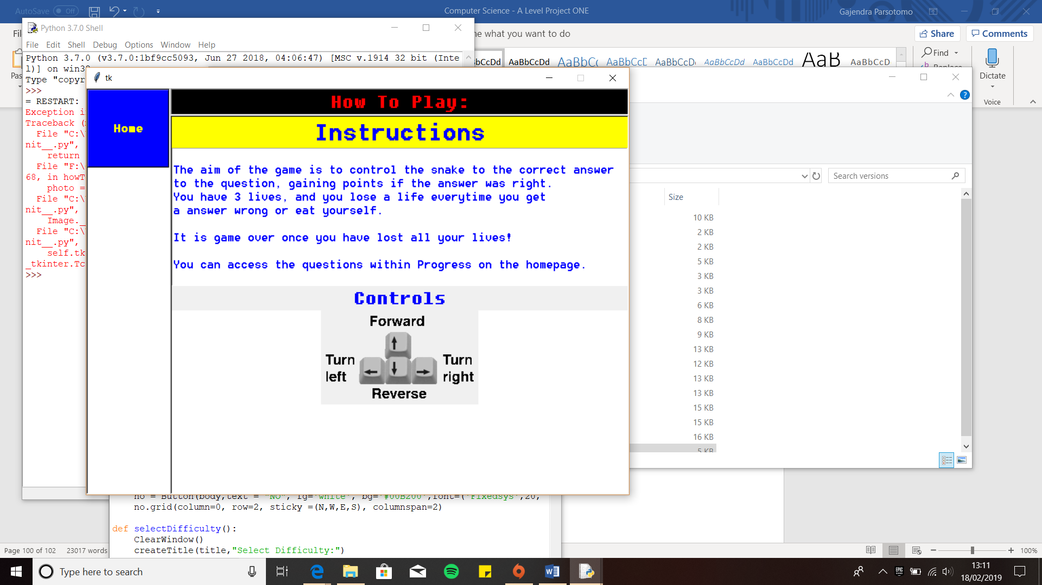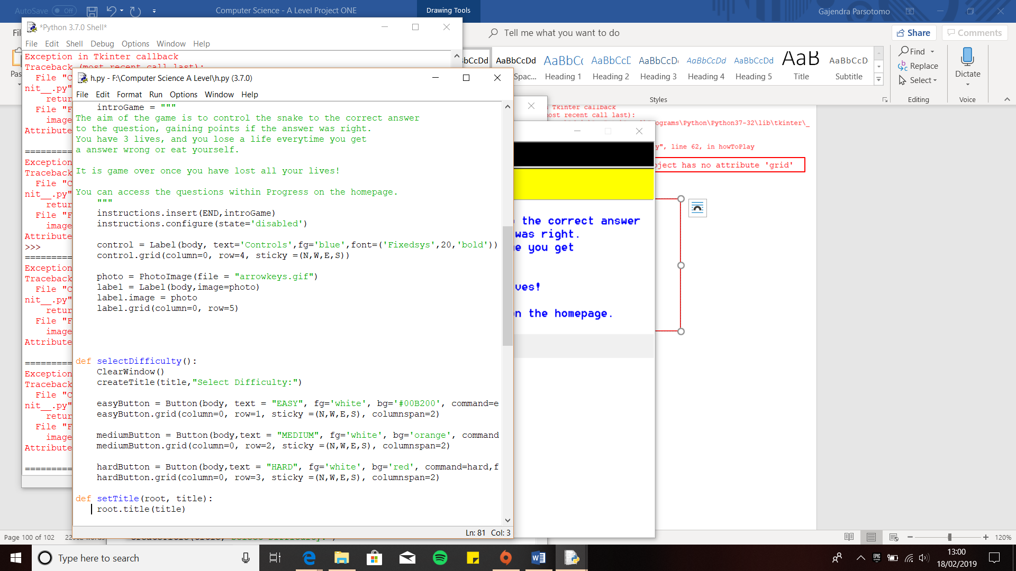The next sub-section I coded was ‘How to use Progress’, which instructs the user as to what 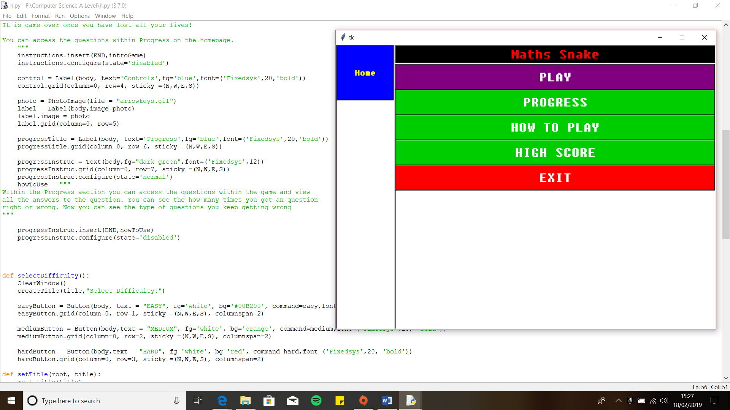the progress tracker will show.

**Iterative Testing:**

**Test 3, No.2**

This is the output I received after implementing the code. The Image now shows up, in the correct position error-free.

To fix this, I decided to approach this in a different way. From the site I found this method on they used Label, therefore I decided to do this the same way.

I first created a new variable called photo, which stores the and opens the image, using PhotoImage. Next, I created a variable called label, which is where I will use the widget ‘Label’. Within the widget I have made another viable called image and assigned the variable photo to it. Next following the method from the site, to prevent garbage-collection by Python, this keeps the reference, so it keeps displaying the image. Finally, I used the grid method on the label so state where the image should be positioned.

**Output:**

To create this sub-section, I have used the same method of coding as I did with the instruction sub-section.

I have created a variable for the sub-section heading called ‘progressTitle’, and variable for the instructions, called ‘progressInstruc’. Finally, a variable called howToUse for the actual instructions. I have implemented the same method using the text widget to display the instructions.

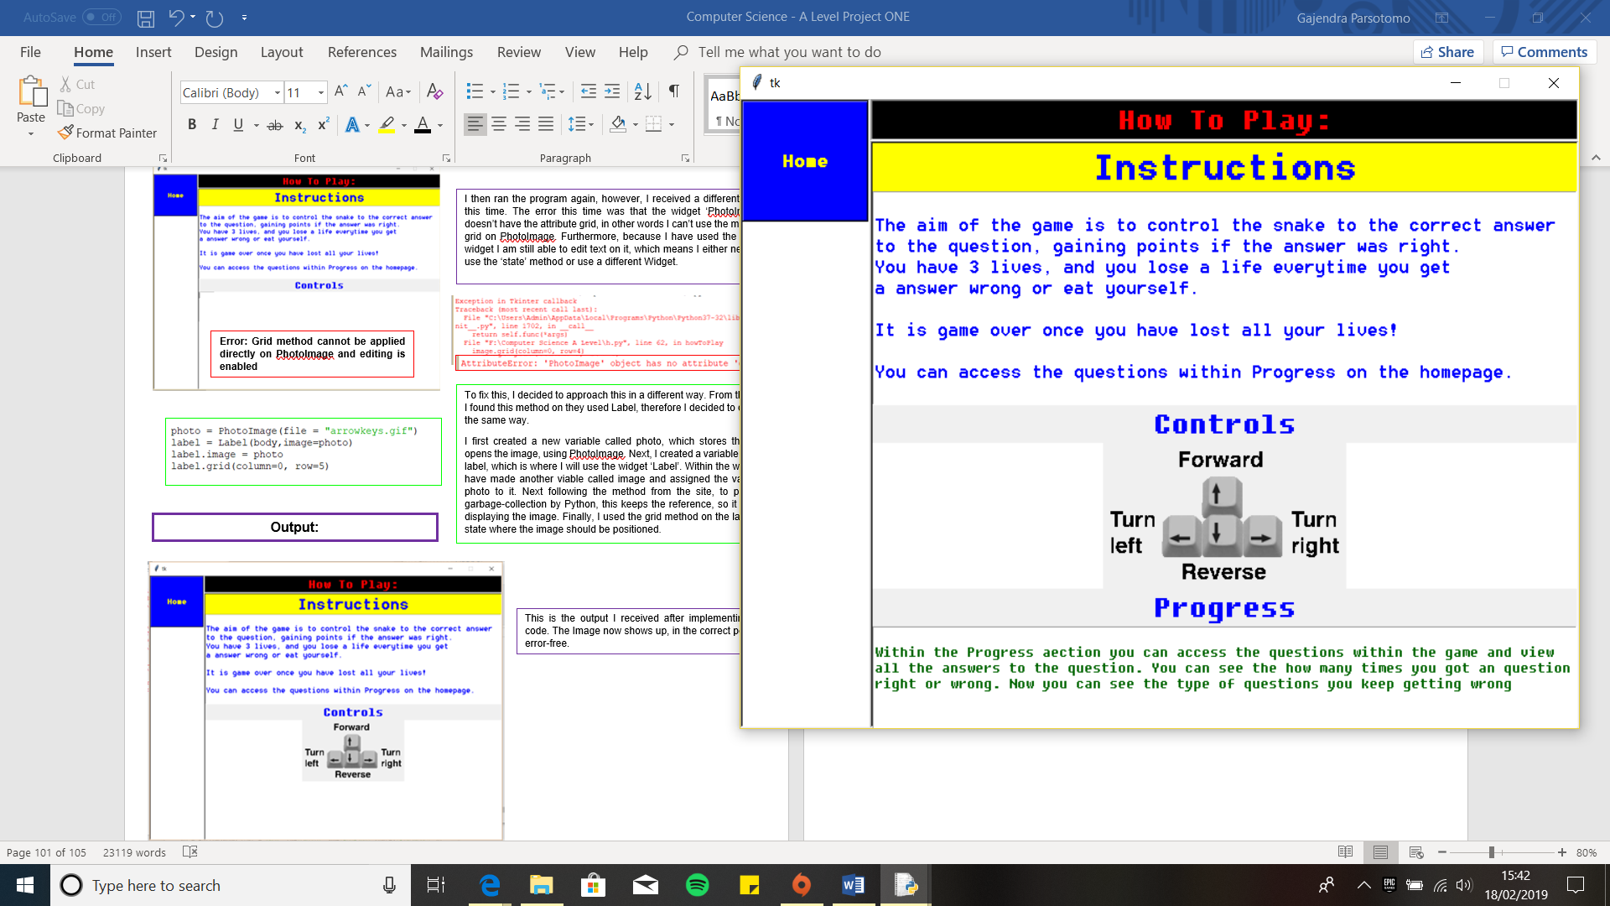

**Iterative Testing:**

**Test 3, No.3**

This is the output the whole How to Play section. The Progress sub-section is outputted correctly with the sentences in the correct layout.

With the last section completed the How to Play section has been fully coded with little corrections left.

**Output:**

## **Creating Snake**

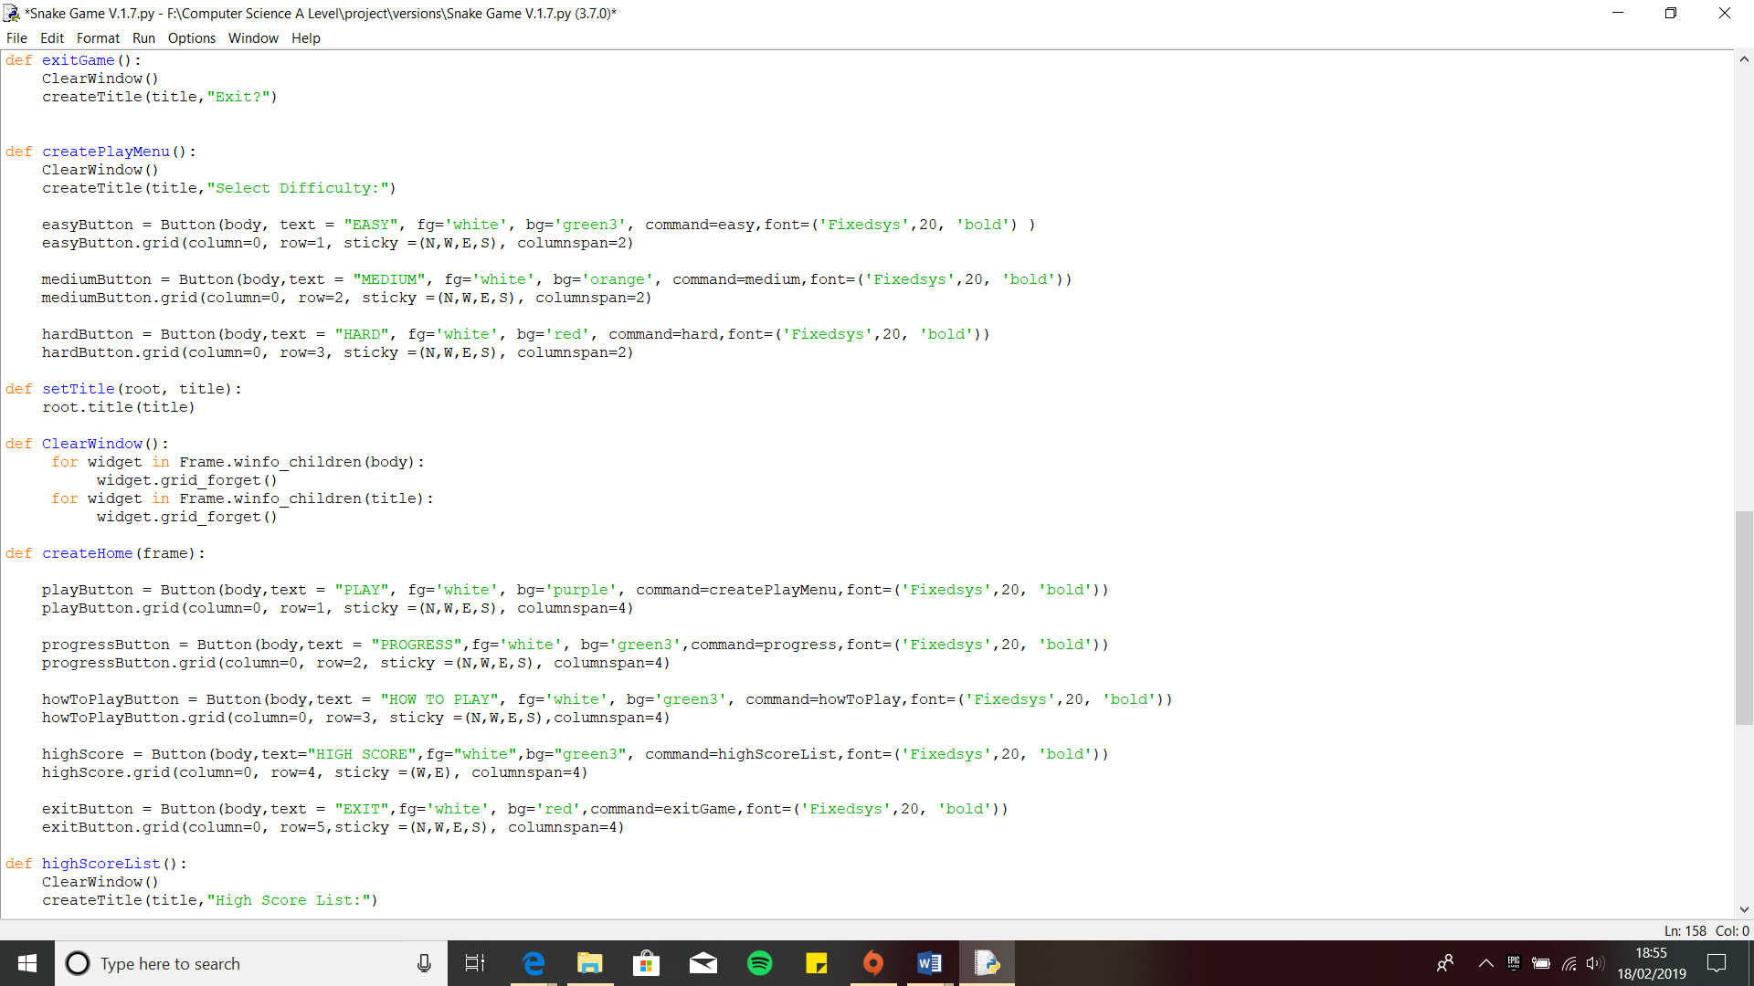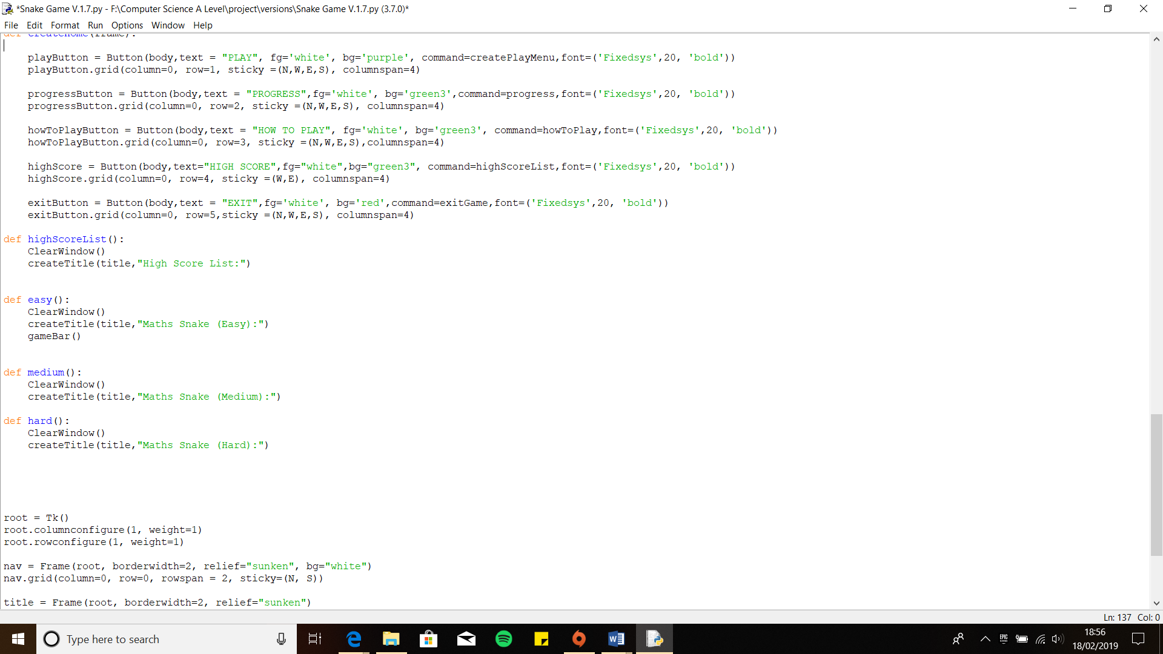In version 1.6, I started to code the game. The first part of the game I have decided to code is the actual game Snake. For the Snake game I have Object Oriented Code, because it is more efficient to code the game this way then using procedural as there will be repeated actions.

I first added four functions which will lead the user to the game section.

createPlayMenu function contains the Select Difficulty Level Menu. It has the following buttons Easy, Medium and Hard.

Then for each button I have created a function which will contain the game.



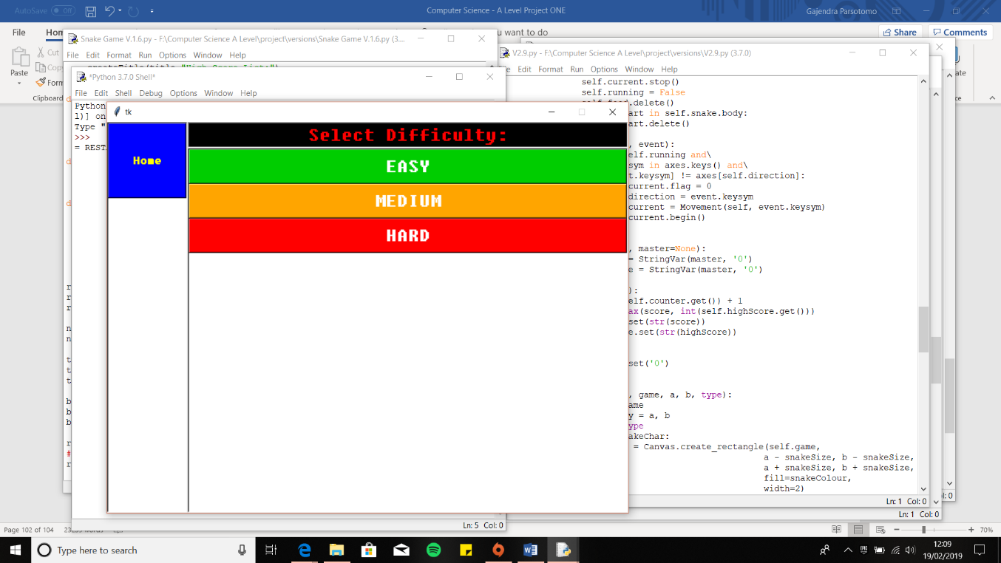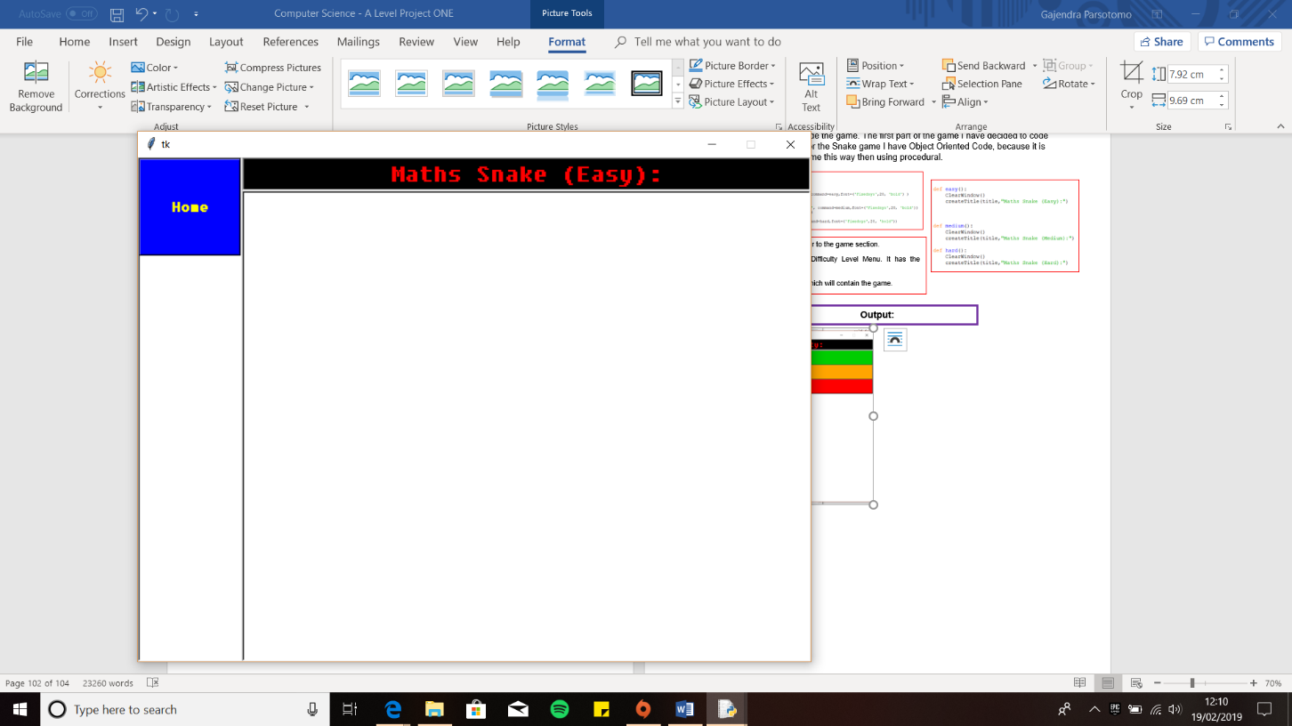

**Iterative Testing:**

**Test 6, No.2**

**Output:**

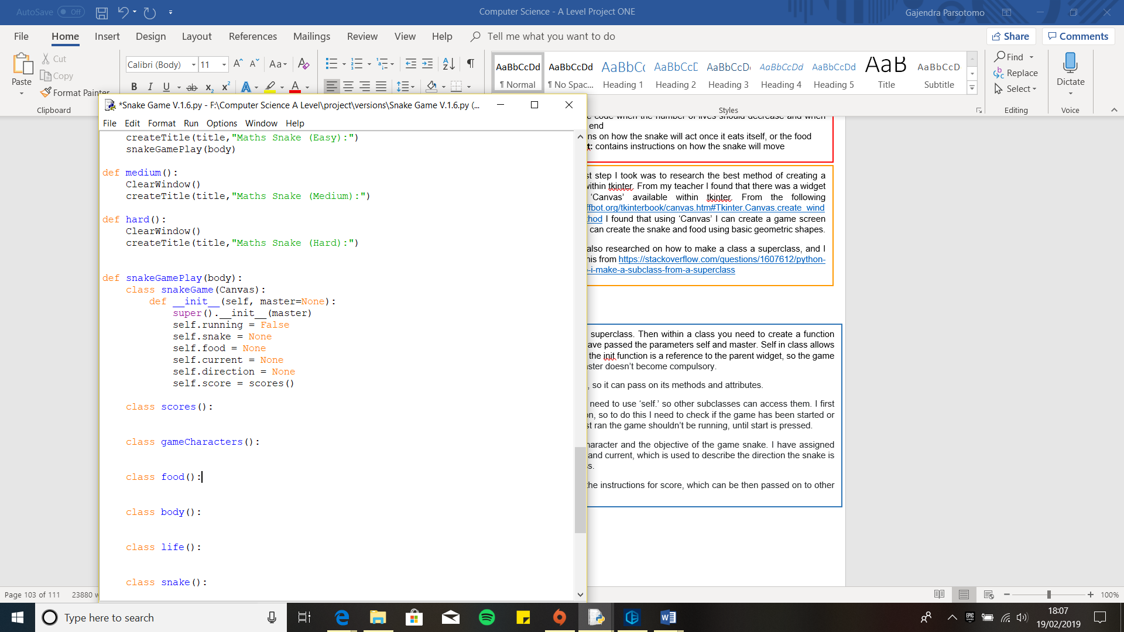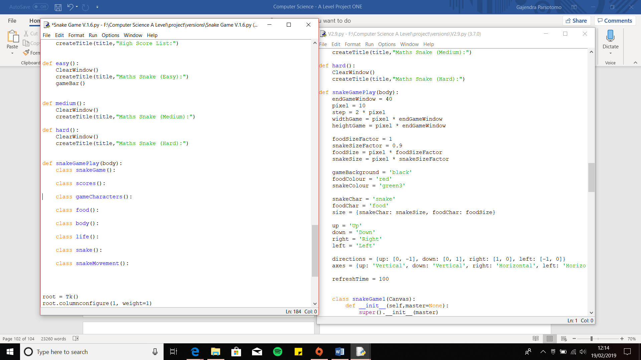

I first passed Canvas as a parameter to snakeGame, since this class is my superclass. Then within a class you need to create a function called ‘__init__’, which allows me to initialise the attributes within the class. I have passed the parameters self and master. Self in class allows me to access the attribute and methods within the class. Master is used within the init function is a reference to the parent widget, so the game is built with the parent widget. Making it equal to None, is so the argument master doesn’t become compulsory.

The next line which I found online it shows how to make the class a superclass, so it can pass on its methods and attributes.

Then I stared to add the necessary attributes to the class, and to do this you need to use ‘self.’ so other subclasses can access them. I first added the attribute ‘running’ because my client wants a start and restart button, so to do this I need to check if the game has been started or not. Therefore, to do this I have assigned a Boolean value, False, as when first ran the game shouldn’t be running, until start is pressed.

Then I created the attributes ‘snake’ and ‘food’, as that is the main player character and the objective of the game snake. I have assigned ‘None’ to each one as they are currently empty. I’ve done same with direction and current, which will be used to save the direction the snake is facing but currently it is ‘None’ and current is used to save the current progress.

For score I have assigned it be equal to the class scores as that will contain the instructions for score, which can be then passed on to other subclasses, just by using the attribute.

The first step I took was to research the best method of creating a game within tkinter. From my teacher I found that there was a widget called ‘Canvas’ available within tkinter. From the following <http://effbot.org/tkinterbook/canvas.htm#Tkinter.Canvas.create_window-method> I found that using ‘Canvas’ I can create a game screen where I can create the snake and food using basic geometric shapes.

I have also researched on how to make a class a superclass, and I found this from <https://stackoverflow.com/questions/1607612/python-how-do-i-make-a-subclass-from-a-superclass>

I now started to code the game, and the very first thing I did was create a function called snakeGamePlay and passed the parameter body. The reason I did this first is because I can then call the whole game as a function within the difficulty level functions. I have passed the body frame as a parameter as the game will be within the body frame.

Within the function, I started off creating the skeleton of the game, as to what sort of classes I will need to code just the snake. I have created the following classes for the following reasons:

* **snakeGame:** Will contain the main elements for Snake, as this will be my super class
* **scores:** The score tracker will be created within here which will increment the score when the conditions are met
* **gameCharacters:** Within in this class I will create the actual snake and the food
* **food:** This class will contain the instructions as to where the food should be created and what happens to it when eaten
* **body:** This will contain instructions on the snake’s body like when it should grow
* **life:** Will have the code when the number of lives should decrease and when the game should end
* **snake:** Instructions on how the snake will act once it eats itself, or the food

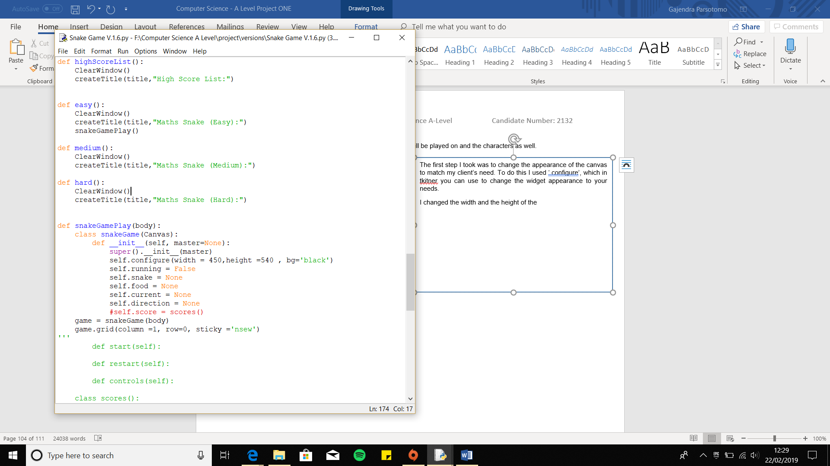My next step was to create the canvas, where the game will be played on and the characters as well.

Finally, I placed the function snakeGamePlay, which will contain the whole game, within the function easy. Therefore, when the user presses easy, the game function will be called.

Then to test out how the canvas looks like, I need to first put the canvas into the body frame. To do this I created a variable called ‘game’, since this is going to be the main screen the game is played on. I assigned the class snakeGame to the variable, and passed the parameter, body so it can be placed with that frame, using the gird method. I changed the position of the canvas to column 1, as the layout of my game is on the right-side.

The first step I took was to change the appearance of the canvas to match my client’s need. To do this I used ‘.configure’, which in tkitner you can use to change the widget appearance to your needs.

I changed the width and the height of the canvas, so it fits within the body frame to a size I am satisfied with. I didn’t want the canvas to fill the whole frame as I need space for the buttons and trackers. I then changed the colour of the ‘Canvas’ to black, to match the criteria by my client.

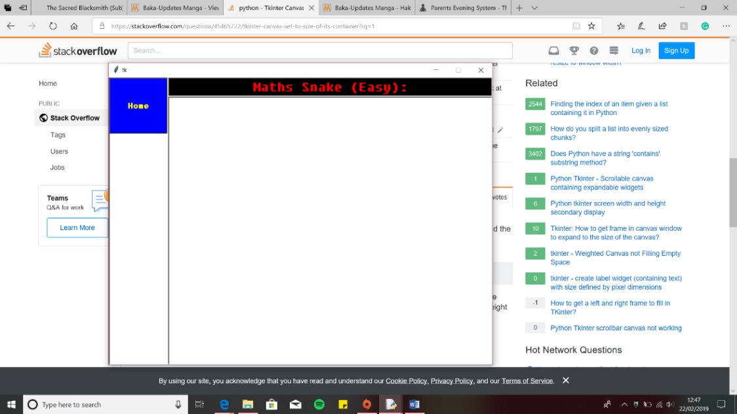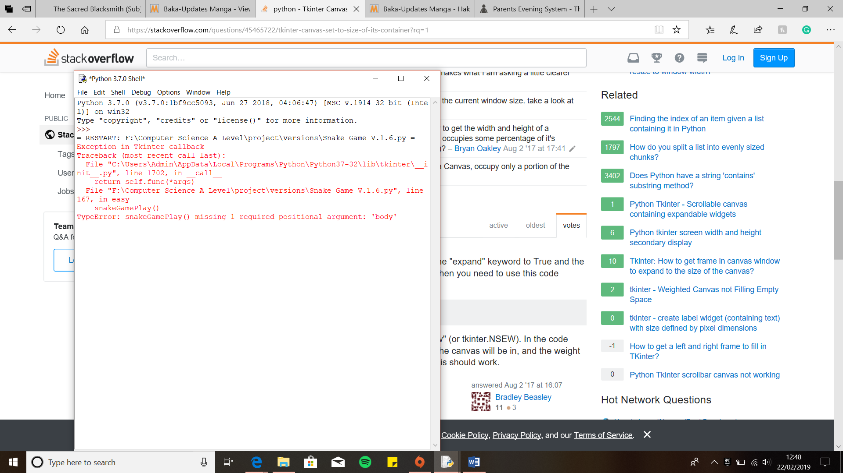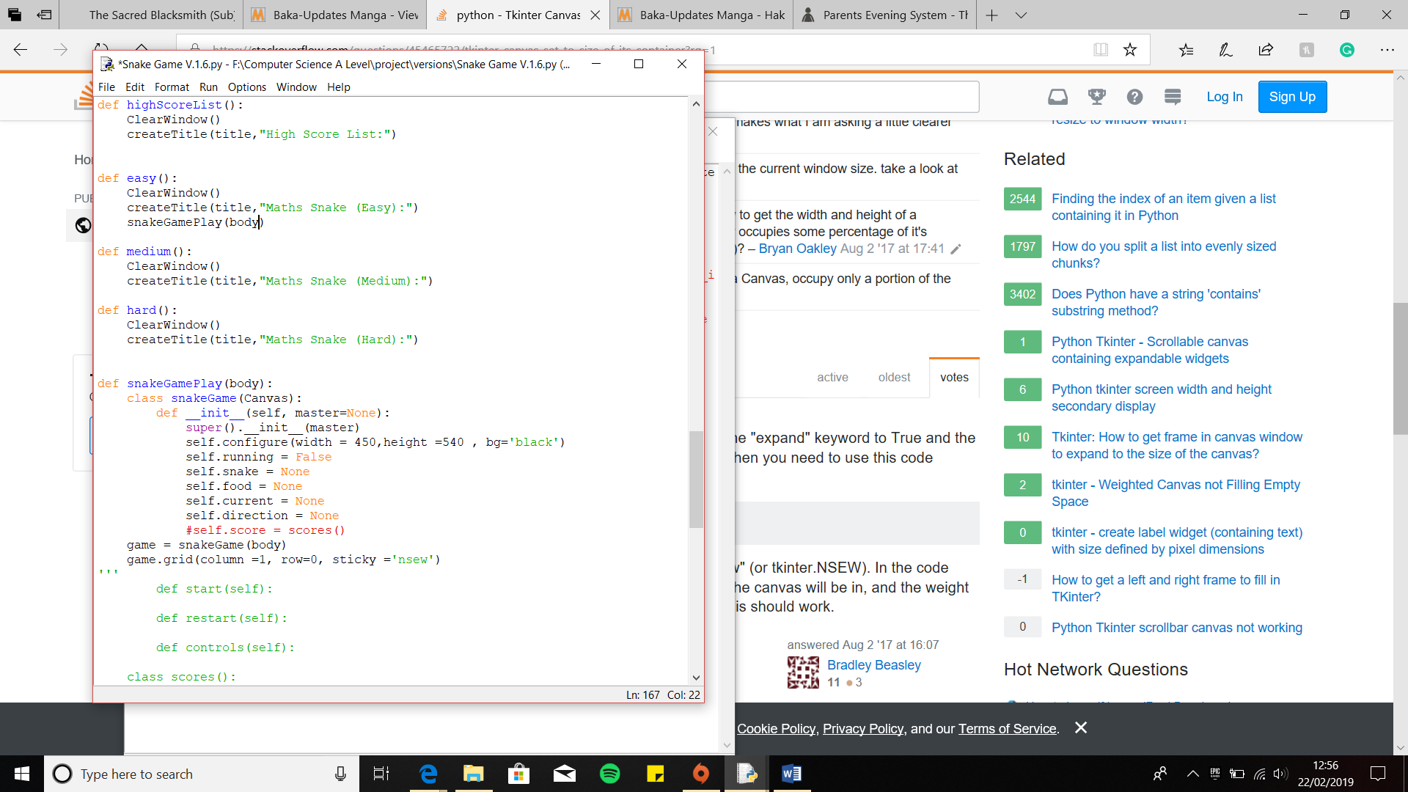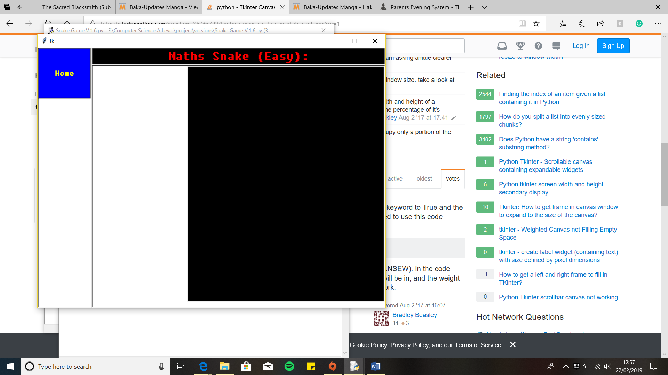Next, I decided to create the snake and the food using the ‘Canvas’ which allows you to draw basic shapes. For shapes I will be using for the snake and food are rectangles and ovals respectively.

**Error: Argument missing**

I received an error when I ran the program. The error was an argument was missing, body, within snakeGamePlay. I have passed the function snakeGamePlay to the function easy, without the positional argument, body. Withou that the function has no place to be placed thus resulting this error.

Therefore, to fix this I just need to add body within the function.

**Output:**

The ‘Canvas’ is now displayed within the frame.

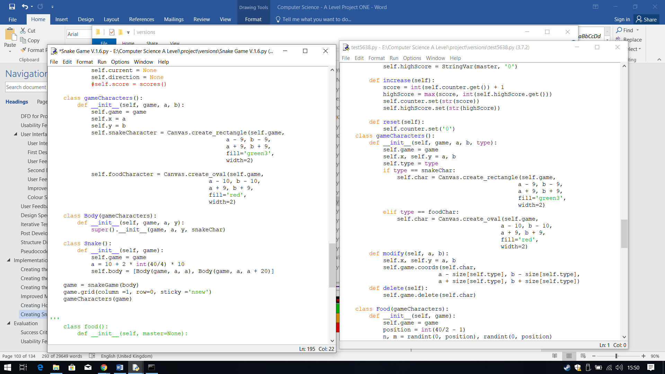

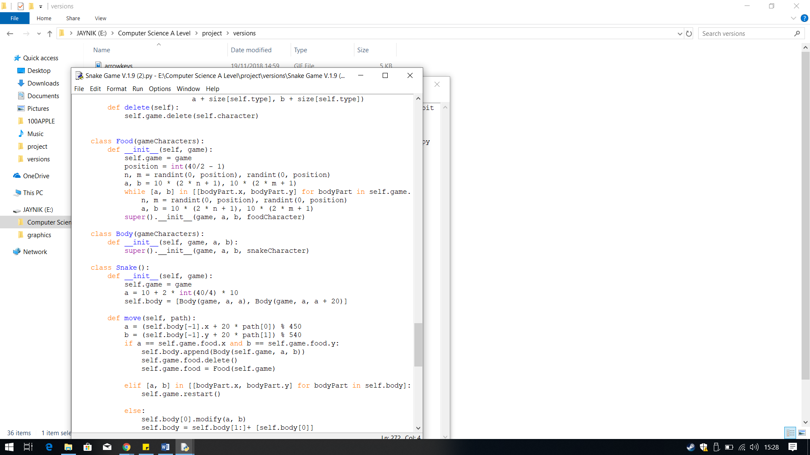

Next I filled in the Body class. This class as the name suggests will be used to create the snake body and add a new body when the condition for it is met.

The first thing this class requires is the actual method to create the snake body part (the square), therefore I have passed the argument gameCharacters so it can use its methods and attributes. Within the init function I have passed game, a and b as these will be used to define where the body should be placed. Then I made this class a super class so it is easier for me to use this classes methods as there will no need for instantiation. Within the super class I have passed snakeCharacter so when used it knows to use this to create the square.

To create the snake game, need to create the shapes for the characters within the game. To do this, I have passed the parameter game, since that is where the snake and the food will appear, as I have stored the gameplay screen, super class snakeGame, within this variable.

Then within the class I have then created the attributes x and y to be equal to a and b. The reason I have done this is so later on it will become less confusing when refer to the coordinates of the food and snake. It will be defining what a and b are later which are fixed for the characters object so they can be created on the game anywhere. I’ll be incrementing a and b to the snake head.

Then I created attributes called snakeCharacter and foodCharacter and using the code I found from <http://effbot.org/tkinterbook/canvas.htm> I created a square and a circle. Using the tkinter function Canvas.create_rectangle and Canvas.create_rectangle which allows me to create a square and circle. Within each brackets I have placed where the square (snakeCharacter) needs to be created, which is the Canvas therefore I placed the attribute game. Then I defined the dimensions of the square and circle which done by subtracting and adding the dimension from a and b. For the square I made the dimension equal for the circle the dimensions are different so the circle is slightly wider than the snake. Next I changed the colour of each of them using fill, which you use to make it equal to the colour you want the shape to be. I changed the colour for the snake and food ‘green3’ and red respectively like the client wanted. Finally, I added a boarder around the shapes using width and I defined the size as 2.

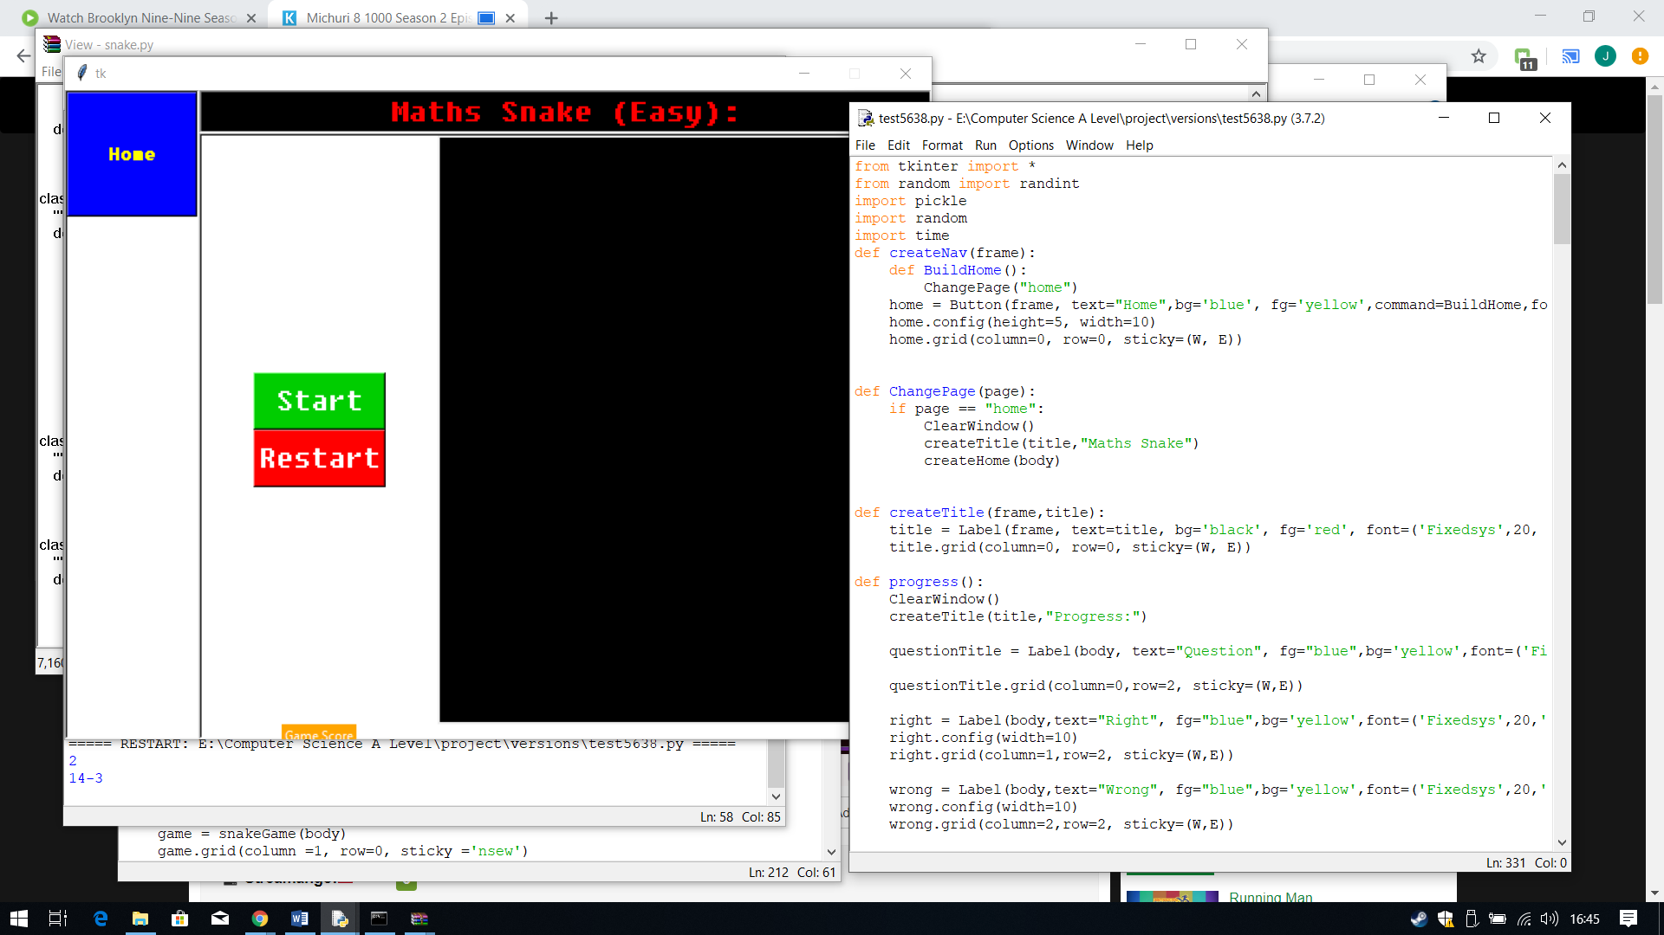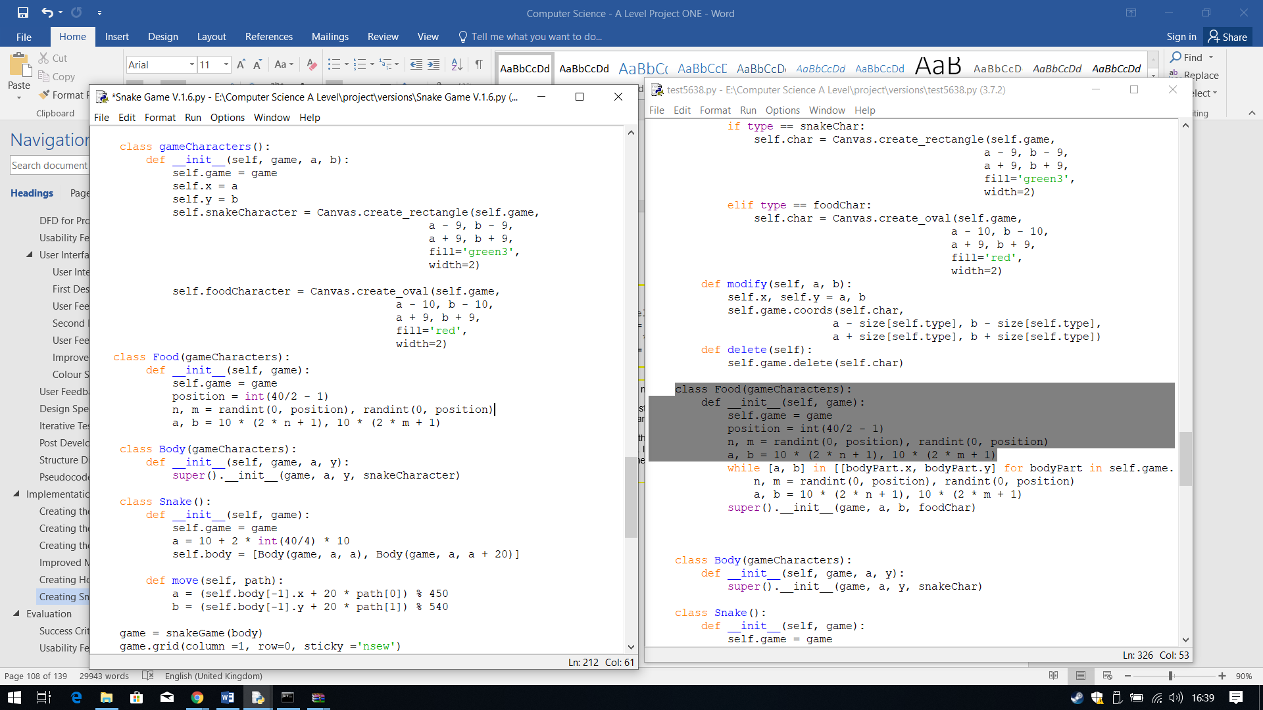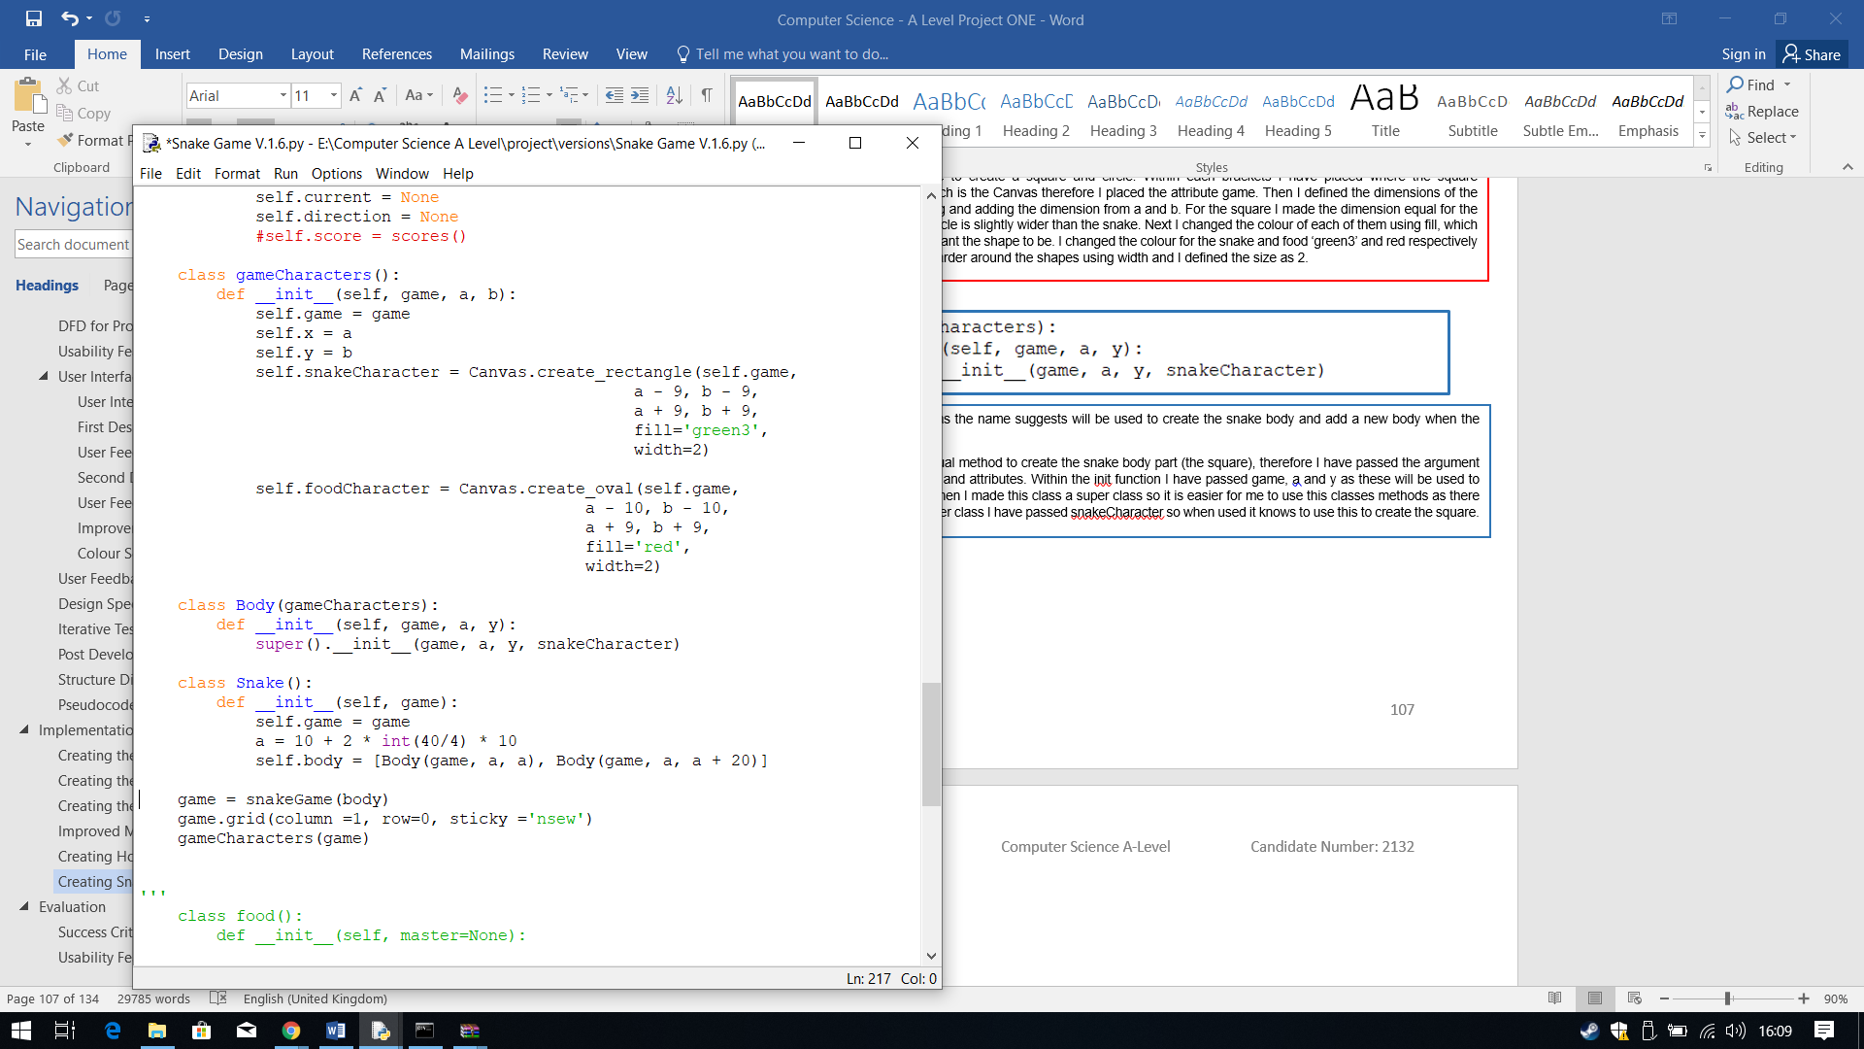

Before I carry on with the snake I decided that I should input the attributes needed for the food to work.

The first attribute is position, which is going to be used to determine the random position of the food. Next I needed 2 random positions for the food, so I have created n and m which will store random positon between 0 and position. I have used randint from the library random which helps to select random numbers from a certain range. Then using this I have used it to save it to the coordinates for the food a and b. I have used this formula to make sure the value of a and b are even.

For init in the class Snake, I have defined 2 new things. One I have defined a and the snake’ body.

The attribute a I have created decides the staring position of the snake at the beginning of a game. The height of the canvas is 540, I want the snake to start about halfway the canvas at the beginning. Therefore, to define this staring point I have come up with this.

The attribute body is a list that will contain the starting length of the body, which is 2 squares and then as the game goes on the snake body will be increased and saved to the list. In the list I have called the class Body and then placed the information needed to create the snake body parts, which is where (game), the x and y coordinates (a). For the second body part I have made it + 20, so it is placed behind the head.

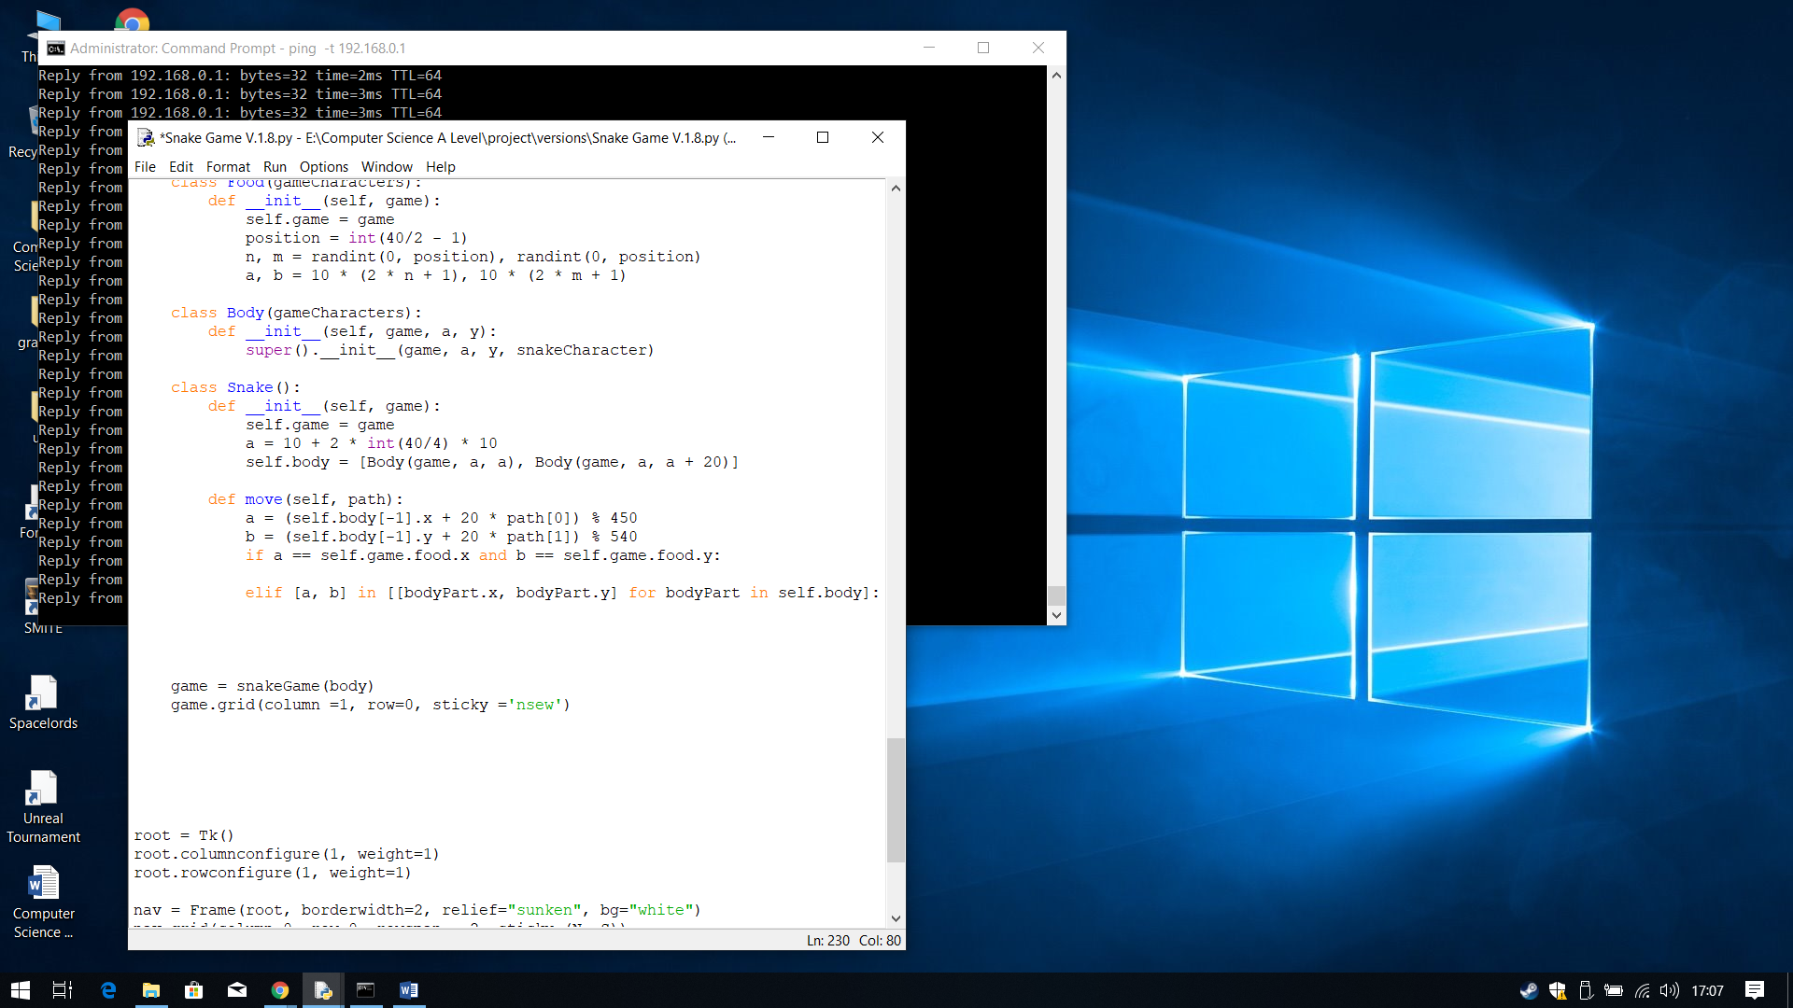In version 1.7 I have started to create a working snake game.

Within the class Snake I have created a new method called move, this define how the snake will move and what happens when certain conditions are met. I first put the tail of the snake in the first position, this allows the snake to transverse through the game canvas from one end to another Then I created the conditions I am going to need to check. The first one is to check whether or not the coordinates of the head are the coordinates of the food the second is if the head is the same coordinates as any part of its body.

I have done this with the class food as well, as there is a condition as to where te food can appear. The condition of where the food can appear is where there is no snake, so I am using a while loop to constantly check this since the snake moves around. I have also made the class into a super class so it is easier to use.

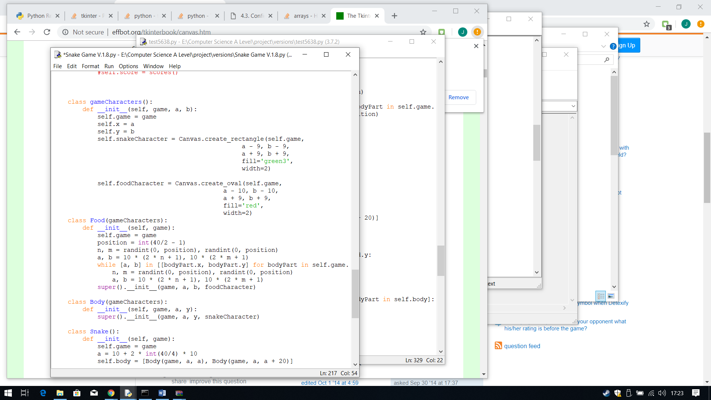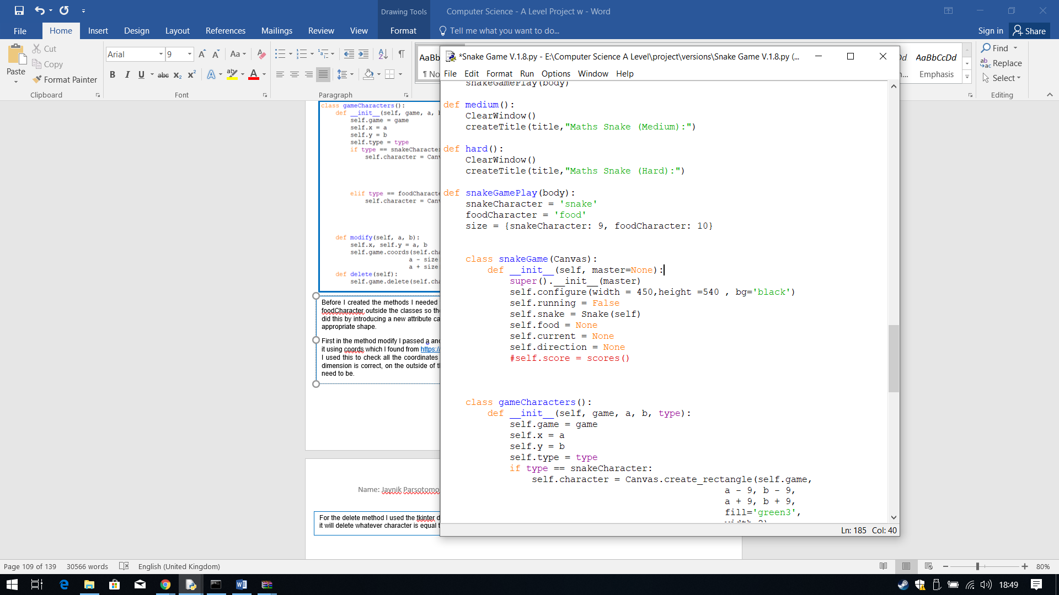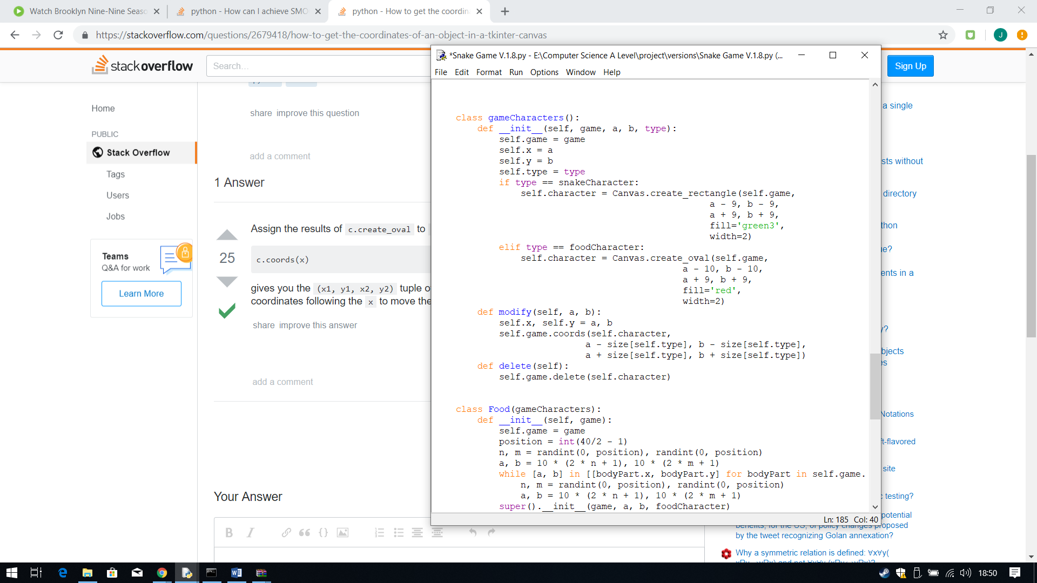

Each of the condition checkers is checking for each square in the body list as to where it is positioned, comparing it to the a and b. I have called each square in the body, bodyPart for easy recognition as to what I am checking here and it checks each bodyPart x and y coordintes within the list, body.

When creating these conditions, I realised I hadn’t created 2 things necessary for the game to work. One is a way to delete the characters, the food when eaten or when the game ends. The second is a way keep track of the coordinates of the snake, I need a method which continuously modify the snake’s coordinates so it can be easy to check what the coordinates are. Therefore, within the class game characters I have created two new methods delete and modify.

Before I created the methods I needed to check the which character is being used, therefore to do this I moved the snakeCharacter and foodCharacter outside the classes so they can use it anytime they want. I then changed the way it picks which character is being picked. I did this by introducing a new attribute called type. Then using an if statement I can now check which one is being used and then create the appropriate shape.

First in the method modify I passed a and b as they will change constantly. Then to check the coordinates of an object on a canvas I can find it using coords which I found from <https://stackoverflow.com/questions/2679418/how-to-get-the-coordinates-of-an-object-in-a-tkinter-canvas>. I used this to check all the coordinates of the tkinter objects on the canvas and then save them to a and b. Then to make sure that the dimension is correct, on the outside of the classes I created a variable size which saves the value the snakeCharacter and foodCharacter need to be. I have put character and type in the brackets, so it knows it is modifying one if the characters and then it checks which character by checking type.

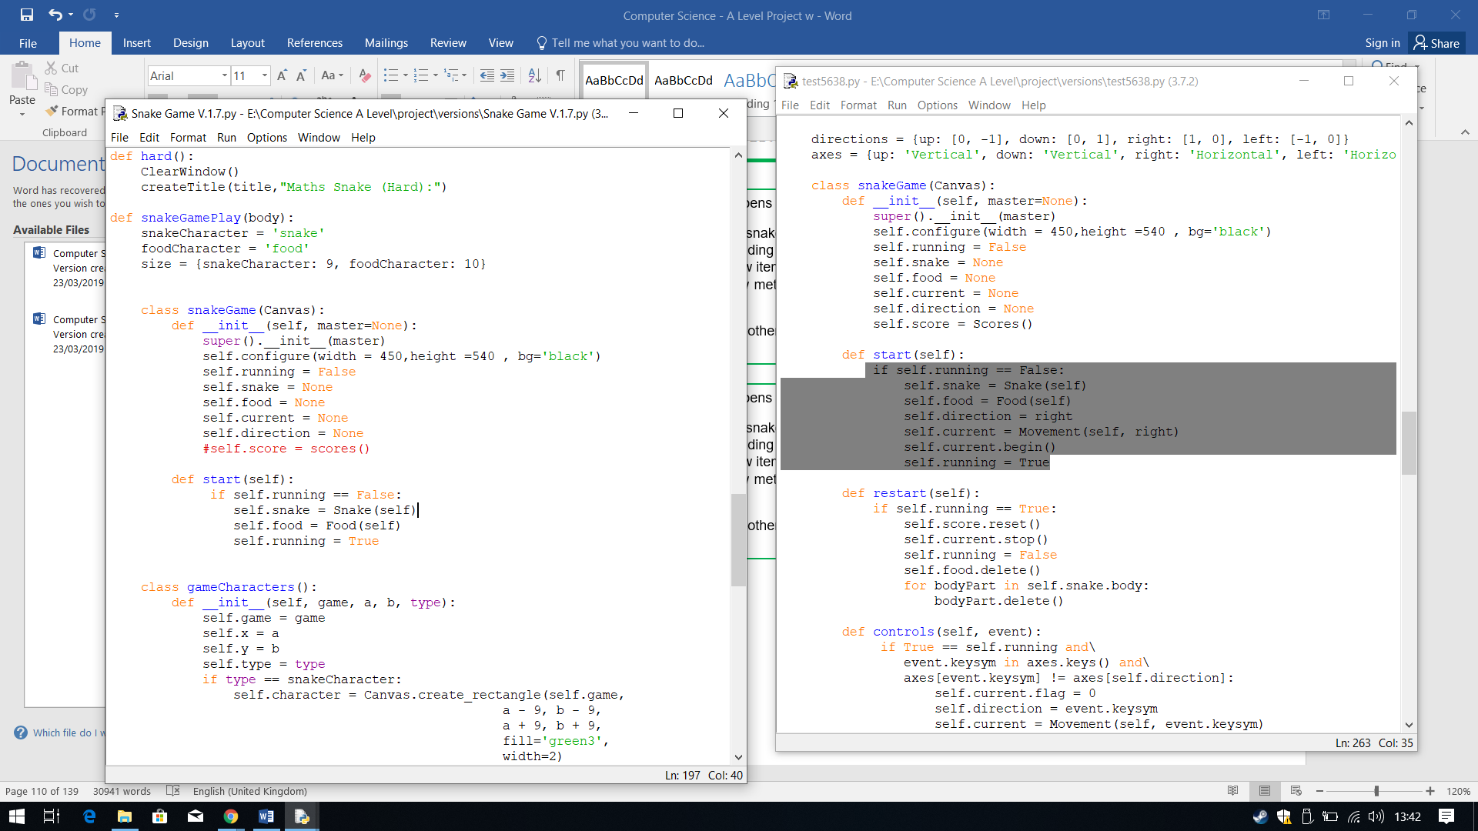

I then started to fill in the condition as to what happens when it is met.

First I did the condition of what happens when the snake collides with the food. The first thing I did was to grow the snake, by adding a new body part to the list. This was done by appending the new body part to the list and then give the new position and dimension of the body part. I have used append as it adds a new item of a list to the end of the list perfect for growing the snake. Then it is followed by the food getting deleted, where I used the new method I created. The finally thing I did was to create new food and I did this by calling the Food class.

I have added an else statement, so if none of the other conditions are met it will carry on modifying the new coordinates of the head, which is why I selected the first item in the list which will represent the head coordinates. The second line adds the rest of the body (squares) to the head so it follows it will follow it one after another. The colon which learnt from <https://www.tutorialspoint.com/What-does-colon-operator-do-in-Python> is a way to slice a part from a sequence object, in this instance I am using it for a list. This colon allows me to process a sequence of an instruction on an item of a list from a given index to every other item in the list until the end of the list. Therefore, I chose the second item first then the placed the colon with the index, so it will add every item in the list to the first item.

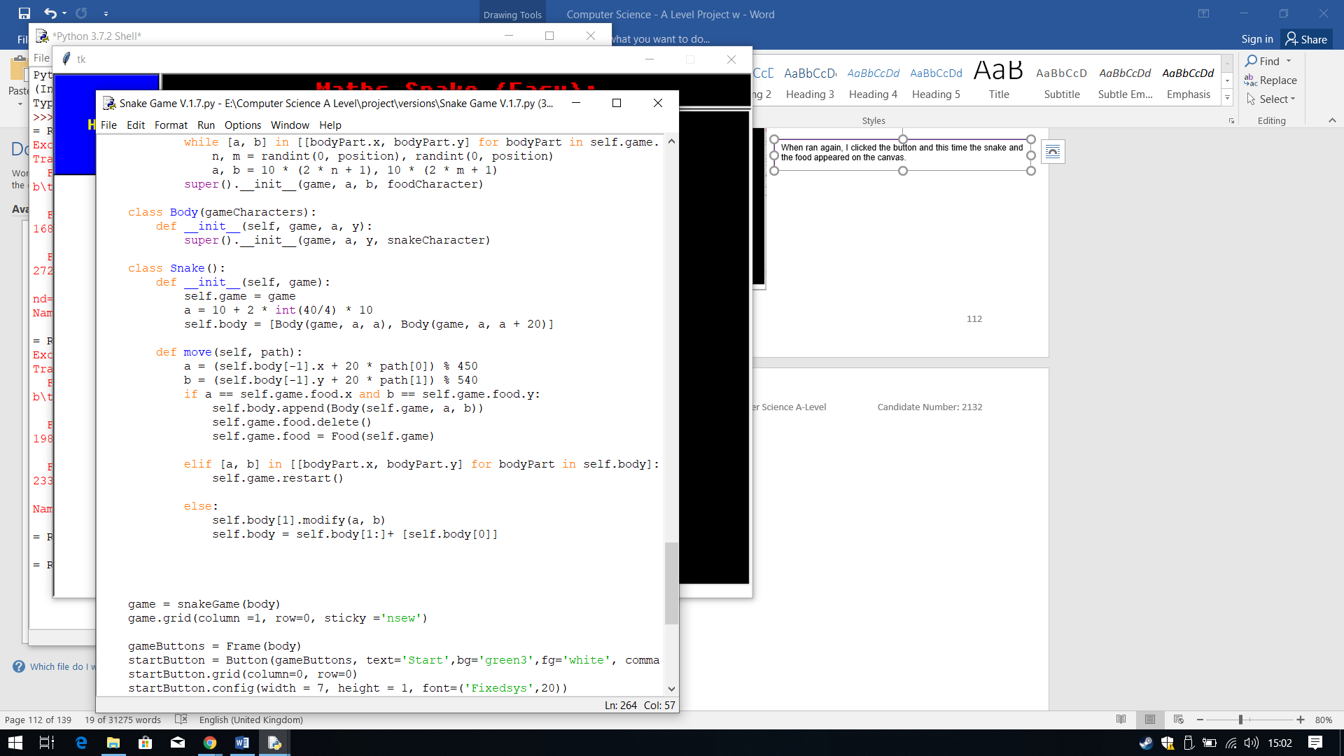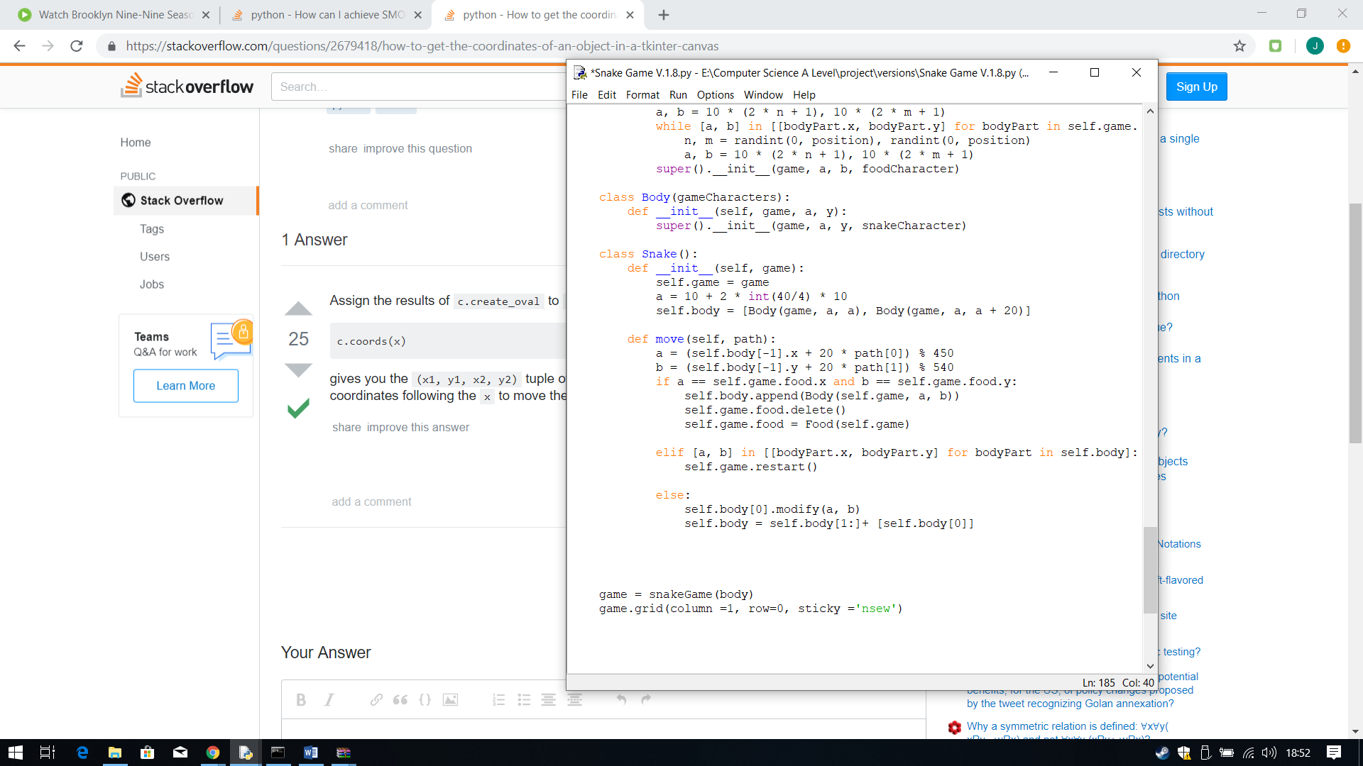

Next I fulfilled the condition my client wanted which is a start button, when clicked the game starts. Therefore, within the class snakeGame() I have created a new method called start. Within this method, am first using an if statement to check if the attribute running is equal to FLASE, if it is then it will do the following. Create the snake and food by calling the class, and change it so running is now equal to True, therefore the game has started.

For the delete method I used the tkinter delete functions which deletes whatever you pass in the brackets, I passed character so when used it will delete whatever character is equal to in the context it is being used for.

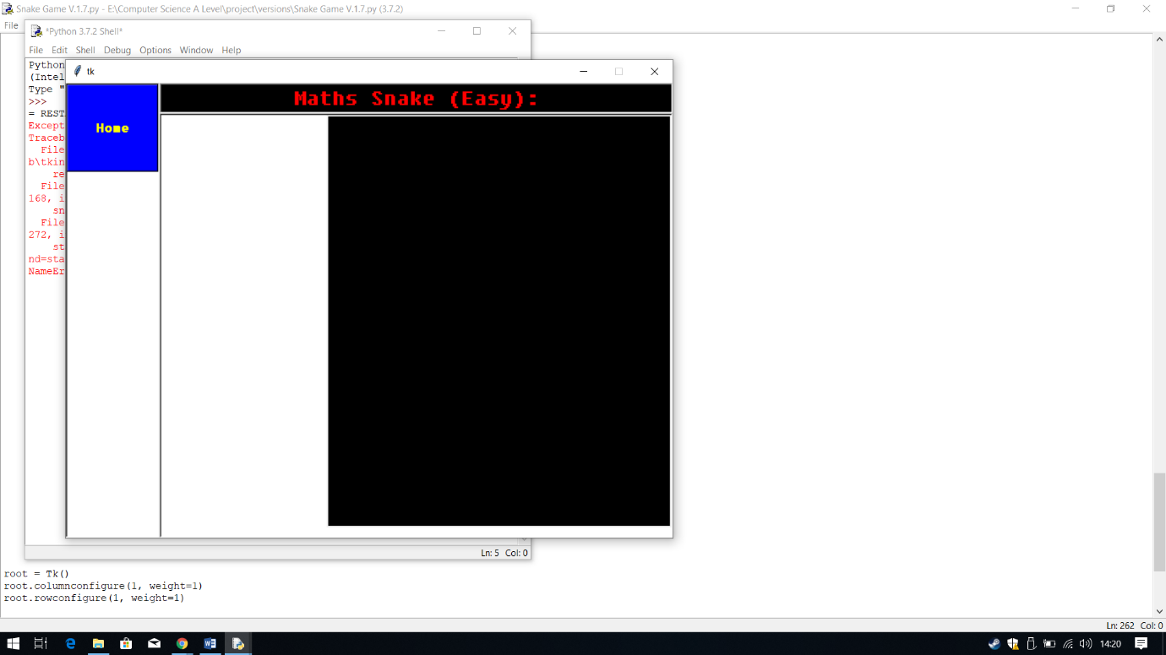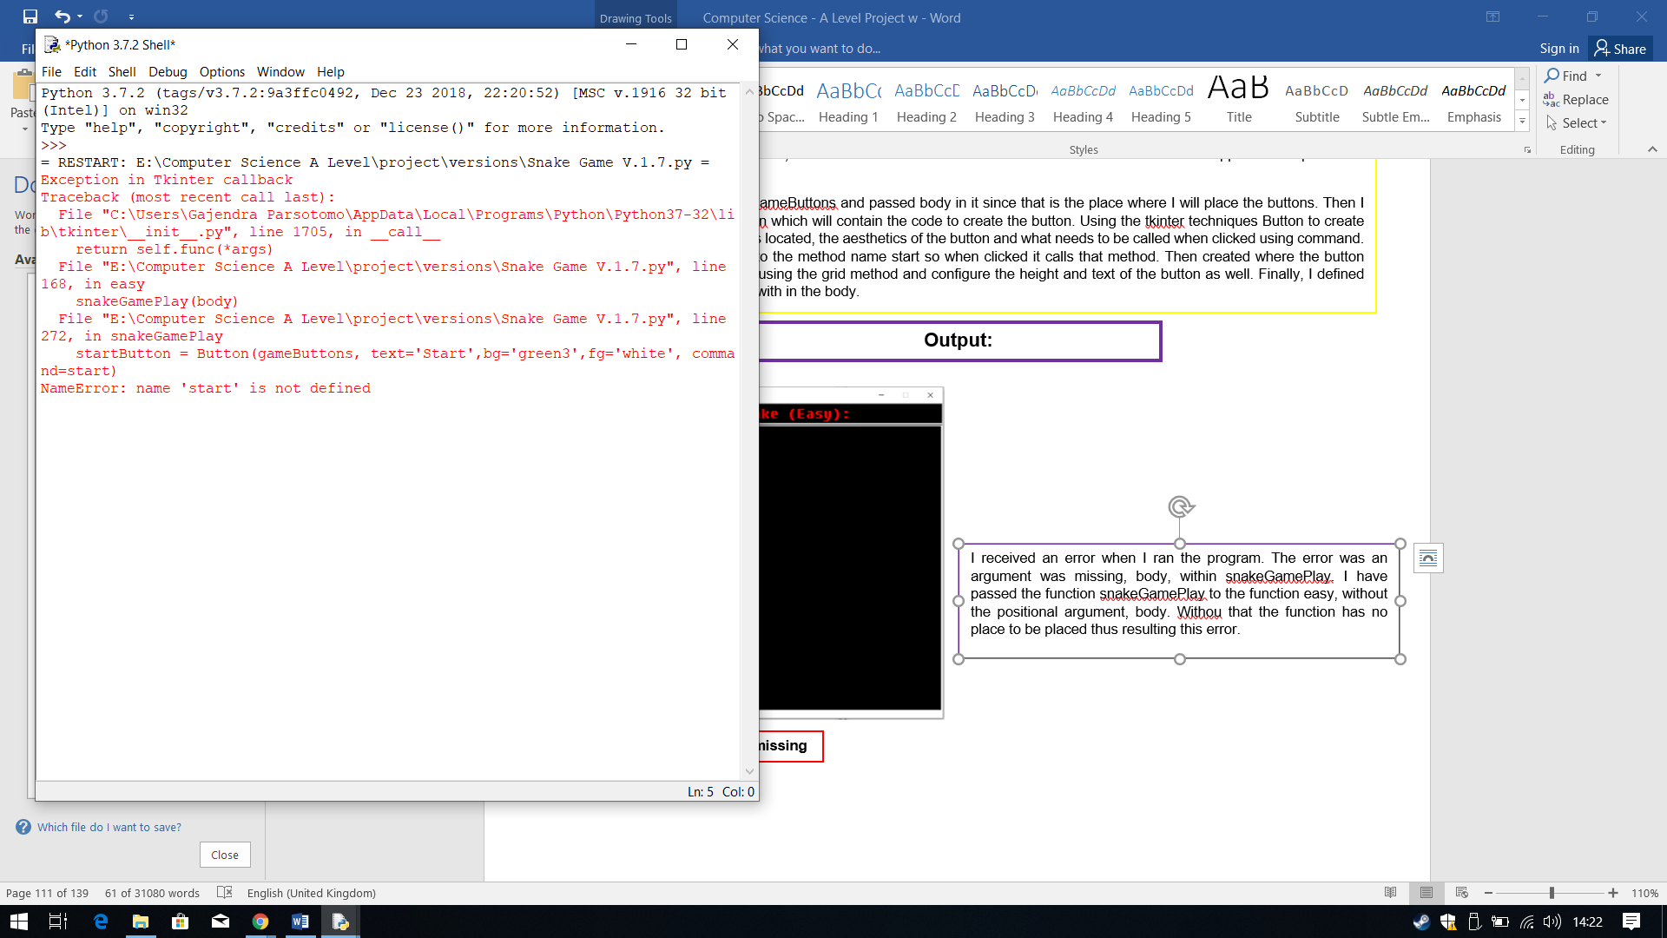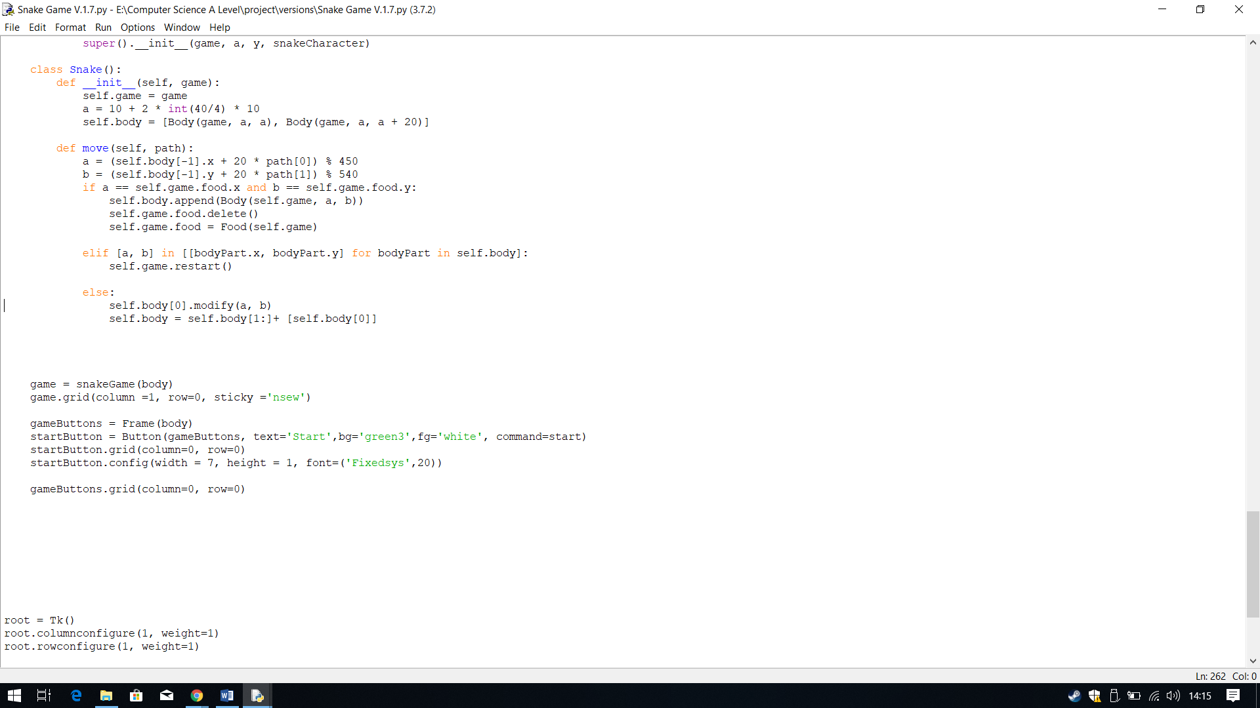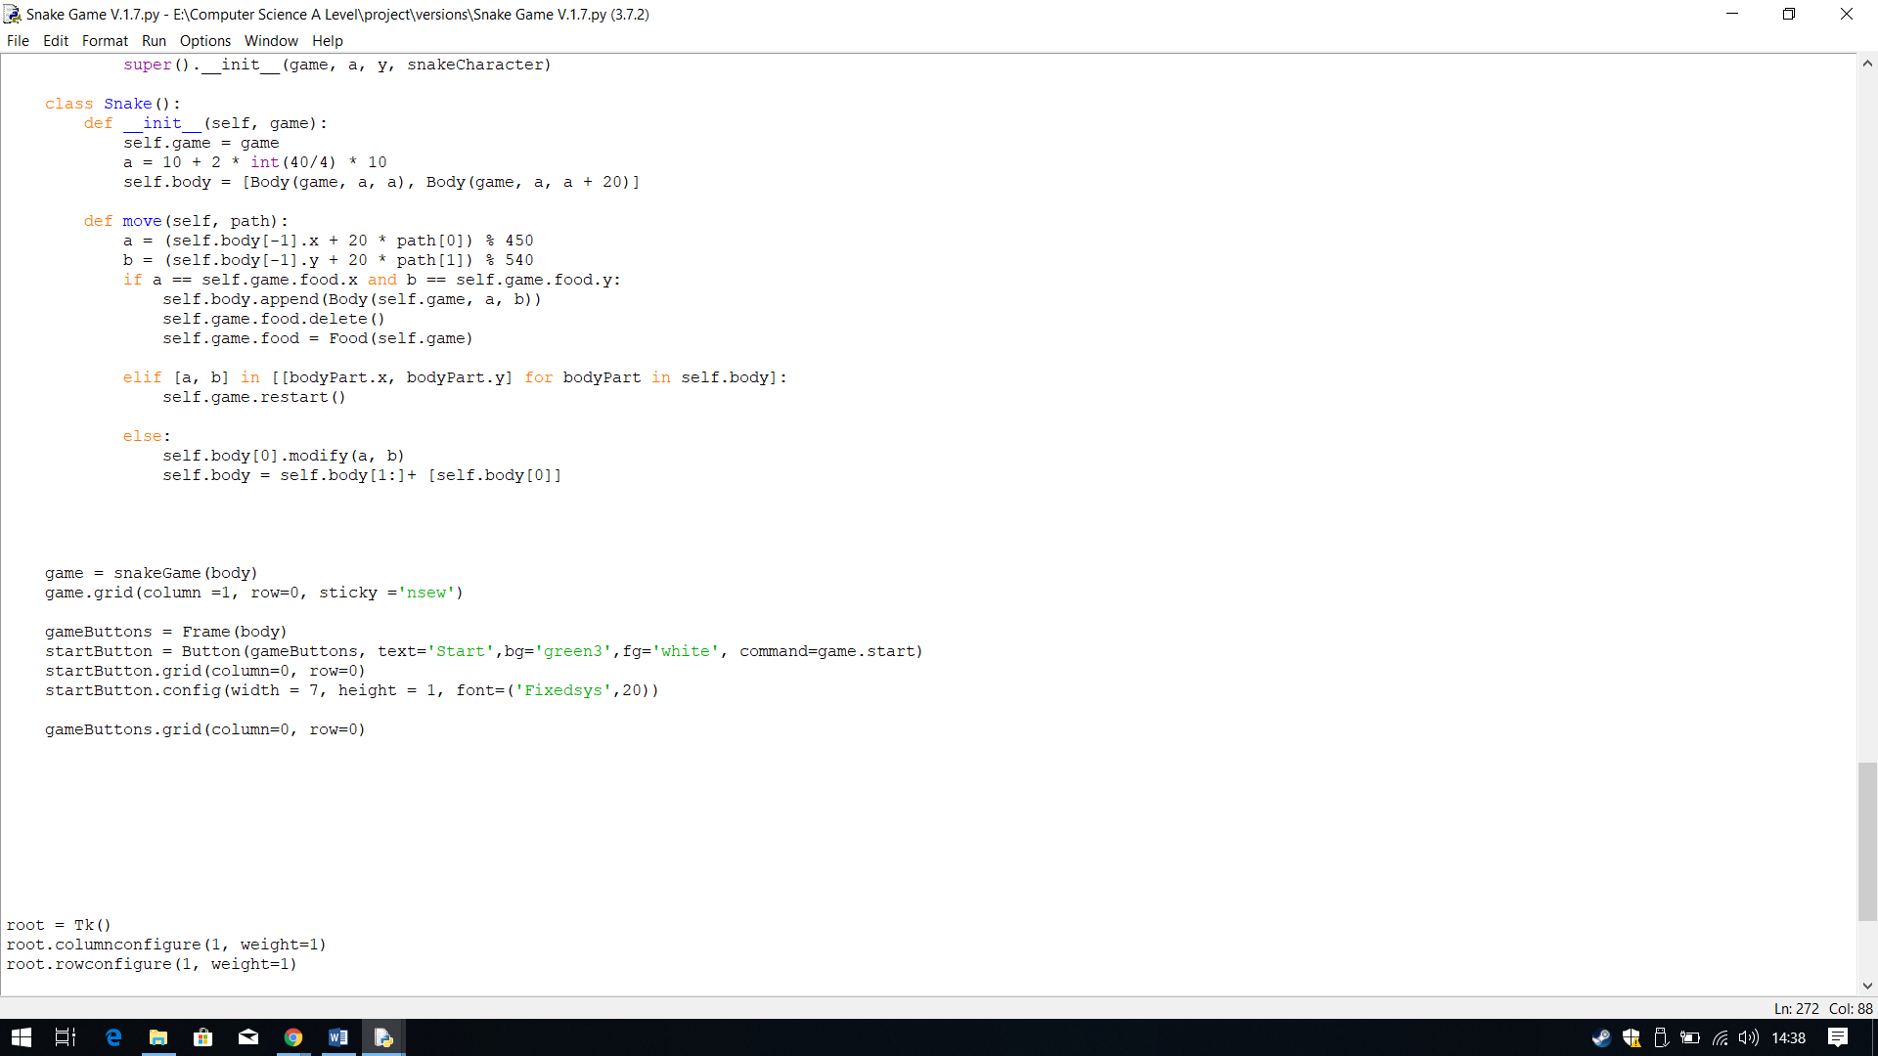

Since I had already created a variable containing the snakeGame class, game I just need to specify the method I am trying to call, which is start. Therefore I made command equal to game.start, so it calls the class and the method within the class called start.

I received an error when I ran the program. The error was start was not defined when it tried to called it when I clicked the button. I then realise it wasn’t able to call it as the method belongs to a class and can only be accessed within a class.

Therefore, to fix this I needed to call the class and then the method within the class.

Next I decided to create the start button, so then I can test whether or not it works and if the snake and food appear as I expect them to.

I first created a new frame called gameButtons and passed body in it since that is the place where I will place the buttons. Then I created a variable called startButton which will contain the code to create the button. Using the tkinter techniques Button to create the start button, I defined where it is located, the aesthetics of the button and what needs to be called when clicked using command. I have made the command equal to the method name start so when clicked it calls that method. Then created where the button should be placed within the frame using the grid method and configure the height and text of the button as well. Finally, I defined where the frame should be placed with in the body.

**Error: ‘start’ not defined**

**Output:**

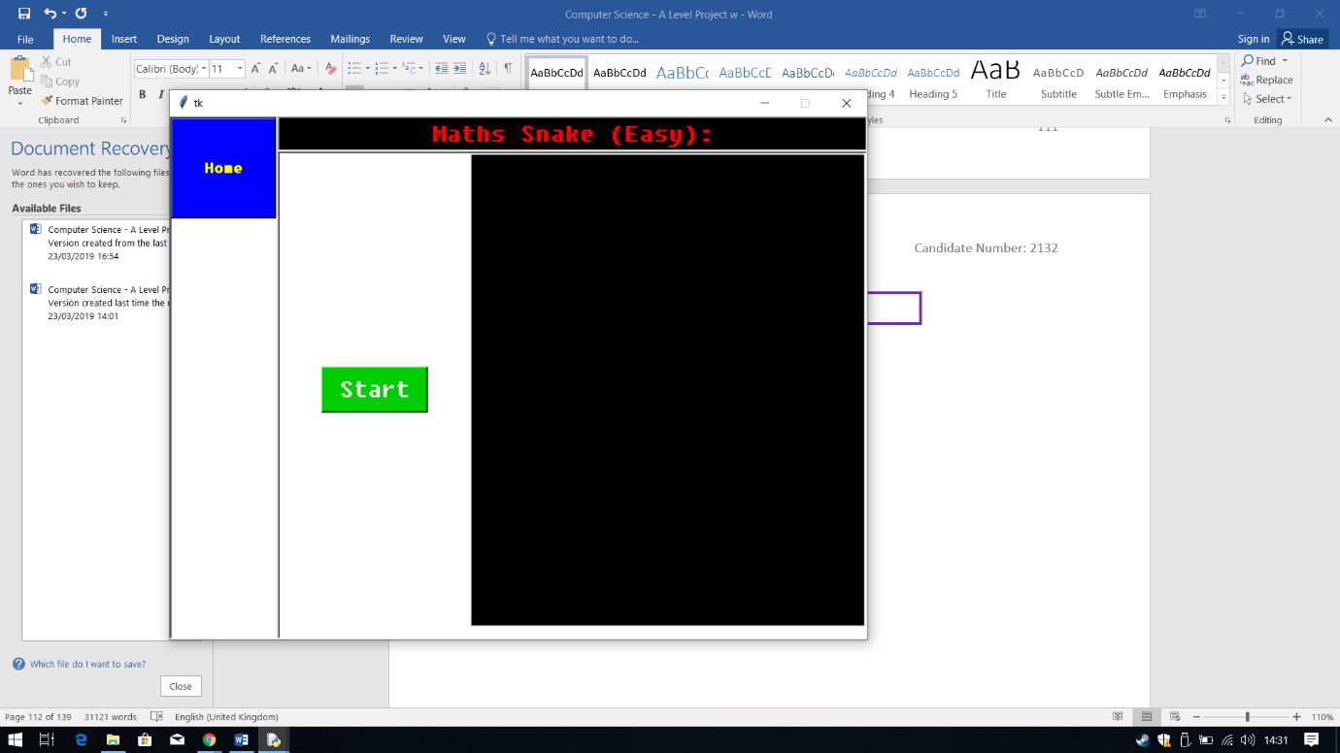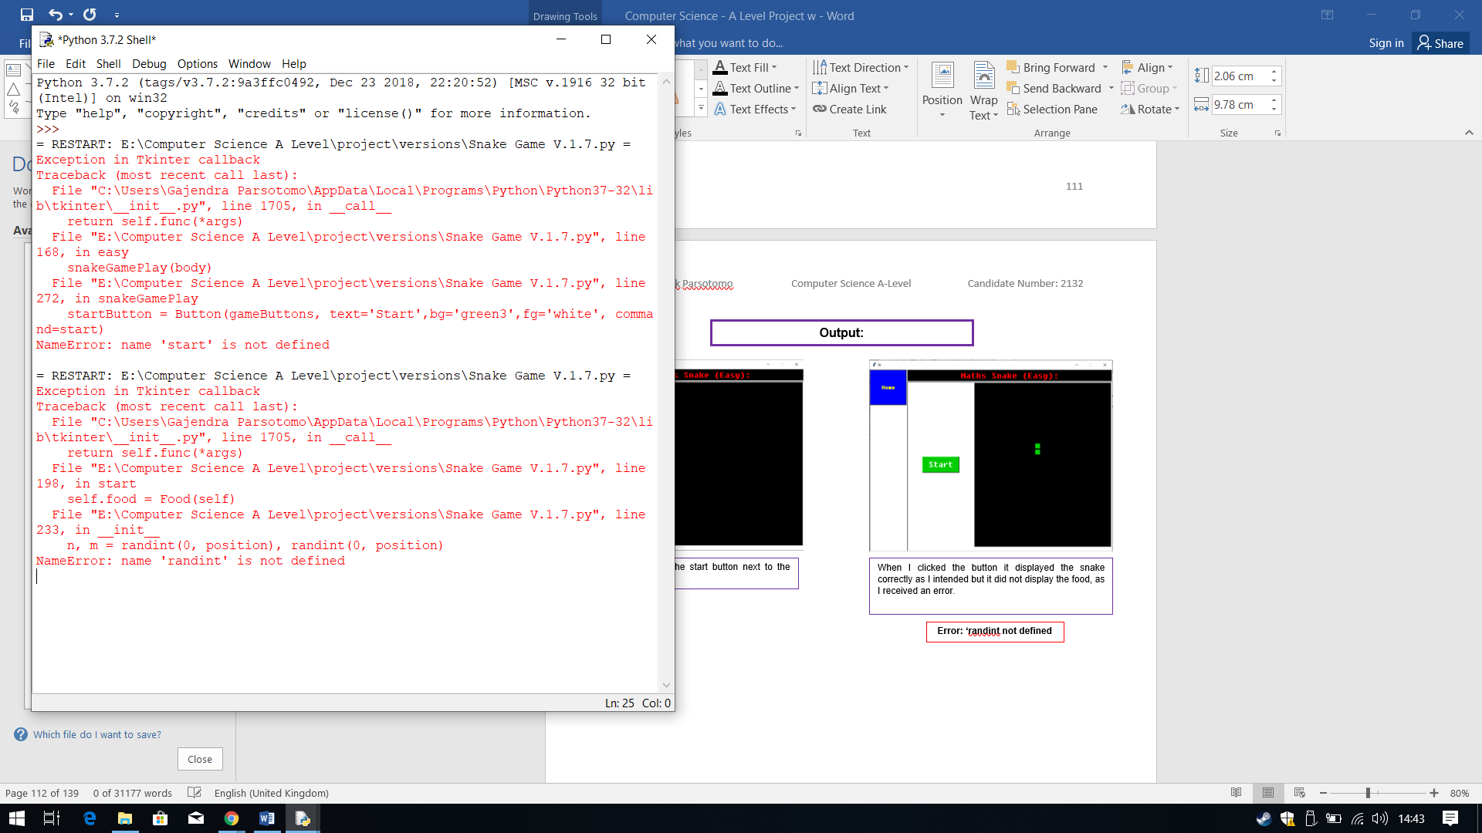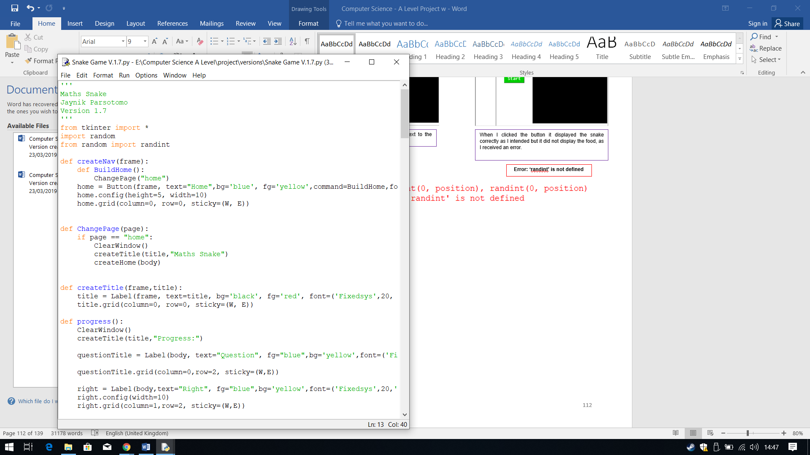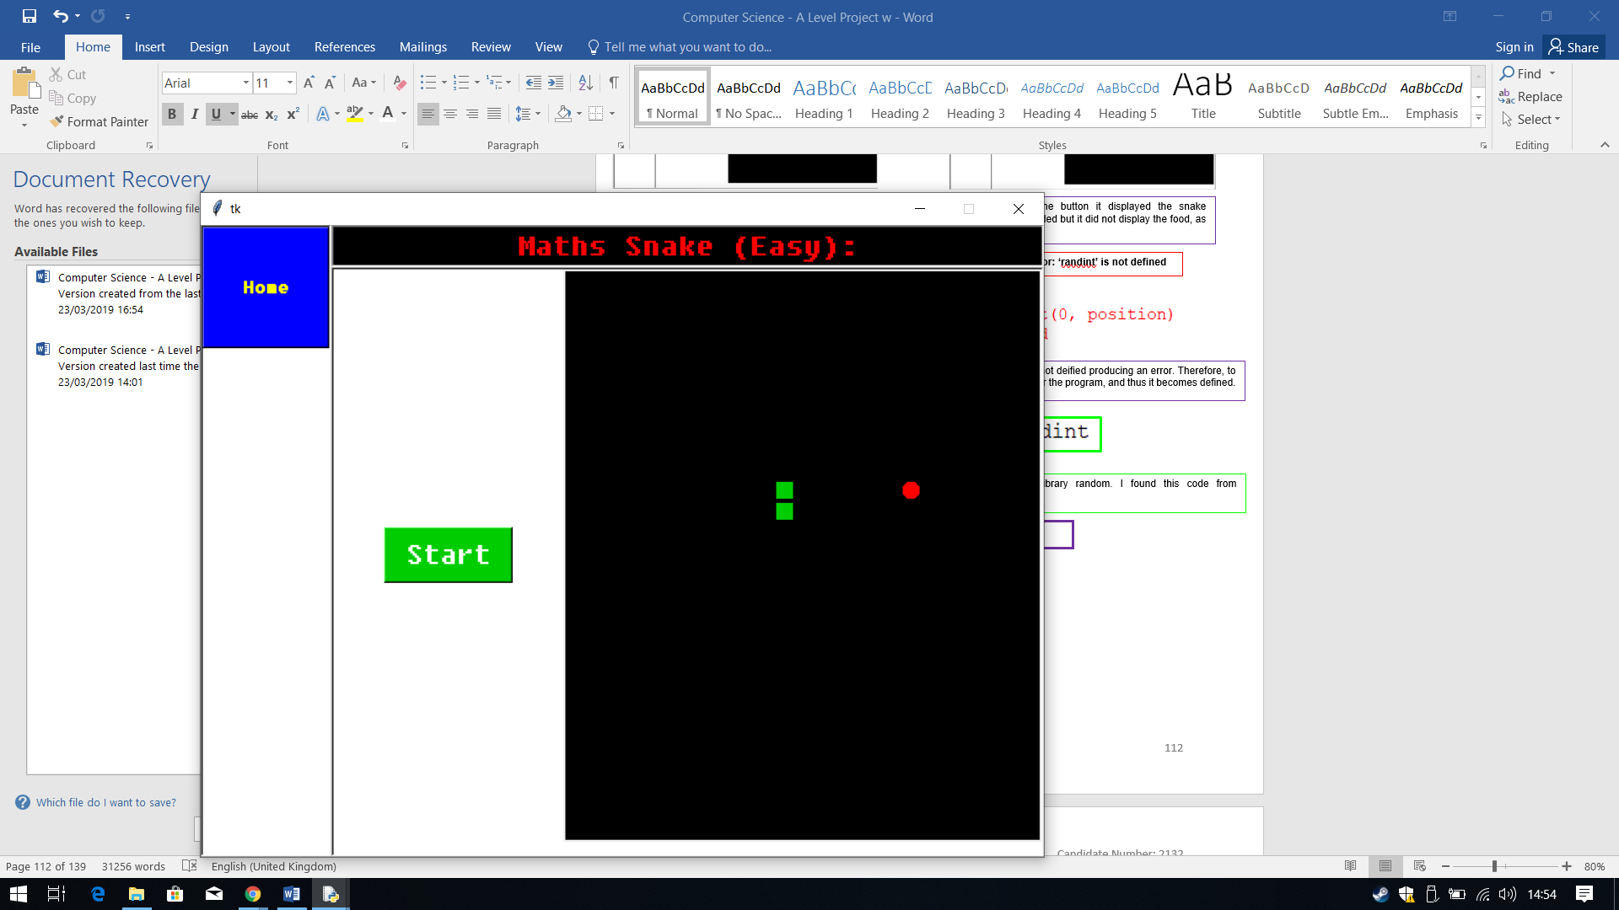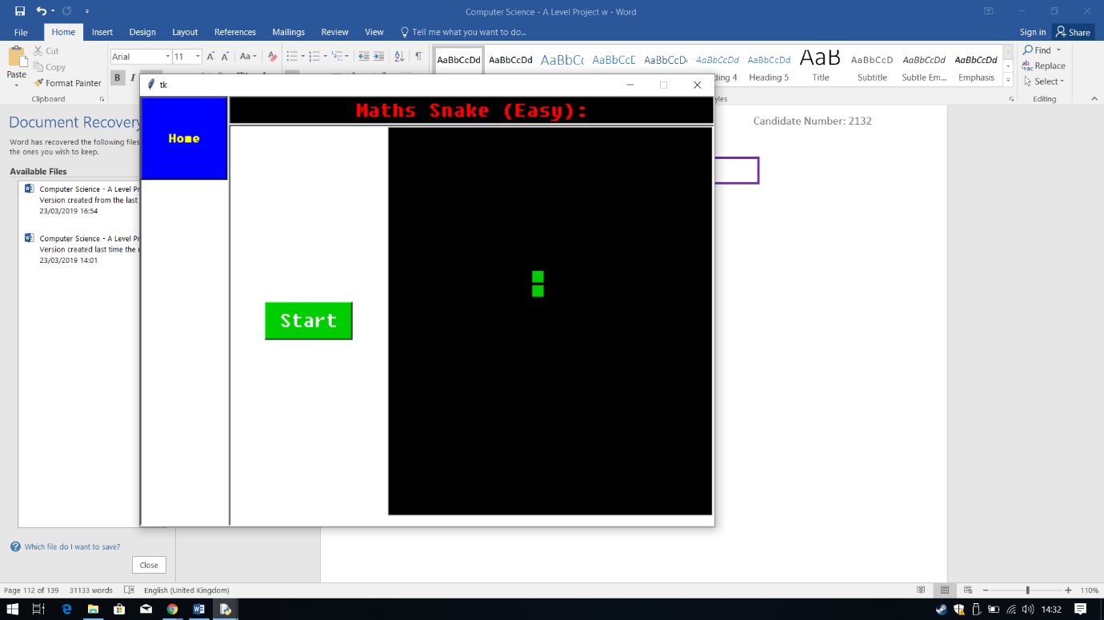

Therefore, I used the code from above to import the whole of randint from the library random. I found this code from <https://www.codecademy.com/en/forum_questions/55c1eabde39efed2110002ae>

**Output:**

When ran again, I clicked the button and this time the snake and the food appeared on the canvas.

The error I received was the randint function that I used from random does not exist thus it is not deified producing an error. Therefore, to fix this I decided it is best to import the whole of randint from random, so there is no confusion for the program, and thus it becomes defined.

**Error: ‘randint’ is not defined**

When ran, it displayed the start button next to the gameplay canvas.

When I clicked the button it displayed the snake correctly as I intended but it did not display the food, as I received an error.

**Output:**

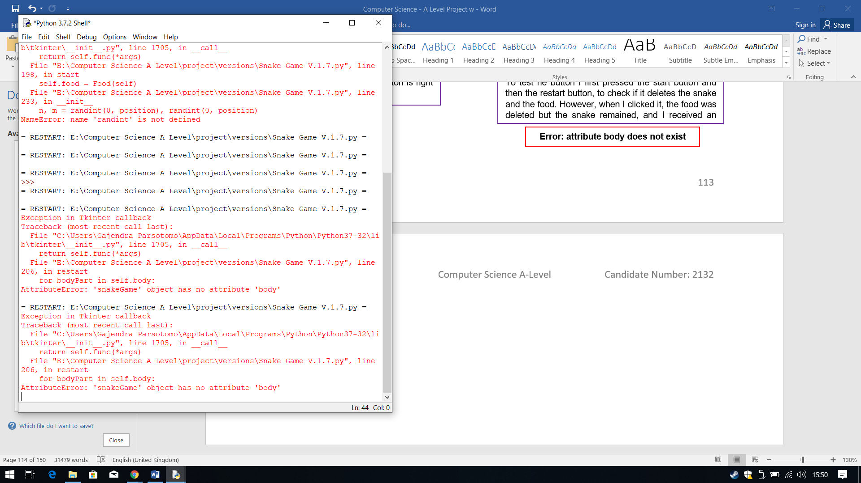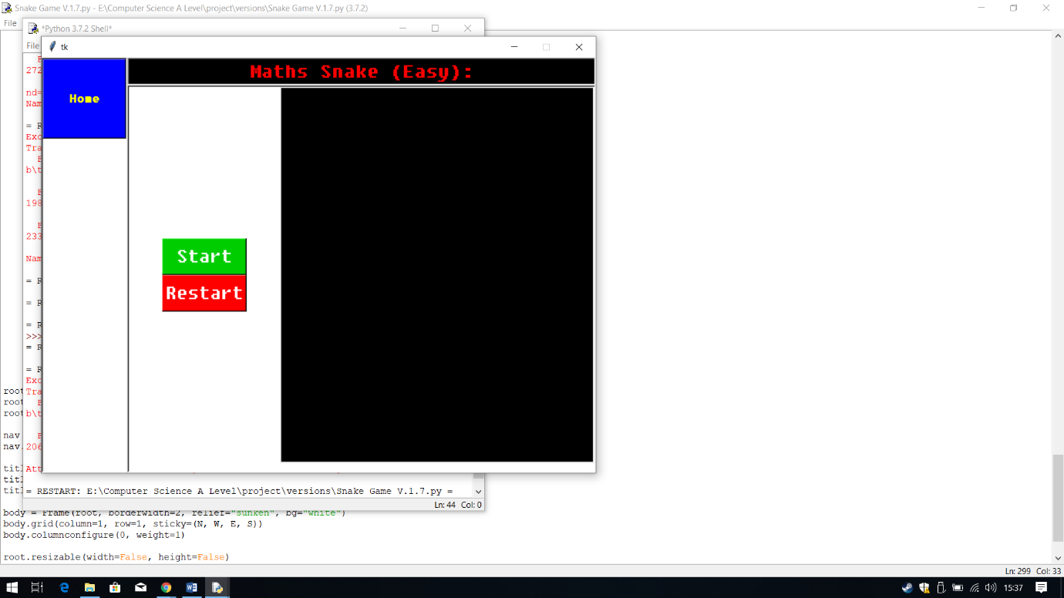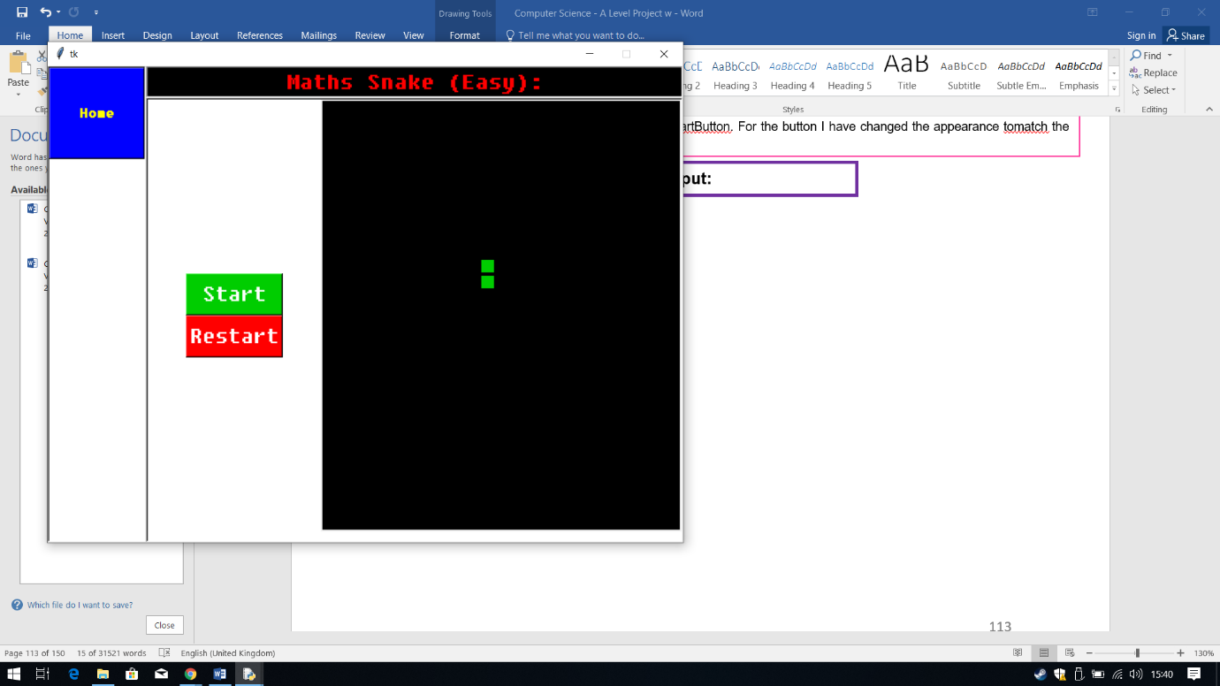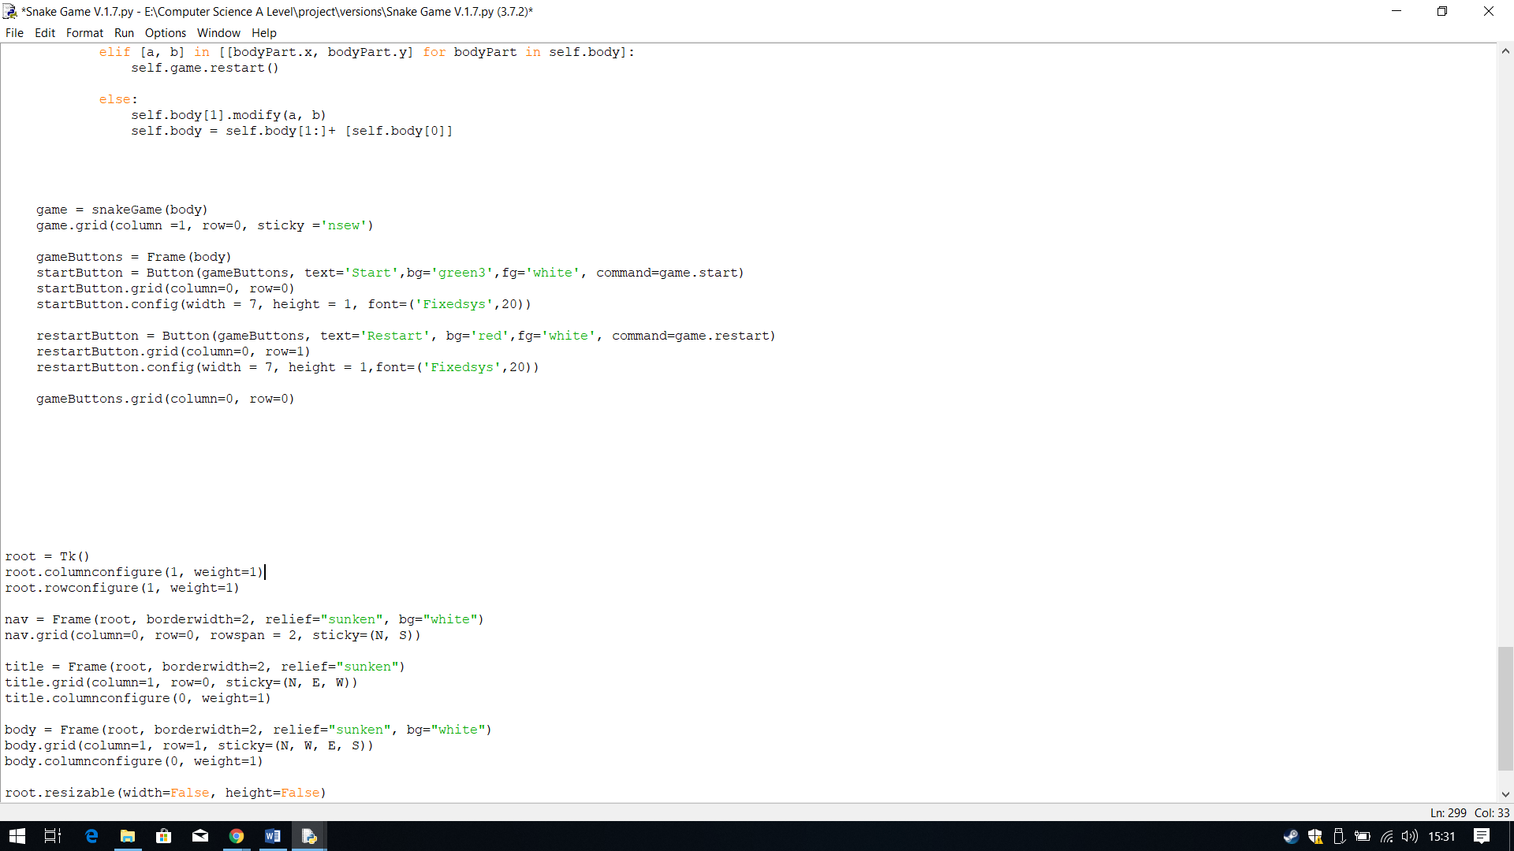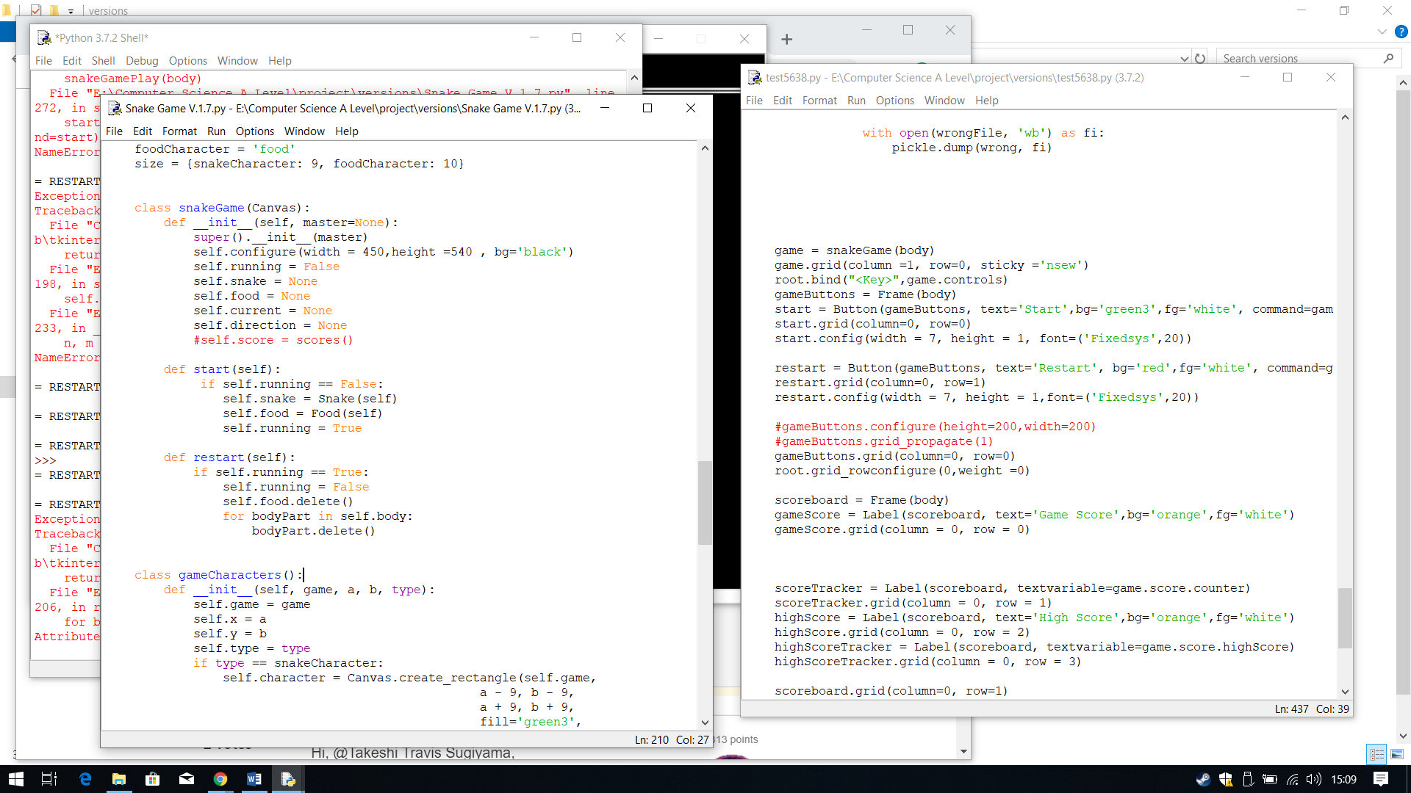

To test he button I first pressed the start button and then the restart button, to check if it deletes the snake and the food. However, when I clicked it, the food was deleted but the snake remained, and I received an error.

This is the output when ran, the restart button is right underneath the start button.

I then created the actual button, saving it to the variable restartButton. For the button I have changed the appearance tomatch the client’s design and the command to call the method restart.

**Error: Attribute ‘body’ does not exist**

**Output:**

Next I decided to create the restart button. Therefore within the snakeGame() class I created a new Method called restart.

For the restart button, I need to check whether or not the game is running therefore I need to check if running is equal to TRUE. To do this I used an IF statement, so if running is TRUE then it will change the Boolean value of running to FALSE, it knows the game has ended.

Then it needs to delete all the game characters on the canvas, which I can do by using the method I have already created in the gameCharacters() class, delete(). I first need to specify the character to be deleted, which is food. This is the attribute food not he class Food(), since the food that is on the canvas is stored within this attribute.

Next I need to delete the whole snake, which means I need to delete all the bodyParts/squares within the list (body), therefore it is emptied. To do this I used a FOR loop, so for every bodyPart within the list, body, delete it using the method delete. The bodyPart contains each individual square created using the gameCharacter() class.

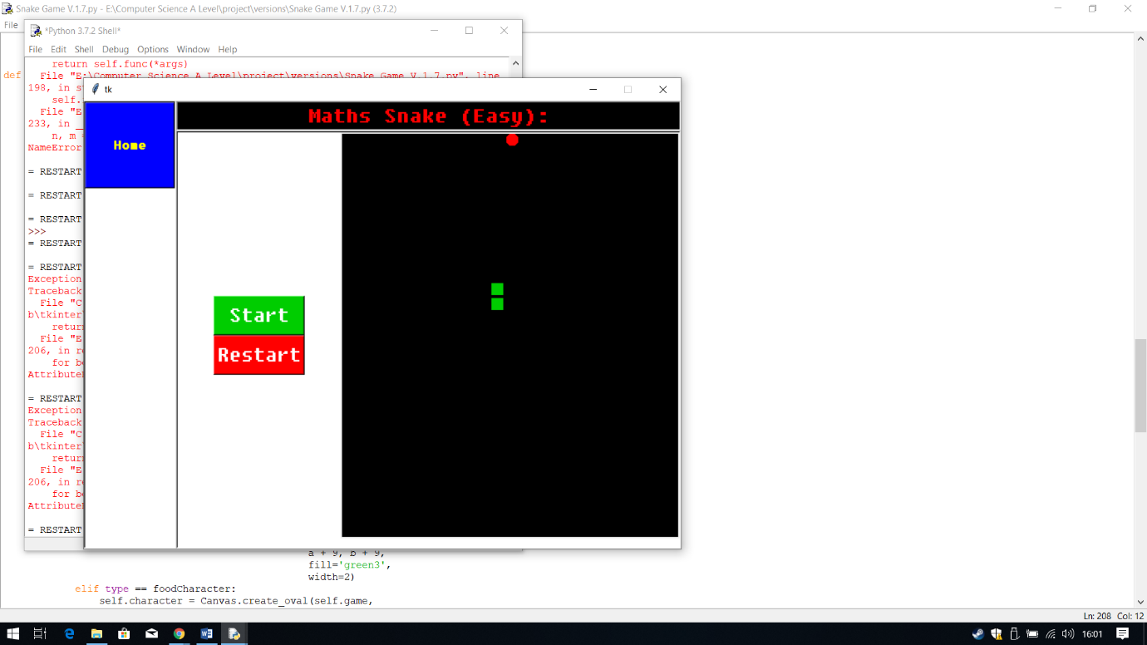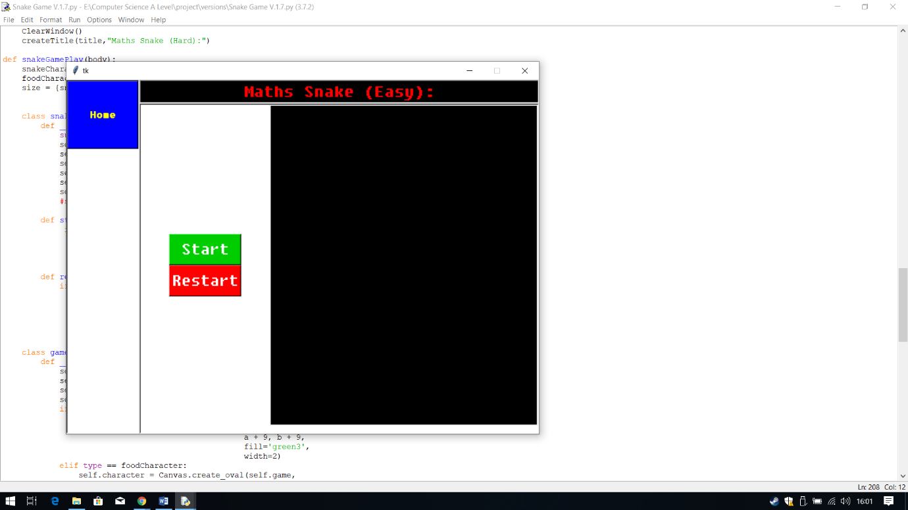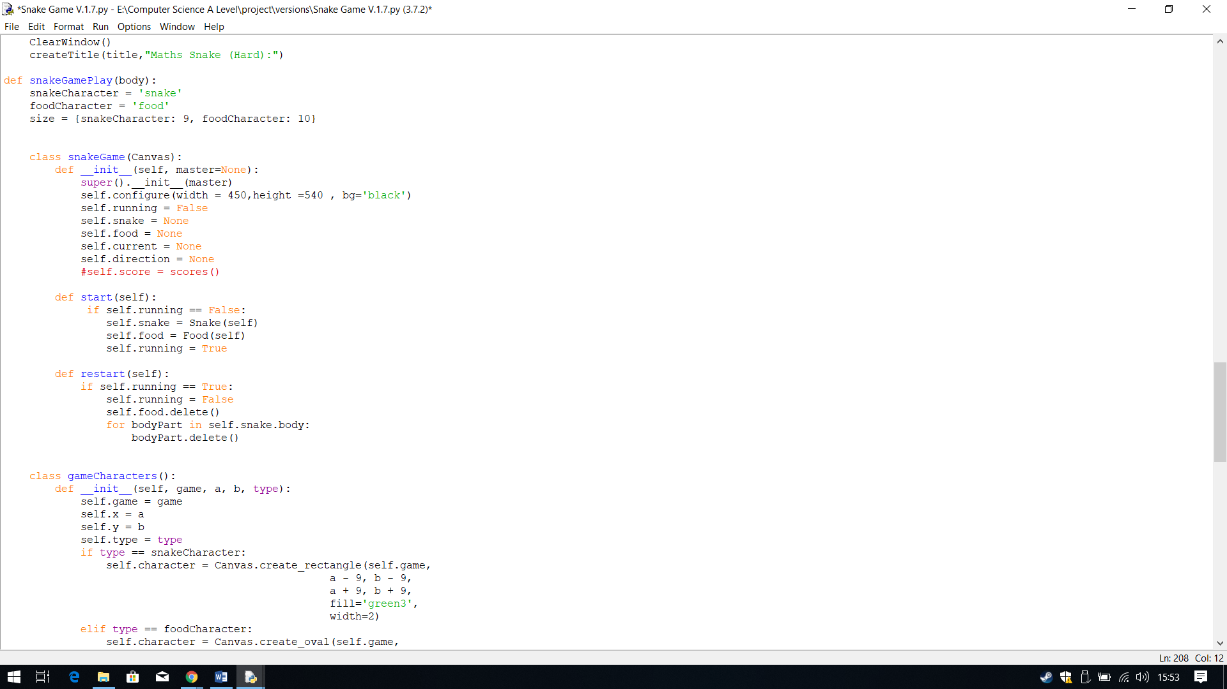

**Iterative Testing:**

**Test 7, No.1**

When I pressed the restart button, this time the snake and the food got deleted.

**Output:**

The problem is cause by the attribute not existing. The snake is stored within a attribute like the food, therefore to fix this I need to use that attribute, which is the attribute called snake. This attribute stores the whole snake class, therefore to access it I just need to call that attribute and then the list from the attribute.

## **Controls**

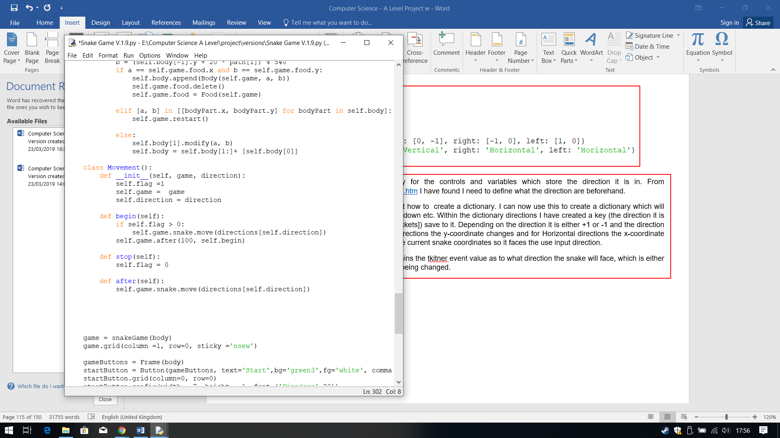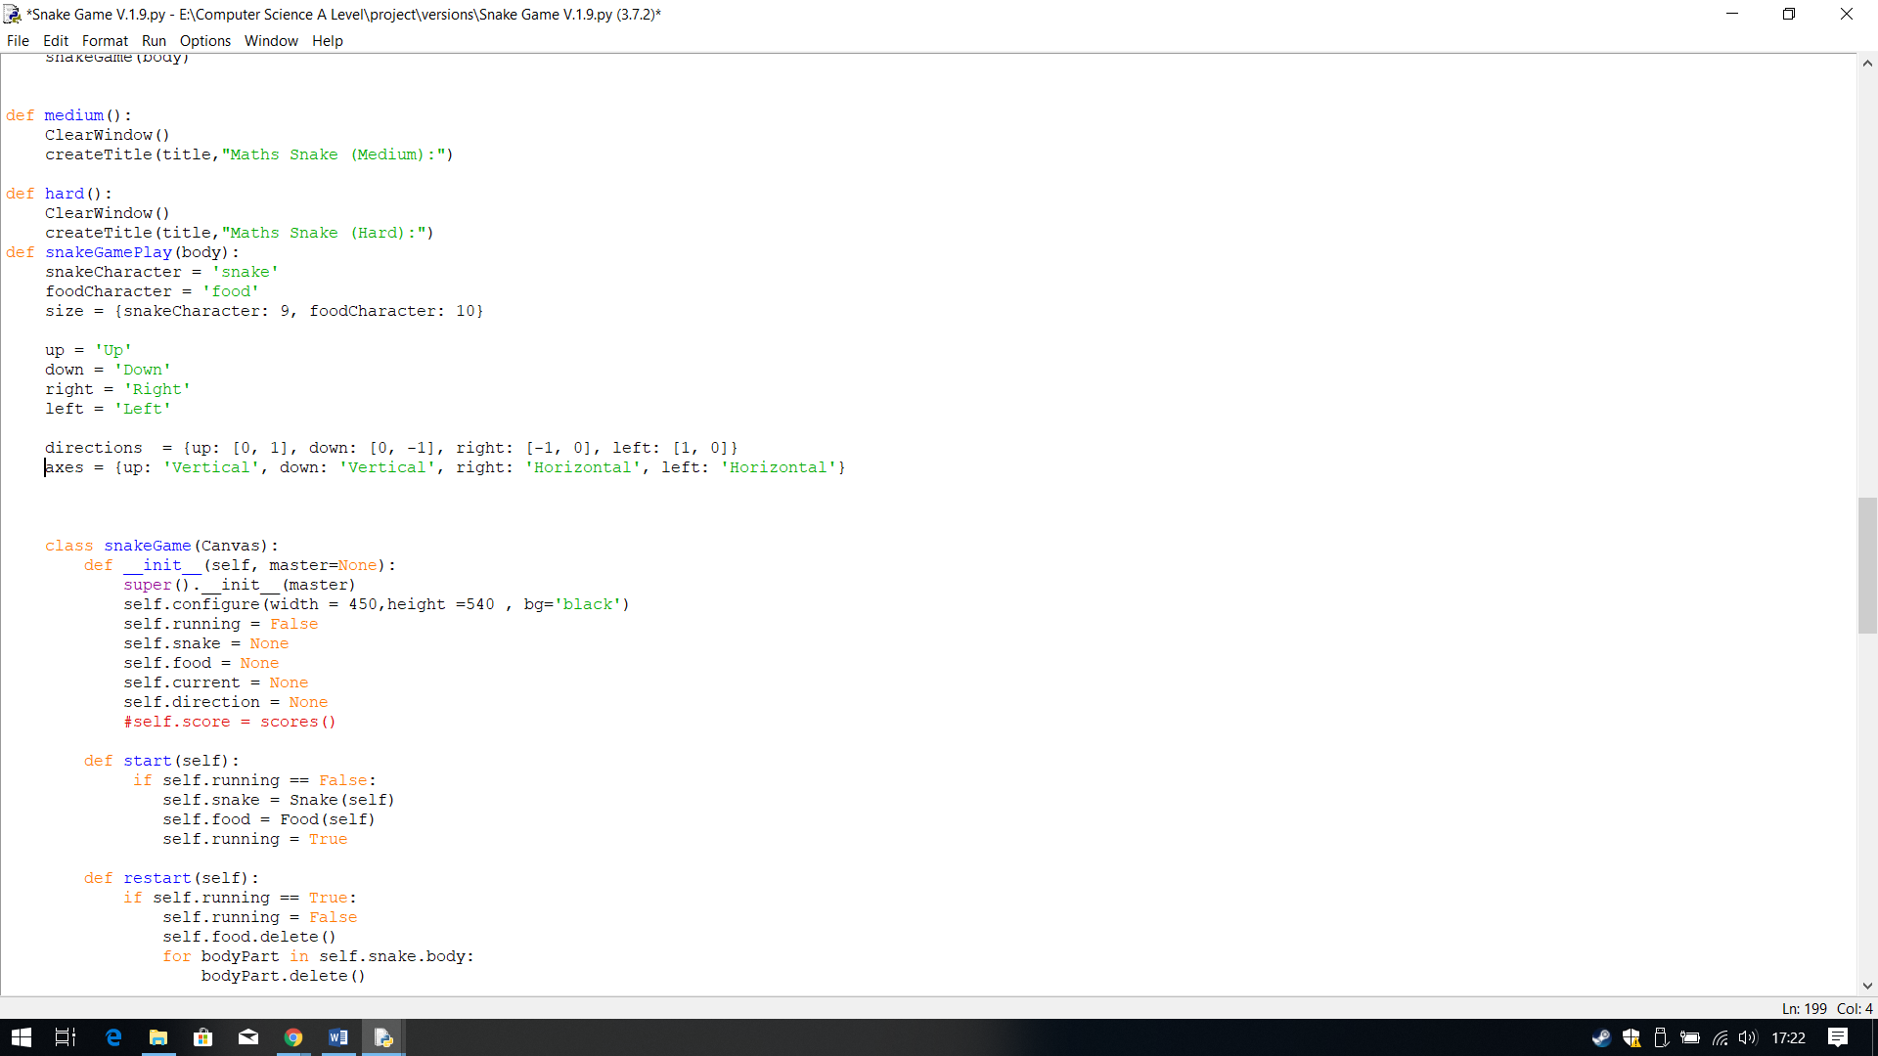In Version 1.8 I started to implement the snake for constant movement and the controls as well.

To create the controls I first created a dictionary for the controls and variables which store the direction it is in. From <http://effbot.org/tkinterbook/tkinter-events-and-bindings.htm> I have found I need to define what the direction are beforehand.

From <https://realpython.com/python-dicts/> I have learnt how to create a dictionary. I can now use this to create a dictionary which will save the directions coordinates for each direction, up, down etc. Within the dictionary directions I have created a key (the direction it is for) with the value (coordinates hence the [square brackets]) save to it. Depending on the direction it is either +1 or -1 and the direction depends on which one changes x or y. For Vertical directions the y-coordinate changes and for Horizontal directions the x-coordinate changes. This dictionary will be use to + or – 1 from the current snake coordinates so it faces the use input direction.

I have also created a dictionary called axes. This contains the tkitner event value as to what direction the snake will face, which is either Vertical or Horizontal, so it knows which coordinate is being changed.



After the snake attribute, I then called the method within the Snake class which define the snake’s characteristic, move. I save the direction of the snake to move, so it knows where to apply the characteristics. Did this by opening the dictionary for directions, and then used the attribute direction which will be used to store the direction I want it to face at the beginning,

Within the class Movement() I have created a method called begin. This method will describe the movement at the beginning of the game, therefore it will be use to describe what happens when the user presses start. It will also be used to move the snake after an event in a constant direction.

I have first used an IF statement to check if the flag is greater than zero, as this will be my command line to check that the event start has occurred. Then I need to define which direction the snake will move/face (in constantly) when start is pressed. Therefore, to do this I first called game, which contains all the attributes, then the specific character am choosing for movement which is snake.

Before I can define the controls, I first needed a way to track the movement of the snake a t the start, and after each change in direction from user input. Therefore, I decided to create a new class called Movement().

Within this class I have passed game and the dictionary direction since it is need to state the direction of the snake at the beginning and after each movement/input. To help keep track movement and button click as well I am using a python programming technique called flag. I was told of this technique from my teacher, so I research what this is for in depth, using <https://medium.com/@zzzuzum/command-line-flags-python-and-tensorflow-85ab217dbd5> and <https://www.cs.uky.edu/~keen/115/reading/flags-py.html>. Flags are command lines to check if an event has occurred or not. I can do this using a Boolean value if it is true or flase. In this case I am going to use 1 for true and 0 for false.

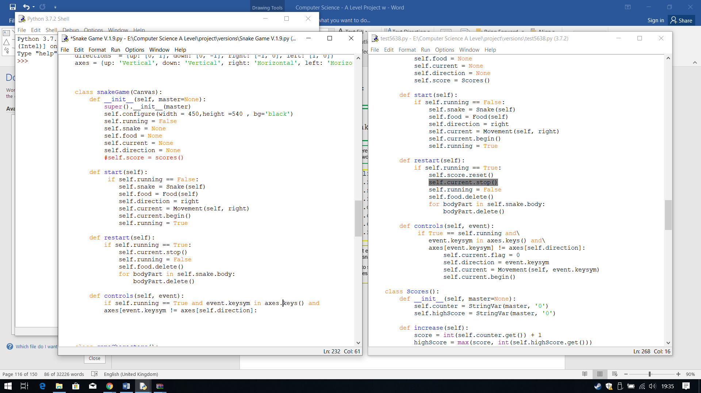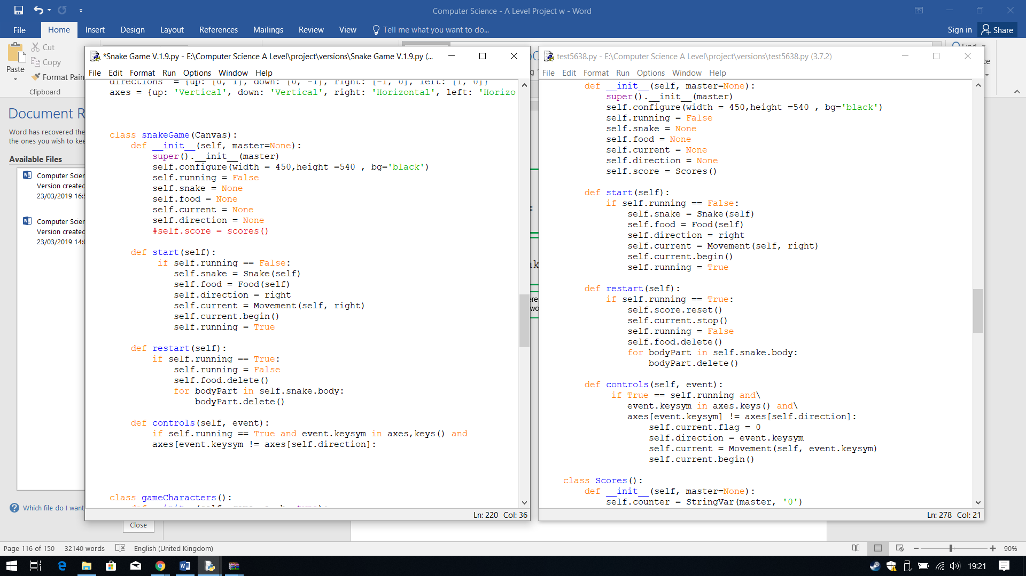

In restart I have used current for the method stop, so it saves the current progress as stop, and it knows the flag is equal to zero, thus the game will stop running.

I first went back to edit the buttons method. I first edited the start method, where I defined the attribute for direction as being equal to right. This will make sure that the direction of the snake when start is clicked, it is facing right.

The using the attribute current, which I am using to store the current direction of the snake and passing it to Movement. I then used it to save the direction to begin so when it called it faces the right direction.

Next I created another method within the class called stop, and within this class it holds the flag but this time set equal to zero.

I then created another method called after, where I copied the code from the method begin. I will use this method to keep track of the direction it is facing after an user input, in other words after an even occurs.

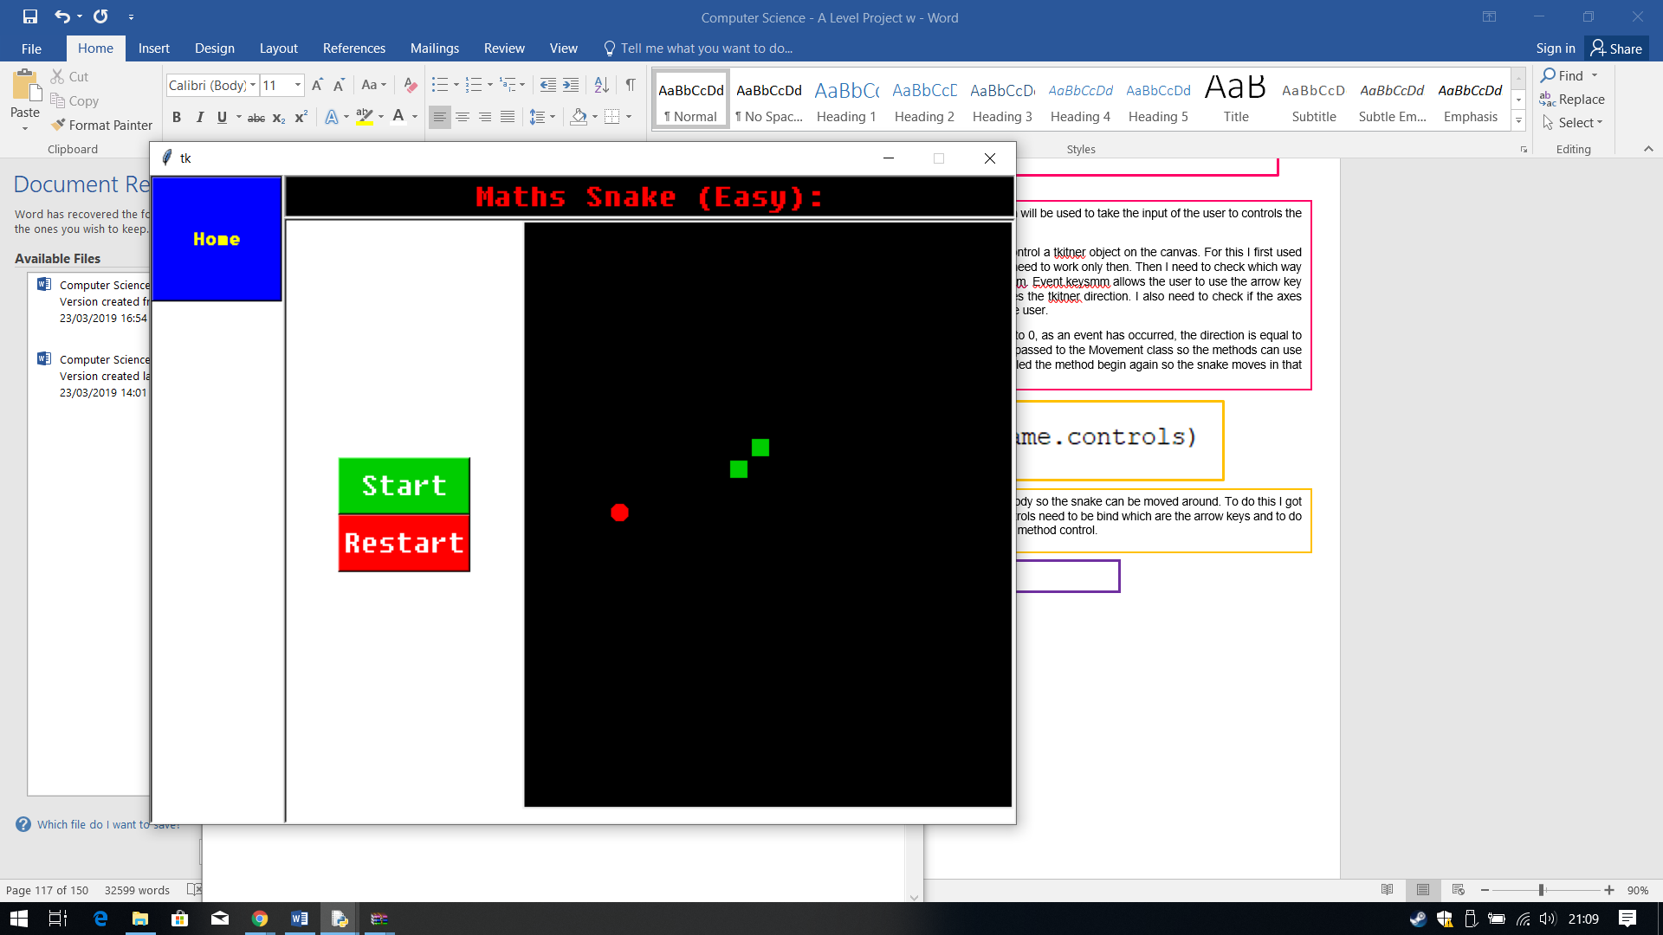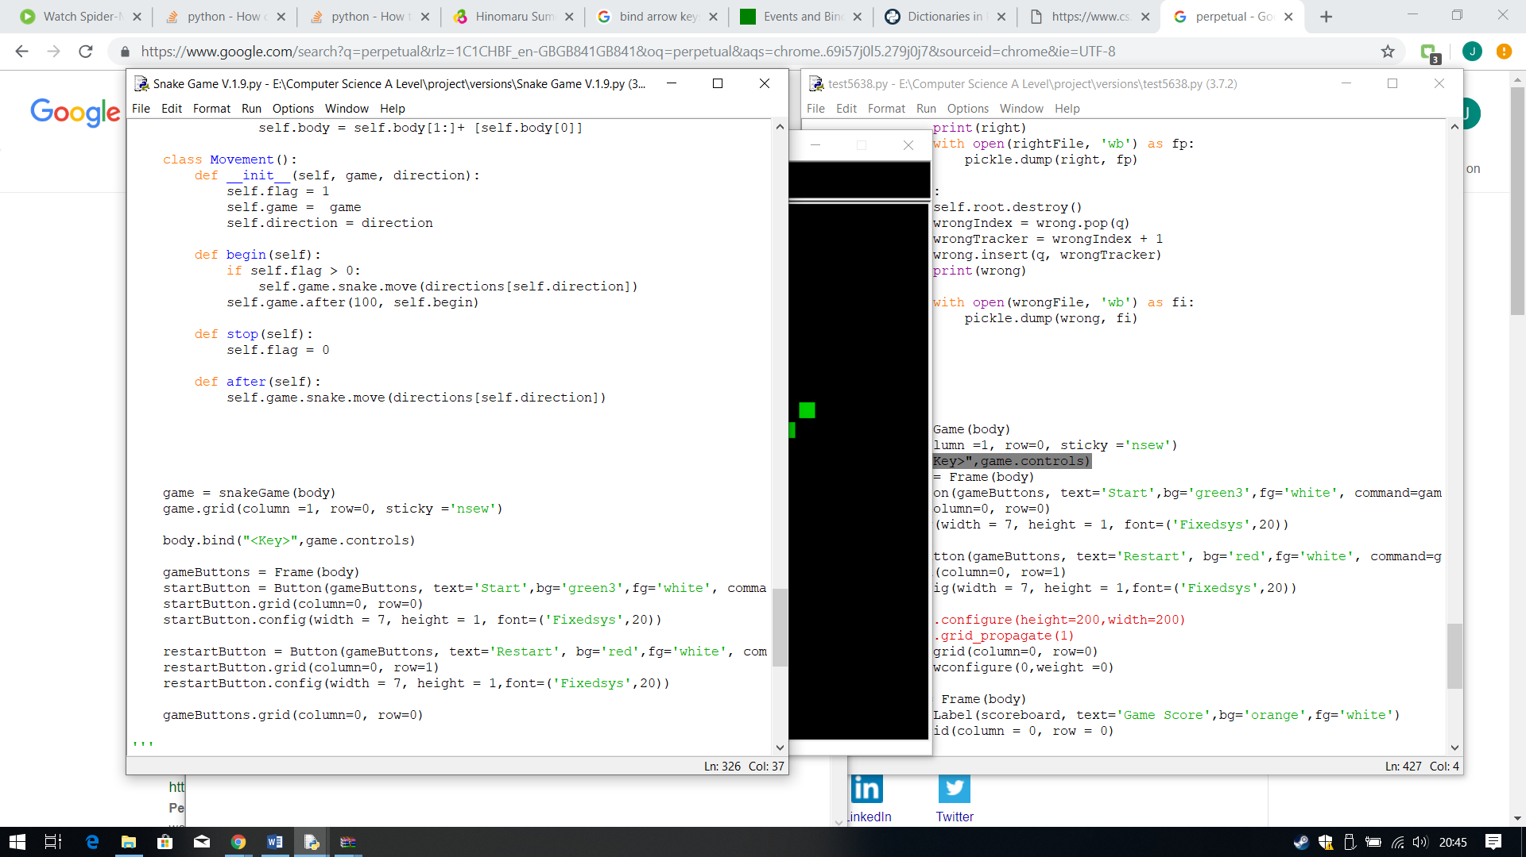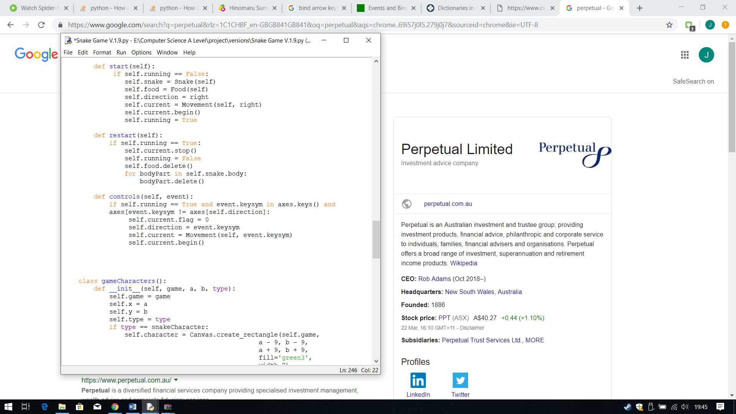

When ran I the program I got a logical error. The program ran but the output Is different to the expected output.

The snake moves constantly however there are 2 things that are wrong with it, 1. The snake is moving constantly in the wrong direction, 2. The snake’s squares move separately. I stated the snake direction as right, at beginning however the snake here moves to the left, opposite direction to what I want. Furthermore, the controls don’t work either, when I press the keys the snake does not change direction.

However, I managed to succeed at the snake traversing through the edge of the screen, and coming out of the other opposite end. Furthermore, the starting position of the snake when I press start is always the same positon, which is what I wanted.

Within the class snakeGame() I have created new method called controls, which will be used to take the input of the user to controls the snake using the arrow keys.

Within this method I have passed the tkinter function event, which is used to control a tkitner object on the canvas. For this I first used an IF statement to check the game is running is equal to TRUE, since controls need to work only then. Then I need to check which way the control of the key is going and save this to the tkitner fucntion event.keysysm. Event.keysmm allows the user to use the arrow key to input the direction. I use this to check the keys within the axes which defines the tkitner direction. I also need to check if the axes direction is not the same as the current direction of the key being inputted by the user.

If all the conditions are met then the it will do the following, the flag is changed to 0, as an event has occurred, the direction is equal to the key input (the event). The direction of the key input is saved to current and passed to the Movement class so the methods can use it and the flag is rested back at 1 so it is ready for the next key input. Finally called the method begin again so the snake moves in that direction constantly.

**Errors: Wrong Direction, Snake’s squares separate and Controls don’t work**

**Output:**

Finally, to allow the user to control the snake I need to bind the controls to the body so the snake can be moved around. To do this I got the frame and thin used bind to bind the keys. In the brackets I called which controls need to be bind which are the arrow keys and to do this I used the tkinter event function “<Key>” and then specify how, which is the method control.

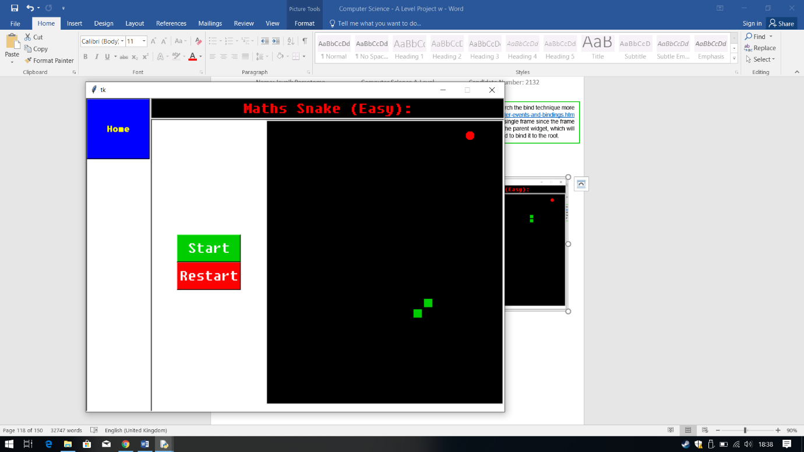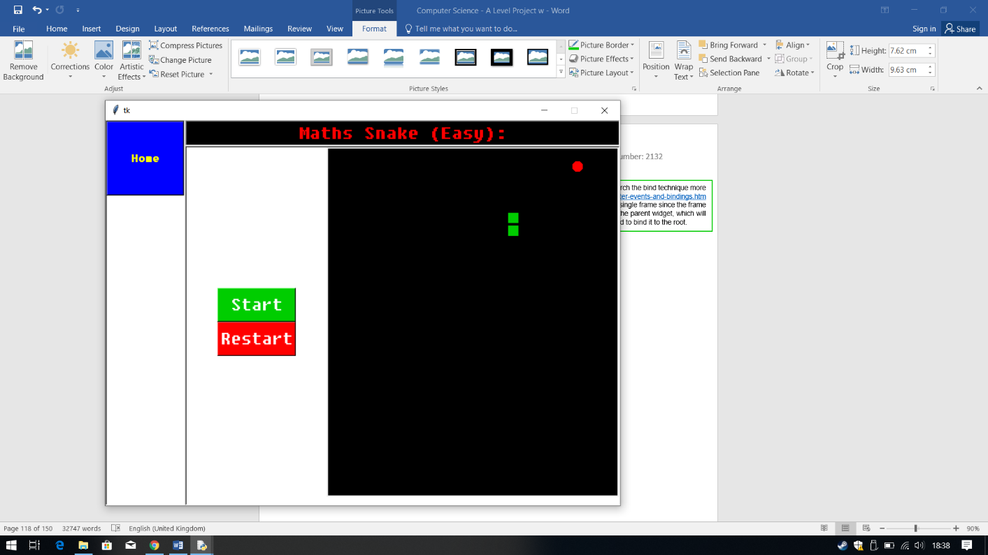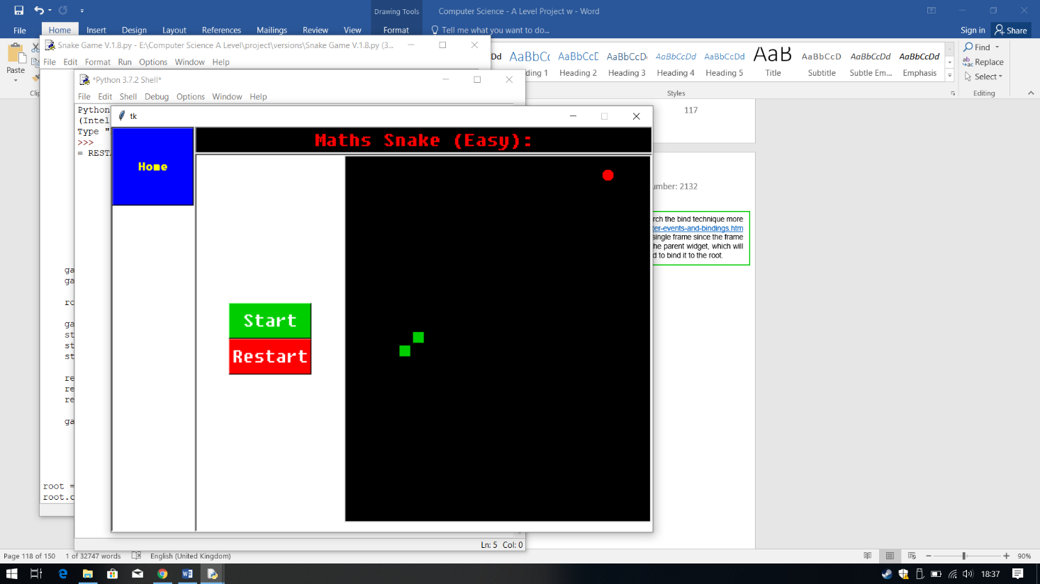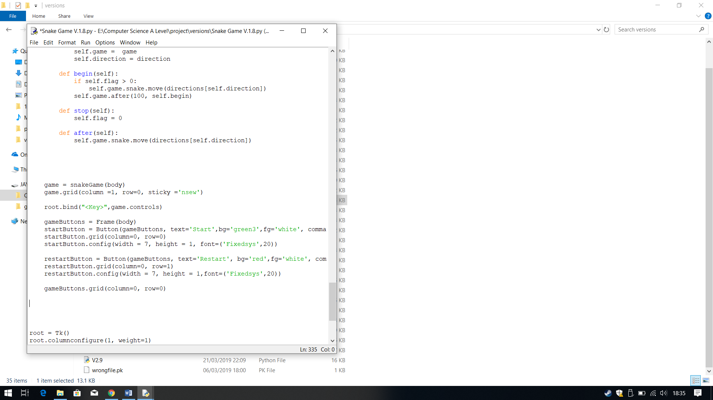

**Iterative Testing:**

**Test 8 No.1**

**Error: Control Keys moves the Snake in the opposite direction.**

When ran, I tested the controls, when I tried the arrow keys the snake responded and moved however it did not move in the correct direction.

For example, the first screenshot show snake moving upwards, however the arrow key I pressed was the down key. Screenshot 2 is where I pressed the left arrow key but the snake travelled in the right direction.

Therefore, this shows that I have created the wrong directions for the controls. This gives me a hint to solve the snake moving in the wrong direction as well.

**Output:**

I first fixed the controls. To fix the controls I research the bind technique more and I found from <http://effbot.org/tkinterbook/tkinter-events-and-bindings.htm> that to bind the controls you can’t just bind it to a single frame since the frame is an child widget. I need to bind the controls to the parent widget, which will then work within the child widgets therefore I need to bind it to the root.

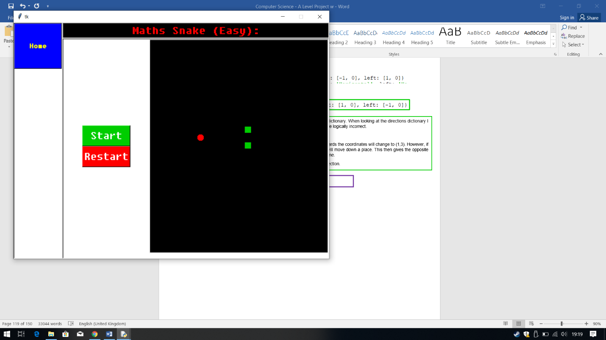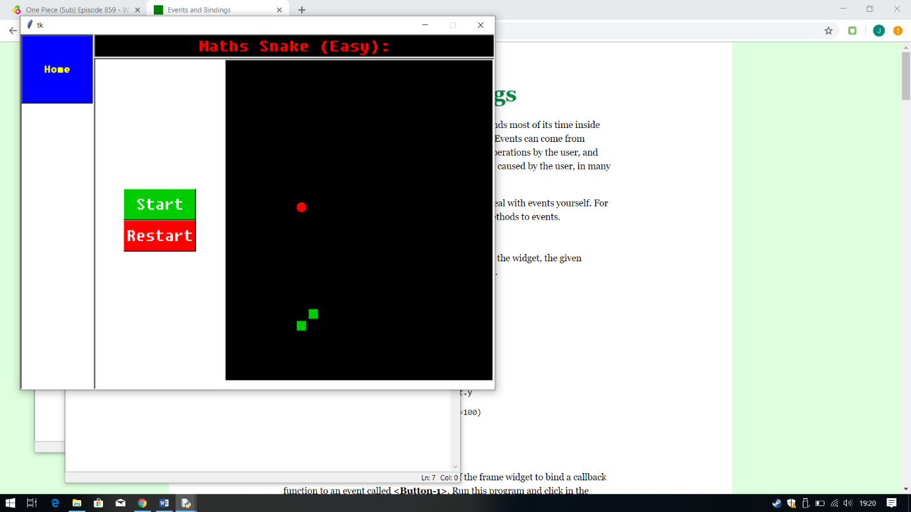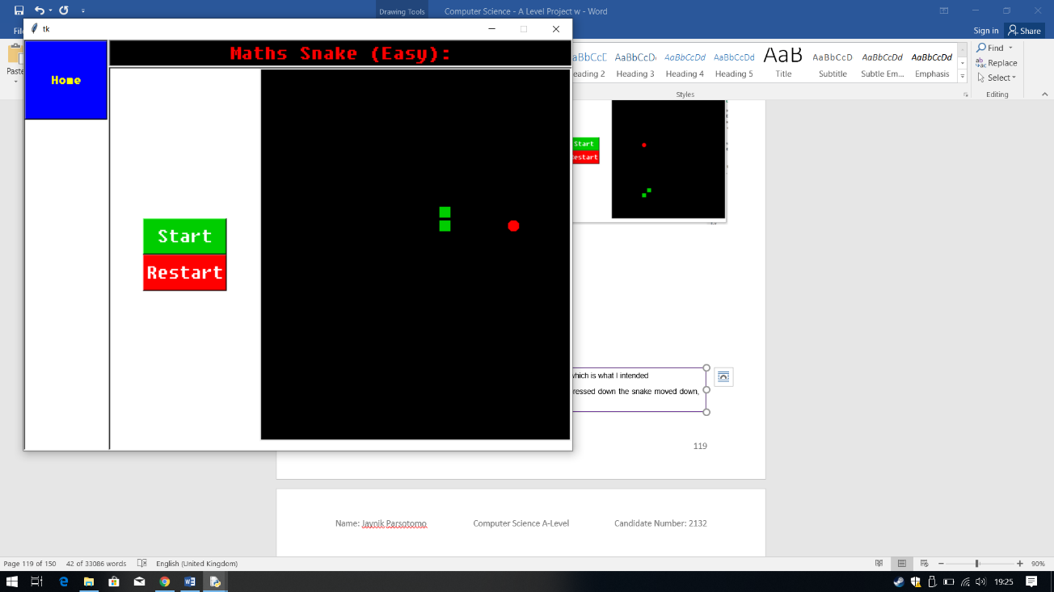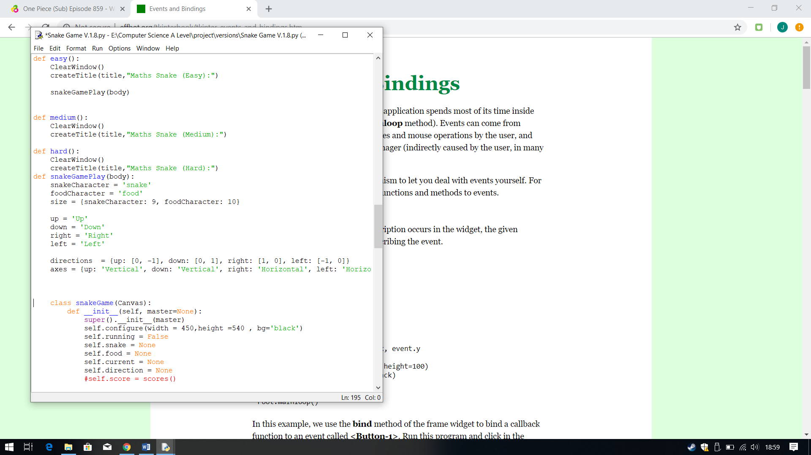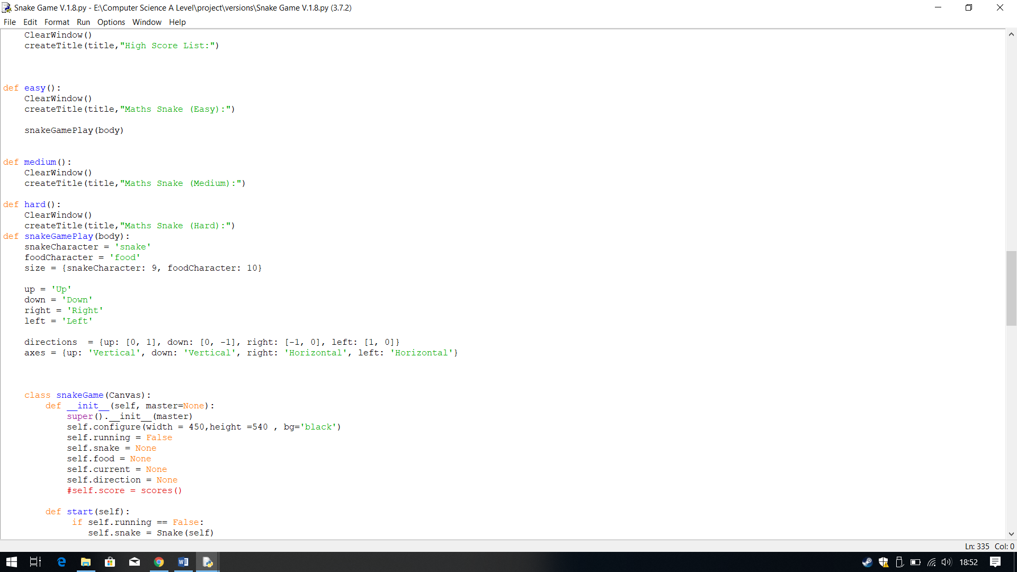

This time when I pressed start the snake moved in the right direction, which is what I intended Shown in screenshot 3.

The snake also responded to the control keys correctly, so when I pressed down the snake moved down, shown in the first screen shot.

To fix the control’s direction, I presumed that there is a problem with the directions dictionary. When looking at the directions dictionary I saw that the coordinates change does not make sense, the directional coordinates are logically incorrect.

Example:

I the current coordinates are (1,2) then when the user wants to move the snake upwards the coordinates will change to (1,3). However, if you compare that to a y-axis, you can see the (1,3) is below (1,2), thus the snake will move down a place. This then gives the opposite direction to what I expected. To to change this I need to minus 1, so it moves up by one.

Therefore, to fix this I changed the directions by swapping them with the opposite direction.

**Output:**

**AFTER:**

**BEFORE:**

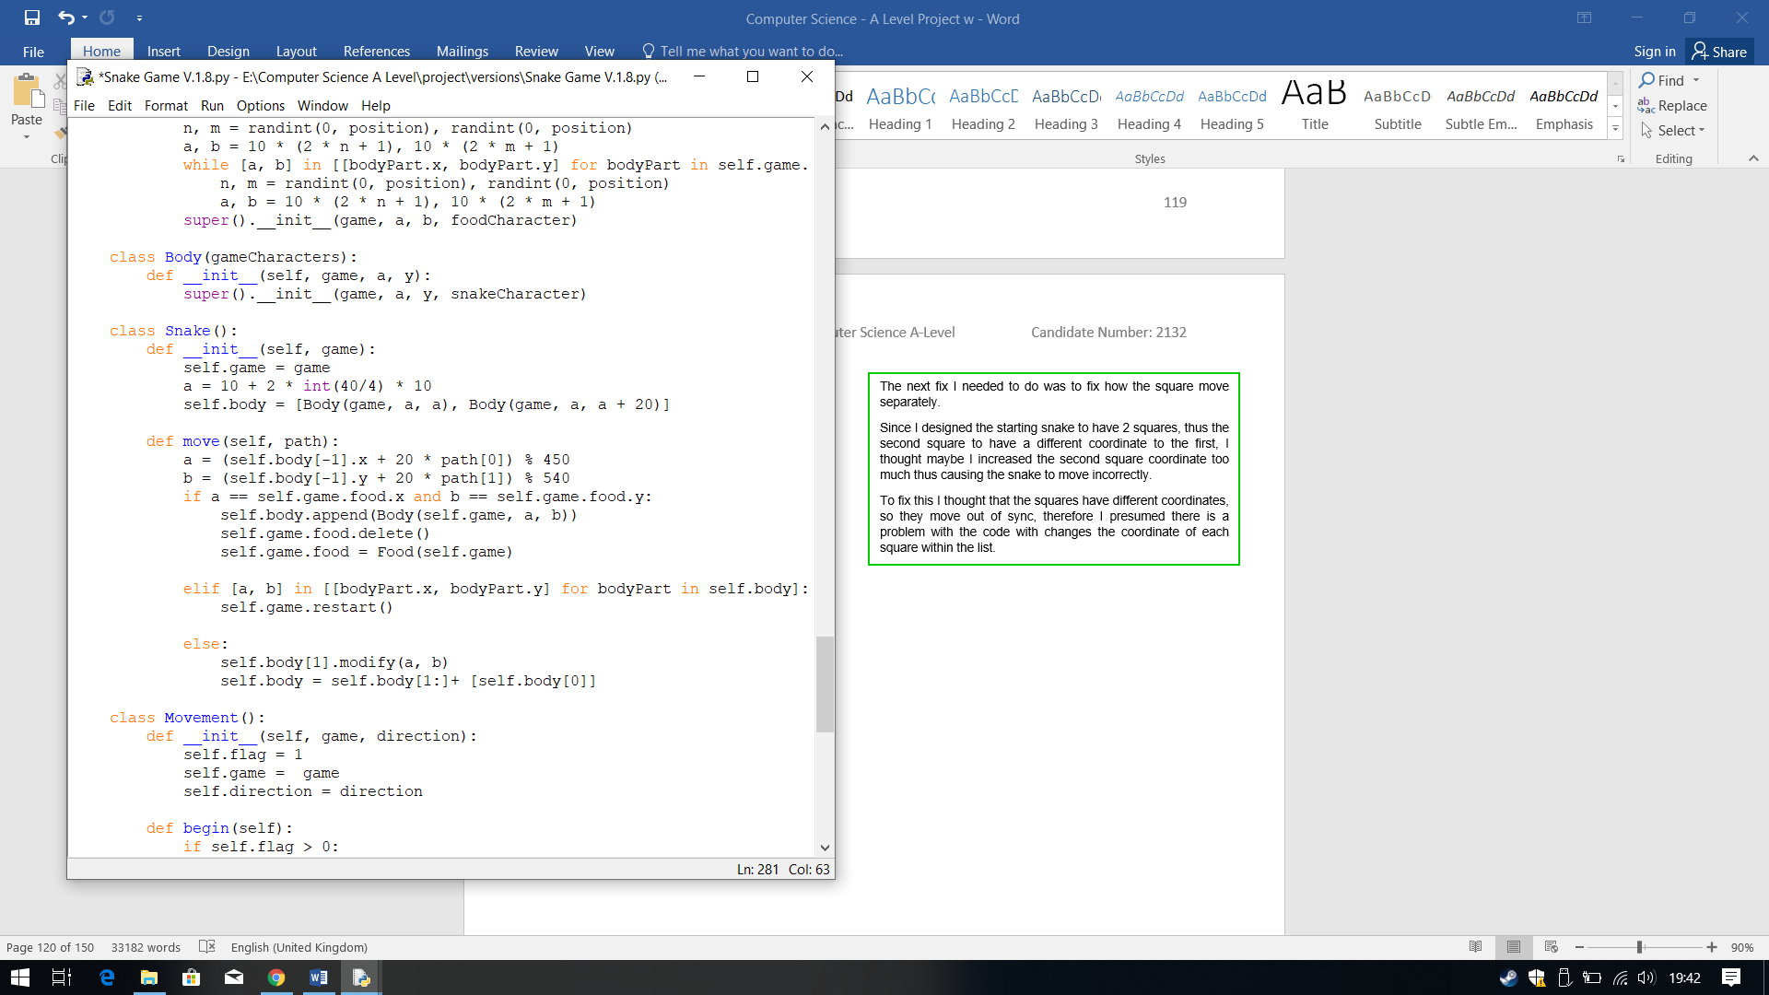

**BEFORE:**

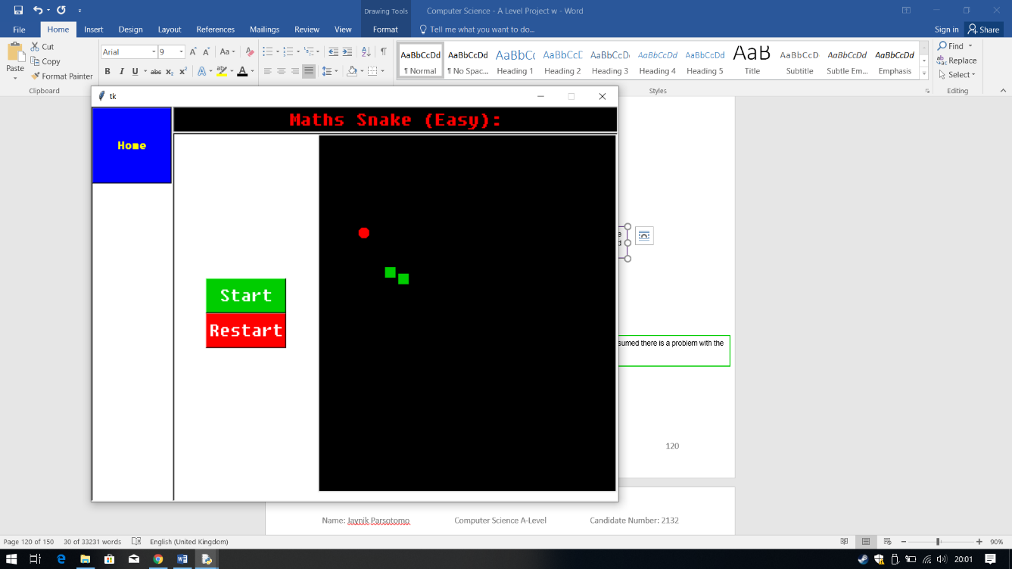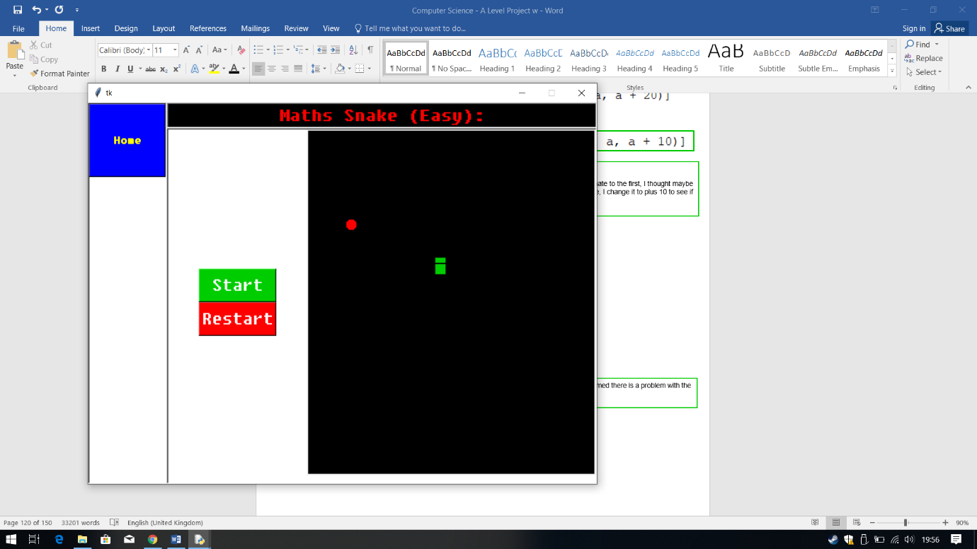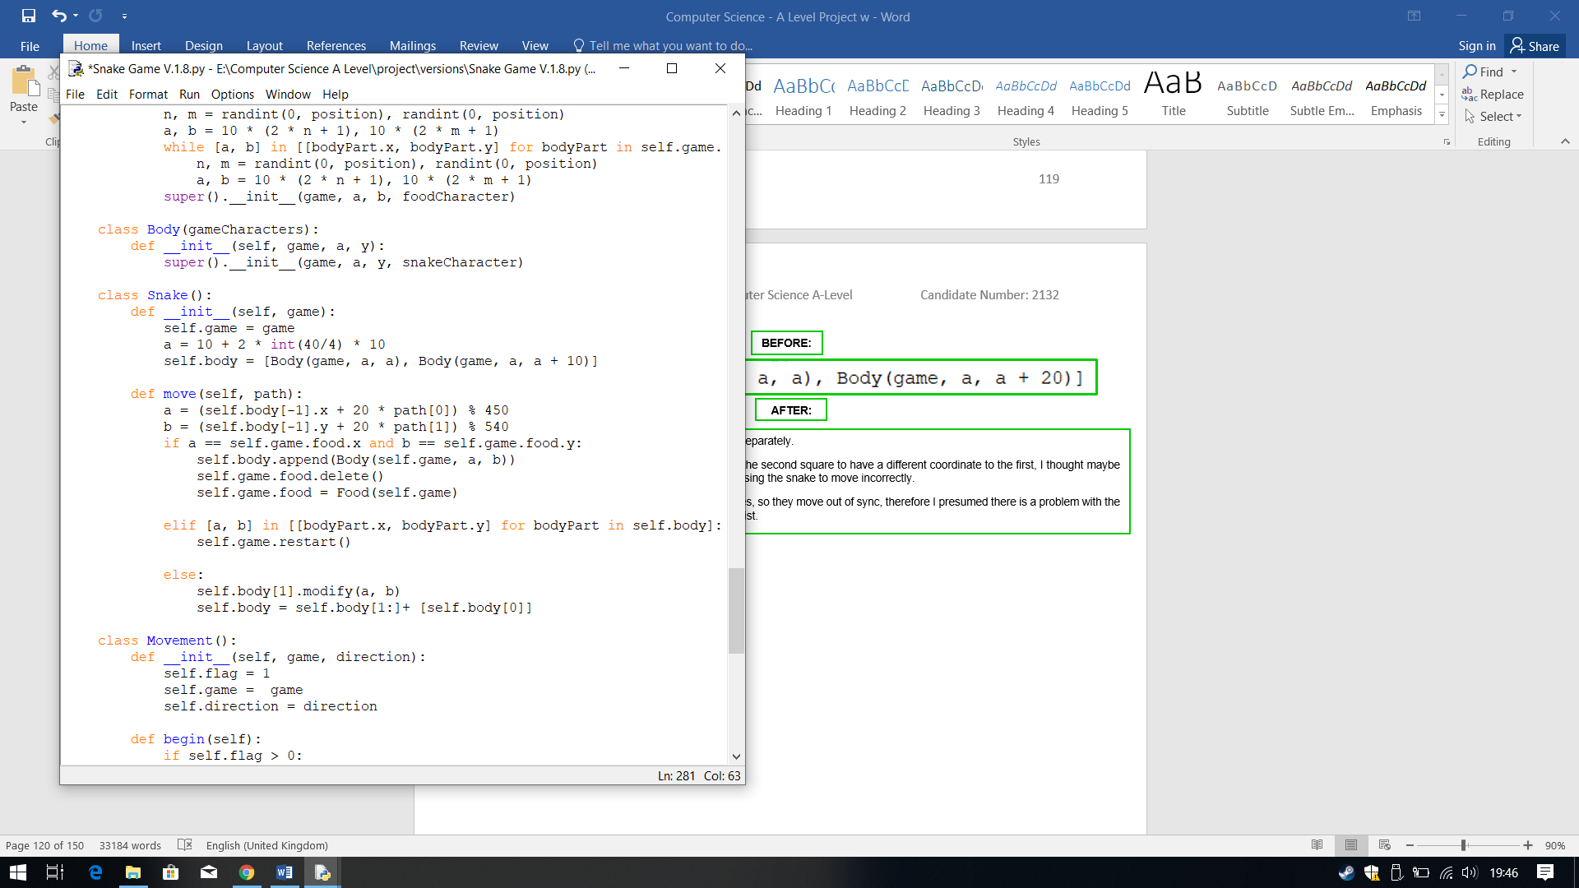

**Iterative Testing:**

**Test 8 No.2**

The next fix I needed to do was to fix how the square move separately.

Since I designed the starting snake to have 2 squares, thus the second square to have a different coordinate to the first, I thought maybe I increased the second square coordinate too much thus causing the snake to move incorrectly. Therefore, I change it to plus 10 to see if it decreases the gap and keep

The output was incorrect as it made the snake look worse, it caused the snake squares to overlap, which is not what I wanted and the squared still moved separately.

**Output:**

**AFTER:**

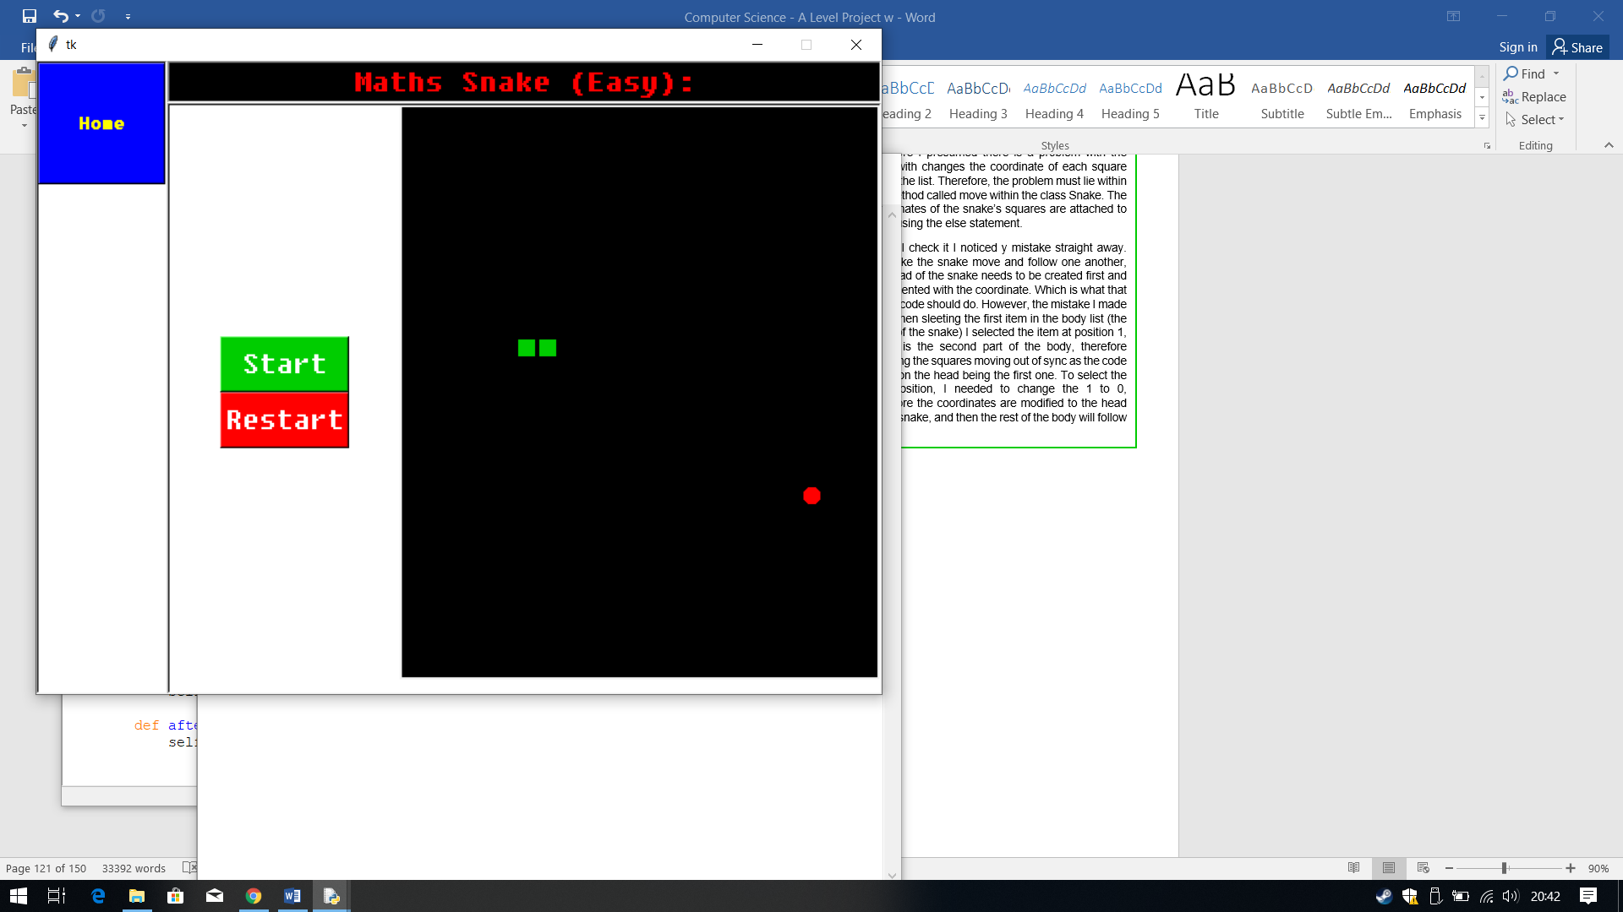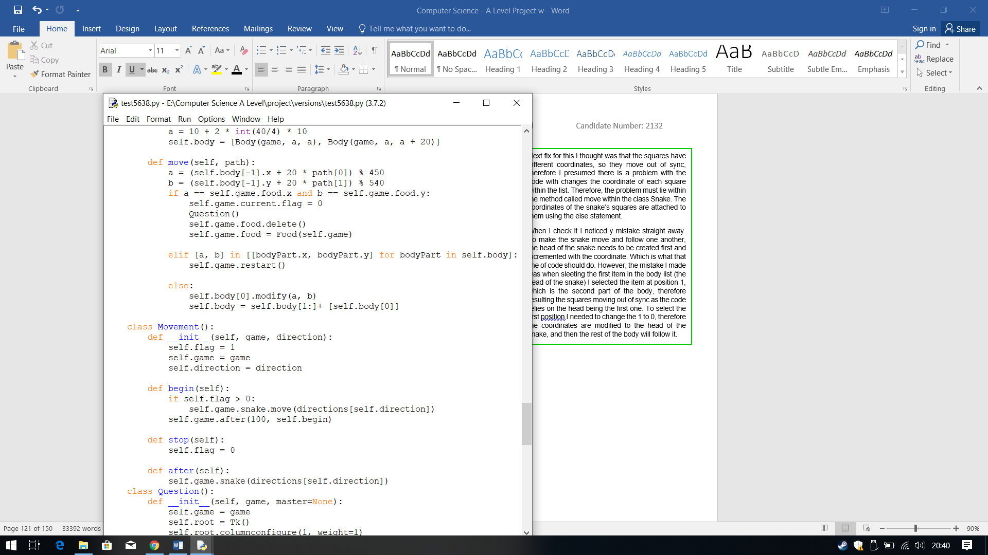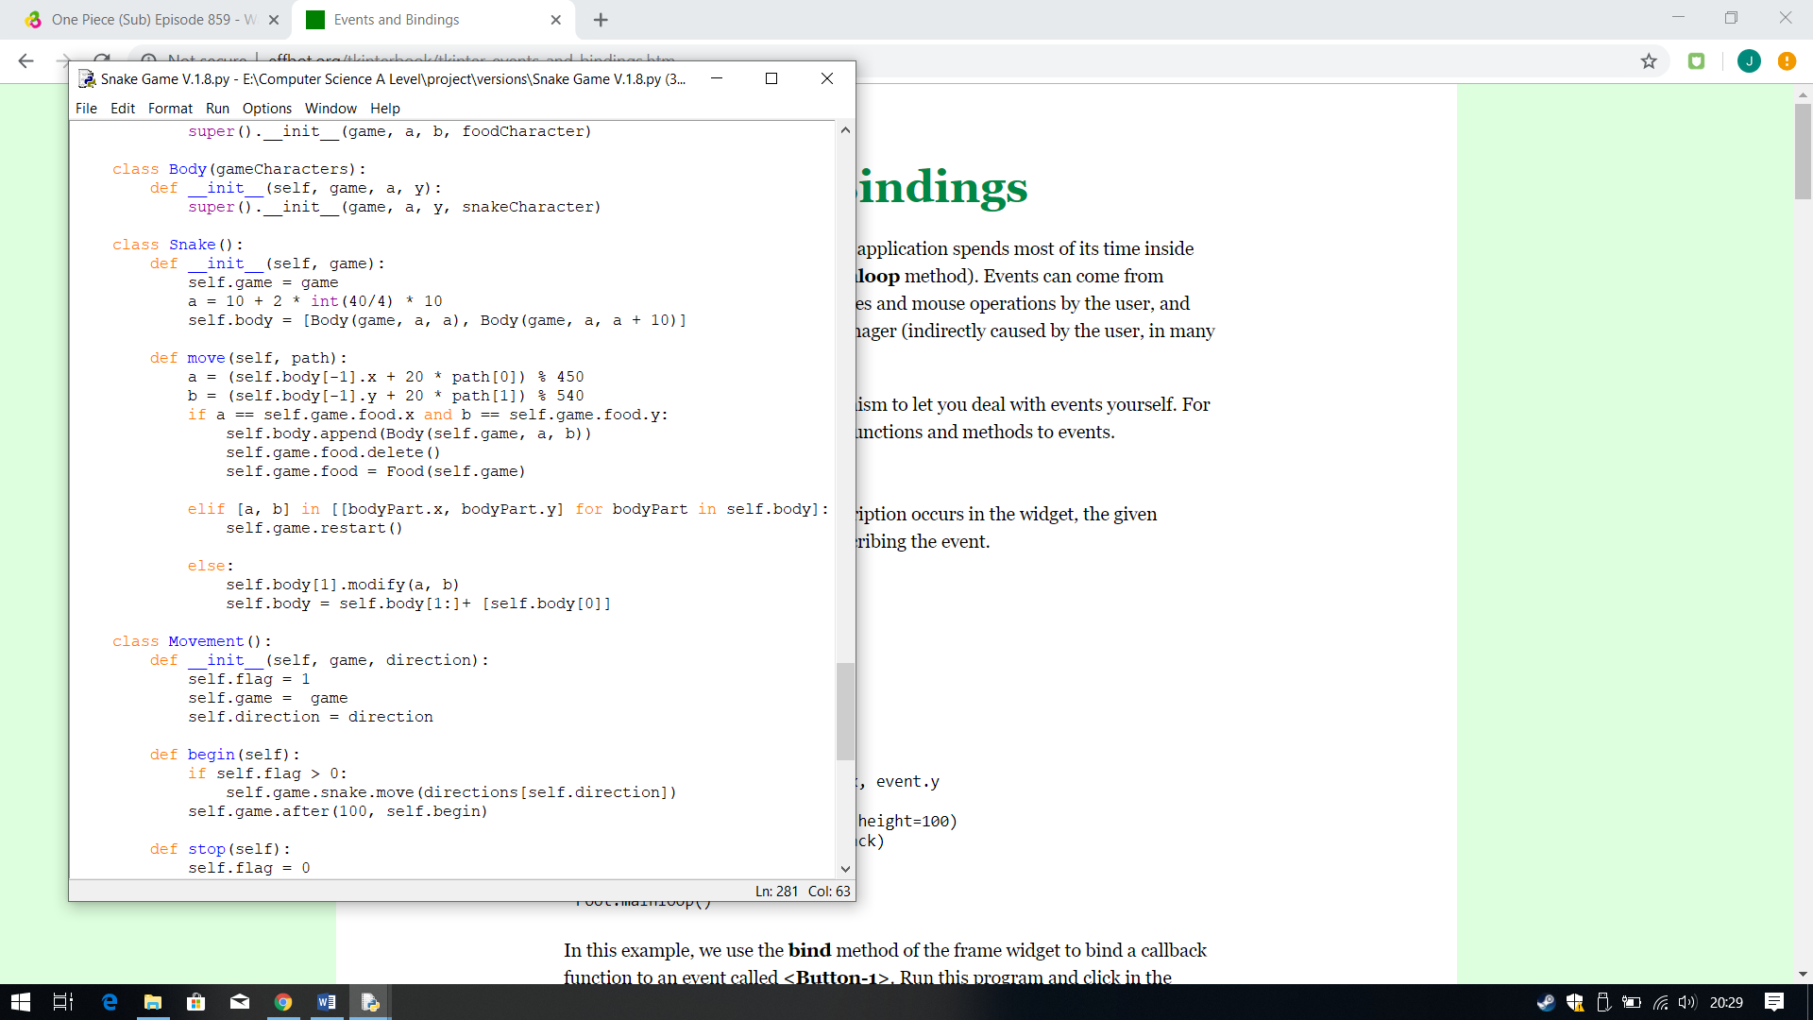

**Iterative Testing:**

**Test 8 No.3**

The output I received was correct it moved as to what I had expected. The snake now moves with the second square following behind the snake head like I wanted to.

Next fix for this I thought was that the squares have different coordinates, so they move out of sync, therefore I presumed there is a problem with the code with changes the coordinate of each square within the list. Therefore, the problem must lie within the method called move within the class Snake. The coordinates of the snake’s squares are attached to them using the else statement.

When I check it I noticed y mistake straight away. To make the snake move and follow one another, the head of the snake needs to be created first and incremented with the coordinate. Which is what that line of code should do. However, the mistake I made was when sleeting the first item in the body list (the head of the snake) I selected the item at position 1, which is the second part of the body, therefore resulting the squares moving out of sync as the code relies on the head being the first one. To select the first position, I needed to change the 1 to 0, therefore the coordinates are modified to the head of the snake, and then the rest of the body will follow it.

**Output:**

## **Snake Features**

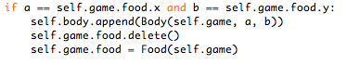In version 1.9 I tested to see if the snake game features, function correctly. Features I tested were if the snake grows or not when the condition for the IF statement is met, which is the food has been eaten, if the food deletes itself and creates a new food at a random new location. I also need to see what happens when the snake eats itself.

The first line of code checks if a and b, the x-coordinates and y-coordinates of the snake head, to be equal to the x-coordinates and y-coordinates of the food. This is done by using 2 equals signs to compare them and then using .x or .y to check the coordinates of the food. I am checking the attribute food, since the food is being stored within there.

This line is used to delete the food that the snake has just ‘eaten’. This is achieved by first calling the food, which is stored within the attribute food and then using the delete method to delete that specific tkinter object. This then should cause the food to be deleted.

This line adds the new square to the list (body). To create a new square, I use the class Body and pass the parameters game, a and b which give the place and coordinates as to where to create the new square. It will pass this information to the class Snake() where it will use the a and b value to create the square.

The final stage is to create a new food at a new random location. This is easily achieved by using the class Food(). I save this class to the attribute food, which is used to save and display the food. Within the class I have passed the parameter game, as the class needs to know where to display it.

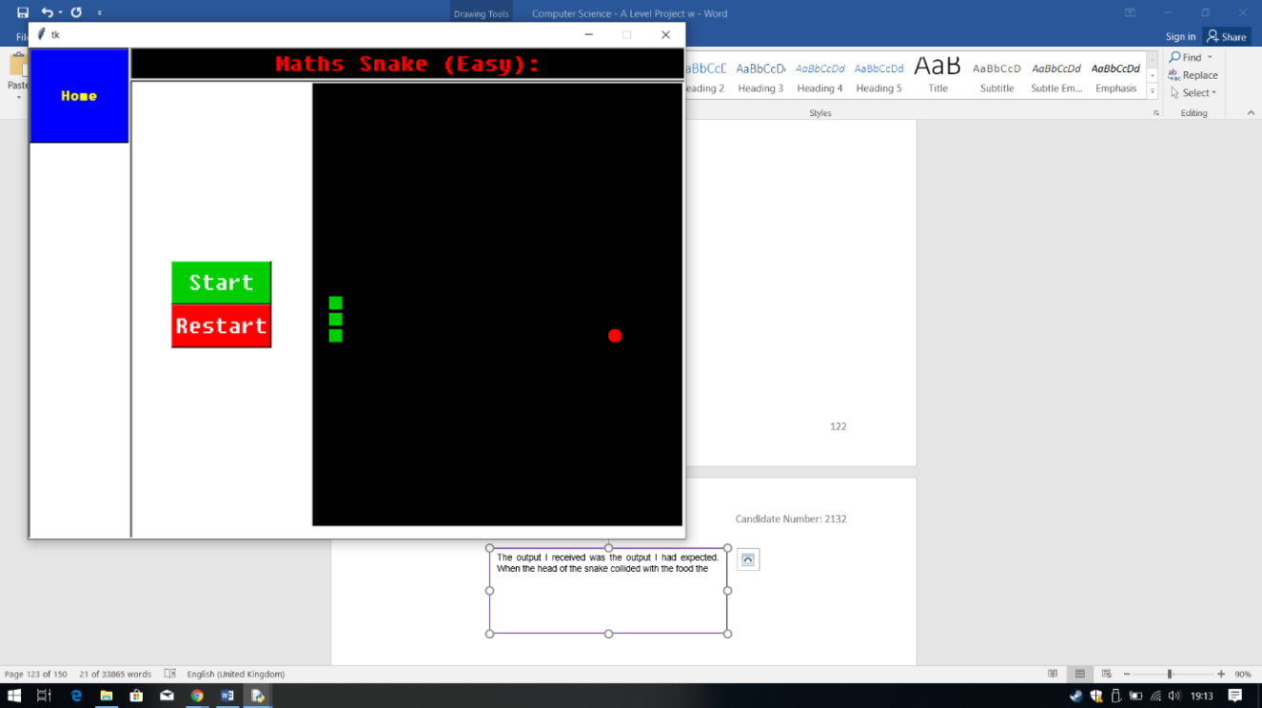

**Output:**

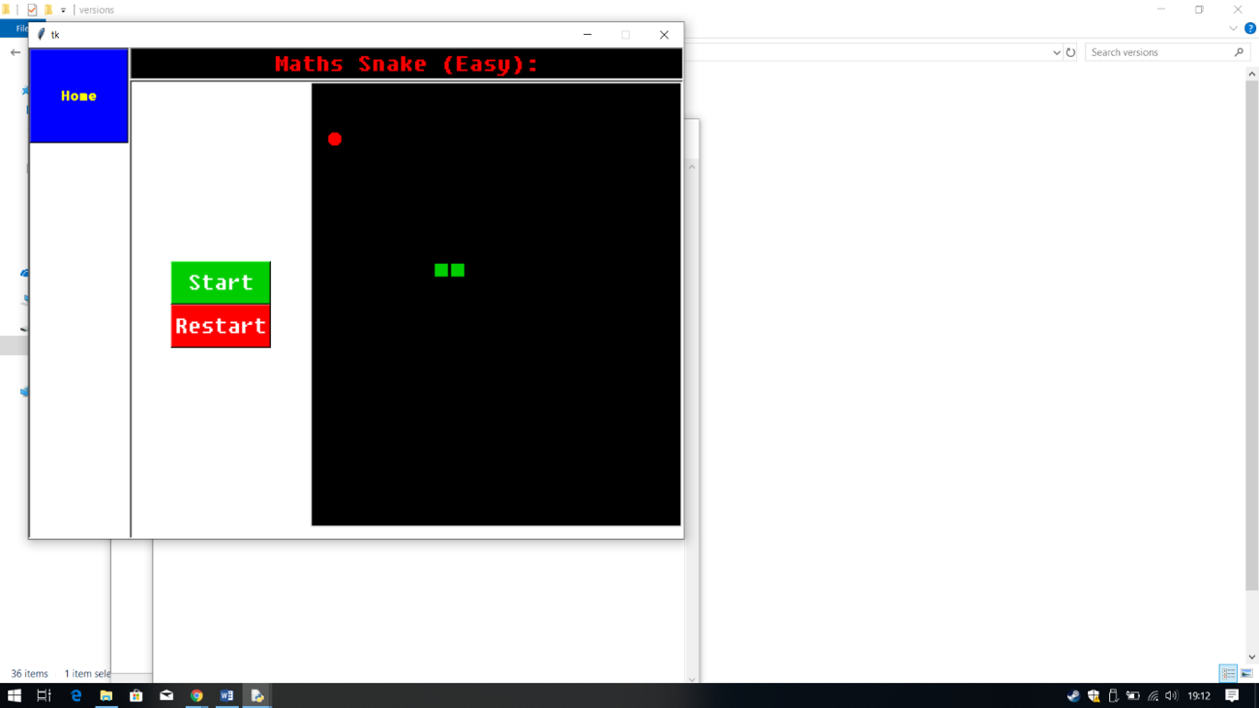

**Iterative Testing:**

**Test 11, No.1**

**Iterative Testing:**

**Test 10, No.1**

The output I received was the output I had expected. When the head of the snake collided with the food the events that I wanted to happened, happened.

Screenshot 1 displays the start of the game, and then in screenshot 2 I controlled the snake to eat the food. The snake ate the food the snake grew by one square, the food that was eaten disappeared and then finally a new random food appeared on the screen.

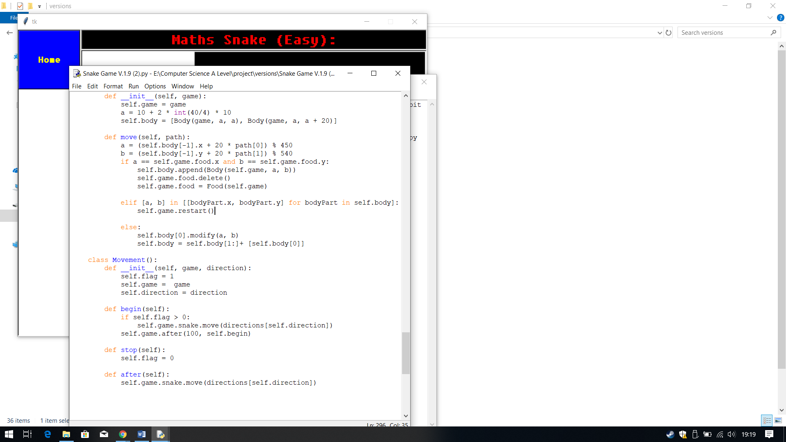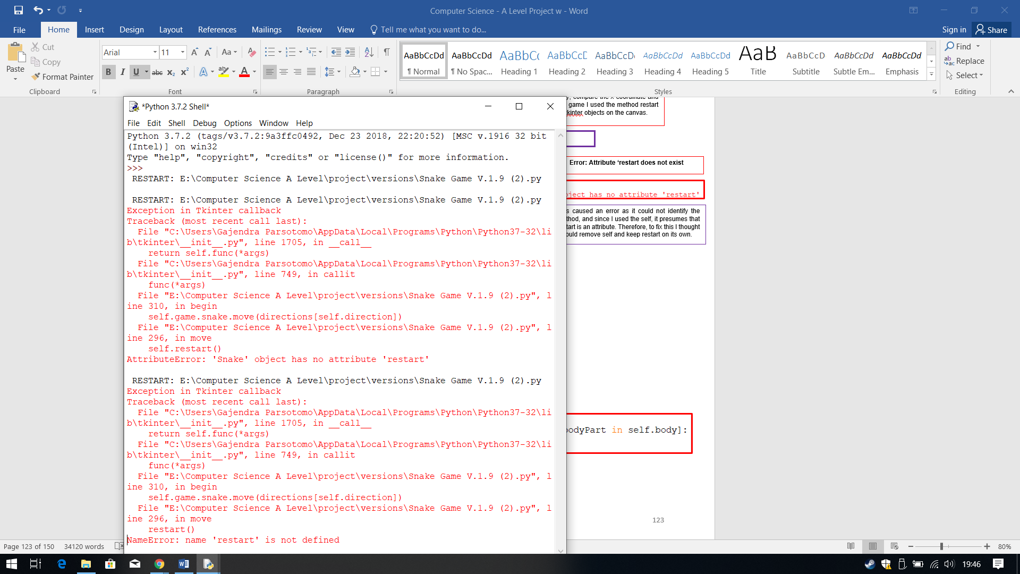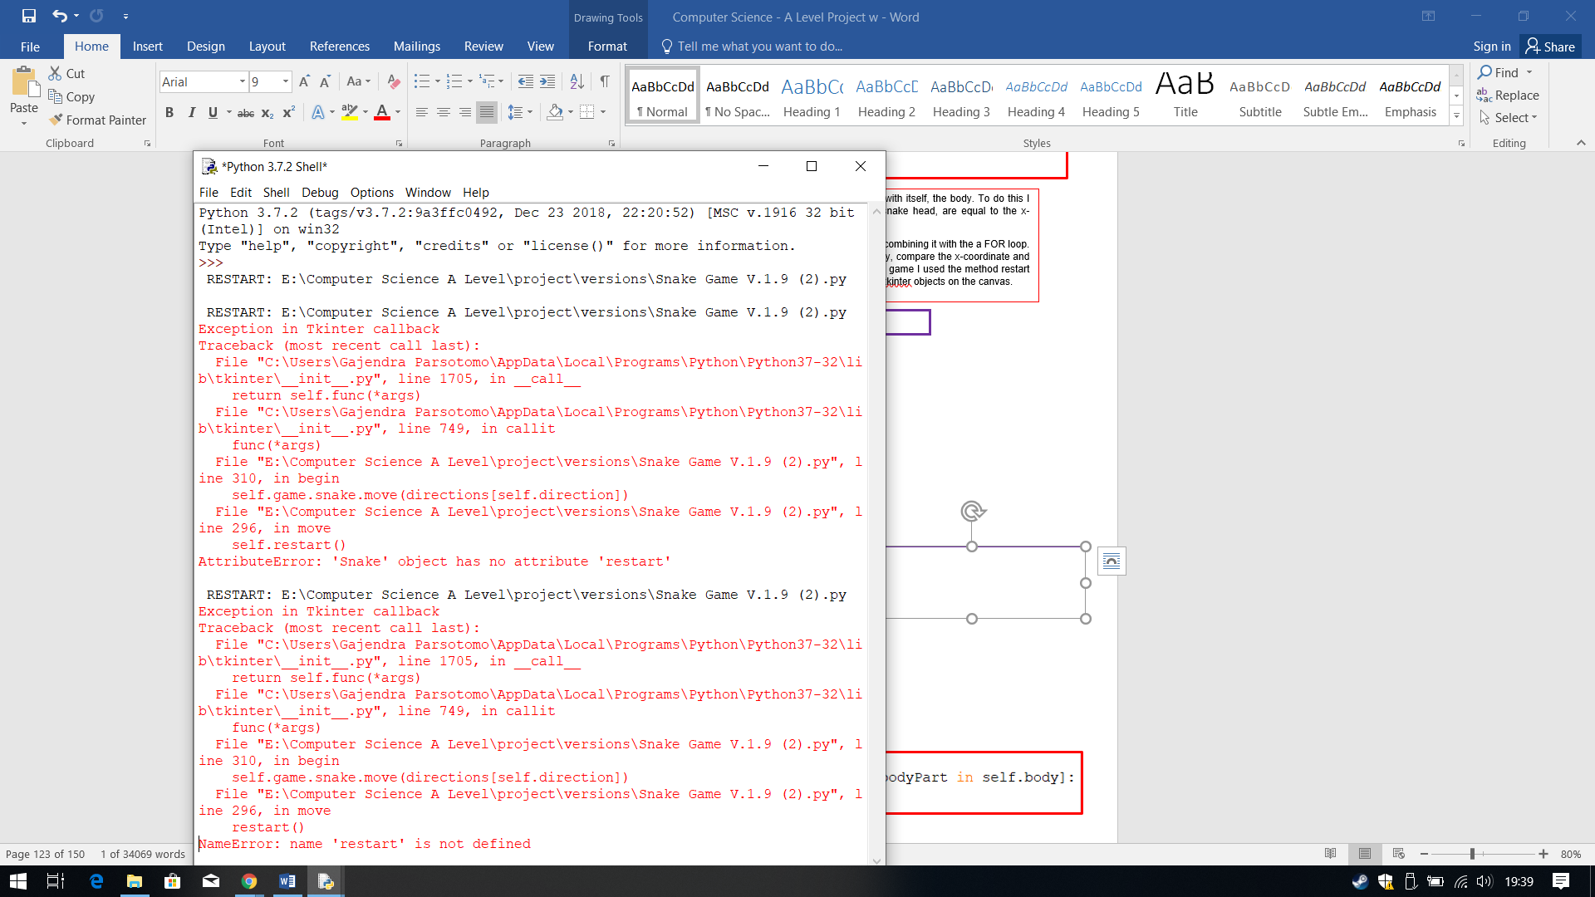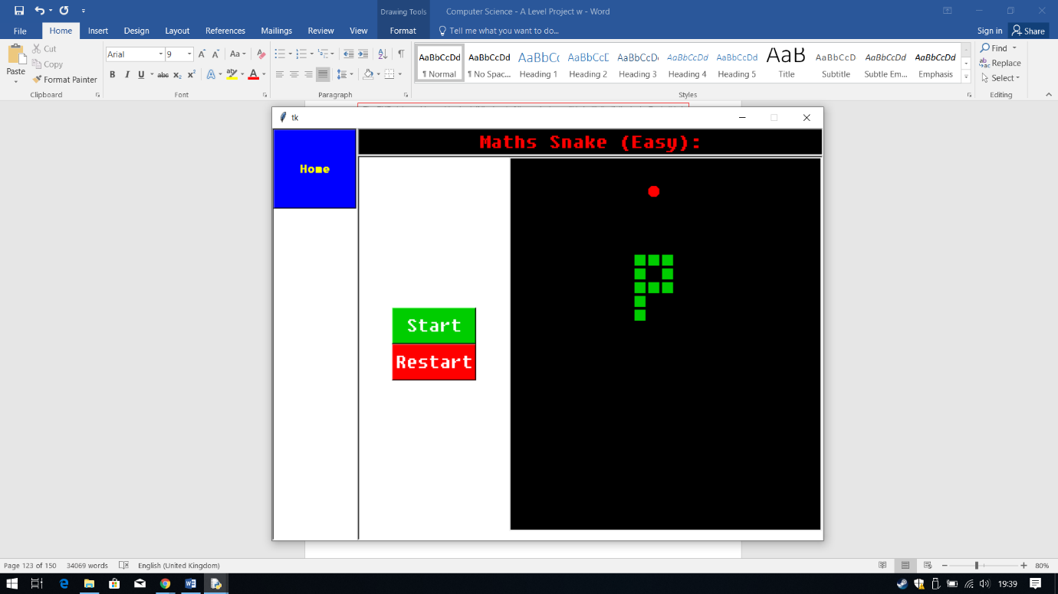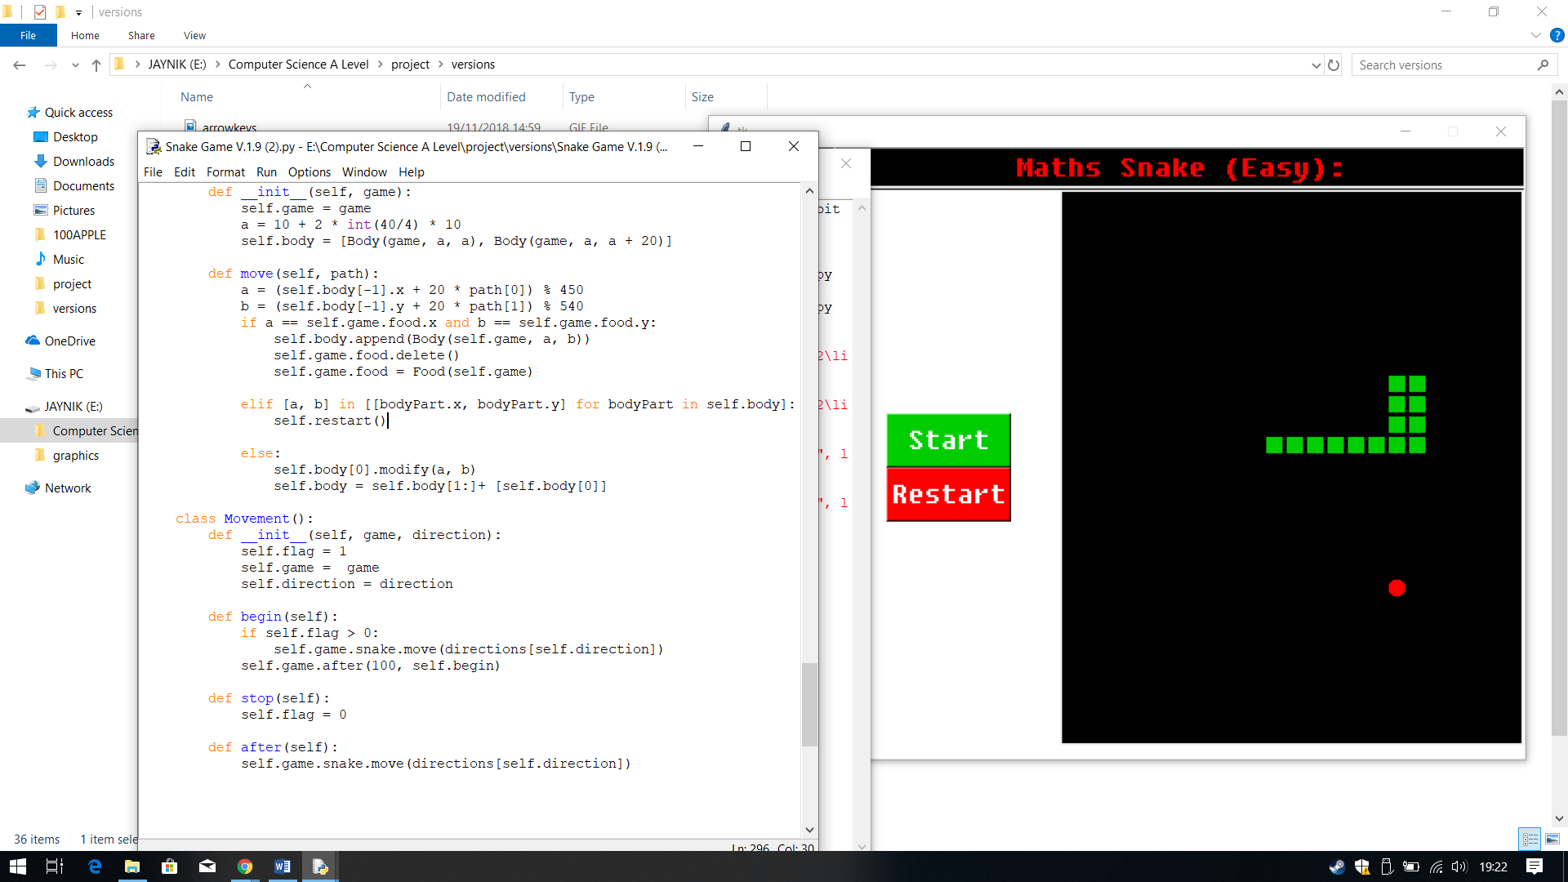

**Iterative Testing:**

**Test 9, No.1**

Therefore, to fix this I thought I would remove self and keep restart on its own.

.

The last error gave me a hint as to how to fix this. I need to define where restart is, which can be done using the attribute game which stores the class holding the method restart. Therefore, I called game and then restart.

This caused an error as it could not identify the method, and since I used the self, it presumes that restart is an attribute.

**Error: Attribute ‘restart does not exist**

However, this caused different error, where the program has no idea what restart is, asking for it to be defined.

**Output:**

The ELIF statement is used to check if the head of the snake has collided with itself, the body. To do this I checked if the coordinates a and b, the coordinates incremented to the snake head, are equal to the x-coordinates and the y-coordinates of a square in the list body.

This was achieved by checking each square in the list by calling it bodyPart, combining it with the a FOR loop. The line of code shows for every bodyPart (acts as a counter) in the list body, compare the x-coordinate and the y-coordinate to a and b. If they are equal, the game will end. To end the game I used the method restart from the class SnakeGame(), which stops the game play and deletes all the tkinter objects on the canvas.

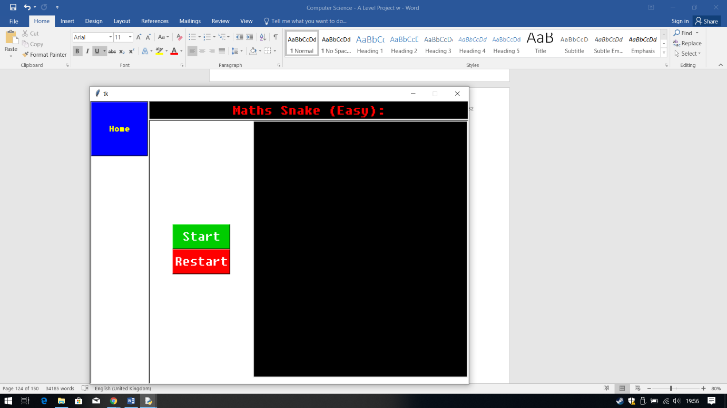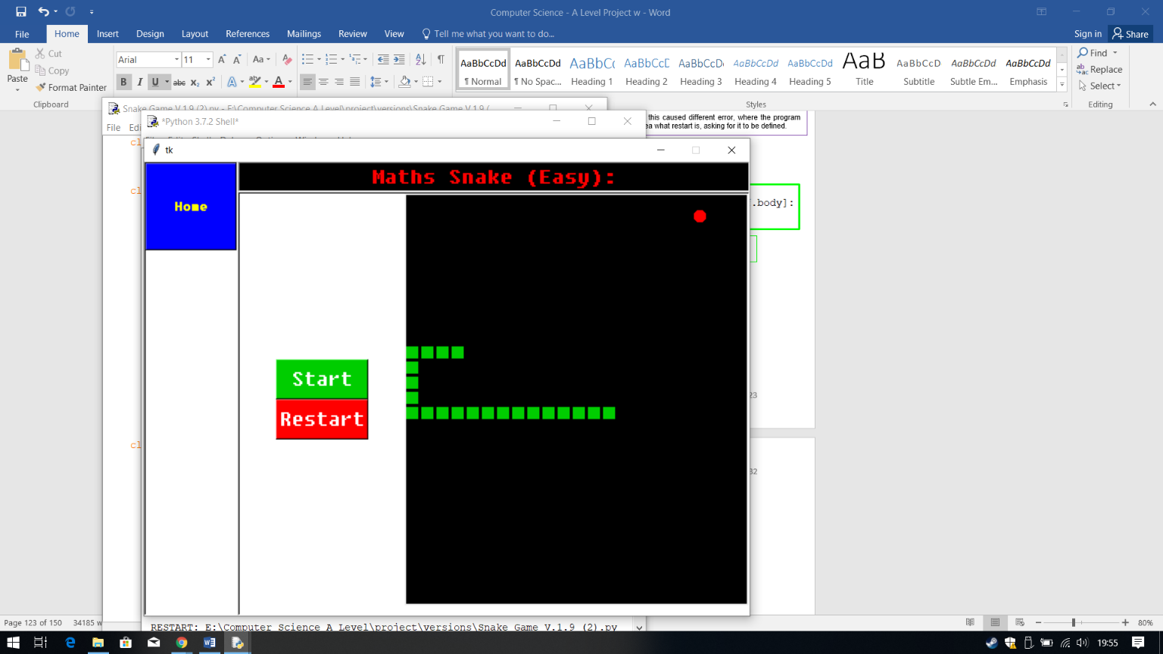

**Iterative Testing:**

**Test 9, No.2**

The first screenshot shows the snake before colliding with itself and the second shows the result of the snake colliding with itself. It shows how the canvas was cleared out, the snake and the food were deleted like I wanted to.

**Output:**

## **Score Tracker**

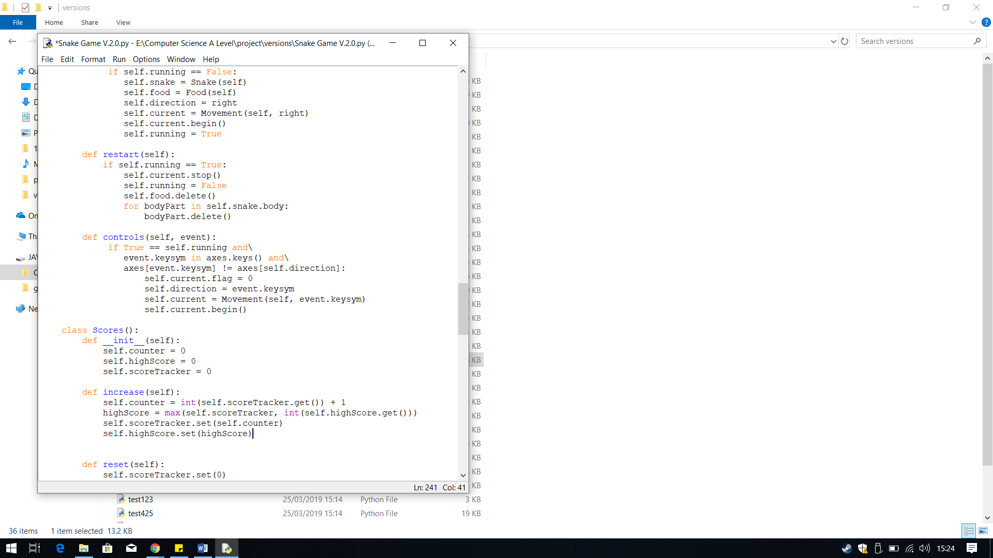In version 2.0 I have designed the score tracker to be displayed and the high score tracker as well.

To create the score tracker, I used the class Scores, which I had previously created.

Within the class I first defined the attribute I am going to use.

**Self.counter –** This will be used to keep track of the score. It will tack the current score during the game. I have assigned the value zero as that will be the starting score.

**Self.highScore** **–** This will be used to display the current high score to the user. Because the score tracker is not yet completed, I have set the value to zero.

**Self.scoreTracker –** I will be using this to display the current score to the user. I have set the value to zero as the starting value of the current score will always be zero.

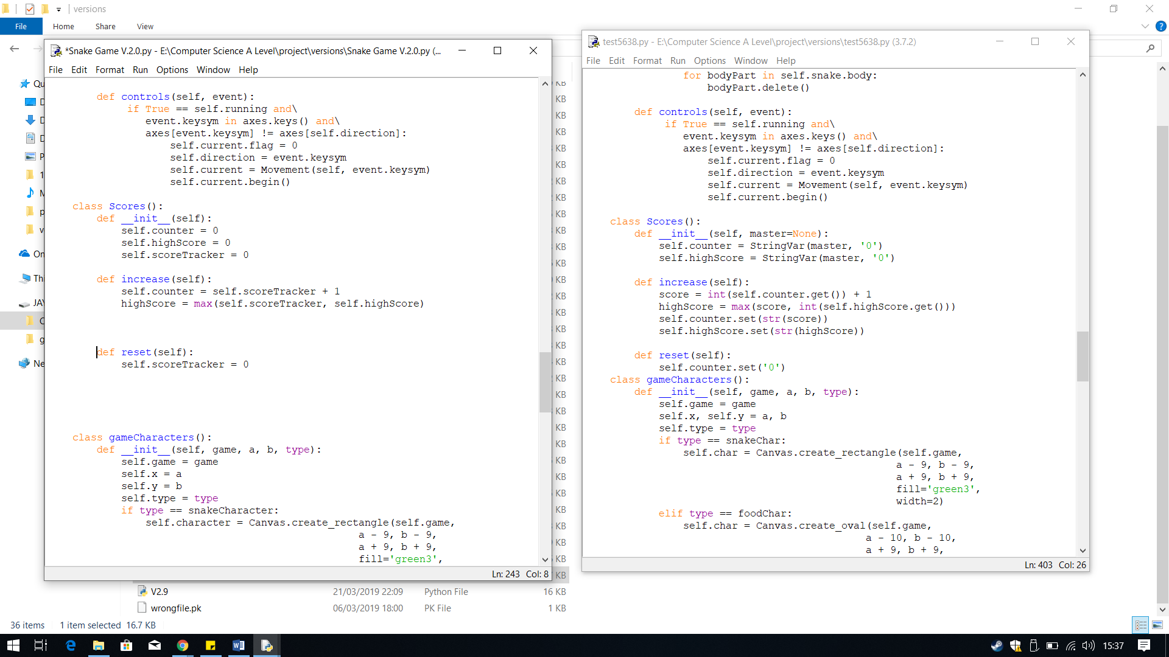

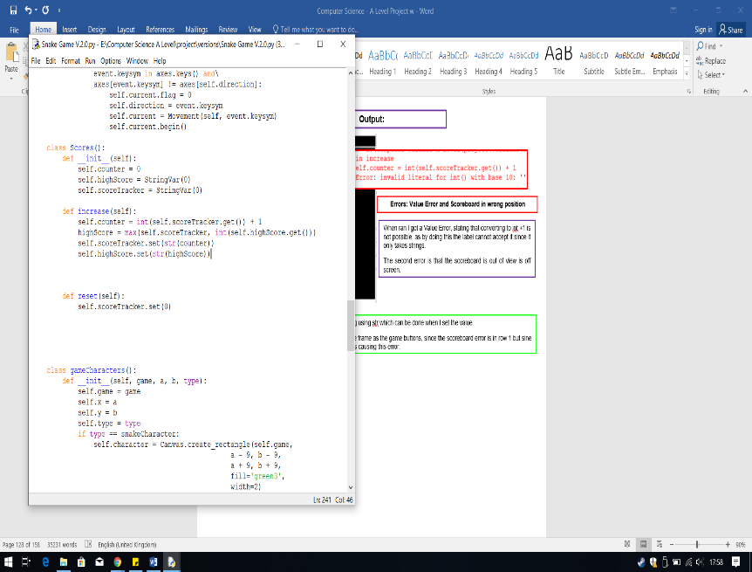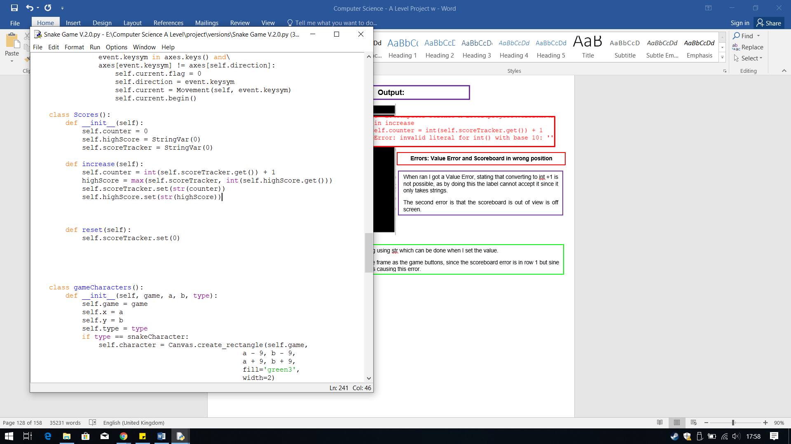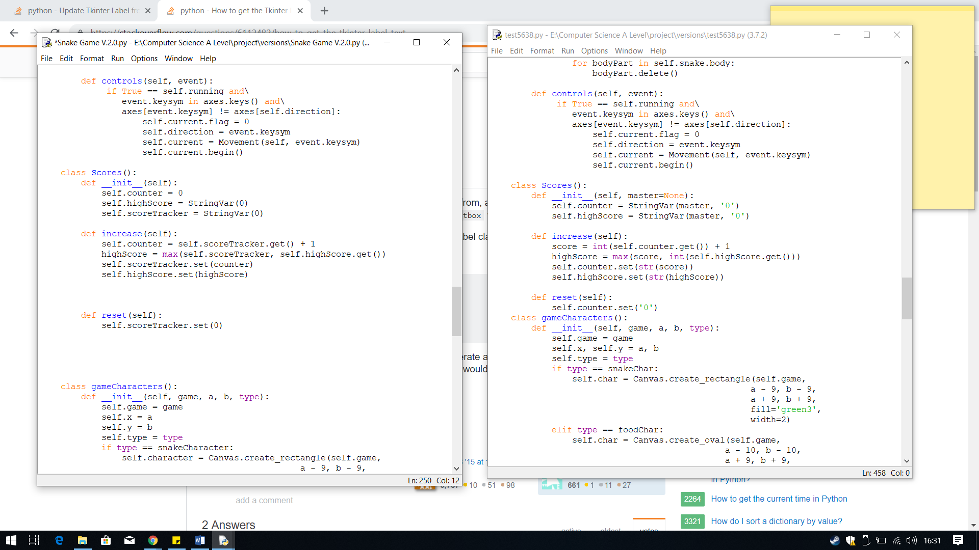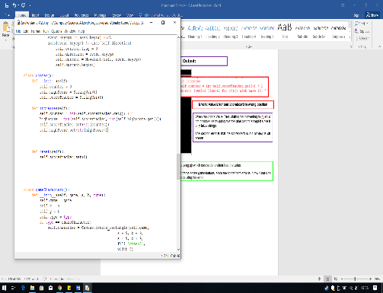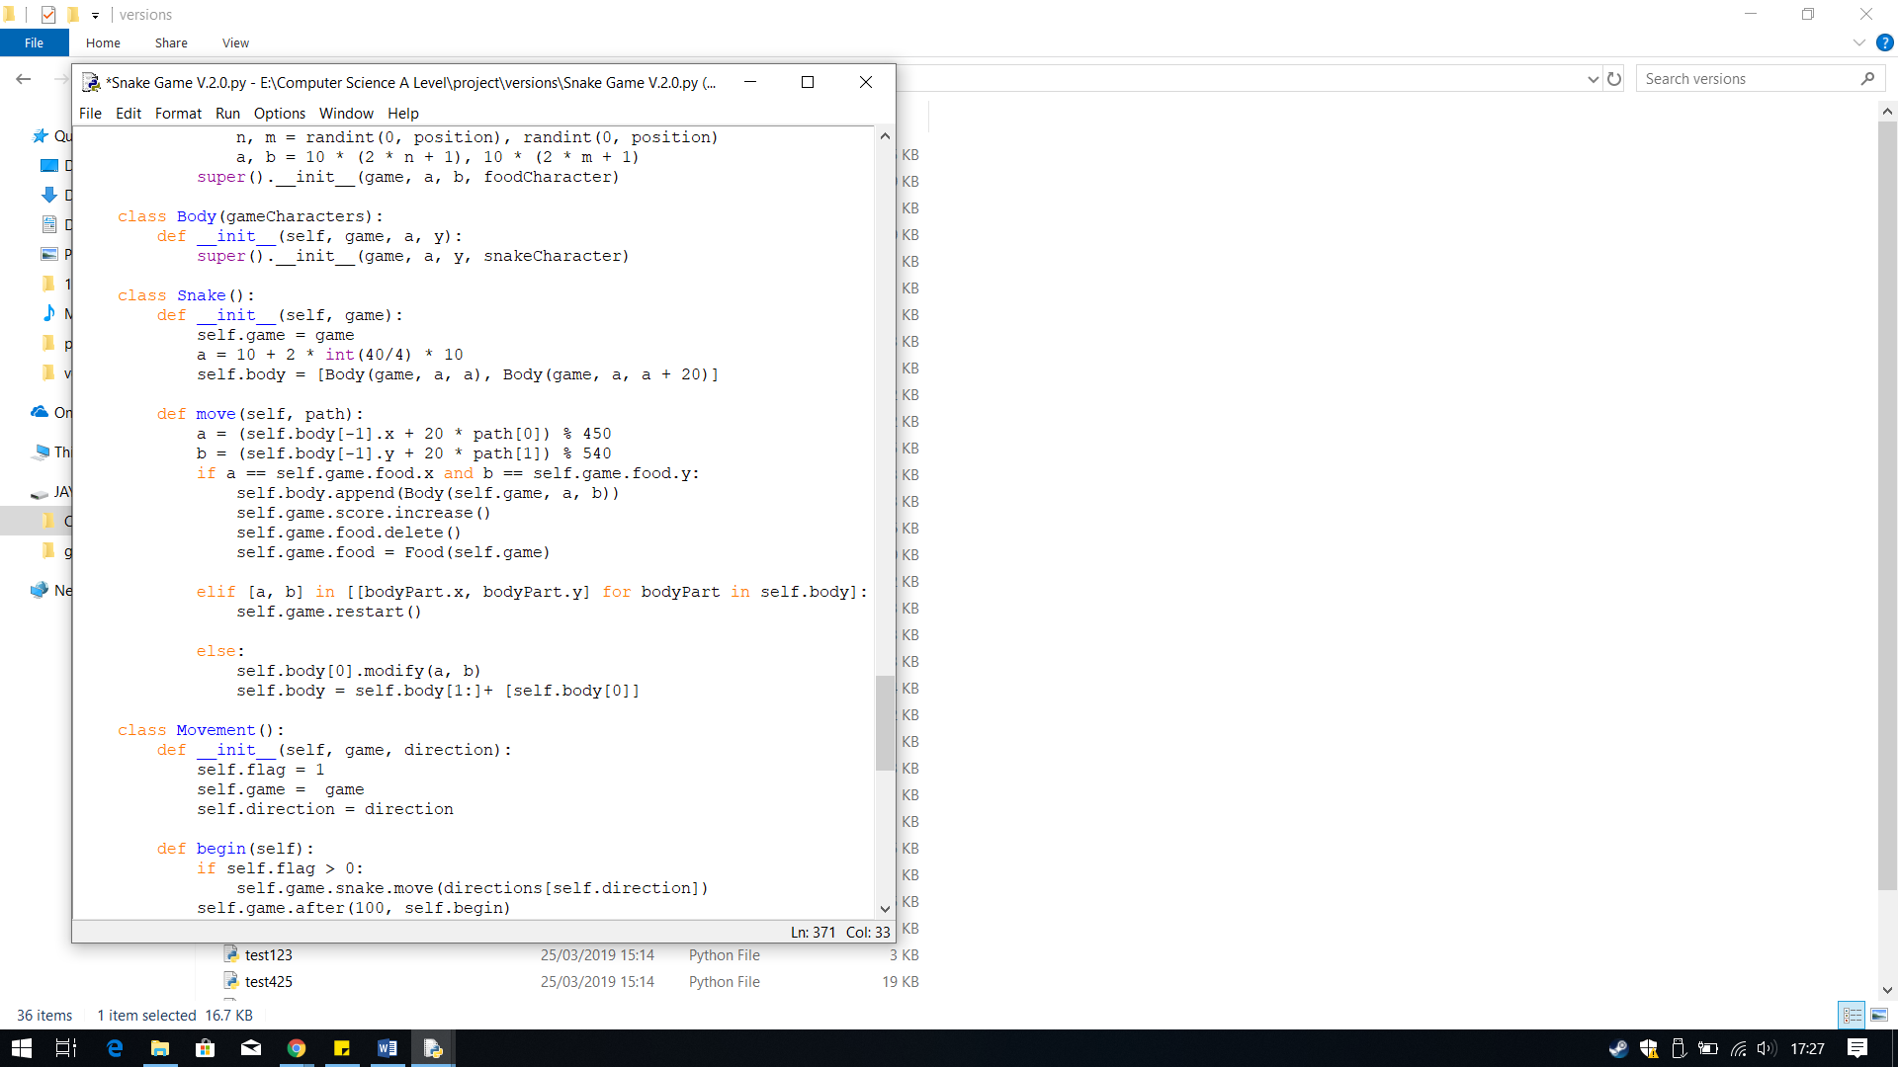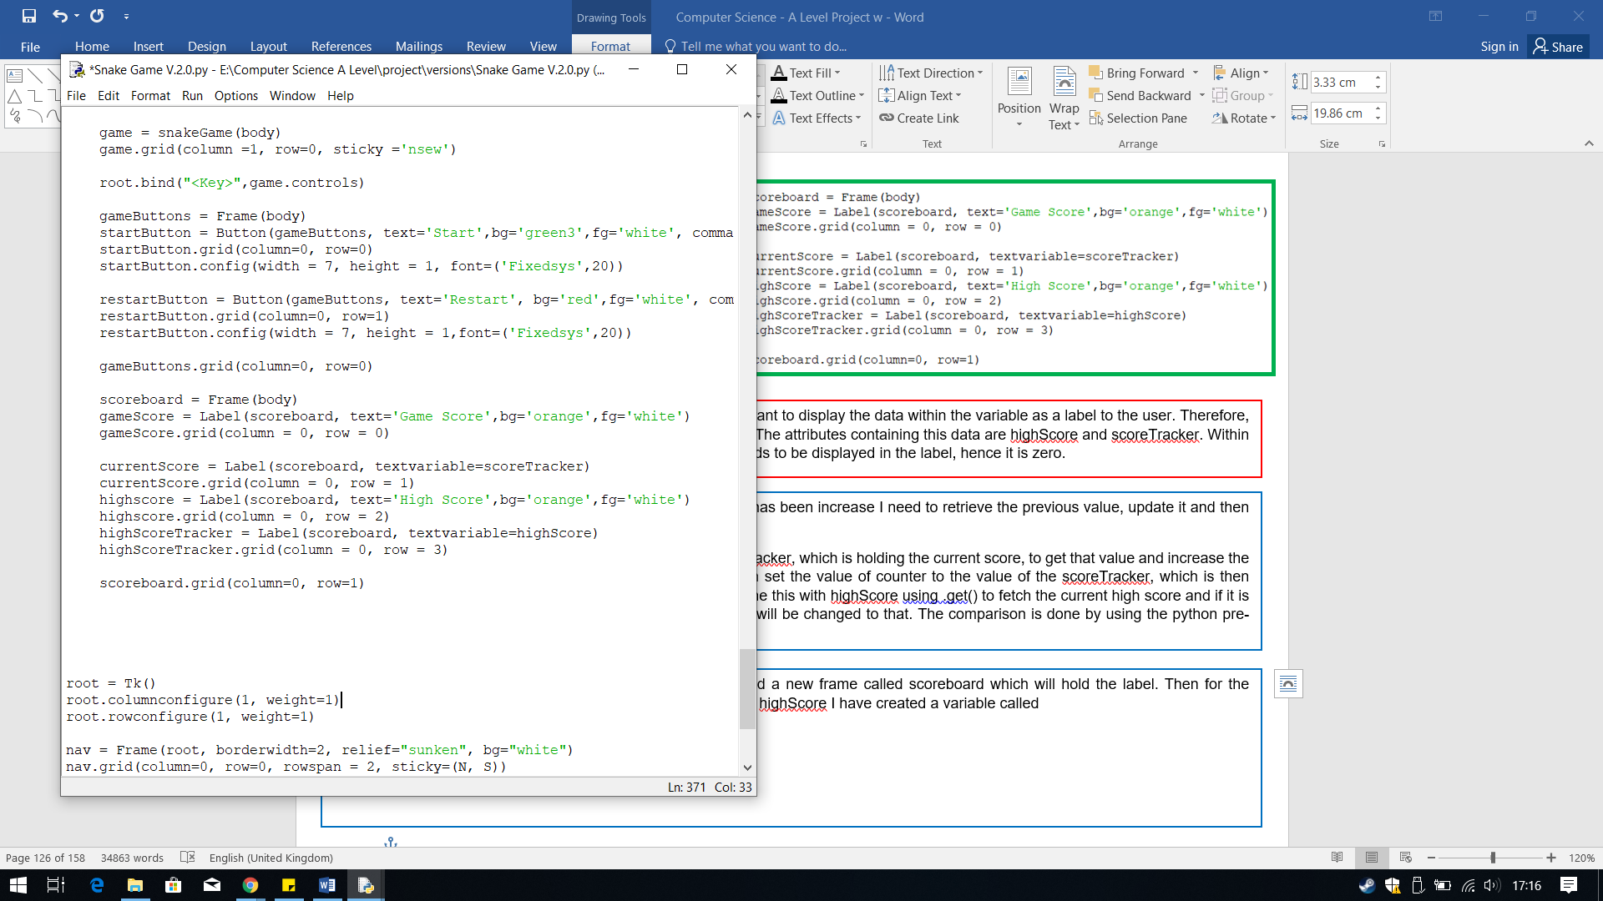

To make the score tracker work I need a way to increase the score each time the condition to increase the score is met. To do this I decided to create a method to fulfil this purpose, I created the method increase.

Within this method I have placed first called the counter and then saved the scoreTracker adding one to it. This will increae the current score of the scoreTracker each time.

Then I have saved the highScore attribute to the highest value of the scoreTracker. I have done this by using max, so it picks the highest value from scoreTracker and saves it to highScore.

**Logical Error: Can’t use attributes for label**

Before I can carry on I needed to test if this works however, I have no way of displaying it to see if the score tracker works. This is because in labels I only know how to display text I have written; I do not know how to display data from a variable/attribute. Therefore, I first researched how to do this. I found out how to do this from <https://stackoverflow.com/questions/2603169/update-tkinter-label-from-variable> and from <https://stackoverflow.com/questions/6112482/how-to-get-the-tkinter-label-text> I found when a label is updated with the information I need to use .get() to get the current score and then increase it , so the label is updated.

I then created a method called reset, which will be used to rest the scoreTracker back to zero when the game has ended.

To call the method of increasing the score whent eh food is eaten I need to call it within the Snake class in the method move. The highlighted code does this. I have an attribute within the super class snakeGame called scores, which saves the Scores() class to it. Therefore, to access I need to access the class snakeGame, game, then the attribute, scores, finally the method, increase.

From stackoverflow I found that I need to use StringVar if you want to display the data within the variable as a label to the user. Therefore, I used this in the variables that have data I will need to display. The attributes containing this data are highScore and scoreTracker. Within the brackets for StringVar it contains the starting value that needs to be displayed in the label, hence it is zero.

To update the label, scoreTracker and counter whenthe score has been increase I need to retrieve the previous value, update it and then set that value to the label.

This can be achieved by using .get(), where I used it on scoreTracker, which is holding the current score, to get that value and increase the score, which is then saved to counter. Then using .set(), I can set the value of counter to the value of the scoreTracker, which is then displayed to the user through the label currentScore. I have done this with highScore using .get() to fetch the current high score and if it is lower than the score within scoreTracker, the highScore value will be changed to that. The comparison is done by using the python pre-defined function max.

When the game ends I need to set the scoreTracker back to zero when a new game starts to do this I have used .set(0) with the attribute scoreTracker, therefore the value in the label is changed to zero thus resetting the score.

These lines of code create the scoreboard. I have first created a new frame called scoreboard which will hold the label. Then for the scoreTracker I have created a label called currentScore and for highScore I have created a variable called highScoreTracke. I have also created labels to be palced above them to tell the user clearly what the numbers are for.

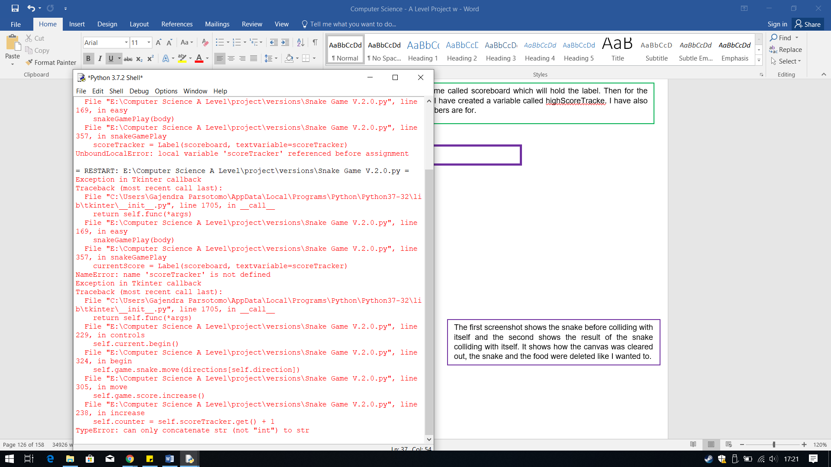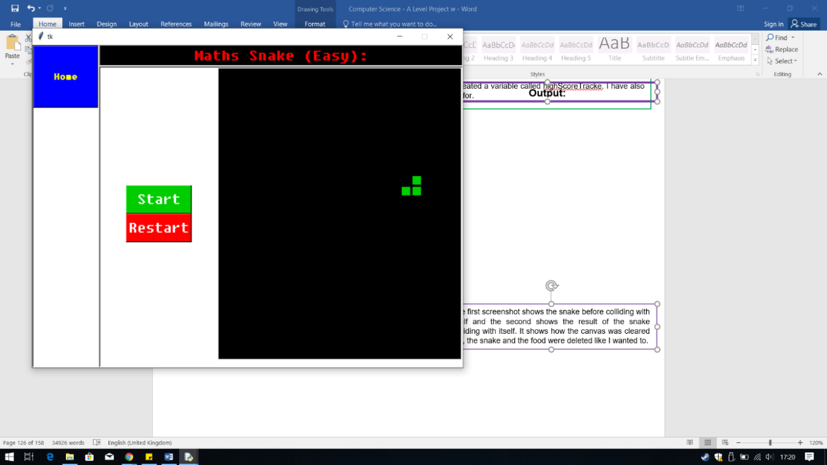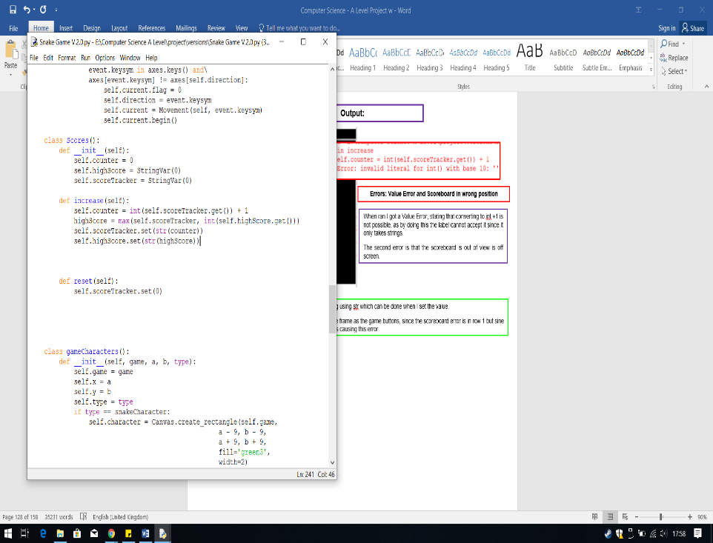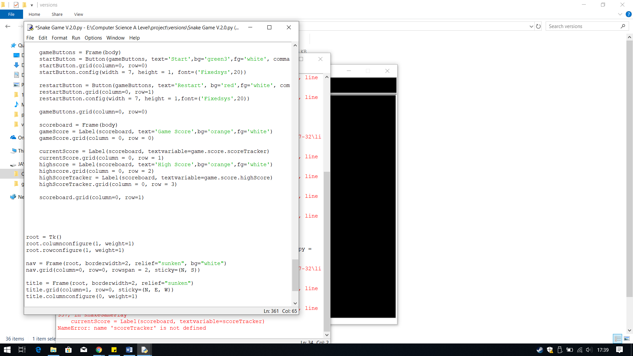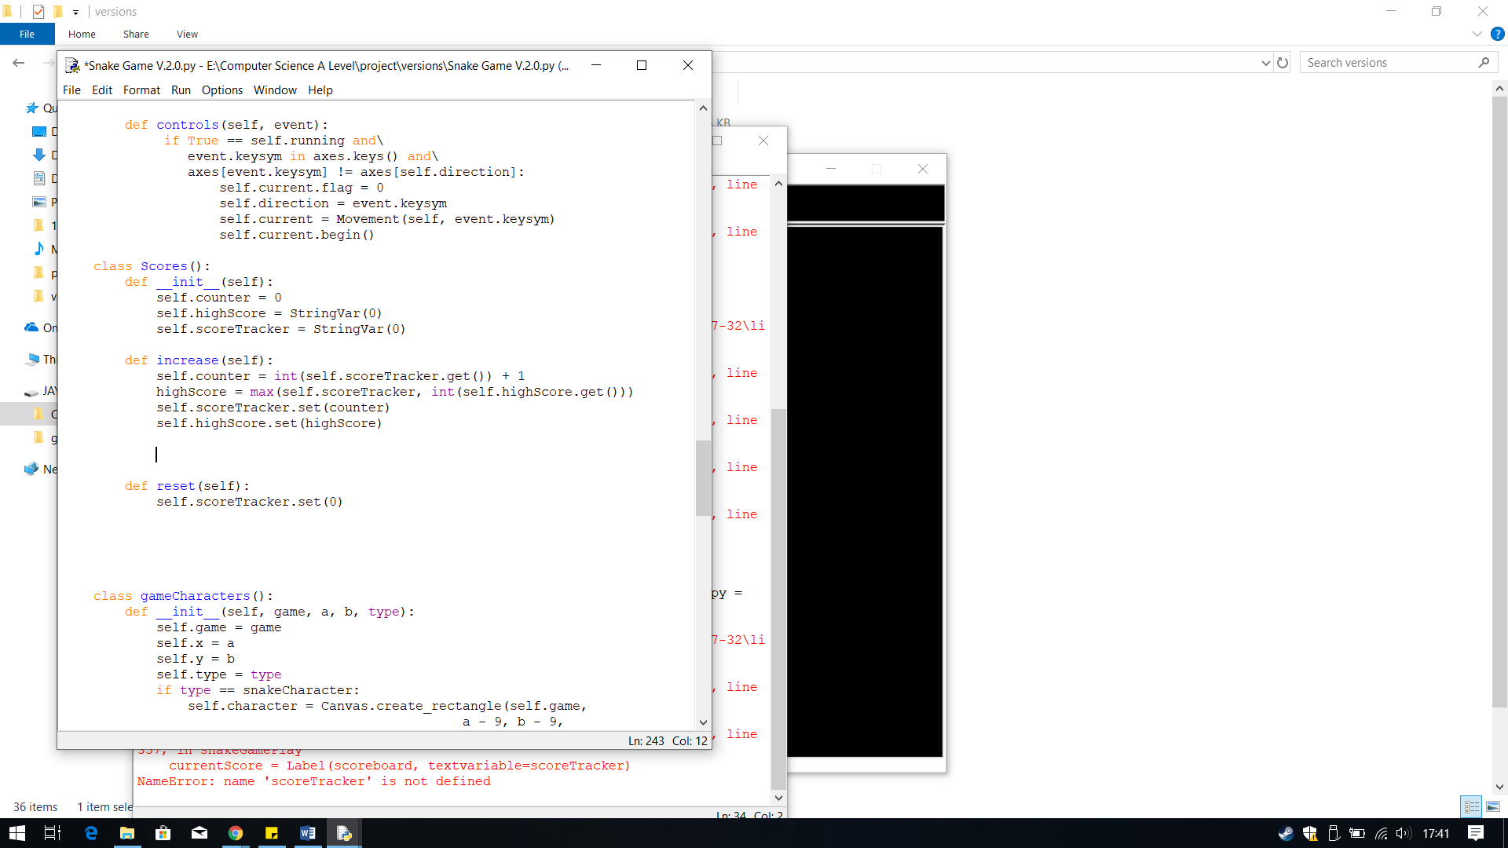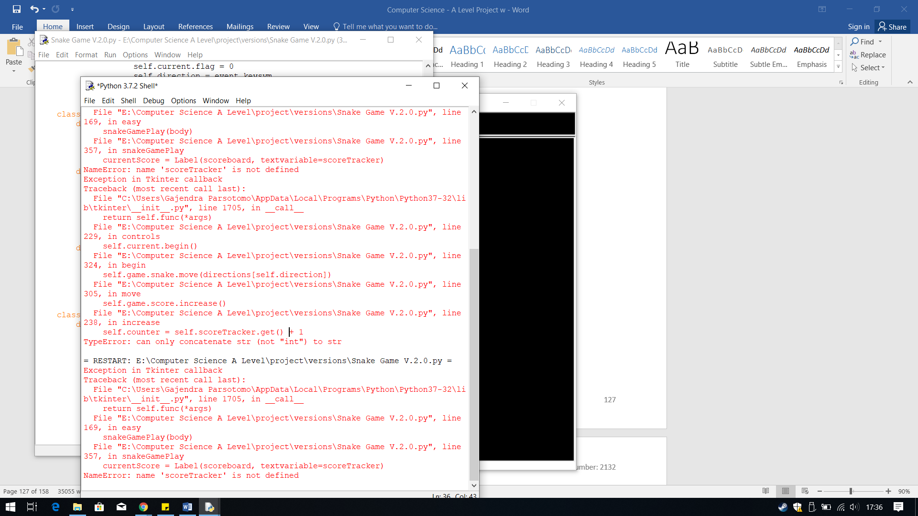

**Error: scoreTracker is a string**

The output I received when the snake ate the food, was an error. The error generate says the scoreTracker cannot add one to its value as it is a string not a integer.

Therefore, to fix this I simply need to convert the scoreTracker to an integer which can be achieved by using int. I have done this for highScore as well since max only works with integers.

When ran I got an error saying scoreTracker is not defined, since it is an attribute belonging to a class, therefore I can access it through the same method as accessing the method increase().

**Error: scoreTracker is not defined**

**Output:**

**Output:**

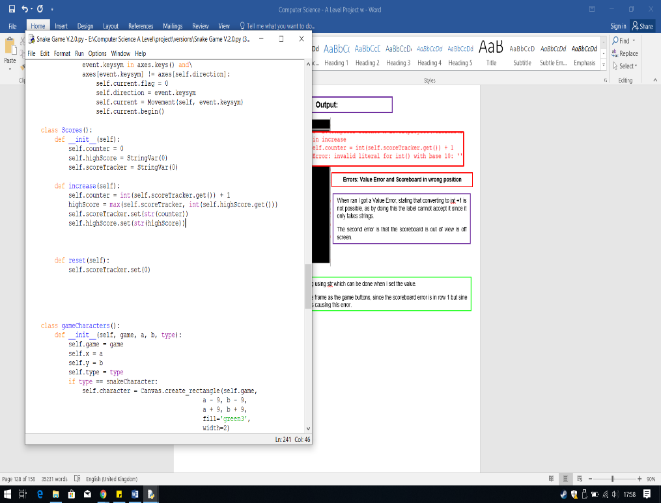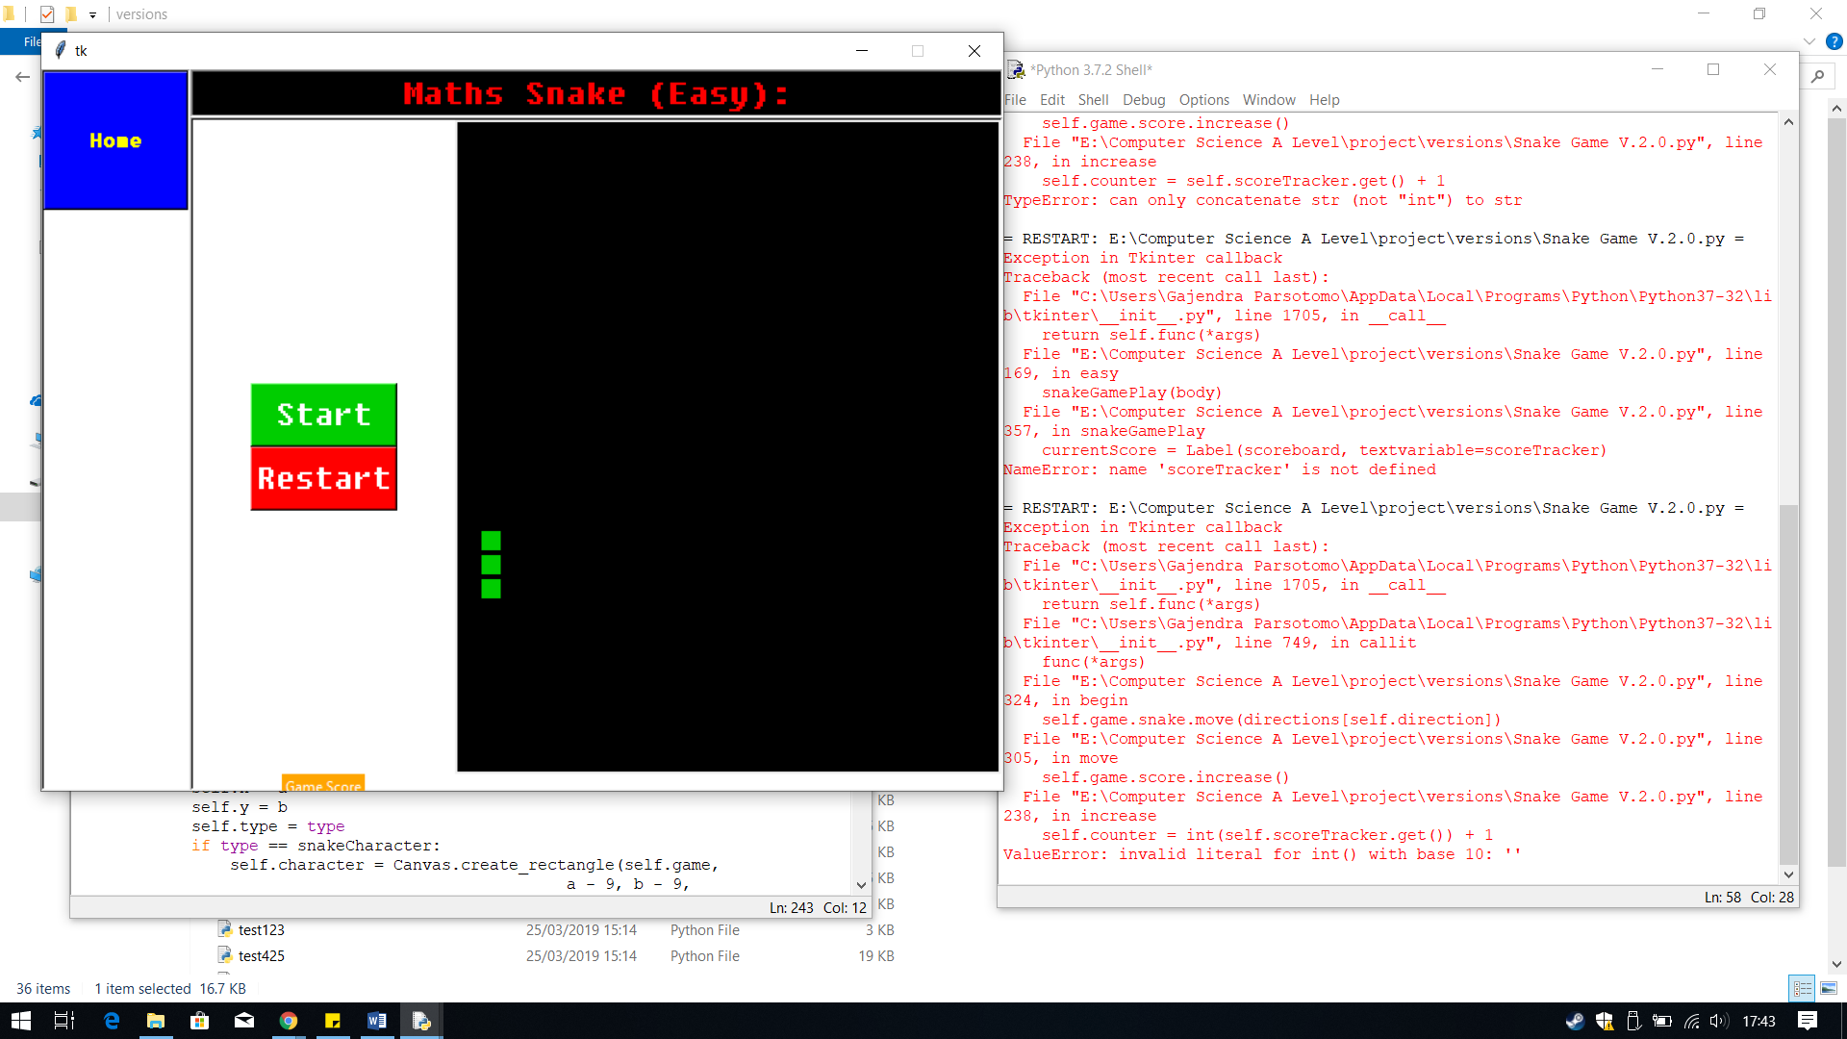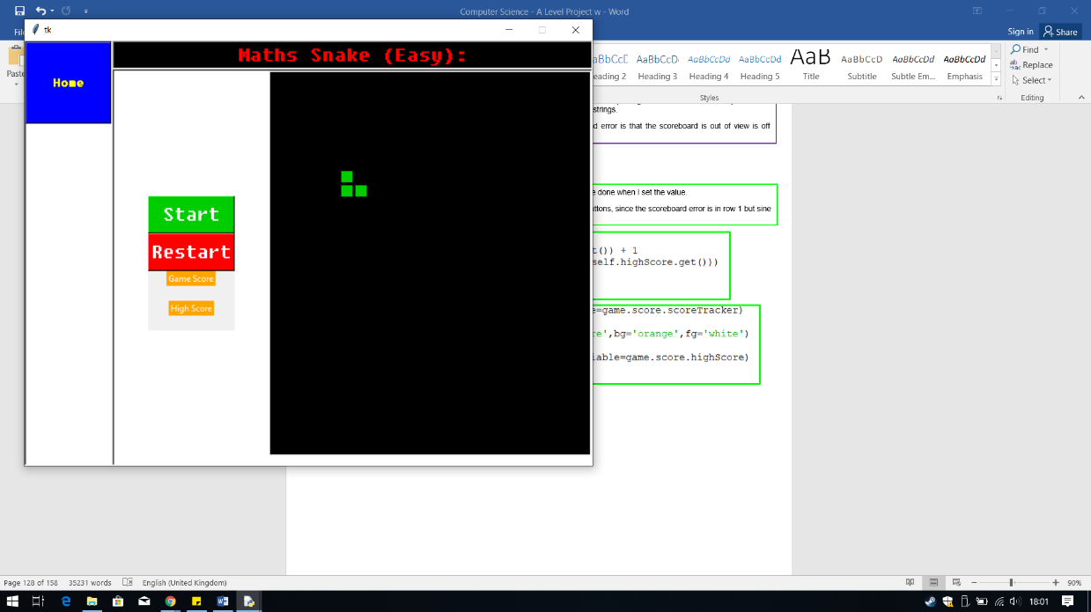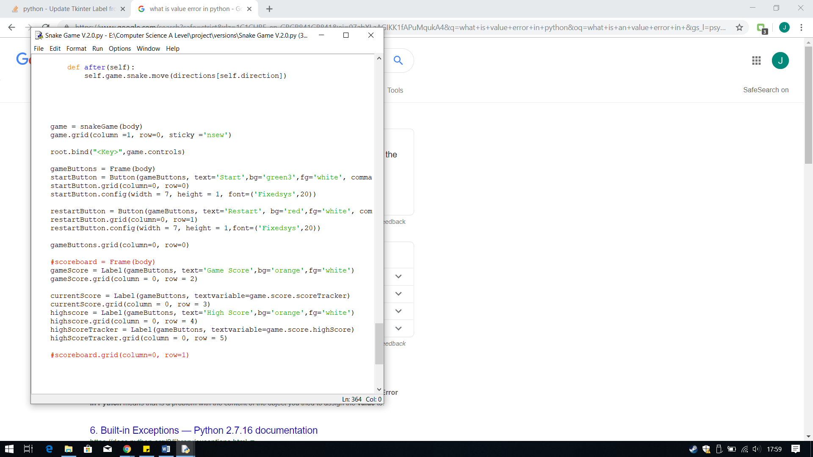

When ran this time the scoreboard showed up, however the scores weren’t there and when the snake ate the food I got the same error.

Therefore, since the score didn’t show I thought I would convert the zeros In StringVar to strings using quotations.

When ran I got a Value Error, stating that converting to int +1 is not possible, as by doing this the label cannot accept it since it only takes strings.

The second error is that the scoreboard is out of view is off screen.

**Errors: Value Error and Scoreboard in wrong position**

**Errors: Value Error**

**Output:**

To fix the value Error, I just need to convert it back to a string using str which can be done when I set the value.

TO fix the scoreboard I just need to put the labels I the same frame as the game buttons, since the scoreboard error is in row 1 but sine row 0 contains the game screen, this expanded the row, thus causing this error.

**Output:**

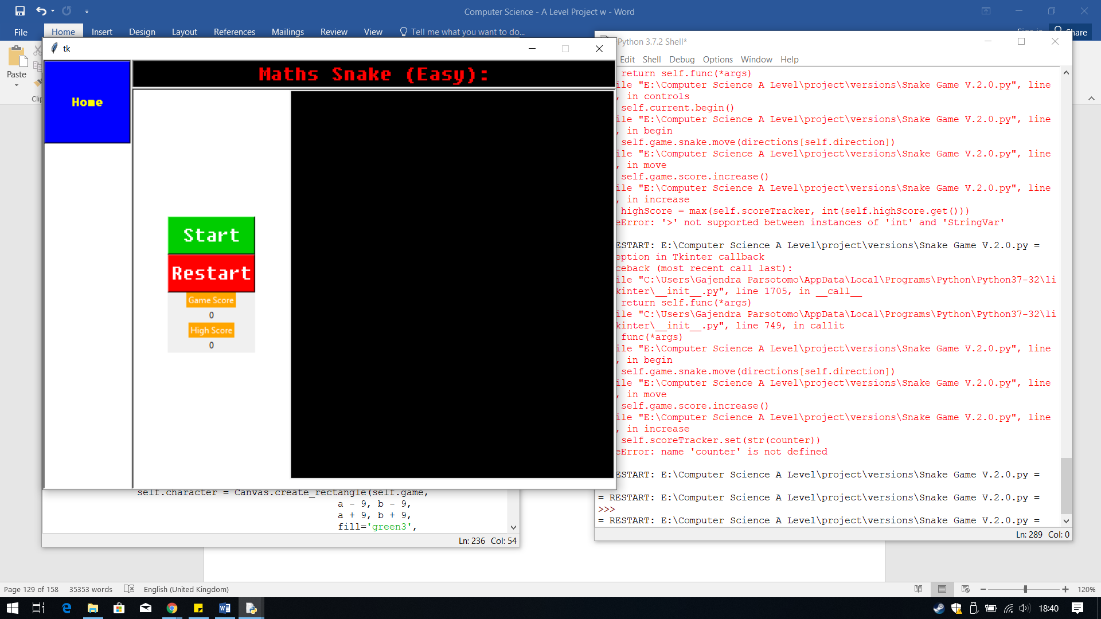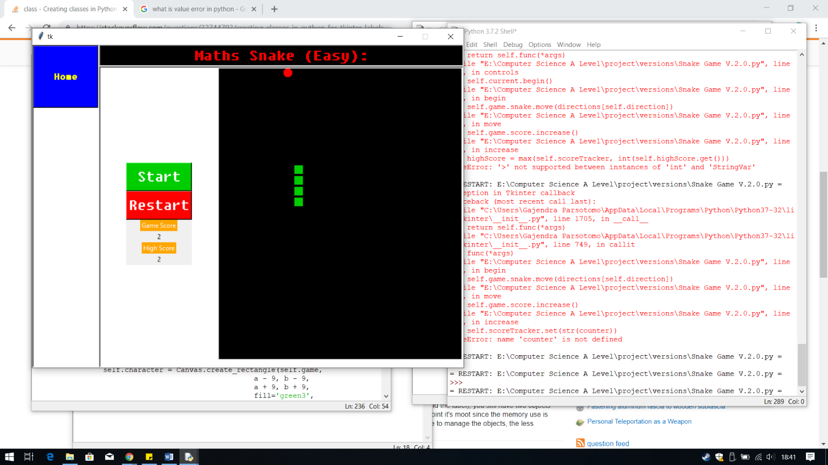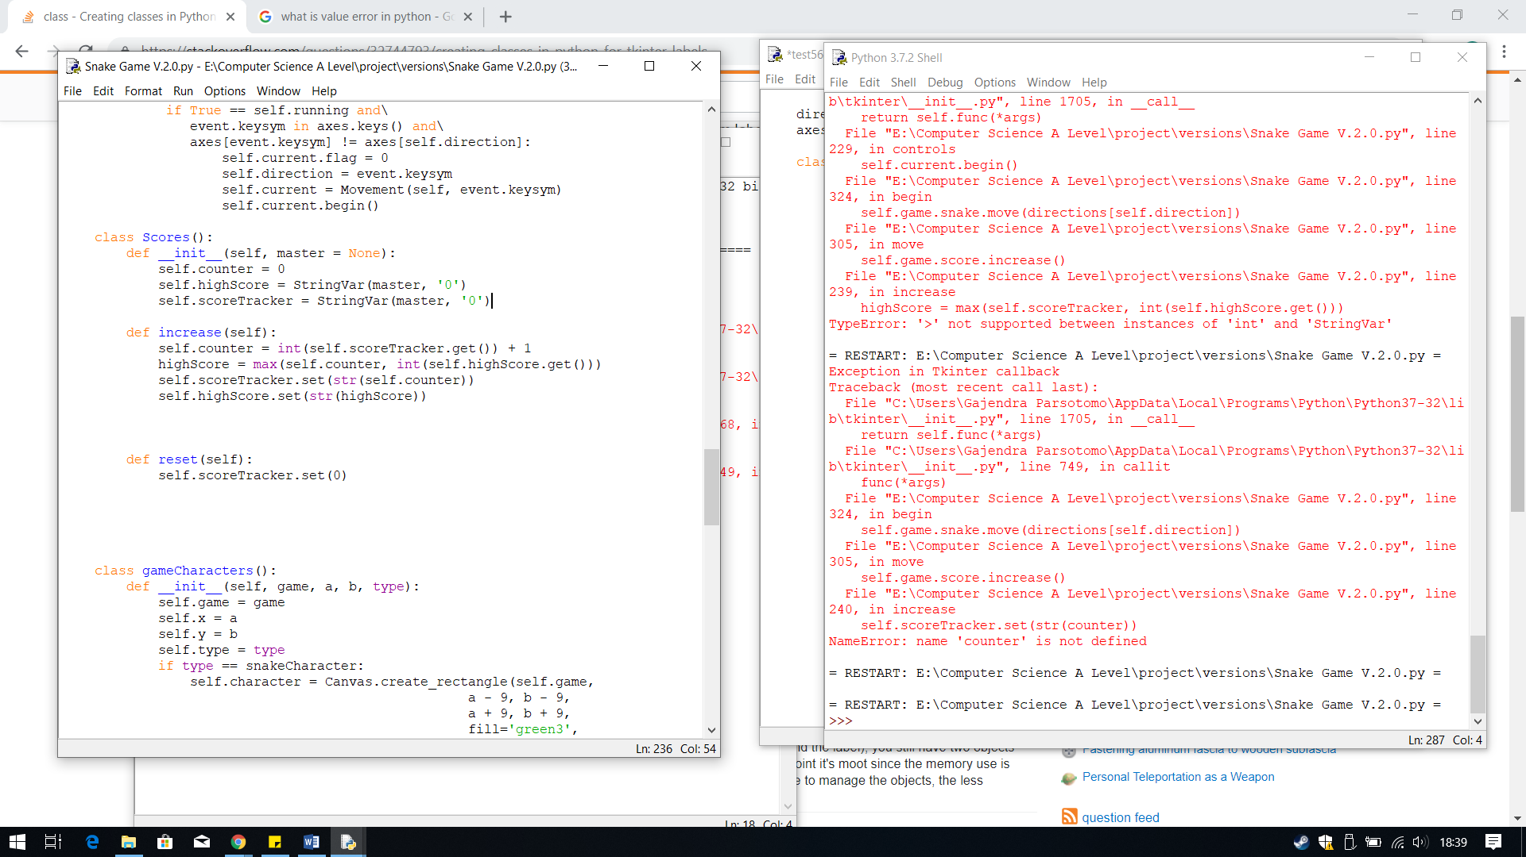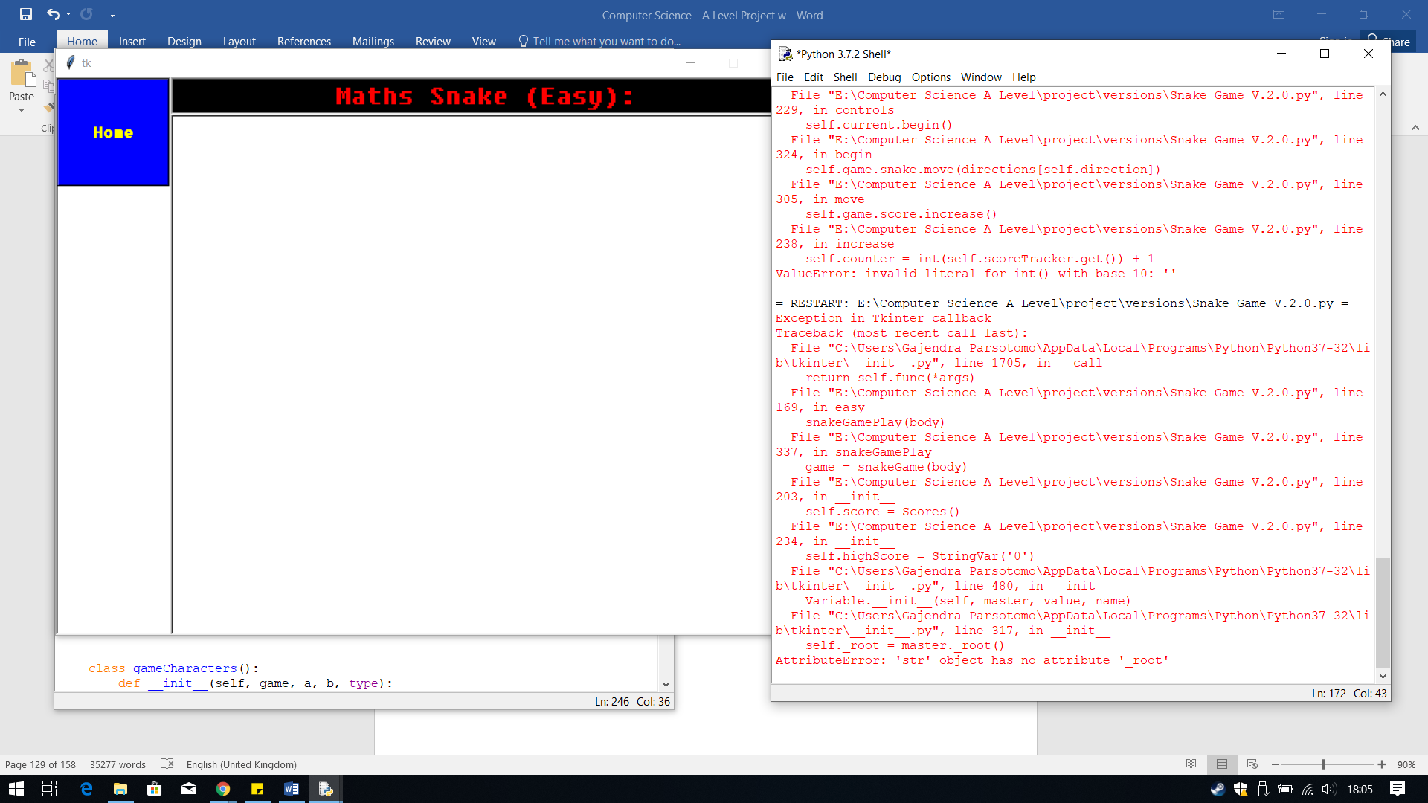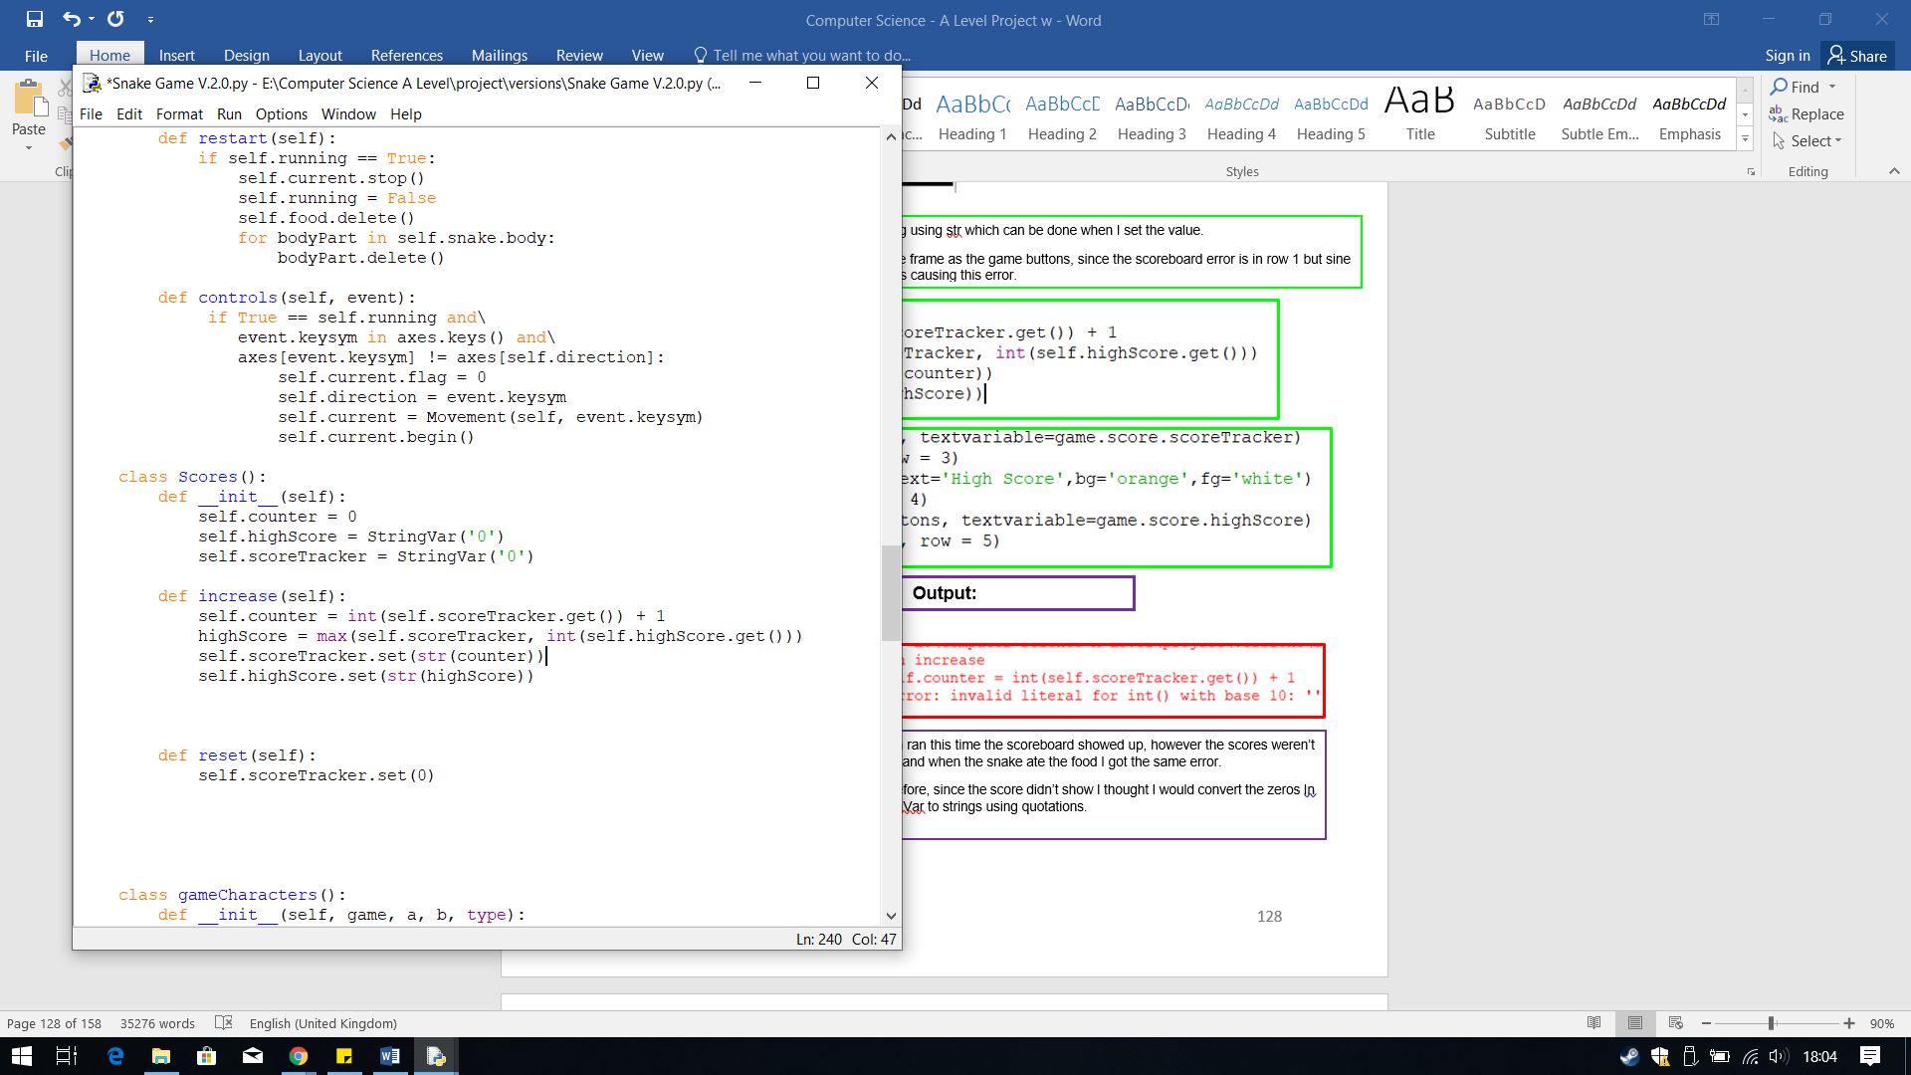

The output I received this time was the expected output. This time the numbers showed up on the scoreboard, and when the snake ate the food this time the score increased.

**Output:**

This time the error caused the program not to work, therefore I decided to research online on how to create a label from a class, using its attribute. From the following link <https://stackoverflow.com/questions/32744793/creating-classes-in-python-for-tkinter-labels>, I have found that I need to classify the parent widget as to where the label needs to be displayed. Therefore, to fix this error I need to use master, which defines the parent, the root.

**Errors: no attribute root**

**Output:**

## **Questions**

In Version 2.1 I have designed the questions to be answered during the game. Since the questions will be pop-up I have deicide to code it in a separate file to test it functions correctly.

Next I needed to create a way for the user to enter their answer to the question. Therefore I look online and found from <http://effbot.org/tkinterbook/entry.htm> which told me to use a tkinter function called Entry. This tkinter function creates an entry box for you.

Finally, I created a button with the text submit which will allow the user to submit their answer to check if it was right or wrong.

The next lines of code create a label, which will hold the question to be answered for the user.

The first thing I did was create a class called Question(), so then I can incorporate this into the snake game.

Within the class I have first created a new root, using Tk() so I will create the pop-up. Then I configured the properties, like the columns and rows, and the size of the pop-up as well.

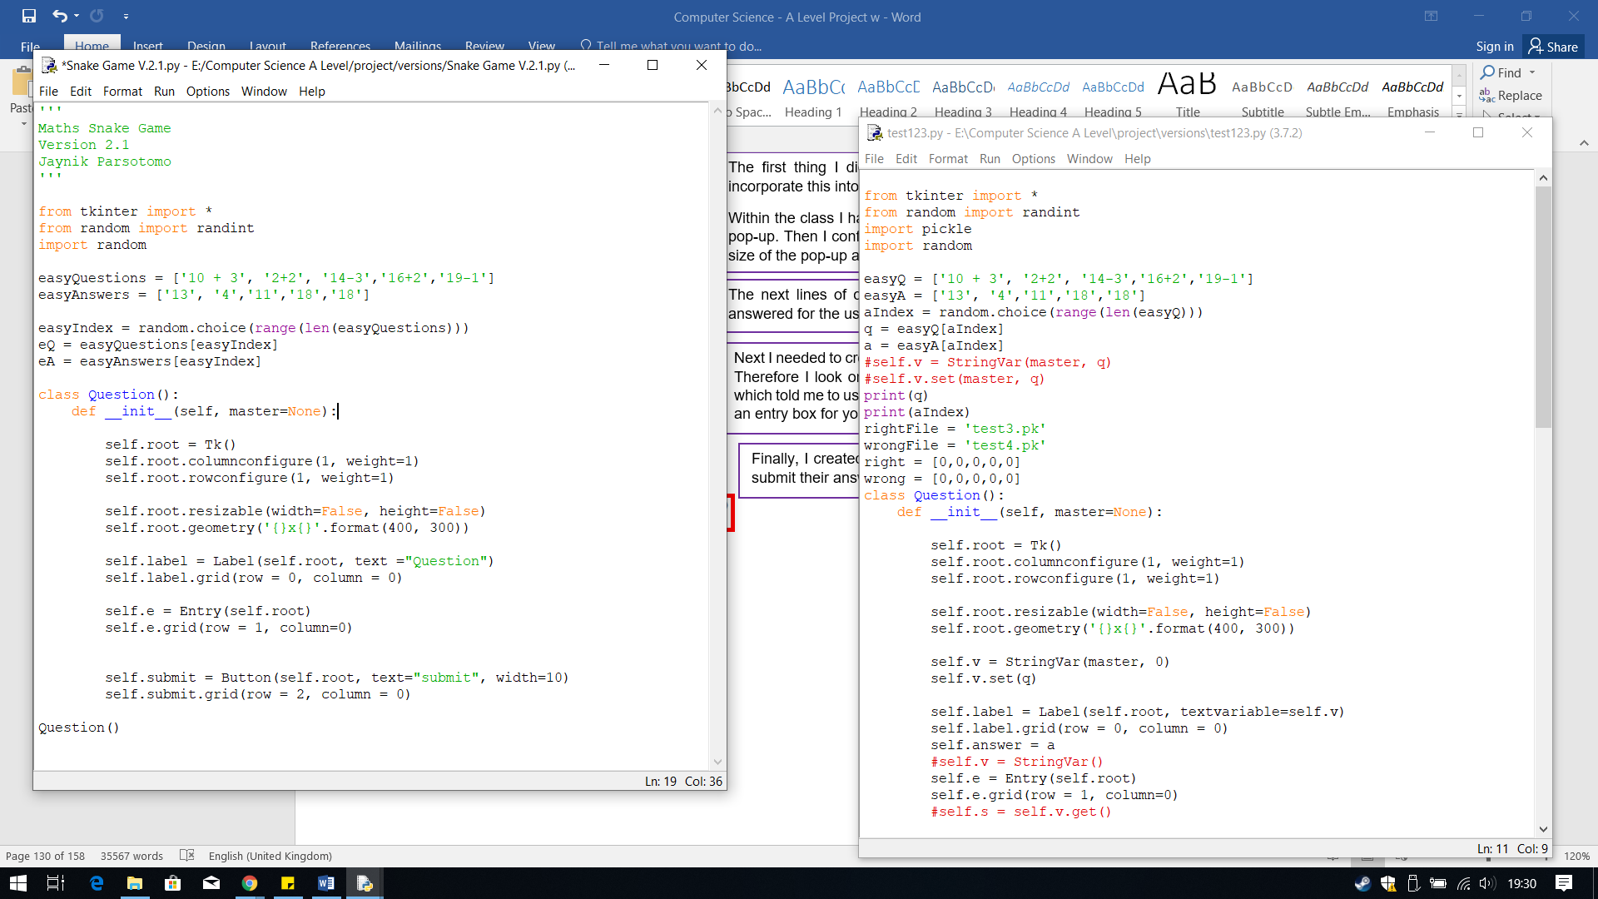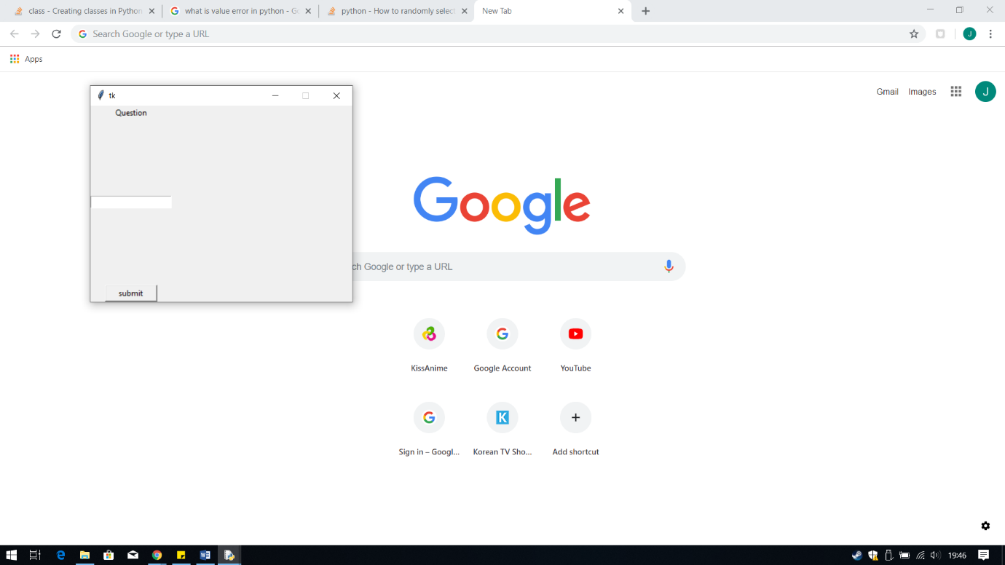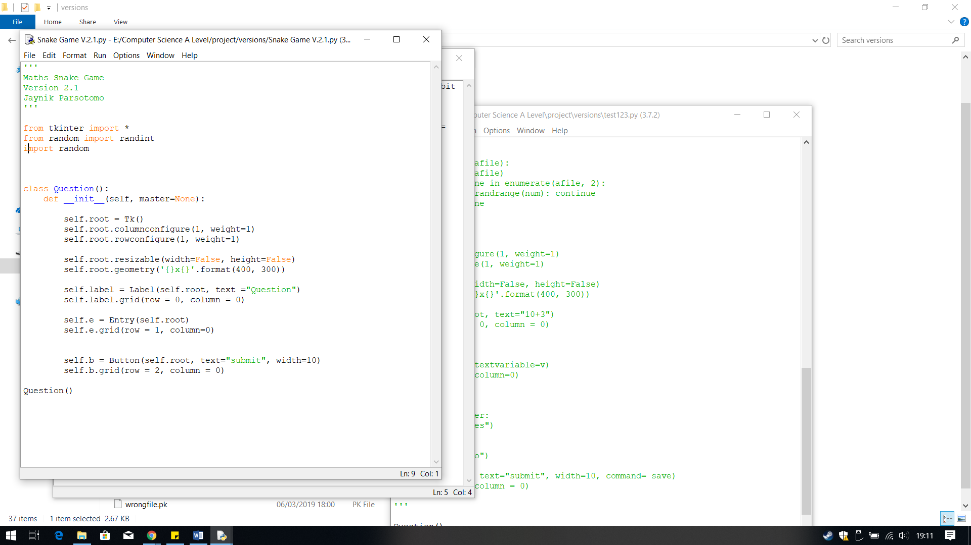

The next line, which I found from, <https://stackoverflow.com/questions/306400/how-to-randomly-select-an-item-from-a-list>, which told me to use this code from the library random, random.choice. This line of code randomly selects an index from the list easyQuestions, which is why I called it easyIndex.

I have created a list of questions and answers for the easy level. The answers to the questions are in the same index so I can retrieve them more easily.

These lines of code pick out the matching question and answer within the list using the random index.

The output I received was correct, the label, entry box and the button all appeared correctly.

**Output:**

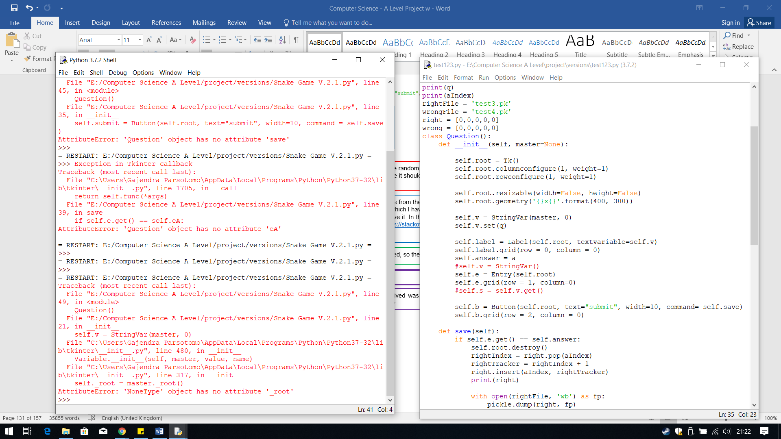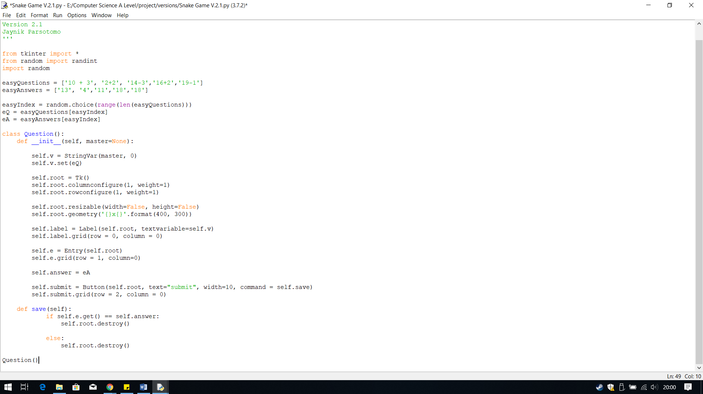

The solution is to place the label after the root has been created.

**Errors: no attribute root**

The output I received was that the attribute root does not exist, which is the same type of error I had with the score tracker labels. Therefore, I assumed that the error lies within the label not being able to place it within the parent, the root

**Output:**

This code calls the method save is when the button submit is pressed, so then the series of instructions happen.

I then created a method called save. This method will get the value from the entry box and compare it to the answer. I have created an IF statement to check if the answer is equal to the eA, which I have assigned to the attribute answer. To check the answer inputted by the user I used ,get on the entry box, to retrieve it. In the if and else statement, I needed the pop-up to close when the user submits their answer therefore, from <https://stackoverflow.com/questions/110923/how-do-i-close-a-tkinter-window> I found root.destroy() does this.

This part of the code saves the random question selected using the random index. I have used the same method as I did for the labels for the scoreboard. I have called this v, and placed where it should be created and then set the value to it so it can be used in the label.

**Output:**

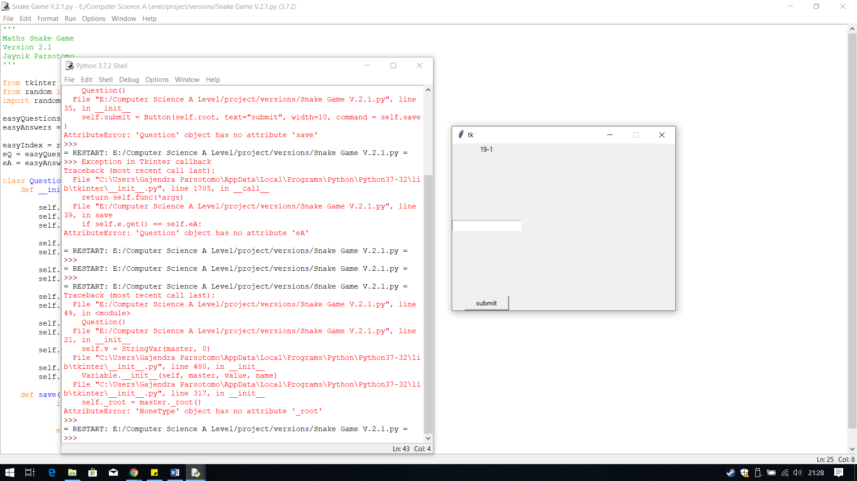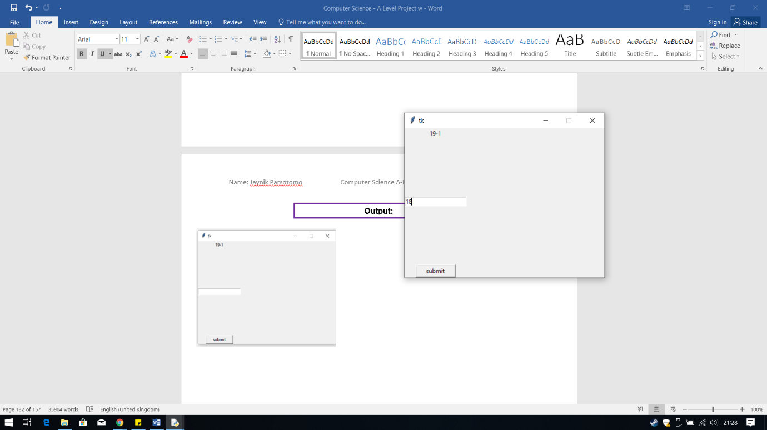

The output this time was error-free, the question showed up and when I entered the answer and pressed submit, the pop-up closed. Therefore, the code root.destroy() works and the answer is retrieved as well.

## **Progress Tracker List**

In version 2.2, I created the progress tracker to keep track of the number of times the user gets each question right and wrong. I did this by creating a list.

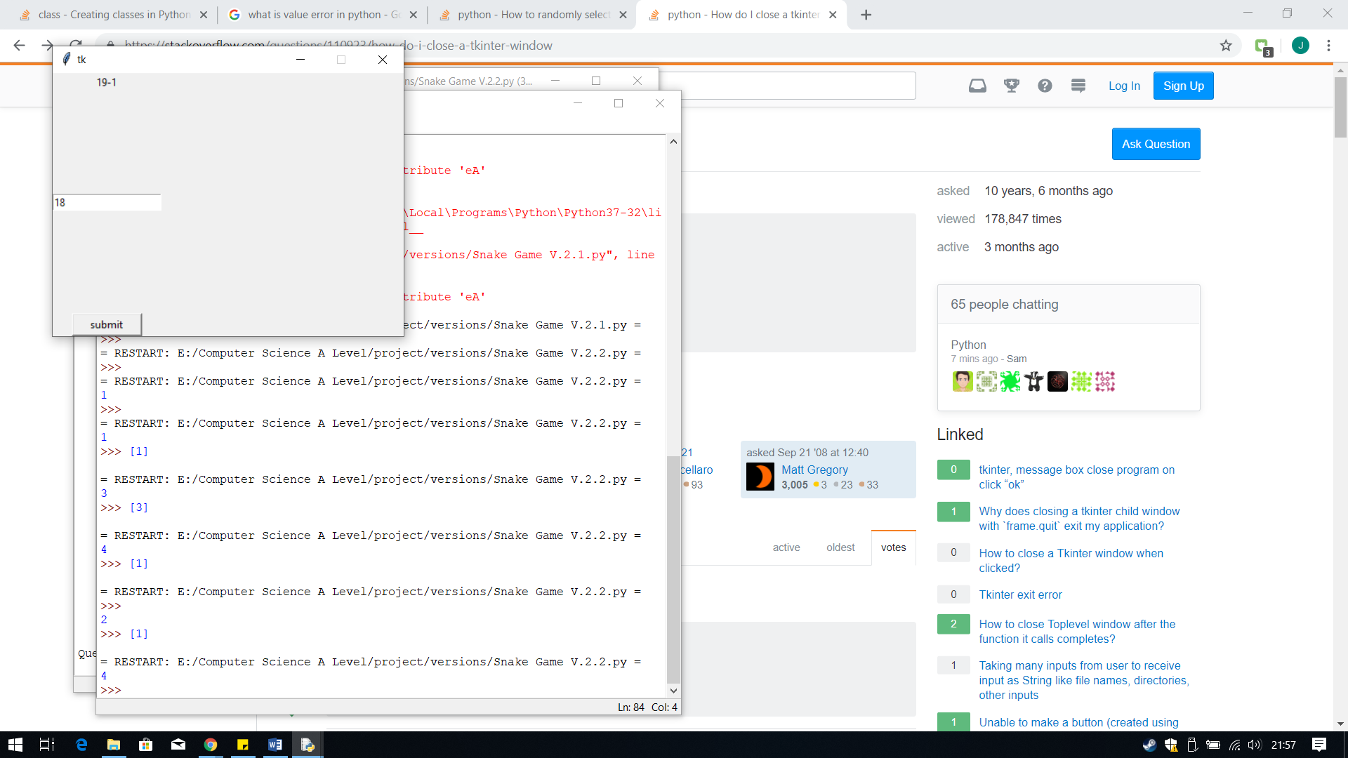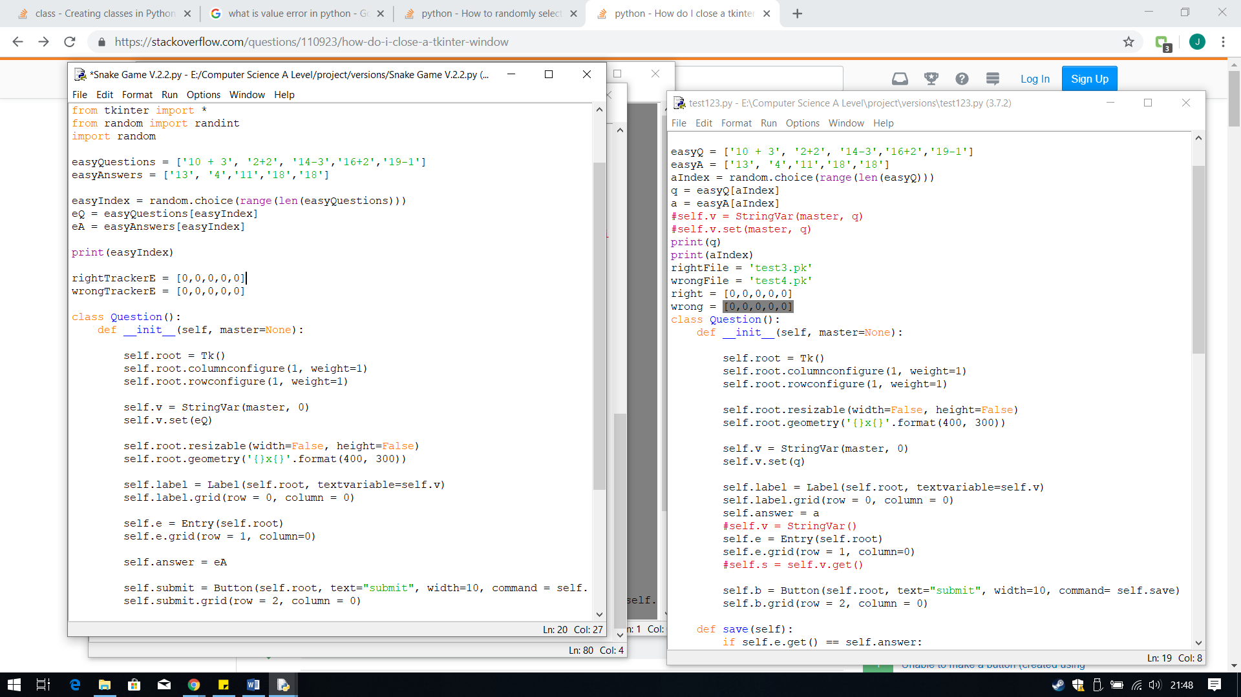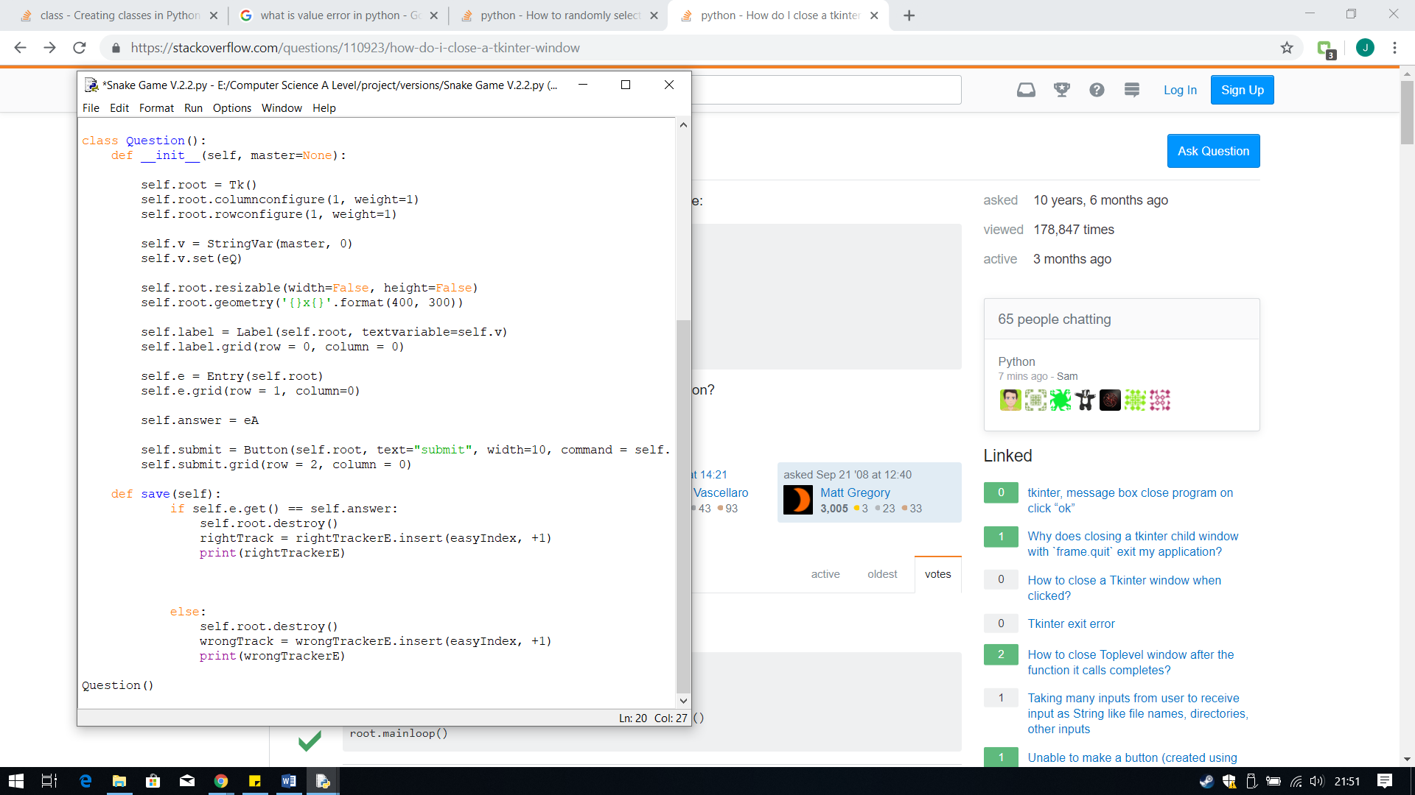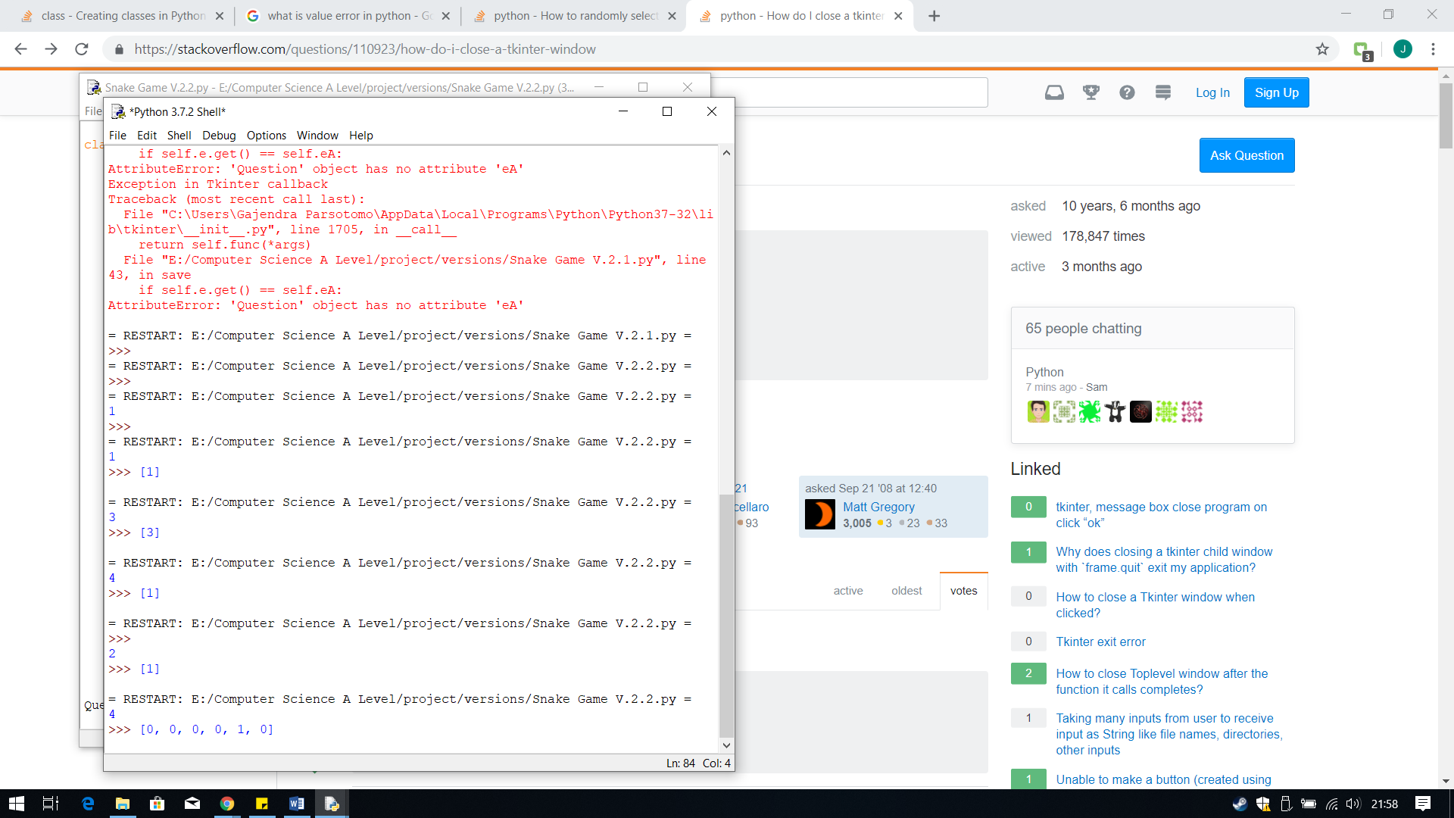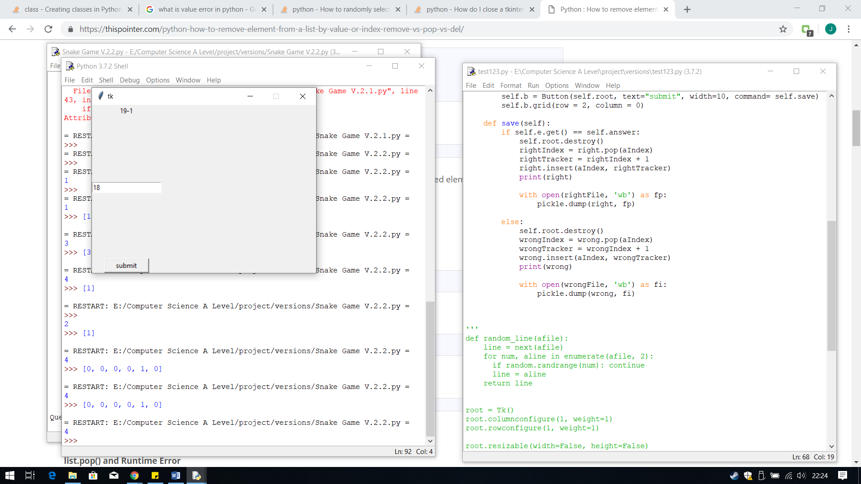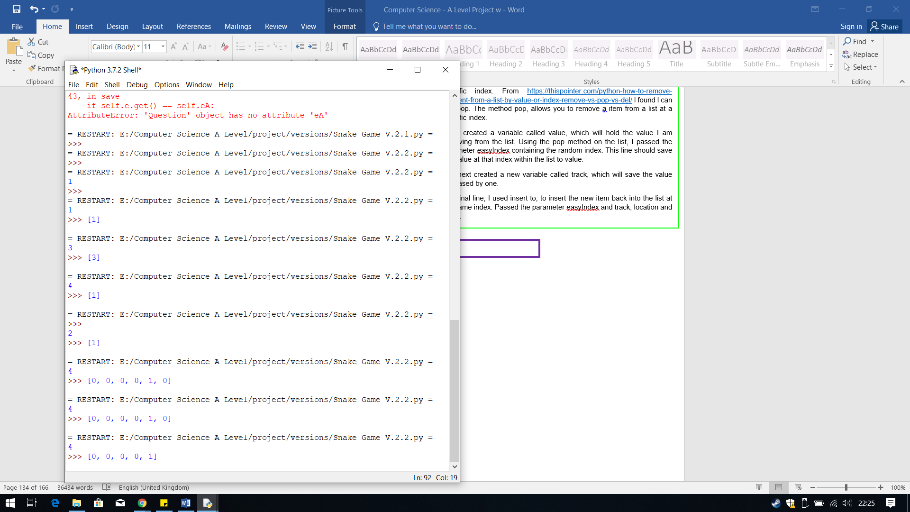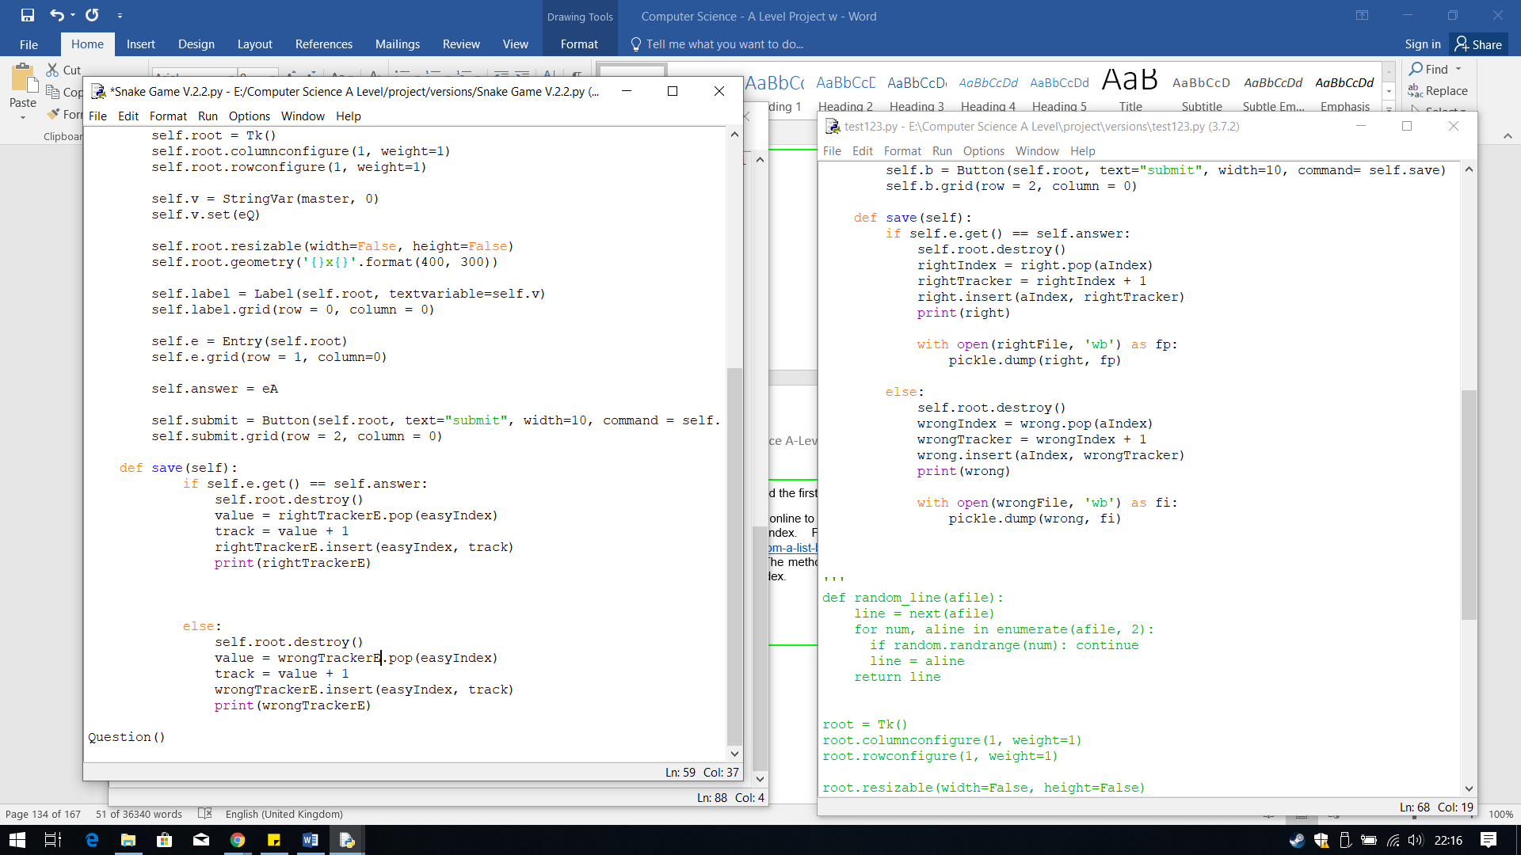

The outcome from this test was not what I wanted.

When I entered the value and submitted for the right tracker, I expected the index of where the question is, value 0 is changed to 1. However, from this I found that insert does not do this, it inserts the value to that index but if there if there is already a value at that index it will simply move that value to another index. This caused the list to increase from 5 items to 6.

Another problem with this method is that when the program is finish running and ran again the list is reset thus previous list data is lost.

I have created these variables to store a list, of zeros, where I will add the 1 to the tracker each time the question at that index is answer correctly or incorrectly.

To plus one to the tracker at the index I am going to keep the tracker in the same order as the question and answers, to make it easy to use the random index.

For each one I have created a variable that uses the list function insert where you can pick a location, index as to where you want to insert the value. In this case I am using the random index, easyIndex and the value I am inserting is +1, so it will add on to the value at that index.

The solution to the first problem is to find a method which first take the value out of the list and increases the value, and then inserts it back, thus the list size remains the same.

To solve the second problem, I need to find a way to save a list change whilst a program is running and then place that back in when the program is running again, repeating this process.

**Logical Errors: Wrong Method, List Restarts**

**Output:**

The output I received was what I expected. The location the question I answered is 4 therefore the tracker needs to increase the last zero by 1, which it did. Therefore, this method is successful, solving the first problem

**Output:**

I first solved the first problem.

I first went online to find a method in python to remove a item in a list at a specific index. From <https://thispointer.com/python-how-to-remove-element-from-a-list-by-value-or-index-remove-vs-pop-vs-del/> I found I can use pop. The method pop, allows you to remove a item from a list at a specific index.

I first created a variable called value, which will hold the value I am removing from the list. Using the pop method on the list, I passed the parameter easyIndex containing the random index. This line should save the value at that index within the list to value.

The next created a new variable called track, which will save the value increased by one.

The final line, I used insert to, to insert the new item back into the list at the same index. Passed the parameter easyIndex and track, location and value.

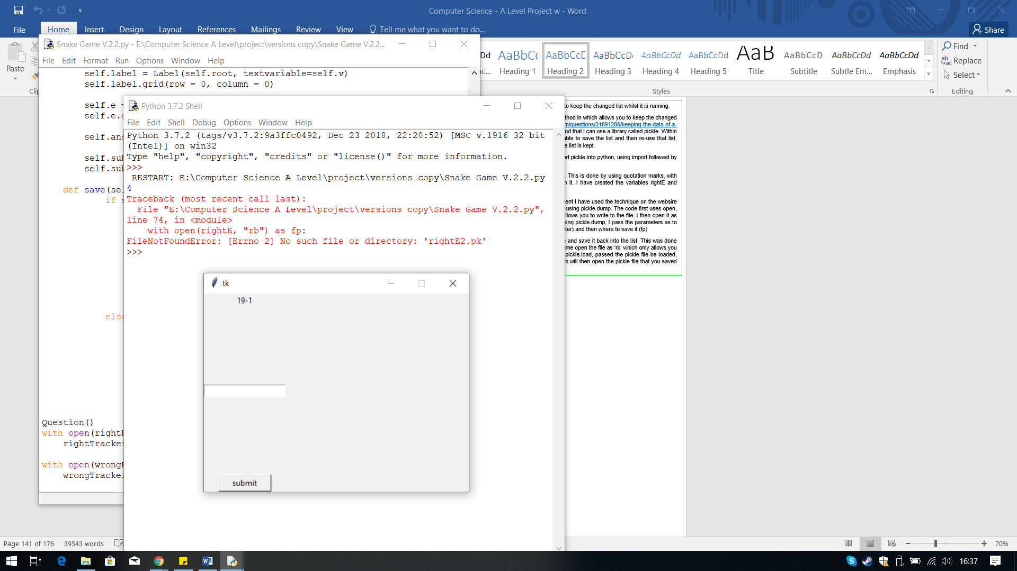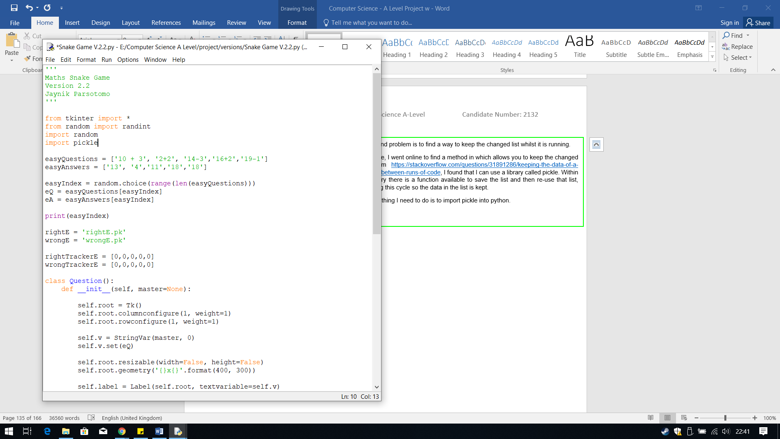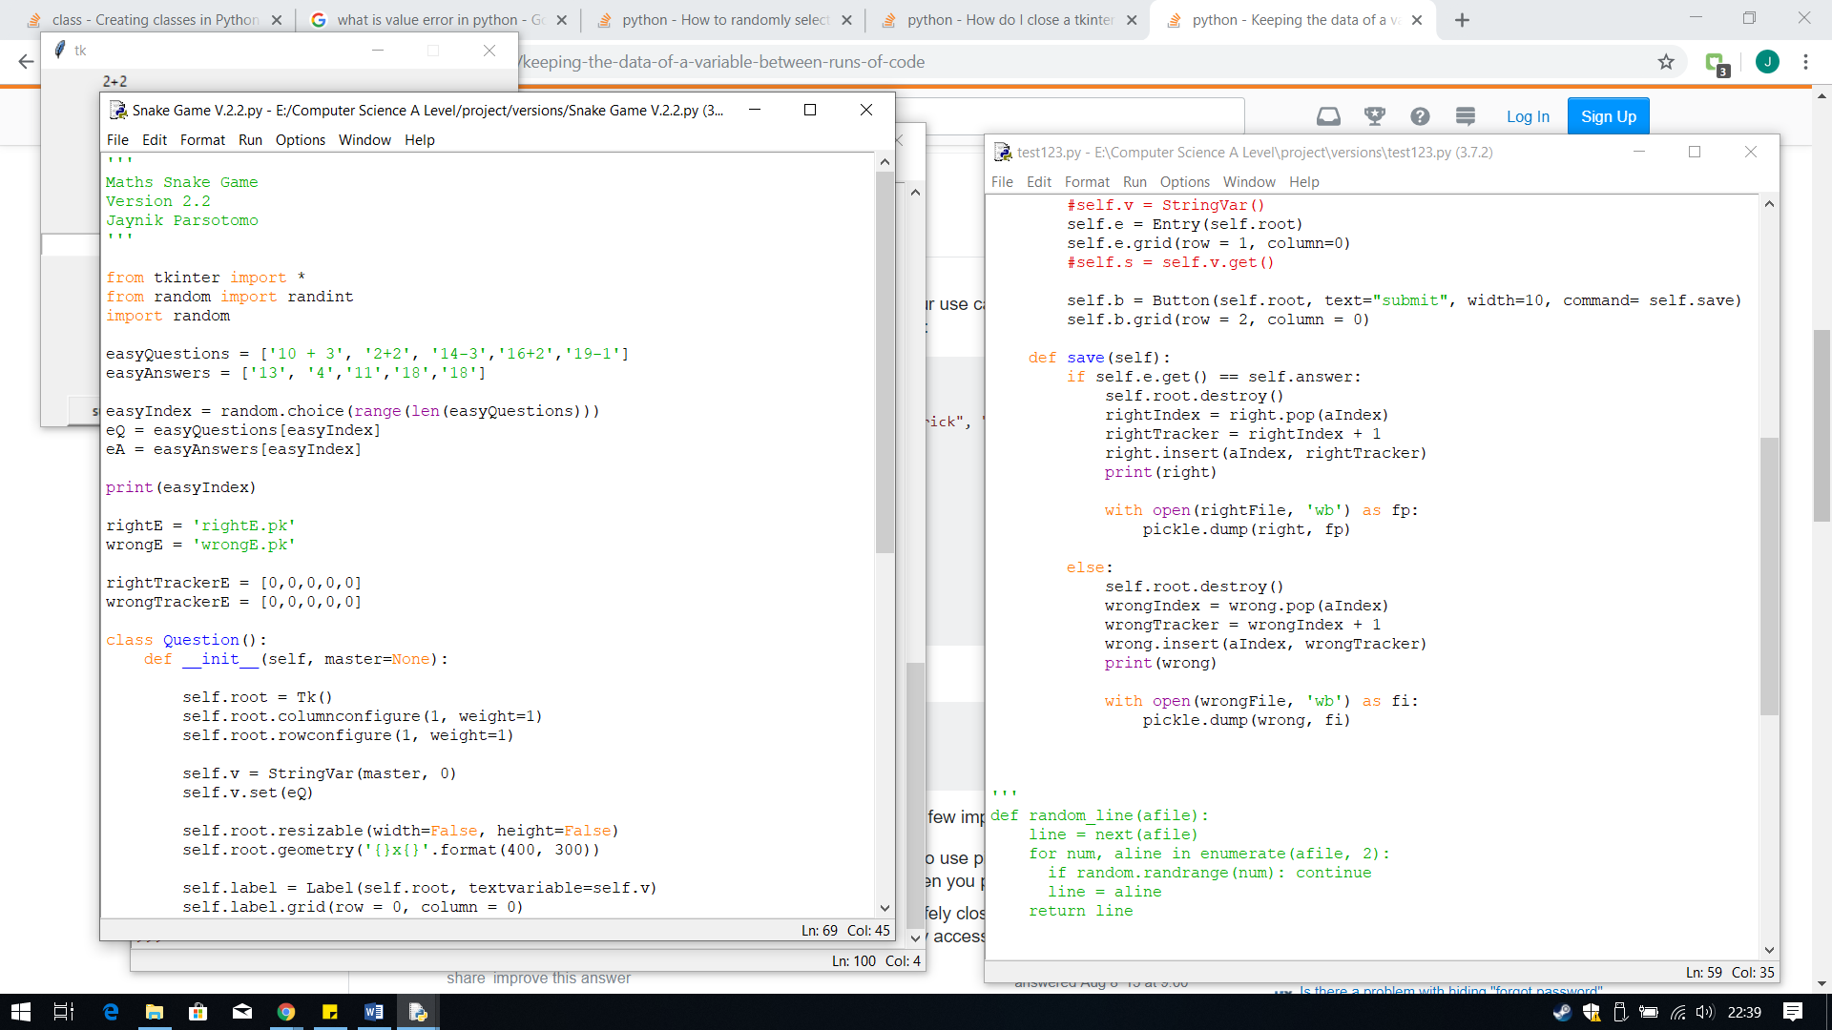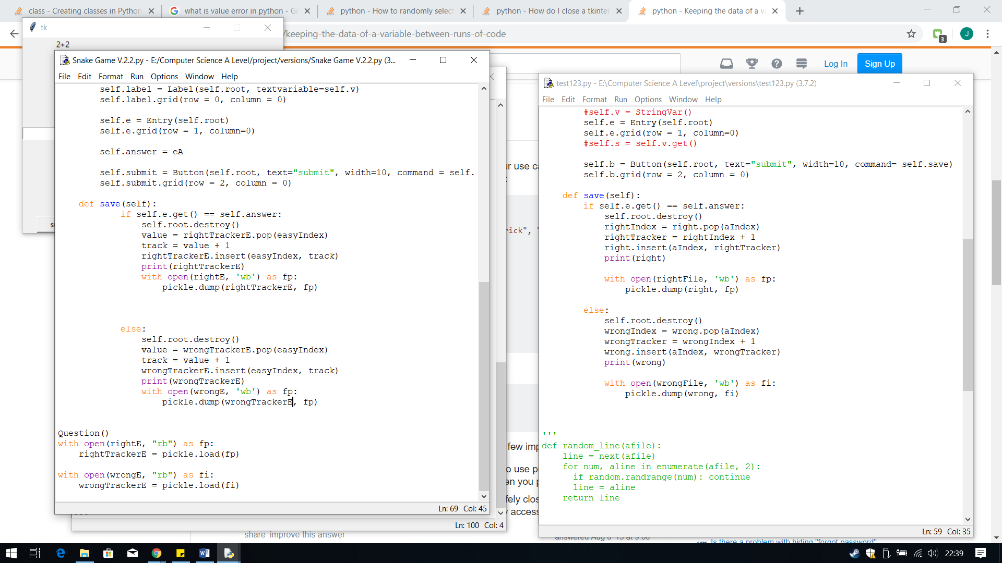

The solution to this problem is simple, I just need create the file by filling the pickle file with the list data, which is what the pickle.dump line does. Therefore, if I carry on with the testing, by entering an answer, the error should disappear.

My second problem is to find a way to keep the changed list whilst it is running.

Therefore, I went online to find a method in which allows you to keep the changed list. From <https://stackoverflow.com/questions/31891286/keeping-the-data-of-a-variable-between-runs-of-code>, I found that I can use a library called pickle. Within this library there is a function available to save the list and then re-use that list, repeating this cycle so the data in the list is kept.

The first thing I need to do is to import pickle into python, using import followed by the library name.

The I need to create the pickle files. This is done by using quotation marks, with the file name followed by .pk within it. I have created the variables rightE and wrongE to save the pickle file to.

Then within the IF and ELSE statement I have used the technique on the websire which saves the list to the pickle fiel using pickle.dump. The code first uses open, to open the pickle file and the ‘wb’ allows you to write to the file. I then open it as fp, so it is easier to refer to. Then using pickle.dump, I pass the parameters as to what list I want to save first (the tracker) and then where to save it (fp).

The final lines re-open the pickle file and save it back into the list. This was done using the similar technique but this time open the file as ‘rb’ which only allows you to read it, un-editable. Then I used pickle.load, passed the pickle file be loaded, and save this to the list variable. This will then open the pickle file that you saved after running to the code, to the list.

**Error: Pickle File Not Created**

When ran, I received an error, because I have tried to load a Pickle File that has not be created yet, causing this error.

**Output:**

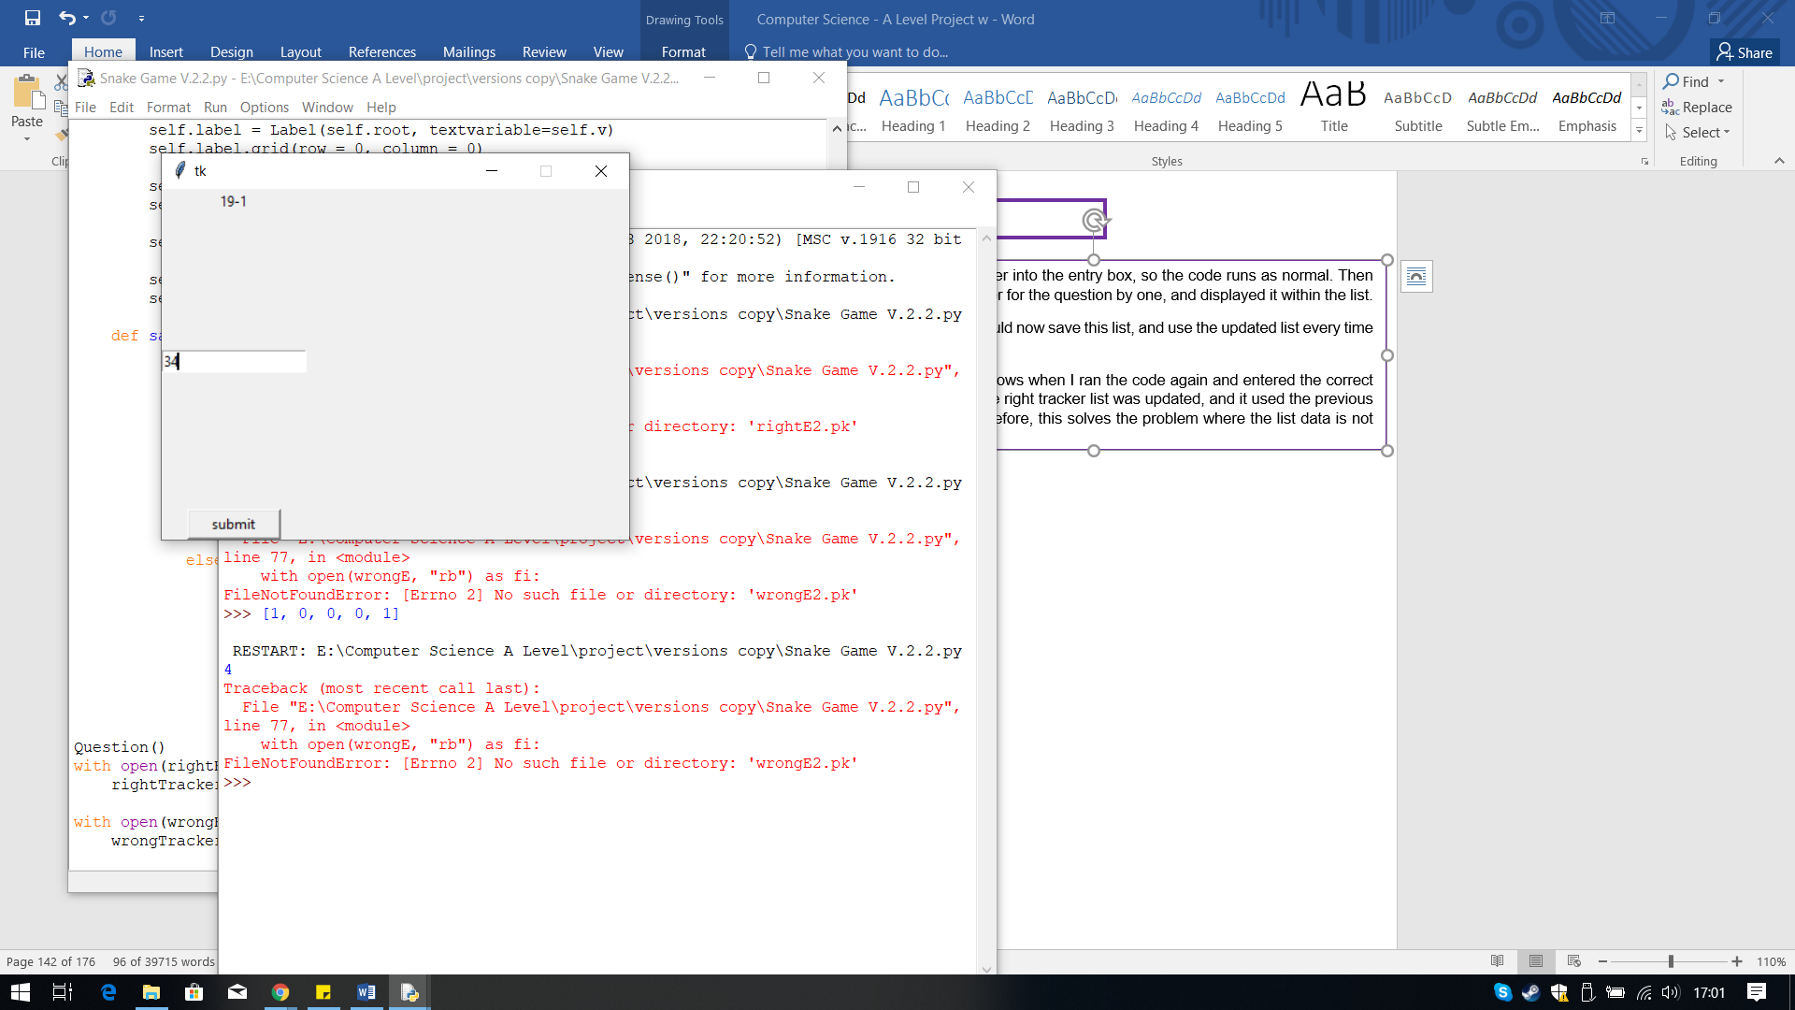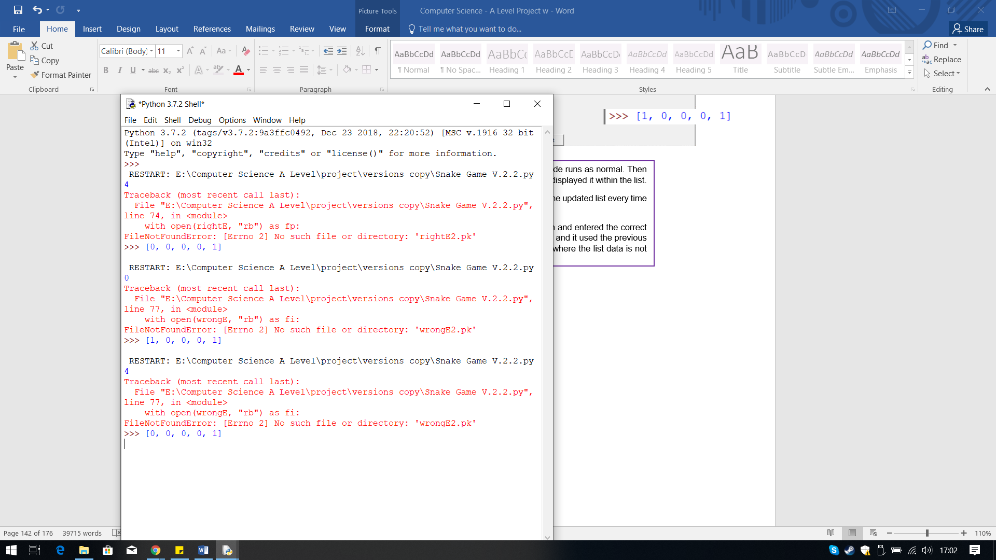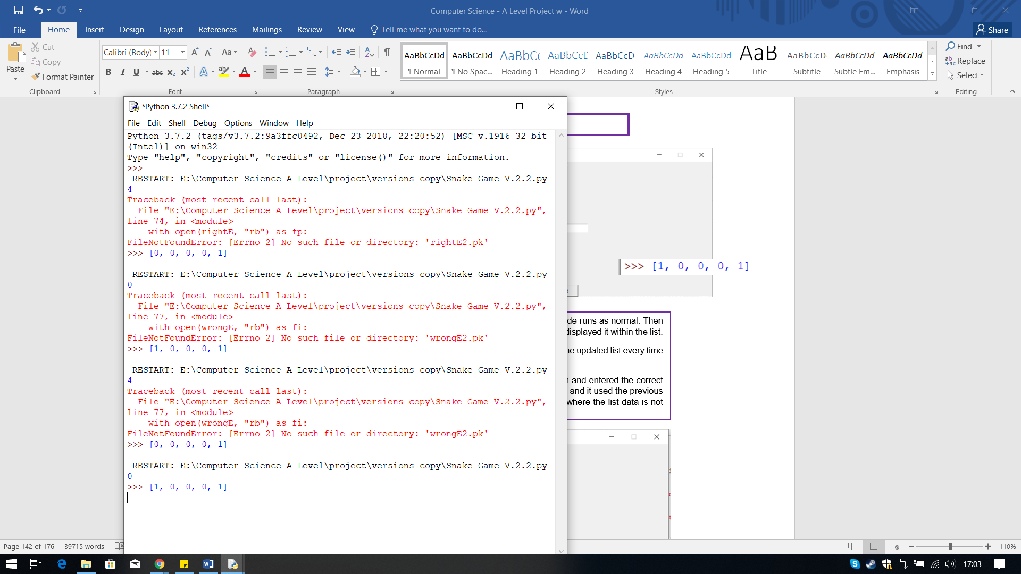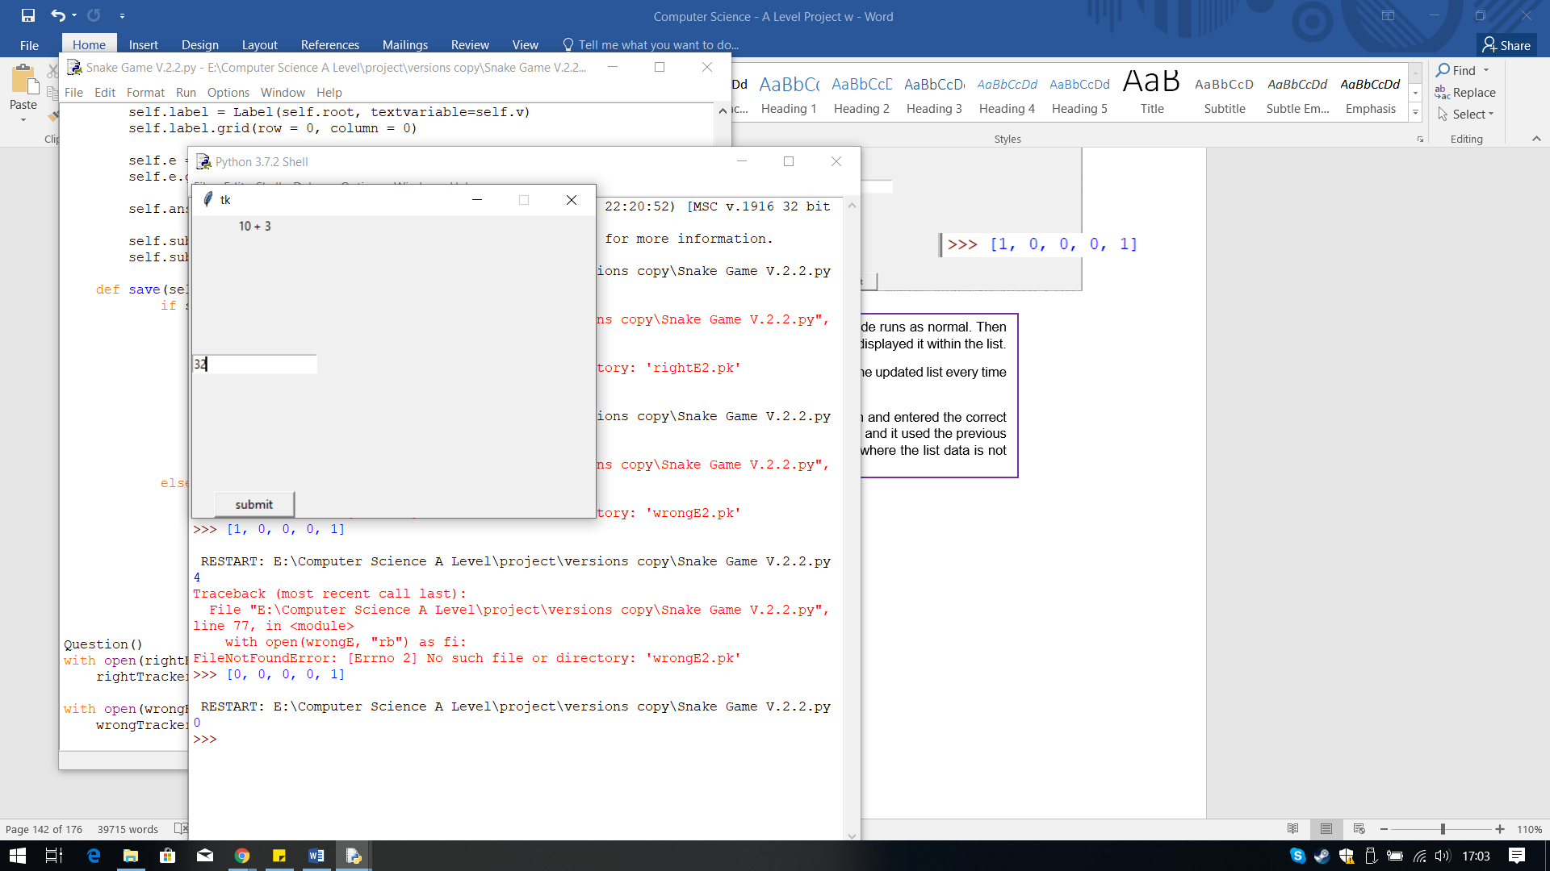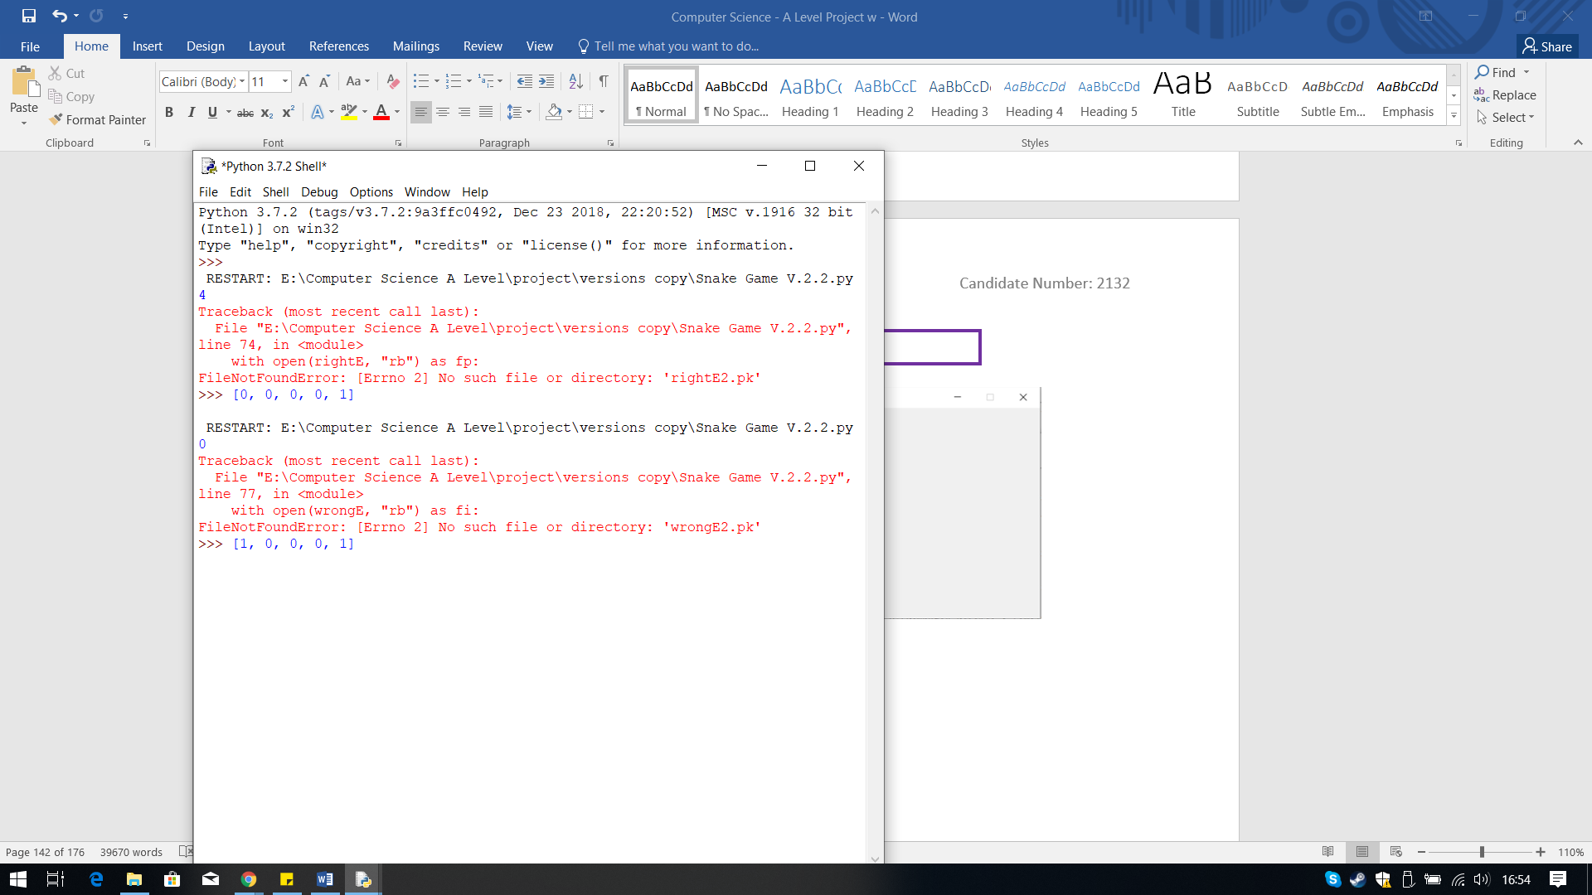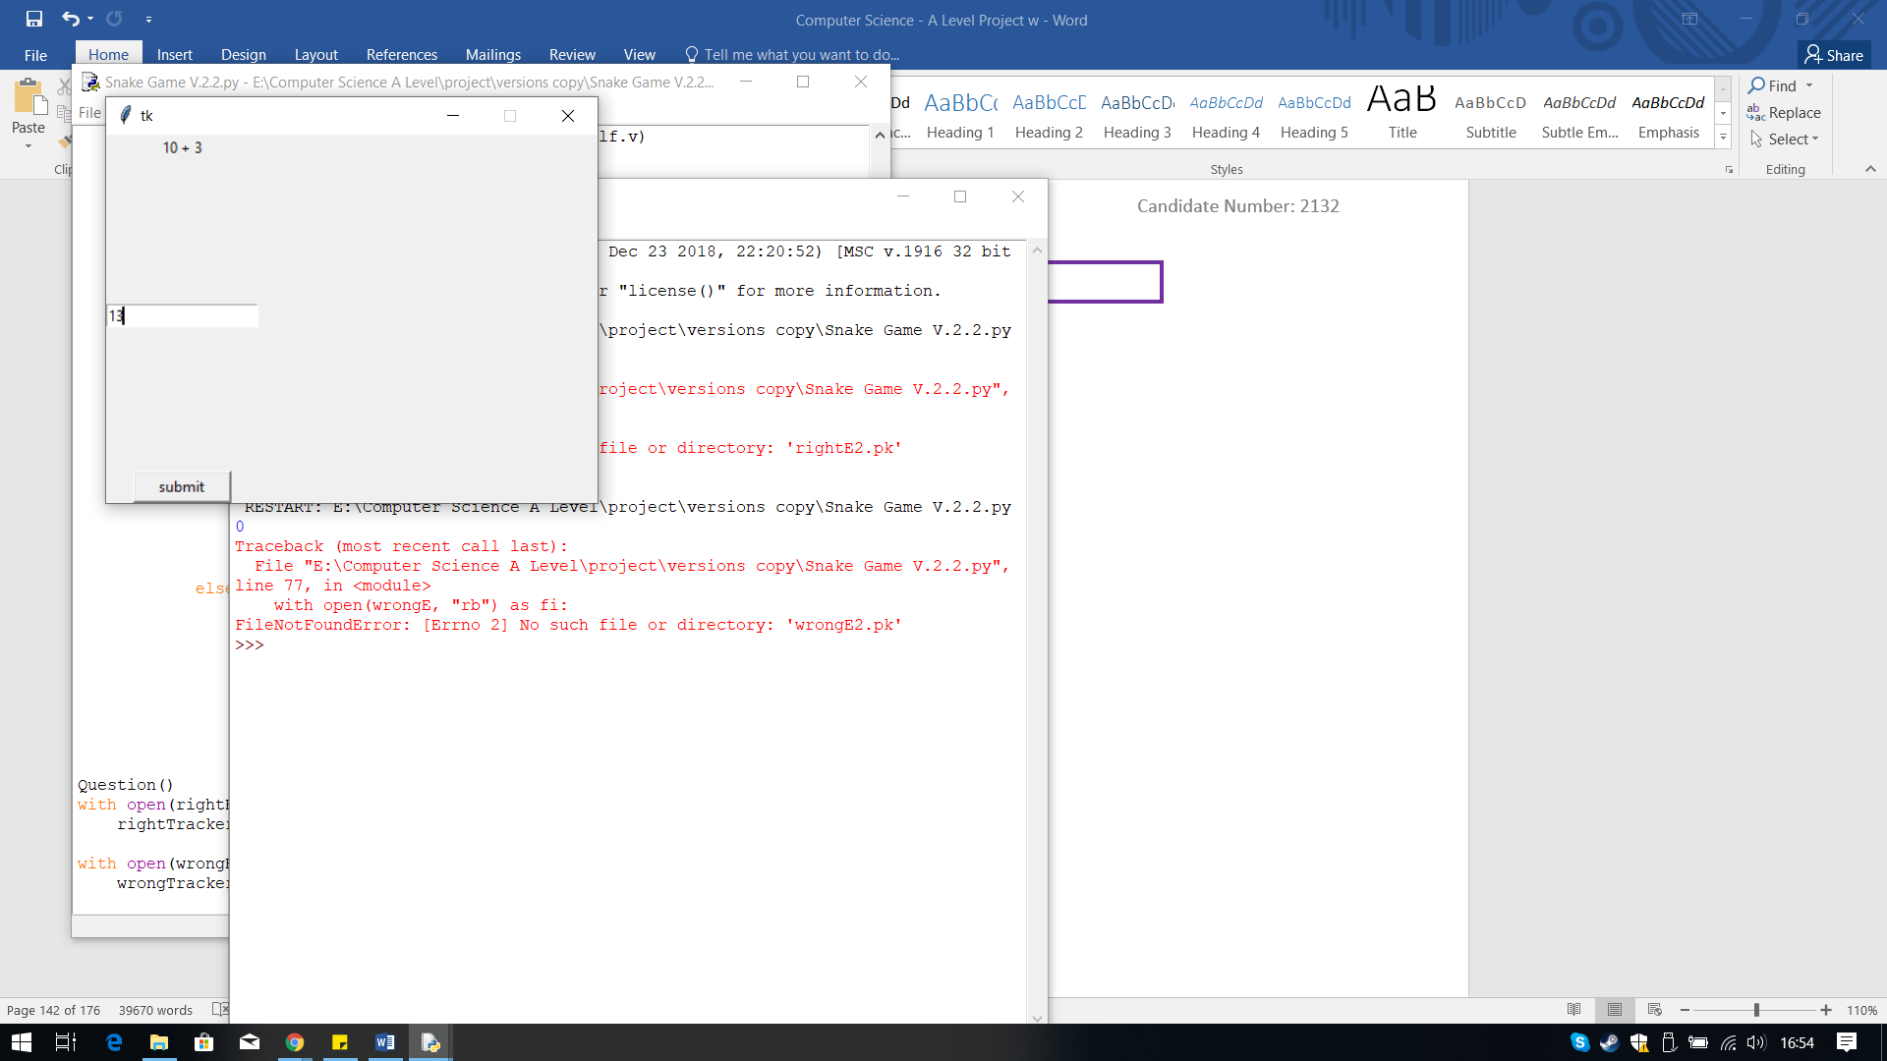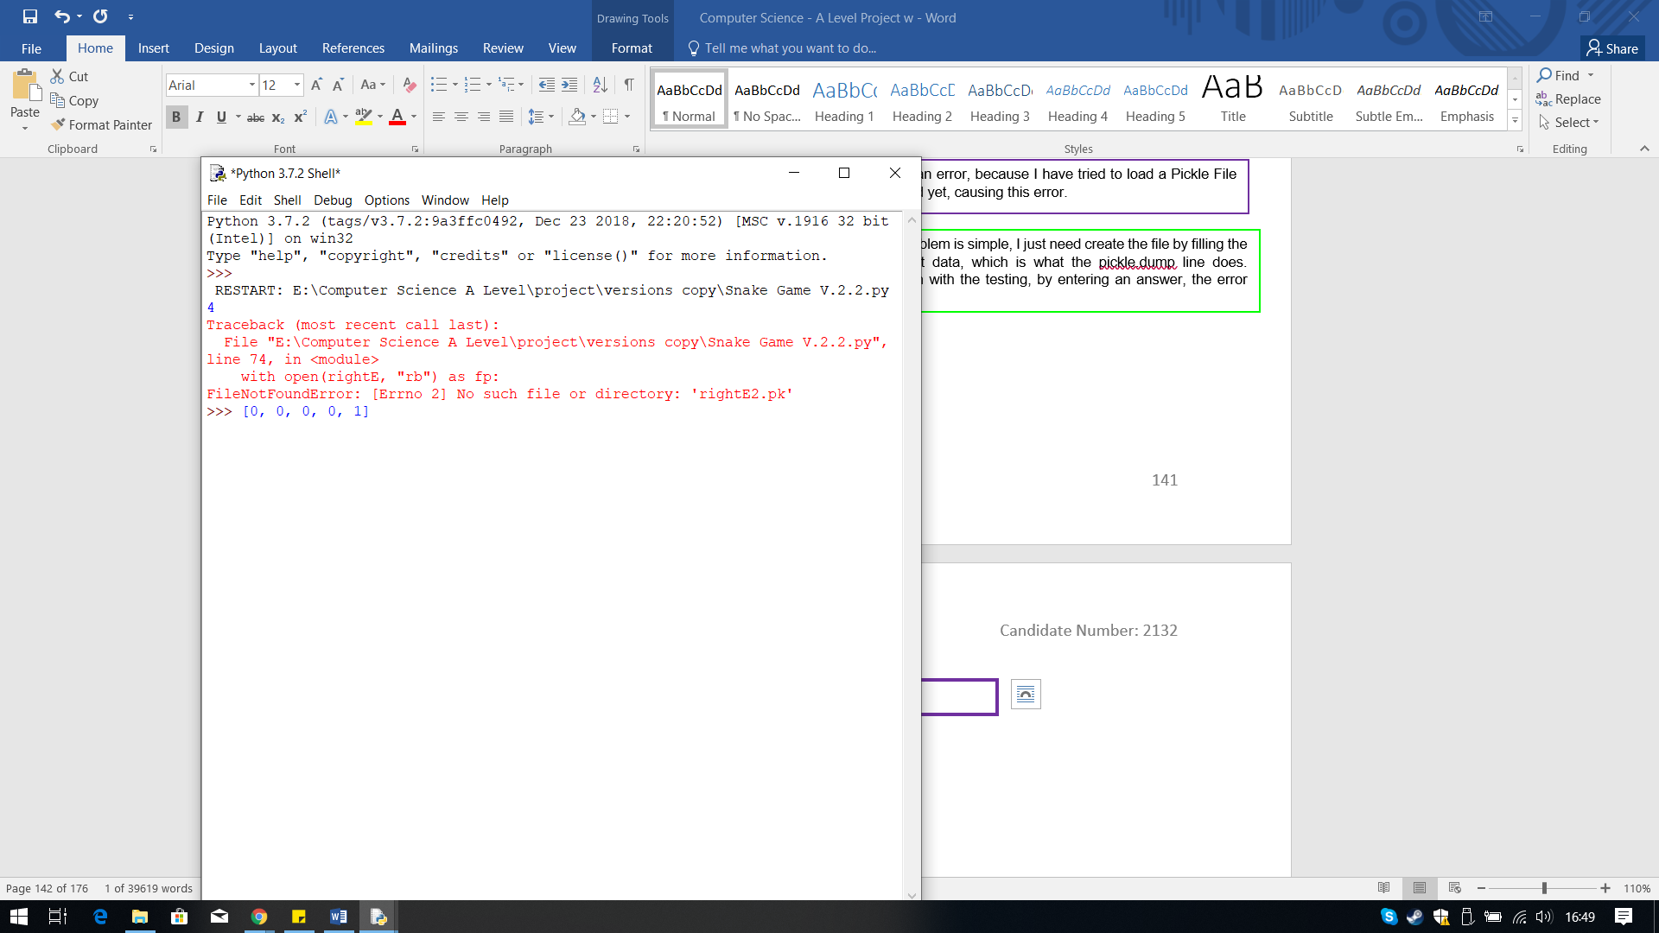

I tested the code for the wrong tracker list as well, when tested the output received was the expected one. The list updated and the updated list in the next run.

I entered the correct answer into the entry box, so the code runs as normal. Then it increases the right tracker for the question by one, and displayed it within the list.

The code pickle.dump should now save this list, and use the updated list every time the code is ran.

The second screenshot shows when I ran the code again and entered the correct answer to the question, the right tracker list was updated, and it used the previous list that was created. Therefore, this solves the problem where the list data is not saved.

**Output:**

## **Incorporating the Progress Tracker and Questions into the Game**

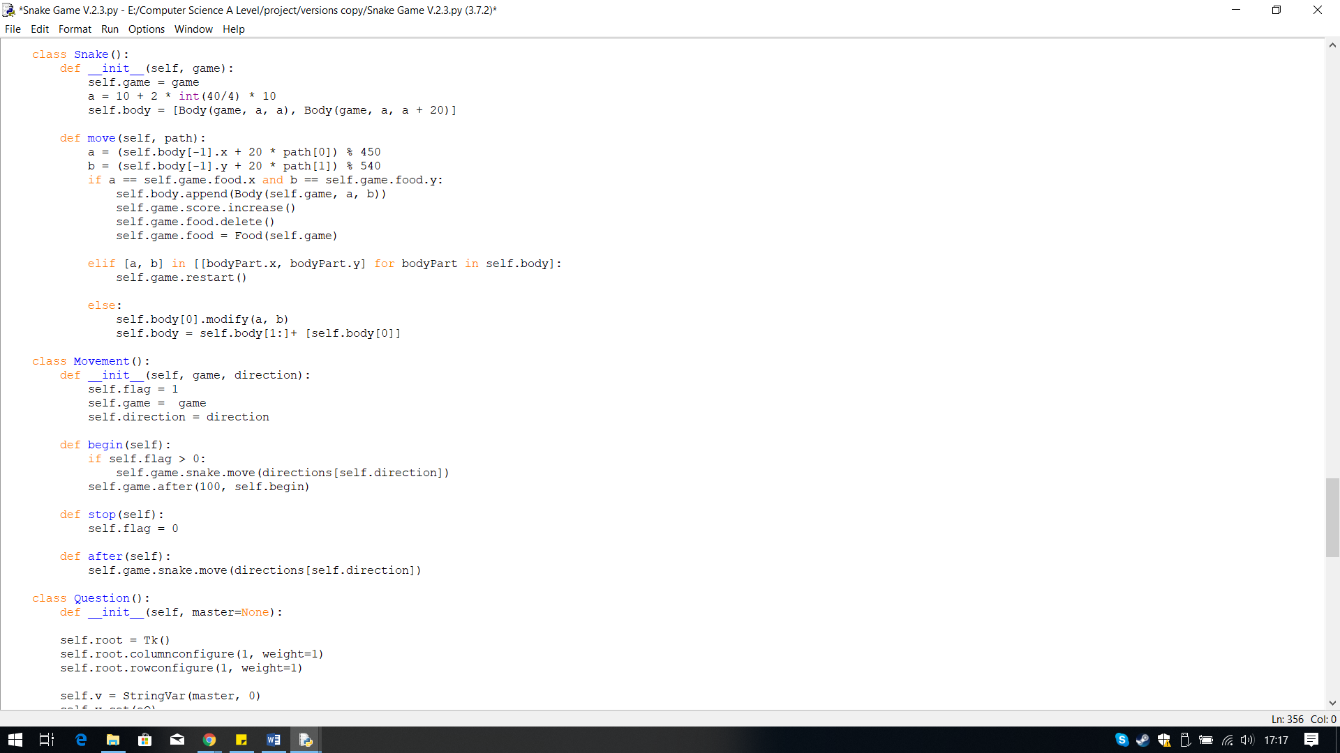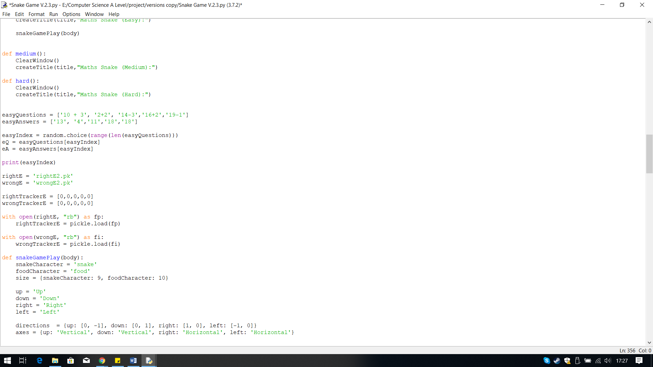In version 2.3 I incorporated the code for the questions and the progress tracker into the game.

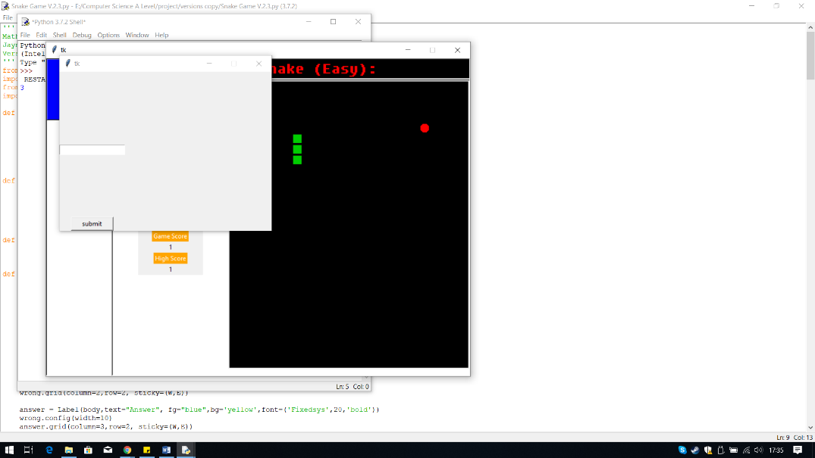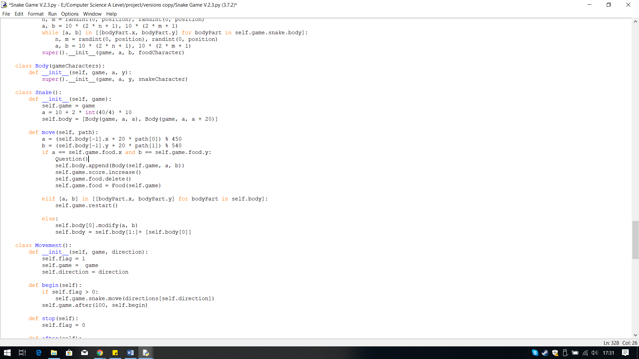

When ran, I controlled the snake to eat the food, and when it did the pop-up window appeared. However, there were 2 errors.

The first error was to do with the pop-windows, not displaying the question. The question should be displayed at the top, above the entry box but it did not appear.

The second error is the game carries on. When the question appears the gameplay should temporally pause until the question has been answered. I have not thought about this yet, as I have not yet incorporated a method to pause gameplay.

**Errors: Question does not appear and Game carries on**

**Output:**

Within the snake game, the question need to pop-up when the food is eaten by the snake. Therefore, I have called the Question class within the IF statement that checks if the food has been eaten.

I have placed the Class Question() underneath the classes that create the snake game. I have placed the global variables like the question list outside the classes and functions because other functions like the Progress Tracker function will need to be able to access them.

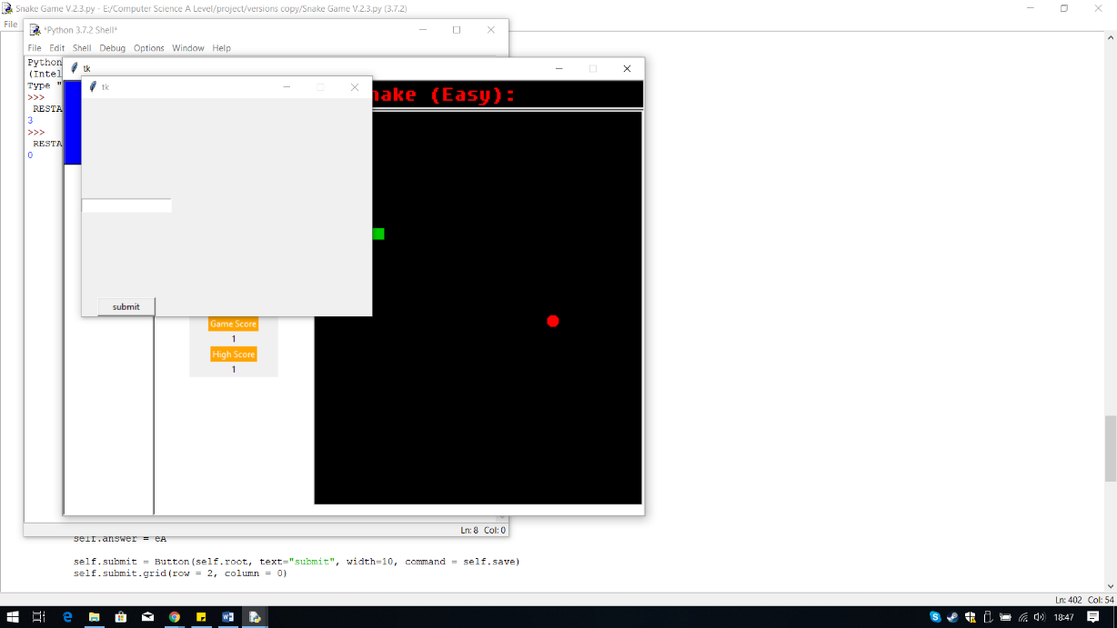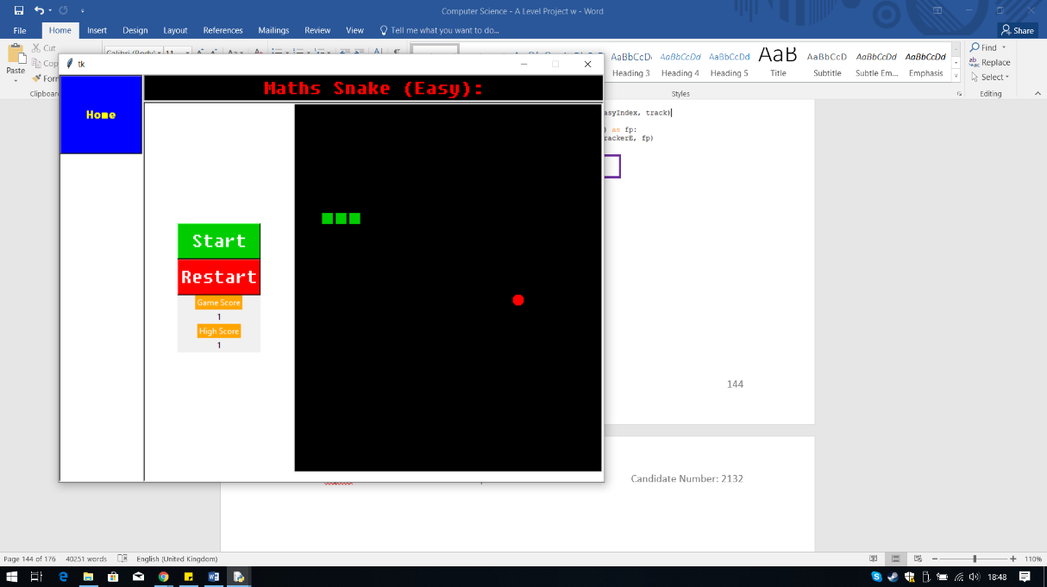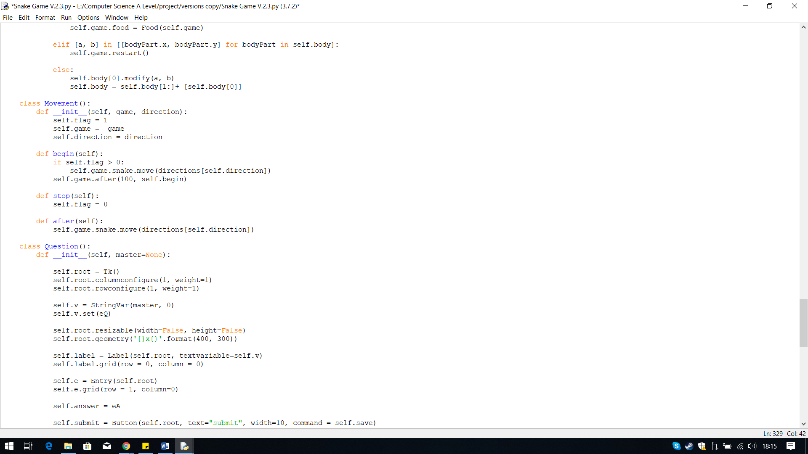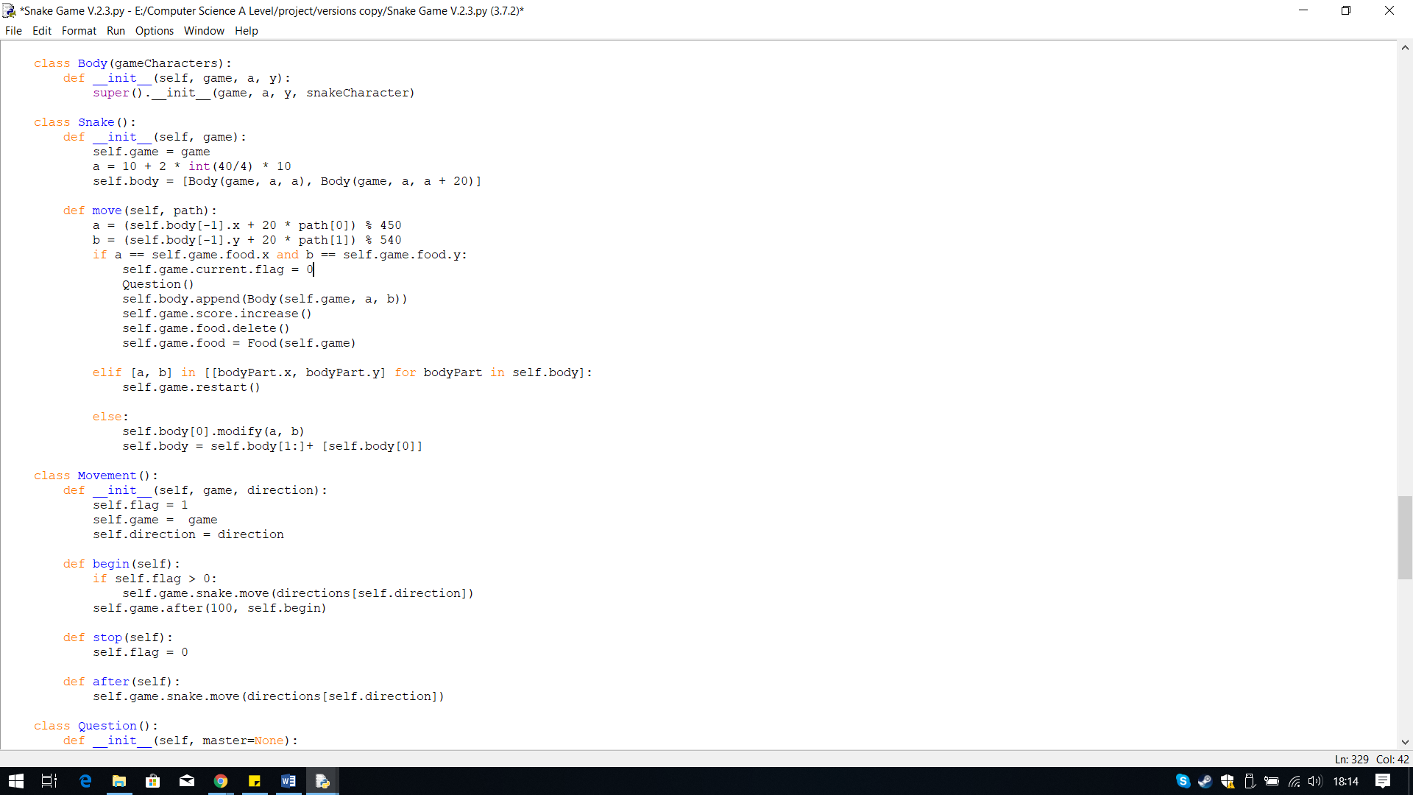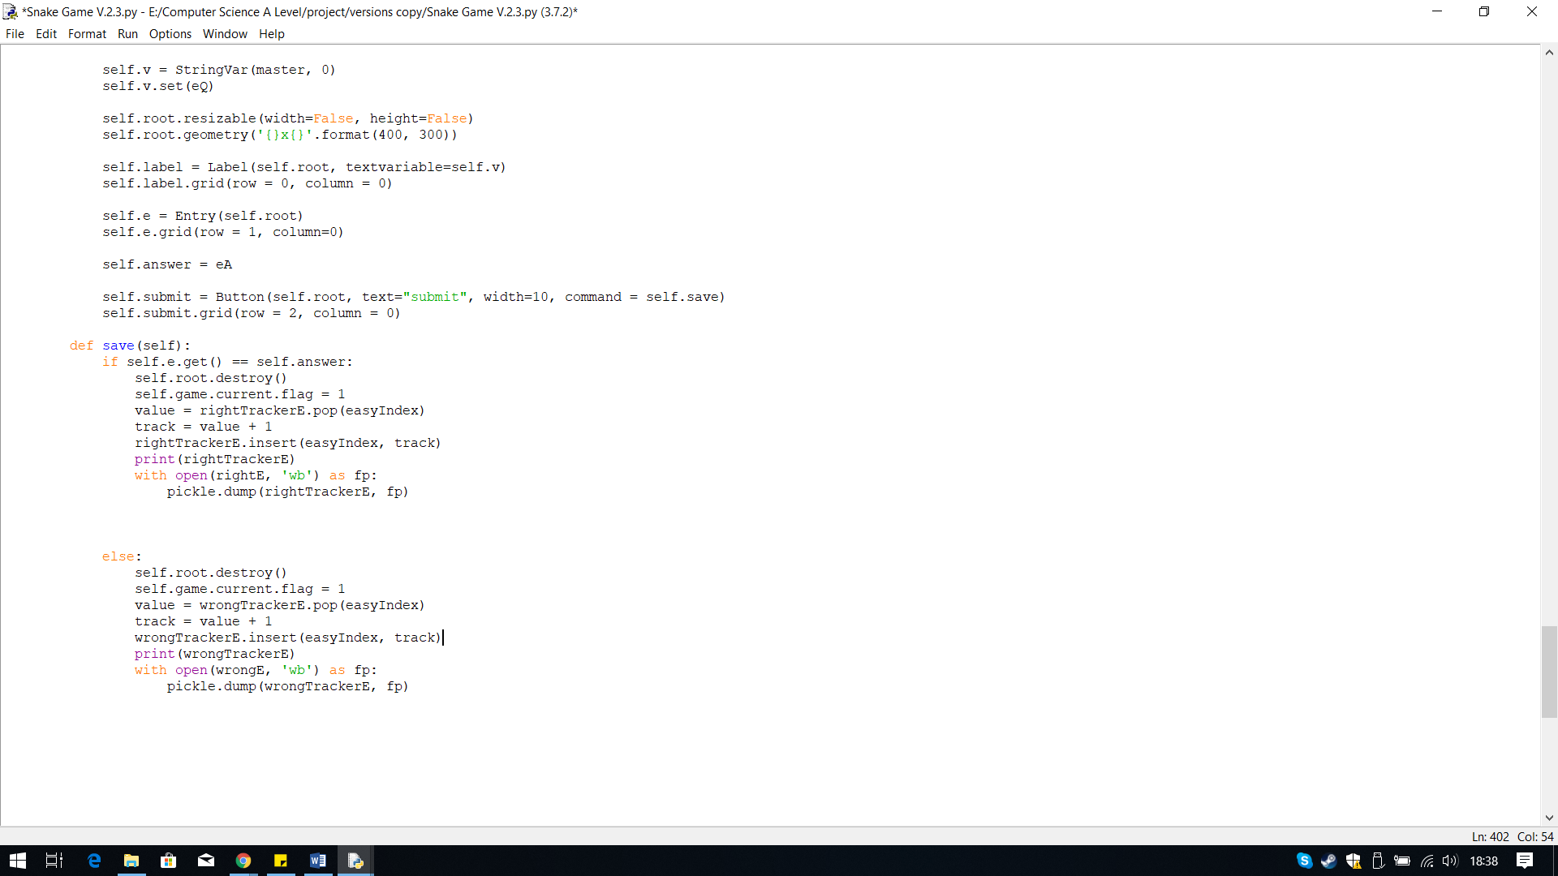

The output, when the snake ate the food this time was the game had stopped. When the question window appeared the game play was paused.

Next, to restart the gameplay, I simply need to change the current flag value back to 1, which means the game is running again, thus the game will restart.

Therefore, using the same attributes, I changed the value back to 1 in the method save within the class Question. The reason for this is so the game remains paused until the question has been answered, and the answer is submitted.

The way my teacher told me to use the flags was first to call then and set the flag to zero and save this to the attribute current. Current is used to save if the game is running or not, therefore by settling the current value of the flag to zero means the game is not running. This means when the food is eaten the game should pause because the current value has been changed.

This is the Movement Class that contains the flags. Within this class I am using the flags to determine if the game is running or not, and using a Boolean value, 0 and 1.

**Output:**

I first decided to tackle the first problem. When searching online to find a solution to this problem of how to pause a tkinter window, I found this sort of error has something to do with threading. Both tkinter windows are running in different threads, they act independent of each other, therefore to stop the gameplay in the other tkinter window I need to pause the thread.

To fix this problem I received help from my Computer Science teacher, because I attempted solve the threading issue but the fix I found caused my Python to stop working.

The solution my teacher found was to use the flags I have created within the Movement() Class.

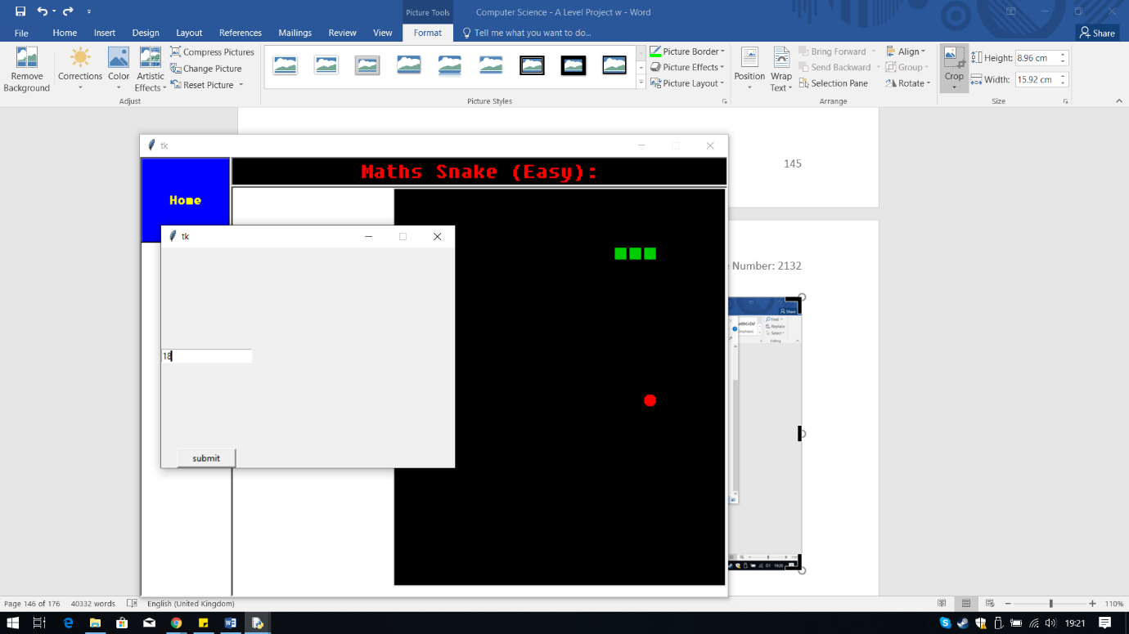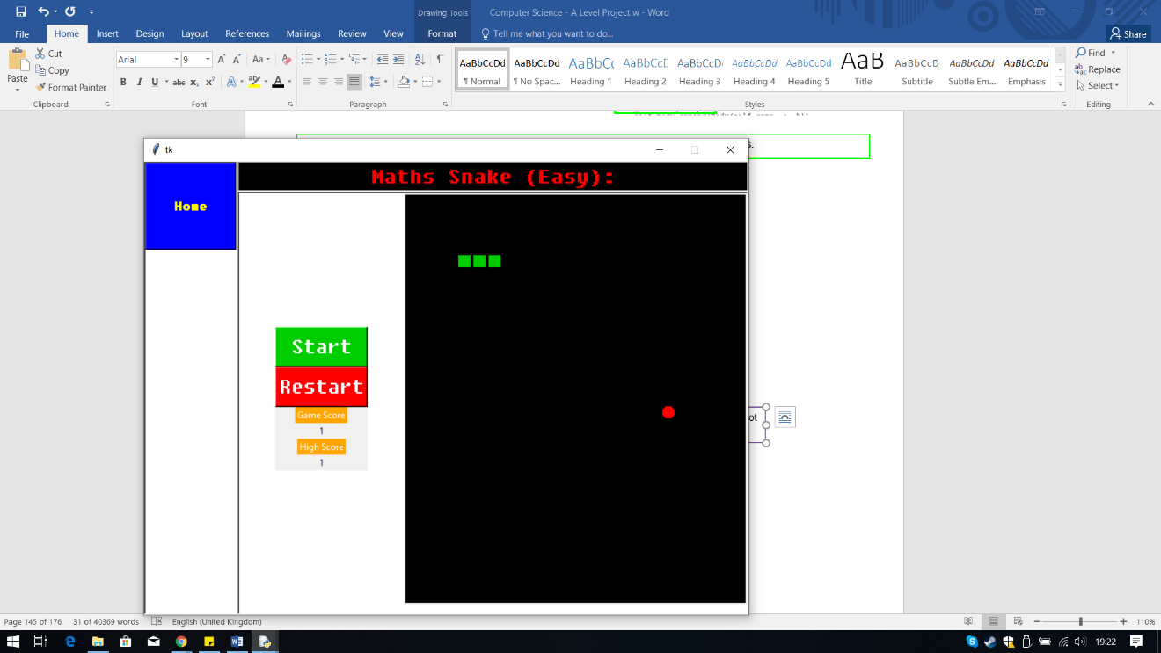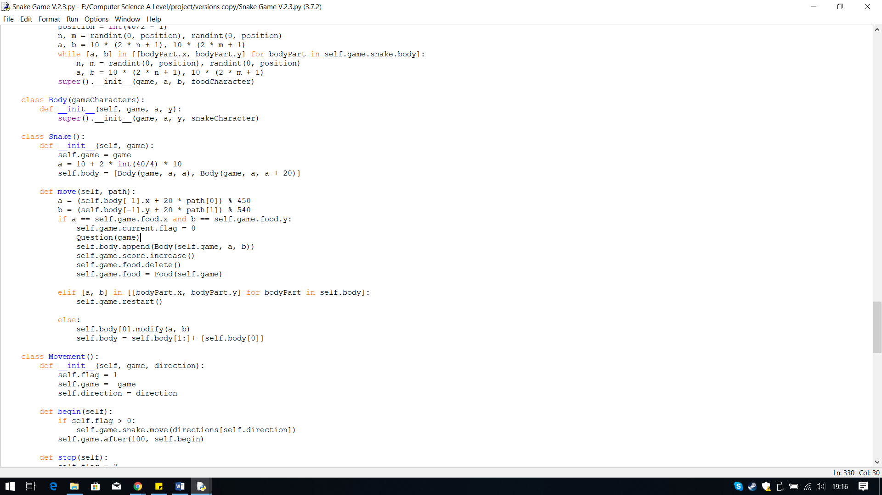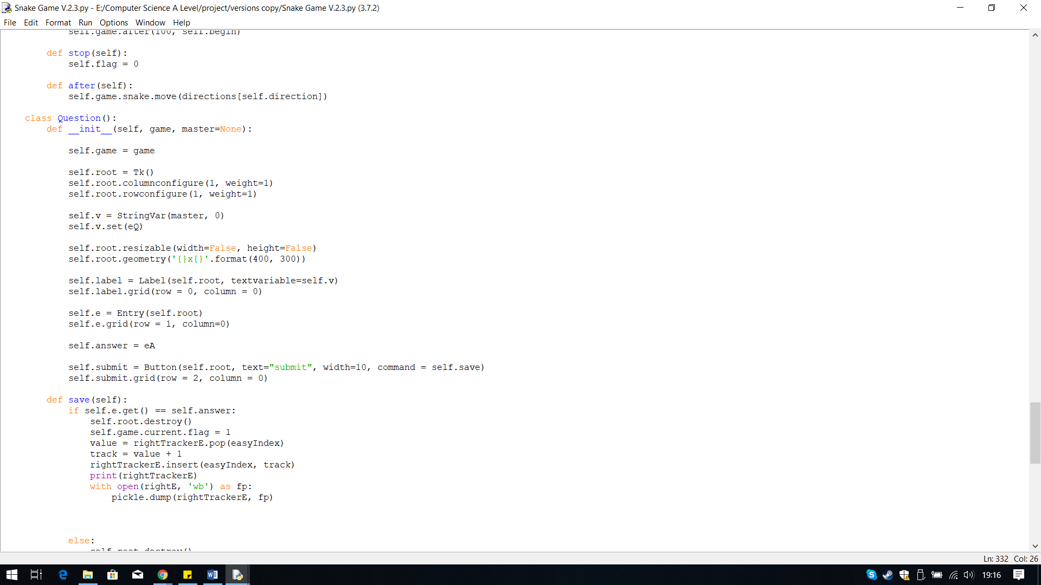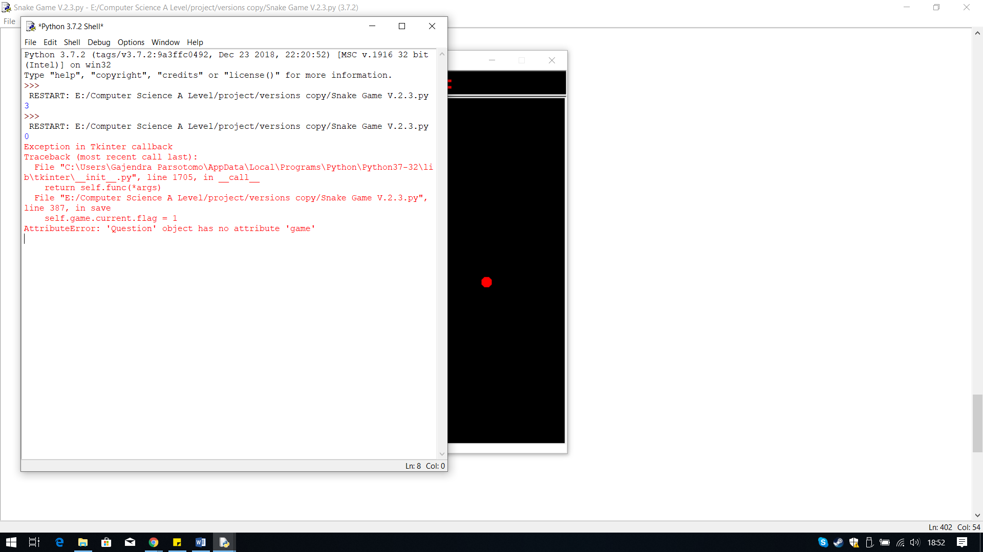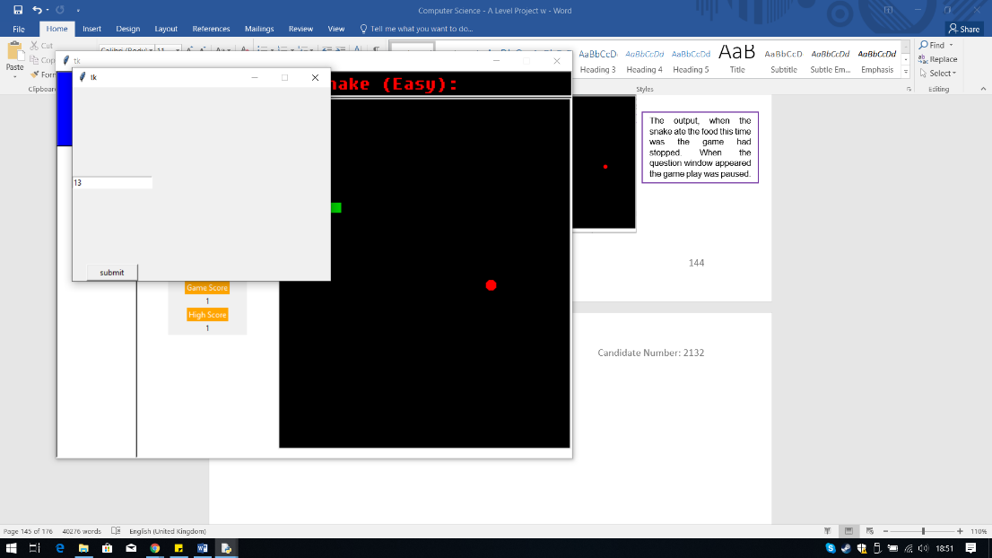

When I submitted the answer, I received an error that the attribute game does not exist therefore to fix this I need to declare the attribute game in the class first.

When ran this time, the gameplay restarted, when I submitted the answer.

**Output:**

I have created the attribute in the class Question and passed it as a parameter when calling the class.

**Error: Attribute game not found**

In version 2.4 I changed the condition of when the score increases and the body grows, which is when the answer to the question is correct.

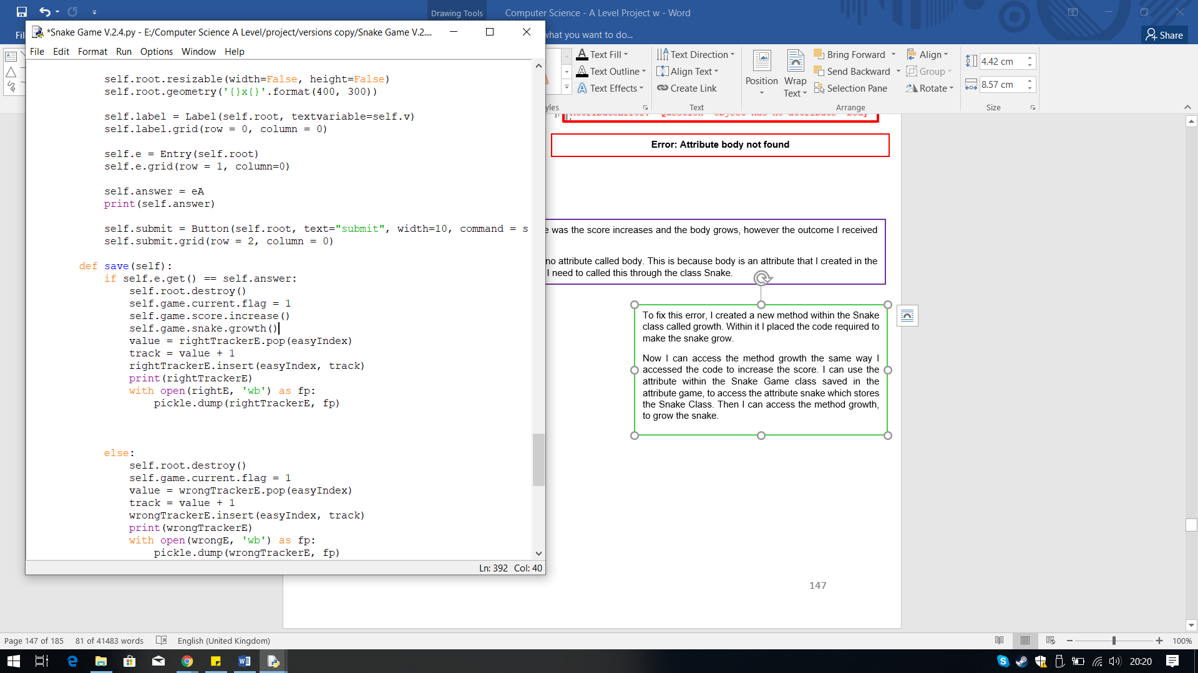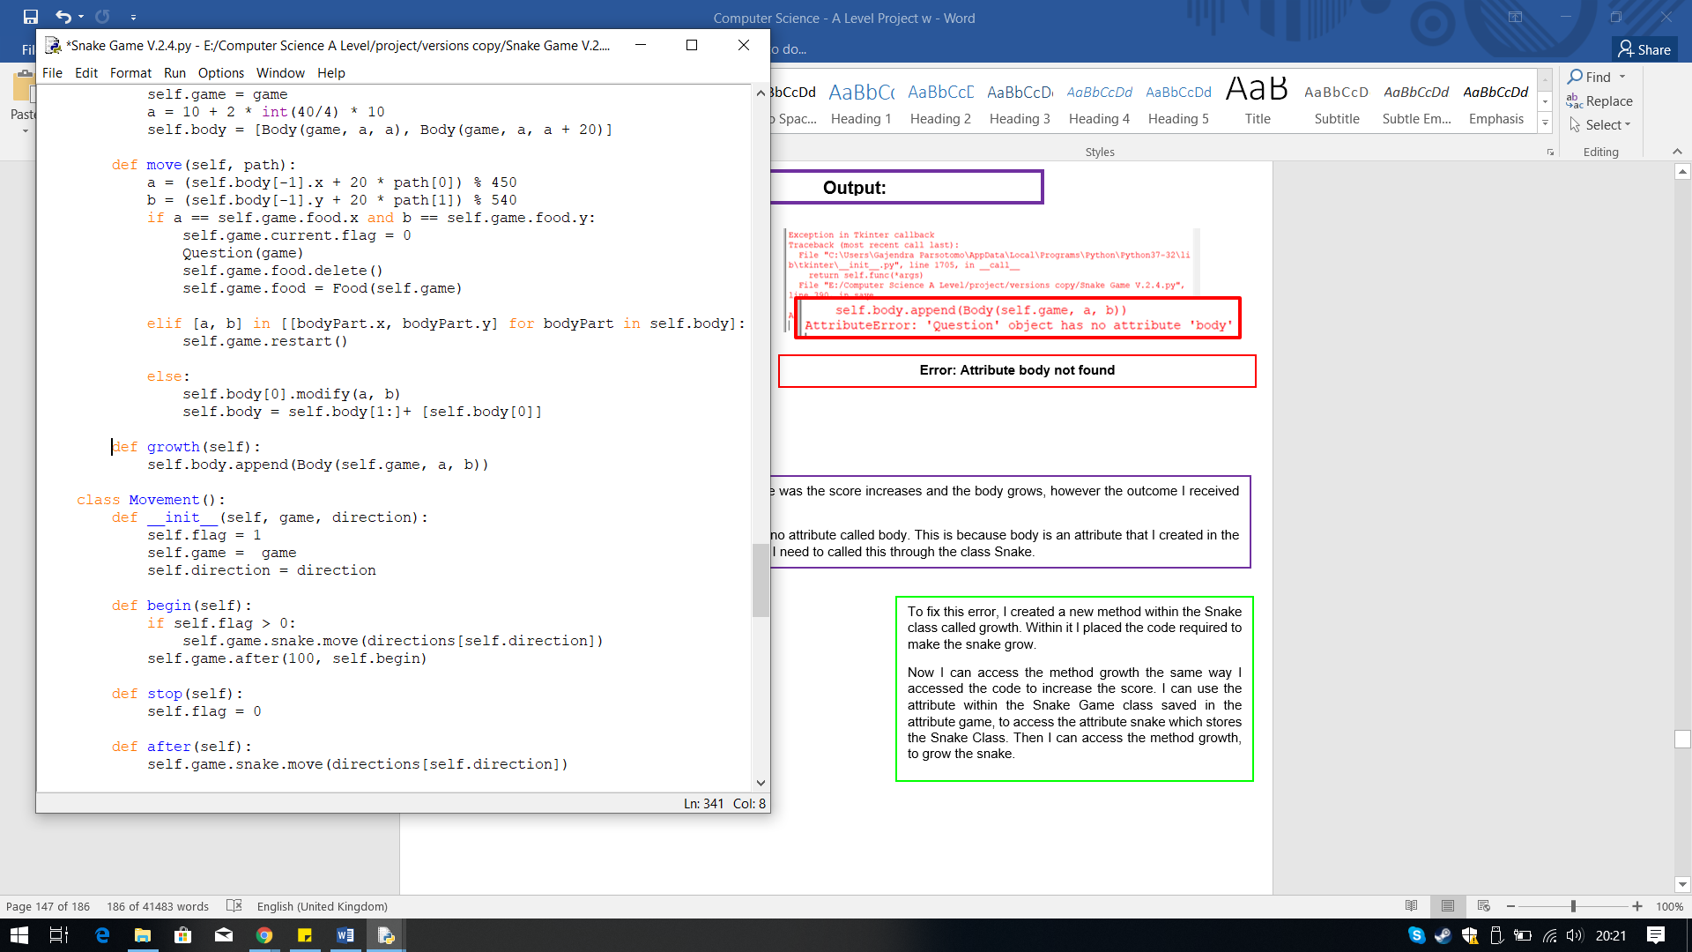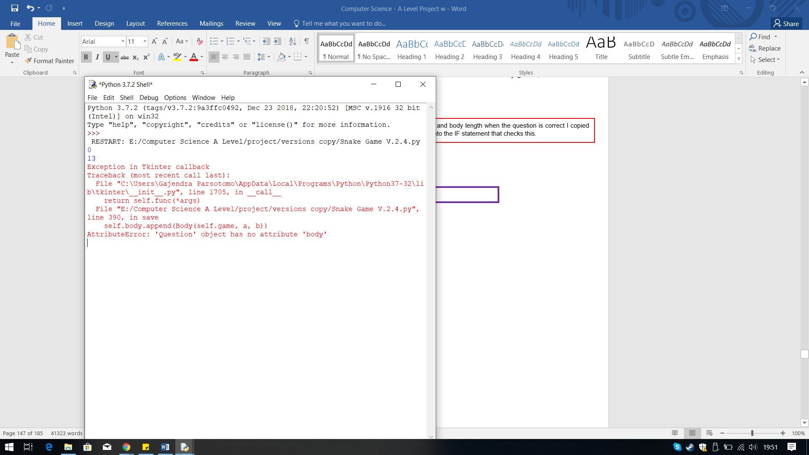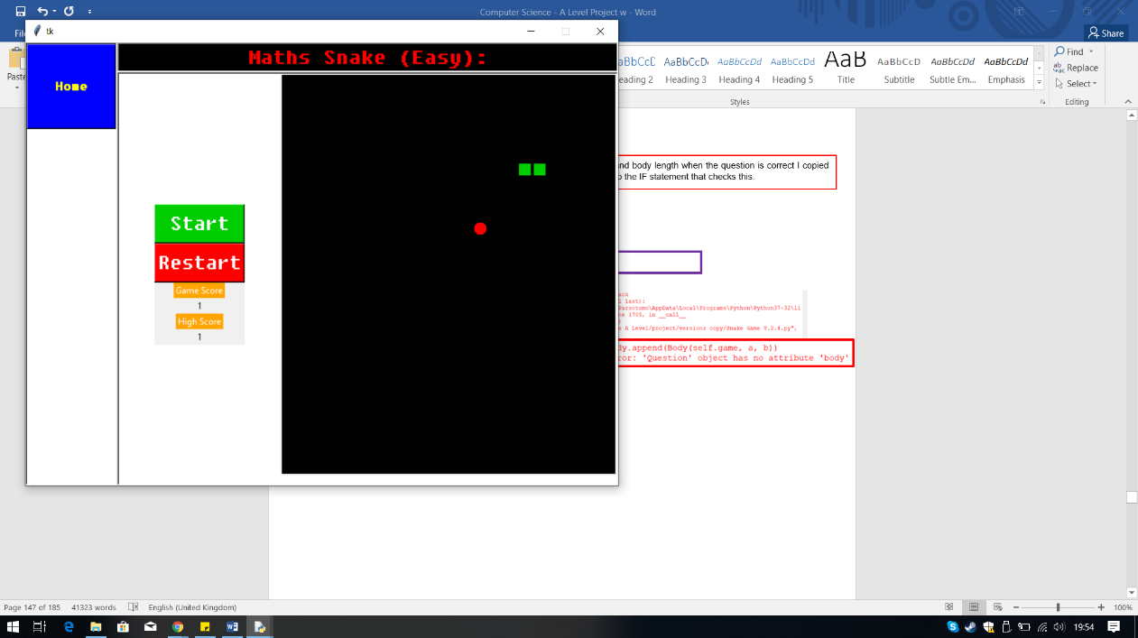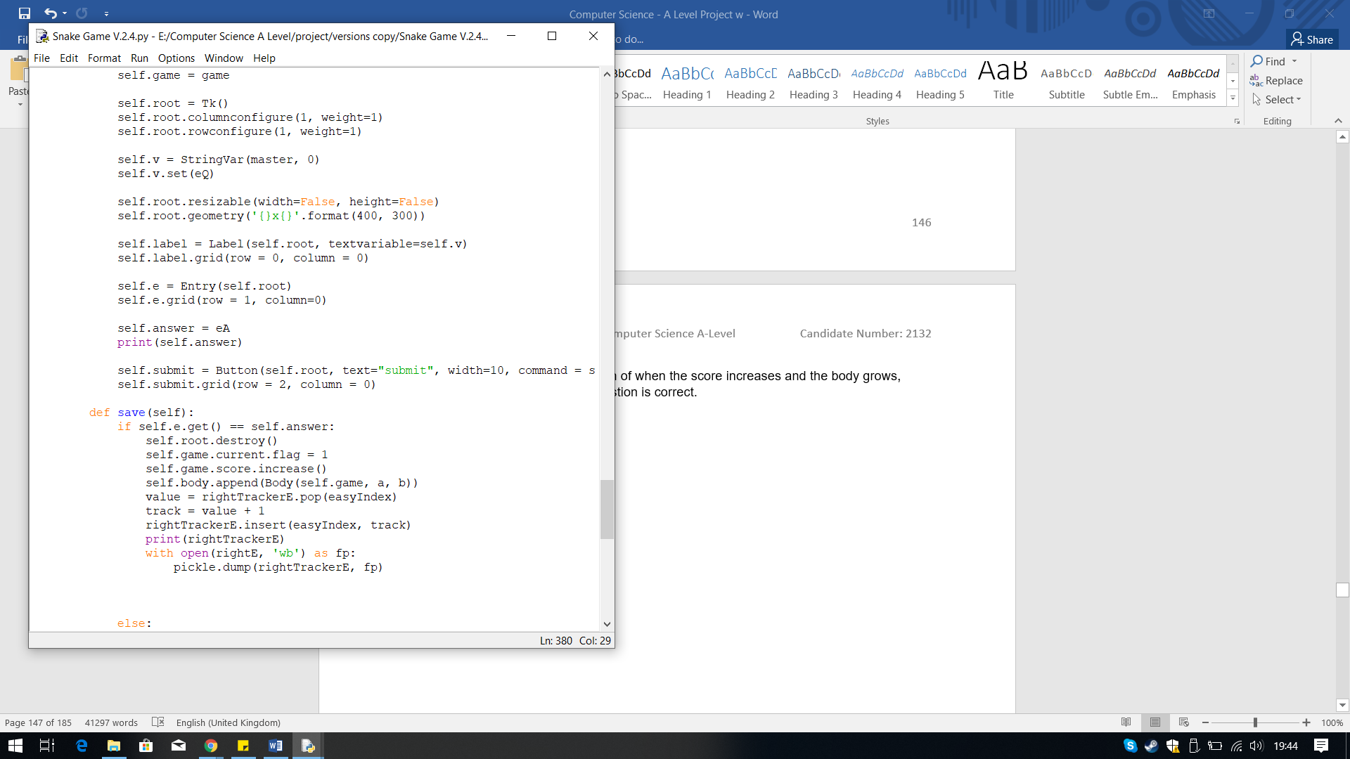

**Iterative Testing:**

**Test 11 No.2**

**Error: Attribute body not found**

When I answered the question, the expected outcome was the score increases and the body grows, however the outcome I received was the score increased but the body did not.

I received an error that states the class Question has no attribute called body. This is because body is an attribute that I created in the Snake class, which belongs there, therefore to fix this I need to called this through the class Snake.

To fix this error, I created a new method within the Snake class called growth. Within it I placed the code required to make the snake grow.

Now I can access the method growth the same way I accessed the code to increase the score. I can use the attribute within the Snake Game class saved in the attribute game, to access the attribute snake which stores the Snake Class. Then I can access the method growth, to grow the snake.

**Output:**

To increase the score and body length when the question is correct I copied and pasted the code into the IF statement that checks this.

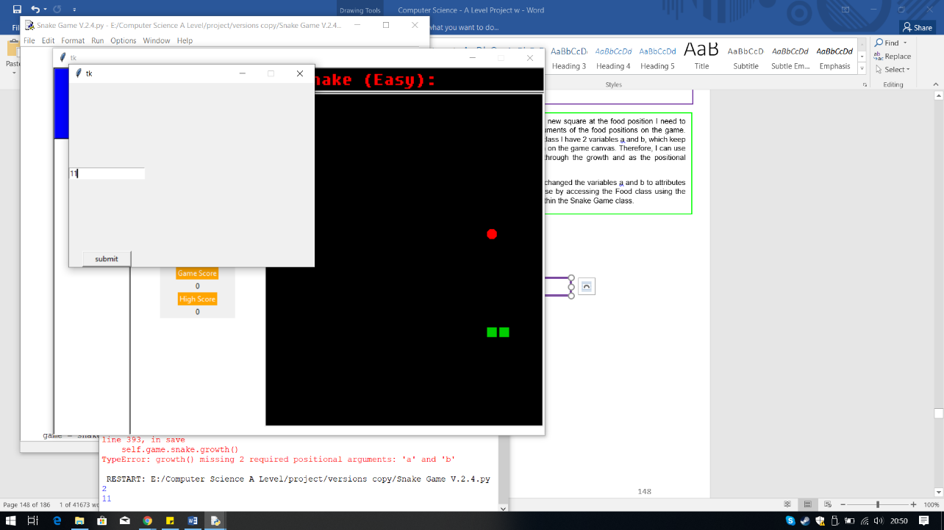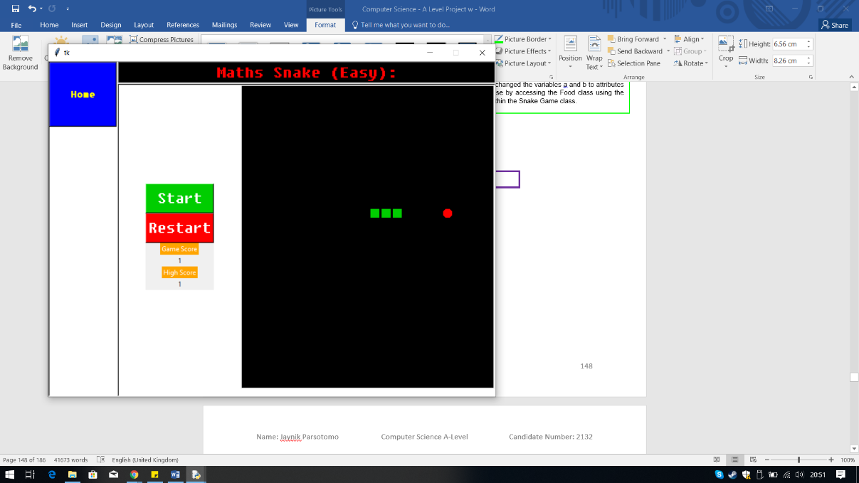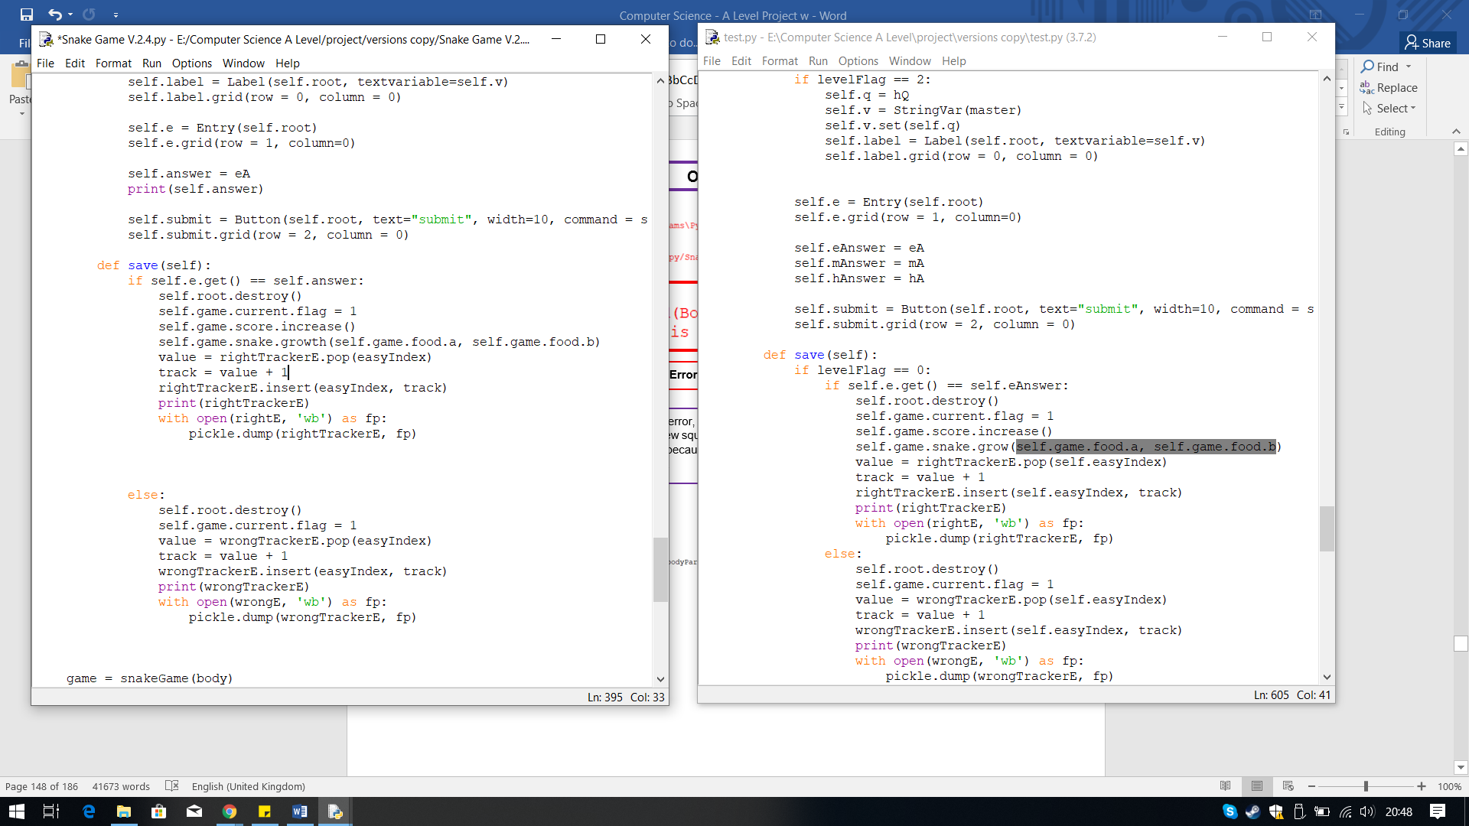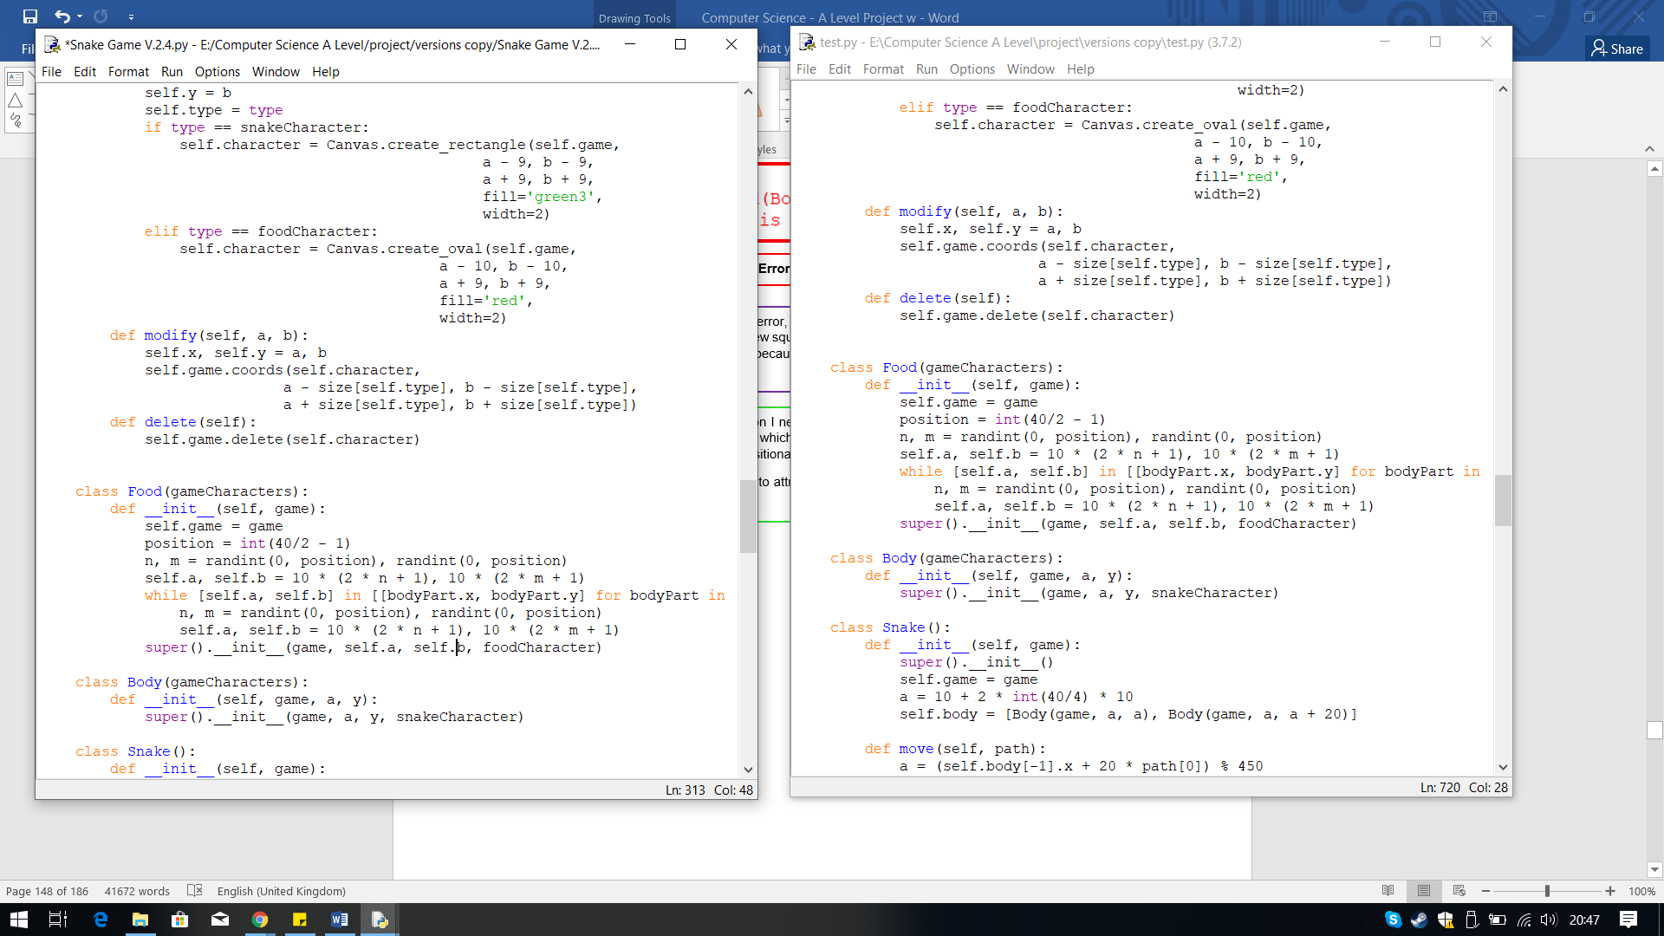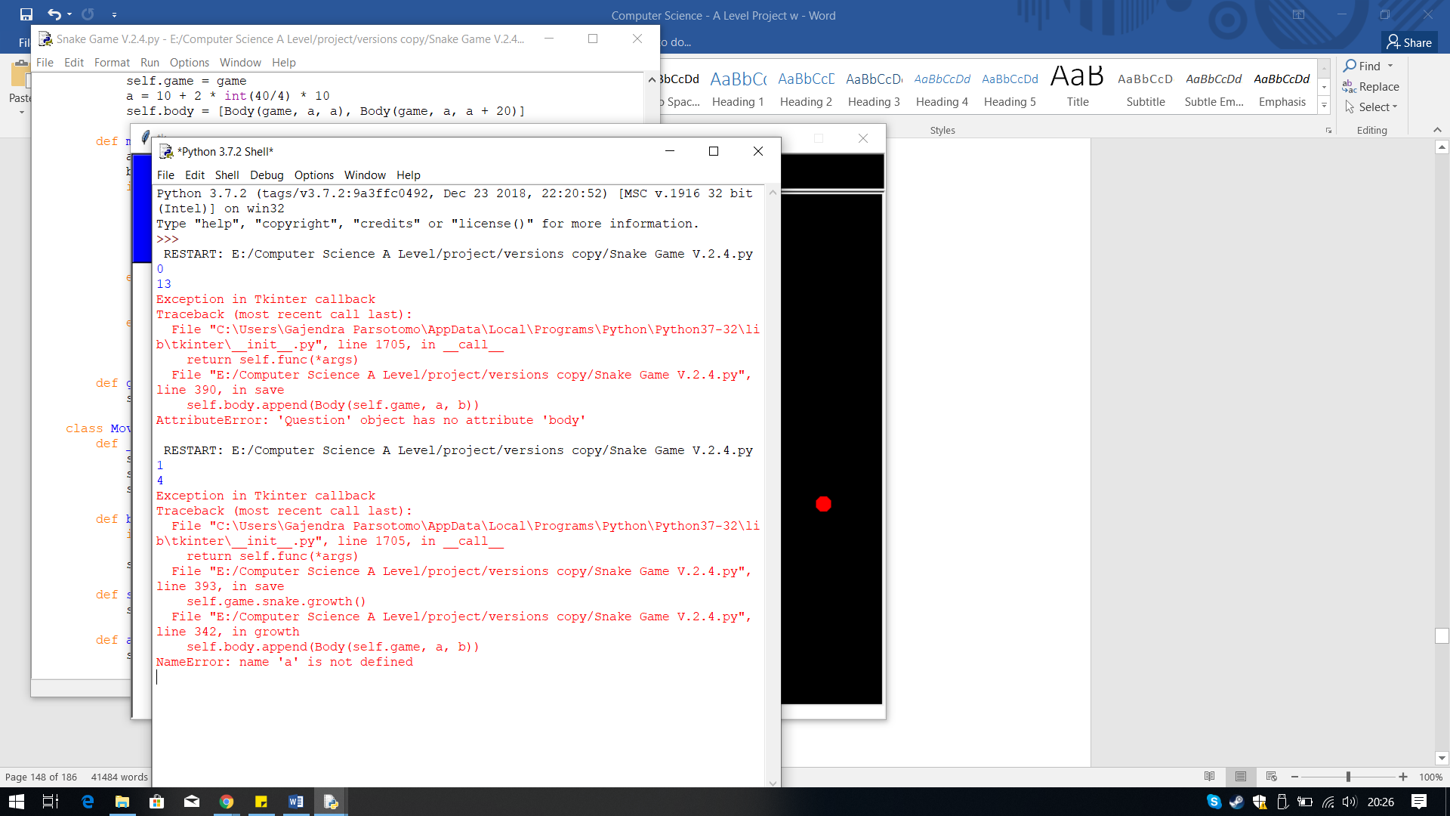

**Iterative Testing:**

**Test 12 No.1**

**Iterative Testing:**

**Test 11 No.3**

This time when the answered correctly the snake grew, fixing the error.

**Output:**

Therefore, to create the new square at the food position I need to pass the positional arguments of the food positions on the game. Luckily, within the food class I have 2 variables a and b, which keep track of the food positon on the game canvas. Therefore, I can use these and pass them through the growth and as the positional arguments.

Within the Food class I changed the variables a and b to attributes using self and pass these by accessing the Food class using the attribute food located within the Snake Game class.

.

When I answered the question this time I got a different error, saying a is not defined. The variables a and b define the head coordinates of the snake at where the food is, so when passed the new square is added at those positions and incremented to the body list. However, in the method growth a and b are not being identified because they do not exist within the method and class Question. They are not variables or attributes being defined in the class Snake.

.

**Error: ‘a’ not defined**

**Output:**

## **Questions for the other Difficulty Levels**

In version 2.5 I have created a way to determine which difficulty level the user has selected, thus allowing the correct questions to be chosen.

I now needed a way for the class to recognise which difficulty level has been selected. To do this I have decided to use a flag. This flag will be placed within each difficulty level function but with a different value, as shown in the screenshot.

I have called the variable levelFlag, because it will be used to define which level it is. The levelFlag will be set at a value zero, and then I will change the value of the flag in each function, to 0, 1, 2 for easy, medium and hard respectively.

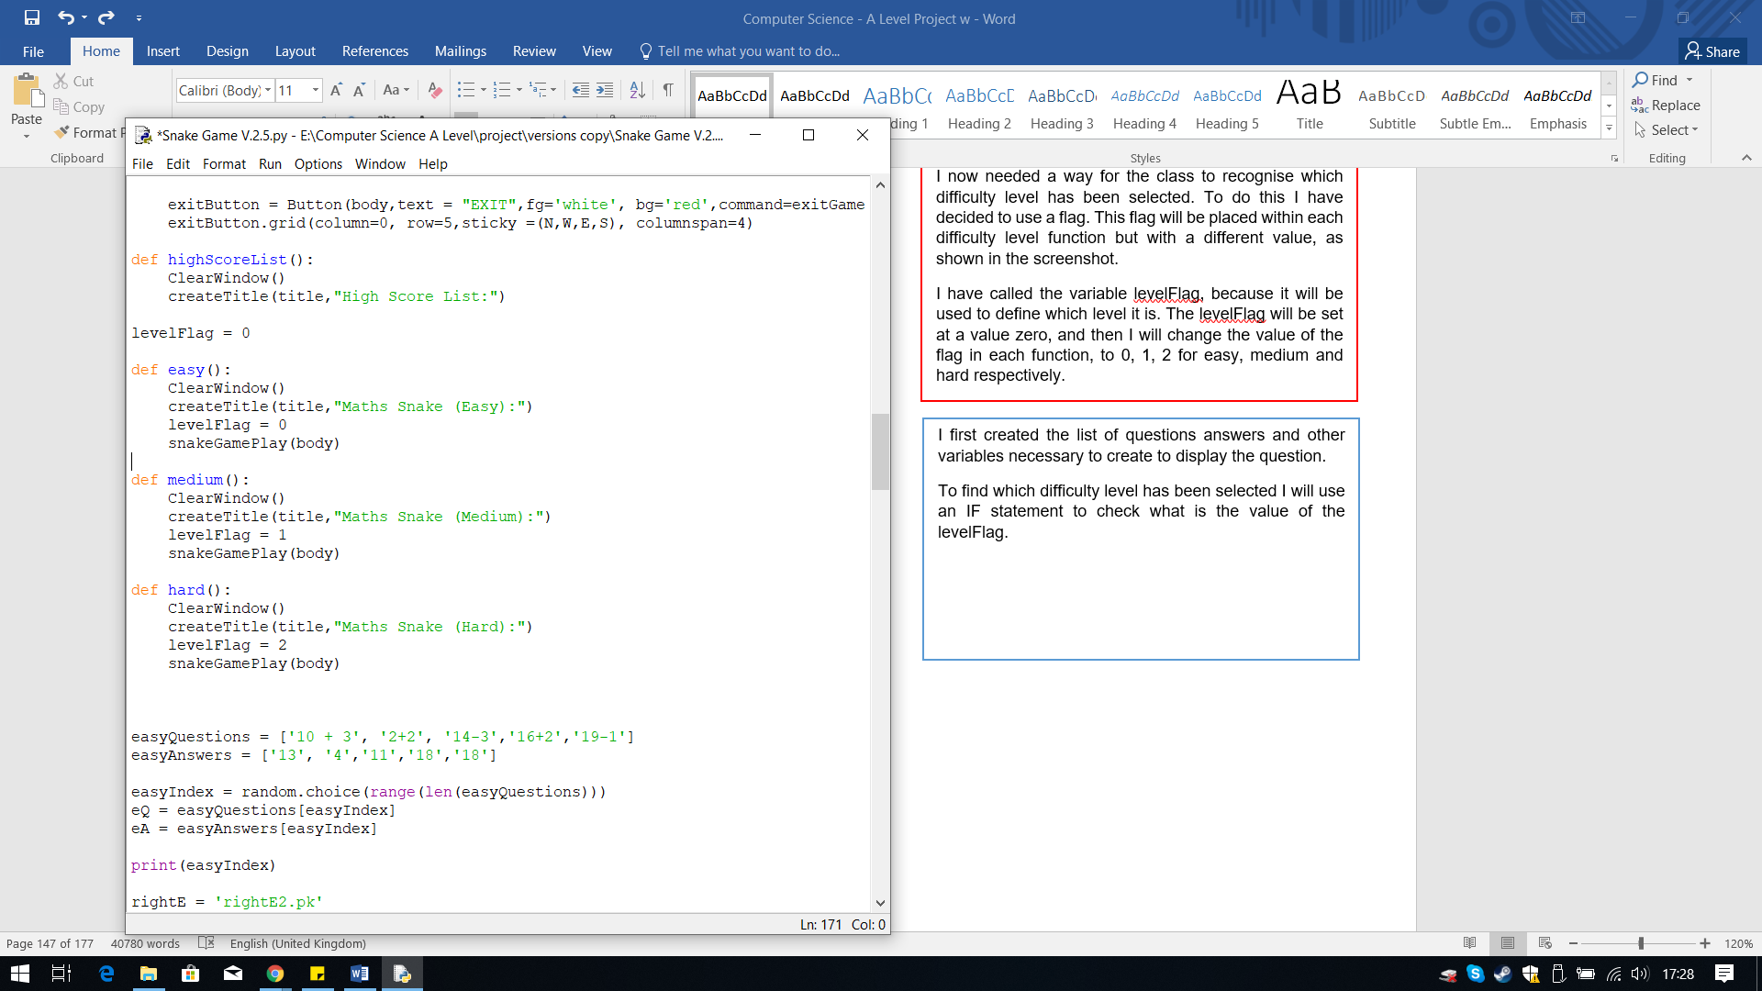

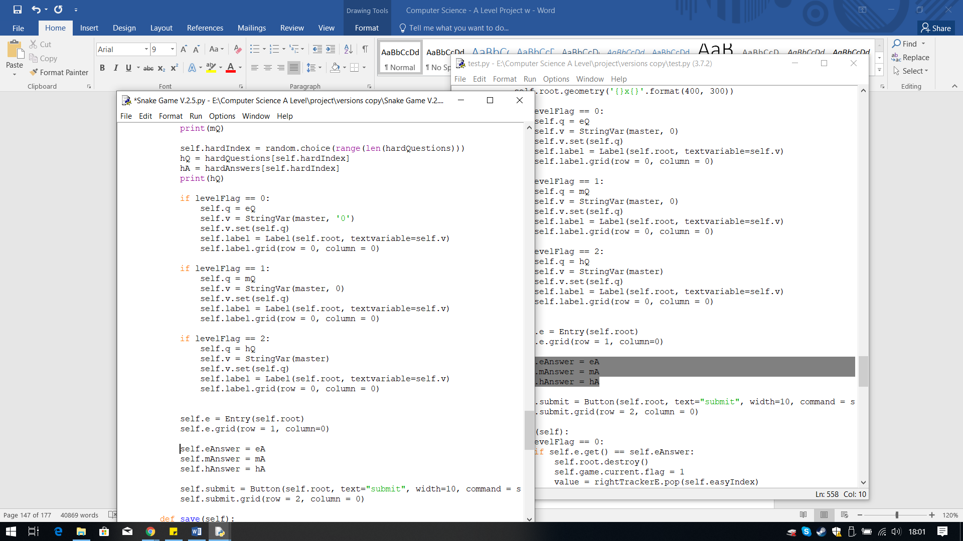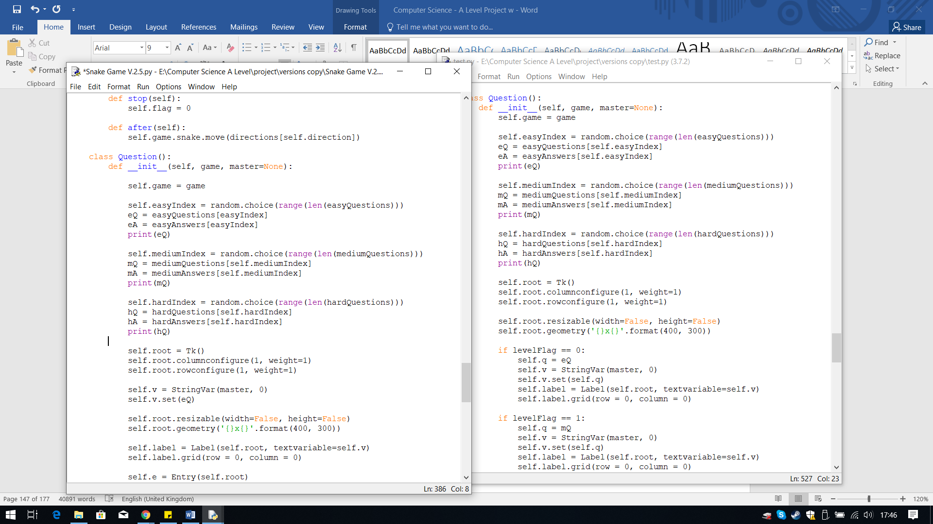

To find which difficulty level has been selected, and which question needs to be displayed. I used an IF statement to check what the value of the levelFlag.

Then within each IF statement I have created the label for the question to be displayed within the tkinter window pop-up.

Outside the IF statement I have created the attributes that will store the answer to the question selected.

When I was running the code to test the Question class with the game classes I realised that there was a logical error. The logical error is the same question is chosen. The reason for this error is the when selecting the random index, the variable which stores this is global, therefore it is only ran once. So when it is used it will use the same index over and over again, resulting in the same question being chosen.

To fix this error I simply need to make the variables local, therefore I placed them within the Question() class. I made the index for the questions an attribute so I can reuse it in the methods.

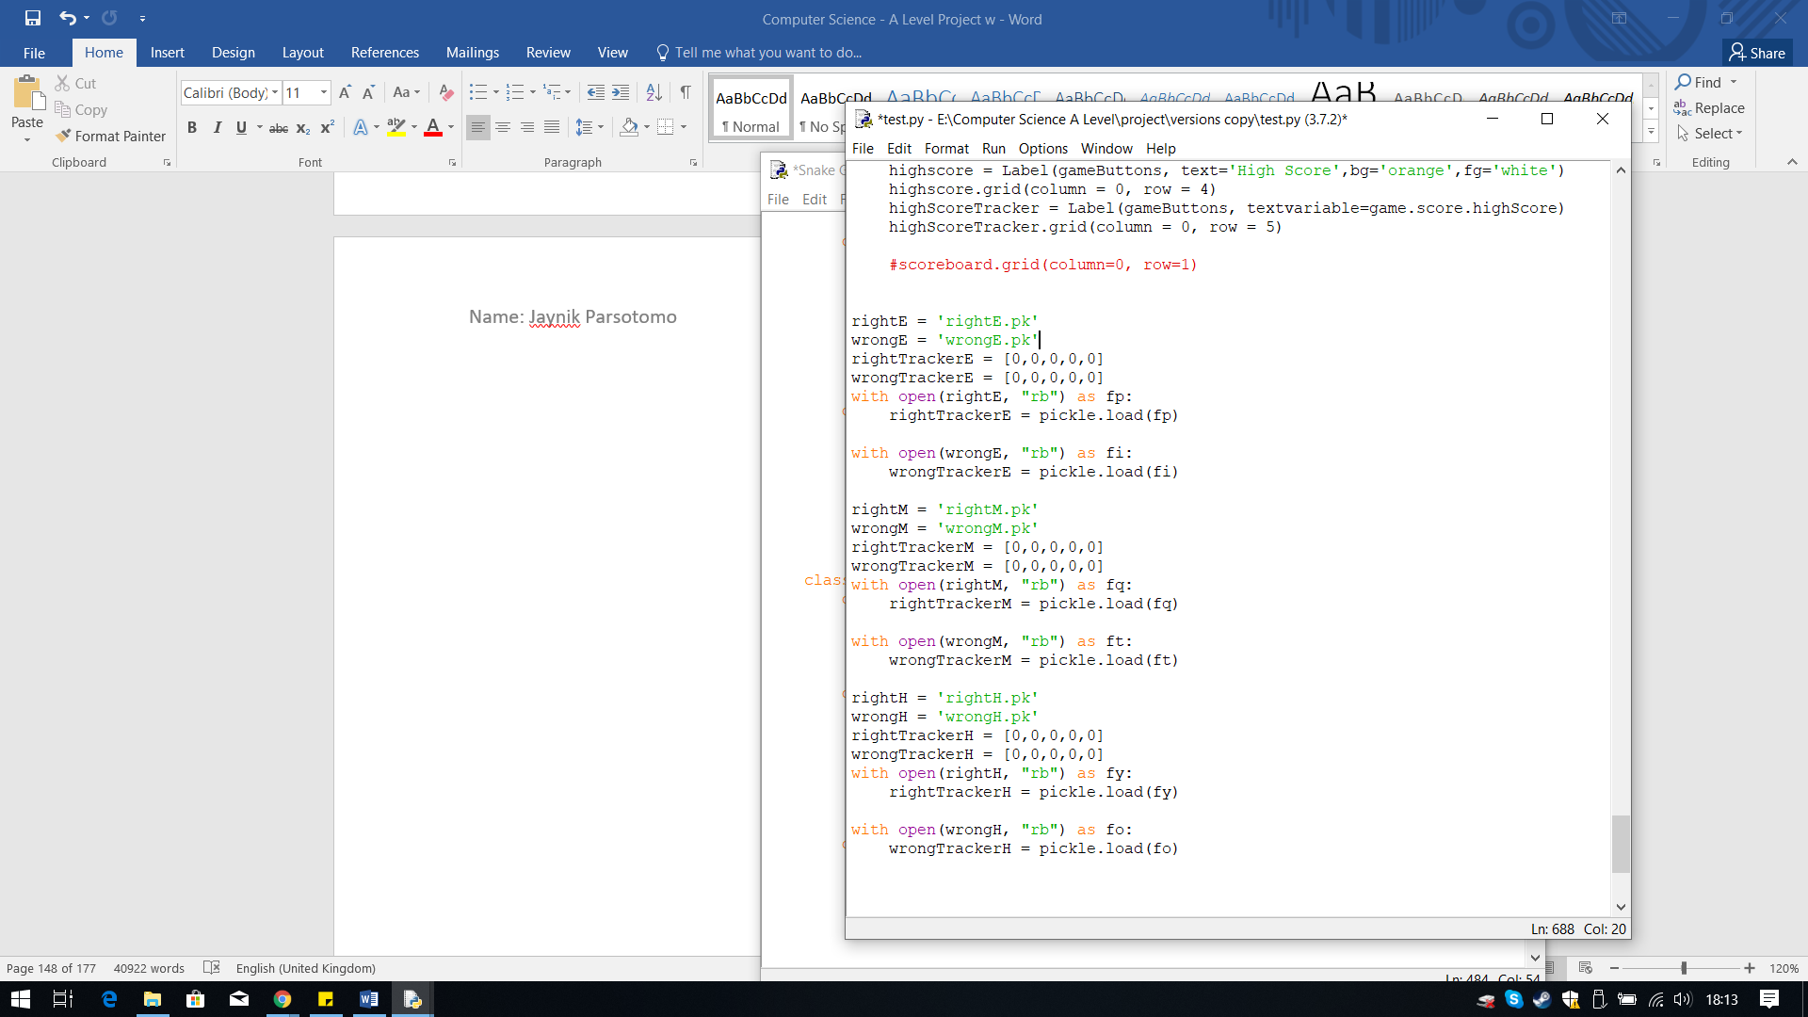

The final step I needed to do was to check if the answer is correct, and make sure it checks the correct answer and updates the correct tracker, for the selected level. To do this I used the IF statements again, to check the value of the levelFlag.

Within each IF statement I have reused the code from before which uses an If and else statement to check if it is right or wrong. The only thing I have changed are the variables and attributes needed to update the correct tracker.

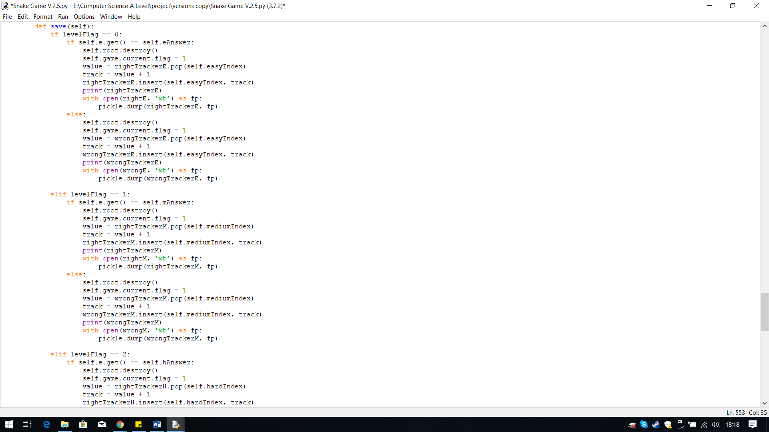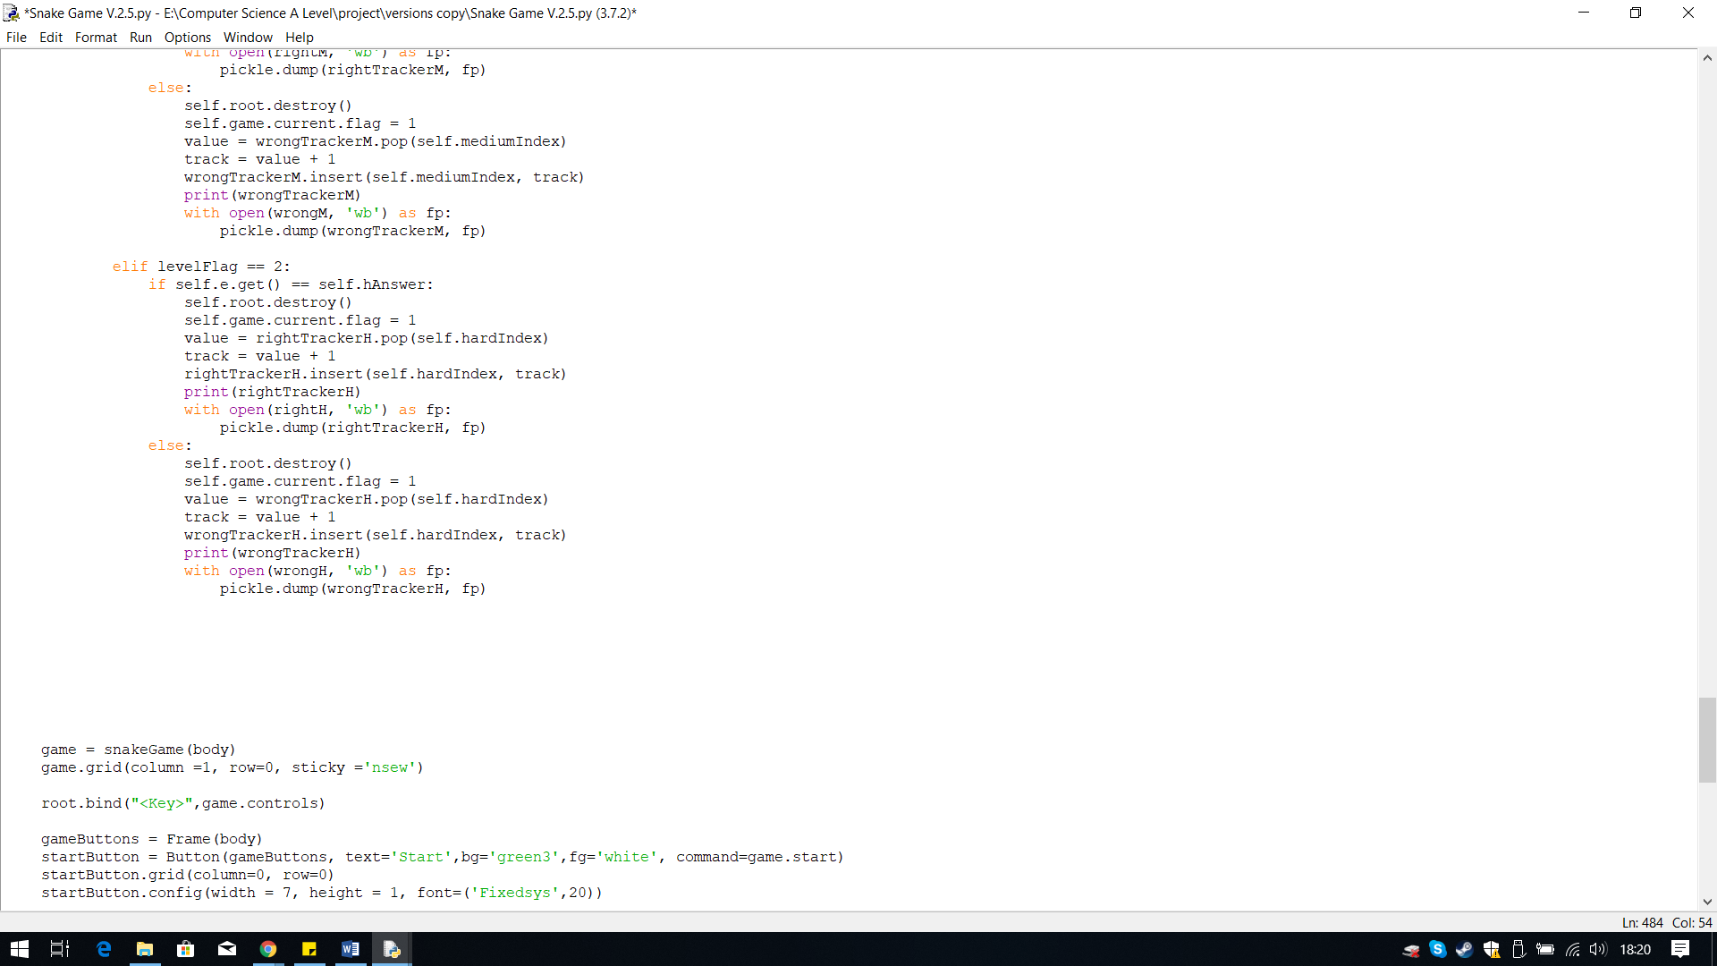

Before I can check if the user’s answer is correct, I first needed to define the tracker lists for each level and create a pickle file for each one.

I have created these outside the classes and function so they are global, since other functions will use them, like the Progress Tracker.

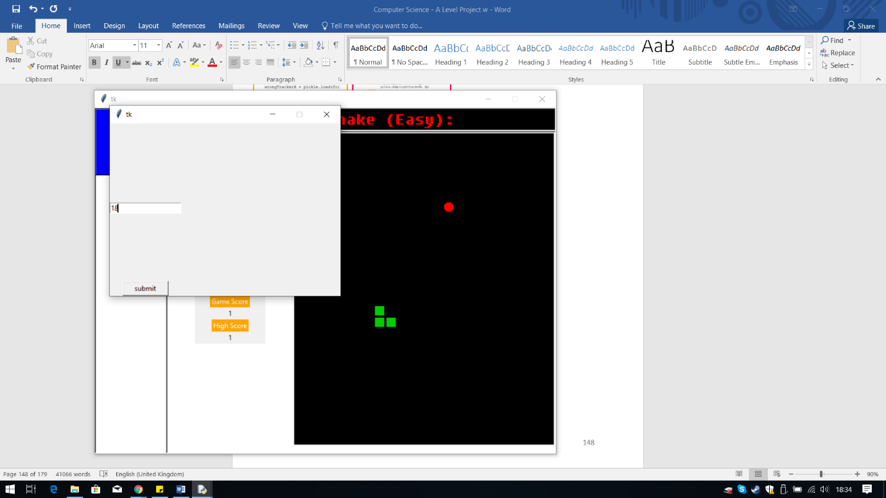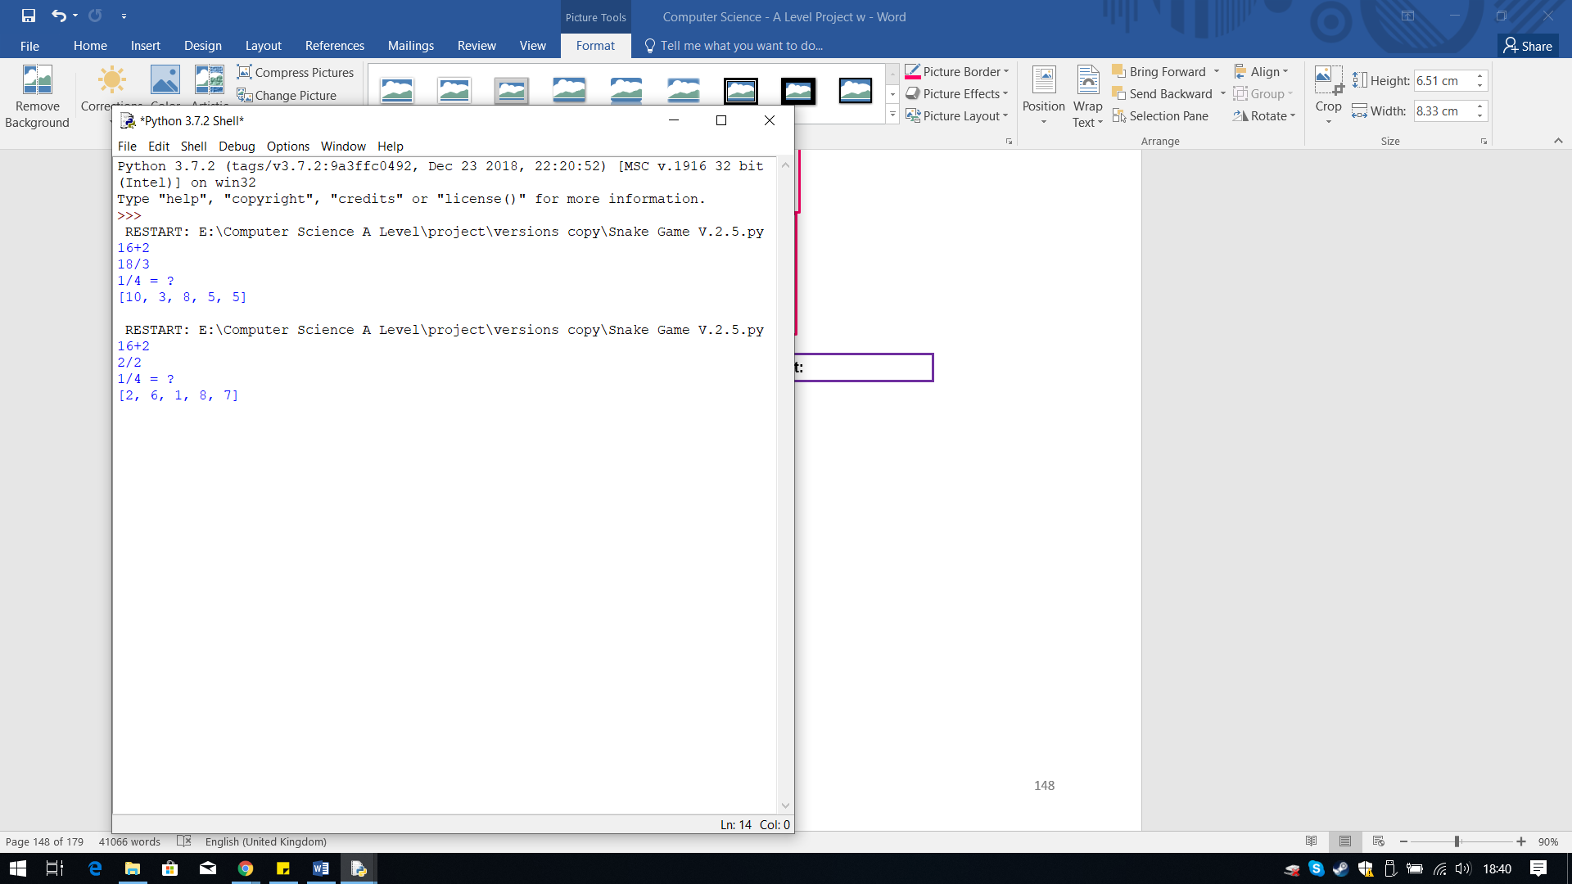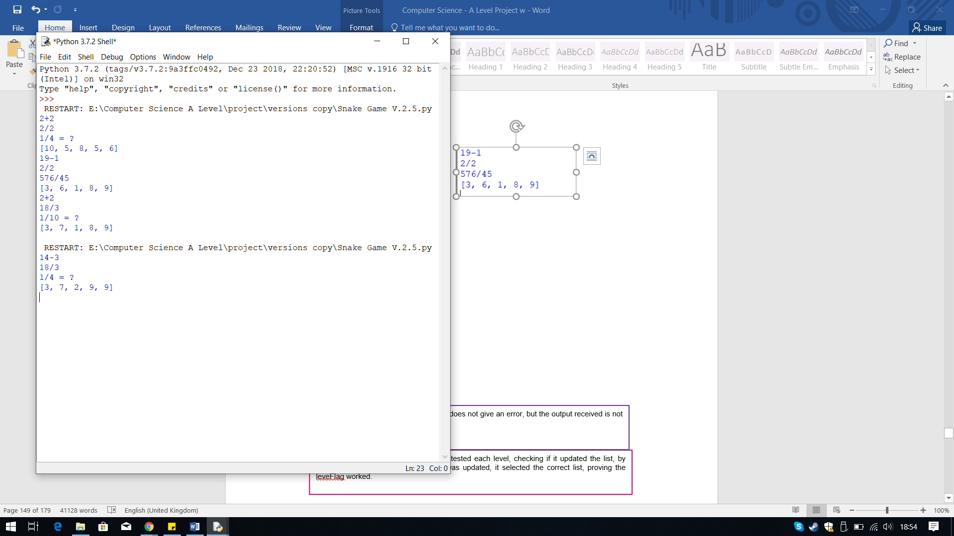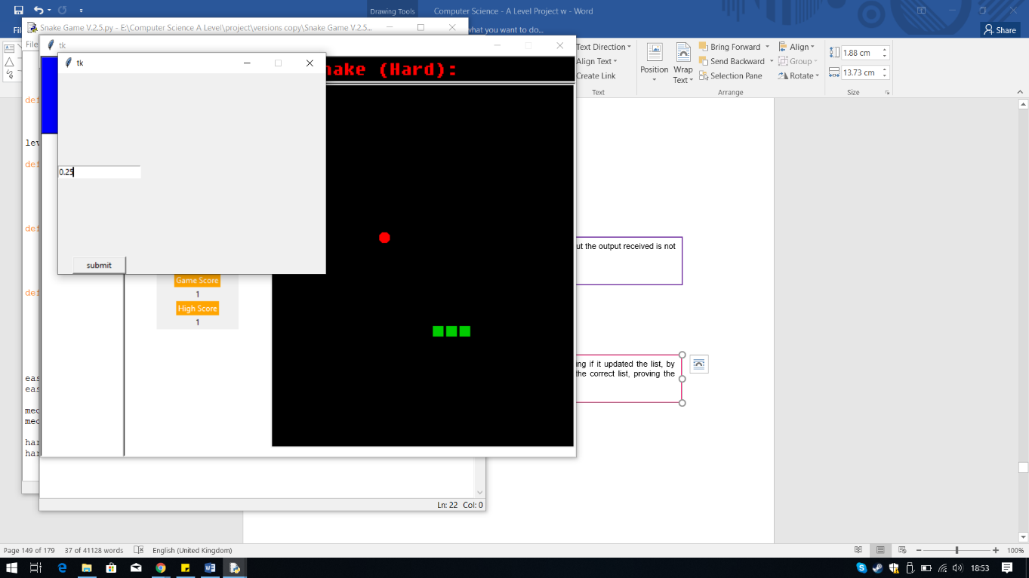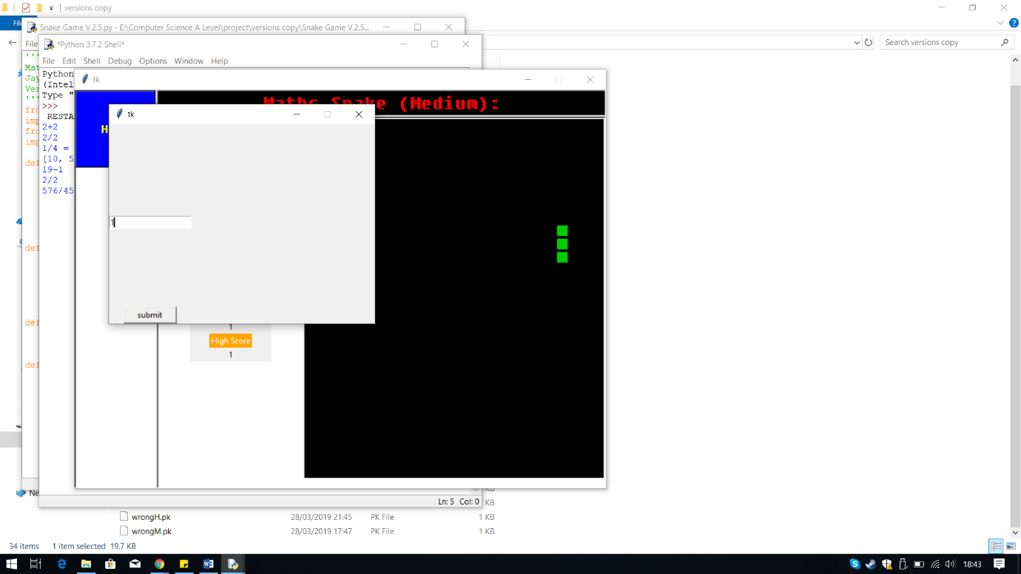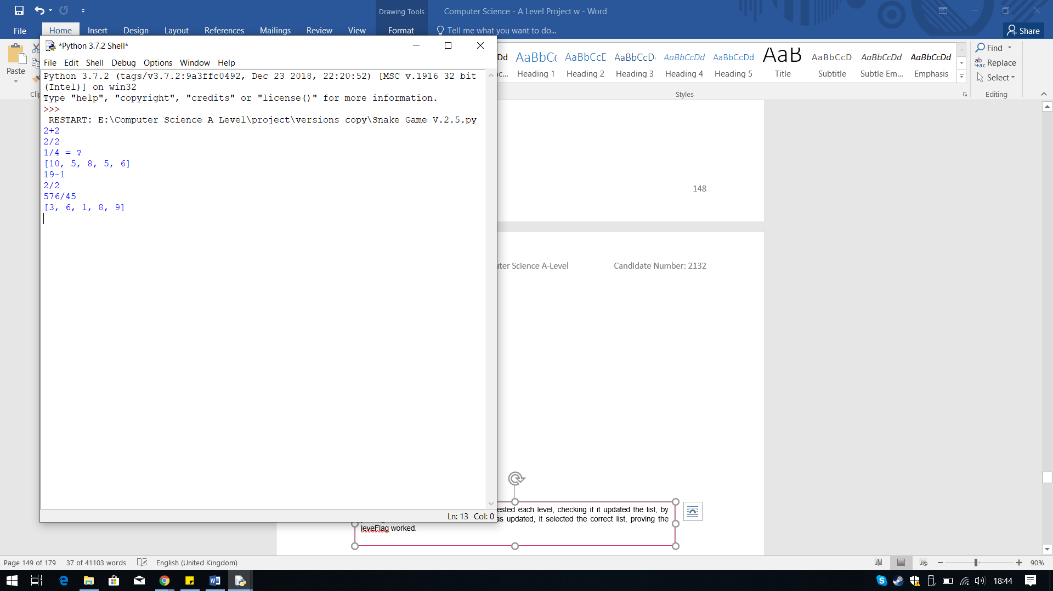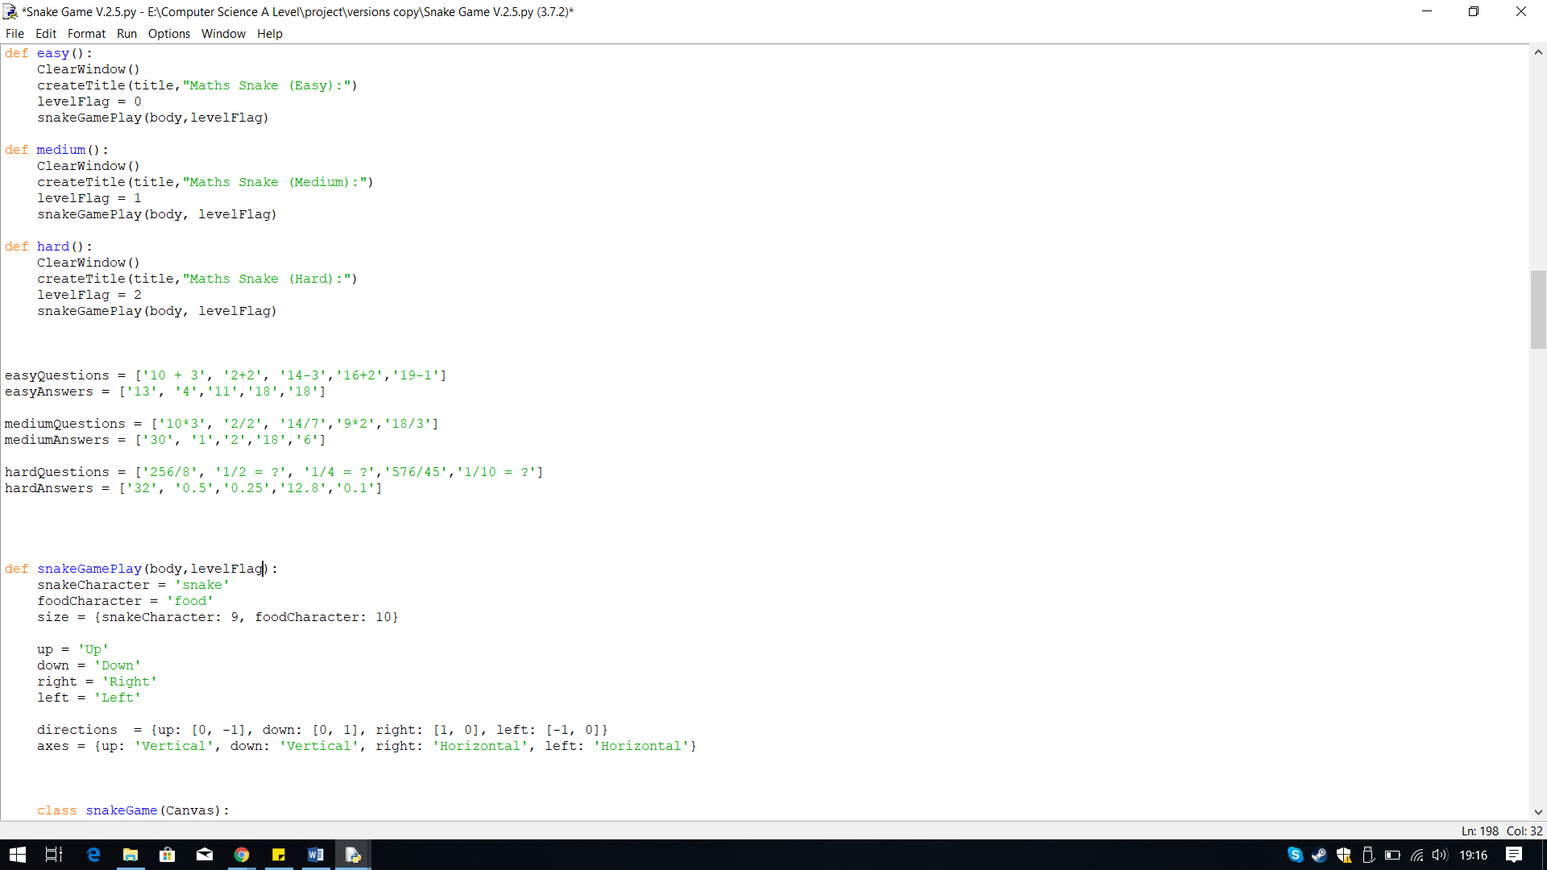

**Output:**

**Iterative Testing:**

**Test 12, No.2**

I have passed levelFlag as a parameter in the function for the game itself and where I am calling the game function as well.

The solution to this problem is I simply need to get the program to use the local levelFlag, therefore I need to pass levelFlag as a parameter through the game function, when I am calling it.

When ran, I got a logical error. The code does not give an error, but the output received is not what I wanted. The error was that the incorrect tracker is getting updated, for the medium and hard level, the wrong tracker for easy is the one getting updated.

The reason I believe this is happening is because the function cannot recognise the change in value for the levelFlag. The function currently is using the default value of the global variable levelFlag, not the local variable within the Difficulty Level functions

**Logical Error: Incorrect tracker getting updated**

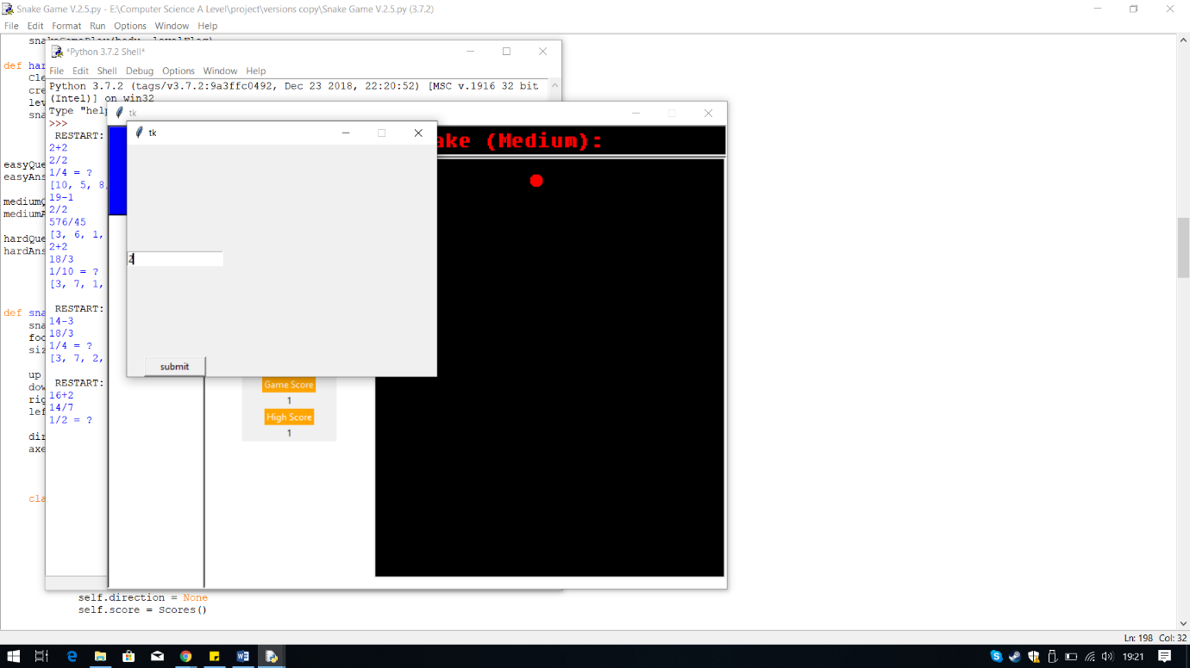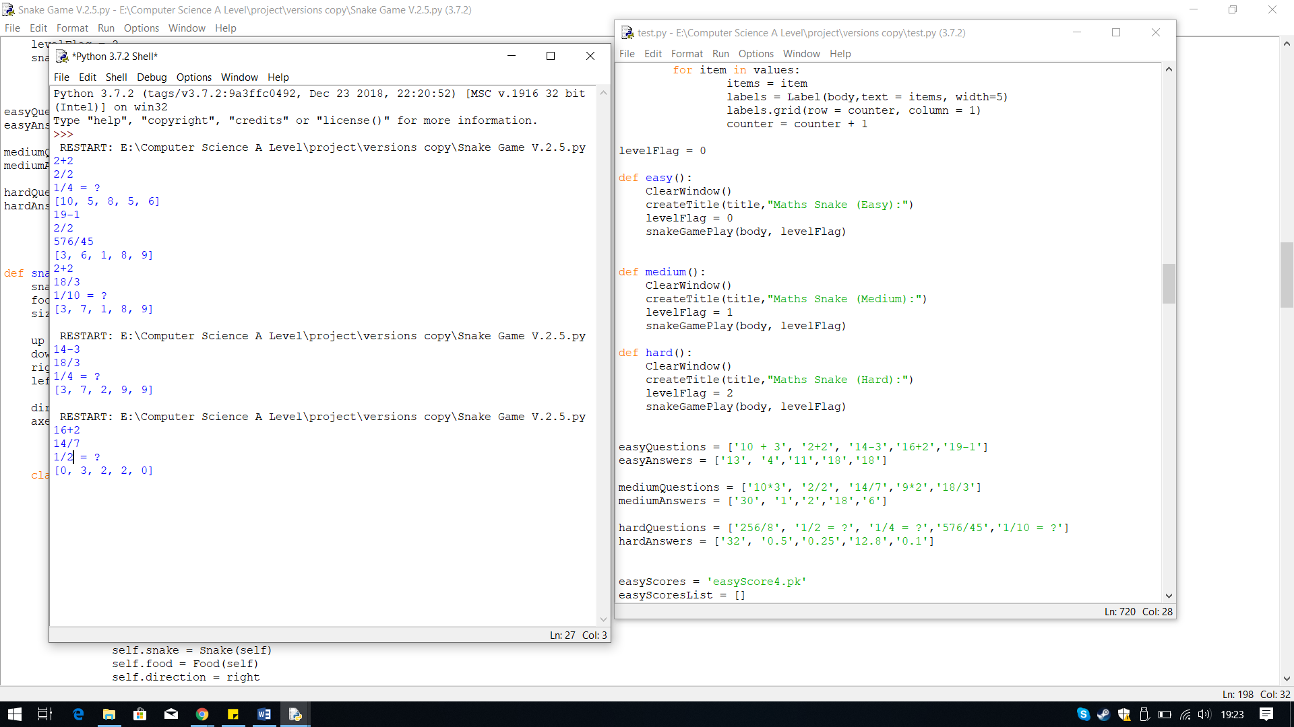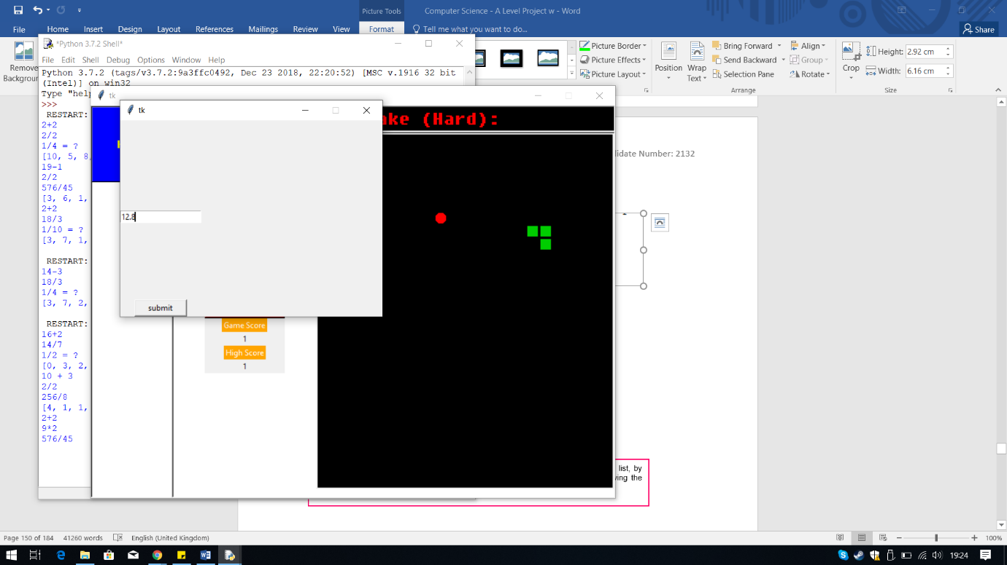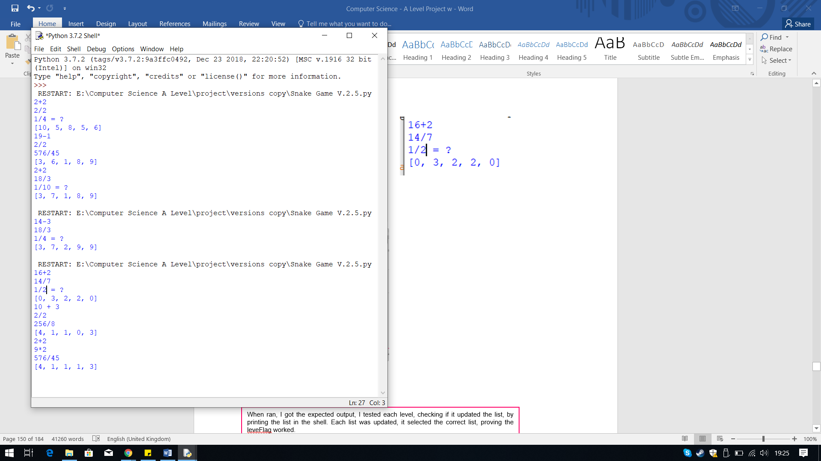

When ran, I got the expected output, I tested medium and hard level, checking if it updated the correct list this time. The result I got was the correct list being updated, since both list where different, proving the levelFlag works, and solving the problem.

**Output:**

## **Score Lists**

In Version 2.6, I have designed the score list for each level that will store scores the user attains during the game.

Within the Scores() class, in the method reset(), I implemented the code which adds the final game score to the appropriate list. I placed it within reset because I used this method to reset the score when the game ends therefore it is the most appropriate place for the code to store the final score.

To do this I used the levelFlag with an IF statement, like I did within the Question() class. Within each statement, I have first put a line of code which adds the final game score to the appropriate list. I did this by using the list method, append(), which adds the value to the end of the list. Then I have passed the parameter counter which is an attribute that stores the current game score as a integer. Therefore, the current score, meaning the end score, is added to the list.

The next line is exactly the same code which I used in the Question() class that is used to save the data so it can be used again. The only difference is I have changed the variables so the appropriate list is saved to the appropriate pickle file.

For the score list, I first needed to create a pickle file, like I did for the trackers. This is because I need to keep the save data when I am adding the score, after each game. Then create a list where I will be adding the game score.

I stored the pickle files for each score list within a variable with a naming convention which contains the level difficulty followed by ‘Scores’.

Then I created a list for each level score list, using square brackets.

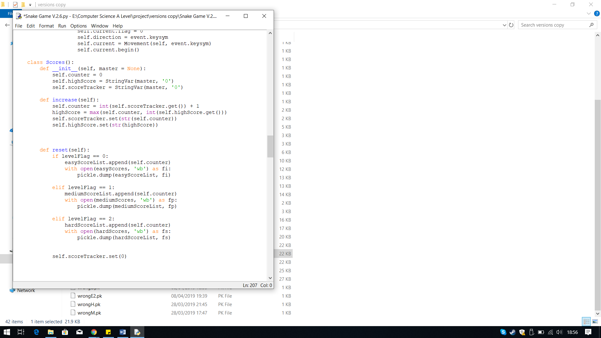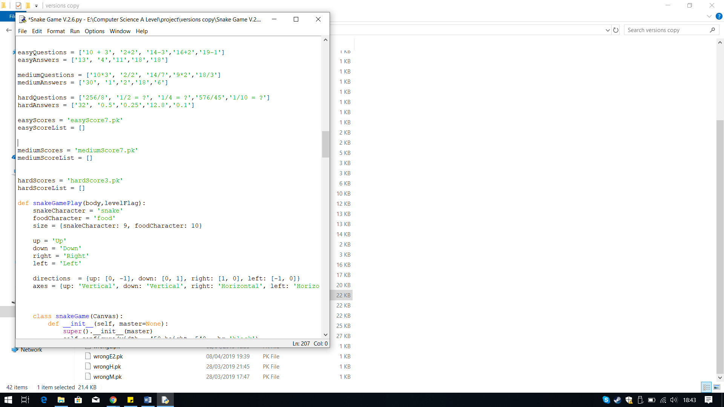

**Output:**

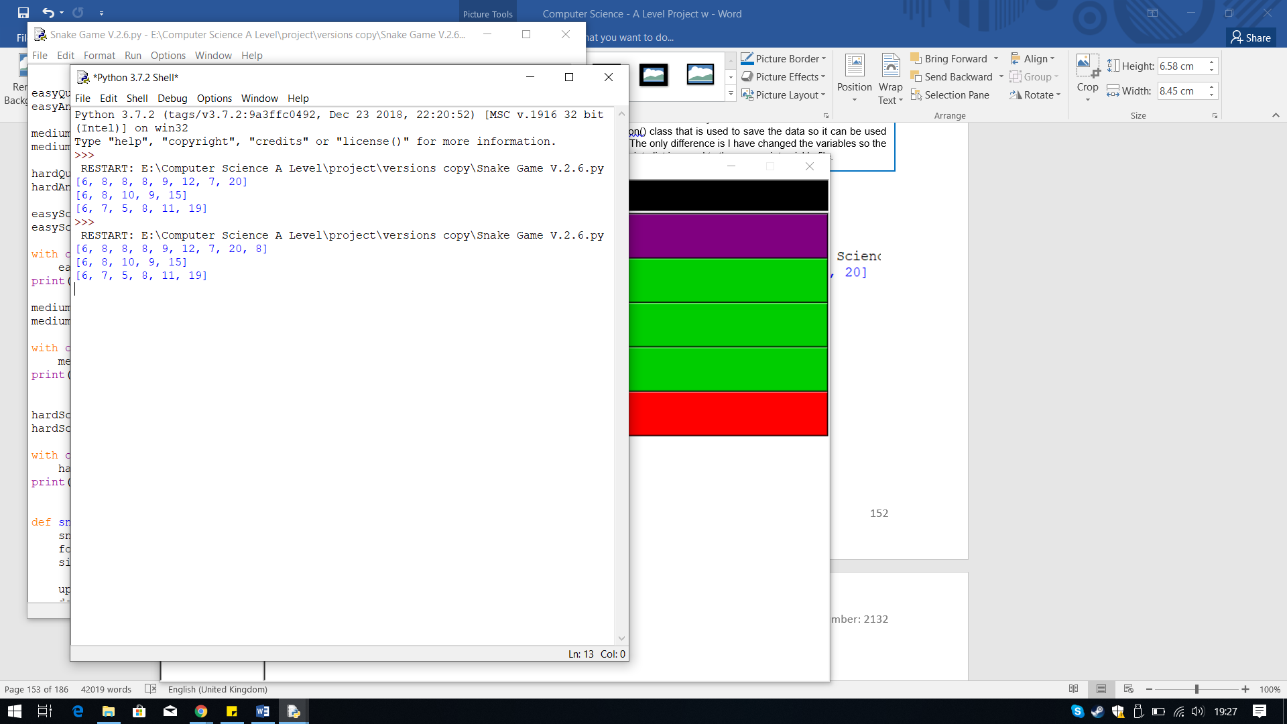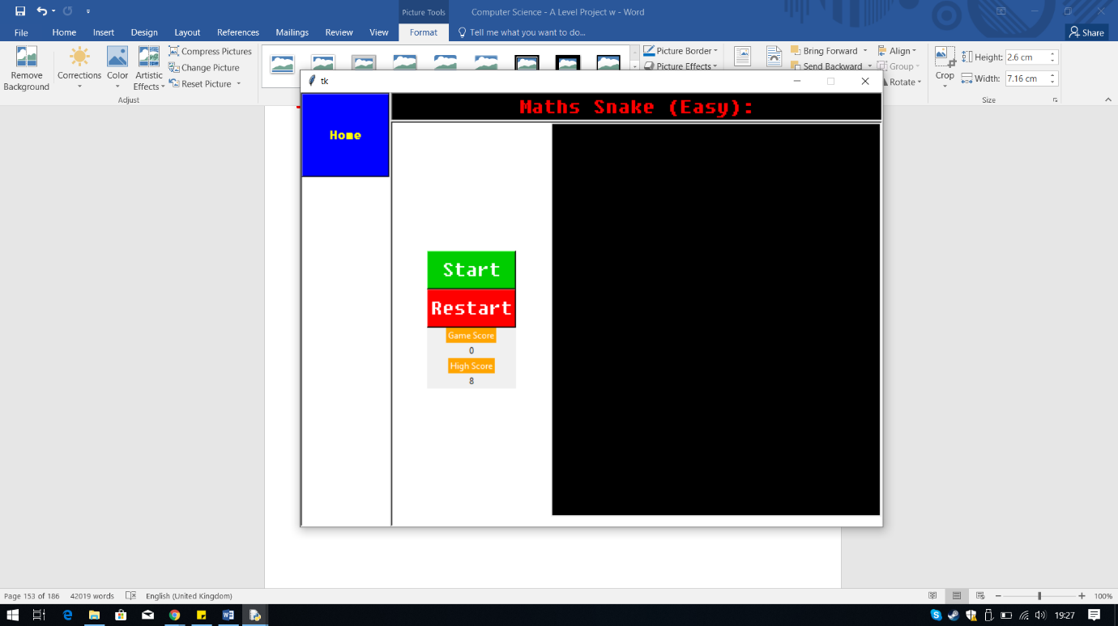

**Iterative Testing:**

**Test 13 No.1**

Before I ran the code I added some code to output the list in the Python shell to see if it works. I first played the game to get a score of eight, so then the code should append this to the list, adding it in the last position. The first list is for the easy level scores and the recent game score was added at the end.

## **Highest Score**

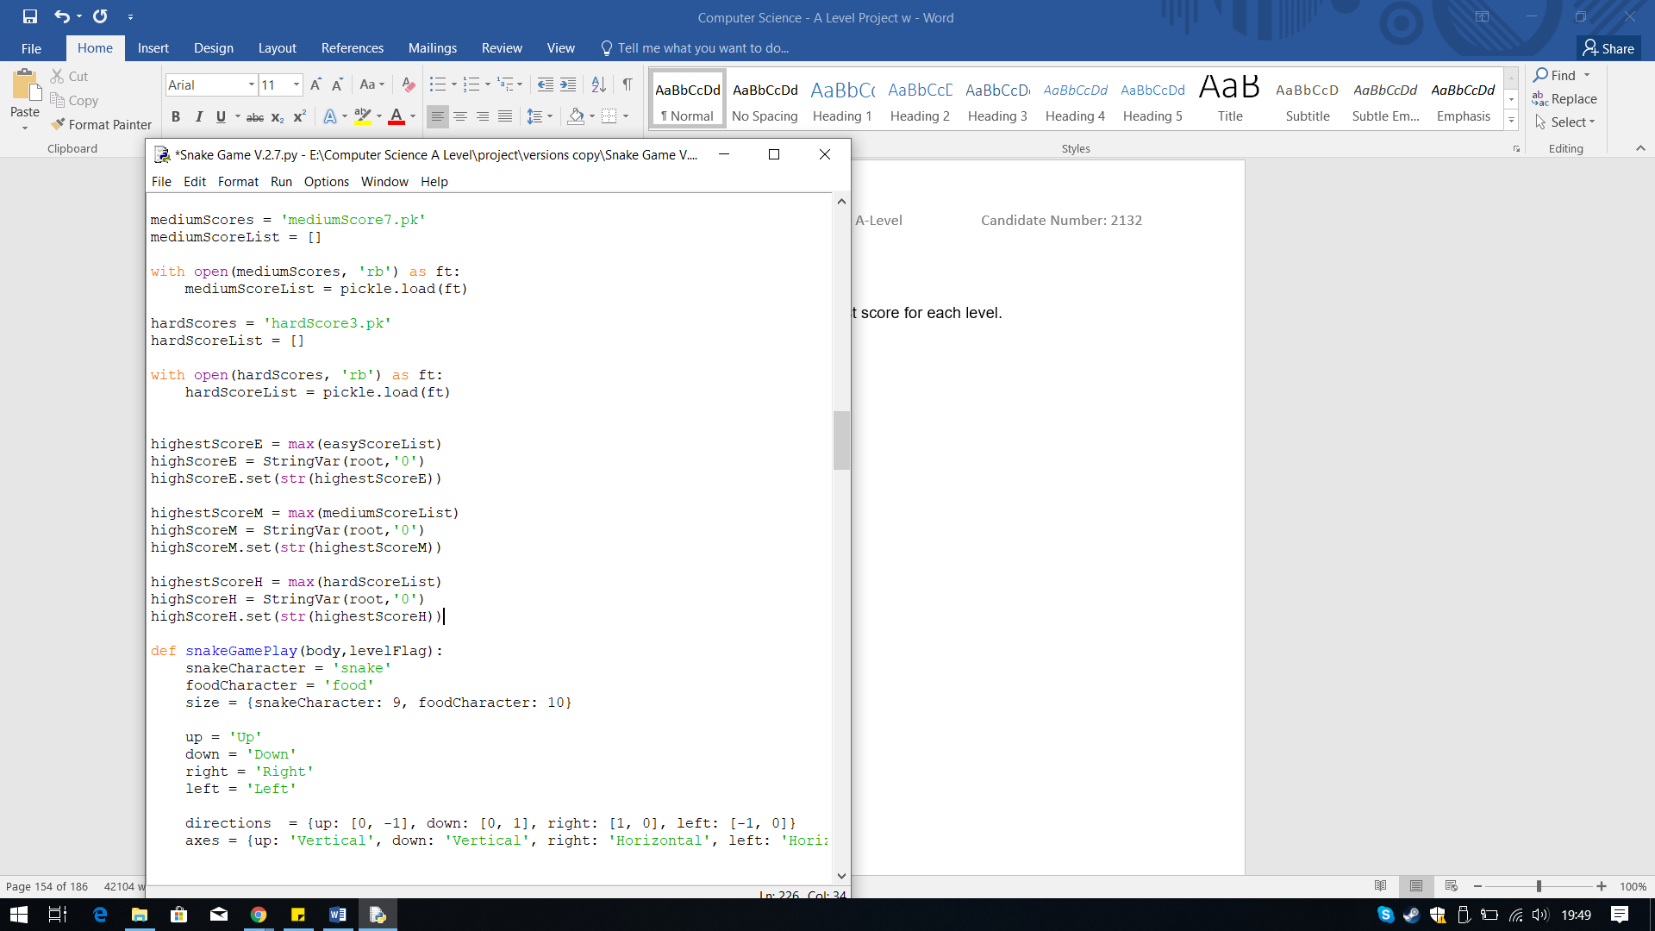In Version 2.7 I created a way to display the highest score for each level.

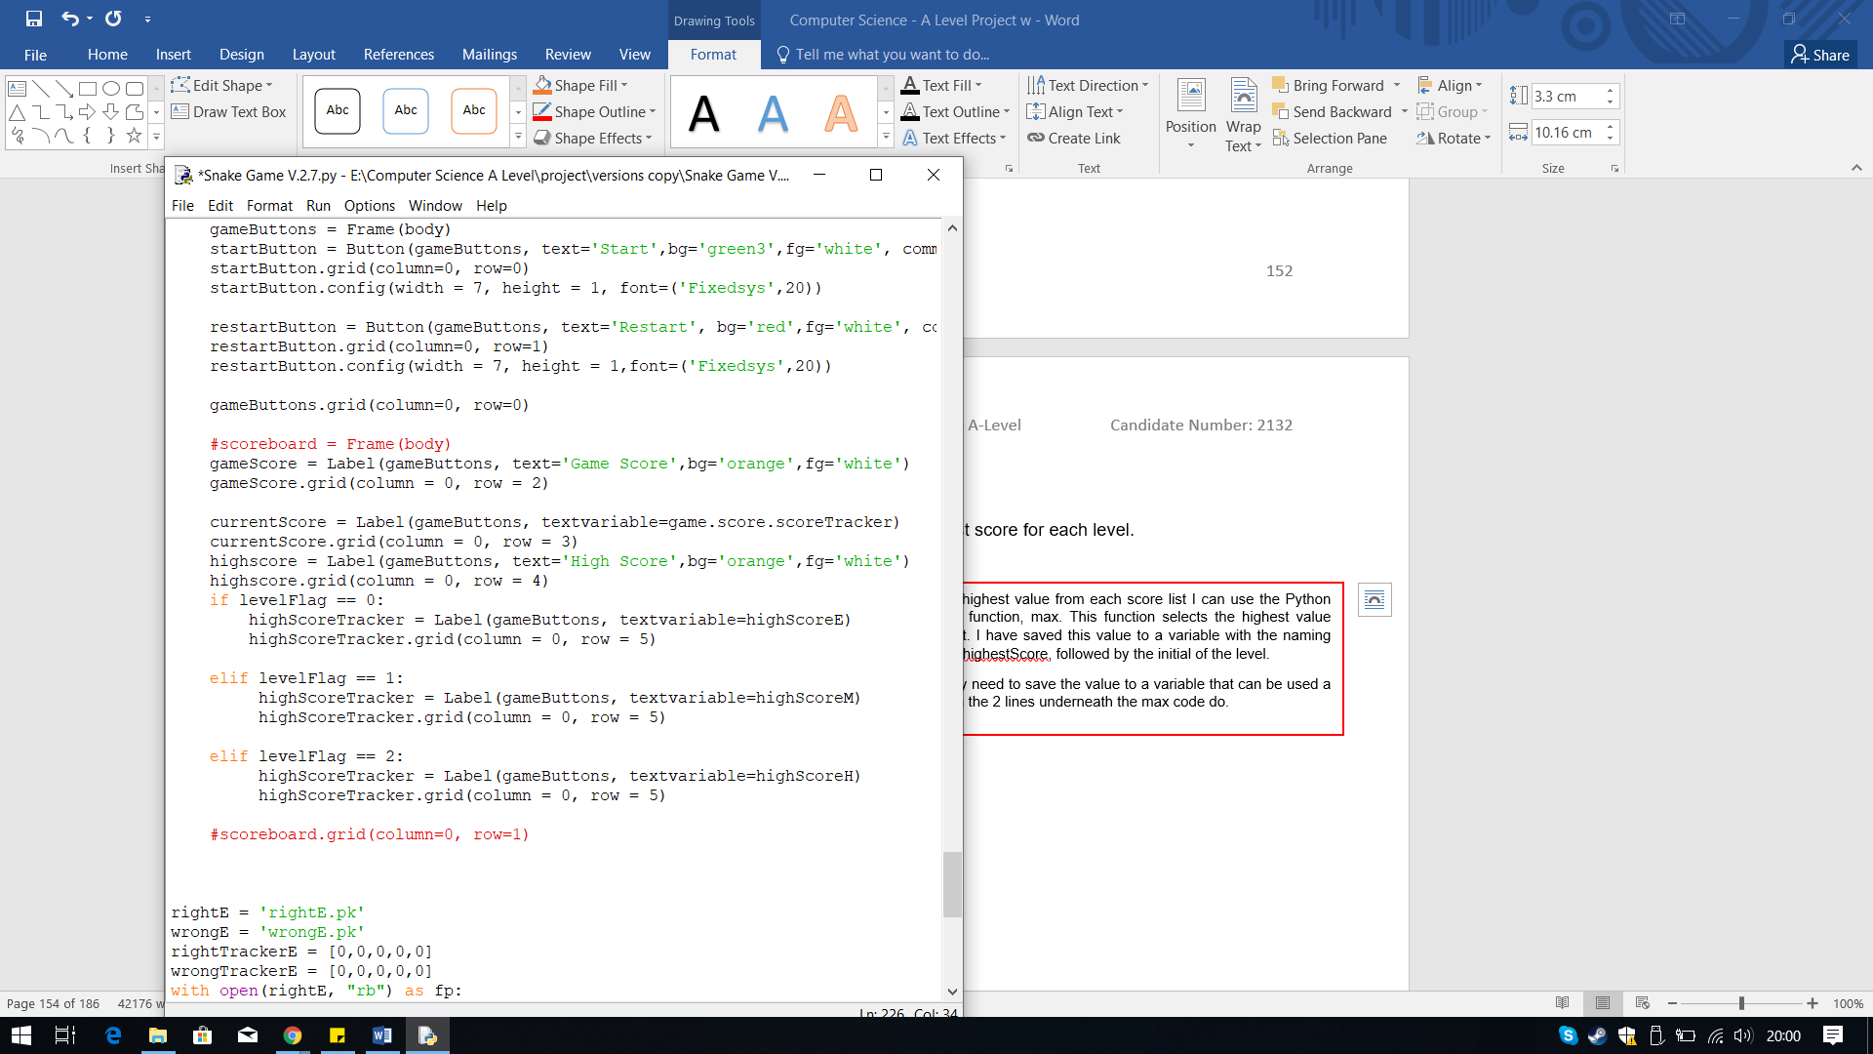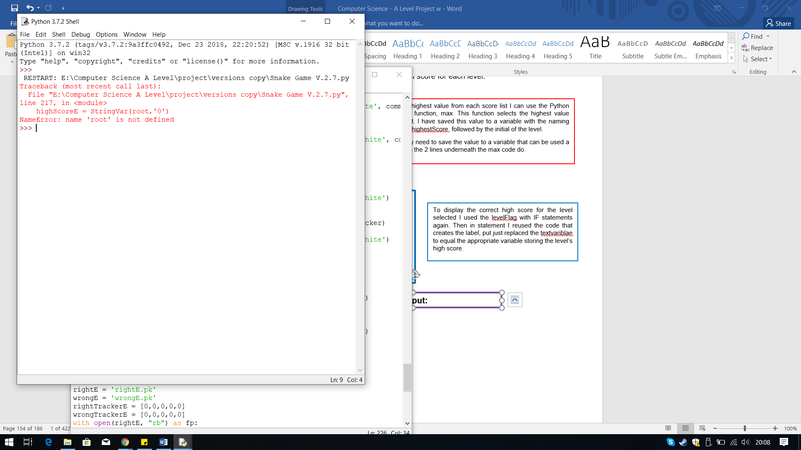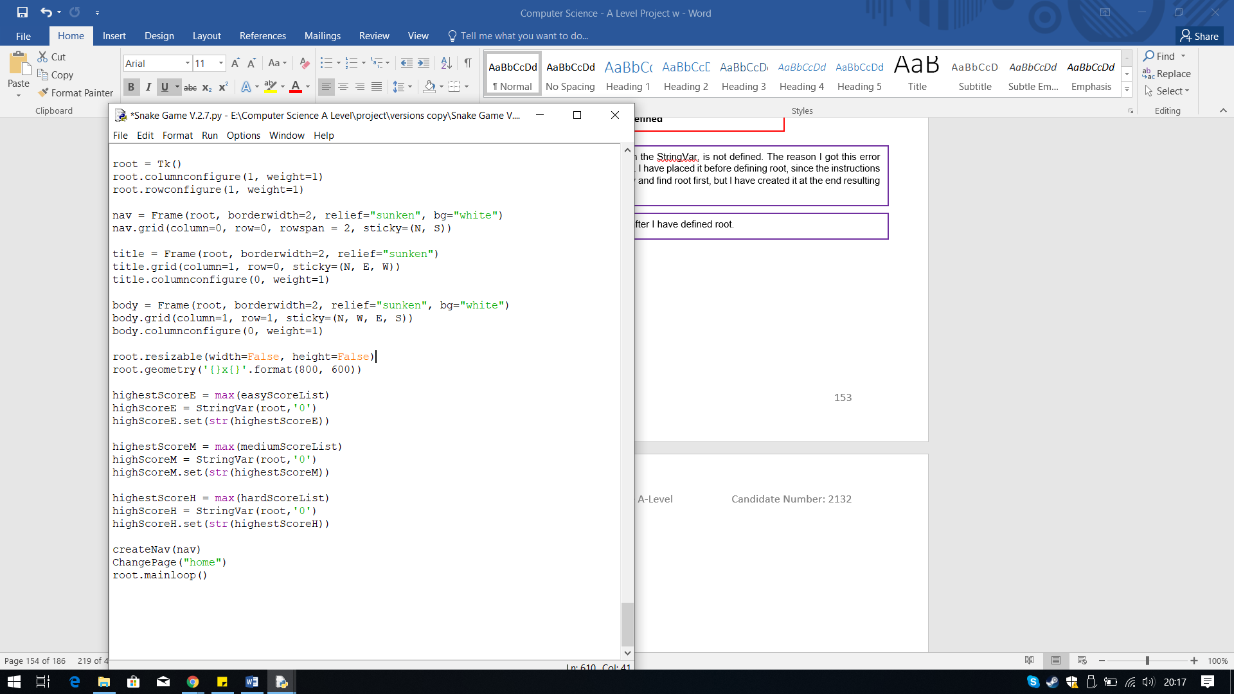

**Iterative Testing:**

**Test 13 No.2**

To display the correct high score for the level selected I used the levelFlag with IF statements again. Then in statement I reused the code that creates the label, put just replaced the textvariblae to equal the appropriate variable storing the level’s high score.

To get the highest value from each score list I can use the Python pre-defined function, max. This function selects the highest value from the list. I have saved this value to a variable with the naming convention highestScore, followed by the initial of the level.

The I simply need to save the value to a variable that can be used a label, which the 2 lines underneath the max code do.

Therefore, to fix this error I simply need to place these lines of code after I have defined root.

When ran I received an error right away. The error states root, within the StringVar, is not defined. The reason I got this error was because of the position I placed this piece of code within the code. I have placed it before defining root, since the instructions are carried out in a sequence, so when this code is processed it will try and find root first, but I have created it at the end resulting in this error.

**Output:**

**Error: Root not defined**

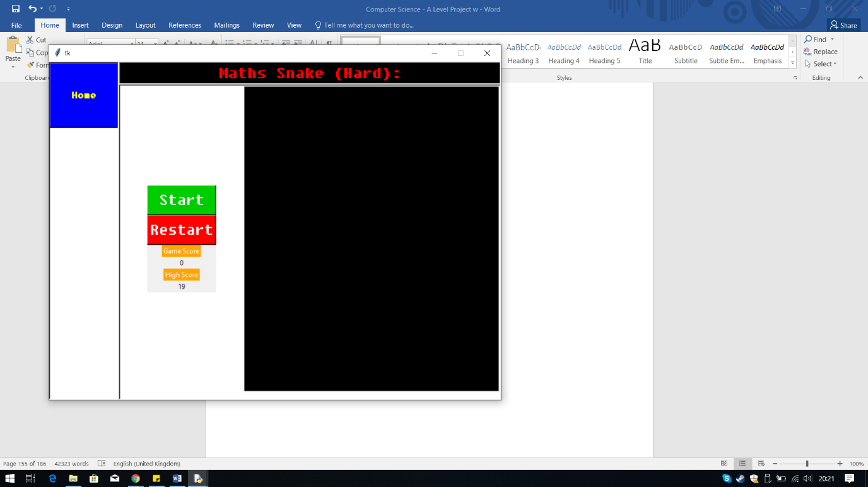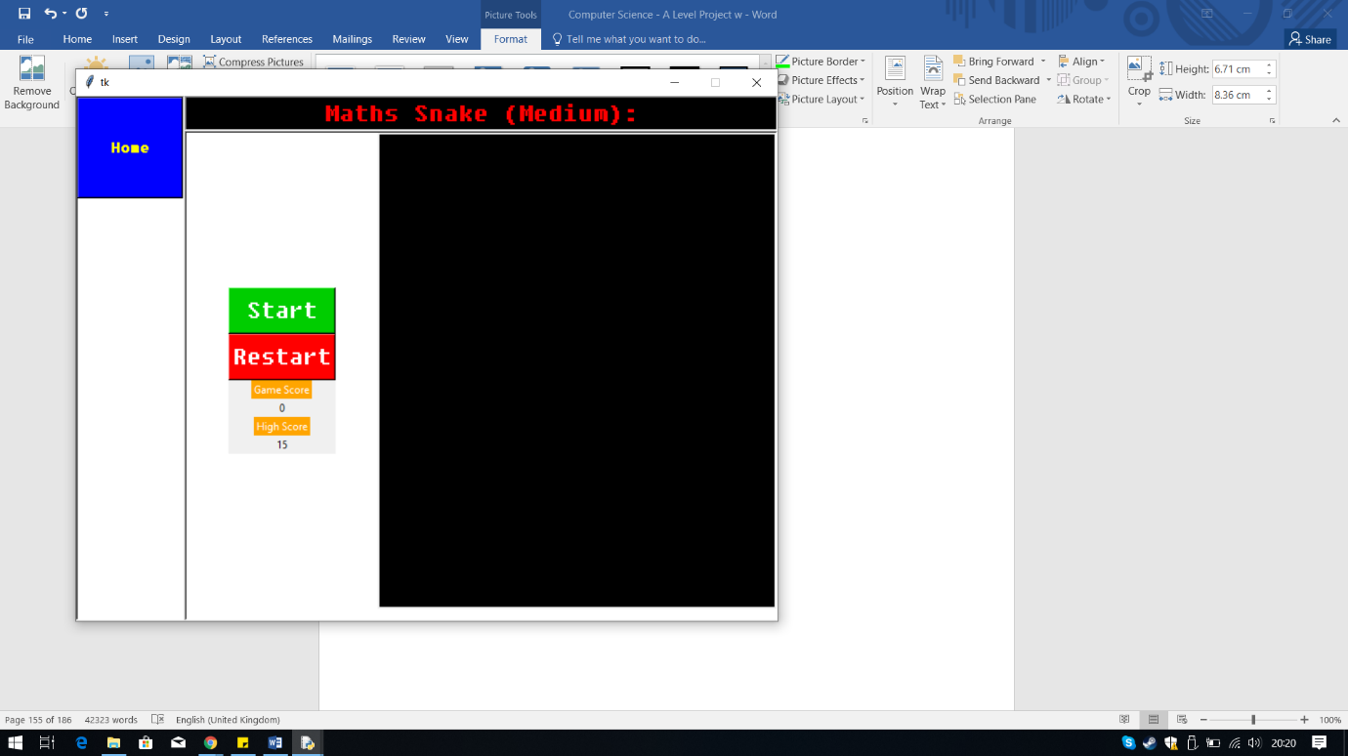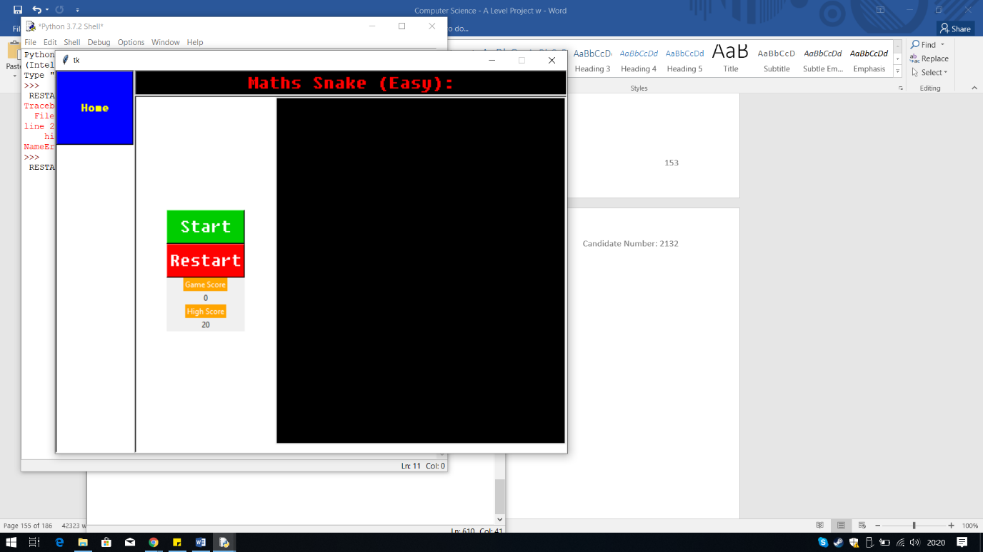

This time I got the expected result, the high score for each level is being displayed correctly.

**Output:**

## **Fixing the Question’s Labels**

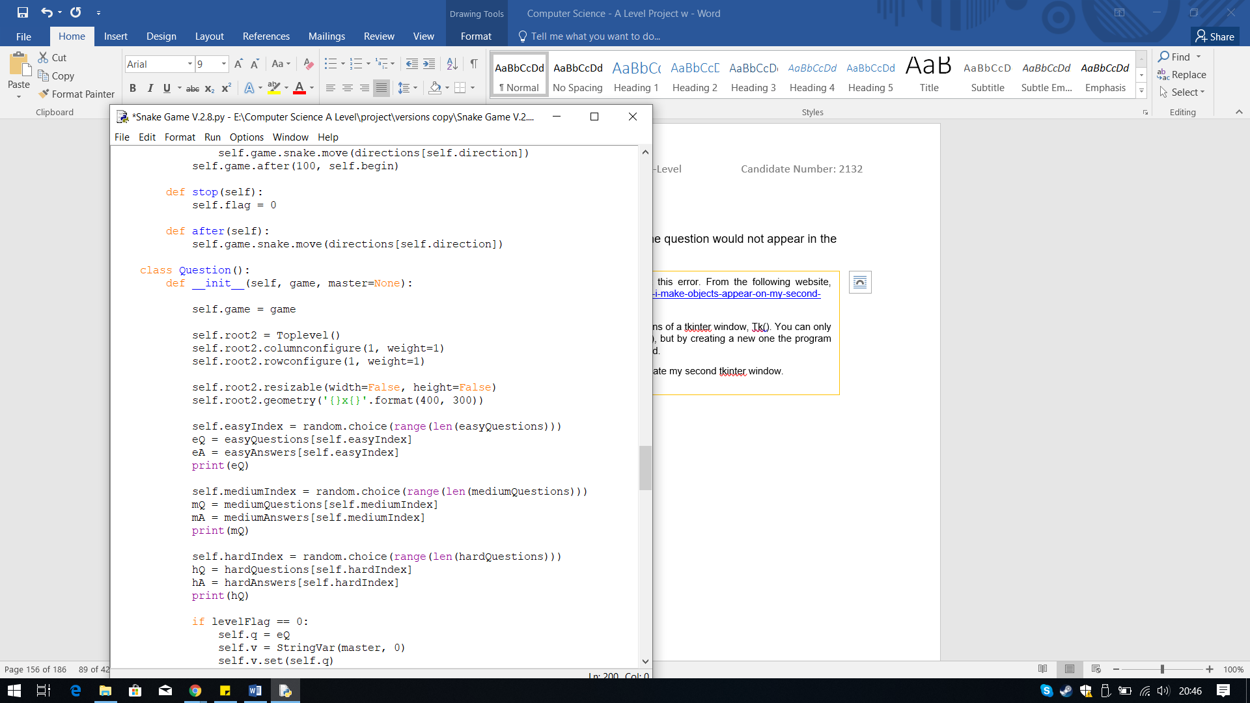In Version 2.8 I have decided to fix the error where the question would not appear in the pop-up.

I first researched online to find out why and how I can fix this error. From the following website, <https://stackoverflow.com/questions/46809771/tkinter-how-can-i-make-objects-appear-on-my-second-window-rather-than-the-firs>

From this website I found out that you cannot call 2 instantiations of a tkinter window, Tk(). You can only have one window, as tkinter is designed to work with one Tk(), but by creating a new one the program assumes that the new window doesn’t not know how to respond.

From this I found I need to use Toplevel() instead of Tk() to create my second tkinter window.

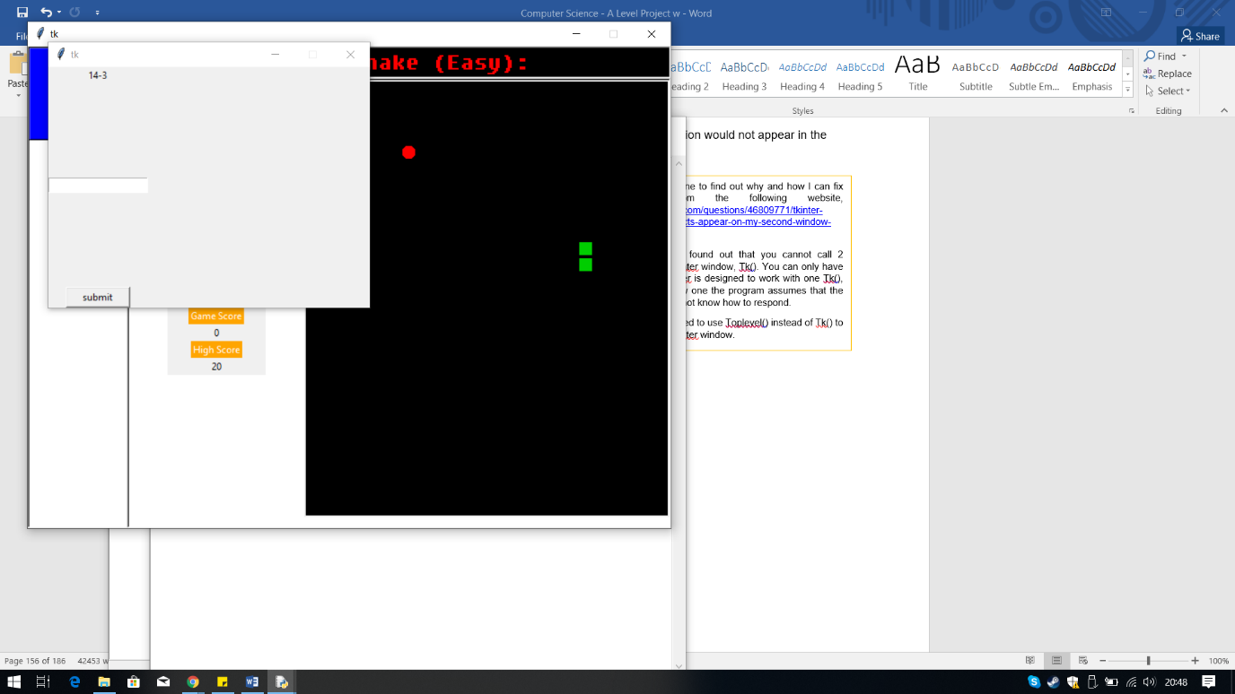

**Iterative Testing:**

**Test 12 No.3**

This fix the issue of the question not appearing, as shown in the screenshot above.

**Output:**

## **Display the Top 5 Scores**

In Version 2.9 I have created the High Score List section, which displays the top 5 scores for each level.

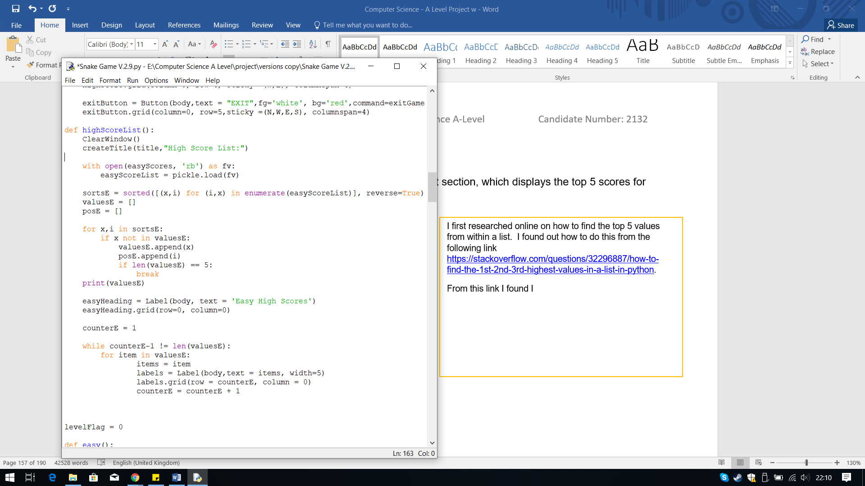

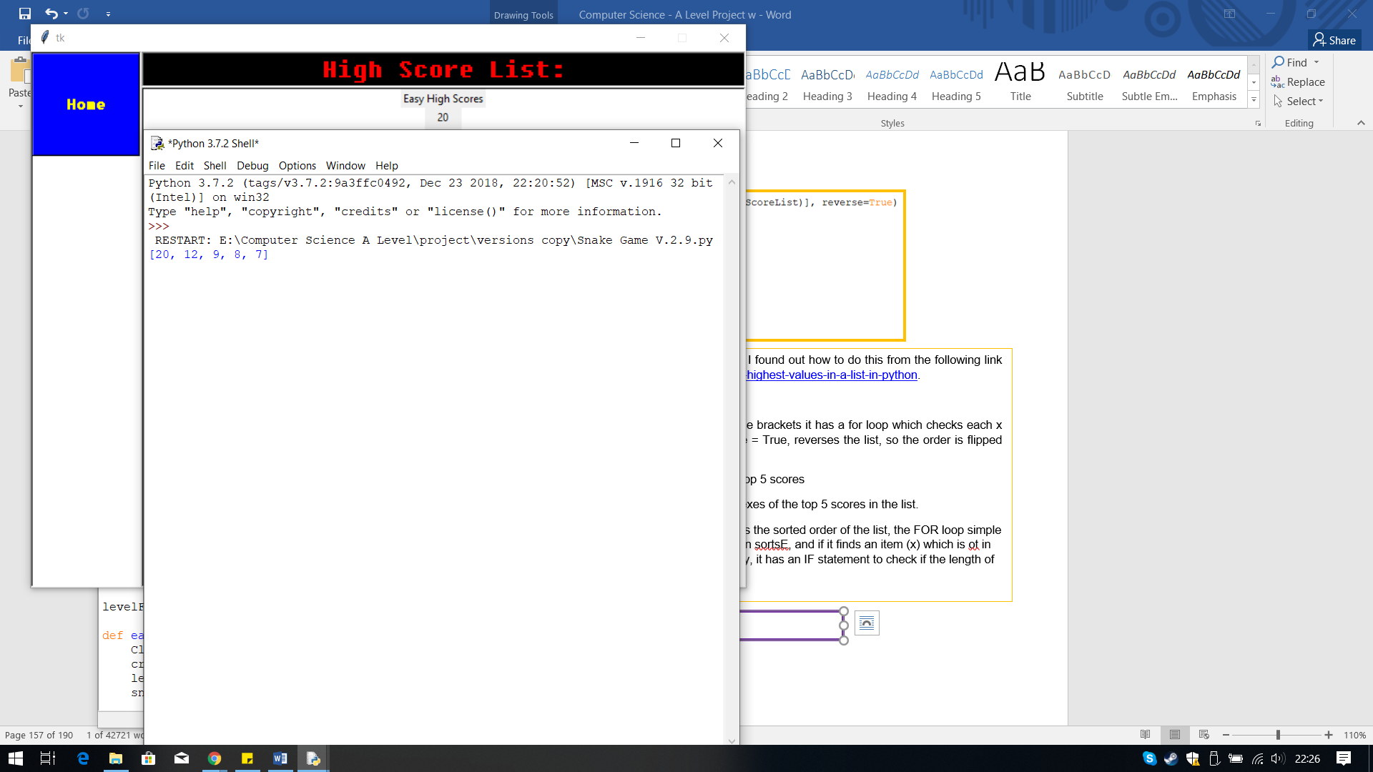

The output from this code was correct as it created a list for the top 5 scores from the list.

**Output:**

I first researched online on how to find the top 5 values from within a list. I found out how to do this from the following link <https://stackoverflow.com/questions/32296887/how-to-find-the-1st-2nd-3rd-highest-values-in-a-list-in-python>.

The highlighted code finds the top 5 values from the list.

SortsE – This variable sorts the list, using the built-in function sorted. In the brackets it has a for loop which checks each x and I value, item and index, in the enumerated list of the scores. Reverse = True, reverses the list, so the order is flipped since sorted sorted the list from smallest to biggest.

ValuesE – This is a variable storing an empty list which will then store the top 5 scores

PosE – This is a variable storing an empty list which will then store the indexes of the top 5 scores in the list.

Next the code uses a for loop to find the top 5 values. Since sortsE contains the sorted order of the list, the FOR loop simple needs to get the first 5 values. To do this it checks x(items) and i(indexes) in sortsE, and if it finds an item (x) which is ot in valuesE, append it to the list valuesE and the position of it into posE. Finally, it has an IF statement to check if the length of the list is equal 2 5, if so break the loop.

Next I needed to display this list in the High Score List Section.

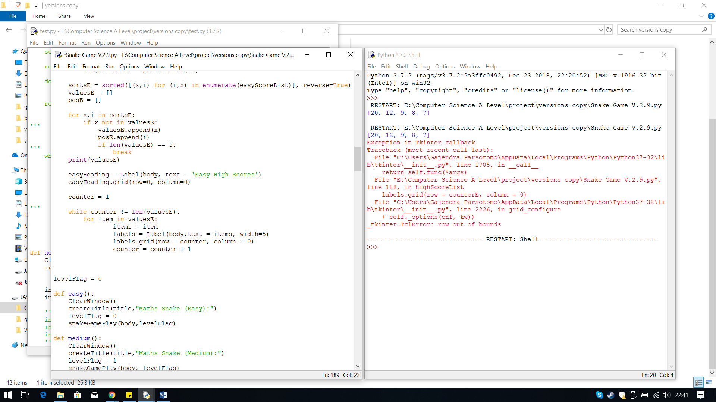

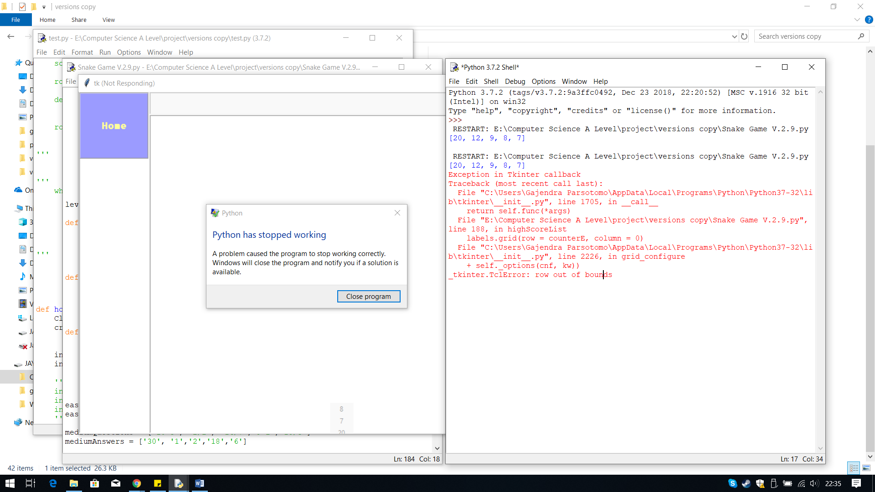

**Iterative Testing:**

**Test 4 No.1**

When ran I clicked the High Score List Button, but then my python crashed and wouldn’t load and within the shell I received this error.

The reason for this error is because the counter is the wrong value when comparing for the last item. In my list there are 5 items so the length is 5, the loop adds one each time, increasing the row by one however when it gets to the fourth item, the counter value is 4 so when it adds one it becomes five, the loop stops but there is still one more item.

**Error: row out of bounds**

**Output:**

The code above is something I came up with.

I first created the label for the Easy High Scores heading, and displayed that in the first row and column.

Then I created a counter, made it equal to 1. Then using a WHILE loop, with the condition while counter is not equal to the length of the list. In the while loop I have embedded a for loop which checks each item in the list valuesE and save that item to a variable called items. Then I created the label which will display the item currently in the variable items. I make the text equal to items. Then for the position of the label, I made the row equal to the counter, so it will keep placing it in the next row bu the column remains the same. Finally, plus one to the counter and repeat the loop for the next item in the list until counter is equal to the length of the list.

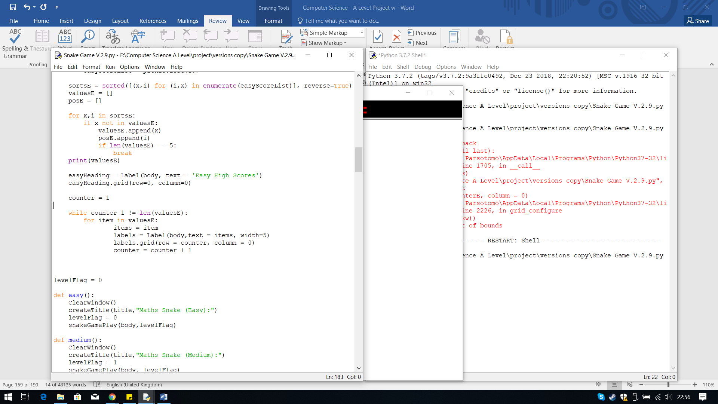

The solution to this problem is to subtract one from the counter, when comparing.

**Iterative Testing:**

**Test 4, No.2**

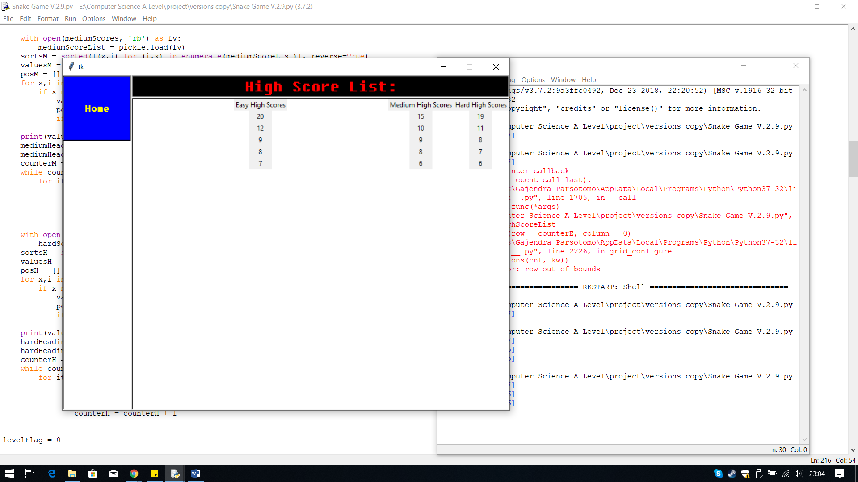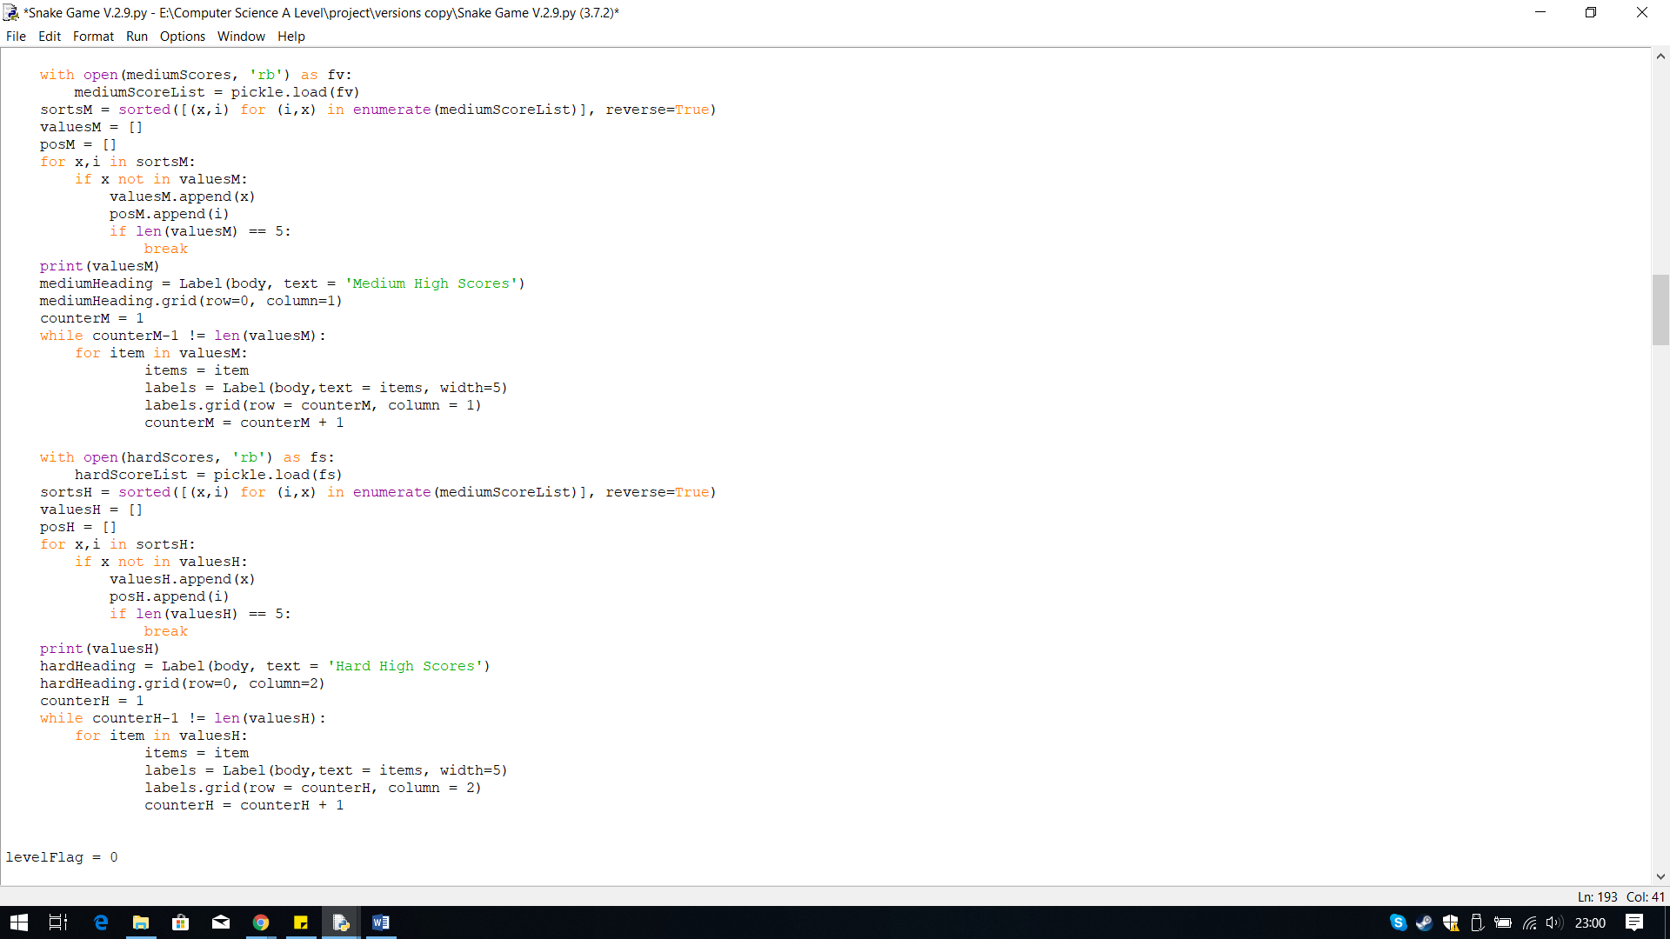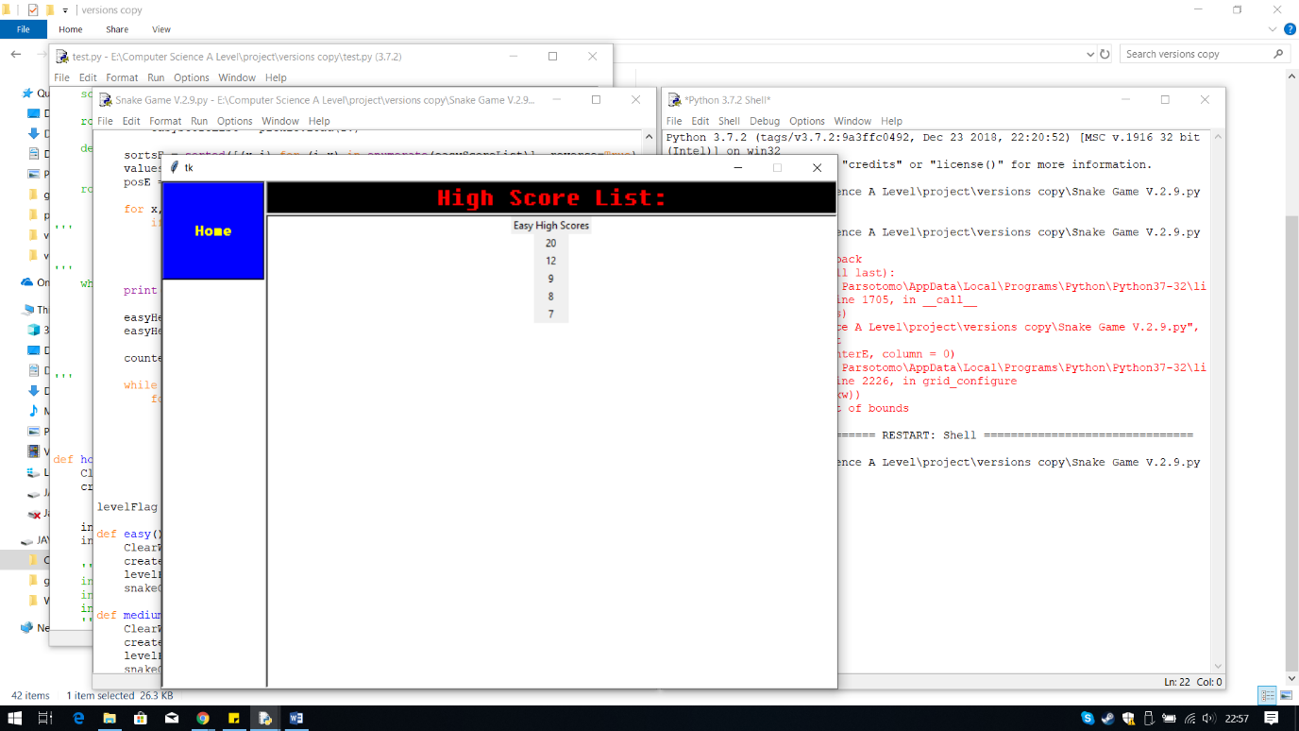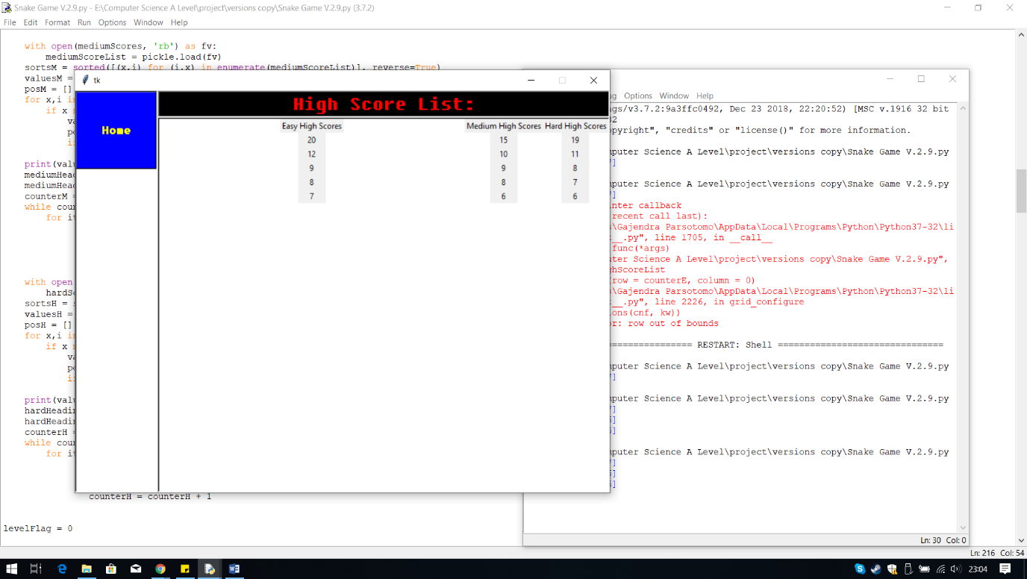

The high score list for easy now appears in the section.

**Output:**

I then copied the code, edited so the top 5 scores for the levels Medium and Hard appear. Furthermore, created different counter variables for each one as the while loop changes the value of the counter so I need more than one.

**Output:**

## **Displaying the Progress Tracker**

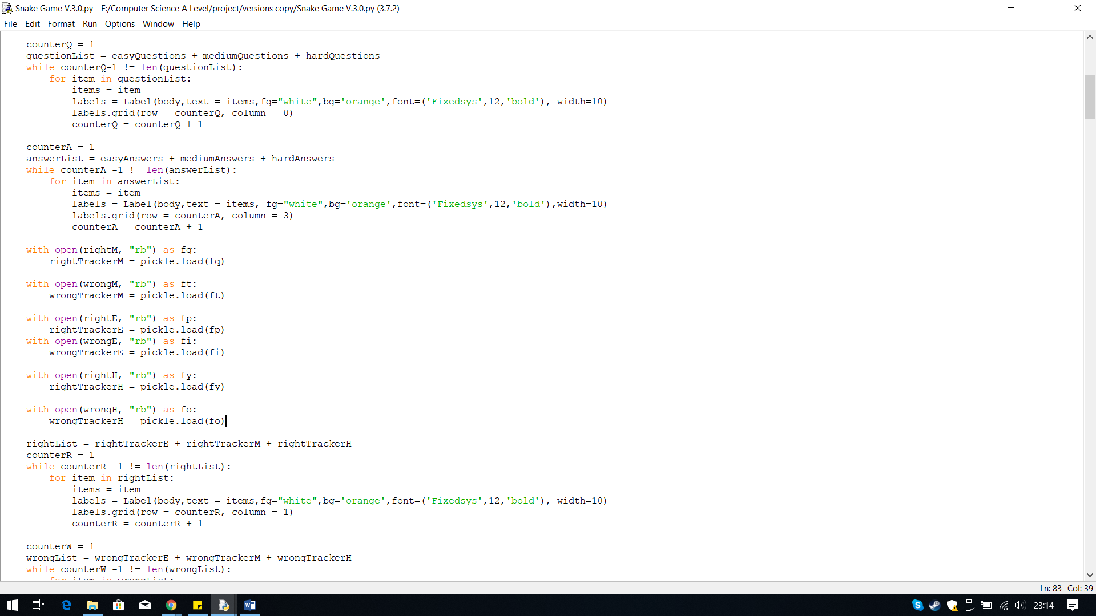In Version 3.0 I have used the same from the High Score List that displays the list, in the progress tracker section.

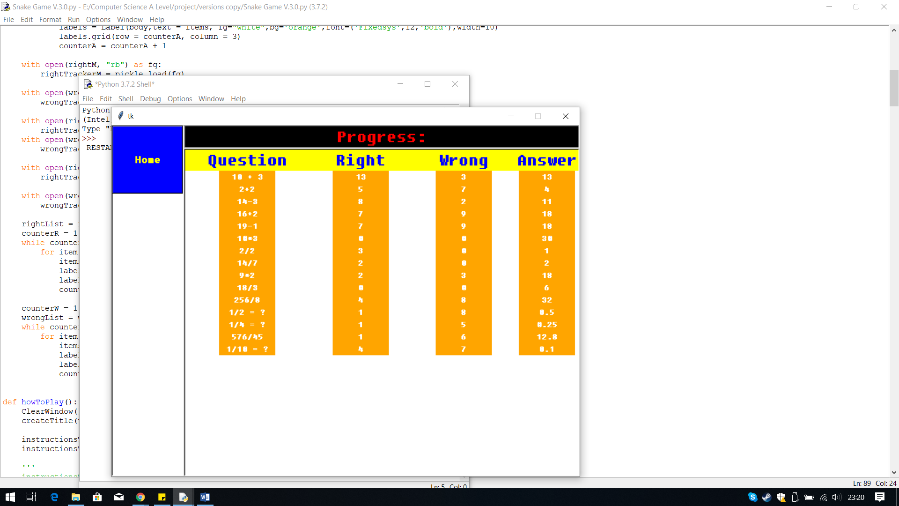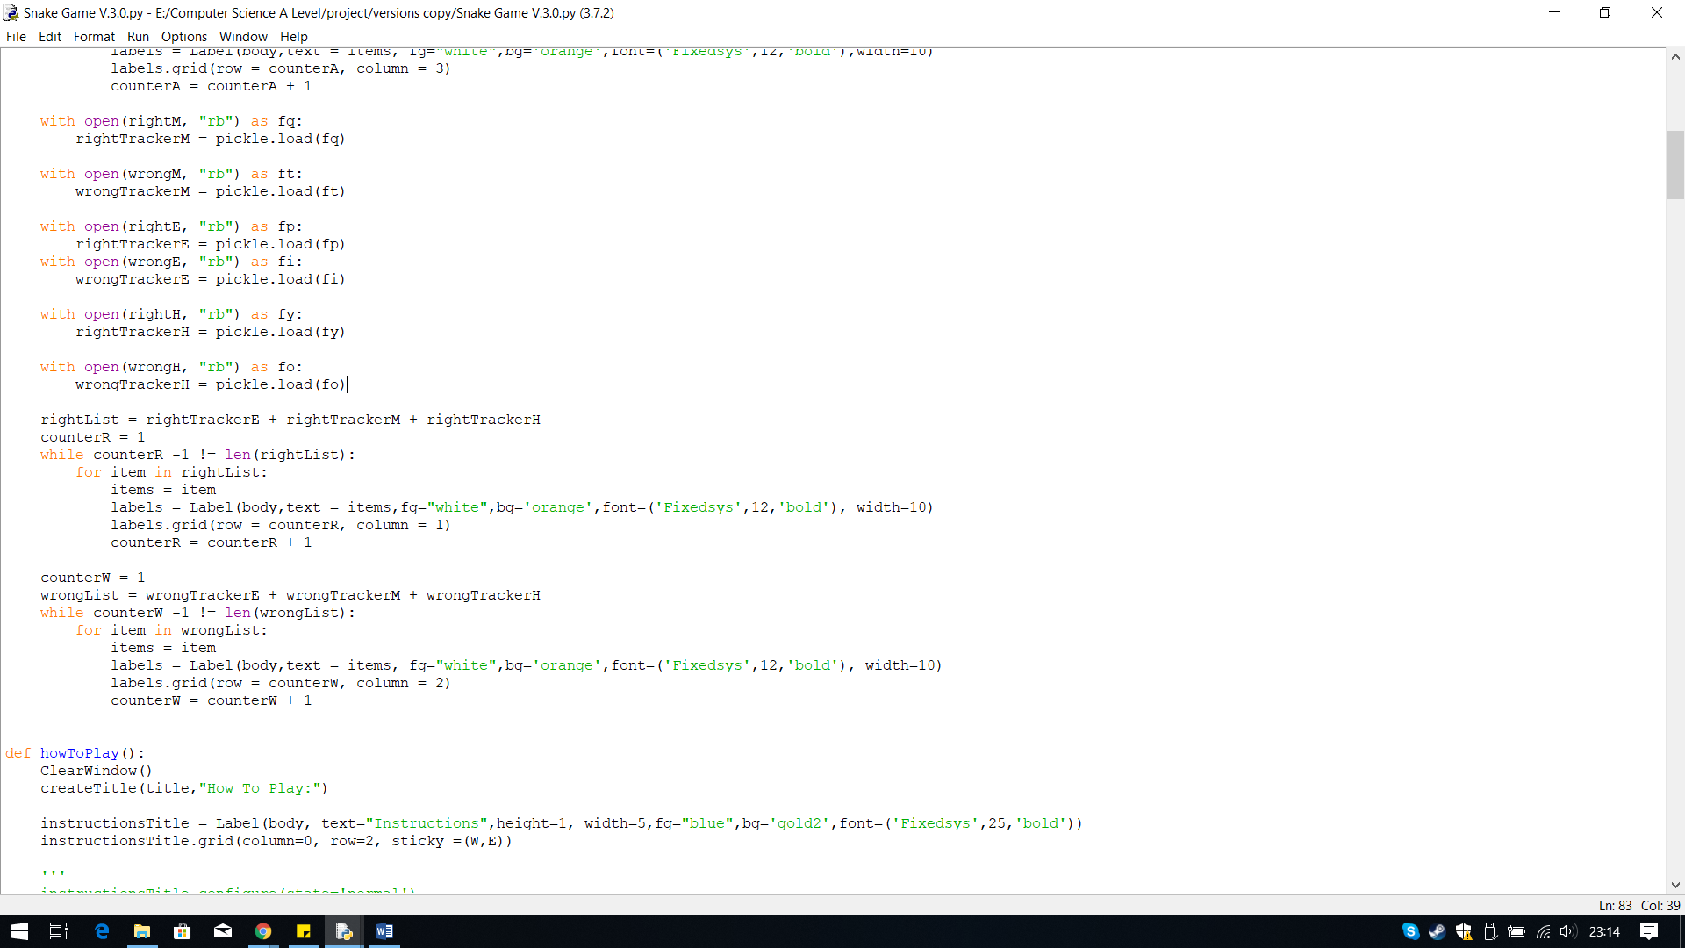

**Iterative Testing:**

**Test 2, No.1**

The questions, answers, right and wrong tally are all displayed under the correct heading.

**Output:**

I copied the code that creates the labels from the high score section. To make the code as short as possible so I don’t have lots of loops displaying each list, I created a single variable for all the different types of list, to be stored in. For example, all the questions are stored within the questionList variable. I stored all the list using the plus list which joins the list together to create one big list.

I have also added some colour and changes to the font to make it more attractive.

## **Final Code Annotated**

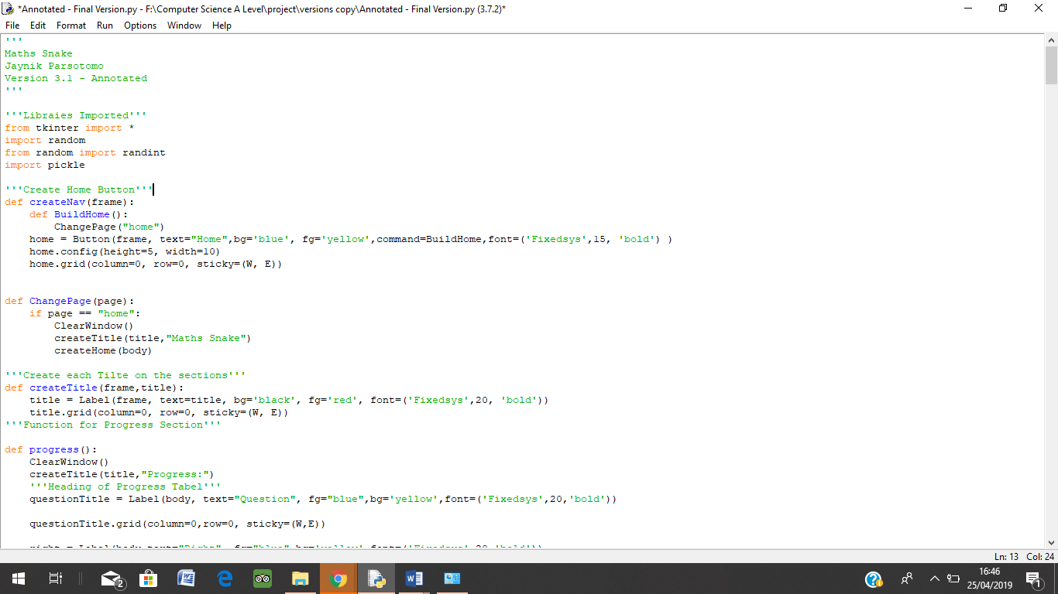

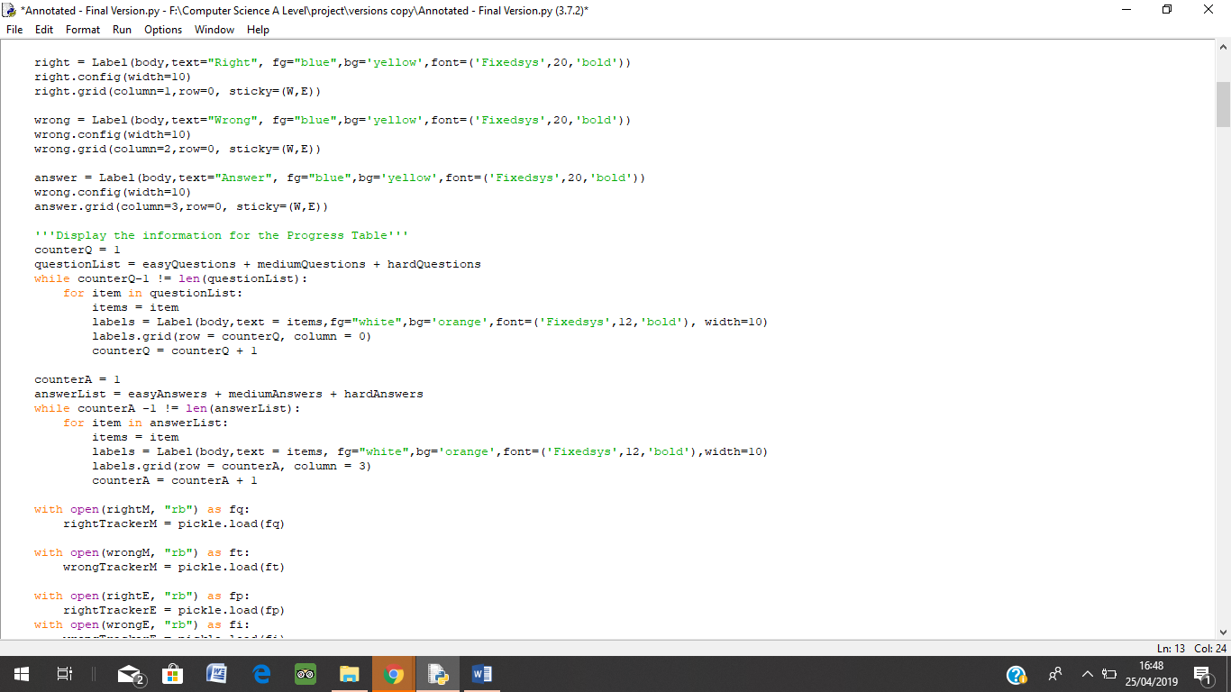

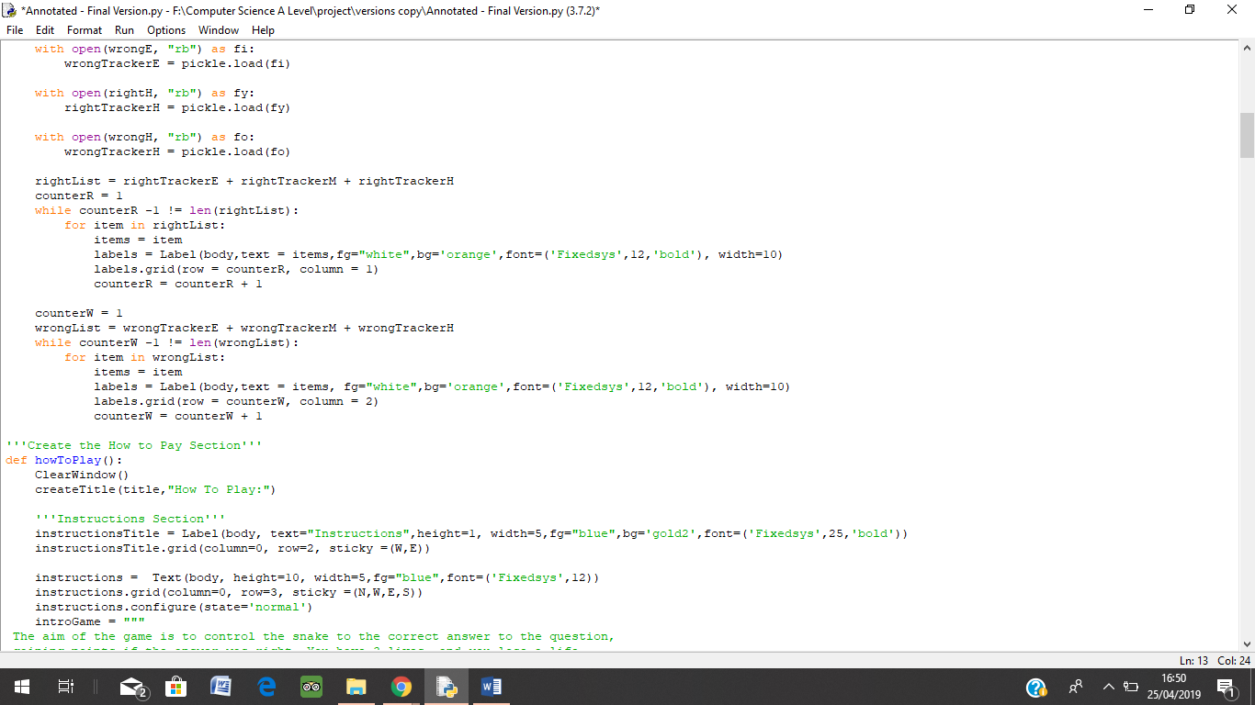

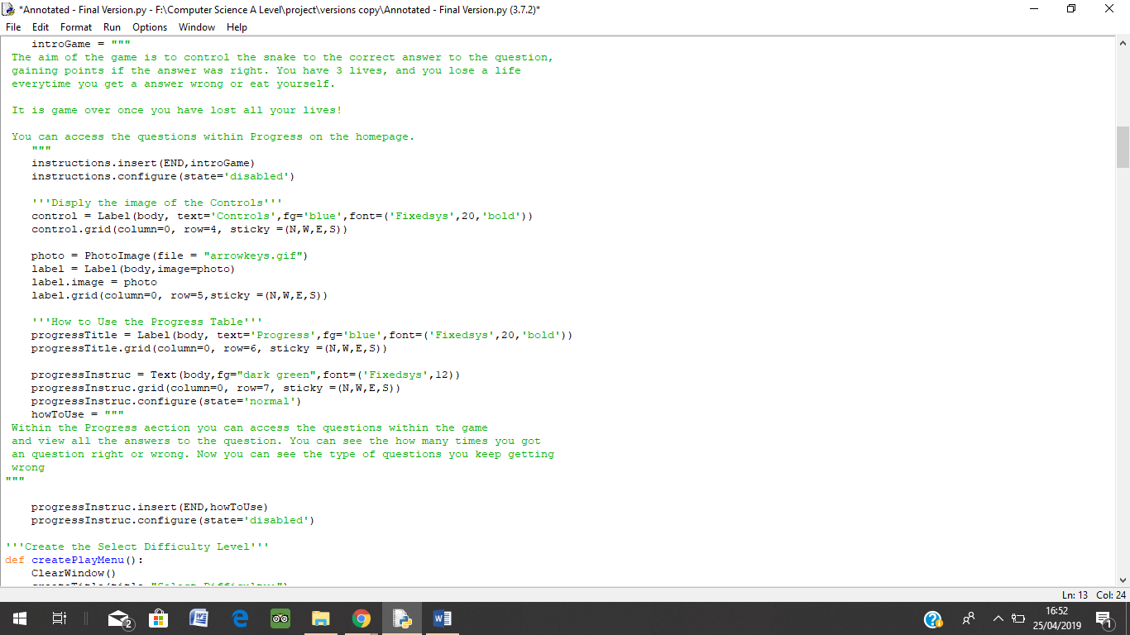

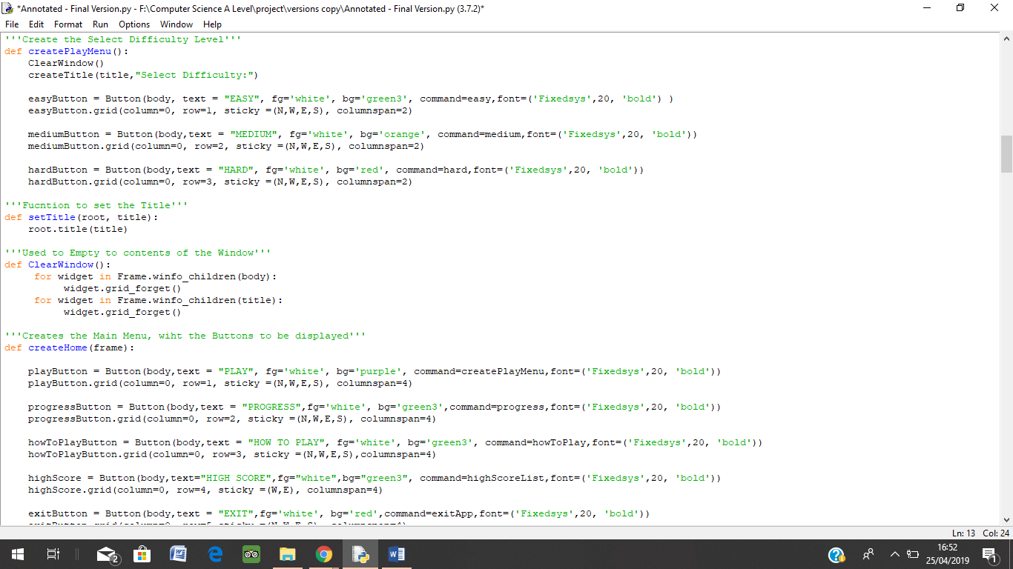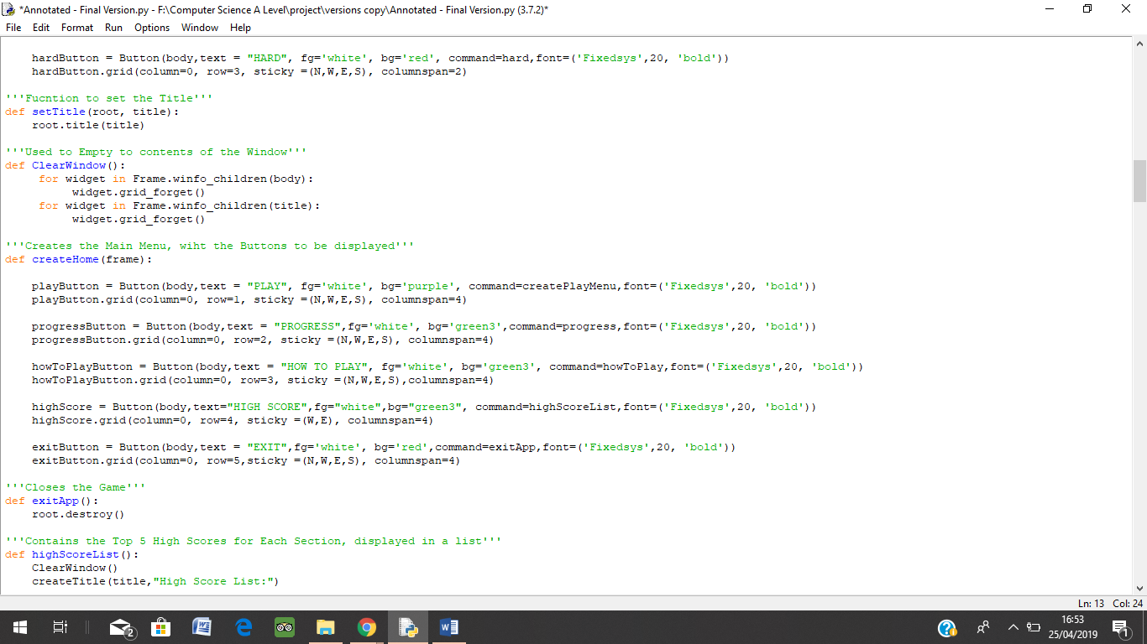

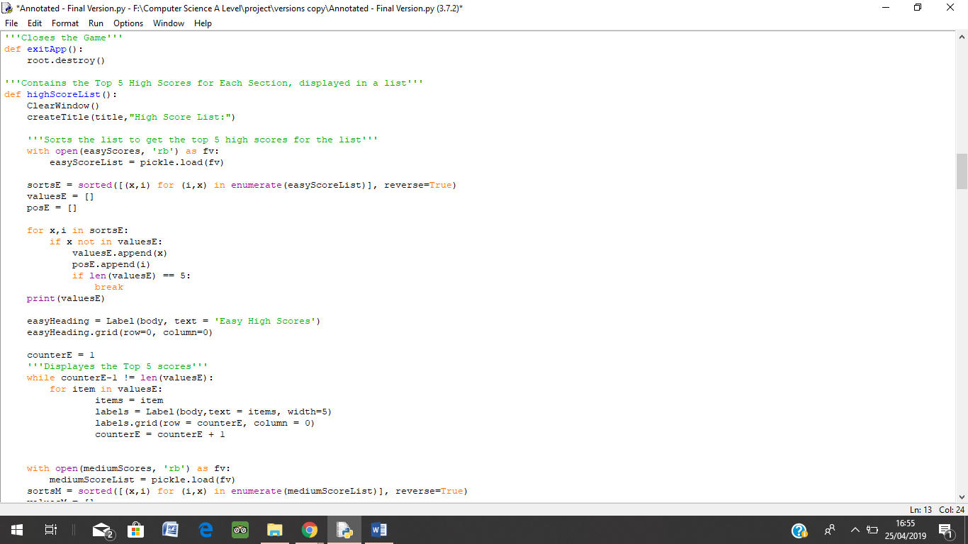

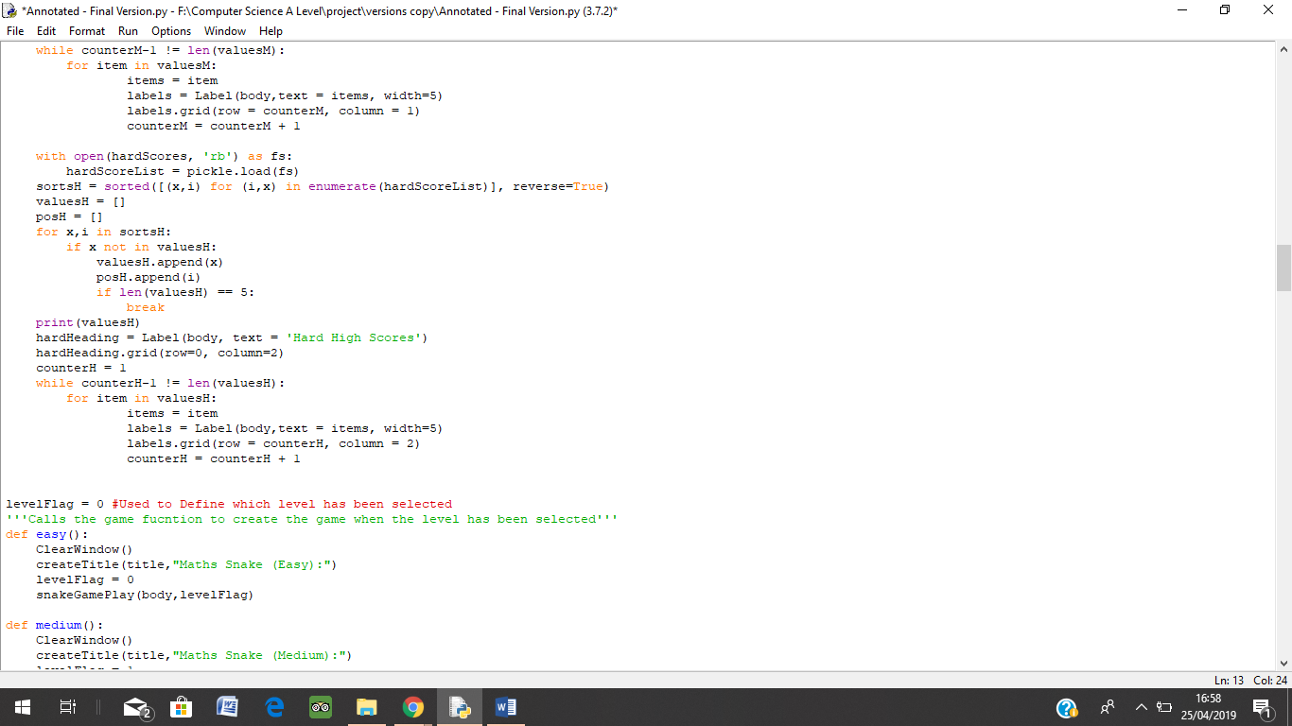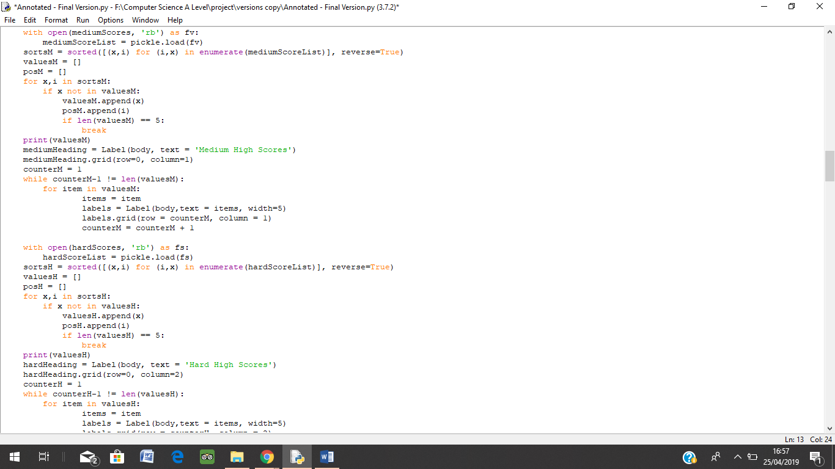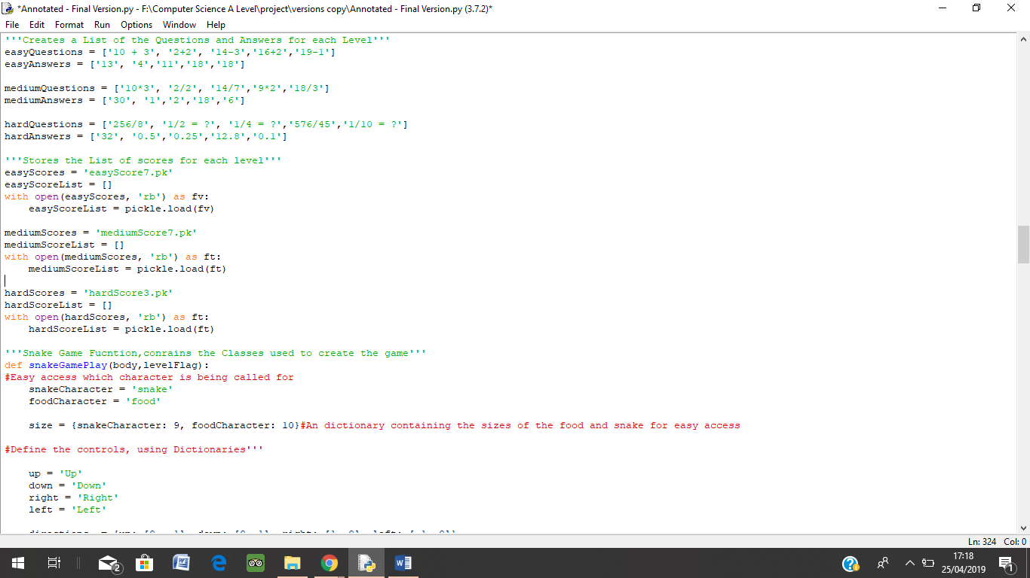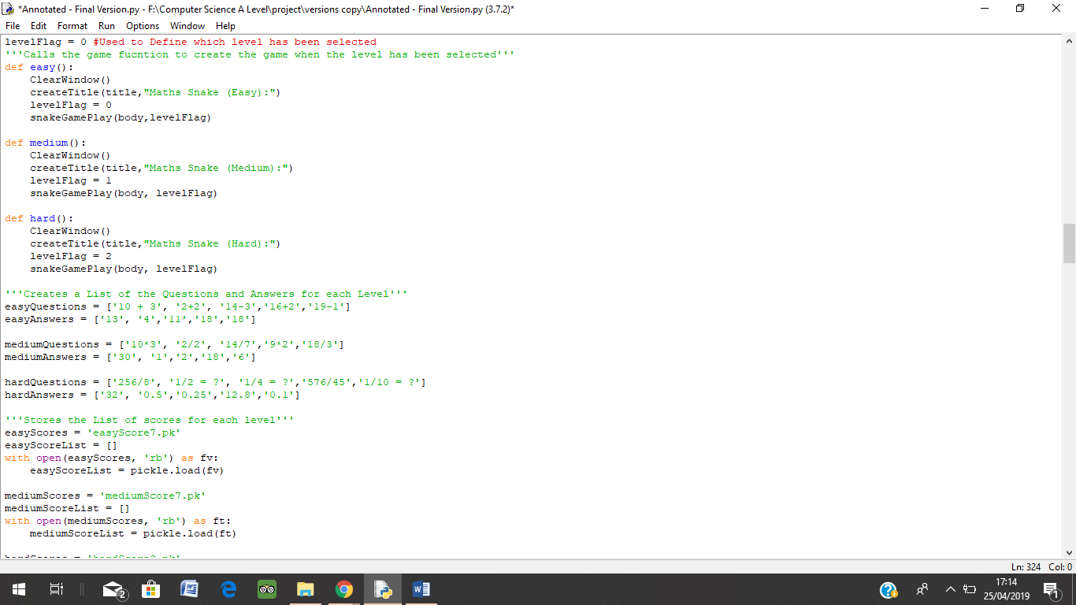

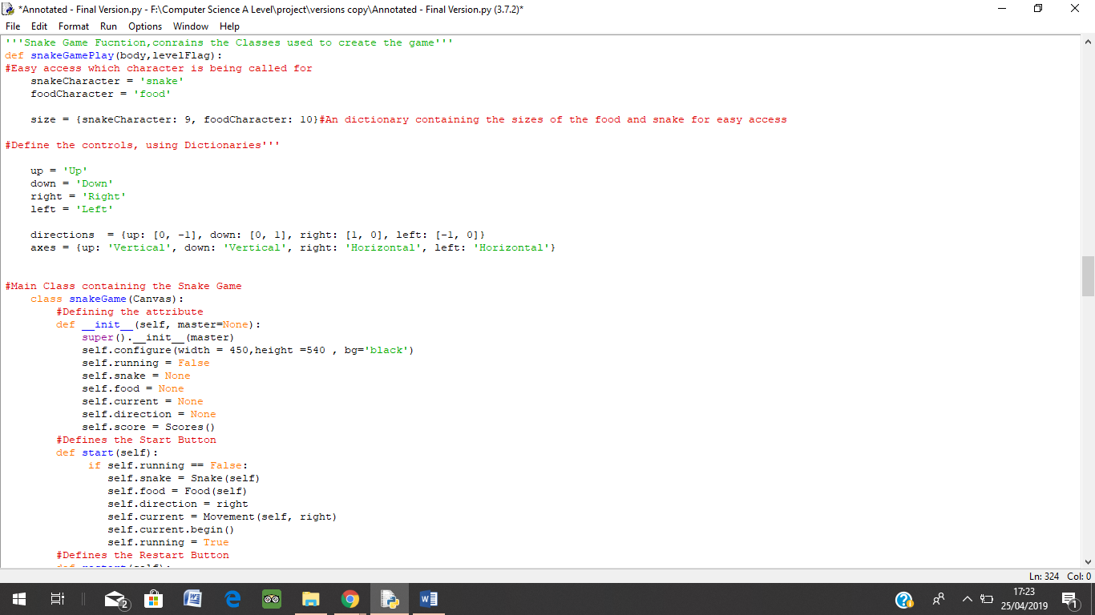

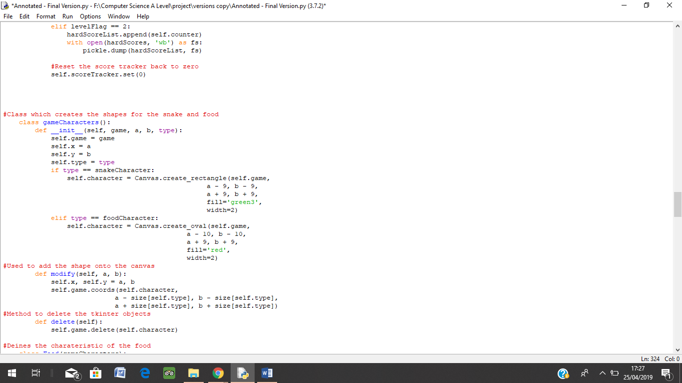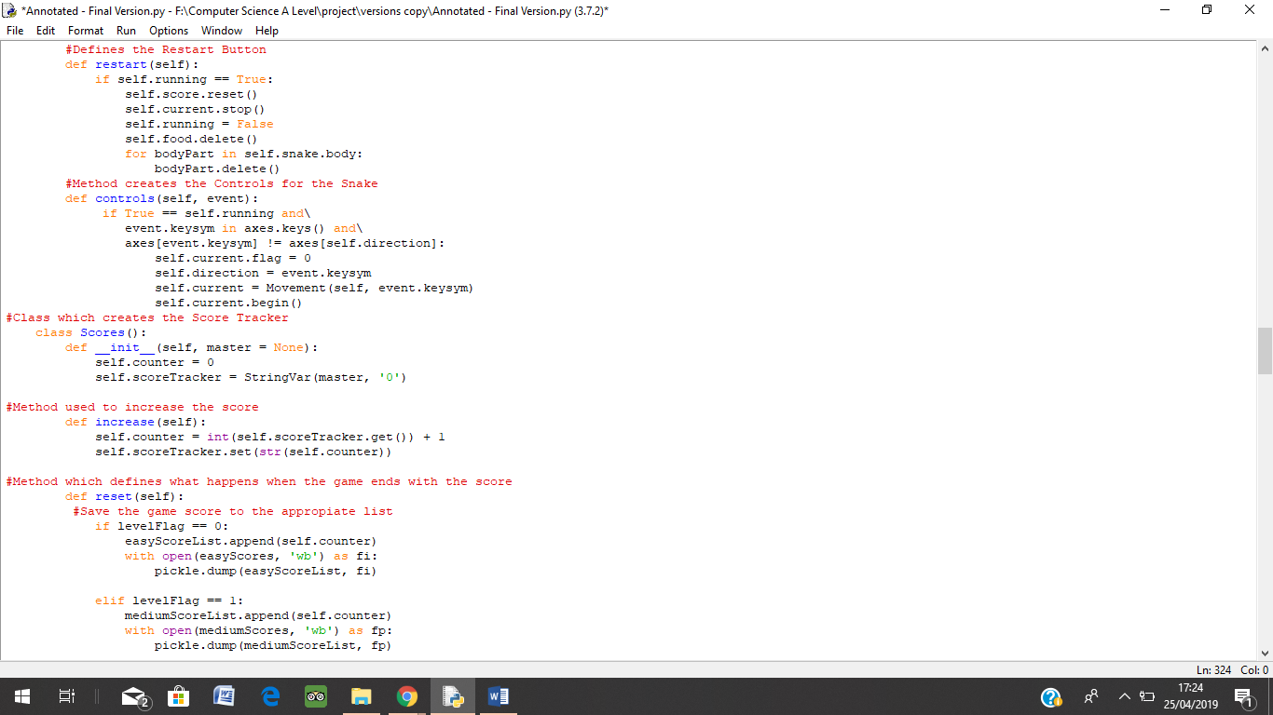

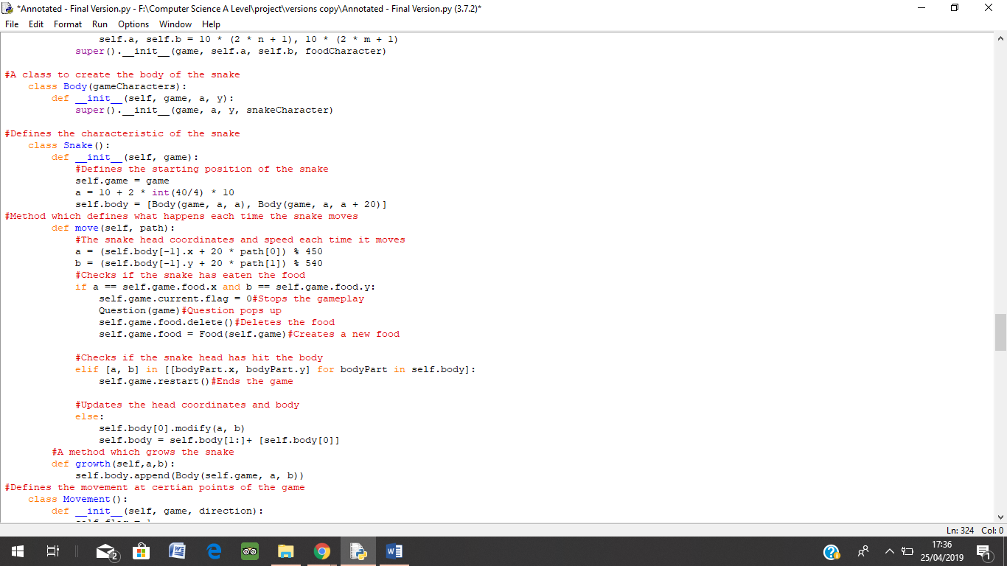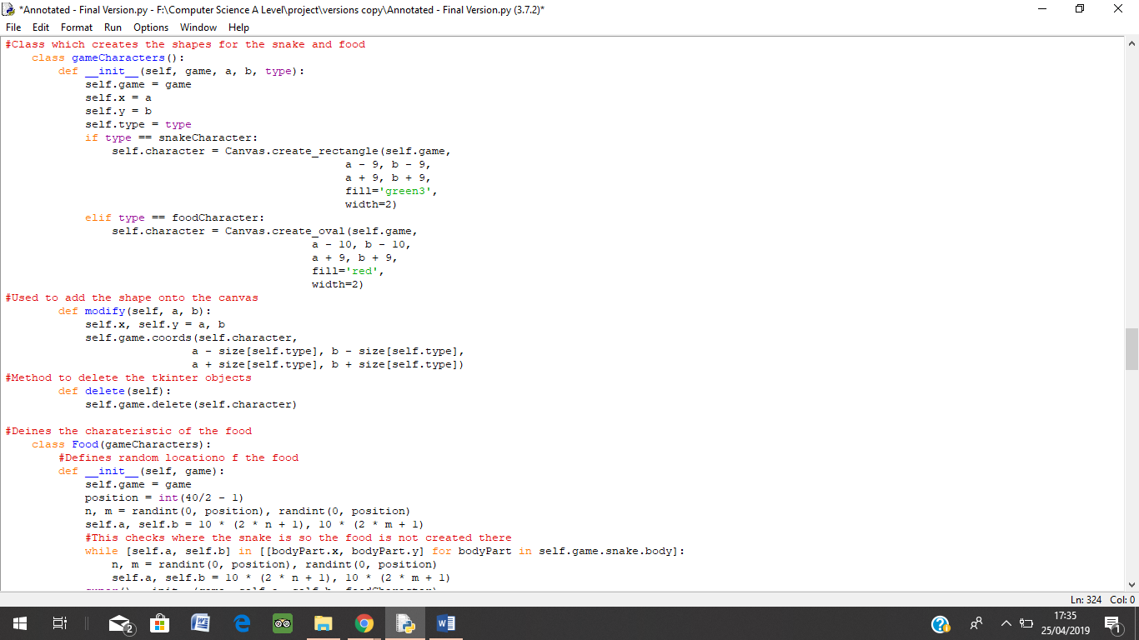

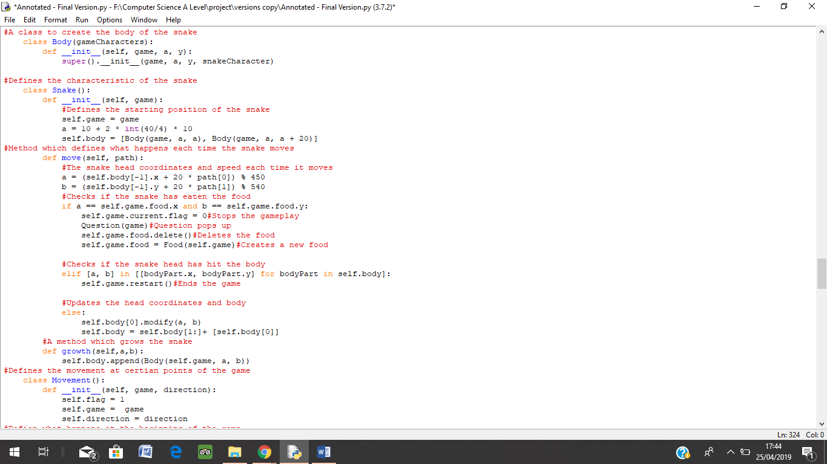

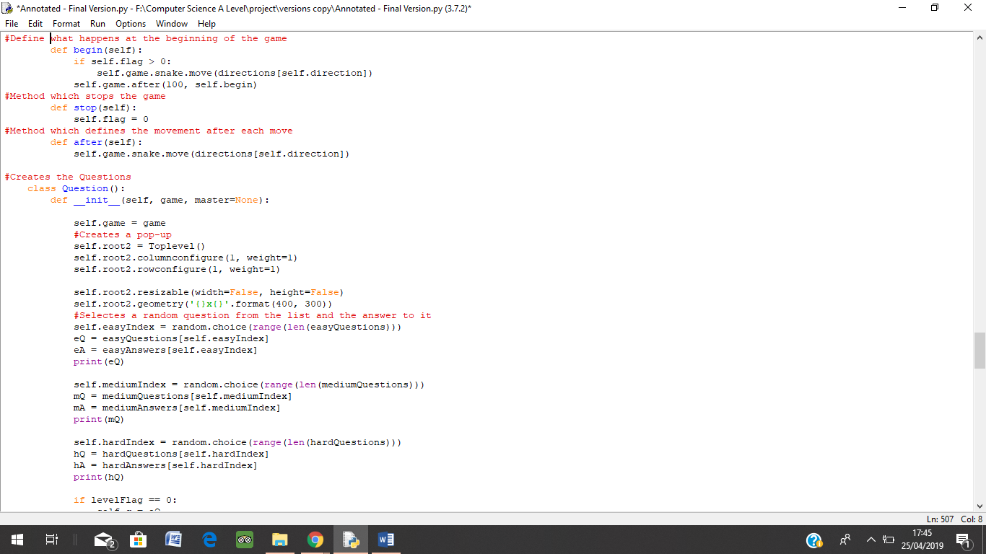

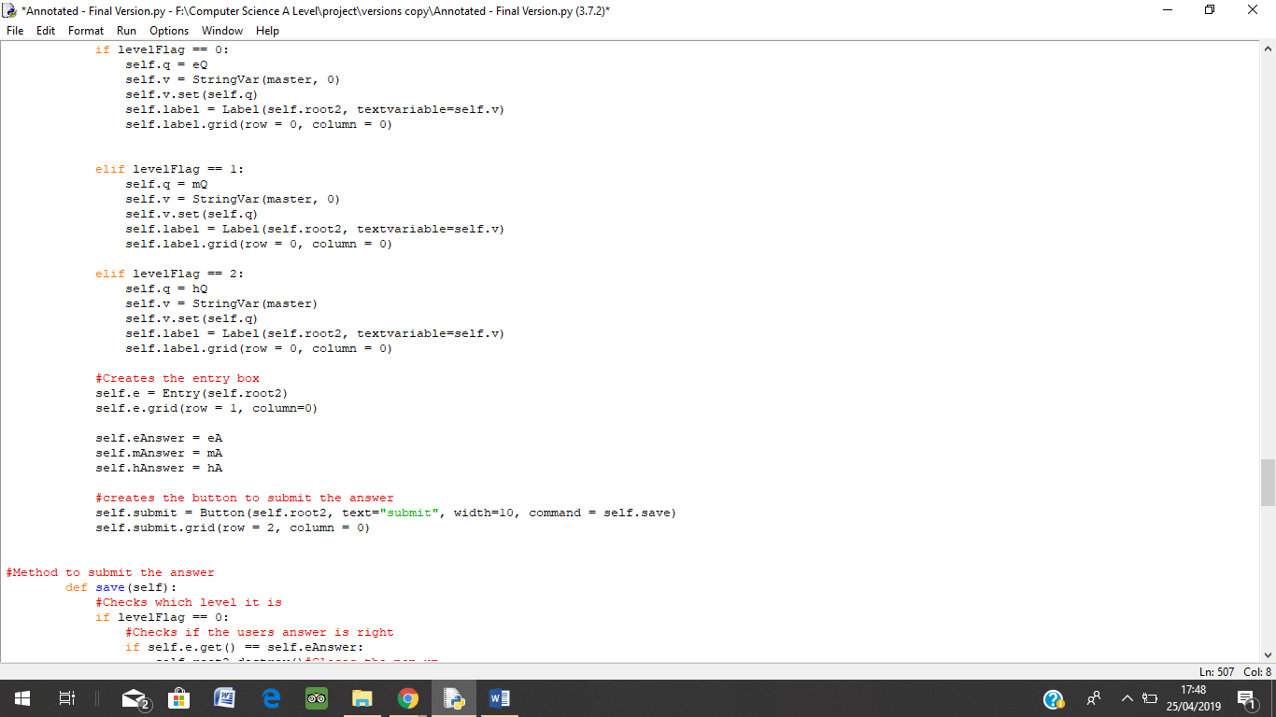

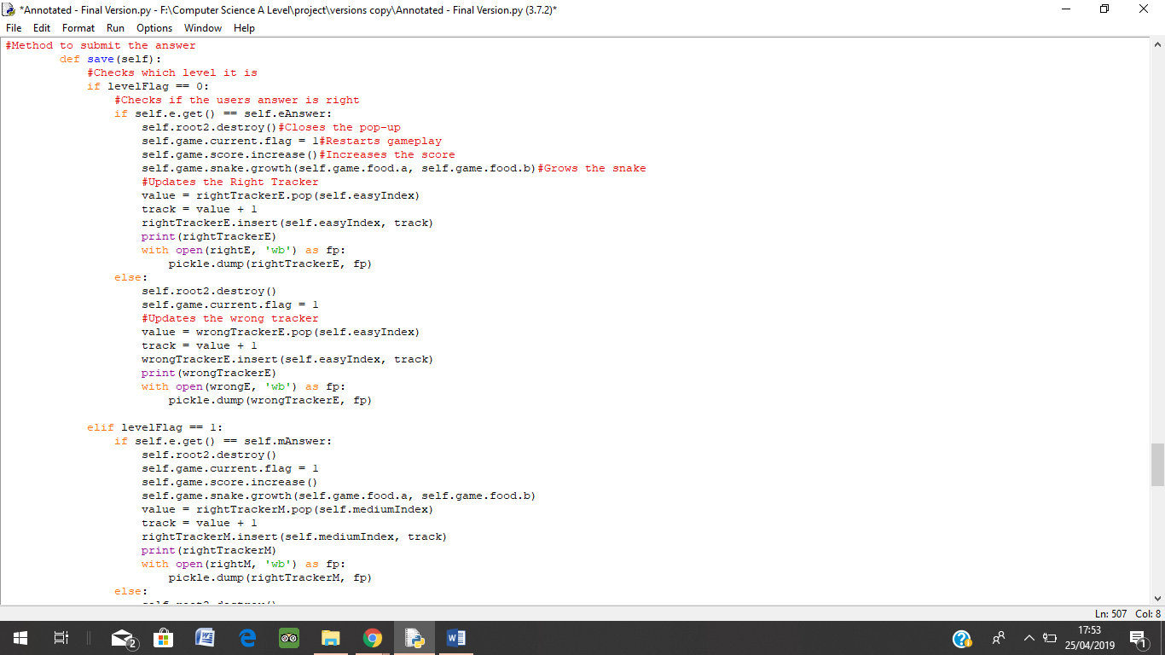

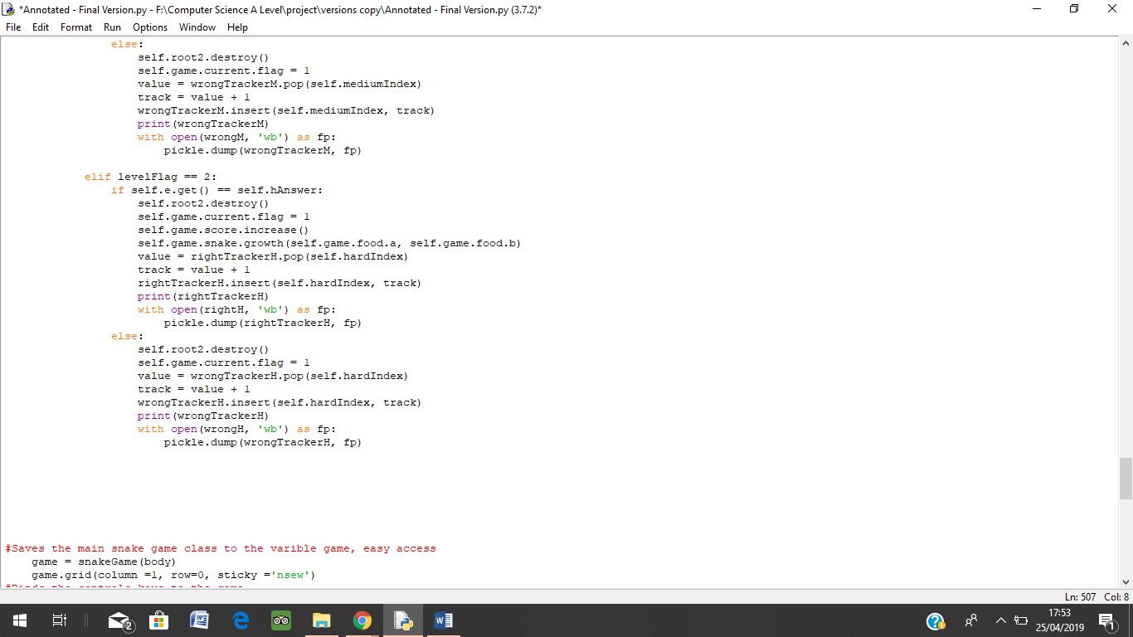

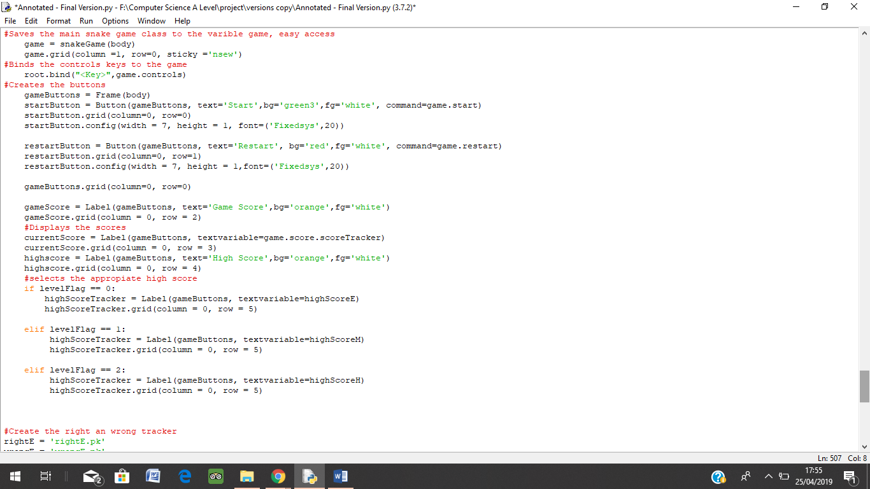

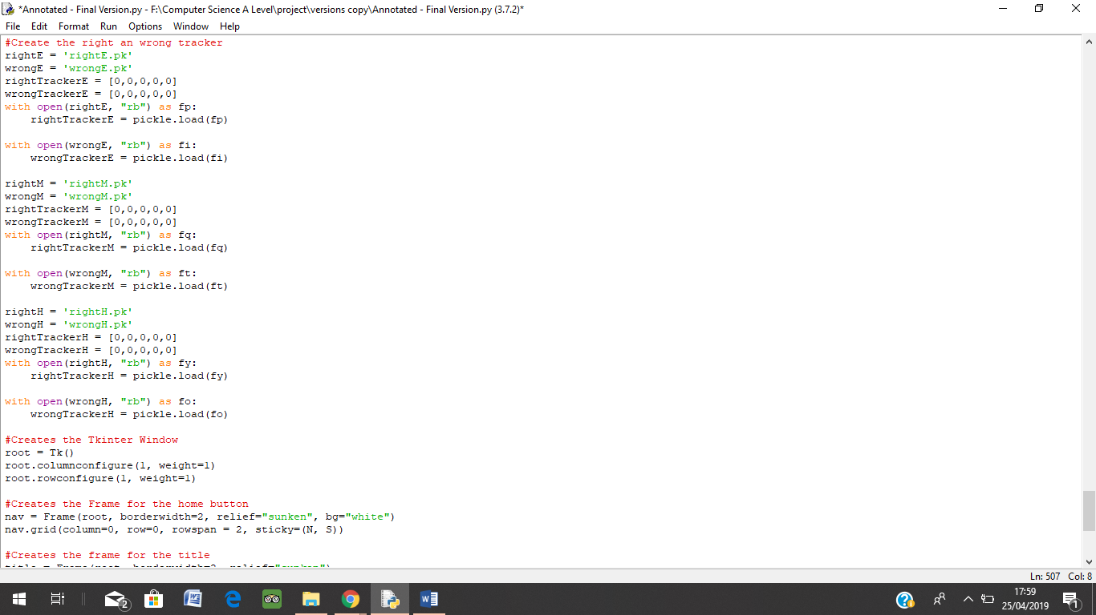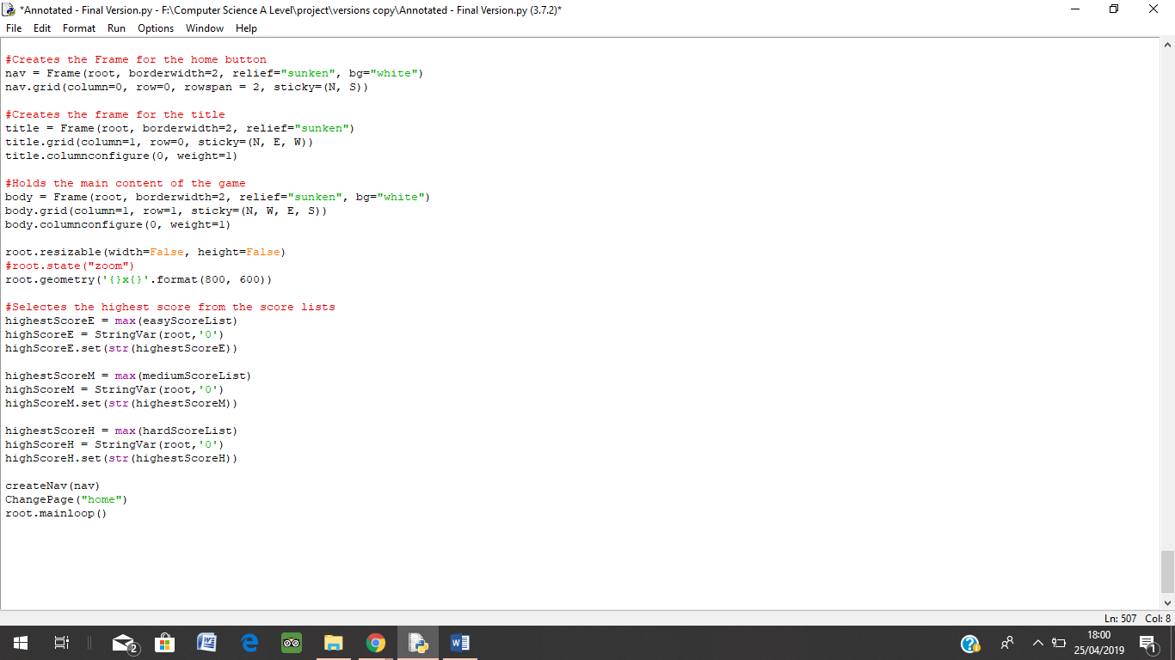

## **Iterative Testing**

|  |  |  |  |  |  |  |  |  |
| --- | --- | --- | --- | --- | --- | --- | --- | --- |
| Test No. | Test Subject | Type of Testing | Input, Output and Functionality Expected | No. of Test | Actual Outcome | Errors | Fix | Justification |
| 1 | Main Menu Button: Play | Black Box | **Input:** Play is clicked by the User  **Output**: Display Select Difficulty Menu:   * Select difficulty title * Easy Button * Medium Button * Hard Button | 1 | Reference: Page 97 | Reference: Page 97 | Reference:  Page 97 | Using Black Box test as I only need to check the if the output is correct when the button is clicked. In this test I do not need to concern myself with the functionality of the code. From this test I only need to show that the user is taken to Select Difficulty Level which is specified within the Success Criteria |
| 2 | Reference: Page 100 | Reference: Page 100 | Reference: page 100 |
| 3 | Reference: Page 104 |  |  |
| 2 | Main Menu Button: Progress | Black Box  White Box Testing | Display Progress Table | 1 | Reference: Page 158 |  |  | Using Black Box test as I need to check the if the output is correct when the button is clicked. A table that shows how many times the user got a question right and wrong. Calculates this. |
| 2 |  |  |  |
| 3 |  |  |  |
| 3 | Main Menu Button: How to Play | Black Box | Input: How to Play is clicked  Output: Instructions, Controls and Extra Info on Progress | 1 | Reference: Page 105 | Reference: Page 105 | Reference: Page 105 | Black Box testing as I just need to see if the correct output is given or not. Each section within this Page should have a heading followed by the content |
| 2 | Reference: Page 106 | Reference: Page 106 | Reference: Page 107 |
| 3 | Reference: Page 108 |  |  |
| 4 | Main Menu Button: High Score | Black Box  White Box Testing | Input: High Score Button is Clicked  Output: Top 5 High Scores for each level  Functionality: Scores within a file are compared to give the top 5 scores | 1 | Reference: Page 156 | Reference: Page 156 | Reference: Page 157 | For this part I need to test the input and output when eh button is clicked but also the data that is shown is the correct data. Black box to test that the correct output is given according to the Success Criteria. I also need to check that the code is functioning correctly by comparing all the scores within the file and retrieving the top 5 scores, to do this I need to check the code |
| 2 | Reference: Page 157 |  |  |
| 3 |  |  |  |
| 5 | Main Menu Button: Exit | Black Box | Input: Exit is clicked  Output: Game Closes  Functionality: The pre-defined function used works as expected, and that is called upon input | 1 | Reference: Page 103 |  |  | The output given when the button is pressed is that the game closes straight away. For this I need to make sure I am using the correct function, thus using White Box Testing, so it meets the requirements of the success criteria. |
| 2 |  |  |  |
| 3 |  |  |  |
| 6 | Select Difficulty Menu | Black Box | Input: User selects a level by clicking a button  Output: Directs user to Snake Game | 1 | Reference: Page 104 | Reference Page: 104 |  | This is to check that the buttons for this section leads straight to the game |
| 2 | Reference: Page: 109 |  |  |
| 3 |  |  |  |
| 7 | Game | Black Box | Input: Start and Restart  Output: Game screen, scoreboard, lives and start and restart button – game starts and stops | 1 | Reference: Page 119 | Reference: Page 119 | Reference: Page 119 | Black Box Testing the correct output has been given and matches the success criteria. Checks that the input from the start and restart button give the correct output. |
| 2 |  |  |  |
| 3 |  |  |  |
| 8 | Snake Movement | Black Box  White Box Testing | Input: Snake is Controlled using arrow keys  Functionality: The snake follows the direction the correct directions  Output: Snake moves in that direction | 1 | Reference: Page 123 | Reference: Page 123 | Reference: Page 124 | This is needed so the correct input is giving the correct output, and white box makes sure that the correct code is needed |
| 2 | Reference: Page 125 | Reference: Page 125 | Reference: Page 125 |
| 3 | Reference: Page 126 | Reference: Page 126 | Reference: Page 126 |
| 9 | Collisions with body | White Box Testing | Functionality: Constant check if the head of the snake has collided with body, by checking if they have the same coordinates, then the functions for life tracker will be called upon | 1 | Reference: Page 128 | Reference: Page 128 | Reference: Page 128 | White Box will test that it does this check constantly and the correct function for the function that is directly affect by this event is called upon. This is needed so the life tracker can go down, |
| 2 | Reference: Page 129 |  |  |
| 3 |  |  |  |
| 10 | Collisions with food | White Box Testing Box | Functionality: Checks if the coordinates of the head and the food are the same. Then the function for deleting and creating the food tis called and a question should then appear | 1 | Reference: Page 127 |  |  | This needs to be tested so that when the collision happens the coordinates are checked so the correct functions can be called upon, for the next stage. White Box testing will test that the code functions correctly, as intended. |
| 2 |  |  |  |
| 3 |  |  |  |
| 11 | Snake Growth | White Box Testing, Black Box Testing and Extreme Testing | Input: Snake grows when user has entered correct answer to question  Output: Snake grows by one square  Functionality:  Extreme: How big the snake can get, if it affects gameplay | 1 | Reference: Page 127 |  |  | This is one of the most important factors of snake, that the snake grows. Therefore, will need to test that it is outputting the growth, the code for it functions correctly, by incrementing a square. I need to test this as a extreme value to see if there is a limit to how big the snake can get. |
| 2 | Reference: Page 145 | Reference: Page 145 | Reference: Page 145 |
| 3 | Reference: Page 146 | Reference: Page 146 | Reference: Page 146 |
| 12 | Questions | White Box Testing, Black Box Testing and Extreme Testing | Input: Entry box, user enters answer  Output: The question in a pop-up window  Functionally: Each time the user gets it right or wrong the value for the tally of that question is incremented | 1 | Reference: Page 146 | Reference: Page 146 | Reference: Page 146 | White box testing is important that the value for the question right or wrong is increased otherwise the progress table would not update |
| 2 | Reference: Page 149 | Reference: Page 149 | Reference: Page 149 |
| 3 | Reference: Page 154 |  |  |
| 13 | Score Tracker | White Box Testing | Functionality: The score increments each time the user gets a question right; the score then is saved to a file when the game ends | 1 | Reference: Page 151 |  |  | Need to make the score increase only if the answer was right otherwise the program is errored |
| 2 | Reference: Page 152 | Reference: Page 152 | Reference: Page 152 |
| 3 |  |  |  |
| 14 | Life tracker | White Box Testing | Functionality: Life decrease when snake eats its own body and when 0 game stops | 1 |  |  |  | White box testing is needed to see if the life goes down or not only if the answer to the question is wrong or snake has collided with its body |
| 2 |  |  |  |
| 3 |  |  |  |
| 15 | Home Button | Black Box | Input: Button is clicked  Output: User is directed to Main Menu  Must be displayed on every page | 1 | Reference: Page 103 | Reference: Page 103 | Reference: Page 103 | This is an important feature as in the success criteria this button needs to be on every page, so the user gets back to the main menu from every page. |
| 2 |  |  |  |
| 3 |  |  |  |

# Evaluation

## **Post Development Testing**

|  |  |  |  |  |  |  |  |  |  |
| --- | --- | --- | --- | --- | --- | --- | --- | --- | --- |
| Test No. | Test Subject | Description | Type of Testing | Expected Outcome | Actual Outcome | Pass/ Fail | Justification | Fully/ Partially/ Not Met | Solutions to Failures |
| 1 | Main Menu | Does are all the main menu buttons and colours correct? | Black Box Testing | Main Menu to contain:   * Play Button - Purple * Progress Button – Green * How to Play Button – Green * High Score Button – Green * Exit - Red |  | Pass | According to the success criteria the main menu needs ti have all these buttons with the correct colours displayed as the Client wants, therefore Black Box testing will test the output, the correct output is given or not. | Fully Met |  |
| 2 | Play Button | Does the button work? Dies the button take the user to the Select Difficulty Page? Are the correct buttons and colours being outputted? | Black Box Testing | Direct to Select Difficulty Menu when users press Play:  Easy Button – Green  Medium Button - Orange  Hard Button - Red |  | Pass | The success criteria state these button and symbolic colours need to appear as the client wants. Black Box Testing test the output, thus design whether the correct buttons and colours are displayed or not | Fully Met |  |
| 3 | Easy Button | Is the user directed to the game? Does the title have the correct level in it? | Black Box Testing | When users press Easy:  Maths Snake (Easy):  Game buttons and trackers  Game Screen |  | Pass | Black Box Testing will test that the outputs are correct. That the output is whether the expected or not. | Fully Met |  |
| 4 | Medium Button | Is the user directed to the game? Does the title have the correct level in it? | Black Box Testing | When users press Medium:  Maths Snake (Medium):  Game buttons and trackers  Game Screen |  | Pass |  |  |
| 5 | Hard Button | Is the user directed to the game? Does the title have the correct level in it? | Black Box Testing | When users press Hard:  Maths Snake (Hard):  Game buttons and trackers  Game Screen |  | Pass | Fully Met |  |
| 6 | Start and Restart Button | Does the game start when the user presses start? Does the game stop when the user presses Restart? | Black Box Testing | Start Button – Snake and Food will appear  Restart Button – Game Screen will be cleared |  | Pass | Need to test whether the correct output happens when the user presses the buttons. Black Box will test that the button gives the correct output, when pressed | Fully Met |  |
| 7 | Constant Snake movement | Does the snake move constantly? | Black Box Testing and White Box Testing | Snake moves constantly at the rate of 2 bits |  | Pass | The snake needs to move constantly non-stop. Needs to be tested as it is important to the game snake. The movement needs to be checked with black box, if the movement looks correct or not. White Box to see if the function of the code is correct, it does move at that rate | Fully Met |  |
| 8 | Snake Controls – Up Arrow Key | Does the snake move up when the up-arrow key is pressed? | Black Box Testing | Snake moves up |  | Pass | Need to test that the correct controls are being used for the correct direction as the user wanted as stated in the success criteria. Black Box test the correct input gives the correct output. | Fully Met |  |
| 9 | Snake Controls – Down Arrow Key | Does the snake move up when the Down arrow key is pressed? | Black Box Testing | Snake moves down |  | Pass | Fully Met |  |
| 10 | Snake Controls – Left Arrow Key | Does the snake move up when the Left arrow key is pressed? | Black Box Testing | Snake moves left |  | Pass | Fully Met |  |
| 11 | Snake Controls – Right Arrow Key | Does the snake move up when the Right arrow key is pressed? | Black Box Testing | Snake moves right |  | Pass | Fully Met |  |
| 12 | Snake eats food | Does the food disappear when the snake collides with, the food? Does a question pop-up? Does a new food randomly appear? | Black Box Testing and White Box Testing | Snake Eats food:  Question appears in new window  Once question is answered, there should be a new food |  | Pass | Need to test this as the question should appear straight after the snake hits the food. The food should appear randomly on the screen, and the other should be deleted, as the success criteria stated. | Partially Met | The snake sometimes passes straight through the food, this can be fixed by editing the coordinates too match the snake head fully, as when the snake turns it sometimes does not do a complete turn thus half oif the snake touches the food and the other half does not |
| 13 | Snake eats Body | Does the snake collide with the body? Does the number of lives go down? Does the snake carry on moving? | Black Box Testing |  |  | Pass | The snake needs to collide with itself to make the game more challenging and it is an important feature the clients wants, another way for the lives to go down as the client wanted. Black Box as I am testing the output is correct when the input of the snake hitting itself is given. | Partially Met | I haven’t able to incorporate the life tracker, therefore, the game ends when the snake collides with the body |
| 14 | Snake growth | Does the snake grow? Does the snake grow only if the answer to the question was correct? | Black Box Testing | Snake grows by one square |  | Pass | Black box as I need to observe the output only. The success criteria say it should only grow if the answer to the question was correct or not. | Fully Met |  |
| 15 | Snake Travels to the edge of the Game Screen | Does the snake move to through the edge and come out the opposite side? | Black Box Testing | The snake comes out the opposite side |  | Pass | The client wants the snake to go through the screen and come out the other side | Fully Met |  |
| 16 | Question Answered | Is the question there? Is there a entry box? Does the question close when the answer is entered? | Black Box Testing and White Box Testing | Question in pop-up window:  Question at top in a large rectangle  Entry Box underneath the question  E.G.Question: 17 + 3  Answer: 20 |  | Pass | White Box need to make sure the answer is check with the correct answer to the question, and that the tally is increased as well for the Progress Table. Black Box to make the layout is as the client wanted. | Fully Met |  |
| 17 | Answer is Right | Does the score increase when the answer is right? | Black Box Testing and White Box Testing | E.G. Question: 17 + 3  Answer: 20 |  | Pass | This is to make sure that when the answer is correct the score increases | Fully Met |  |
| 18 | Answer is wrong | Does the game carry on when the answer is wrong? | Black Box Testing and White Box Testing | Question: 17 + 3  Answer: 21 |  | Pass | This is to check that the score doesn’t increase, and the game carries on as normal |  |  |
| 19 | Score Tracker | Does the score increase when the answer to the question is correct? | Black Box Testing | Score is increased by 1 if the answer was right, new score is displayed |  | Pass | Black Box testing as I only need to check if the correct input gives the correct output, the score increasing, which is in the success criteria. |  |  |
| 20 | Current High Score | Is the current high score being displayed? If high score is beaten is the high score updated straight away? | Black Box Testing and White Box Testing | Current High Score is shown under current score  High score is updated when the current score suppresses current high score |  | Pass | White Box, to make sure the new high score is saved within the file. Black Box to make sure the display of the score is correct. | Fully Met |  |
| 21 | Life Tracker | Does it start with 3 lives? | Black Box Testing | Display 3 lives when game first starts | No Evidence not done | Fail | Need to make sure lives start with 3 as specified within the success criteria |  |  |
| 22 | Life Decrease | Does the life decrease when answer is wrong?  Does the life decrease when the snake eats the body? | Black Box Testing | Lives decrease by one when answer is wrong, or the snake has collided with itself | No Evidence not done | Fail | This is the only times the number of lives should decrease as this is how the client wants it. |  |  |
| 23 | Game Over | Does the game end when lives hit zero? | Black Box Testing | Game Screen is cleared  Score and High Score are displayed | No Evidence not done  Refer to test 13 |  | Black Box as I only need to see what the output is when the lives hit 0. | Partially Met | Game now ends when the snake eats itself. |
| 24 | Progress Button | Does it direct the user to the progress table? | Black Box Testing | The progress table is displayed |  | Pass | In the success criteria the button Progress should take the user directly where they can see the stats for each question | Fully Met |  |
| 25 | Progress Table | Does the progress table have the correct headings? Does it have the information on the questions underneath the correct headings? | Black Box Testing and White Box Testing | Headings – Questions, Rights, Wrongs and Answer. Underneath should be the questions, tallies and answer respectively |  | Pass | This Is important as this is one of the main features that all the stakeholder will use, so I need to make sure it is displaying correctly using Black Box and it is functionating correctly using White Box | Fully Met |  |
| 26 | Correct tally for right and wrong tracker | Is the tally increased correctly for each question? | White Box Testing | Display the correct number of rights and wrong for a question |  | Pass | White Box as the tally needs to increase each time the user answers the question and the correct tally should be incremented; otherwise progress table is defective | Fully Met |  |
| 27 | Scrollbar | Can the user see all the progress? | Black Box Testing | Scroll down to view more Progress? | Not Done. No Evidence | Pass | Need this so the user can see all the questions as the screen size is not big enough for all the questions | Not Met |  |
| 28 | How to Play Button | Does it direct the user to the How to Play section? | Black Box Testing | Display the how to play section |  | Pass | This is needed as in the success criteria this tells the uses how to use the game. | Fully Met |  |
| 29 | Instructions | Does it have the heading instruction? Does it have the instructions? | Black Box Testing | Display the Heading Instructions  Display the actual instructions |  | Pass | The instructions need to be in the format as specified the success criteria and the design speciation | Fully Met |  |
| 30 | Controls | Does it have the heading Controls? Does it have the controls in the form of an image? | Black Box Testing | Display the Heading Controls  Display the controls as an image |  | Pass | The controls need to be in the format as specified the success criteria and the design speciation | Fully Met |  |
| 31 | How to use Progress | Does it have the heading how to use progress? Does it have the extra info? | Black Box Testing | Display the Heading How to use Progress  Display the extra info |  | Pass | The how to use progress needs to be in the format as specified the success criteria and the design speciation | Fully Met |  |
| 32 | High Score Button | Does the button lead the user to the top 5 scores for each difficulty? | Black Box Testing | High Score Tables for each difficulty level |  | Pass | The success criteria stats that the output of the button being clicked needs to display he high scores of each level, this using Black Box | Fully Met |  |
| 33 | High Score table for Easy | Top 5 scores for Easy | Black Box Testing | Numbered list up to 5 of high scores |  | Pass | The user wants to see the top 5 scores for each level. | Partially Met | Have not been able to add the numbered list in, but eh scores are in order. I can fix this by either creating a for loop to add them in or create an spate label. |
| 34 | High Score table for Medium | Top 5 scores for Medium | Black Box Testing |  | Pass |  |  |
| 35 | High Score table for Hard | Top 5 scores for Hard | Black Box Testing |  | Pass |  |  |
| 36 | High Score File | Does it contain all the high scores? Does it compare the high scores? | White Box Testing | All the high scores are compared to give the top 5 |  | Pass | Need to check whether all the scores are being saved and compared to find the top 5 scores |  |  |
| 37 | Exit Button | Does the game close straight away? | Black Box Testing | The game closes |  | Pass | Game needs to close straight away when exit is pressed as specified in the success criteria | Fully Met |  |
| 38 | Home Button | Does it take the user to the Main Menu directly? | Black Box Testing | Home is pressed  Main Menu is Displayed |  | Pass | This is the back button where the user can use to get to the main menu from any page | Fully Met |  |
| 39 | Screen Size | Is the screen size set at 800 X 600?  It is it adjustable? | Black Box Testing | The screen size is set at 800 X 600 and you cannot change the size of the screen |  | Pass | This was set by the client in the Success Criteria | Fully Met |  |
| 40 | App | Does the game appear as an app? Does it launch when clicked? | Black Box Testing | The game should be available as an app and launch when clicked | No evidence, not done | Fail | This was set by the client in the Success Criteria | Not Met | Not met due to the timescale, not enough time to export the file |
| 41 | Colours and Font | Does the correct colours and fonts appear? | Black Box Testing | The correct colours and fonts should be displayed | All fonts and colours are correct | Pass | This was set in the Success criteria and set in the design stage for certain colours and fonts to be displayed | Fully Met |  |

## **Validation**

Incase the program takes other keyboard inputs when I binded the control keys, I decided to check main key inputs that may be used by the user during the game to check if they were valid or not.

|  |  |  |  |
| --- | --- | --- | --- |
| Keyboard Inputs | Outputs | Valid or Invalid | Reason for Testing |
| W | No Change | Invalid | I tested these key inputs because in some game on the PC, they use WASD to move the game character |
| A | Invalid |
| S | Invalid |
| D | Invalid |
| ENTER | No Change | Invalid | This key is used often, o I need to check this key has any valid function or not in the game |
| ESC | No Change | Invalid | The Escape Key can be used to exit game/applications sometimes, so I check that in this case whether it does this or not |
| Number Keys: 0 – 9 | No Change | Invalid | Tested these incase these keys were valid to control the application as number keys can be used to navigate through applications |
| Function Keys: F1 – F12 | F1 – F9,F11,F12 – No Change  F10 - Paused the Game | Invalid for F1 – F9,F11,F12  Valid for F10 | I tested these keys as Function Keys have 2 purposes. Some are are used to control settings on the laptop or as shortcuts like controlling the volume. Therefore, incase the user uses these during the application I need to check if the input is valid |
| Modifier Keys | No Change | Invalid | These keys are used for shortcuts(CTRL,SHIFT or ALT), these may be valid affecting the game play |
| NumLock Keys | 2,4,6,8 – Controlled the Snake  Rest of the Key Pad – No Change | 2,4,6,8 – Valid  Rest of the Key Pad – Invalid | Within the Number Pad keys on the keyboard there are keys with arrows, these can act as substion for Arrow Keys |

## **Usability Features**

I now need to get the client to test the software, to see if the features developed match their expectations and receive their feedback on what they think and how difficulf they found it to use the program

|  |  |  |  |  |
| --- | --- | --- | --- | --- |
| Feature | Evidence | Easy, Moderate or Hard | Justification | User Feedback |
| Main Menu |  | Easy | The client needs to test the Main Menu buttons to see if it easy for him to navigate through the game | “I found it very easy to use the menu. I could tell what each button is for easily, and it has all the stuff I wanted” |
| Home Button |  | Easy | The client needs to test if he the home button does what he wants | “The button is very easy to use I can use it very quickly, put in a very god place” |
| Selecting Difficult Level | vidence located on page 181 test number 1 | E | Needs testing to see if the way selecting the levels and whether the appearence is correct or not | “It was very easy for me to tell what each button is for. The colours make it more easier.” |
| Snake Game | Evidence located on pages 184 – 186 test numbers 7, 8, 9, 10, 11and 12. | Moderate | The client needs to test if the snake game functions correctly, it does what he wants it to do. | “The snake game was easy to use, but it was annoying that the snake passed through the red circle sometimes” |
| Math Questions |  | Easy | This is the main solution to his problem therefore this must be tested to see whether it is simple emough for him to answer the questions | “The question window that came up at the right time. it was easy to tell where to answer the question and how to carry on with the game” |
| Game Over | Evidence located on pages 187 and 189, test numbers 13 and 18. | Easy | The way the game ends is different ot how it was defined at the beginning when setting requirements. Therefore this needs to be tested to see if the change is acceptable | “The way the game ends is fine. It ends like the old snake game so I don’t mind.” |
| How to Play |  | Easy | The client needs to test if the instruction of. the how to play section is clear | “The instructions and the controls were very clear. I learnt how to play the game very quickly” |
| Progress |  | Moderate/Hard | This section must be tested by the client and the other stake | “I found it a little bit difficult and confusing on what it was what, but after a while I managed to follow what this section tells me. The same colour for all the rows made it difficult to follow across, could be improved” |
| High Score List | Evidence is located on page 192-194, test numbers 32, 33, 34, 35, 36. | Easy | The client must test this to see if the score list is clear to follow | “Very easy to see my high scores but I wish it was more clear with numbers” |
| Exit | Evidence is located on pages 195, test number 37. | Easy | The way the client wanted to exit the game changed from the Success Criteria therefore he needs to test it to see if it does what he wants | “It exits very quickly no problem at all” |

## **Success Criteria**

|  |  |  |  |  |
| --- | --- | --- | --- | --- |
| **Success Criteria** | **Fully Met, Partially Met or Not Met** | **Justification** | **Test Evidence** | **Test Achieved** |
| Available as App | This criterion set by the client was not met. | I have not managed to export the python file and convert it, so the client is able to download it as a app. | This test was not achieved, evidence located on page 196, test number 40. | The evidence shows the game must be launched by running the Python file. |
| Screen Size | This criterion set by the client was fully met. | I have set the game window to the size requested by the client, 800 X 600 and have made sure the window is not adjustable | This test was achieved, evidence located on page 196, test number 39. | The evidence shows that the game is a set size and cannot be adjusted. |
| Title | This criterion set by the client was fully met. | I have placed a title relating to the contents of the section on every single section of the game. I have met the criteria set by the Client to have the title in high contrast colours. | This test was achieved, evidence located on pages 181 - 183, 192, 194, test numbers 1, 2, 3, 4, 5, 24, 28 and 33. | The evidence shows each section having a clear title and in contrasting colours, black background and red font. |
| Easy Navigation  Button is clicked it diverts the user to the Select Difficulty Level Menu. | This criterion set by the client was fully met. | I have created big buttons with clear labels and colours for easy differentiation between each button to make navigation easier. | This test was achieved, evidence located on page 181 test number 1. | The evidence shows all the section accessible from the Main Menu by clicking a button. |
| Back Button | This criterion set by the client was fully met. | I have met this as on every section of the game there is a Home Button available to the user which diverts them back onto the Main Menu. It has been placed in a noticeable area and used unique colours as specified in the success criteria. | This test was achieved, evidence located on page 197 test number 38. | The evidence shows the Home Button when clicked diverts the user to the Main Menu. |
| Main Menu | This criterion set by the client was fully met. | I have made sure that every single section is accessed by the Main Menu as the client intended. I have created buttons as to what should be in the Main Menu specified in the Success Criteria, which is Play, Progress, How to Play, High Score and Exit. | This test was achieved, evidence located on page 181, test number 1. | The evidence shows the Main Menu with all the buttons, with Play Button standing out the most. |
| Play Button | This criterion set by the client was fully met. | The Play Button leads the user to the Select Difficulty Section as the client wanted. | This test was achieved, evidence located on page 181, test number 2. | The evidence shows that when the Play is clicked it diverts the user to the Select Difficulty Level Menu. |
| Select Difficulty Level | This criterion set by the client was fully met. | This section has all three difficulty levels: Easy, Medium and Hard as the client wanted and each button colour is symbolic. | This test was achieved, evidence located on page 181, test number 2. | The evidence shows that there are three buttons with symbolic colours. |
| Gameplay | This criterion set by the client was partially met. | The gameplay contains the following features, the game Snake, score tracker and question and answers however I have not managed to code the life tracker. | This test was achieved, evidence located on page 184 and 189, test numbers 7 - 18. | The evidence shows that the score tracker, questions and the game snake work however I have failed to code the life tracker. |
| Snake | This criterion set by the client was partially met. | The Snake moves at a constant rate and turns in the direction when the user clicks the Arrow Key to move it. | This test was achieved, evidence located on pages 184 – 186 test numbers 7, 8, 9, 10, 11and 12. | The evidence shows the snake moving constantly and the snake being controlled by the Arrow Keys. However the snake sometimes passes through the food. |
| Question | This criterion set by the client was fully met. | When the snake eats the food, a question pops up in a new window with a question and an entry box. | This test was achieved, evidence located on page 188, test number 16. | The evidence shows a question appearing in a new window. |
| Answers | This criterion set by the client was fully met. | In the pop-up windows there is an entry box, which allows the user to input the answer. Then underneath it there is a submit button which allows the user to submit the answer to see if it was right or not. | This test was achieved, evidence located on page 188, test number 16. | The evidence shows that the answer is entered in the entry box and when submitted the pop-up closes. The test shows that it compares the user’s answer to the actual answer to see if it was correct. |
| Score Tracker | This criterion set by the client was fully met. | The score increases at the appropriate time, when the condition to increase the score is met (right answer), it increases and displays the new score to the users. | This test was achieved evidence located on page 190, test numbers 19 and 20. | The evidence shows the score increasing when the answer is correct, and it displays the current high score. |
| Life Tracker | This criterion set by the client was not met. | This objective was an additional feature where the client has lives, so more chances to play the game. However, I not been able to complete this feature due to the time scale, therefore it will not be incorporated into the game. | This test was not achieved, evidence located on page 190 and 191, test numbers 21, 22 and 23. | The evidence shows the feature was not completed. |
| Game Over | This criterion set by the client was partially met. | For this objective during the design and development stage the way the game ends were changed by my client. It was deicide to have a start and restart button, so as soon as the game ends the client presses start straight away. It is partially met as I have not been able to complete the life tracker, so the game doesn’t end when the number of lives hits zero, it has been changed if the snake collides the game ends, however if the answer is wrong the game will carry on as normal. | This test was achieved, evidence located on pages 187 and 189, test numbers 13 and 18. | The evidence shows the game ends when the body eats its own body and the game carries on if the answer was wrong. |
| Progress | This criterion set by the client was fully met. | For this I needed to keep track of the number of times they get a question right and wrong and display this in a table format. I have managed to complete this objective. | This test was achieved the evidence is located on page 191-192, test numbers 24, 25, 26 and 27. | The evidence shows the progress button directing the user to the progress table which contains tally for each question. |
| How to Play | This criterion set by the client was fully met. | I needed to display three pieces of information, Instructions, Controls and How to use Progress which I have completed. | This test was achieved the evidence is located on page 192-193, test numbers 28, 29, 30, 31. | The evidence shows the How to Play section containing all the information specified in the Success Criteria. |
| High Score | This criterion set by the client was fully met. | I have displayed the Top 5 high scores for each level in the High Score Section. | This test was achieved, evidence is located on page 192-194, test numbers 32, 33, 34, 35, 36. | The evidence shows top 5 scores from biggest to smallest for each difficulty level. |
| Exit | This criterion set by the client was partially met. | This objective was changed during the design stage, where it was decided to have the game close straight away if exit is clicked. | This test was achieved, evidence is located on pages 195, test number 37. | The evidence shows the game closing straight away. |
| Colours and Font | This criterion set by the client was fully met | I have used the correct colours and fonts as the client wanted. | This test was achieved, evidence is located on all pages, test number 41 (page 196) | The evidence shows the correct font and colours |

## **Usability Features**

|  |  |  |  |
| --- | --- | --- | --- |
| **Usability Features** | **Evidence** | **Successful, Partially Successful or Failed** | **Justification** |
| Main Menu | Reference: Page 181. Test Number 1 | Successful | This usability feature was successful as it contains all the necessary buttons needed to access all the sections within the game |
| Home Button | Reference: Page 195, Test Number 38 | Successful | This usability feature was successful as it allows the user to go back to the Main Menu from any section |
| Snake Game | Reference: Pages 183 – 188, Test Numbers 6 - 15 | Partially Successful | This usability feature was partially successful as the snake isn’t perfect. The snake sometimes passes through the food, thus not eating it. However, the game does function where the snake moves at a constant rate and it does grow when it eats the food |
| Maths Questions | Reference: Pages 188 – 189. Test Numbers 16 - 18 | Successful | This usability feature was successful as when the food is eaten by the snake, a pop-up appears with the question, an entry box and a submit button. The user can enter their answer into the box and submit it to check if it is right. |
| Life Tracker | Reference: Pages 190 - 191, Test Numbers 21 - 22 | Failed | This usability feature was a failure, as I did not manage to complete it in time, therefore it will not be available in the game. |
| Progress Tracker | Reference: Pages 191 – 192, Test Numbers 24 - 27 | Successful | This was successful as it keeps a tally in a list for each question the amount of times, they get it right or wrong. Then display it to the user in the progress section. |
| High Score Tracker | Reference: Pages 193 - 194, Test Numbers: 32 – 37 | Successful | This was successful as the score increases when the answer is right. The scores are saved in a list and then it will sort it to find the top 5 high scores, to display it to the user. |

## **Future Developments**

**Snake Game**

Snake game was partially successful as it is not perfect. To make this feature successful I would first need to fix the issue with the snake. The problem with the snake currently is sometimes when the snake touches the food it passes through it. The snake passes through the food at two points. One point is when the snake is controlled to turn too early causing the alignment of the snake head and the food to not match thus when checking the food and head coordinates, they do not match. Therefore, the snake passes through the food. The second point when the snake travels through the food is when the user controls the snake to eat the food whilst completing a turn. Whilst turning into the food the whole body passes through it, the food is only registered as ‘eaten’ when the snake body is straight.

For a future development I would need to address this issue as this can cause problems when the snake is above a certain length, it makes it difficult to play the game. Therefore, in the future I would try to come up with a solution to fix it to make it easier for the user to play the game when the snake is too long.

To develop the snake game further I would make variation for each difficulty level. I can develop the level so not only the questions get harder, but the game play as well. In the future I can develop the snake speed to vary depending on the difficulty level. Therefore, Easy level would have the slowest snake speed and Hard level have the fastest snake speed, making the game harder, thus allowing my client to enjoy the game more, and not get bored of the repetition.

Additionally, currently all each level snake game allows the snake to transverse through the wall to come out the opposite end. However, to make the game for each level more varied and increase in difficulty I can introduce another feature of the classic snake game, a wall. This will improve game play the client will be more restricted to move around thus the game becomes more challenging. Therefore, he gets challenged in learning content wise and playing the game, keeping him entertained.

**Life Tracker**

The life tracker was a failure, due to the timescale to program the solution I had to sacrifice this feature. For this feature I was not able to come up with a computational solution on how to solve the life tracker, and due to time pressure, I couldn’t afford to spend time on this extra feature. Therefore, I made the judgement to not incorporate this into the code.

In the future I would develop a life tracker. The life tracker will give the client more chances to play, preventing him from becoming fed up with the game, if he keeps losing. This future development will all the user to see how many lives they have, and it will also influence the way the game will end. Currently the game ends if the snake ‘eats’ itself, however with the life tracker I can change this, so the number of lives go down by one, if the snake eats itself or the question is wrong. Having this will make my client learn the content better so he survives longer.

Furthermore, I can incorporate more learning chances, so if the user loses all their lives, they have a chance to gain more lives by answering a question. This can be incorporated so it is a bonus question but have the difficulty high for this question therefore to answer it the client must improve his mental mathematical skills.

**Questions**

Incorporating Maths questions into the snake game was successful, however the way I designed the questions makes the game iterative. The questions I placed within the game are fixed within a list, so when the question needs to be called a random question is selected from within the list. Therefore, there are only a limited set of questions, so if the game carries on a while the questions will repeat. Furthermore, after a while my client would have seen all the questions and thus learned the content, therefore the game is no longer needed.

To develop this further in the future, I would design the system of creating a question differently. I would develop it by creating a function which randomly selects numbers and a random operator to create a random question. By doing this it will remove the iterative nature of the game, as questions will repeat less often and more questions for the user to test their skills against. This will improve the user experience as well.

In addition to this, when the question appears in the window, the user has unlimited amount of time to answer the question. Which doesn’t help my client as he needs to master the skill of working under pressure and be able to work out he answer in his head quickly as well. Therefore, In the future to tackle these problems I would develop a timer, so if the question is not answered within a certain time frame, the client loses his chance to increase his score.

**Progress Tracker**

Currently the progress tracker, shows the question, a tally for the amount of the times the user has gotten a question right and wrong and the answer to the question. The problem with this is the client can cheat to see the answer to a question, which beats the purpose of the game which is to improve his mathematical skills.

Therefore, for a future development I would change how the answer is shown. I would develop it so the answer is lock, the client cannot see it until a condition is met. The condition would be something along the lines until you reach a certain number on the tally for the right or wrong tracker the answer will remain locked. This will prevent the client from cheating, helping him improve his mathematical skill. The condition checker will also allow the answer to be viewed if the client is struggling, if the tally for the wrong tracker is high.

**Game available as a App**

This feature was not met. I was not able to export the python file which means the client cannot download the game on to their PC without having the need for Python. They need the python software to run the game.

In the future I would export the Python file so it can be downloaded on the client’s computer directly without the need of Python. The client will be able to download the game on devices compatible with the exported file, so he can play it on multiple devices.

## **Maintenance Issues**

Once the client has the software, I will need to conduct maintenance on the software. This is to keep the program maintained so the client doesn’t run into any bugs in the long run. To do this I would conduct a regular maintenance every 2 months for the first year and make sure to fix any bugs found by the client.

During these maintenances I will need to make sure of to do the following:

**Code Maintenance**

During maintenance I need to maintain the code, so it is running as efficient, with the lowest runtime as possible so the software runs smoothly.

To do code maintenance, I will need to check there are no errors in the code, as the software will be used regularly by the client and other stakeholders, thus some bugs that I haven’t spotted may surface interfering with the software. Therefore, during these code maintenances I will need to fix these bugs, so the client can play the game bug-free.

I will also need to maintain the code by checking that there is no wasteful code. There aren’t any functions or variables not being used, which are not necessary to the system anymore, which is being processed for no reason. In these code maintenances I will delete these, so the game runs as fast as possible, less code to be processed.

**Updates with New Features**

After my client or other stakeholders have used the software for a while, and become familiar with the game features, they may want to improve the existing features or add new ones. I can attain this information by collecting user feedback from them. Therefore, to accommodate these wanted features I will need to roll out updates for the software part of the maintenance.

To update the software, I would collect feedback from the client and stakeholders during a maintenance session. With the information I would then come up with a computational solution during the time before the next maintenance session. During the next maintenance session, I would implement the new features into the software, so the client and other stakeholders receive an updated version of the software.

These updates may also include further developments that I had planned to add or improve the software such as the life tracker.

**Memory Maintenance.**

Currently the software has lots of lists, which continue to grow whenever the client plays the game, for example the list for scores will continue to grow each time the game is played. These lists will take up storage on my client’s device, and eventual taking up a noticeable amount of storage.

Having large lists will slow down my client’s PC, causing the runtime for the game to slow down as well. Furthermore, having the computer to process large lists will also slow down the runtime for the code, more data to process.

Therefore, to maintain the software and the speed of runtime I need to conduct Memory Maintenance. To do this I may reset the list, so the high score list to rest if the list has become too large to be processed.

## **Limitation Developments**

**Game not available as an Application**

One of the limitations was the time scale, which was spent on implementing the computational solution. This caused me not to be able to convert the Python file into a downloadable file, which the client can install on their device as an Application to access the game.

This limits my client from playing the game on multiple devices, because currently the client needs Python installed on the device to run the game. This makes it difficult to play on different devices as he cannot download it different devices quickly and play it, he must have python pre-installed.

This limitation causes my client to play the game on a single device, since having Python installed on a device rather than the Application itself will take up more memory space. This is something my client and other stakeholders would not want.

In the future, as mentioned in the future developments, I would convert the Python code to an executable file so my client can download and play the game on multiple supporting platforms.

**Graphics (GUI)**

The graphical user interface limits the solution from looking like what my client wanted or expected, due to the time scale to implement the solution and the programming language/techniques used.

These techniques and time scale drastically affected as to how detailed the graphics of the game could be, thus resulting in a simple and bland look. The poor detail of the graphic compared to the current existing snake games the games my client plays may put him off the game itself.

This can be a future development, where I can develop the graphics to make the game more aesthetically pleasing. This will make the client to become more intrigue to play the game more often. I can develop the graphics by making the snake more realistic, by giving the snake a more snake like body and more detail for the head like the eyes and mouth. In addition to this, I can animate the snake so when it eats the food, it will play an animation of the snake swallowing the food. This would change how the user interacts with the system as it would be a more enjoyable experience for them to use the software.

**Different Operating System, (Mac OS, Android, Linux etc.)**

I have designed the game on a Windows PC, therefore the code used within the game is supported by Windows only. This means if the game is played on a different Operating System to Windows the game may behave differently as some function may not work as intended or even exist.

Furthermore, the code is designed to work only on PCs, therefore if the client wants to play it on a tablet or phone, which runs on a mobile platform the game may not work at all. This is because it has completely different style of code to what works on mobile platforms, limiting the user to only play on the Window PCs.

Therefore, this can be a future development by tweaking the code so it becomes universal, can be ran on most platforms, or even editing a copy of the code so if needed to be ran on another Operating System, the client or other stakeholders can use this version, which would in theory work on the specified platforms.

**Questions**

Another limitation to the solution that I have already considered as a future development are the questions.

The questions within the game are fixed, therefore once the user has played the client for a while, they will eventually have answered all the questions, thus they will no longer be learning new content. This limits my clients learning as he needs to practice with a variety of questions and not ones that he knows the answer to.

# **Bibliography**

*Change TKinter Button Colours: Stack Overflow). Retrieved from Stack Overflow: https://stackoverflow.com/questions/27347981/how-to-change-the-color-of-ttk-button*

*Colour Charts for TKinter: Science Smith. Retrieved from Science Smith: http://www.science.smith.edu/dftwiki/index.php/Color_Charts_for_TKinter*

*Python-course.eu. (2019). GUI Programming with Python: Text Widget. [online] Available at: https://www.python-course.eu/tkinter_text_widget.php*

*Effbot.org. (2019). The Tkinter Text Widget. [online] Available at: http://effbot.org/tkinterbook/text.html.*

*Effbot.org. (2019). The Tkinter PhotoImage Class. [online] Available at: https://effbot.org/tkinterbook/photoimage.htm.*

*Effbot.org. (2019). The Tkinter Canvas Widget. [online] Available at: http://effbot.org/tkinterbook/canvas.htm#Tkinter.Canvas.create_window-method*

*Codecademy. (2019). Is. [online] Available at: https://www.codecademy.com/en/forum_questions/55c1eabde39efed2110002ae*

*superclass?, P., Oakley, B., Peek, K., Copsey, R. and Ballance, C. (2019). Python: How do I make a subclass from a superclass?. [online] Stack Overflow. Available at: https://stackoverflow.com/questions/1607612/python-how-do-i-make-a-subclass-from-a-superclass.*

*Medium. (2019). Command line flags: Python and Tensorflow. [online] Available at: https://medium.com/@zzzuzum/command-line-flags-python-and-tensorflow-85ab217dbd5.*

*Cs.uky.edu. (2019). [online] Available at: https://www.cs.uky.edu/~keen/115/reading/flags-py.html.*

*Effbot.org. (2019). Events and Bindings. [online] Available at: http://effbot.org/tkinterbook/tkinter-events-and-bindings.htm*

*variable, U. and Kerr, G. (2019). Update Tkinter Label from variable. [online] Stack Overflow. Available at: https://stackoverflow.com/questions/2603169/update-tkinter-label-from-variable.*

*text?, H. and Oakley, B. (2019). How to get the Tkinter Label text?. [online] Stack Overflow. Available at: https://stackoverflow.com/questions/6112482/how-to-get-the-tkinter-label-tex [Accessed 10 Apr. 2019].*

*Labels, C. and Oakley, B. (2019). Creating classes in Python for Tkinter Labels. [online] Stack Overflow. Available at: https://stackoverflow.com/questions/32744793/creating-classes-in-python-for-tkinter-labels.*

*Effbot.org. (2019). The Tkinter Entry Widget. [online] Available at: http://effbot.org/tkinterbook/entry.htm.*

*list?, H., Vega, R., Caune, P. and Olszak, J. (2019). How to randomly select an item from a list?. [online] Stack Overflow. Available at: https://stackoverflow.com/questions/306400/how-to-randomly-select-an-item-from-a-lis.*

*window?, H., Gregory, M., Gregory, M., Guiles, M., Gabaraev, I. and Official, B. (2019). How do I close a tkinter window?. [online] Stack Overflow. Available at: https://stackoverflow.com/questions/110923/how-do-i-close-a-tkinter-window.*

*Thispointer.com. (2019). Python : How to remove element from a list by value or Index | remove() vs pop() vs del – thispointer.com. [online] Available at: https://thispointer.com/python-how-to-remove-element-from-a-list-by-value-or-index-remove-vs-pop-vs-del/.*

*code, K. (2019). Keeping the data of a variable between runs of code. [online] Stack Overflow. Available at: https://stackoverflow.com/questions/31891286/keeping-the-data-of-a-variable-between-runs-of-code.*

*first?, T., WAN, A. and Oakley, B. (2019). TkInter: how can I make objects appear on my second window rather than the first?. [online] Stack Overflow. Available at: https://stackoverflow.com/questions/46809771/tkinter-how-can-i-make-objects-appear-on-my-second-window-rather-than-the-firs.*

*How to find the 1st, 3., Majeed, H., Majeed, H., Hunter, S. and Bumachar, E. (2019). How to find the 1st, 2nd, 3rd highest values in a list in Python. [online] Stack Overflow. Available at: https://stackoverflow.com/questions/32296887/how-to-find-the-1st-2nd-3rd-highest-values-in-a-list-in-python.*